Jeevan Vidya – Jan Seva Site Visit Report 2015

I visited Jeevan Vidya and JanSeva Mandal on March 14th and 15th 2015. I started from my hometown, Pune with my friends, Netra and Nilesh on 14th early morning and reached Nandurbar which is near Maharashtra-Gujarat border around 4 pm after a 10-hour journey.
Ms. Martina Fargose, director of Jeevan Vidya came to receive us near the highway and guided us towards Jeevan Vidya premises.
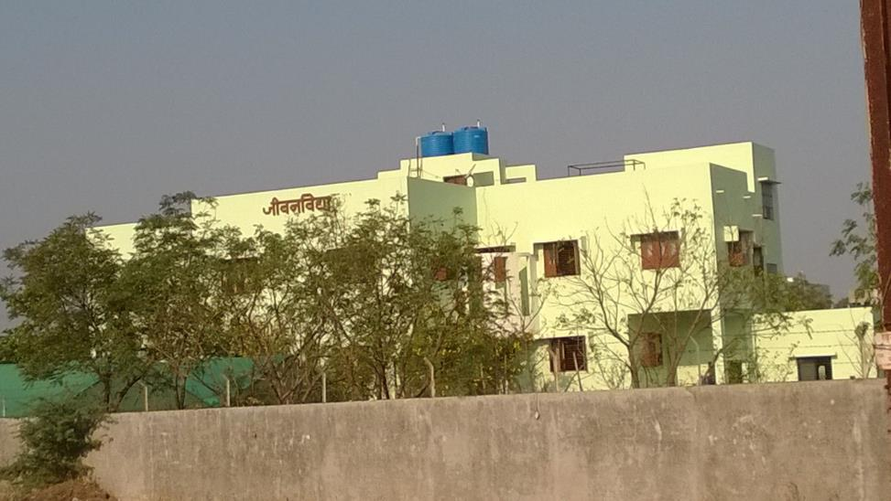
Jeevan Vidya provides lodging and boarding facility for 5th to 12th grade tribal girls who are from nearby villages. The girls were already ready to welcome us by lining along two sides of the entrance pathway. They greeted us with “welcome tai, welcome dada”.
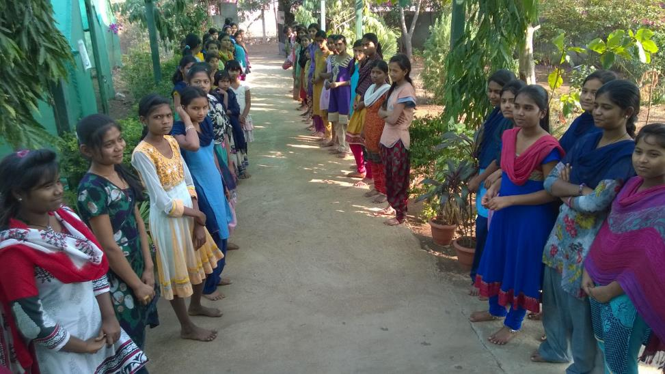

Martina tai had arranged our stay in Jeevan Vidya building itself. She showed us the two guest rooms on the second floor and girls eagerly carried our bags upstairs.
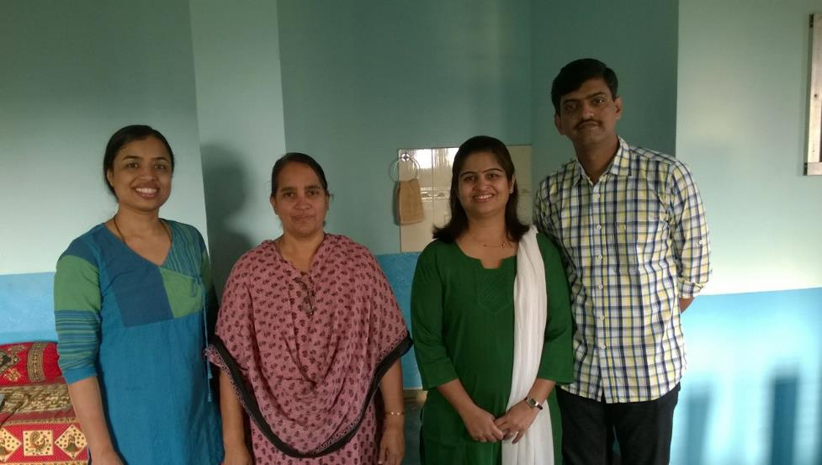
After freshening up, Martina tai invited us for evening tea and snacks in the staff dining area. Staff kitchen and dining area are also on the second floor next to the guest rooms.
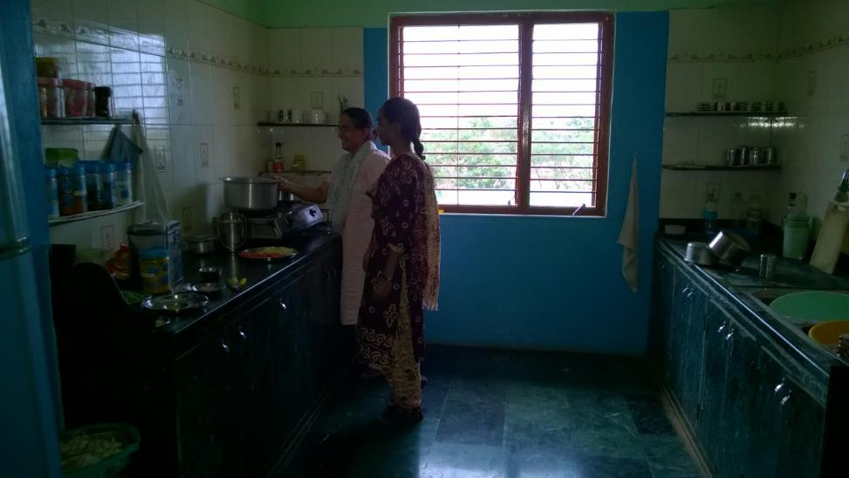
There is also a computer lab cum sewing room on the same floor. After the tea, we started the tour of the campus.
There is a small office on the first floor where Martina tai works. It also serves as a small library and showcases a few awards won by the girls.
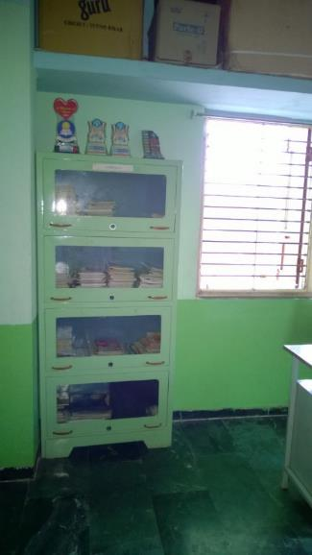
There is a big room on the first floor that all the girls share. They put mats on the floor and use them for sleeping at night and for yoga in the morning.
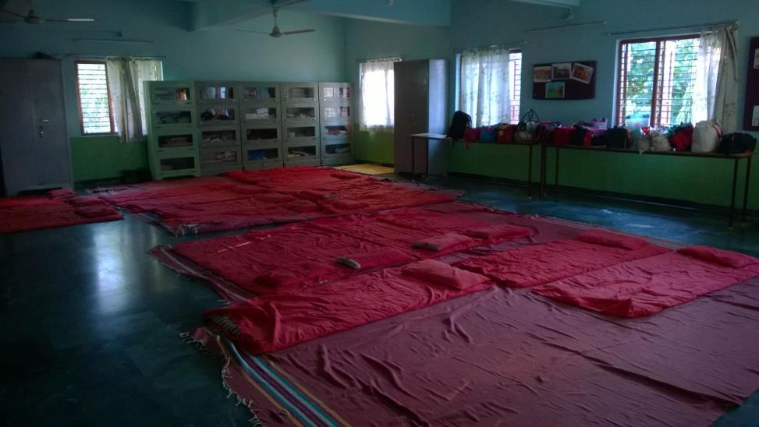
There are lockers along one wall where girls put their belongings and clothes. Cupboards along the second wall are used to keep their books and school bags. There were a few tables along the third wall where some of the girls had kept their suitcases.
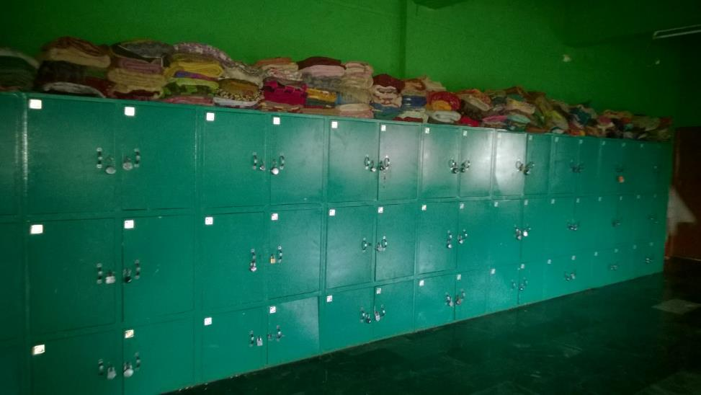
Rest of the suitcases were kept in another big room which also serves as a study room. Since SSC exams were going on when we visited, some of the girls were studying there.
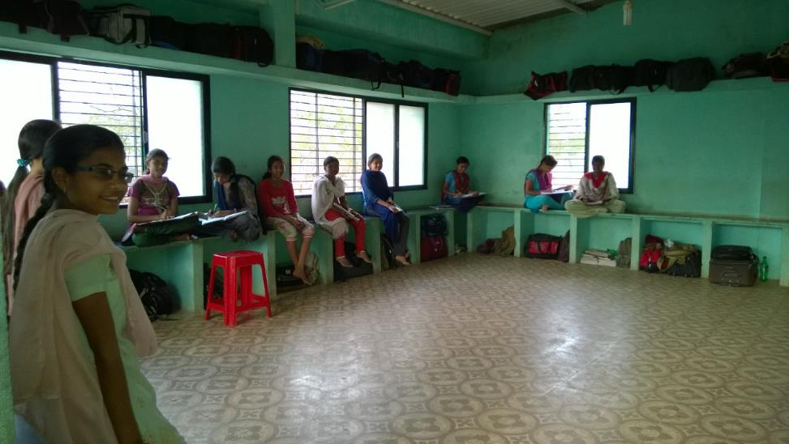
There is also a store room to keep extra kitchen supplies.
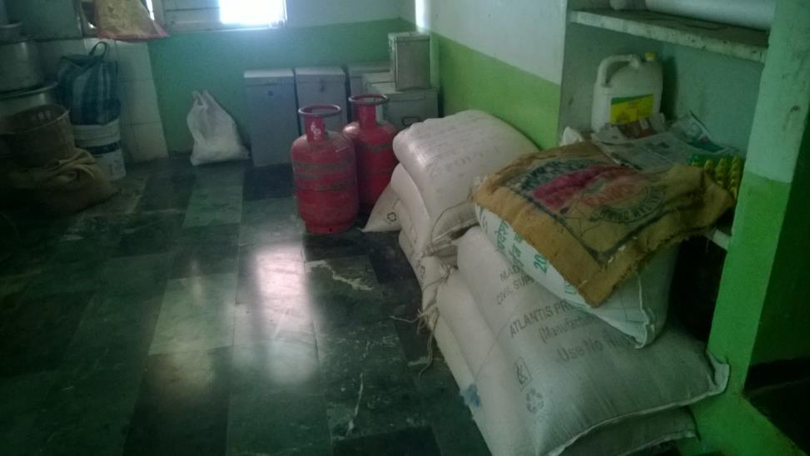
Girls kitchen is also on this floor. It is detached from the main building but very close-by.
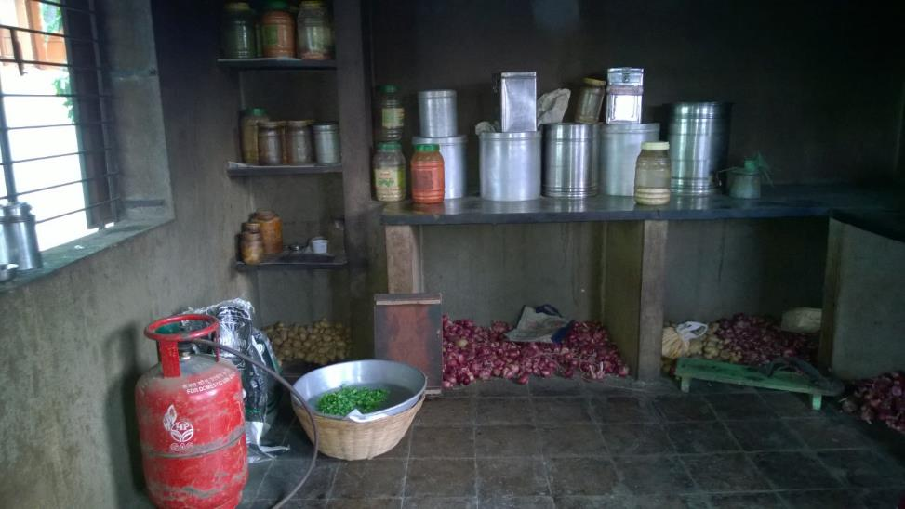
We met two ladies who were cooking evening meal for the girls. The cooks are from the nearby tribal villages as well and commute 15-20 kms every day. They come in the morning, cook breakfast, lunch and dinner and go back to their homes in the evening.
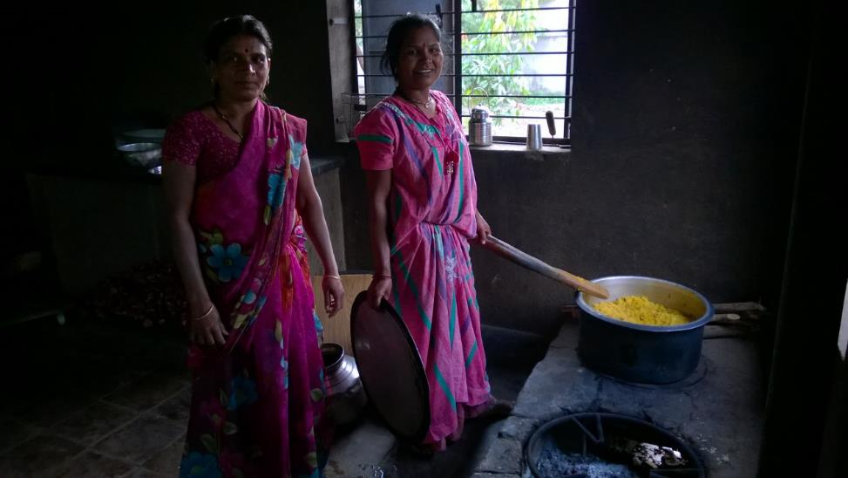

There was another one storied building little farther from the main building that housed bathrooms and toilets for the girls.
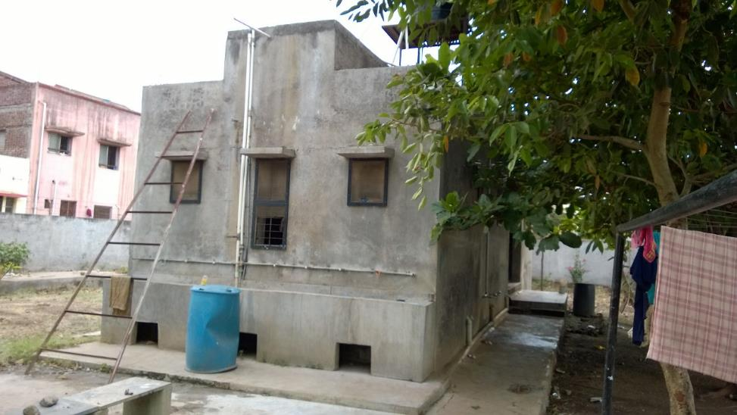
There was also a borewell close-by that is used by the girls to wash their dishes after every meal.
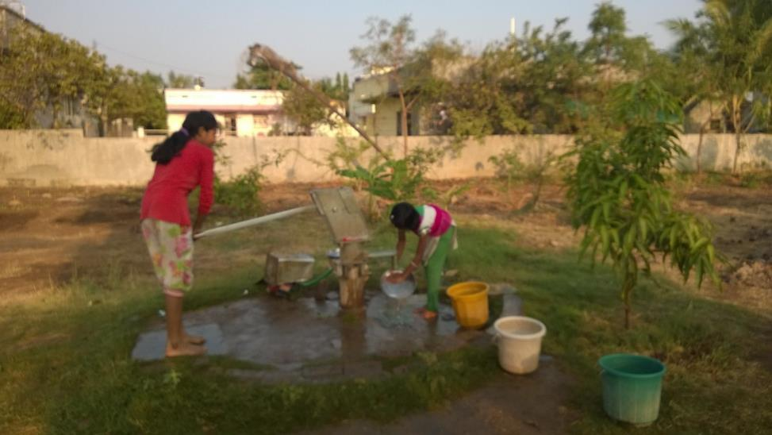

The yard around the building is fairly large and some part of it is used to grow herbs, vegetables and flowers. A greenhouse is used to grow some of them while others are planted outside the greenhouse.
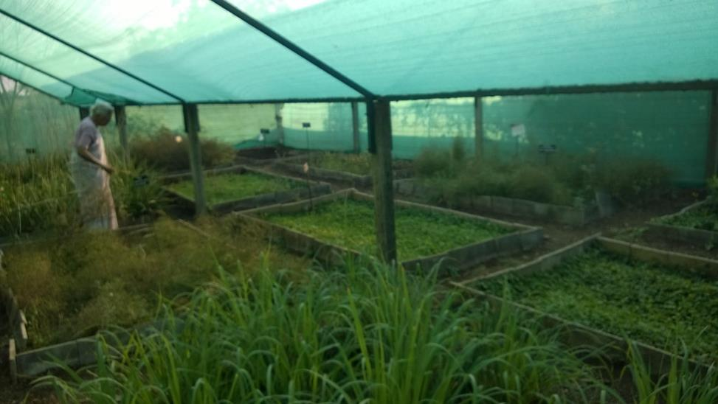
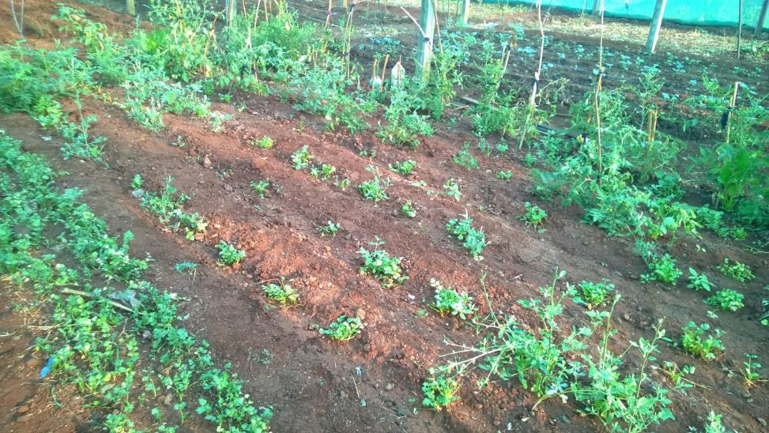
The herbs and vegetables grown there are often used in the cooking. Rest of the yard is used by the girls as a playground.
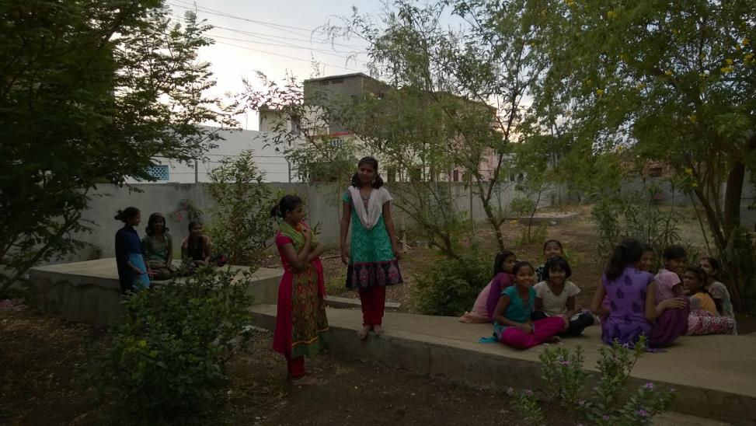
There was another group of women from Gujarat who was also visiting Jeevan Vidya on the same weekend. The girls were planning to perform for all the visitors around 7 pm. So Martina tai suggested that we visit Janseva Mandal in the meantime. She led us to Janseva premises which is about 5 mins walk from Jeevan Vidya.

Fr. Florence Fernandes, director of Janseva welcomed us to the campus. Janseva Mandal provides lodging and boarding facility for 5th to 10th grade tribal boys who are from nearby villages. We visited his office on the first floor and also met the accountant.
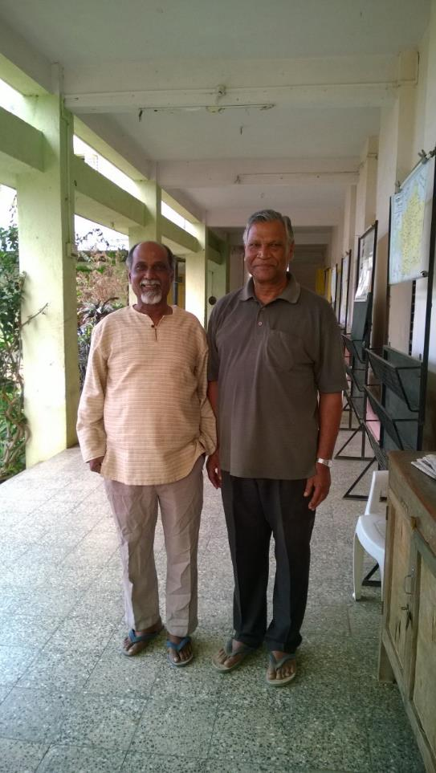
Then we toured the campus with Fr. Florence. Janseva campus is similar to Jeevan Vidya. It has a large room on the first floor that all the boys share. They also use mats on the floor to sleep. There are shelves along the walls where the boys keep their belongings.
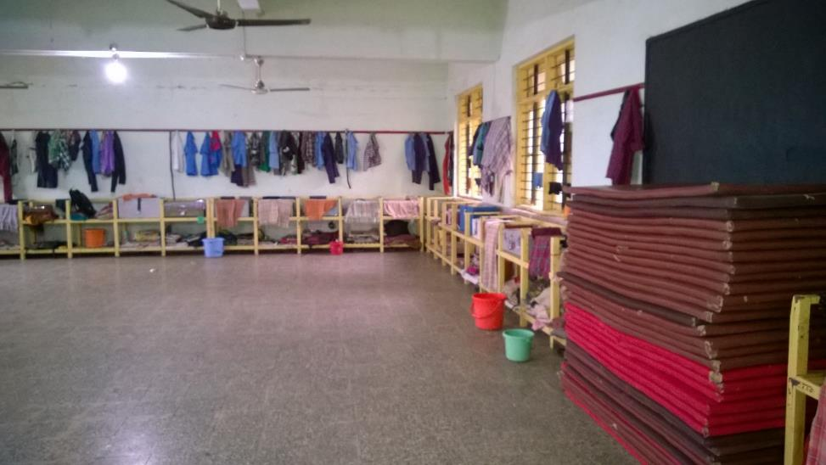
There is a big room on the second floor with some tables and chairs that the boys use as a study room. They were studying when we visited Janseva and a volunteer teacher was supervising and helping them in case of difficulties. The teacher had similar background as the boys and stayed at Janseva when he was studying in the middle school and high school. There is also a computer lab on the second floor.
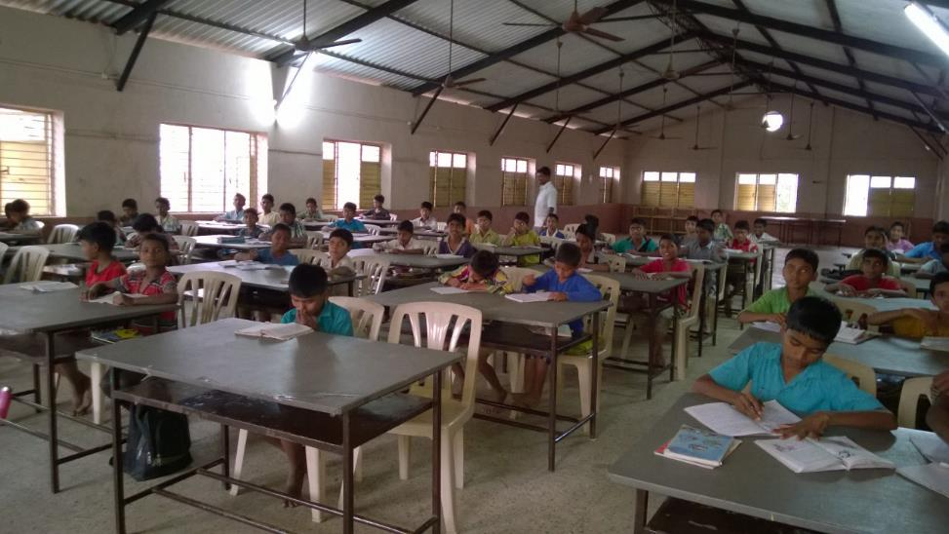
Kitchen, store room and bathrooms for the boys are on the first floor. Yard around the building is used by the boys as a playground.
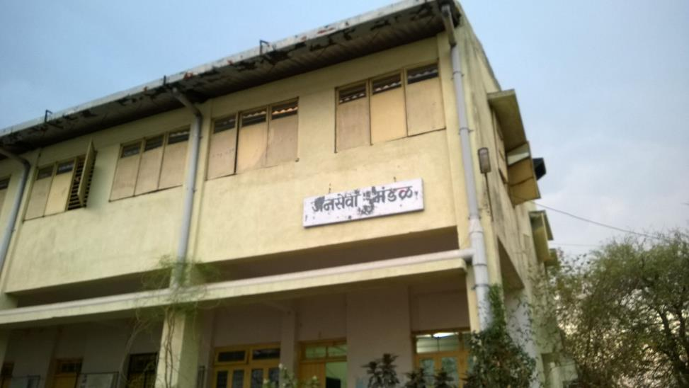
We talked to Fr. Florence for some time and then came back to Jeevan Vidya.
The girls had arranged a variety show to welcome us and showcase their talent. They welcomed us formally by giving bouquets of the flowers grown in-house. Then the 9th graders sang a welcome song for us. Couple more groups presented group dances.
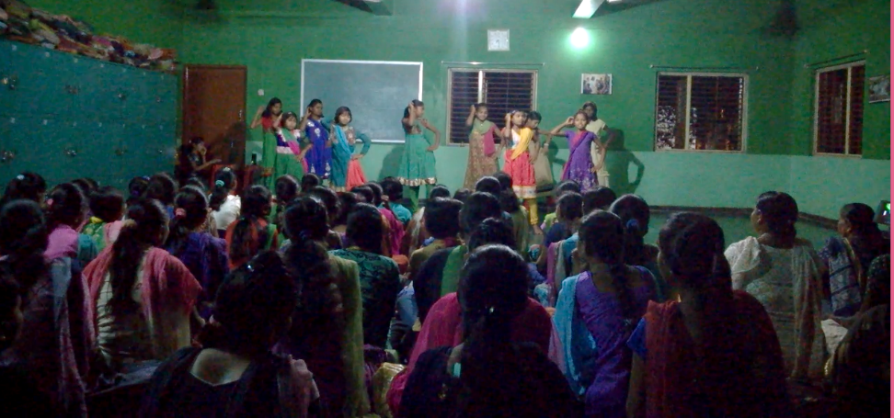
Then an 11 grader gave a speech in Marathi. She told about the things she learnt here including learning to speak, read and write Marathi (as they speak Ahirani at home) and English. They also get to learn cycling and using a computer. They can enroll in karate classes as well as personality development classes. They are encouraged to participate in various competitions outside such as drawing, essay writing and sports. She mentioned that this increases their confidence significantly. The kids also take care of their daily chores along with studies and extra-curricular activities. They wash their own clothes and utensils every day.
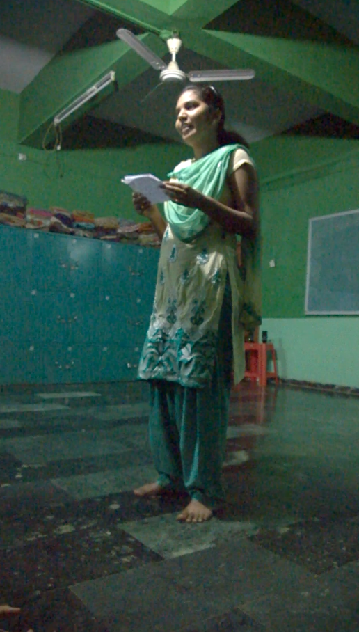

At Jeevan Vidya, all girls are divided into groups of mixed ages at the beginning of the year. Every Sunday one of the groups cooks meals for all the girls in the hostel. Younger girls get the benefit of experience and guidance of the older girls in the group.
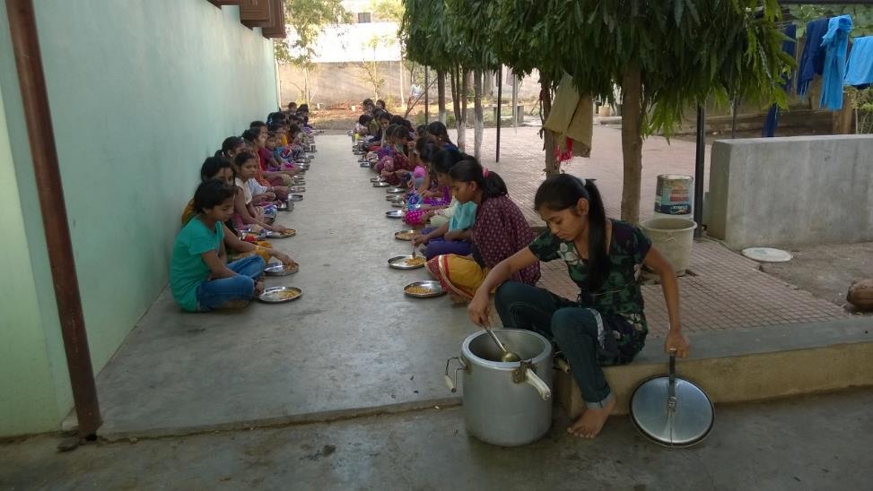
They also help to grow vegetables and herbs which are used in their cooking while also learning the gardening and composting techniques. As girls get to learn so many things while at Jeevan Vidya, their younger siblings and friends still in village are keen on getting an admission here.
We had a yummy dinner after the performance and then called it a day. Next day we woke up around 7 am. The girls gave us hot water buckets for our bath. Jeevan Vidya uses solar power as an additional energy source. We had breakfast and tea with Martina tai and then she along with other catholic members of the staff went to her office for Sunday prayers. We were about to start our return journey as well. The girls came till the main gate and gave us a heartfelt farewell.
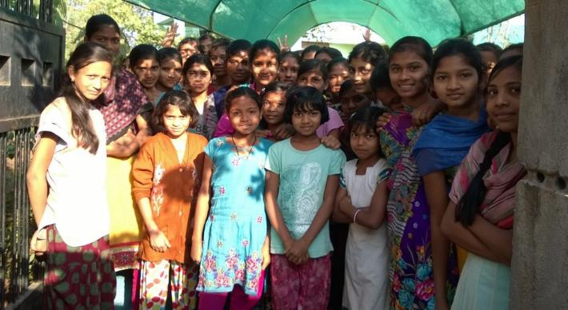
The goal of these projects is to provide lodging and boarding to help kids from the nearby tribal areas in their education. However, what I observed is that these hostels go above and beyond the official mandate by not only tutoring the difficult courses in the school but also teaching them life-skills through extra-curricular activities. True to their name, they rightly teach jeevan vidya to these kids!
