Proposal for School infrastructure and Feeding centre
Support to IDP Children
Title of the project: School infrastructure and Feeding centre support to IDP children
Total budget proposal: 208,760
Item-wise distribution of budget proposed:
- Feeding Centre: 240 days x Rs. 20 per kid (two times feeding) x 25 children = 138,760
- Vessels: 20 sets x Rs. 1500 each = 30,000
- TLM kits: 20 nos x Rs. 2000 each = 40,000
Feeding Centre:
With the above support from ASHA, ASDS proposes to start a feeding centre at Chukkalapadu settlement, Edugurallapalli cluster, Chintur Block, Khammam dist. Chukkalapadu IDP village was formed in the year 2005. People of the village have come and settled in this settlement after their houses in two other places (settlements) were burnt by forest department. ASDS has been working in this village since 2008. After seeing pathetic situation of many of the villagers in the same year 2008, ASDS distributed emergency relief material such as Rice, Dal, Tarpaulins, and Clothes etc. In the year 2009, ASDS began a feeding center with the support from Action Aid. This ran for a year and later got closed after support from Action Aid was stopped. In the same year, due to the persuasion from ASDS, 6 children have got admitted in Residentail Bridge Course (RBC) School, and all of these children are now studying in 2nd and 3rd standards in mainstream Ashram school in Edugurallapalli. In the year 2010, Alternative Learning School (ALS), where children from 6 – 14 years age study, was started by the government in this settlement. The benefit of having ALS being sanctioned by government is that in addition to children having access to education, it provides children attendees with Mid-day meals scheme, as part of which children get free afternoon meal. In the last couple of year, this settlement has also got sanctions of ICDS (take home ration), NREGS cards etc., which is because of ASDS’s lobbying work with the government on IDP’s rights. As on today, 8 malnutrition children from this settlement have also been referred to Nutritional Rehabilitation Centre (NRC).
Eventhough, all the above services have been extended to IDP’s, but the implementation part of all the above services is very poor from the government. For instance, ALS always suffers from irregularity and less amount of funds released by Sarva Shiksha Abhiyan (SSA). This has been making the school to run irregularly with children not getting access to regular education, and also Mid-day meals. In addition, ALS teachers are not feeling really enthused to regularly come and teach to children, because they are paid no salary for few months together. With regard to NREGS, IDP’s are not getting work regularly. One of the main reasons for this is the distance from work place to IDP’s settlement being very far (3 – 5 KM’s on an average). And when it comes to ICDS, take home ration is issued only once a month with less quantity of material. This means that though today IDP’s are given more or less all the services from the government, they are still far away from accessing them. This also means that IDP’s do not have much access to good sources of livelihood yet. This scenario has been contributing indirectly to not satisfying the food needs of children and hence the children are going malnourished. In addition, with ALS not running regularly, children are also loosing access to continuous and focused education. Currently, there are about 15 children in the age group of 0 - 5 years suffering from 2nd to 4th degree of malnutrition in this settlement.
In this situation, through the current proposal of starting a feeding centre, ASDS seeks to achieve
- Improve the nutritional levels of children.
- Ensure ALS works and children go to school regularly.
Though this feeding center, ASDS proposes to feed children in the age group of 0 – 5 years for 240 days. Approximate number of children in the above age group is 25 in this settlement. Below table gives the details of list of food items that a child will be supported with, through this project.
Sl no | Item | No of Days | Grams per Day | Total Grams per Month | Present Market Rate | Rs Per Month per Child
1 | Rice | 26 | 120 g | 3120 | 15.00 | 46.8
2 | Oil | 30 | 10 g | 300 | 65.00 | 19.5
3 | Chenagalu (Bengal Gram) | 15 | 50 g | 750 | 48.00 | 36
4 | Onion | 30 | 10g | 300 | 8.00 | 2.4
5 | Red chilly power | 30 | 2 g | 60 | 110.00 | 6.6
6 | Salt | 30 | 2 g | 60 | 10.00 | 0.6
7 | Pasupu (Turmeric) | 30 | 1 g | 30 | 100.00 | 3
8 | Red gram Dall | 14 | 30 g | 420 | 50.00 | 21
9 | Pappuchakka Sweet | 30 | 10 (1 P) | 200 g | 2.00 | 60
10 | Uppma Ravva | 4 | 120 g | 480 | 25.00 | 12
11 | Talimpulu (Seasoning) | 30 | 3 g | 90 g | 80.00 | 7.2
12 | Bangaladumpa (potatoes) | 8 | 25 g | 200 g | 13.00 | 2.6
13 | Pallilu (ground nut) | 15 | 50 g | 750 | 66.00 | 49.5
14 | Tamarind (Chintapandu) | 15 | 5 g | 150 g | 75.00 | 11.25
15 | Eggs | 2 |  | - | 2.80 | 5.6
16 | Dry Chilly | 30 | 1 g | 30 g | 95.00 | 2.85
17 | Soap | 1 for Month |  | - | 10.00 | 10
18 | Hair Oil | 1 for Month |  | - | 20.00 | 10
 | Total |  |  |  |  | 306.9
Per Day per Child, One time Feeding Rs. 10.23 x 2 Times= Rs. 20.46
Wherever a feeding centre is run by ASDS, it also tries to impart education to the children when they come to eat in the afternoon. So that children not only get food but also some education. And to do it, ASDS employs a teacher at Rs. 2000 a month salary.
Total expenditure on one child per day for two times feeding is Rs. 20. 46 x 25 children on an average x 240 days (8 months) = 122,760. The teacher salary for a month is Rs. 2000 x 8 months = 16,000.
Vessels support to running Alternative Learning Schools (ALS’s):
As mentioned above, currently Alternative Learning Schools sanctioned by government are suffering from the lack of funds and so there some of the basic needs which are lacking in ALS’s. One of them is vessels. Currently, there are 20 ALS’s running for IDP’s and most of them do not have vessels which are useful for cooking; both quantity and quality wise. And vessels support is not part of the funds released by SSA also. So, ALS’s are suffering from not having sufficient and suitable vessels. They are being temporarily managed so far with the donations from people, borrowing from here and there etc. In order to address this, ASDS proposes following list of vessels for the 20 ALS’s.
- One vessel for cooking Rice – 5 KG’s quantity; Rs. 400 each
- One vessel for cooking Curry – 5 KG’s quantity; Rs. 400
- One vessel for catching water – 15 liters capacity; Rs. 300
- One bucket for catching water – 15 liters capacity; Rs. 300
- Plates, Spoons, Mugs etc. – Rs. 100.
Total cost for list of above a–e items is Rs. 1500, which is one set of vessels to be distributed to one ALS. For 20 ALS’s, total cost is Rs. 1500 x 20 sets = 30,000.
Teaching and Learning Material (TLM) kits support:
In order to promote and draw more children to come regularly to the school, Teaching and Learning Material (TLM) usage has been initiated by ASDS, upon the suggestion by Action Aid. This has been going for the last 2 months in 30 IDP settlements, where the feeding centers are run by ASDS. In the feeding centre, children are also provided basic education i.e. teaching letters, numbers etc., with a teacher employed by ASDS. The feedback that ASDS has received about TLM so far is that children are liking the material, and since there are playing material in the kit, which are seldom seen in the IDP villages, children are drawing themselves to the school. One TLM kit consists of some number of slates, one black board, and playing material that give fun as well as teach numbers, alphabets etc. to the children. Following is the short description about TLM, with some photos attached of children using and playing with TLM kits, and some other photos showing list of material that are there in one TLM kit.
Teaching and Learning Material (TLM) will promote independence and autonomy among the children which involves acquiring a repertoire of learning strategies and practices, developing positive learning dispositions, and enhance the will and personal confidence to become agents in their own learning. Teaching and learning material will engage children productively and effectively promotes big ideas in children.TLM is based on psychological, developmental, and educational principles which strengthen cognitive and perceptual-motor processes compatible with each child's stage of development. TLM emphasize active and interactive learning and play between children, family members and adults. They involve and require attentiveness, following directions, being cooperative, thinking, reasoning, and use of verbal language capabilities and visual spacial and manual dexterity. Children move from being dependent on directions to becoming independent and self-reliant. TLM- EDUCATIONAL GAMES enables children to learn the skills of cooperation and collaboration with siblings, peers parents and teachers. TLM helps children get involved in developing their cognitive potentials. In the process they can engage in basic give and take social behaviour of a cooperative and creative nature.
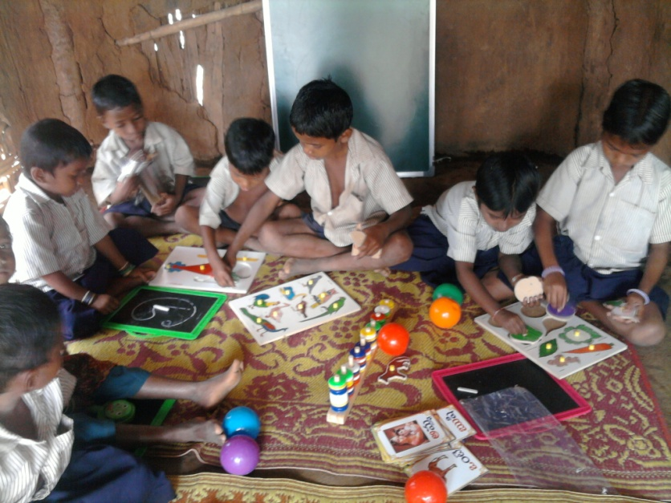

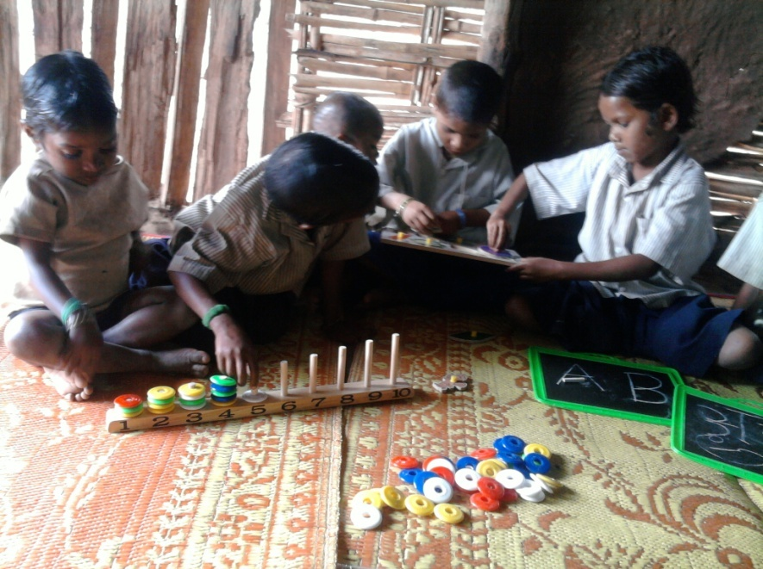

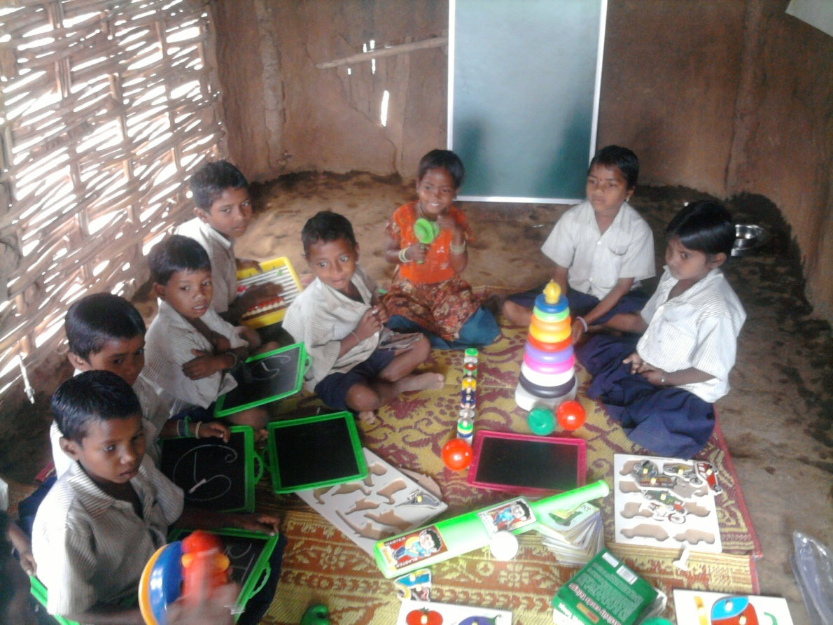

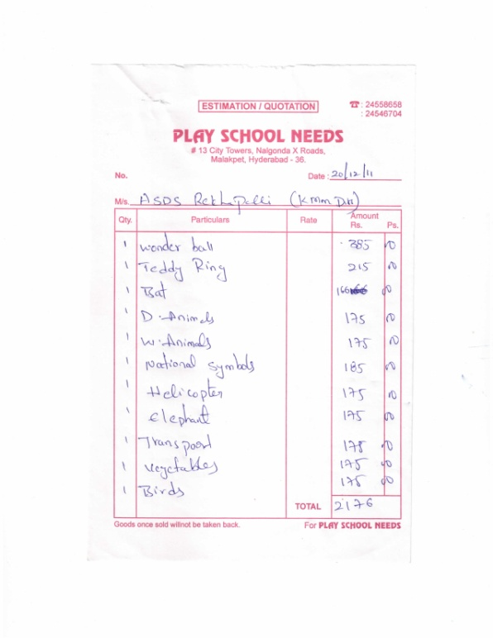
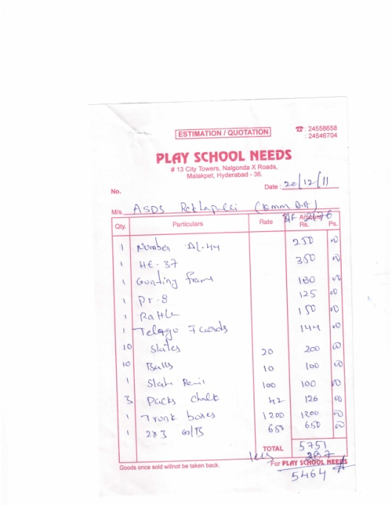

ASDS seeks to support 20 ALS’s that are run by it with the 20 TLM kits, which will help in bringing children regularly to the school.
One TLM costs Rs. 2000 x 20 kits = Rs. 40,000.

