Date:24-06-2007

Dear Sunil,

Greetigs from MICDA

I am herewith sending Audited statements of the recurring expenditure of the school for the year 2006-07. as shown below

MOTHER INDIA COMMUNITY DEVELOPMENT ASSOCIATION:PUTTUR
PROGRAMME:ASHA SCHOOL FOR EDUCATION
RECEIPT AND PAYMENTS OF ACCOUNTS FOR THE PERIOD FROM 01-06-2006 TO 31-5-2007
RECEIPTS |  | AMOUNT | AMOUNT | PAYMENTS |  | AMOUNT | AMOUNT
 |  | Rs. Ps | Rs. Ps |  |  | Rs. Ps | Rs. Ps
To | a) Opening Balance |  |  | By | 1).Salaries
 | Cash at Bank |  | 3061.00 |  | a)Headmaster -1
 |  |  |  |  | HM @Rs.3,500/- X 12 Months | 42000.00
 |  |  |  |  | b)Teachers
 |  |  |  |  | 10 Teachers @Rs.3000 X 12 Months | 360000.00
To | Grant Received from ASHA Delware |  |  |  | c)Accountant -1 @Rs.3000 X 12Months | 36000.00
 | ( Sanjose),USA on 17-10-2006 |  | 91137.00 |  | d)Watchman -1 @Rs.2500 X 12Months | 30000.00
 |  |  |  |  | e)Sweeper -1 @Rs.1000 X 12Months | 12000.00
To | Grant Received from ASHA Seattle,USA |  |  |  |  |  | 480000.00
 | on 04-12-2006 |  |  | By | 2).Administration
 | DD no.154714 | 133200 |  |  | a)Electricity Charges | 23875.00
 | DD no.36646 | 66,825.00 |  |  | b)News papers | 3600.00
 | DD no.574857 | 132570.00 |  |  | c)Telephone charges | 16364.00
 | DD no.592766 | 88,500.00 |  |  | d)School endownment fund | 50000.00
 | Less Fellow ship amount (-) | 130000 | 291,095.00 |  | e)Examination fee for 7th class | 1500.00
 |  |  |  |  | f)Examination fee for 10th class | 1750.00
To | Grant Received from ASHA Seattle |  |  |  | g)School recognition expencess | 22000.00
 | on 07-03-2007 |  |  |  | h)Question & Answer paper | 3200.00
 | DD no.680882 | 131880.2 |  |  | I)Independency day, Teachers Day Celebrations
 | DD no.680696 | 132540 |  |  | Republic day & Annual day Celebration | 9000.00
 | DD no.680883 | 88,799.00 |  |  | j)Bank charges | 2931.00
 | DD no.680697 | 132540 | 485759.2 |  | l)Audit Fees | 5000.00
 |  |  |  |  | m)Unforseen Expenses & Contingencies | 23500.00
 |  |  |  |  |  |  | 162720.00
 |  |  |  | By | Closing Balance |  | 228332.20
 |  |  |  |  | Cash at Bank
 |  |  | 871052.20 |  |  |  | 871052.20

I am very happy to inform you that the recognition for 1st class to 5th class and 6th class to 10th class has been granted. For the 1st to 5th class the recognition is granted for 5 years, and from 6th to 10th class the recognition is for 10 years. Henceforth till the date of recognition expires no expenditure would be incurred under this item. However I would like to state that the process of recognition was inordinately delayed and it became a taxing and Herculean task for me to get the recognition. First and foremost I have to send three sets of proposals for 1st to 5th through Mandal Education Officer to District Education Officer, and a separate four sets of proposals for 6th to 10th through Deputy Education Officer, District Education Officer to Regional Director of Education located at kadapa which covers 4 districts. The proposal consisted of 4 pages with 35 items of check list as shown below

I am very happy to inform you that the recognition for 1st class to 5th class and 6th class to 10th class has been granted. For the 1st to 5th class the recognition is granted for 5 years, and from 6th to 10th class the recognition is for 10 years. Henceforth till the date of recognition expires no expenditure would be incurred under this item. However I would like to state that the process of recognition was inordinately delayed and it became a taxing and Herculean task for me to get the recognition. First and foremost I have to send three sets of proposals for 1st to 5th through Mandal Education Officer to District Education Officer, and a separate four sets of proposals for 6th to 10th through Deputy Education Officer, District Education Officer to Regional Director of Education located at kadapa which covers 4 districts. The proposal consisted of 4 pages with 35 items of check list as shown below

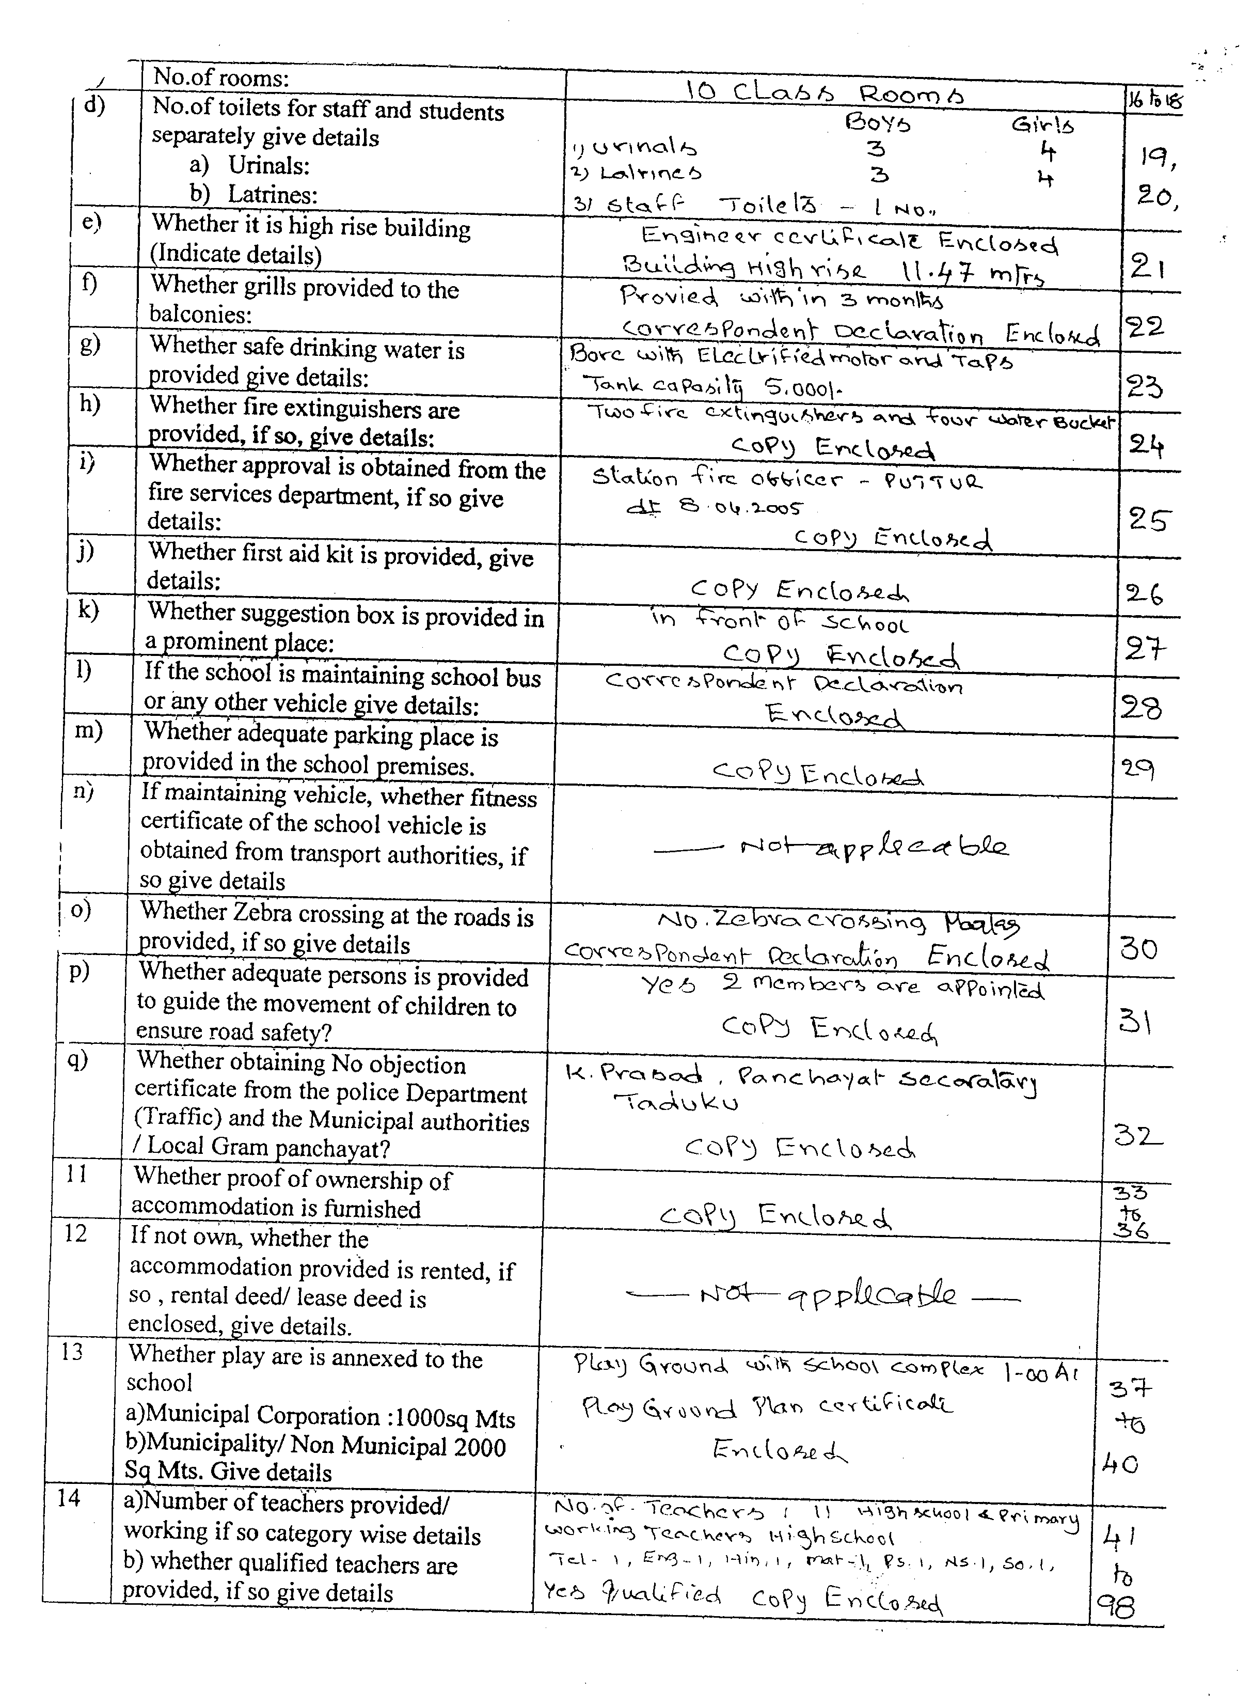

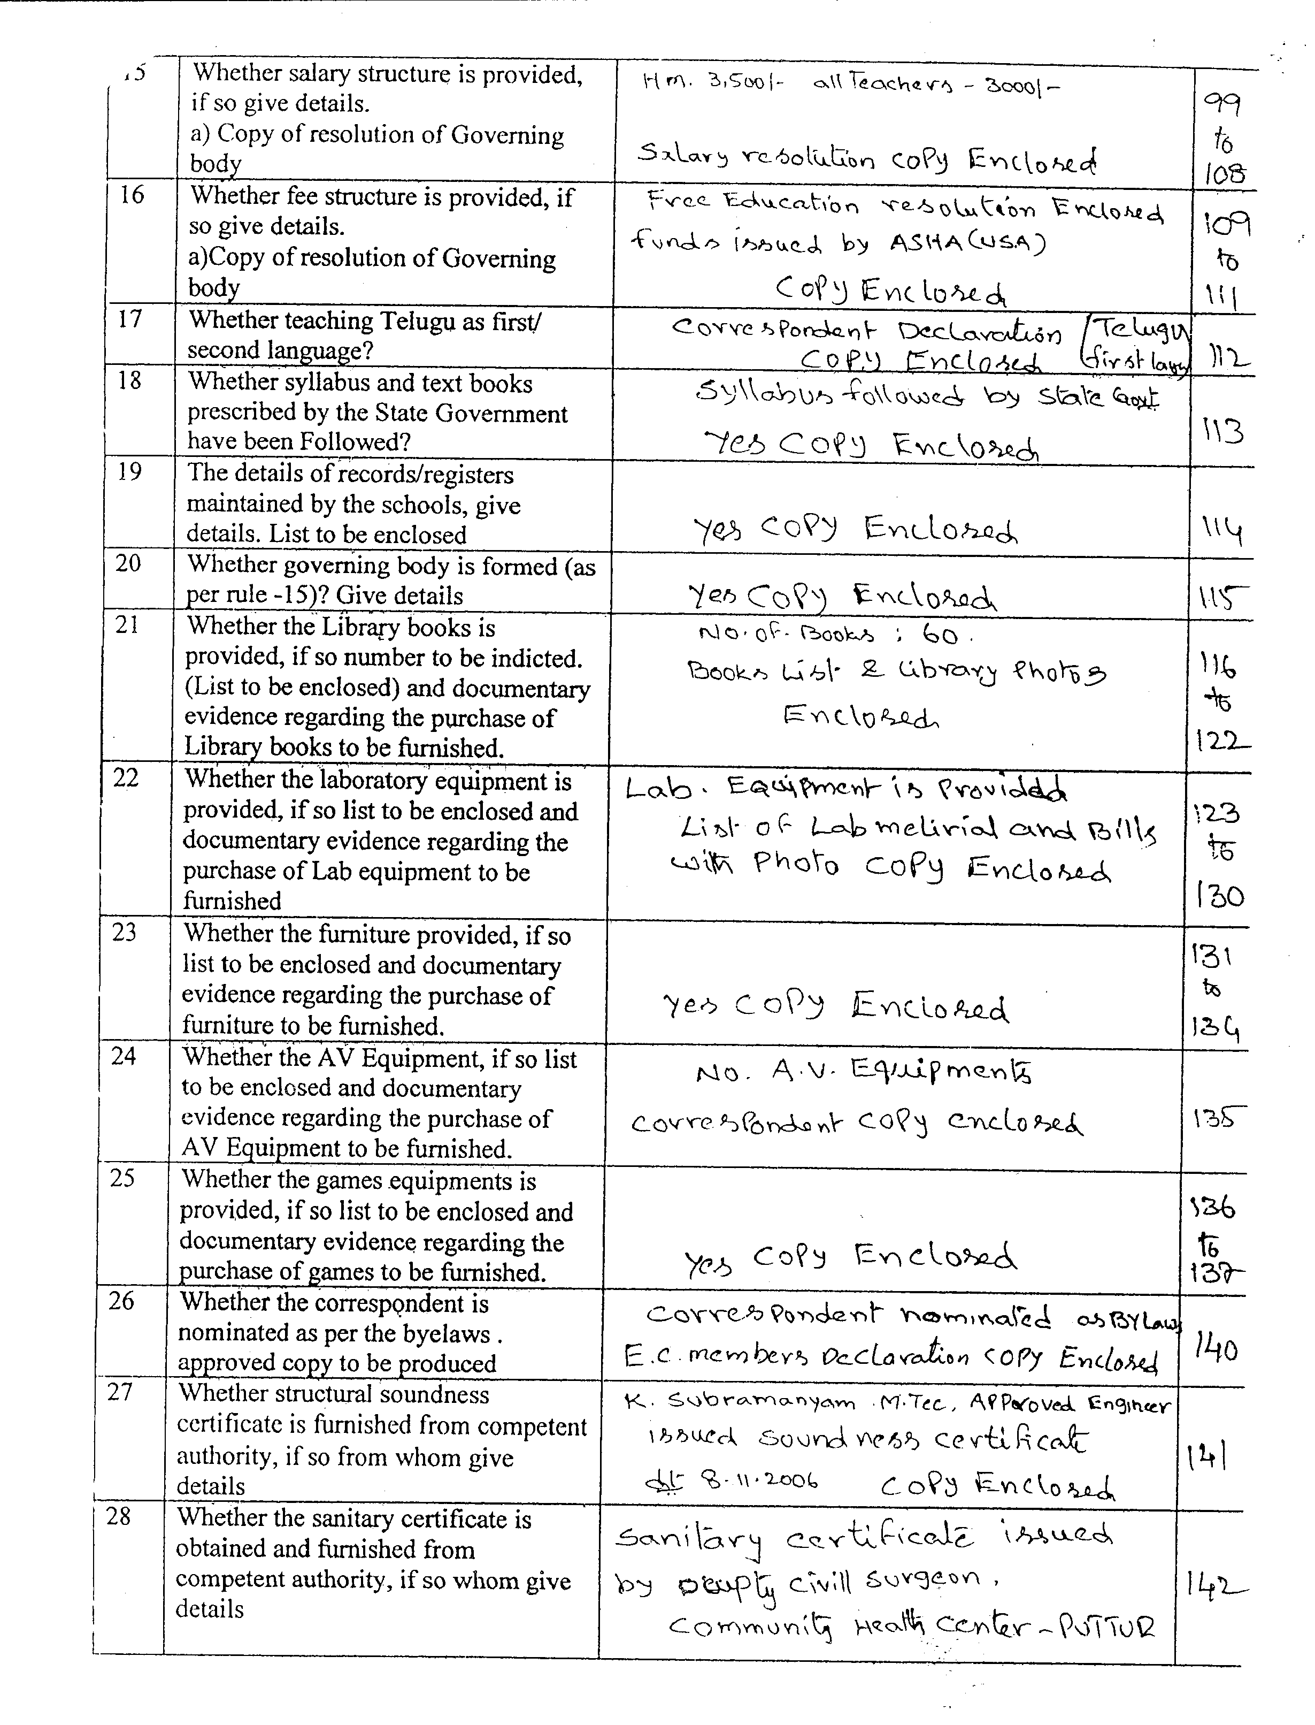

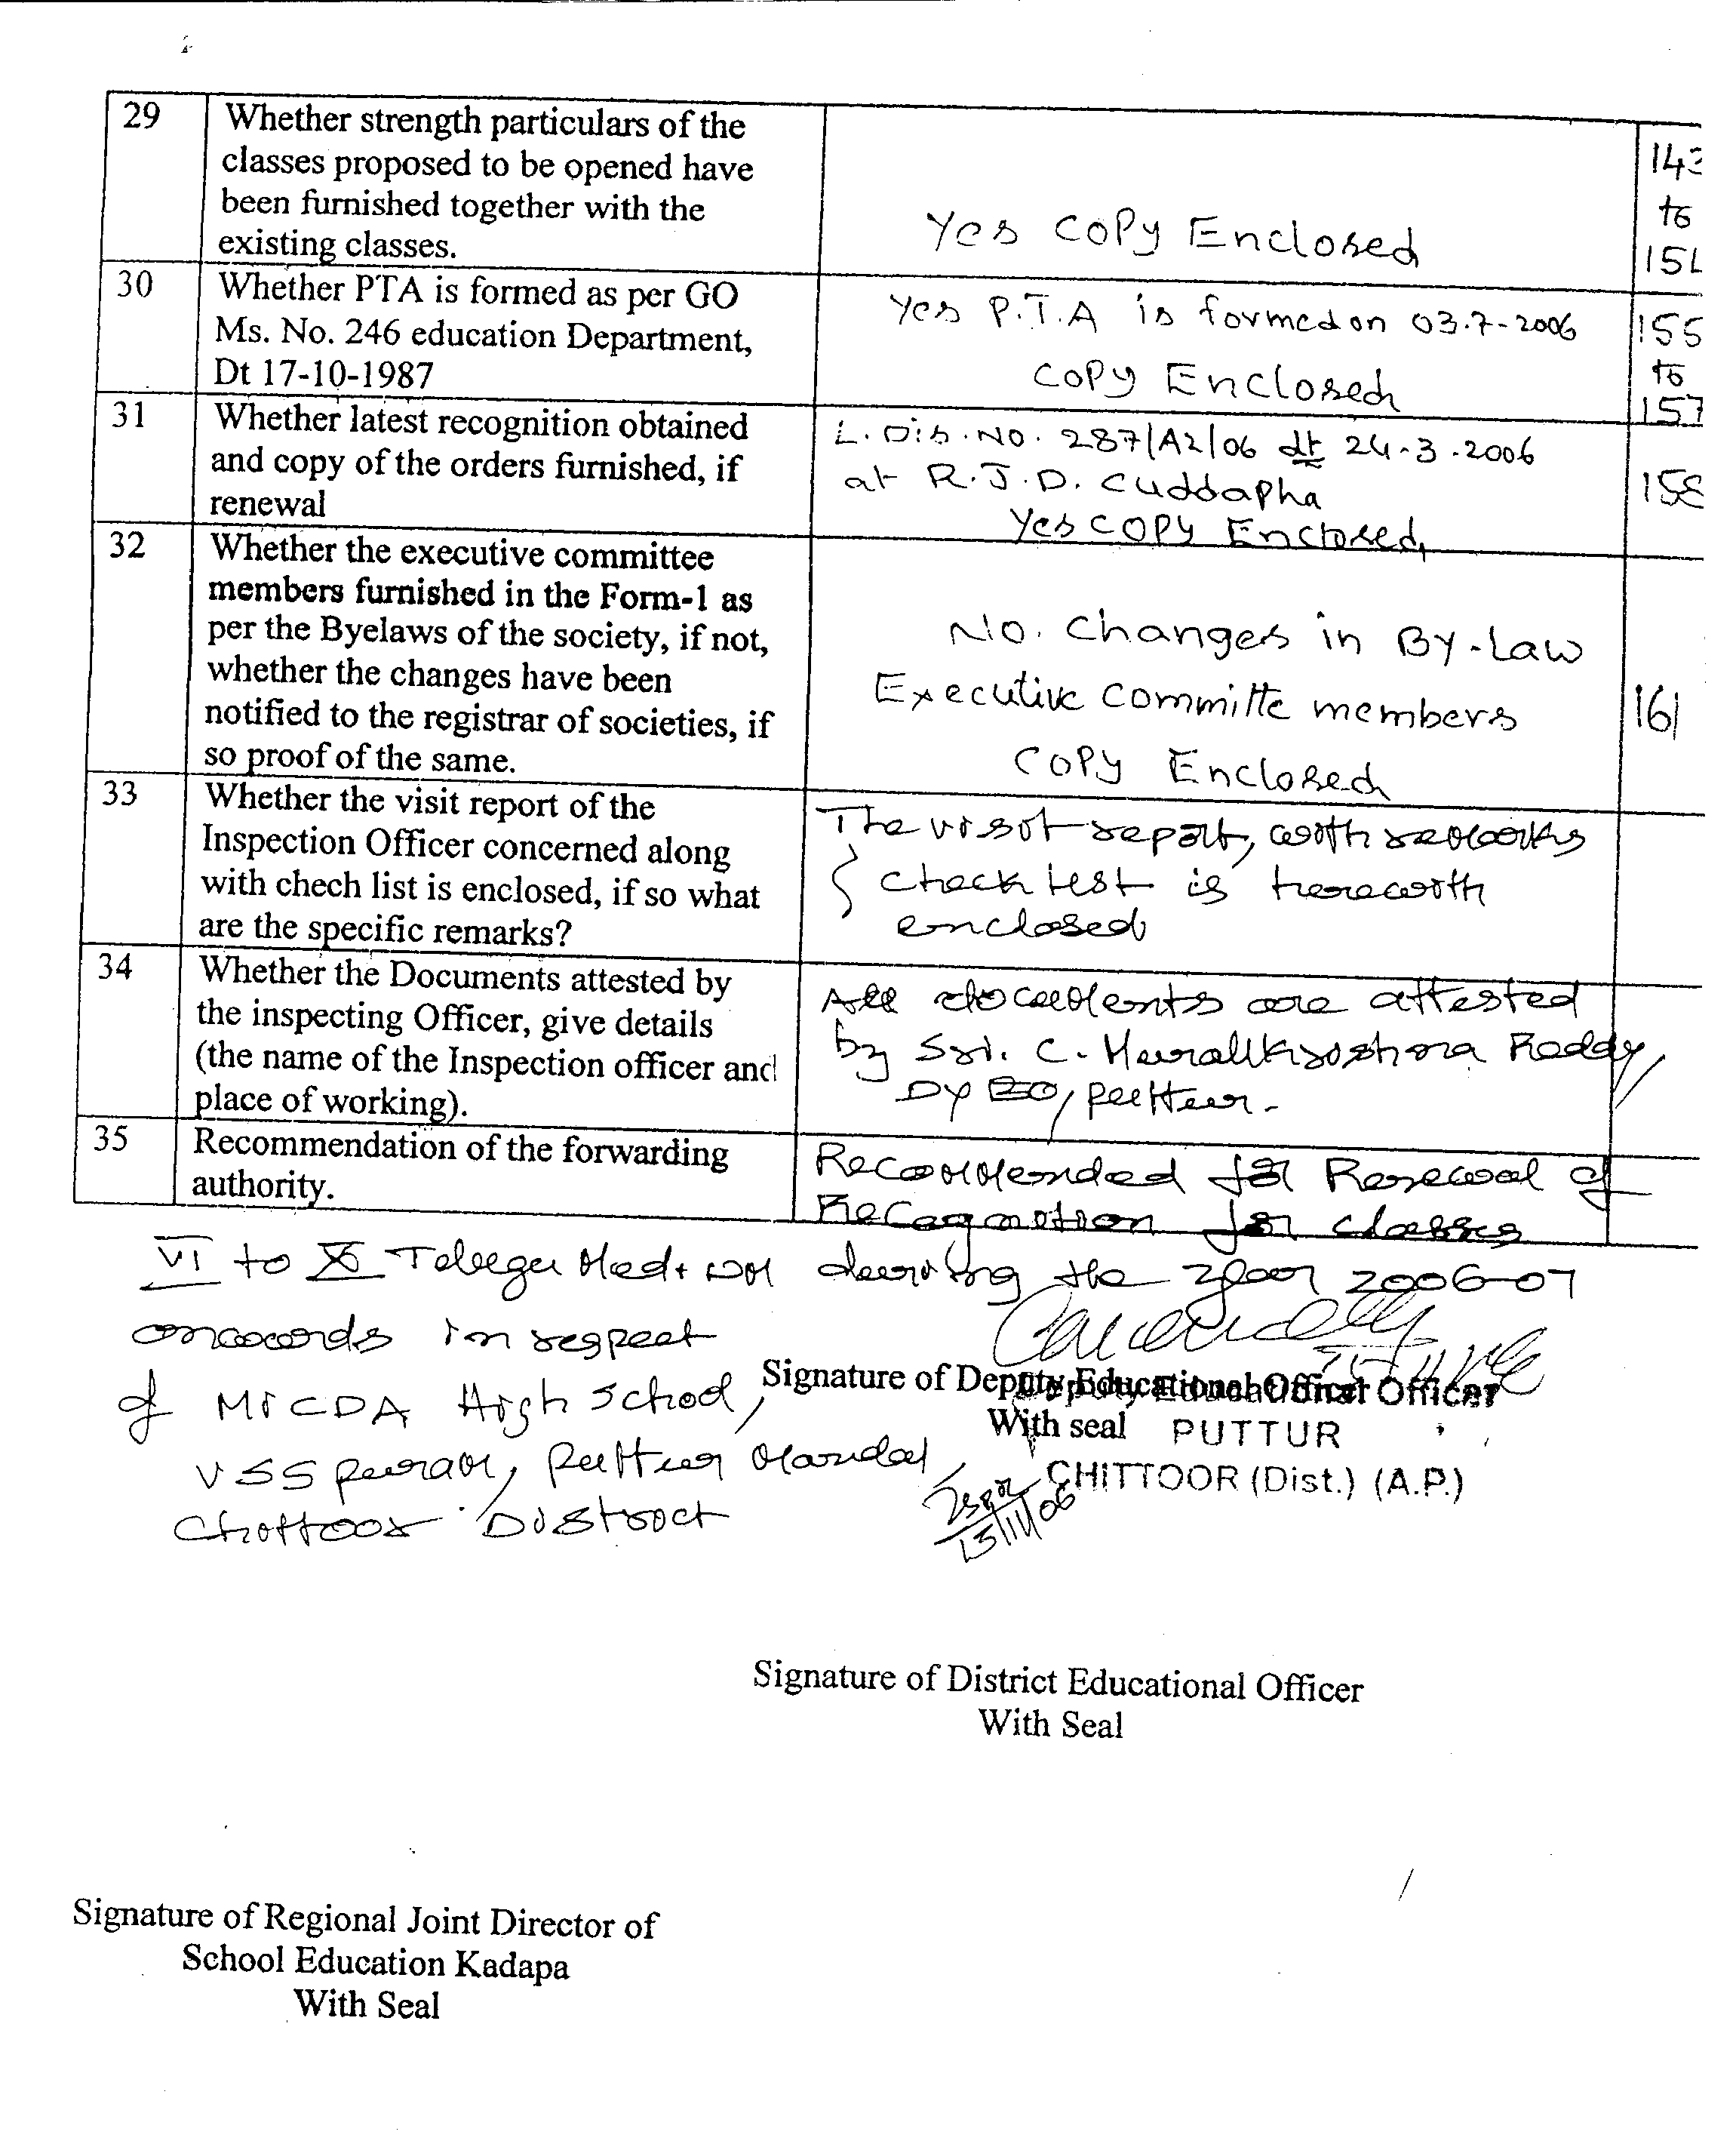

It is of course true that all the requirements in the check list have to be provided in the schools not only for the effective functioning both interms of administration and effective teaching but also as safety measures to protect the students and the staff. As seen from the application and the replies given by me my school full filled all the requirements except audio Visual Equipment, Grills, Desks and 1000 number of books .

During the processing of application of recognition at every stage I had to face lot of difficulties and mental agony. Its because starting from Deputy Educational Officer to Regional director of Education, Kadapa they were expecting some favors particularly financial for acting positively to for according recognition. I had to go to Chittoor and Kadapa umpteen times to talk to the concern authorities for getting the recognition .
Firstly I submitted recognition application for 1st to 5th class to the Mandal Education Officer. The Mandal Education Officer submitted the application after inspecting the school and recommended to the District Educational Officer for the recognition. I am here with showing the recognition letter from DEO Chittoor and the recognition is accorded from 2005-2006 to 2009-2010.

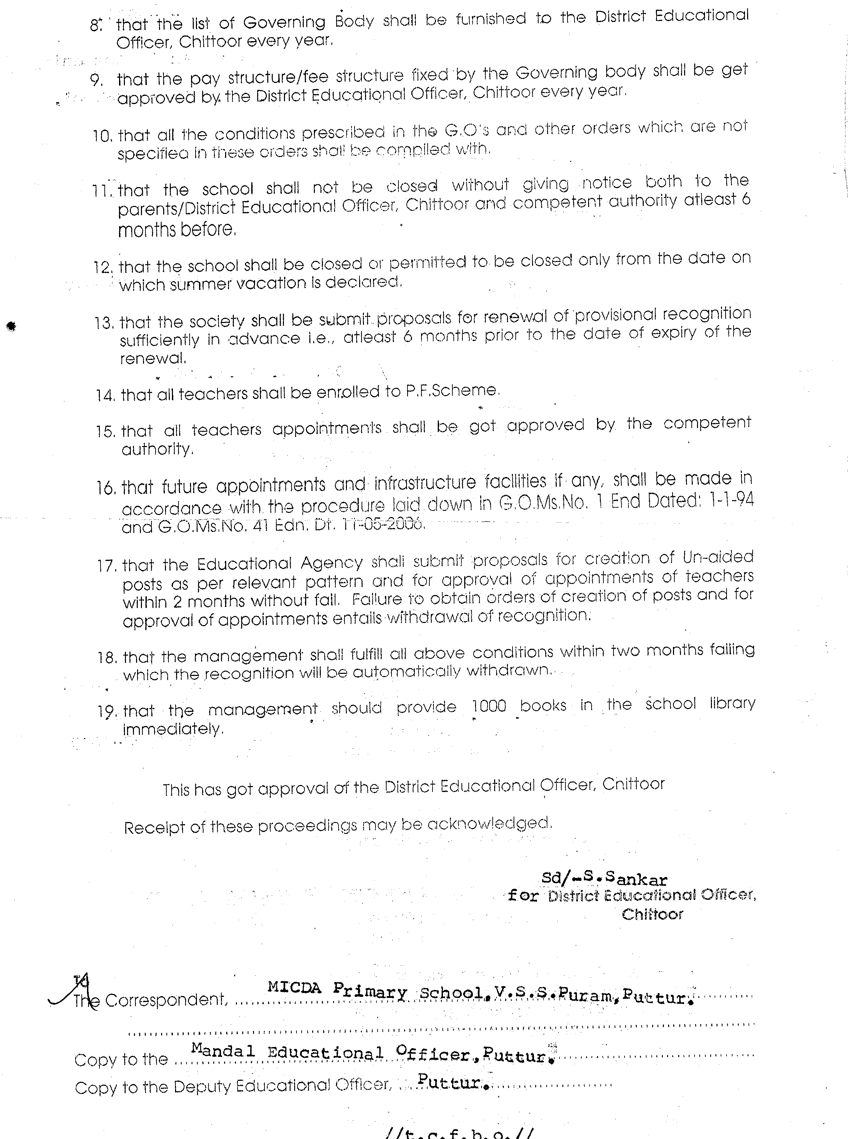
For getting the recognition from 6th to 10th class the process is from Deputy Educational Officer through District Educational officer to Regional Director of Education, Kadapa. Accordingly four sets of applications were submitted to Deputy Educational Officer who recommended to DEO for the further transmission after recommending to Regional director of Education, Kadapa.

The Deputy Educational Officer pointed out that the school does not have, Audio Visual Equipment, Grills for first floor varanda and sports and games items and desks. Showing these as reason he demanded from me huge amount of bribe to recommend for recognition. Despite the fact that most of the private schools lack not even half of the check listed items their applications were forwarded because they could grease the hands of the concerned officer. The private schools can afford to do this because they collect huge amount of fee as well as donations from the parents of the children. I not only refused to accede to his demand but also I questioned him and threatened him that I will report the matter to ACB. Since he has forwarded the applications of private schools for the recognition even though the lack many of the facilities mentioned in the check list. Finally the Deputy EO had to recommend our proposal for recognition to the district Educational Officer chittoor.
Kindly see below the copy of the recommendation letter from the Deputy EO forwarded to DEO, Chittoor.

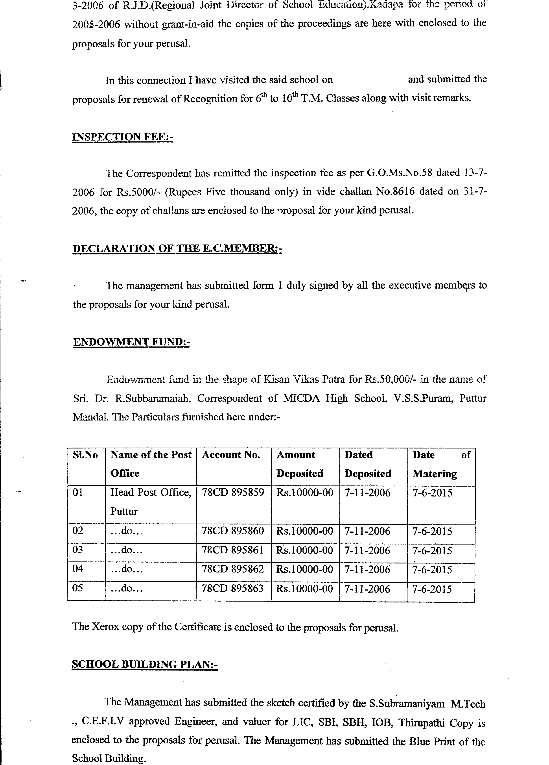
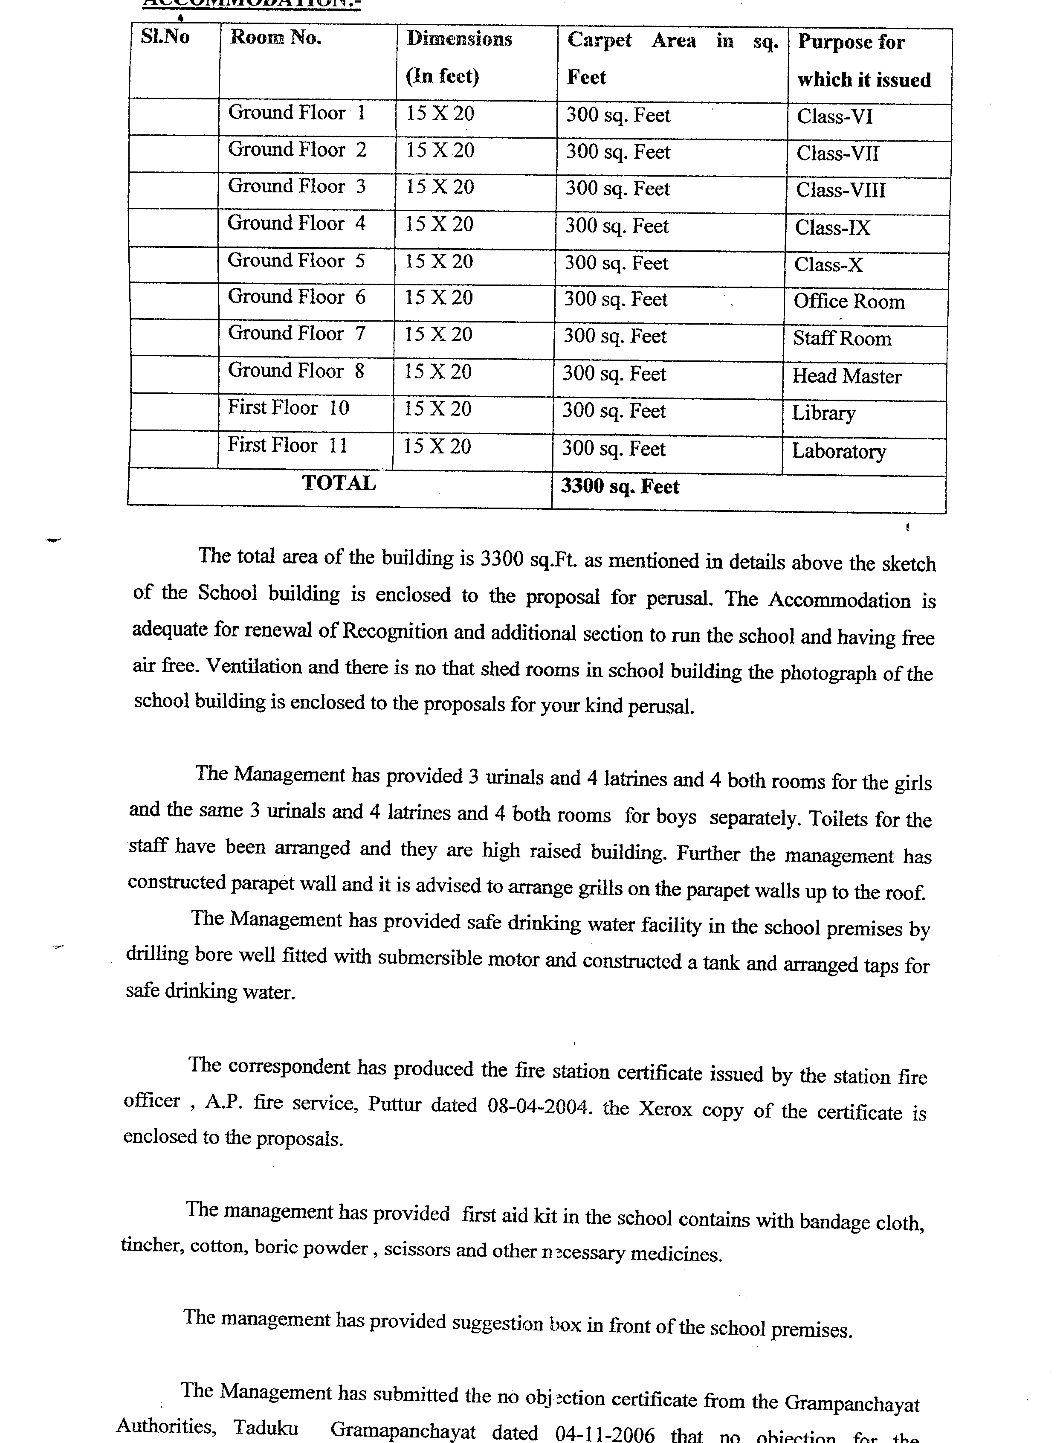
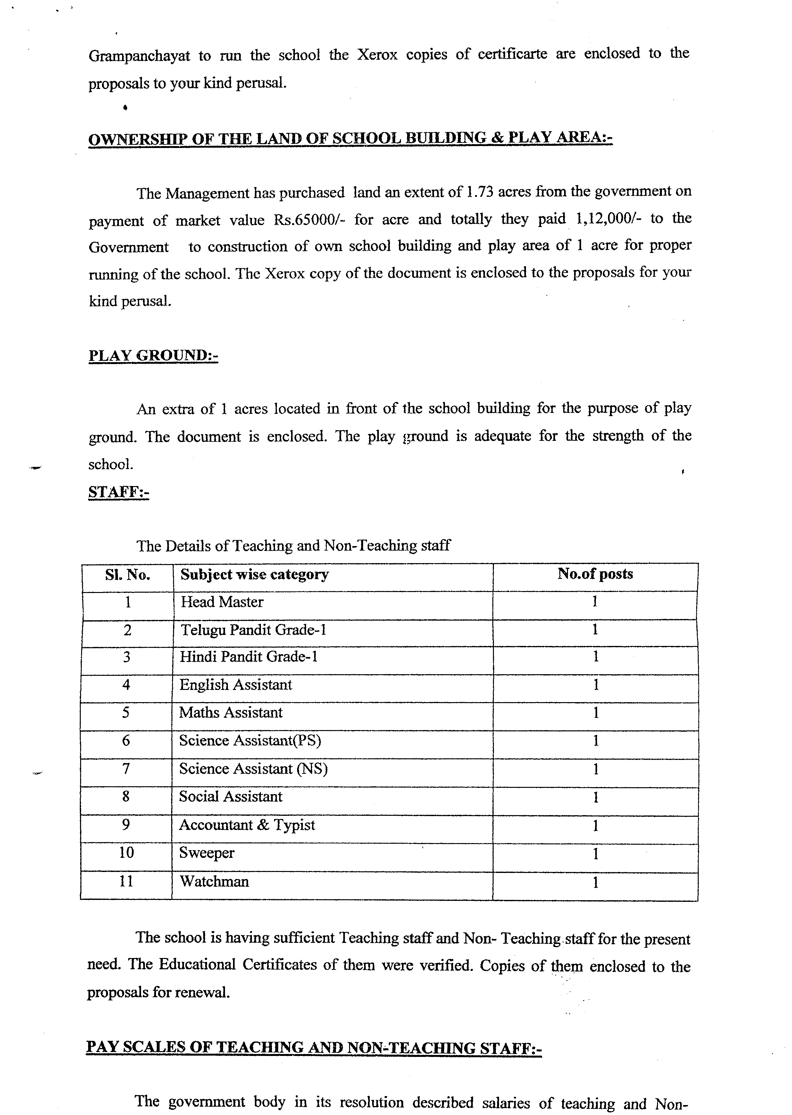
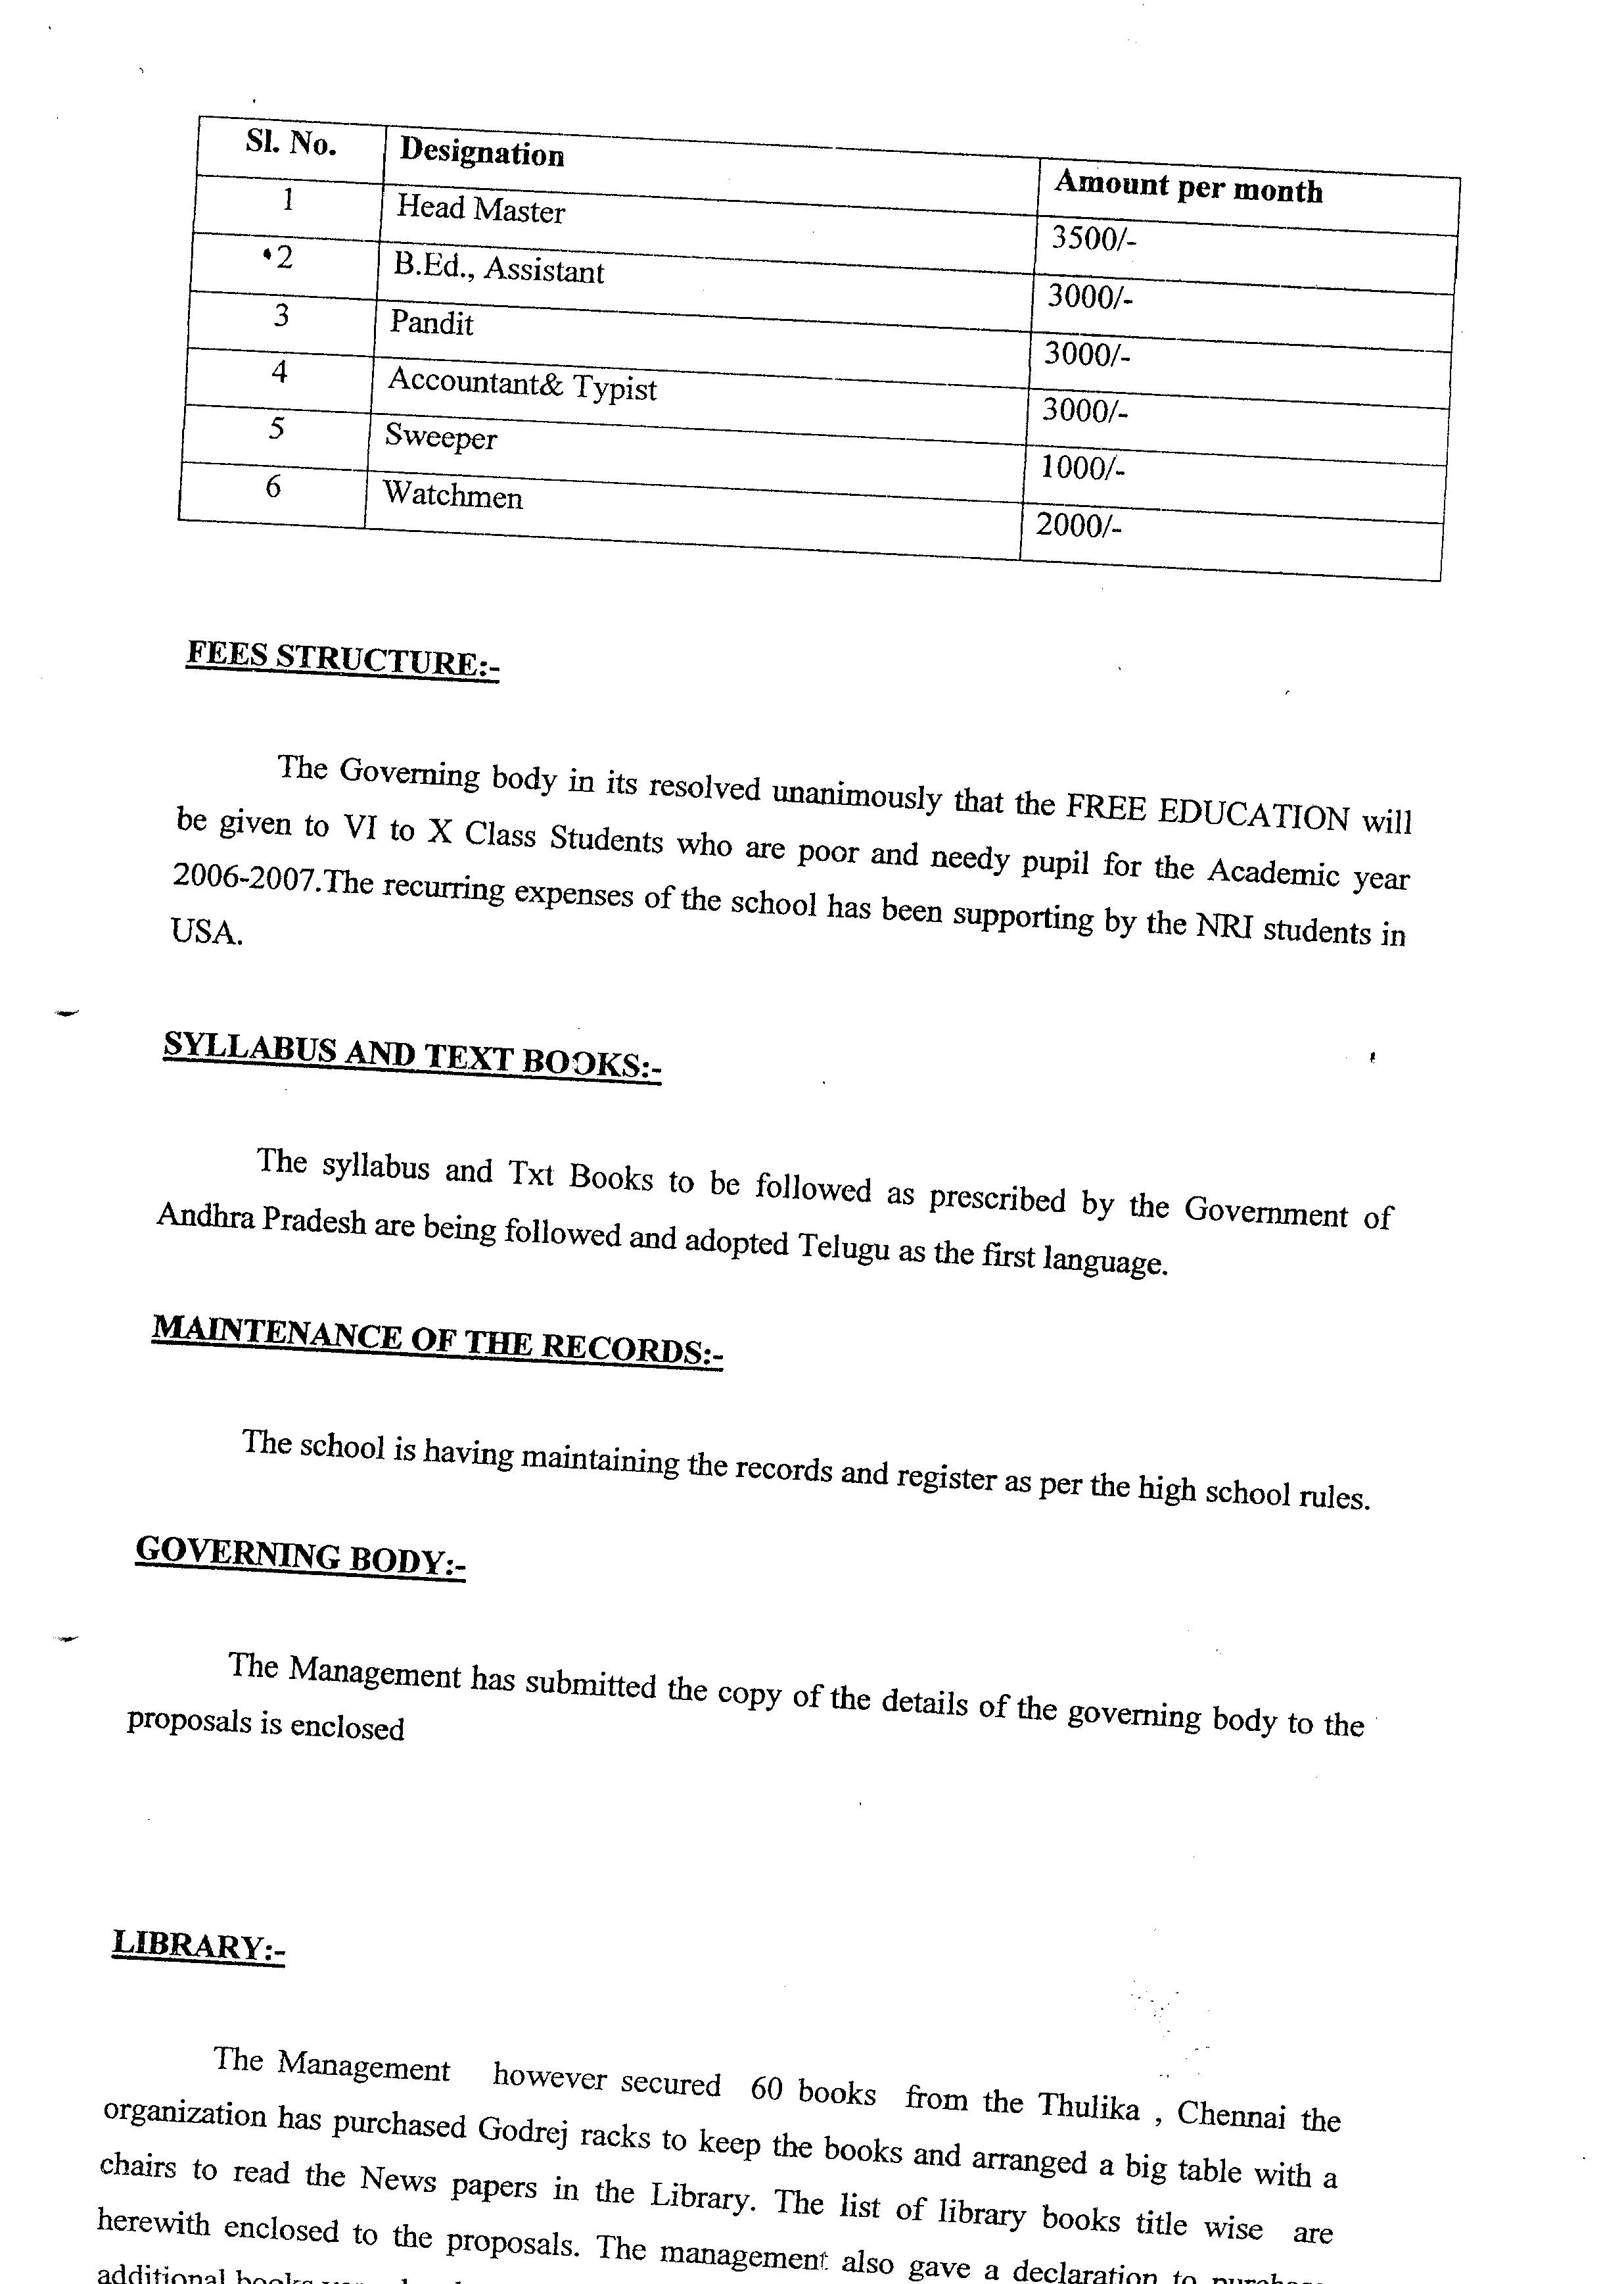
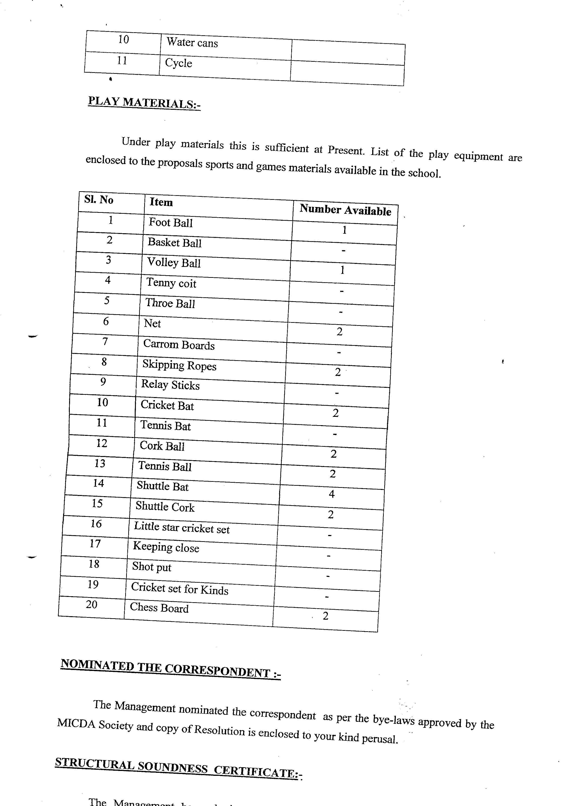
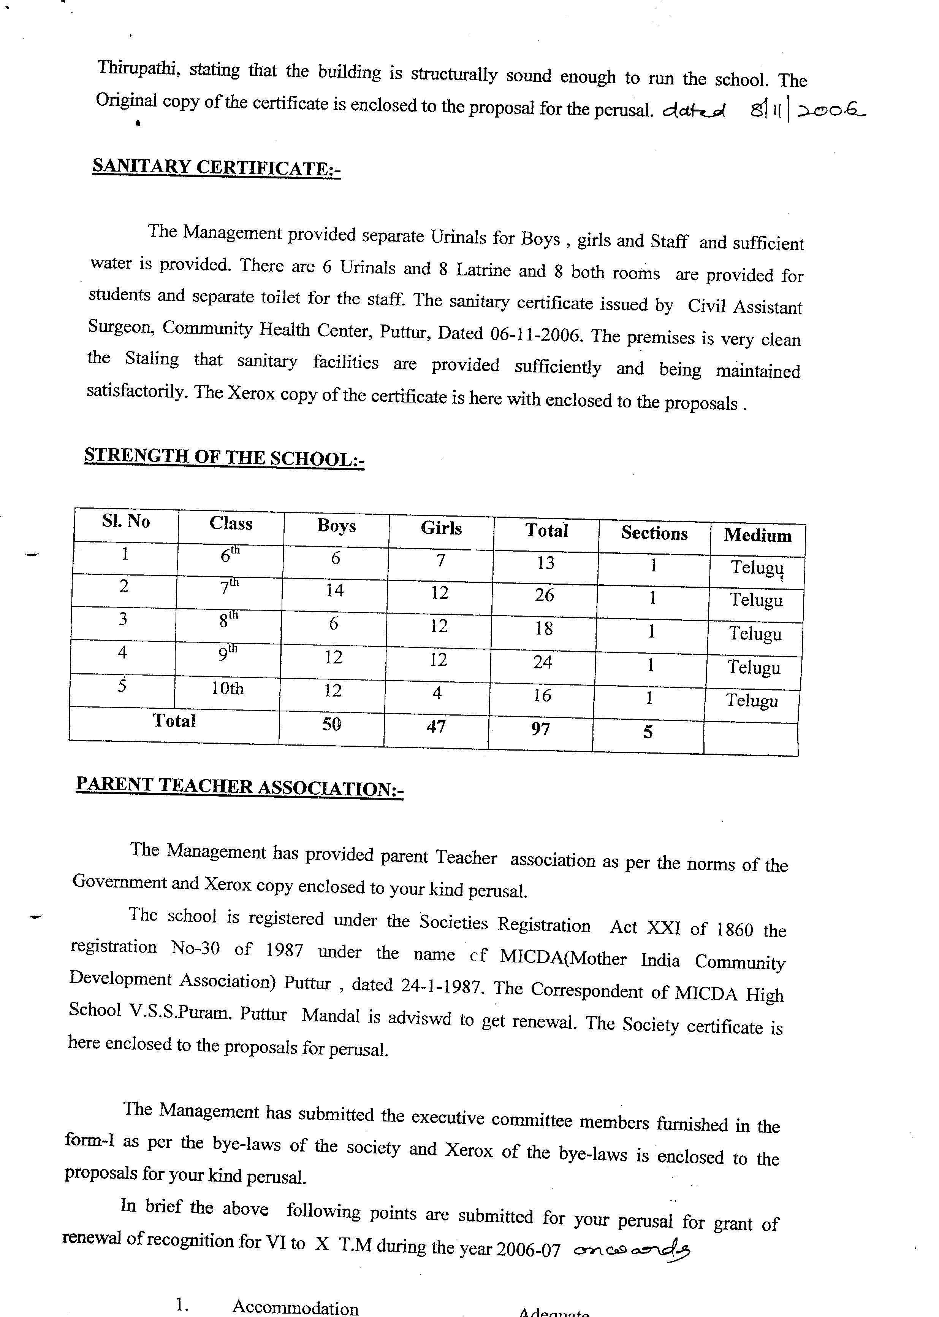
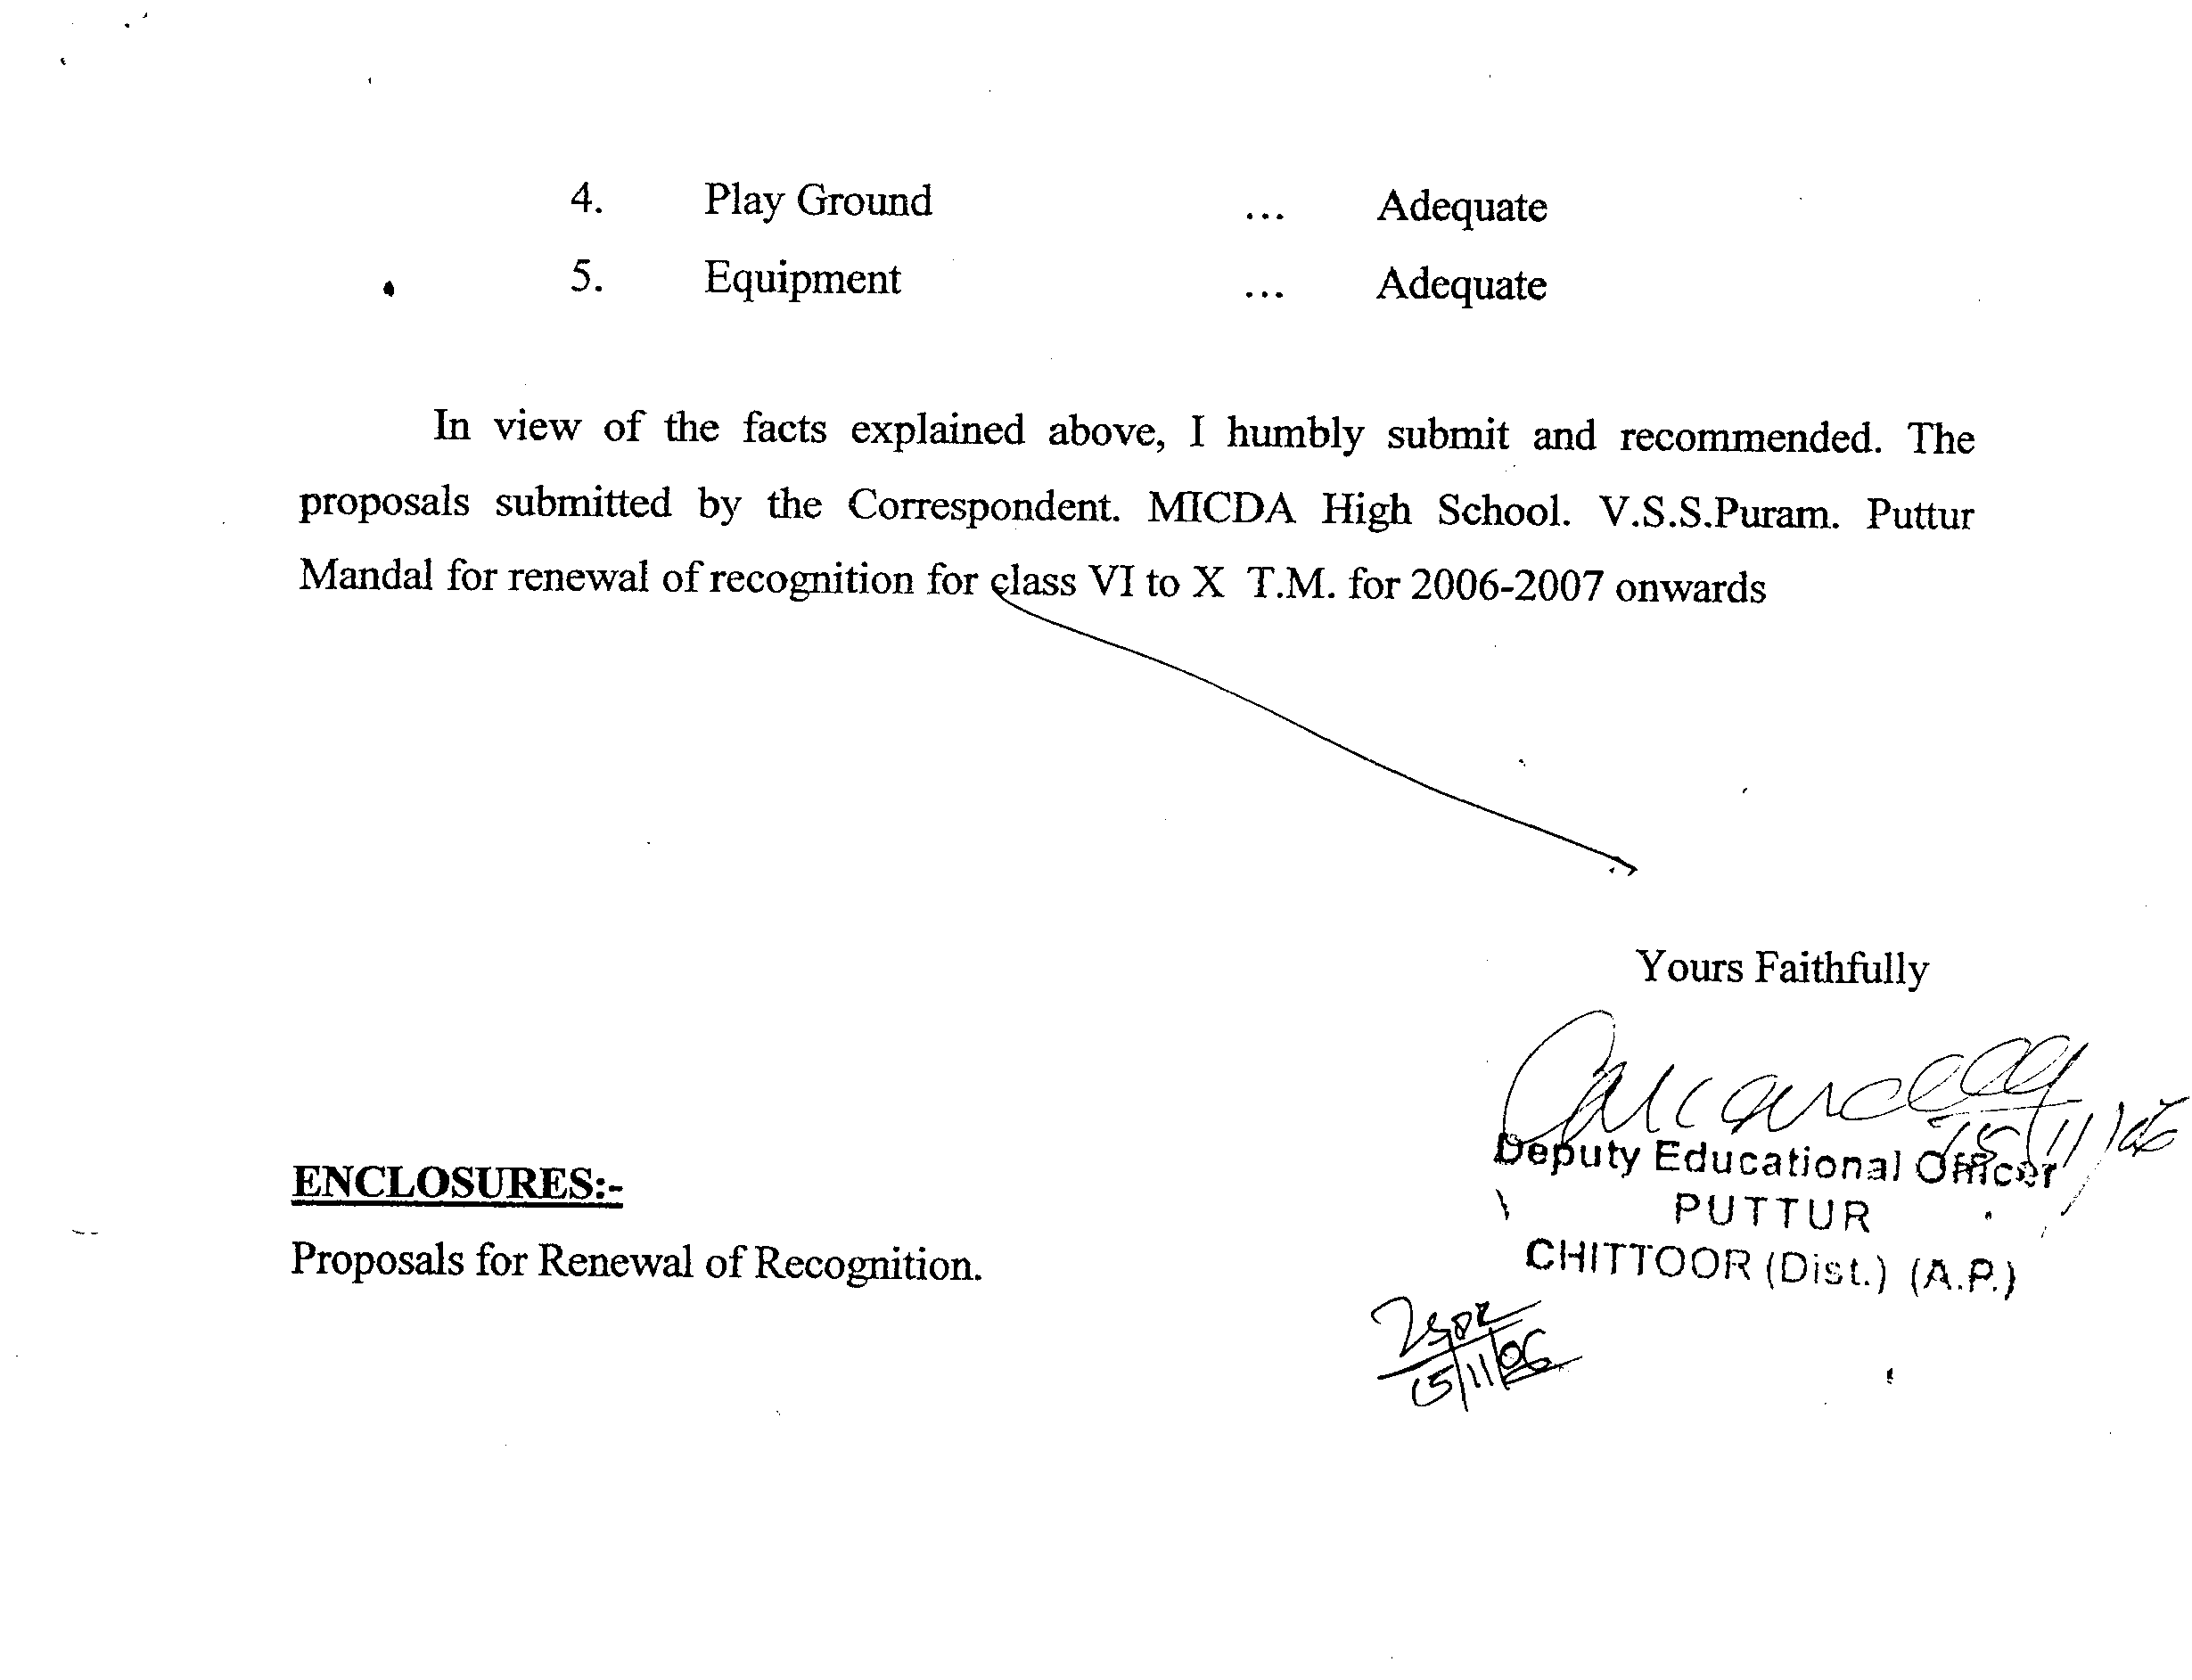
The DEO office staff at chittoor also wanted some favors particularly financial from me to forward the application with a recommendation to RDO,Kadapa But I personally met the DEO Chittoor and explained my difficulties and she is kind enough to forward the application with her recommendation to the RDO, Kadapa
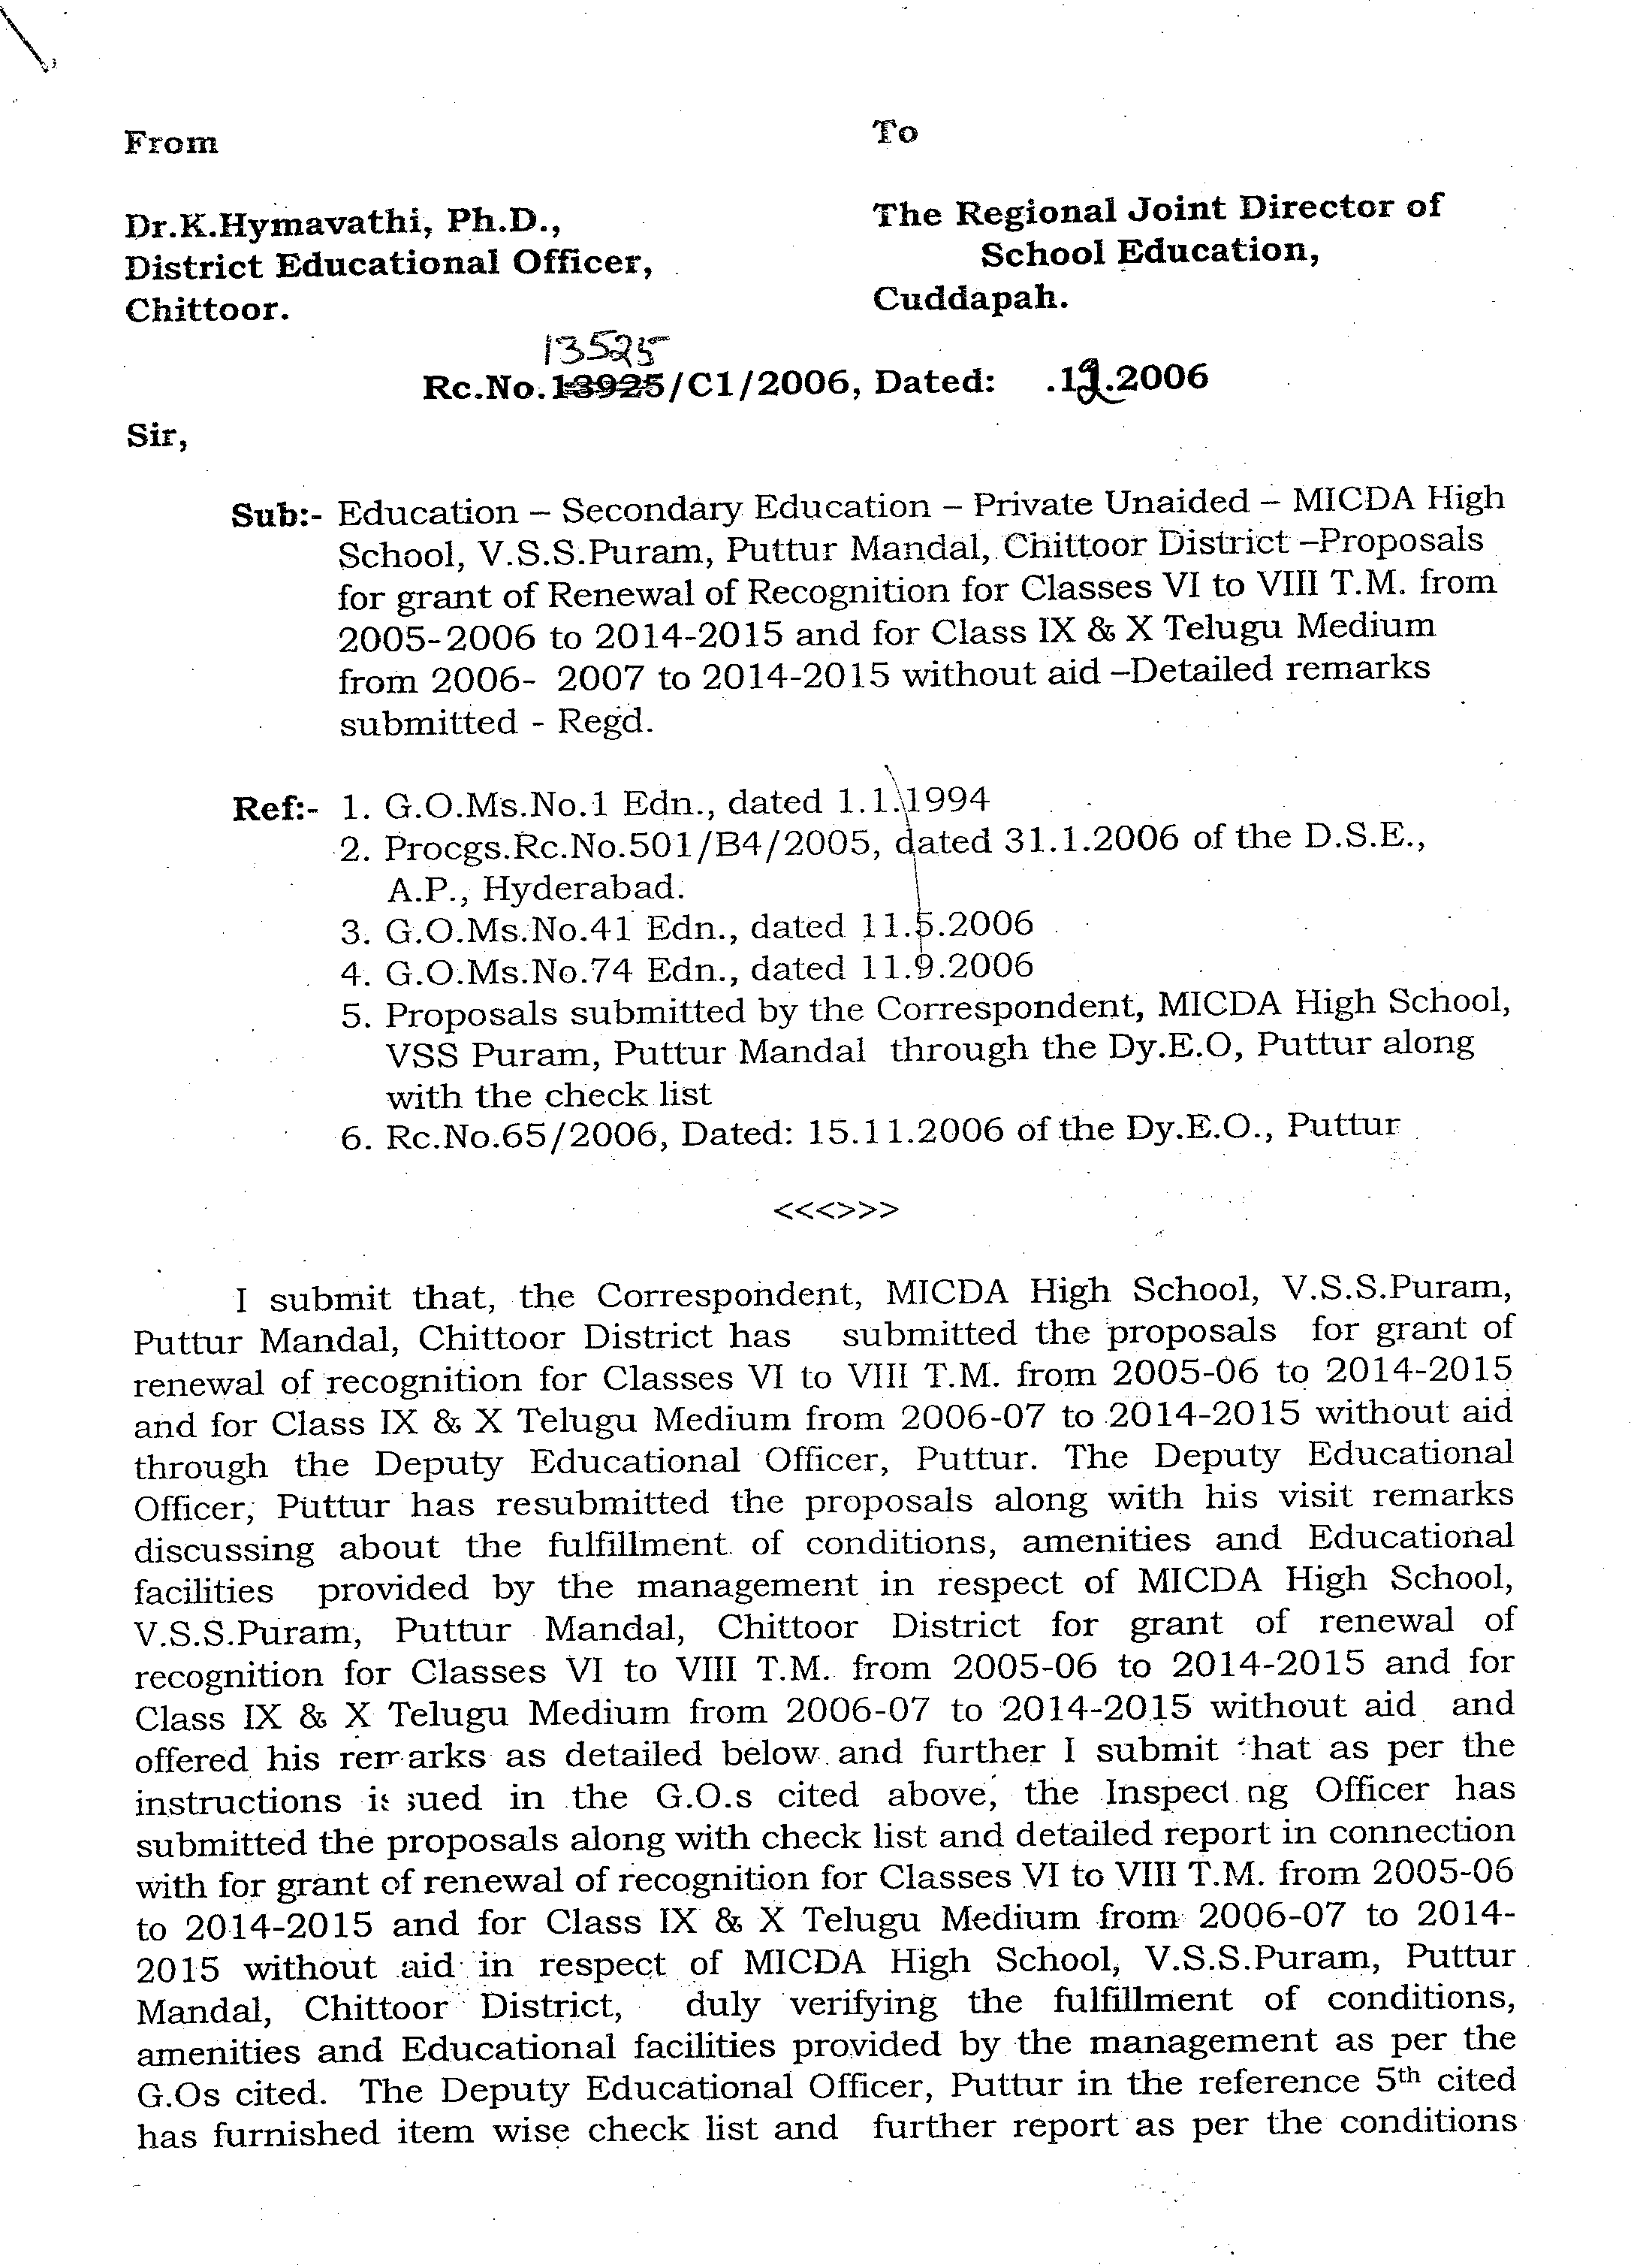
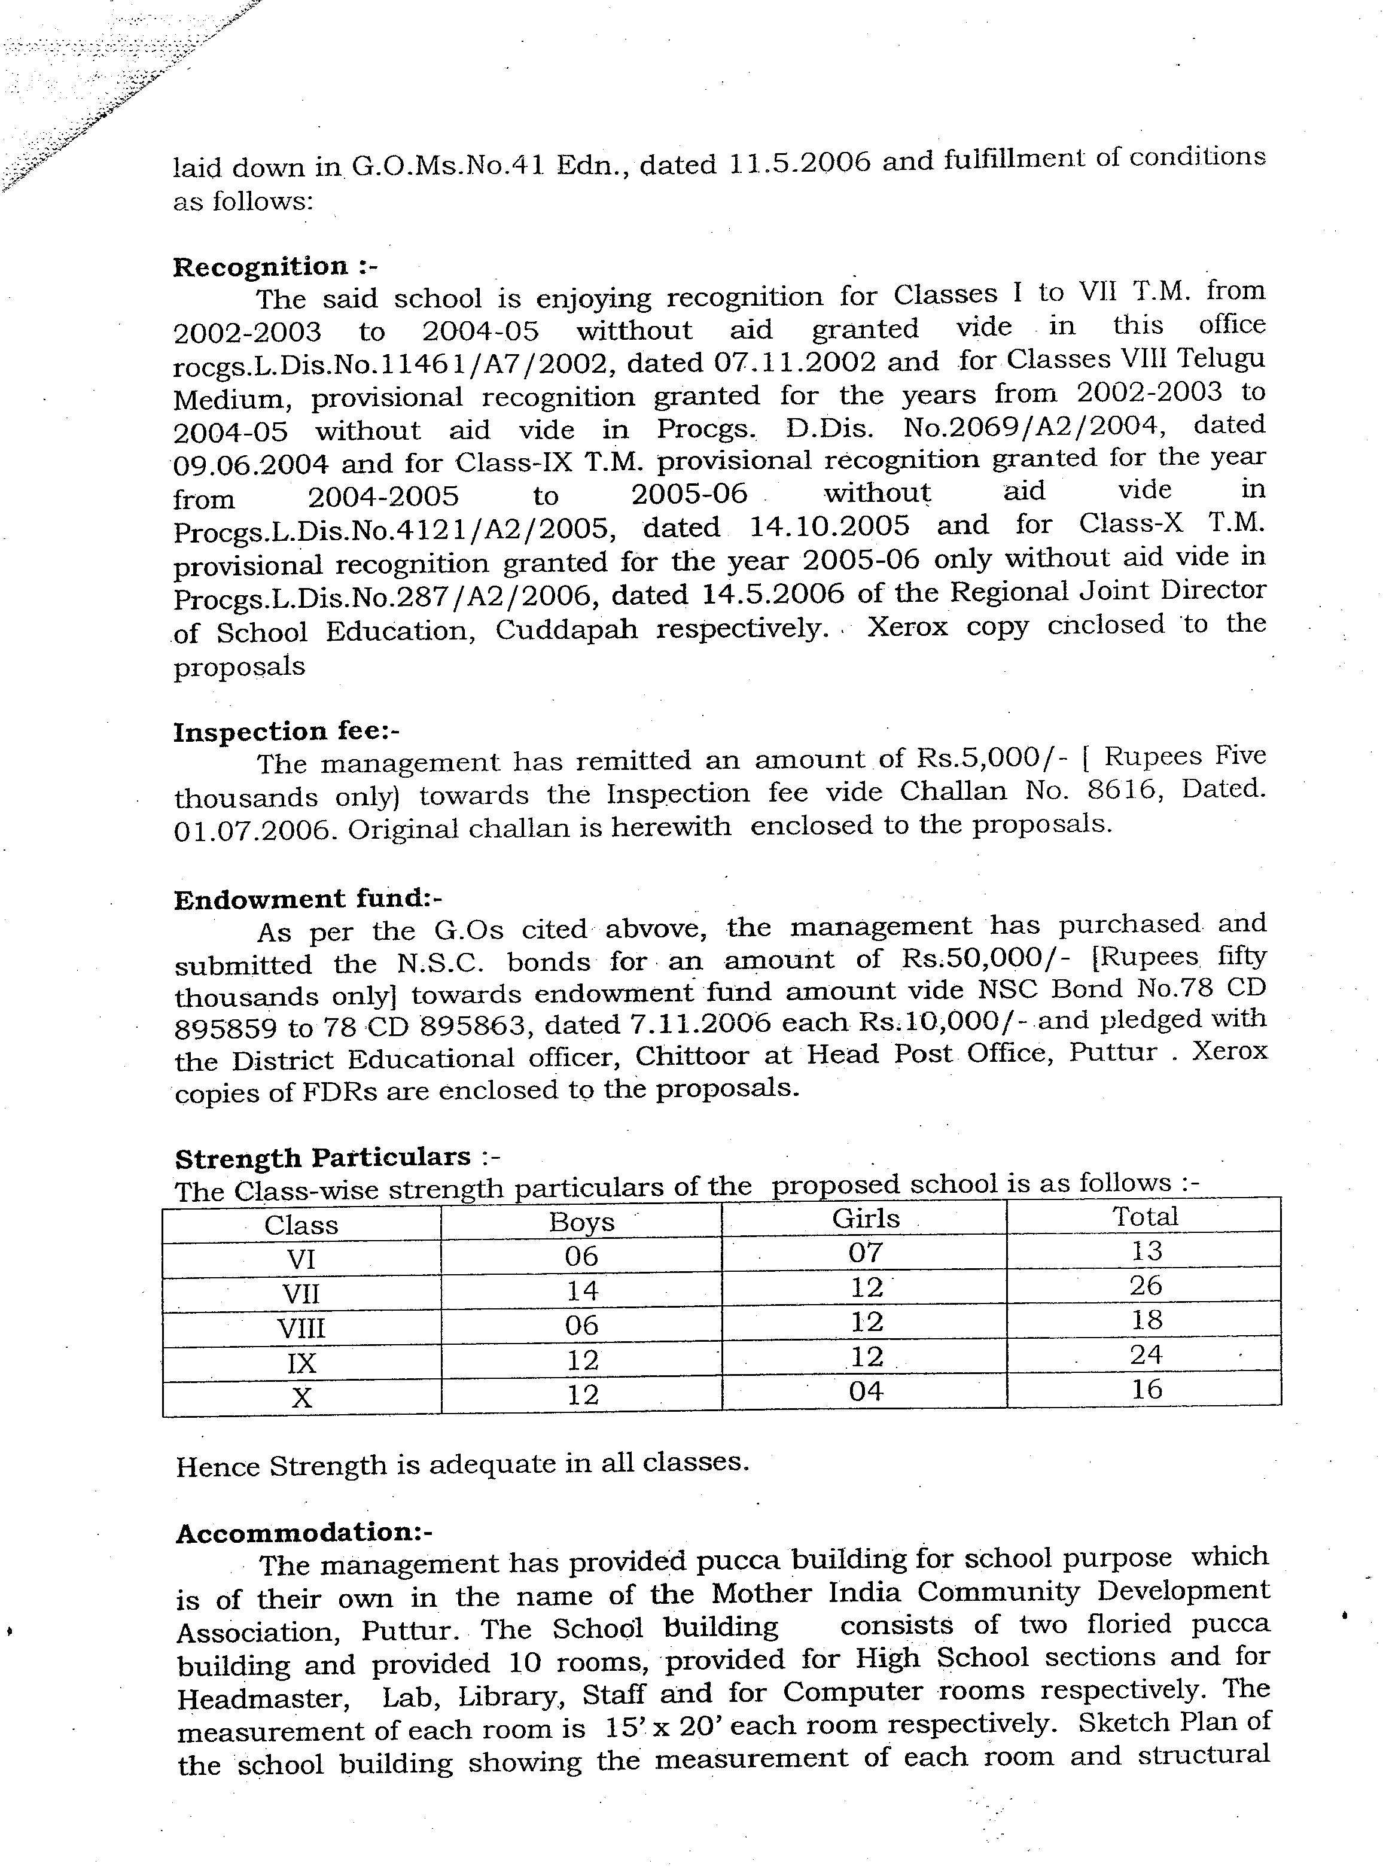
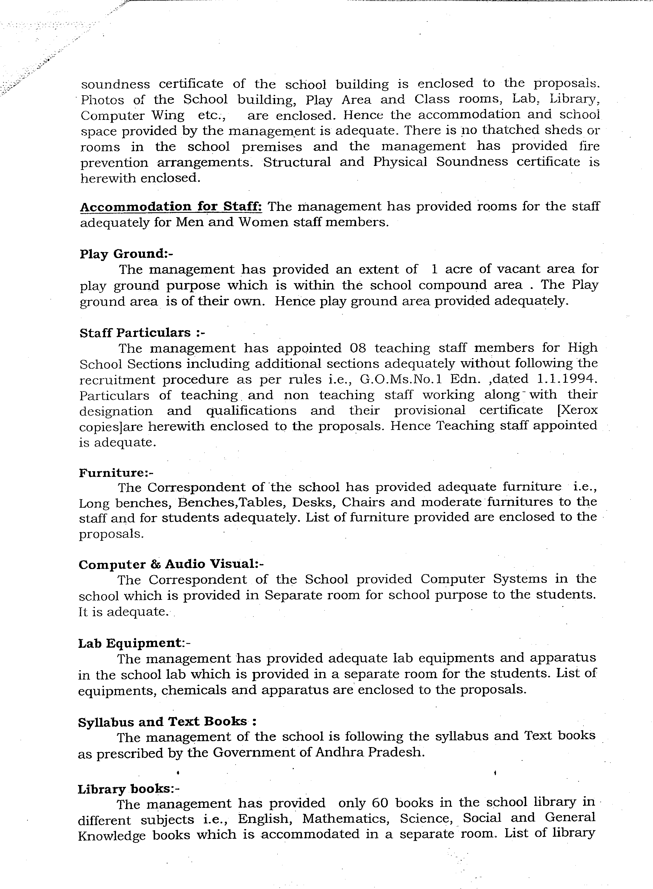
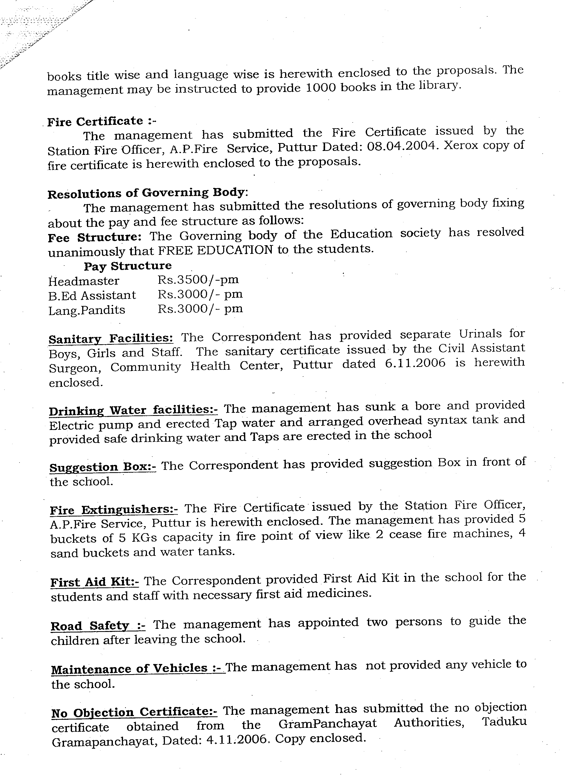
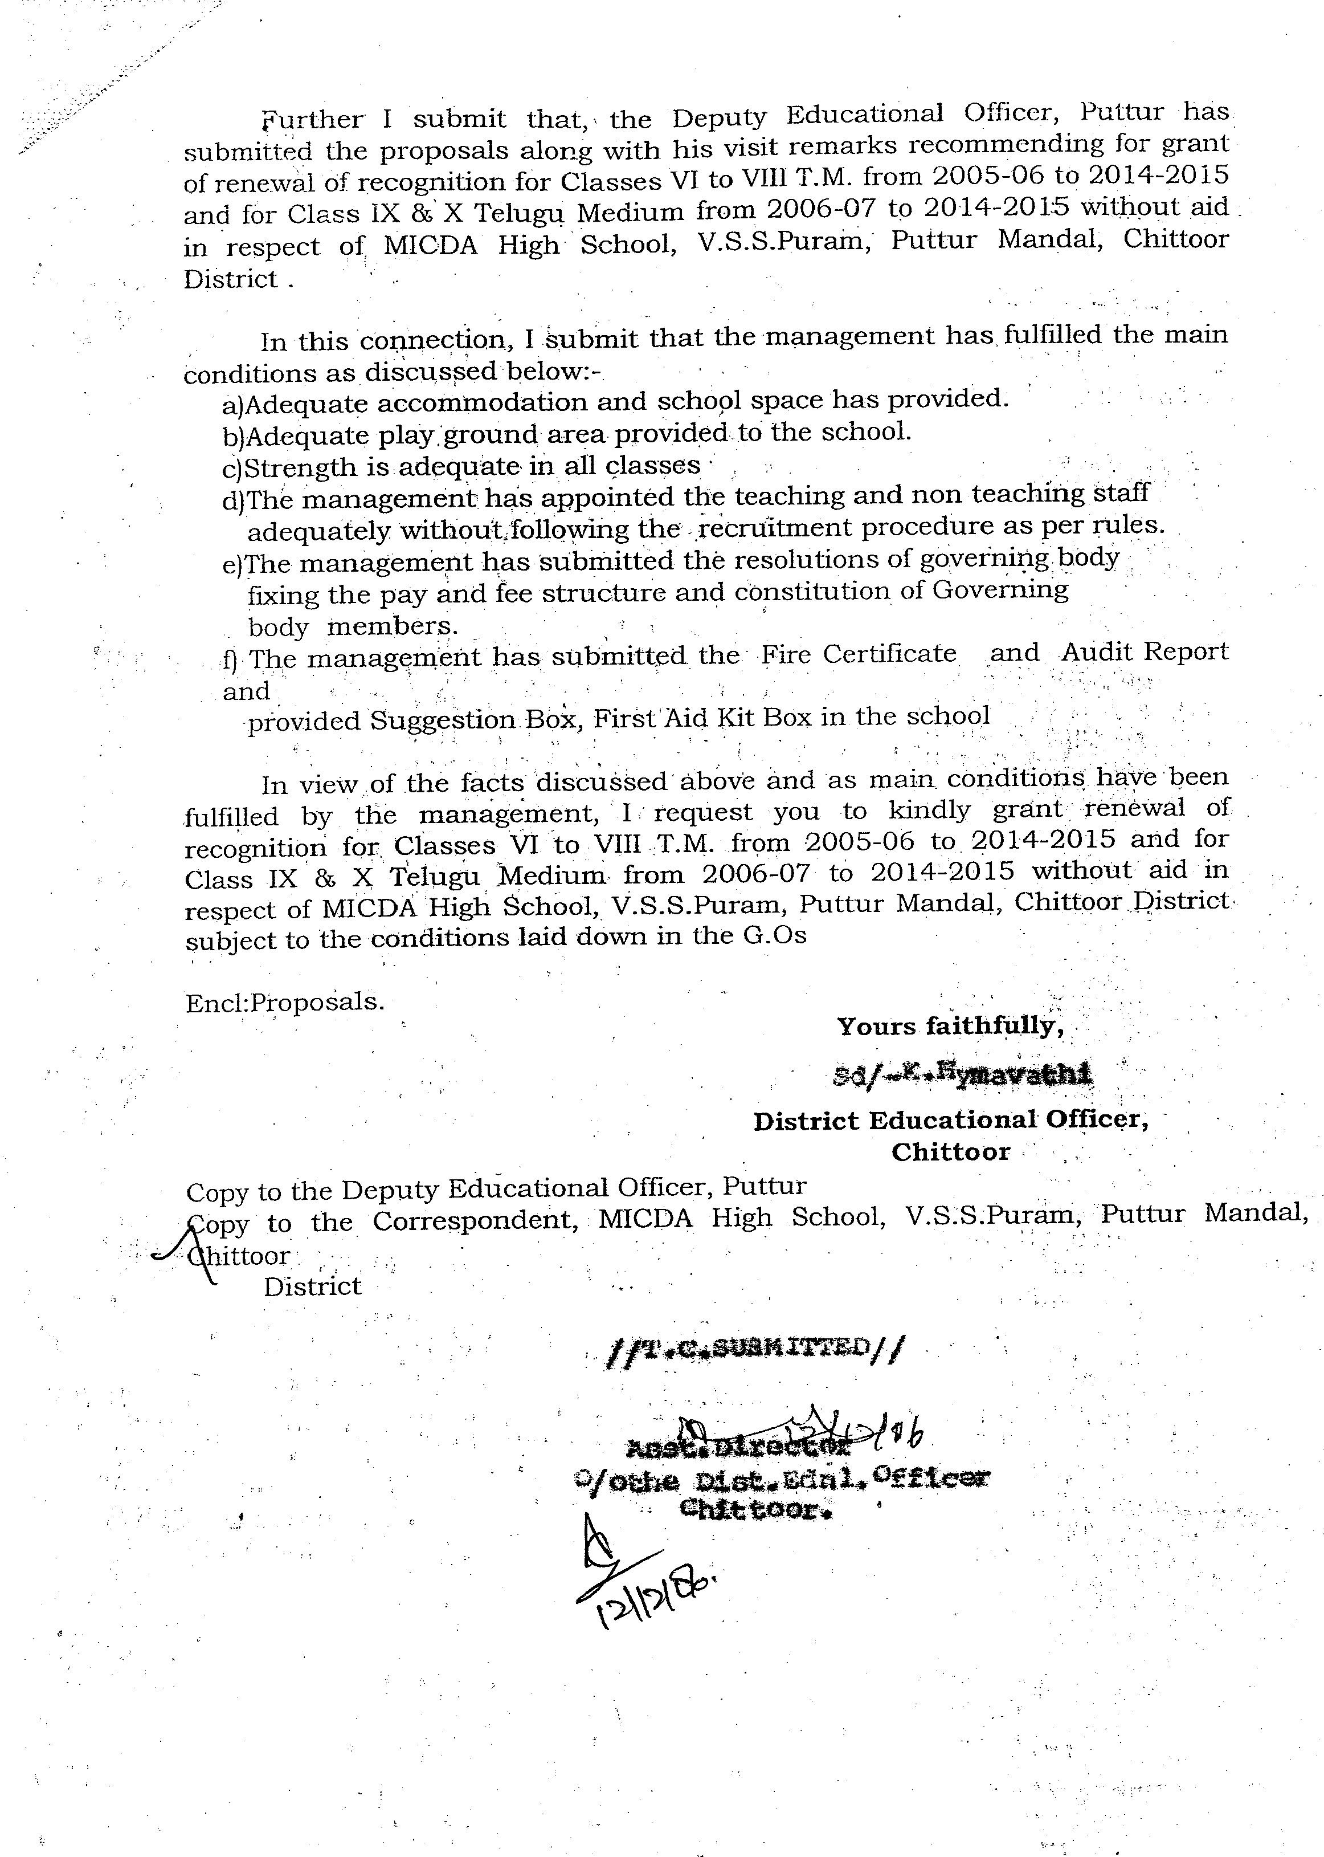
At Regional Directorate, Kadapa they demanded a huge amount of money for granting recognition and they consistently pestered me to full fill their demand . I wanted to meet the Regional Director Kadapa to explain the difficulties of extending the financial favors to his staff . For this purpose I visited Kadapa three times and all the three times he away from Kadapa hence I could not meet him personally. Despite my personal explanation to the office staff they sent me the following letter.

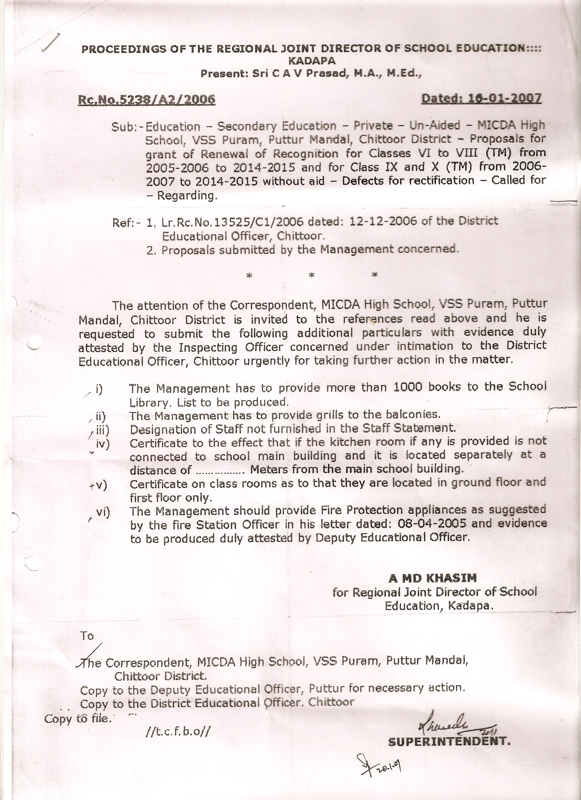
You can see from the letter, except for first two items the rest of the items asked for have already been provided and mentioned in the check list. It is clear from the letter the office did not want to process my application with out myself favoring them with the money asked by them. After receiving this letter I went to Kadapa and told them that I will go on hunger strike in front of the DEO Office Chittoor till recognition is given. I also threatened them that I would give publicity to the schools which they have recognized despite non provision of facilities in the check list. With this action the Regional Director office came around at the last movement and accorded recognition. The letter of the recognition is given below.

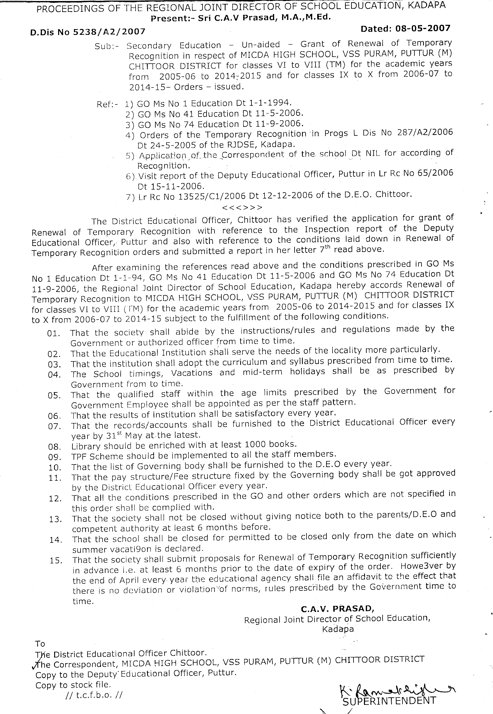
Wi
Th1.Regard to the expenditure for getting recognition for the school Rs:22000/- has been spent. The amount was incurred towards the preparation of proposals, to get certificates from different authorities like Fire Officer, Structural sound certificate from Engineers, Sanitary Certificate form Panchayat, and Recognition fees Rs:2500/- for 1st to 5th class and Rs:5000/- for 6th to 10th class and traveling and living expenses at Chittoor and Kadapa.
Wi2. Regard to the Unforeseen expenses and contingency, on expenditure on following items was incurred
1. 1. Registers
2. 2.Chalk pieces and dusters
3. 3.Rubber pipes to water the plants in and around the school
4. 4.Soil filling and leveling on eastern part of the school building to strengthen it.
5. 5.Online expenses of the school
6. 6.Repair of the Bore well
7. 7.Sanitary equipment
8. 8.Text books transportation and other hospitality

At present the school is being maintained with the remaining balance amount of Rs:2,28,332/-

With warm regards
Sincerely yours

Dr.R.Subbaramaiah

