Overview
My visit was on August 2nd, 2011.
I was extremely impressed Kalanjiyam - with the amount of work accomplished since its inception, the organized fashion of activities, the enthusiasm of both the children and the organization staff – to mention a few. It would be a great understatement to say that Kalanjiyam has done a great job so far, and I am not sure if my thoughts can be summarized appropriately in this short document.
The focus of their work is to find and create a sustained mechanism inside each village for every child to have reasonable education. The idea is to do this without touching the government system, but by supporting it in peripheral ways. The essence of Kalanjiyam is to embed the necessity of education at a very psychological level in every village. i.e. to inculcate (1) a value of education, and (2) teach the villagers the way and means to sustain it.
Direction and Means
A loaf of bread is a good charity, but teaching the means to get it is a greater deed. Along those lines, Kalanjiyam has taken great strides to bring education and its means to many villages they have adopted. They believe that any local govt school is good by itself, however as a first step, it lacks the attendance necessary to keep it going.
Hence with increasing attendance as primary focus they have the following activities.
(a) Have a “aunties” – These are staff of Kalanjiyam who help encourage, motivate the students to attend schools. These people are chosen from local community and hence are already known to the kids. (b) provide students with books and uniforms (c) improve amenities at school (d) and in some cases help with the funding of child itself. Etc ..
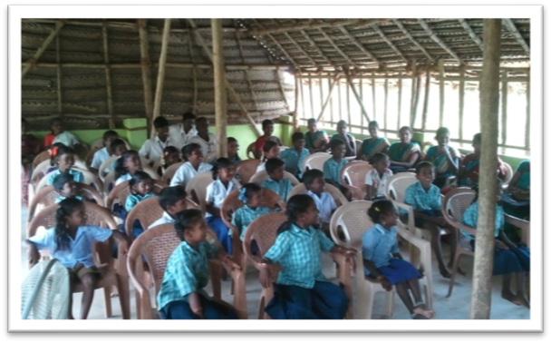
Kids and Their caretakers
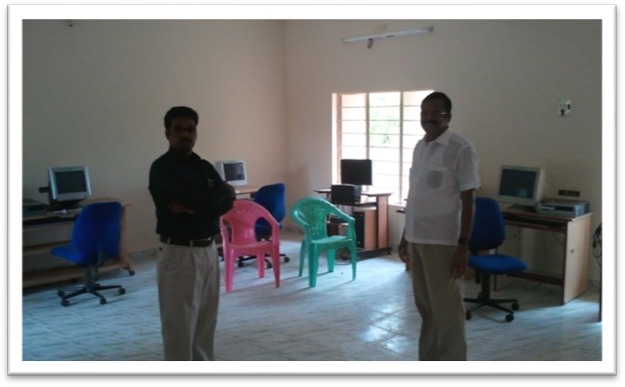
A computer center built for the kids
Ways to maintain health and sanity
(a) improve local health centers (b) Improve the local health awareness by using CDs, appropriate books (c) The health of a child starts from the mothers womb – hence teaching mothers how to care for their kids in their womb, new borns, and all the way till their adolescent age. (d) Teach teenagers to be responsible, by teaching them about the changes in their bodies and their minds.
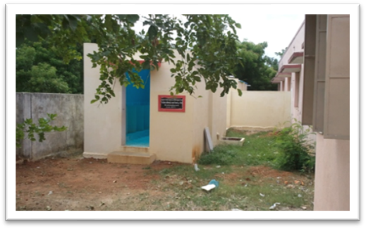

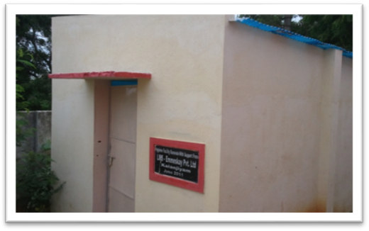
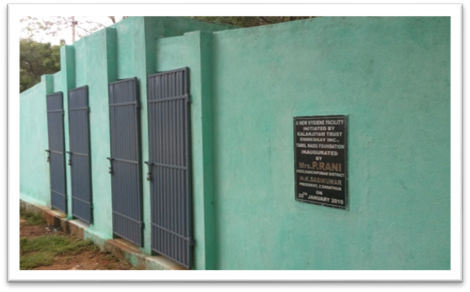

Newly constructed restrooms for ladies and gents in two different schools
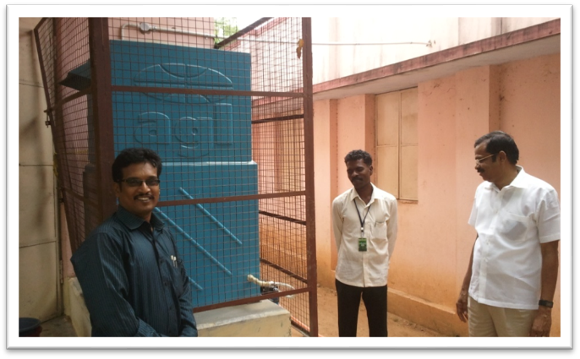
A Reverse osmosis water collector
The next idea is to attempt improve the awareness of the school itself within the villages. For this,
(a) conduct rallies for good causes (like no to plastics) with children. (b) Use the local industry itself to fuel the school supplies and necessities
Lastly, encourage external folks to come and volunteer within these communities to improve the locality. For this they are beginning to construct a simple guest house and a mini-library which can help both the guests and the locals.
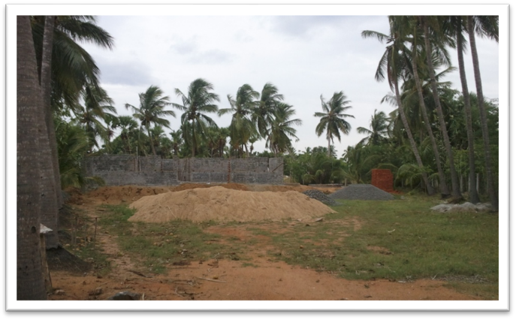
Future projects :
They have lots in the pipeline. It includes
1) improvement in water facilities – both usable water, and palatable water - to all the schools they have currently undertaken [~20 in number],
2) provide computer infrastructure to the schools,
3) provide reasonable health facilities for kids and new mothers, etc..
This is by no means is a complete list of future projects.
As far as financial requirements are concerned, they seemed to be short on quite a few angles. I believe that they are able to sustain for minor requirements like buying amenities for kids, administrative expenses etc. but are short on bigger projects like attempting to bring in more mobile libraries or a small science lab for kids etc.
The Kids:
I found the kids to be extremely energetic, and they are very attached to their caretakers. It was an immense joy to meet them and talk to them about their life ambitions.
Aside thought: The kids need more exposure, and while there are regular (fortnightly) information and seminar type sessions, one or two field trips to different educations places – museums, zoo, huge constructions like river-dams would build dreams within the kids. Those will prove invaluable to their mental growth.

At the end of it all, arnt we all working for the future generations.?
Lets us try to help this wonderful endeavor/organization.

Thanks
-Satya

