Jan Kala Sahitya Manch Sanstha (JKSMS), Jaipur – India
A-17, Ashok Vihar, New Sanganer Road, Mansarovar, Jaipur (Rajasthan) – India – 302020

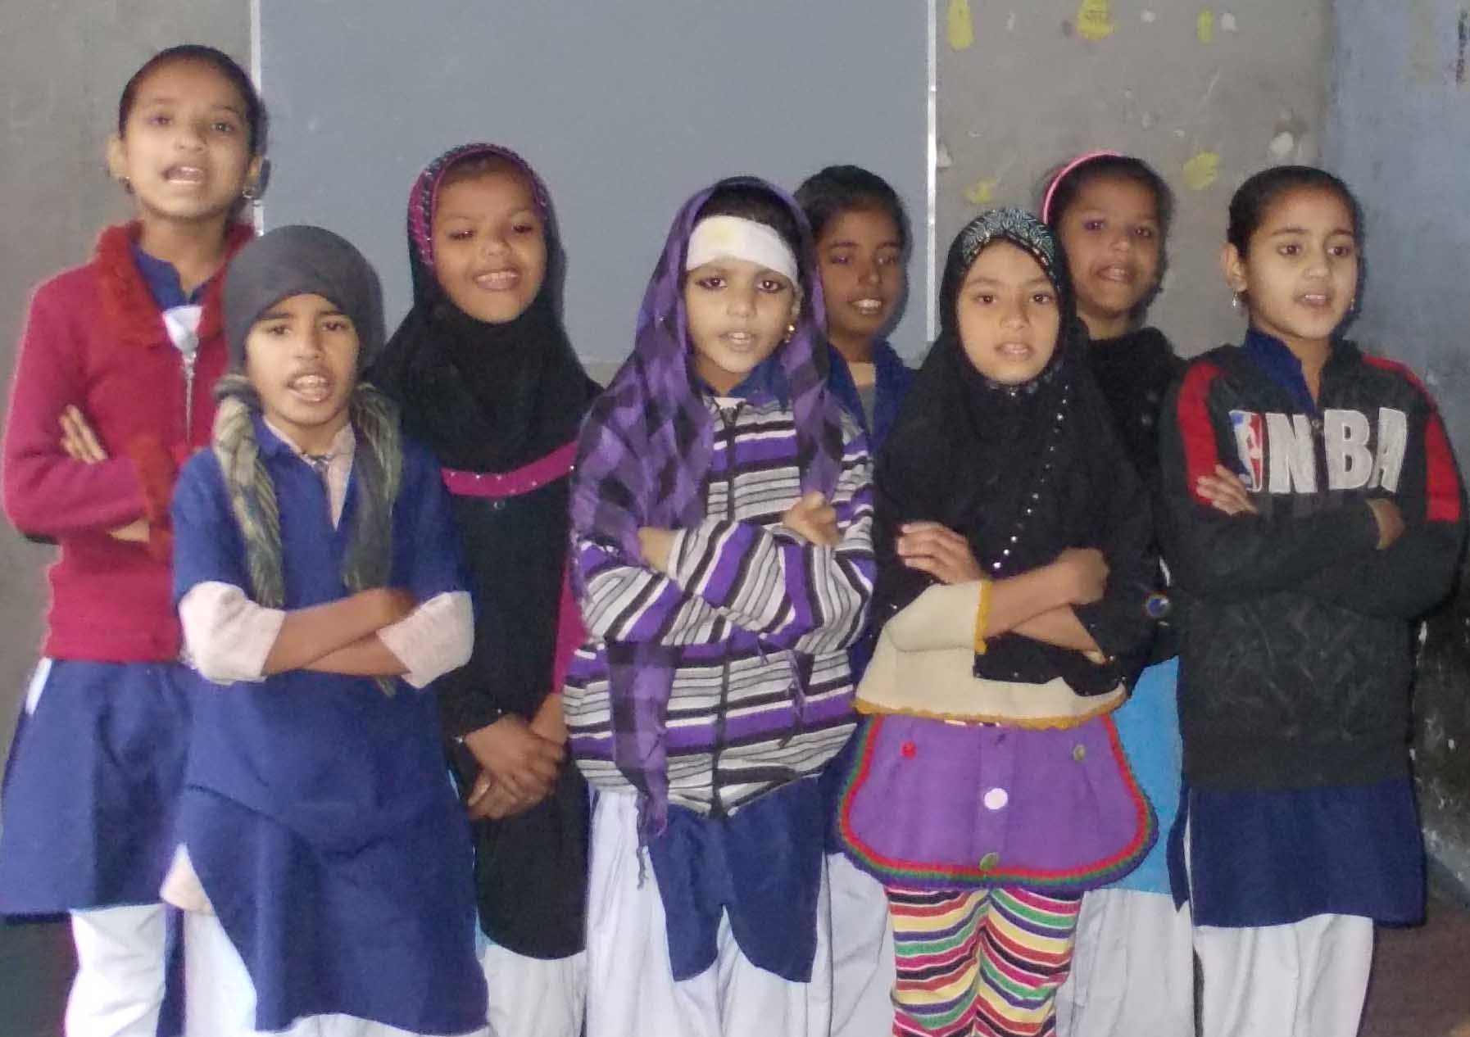
ILM School

Report
2013-14

Supported by
Asha for Education

Preface of JKSMS

JKSMS is a non-governmental and non-profit making awarded on national and state level social organization working for the development – rehabilitation - health and protection of children, women and marginalized artisans from different crafts in Rajasthan state of India. The organization was founded in the year 1983 with its registration under Rajasthan Societies Registration Act 1958 and it is also registered under FCRA (Foreign Contribution (Regulation) Act. JKSMS is member organization of Fair Trade Forum – India. The organization is committed to promote social justice & development opportunities for the needy section of the community. JKSMS believes in universal right to dignity, as well as the right to survival trough opportunities for personal growth and development. The main concern of the organization is to help the oppressed, especially children, women, artisans and other deprived communities surviving without basic amenities.

Many different projects related to child development, women, health and livelihood promotion based on self sustainable mode are taking place from the past several years, i.e. Open Shelter under Integrated Child Protection Scheme, Childline Phone Service, ILM School for the children of artisans, Shelter Homes for orphan and runaway children, Reproductive Health and Child Care Project, Bamboo Cluster Development – Banswara, Livelihood development of the marginalized population and more particularly for the women from Amber Block through self-sustainability, Jaipur Jewelry Artisan Development Project – Jaipur, Rural Tourism Development, Kaastha Kala Cluster Development – Bassi, SHG Promotion of BPL Families artisans of Amber block etc. with the aim of enabling population to live in decent conditions in their villages/cities by resolving issues such as unemployment and social injustice, JKSMS is preventing the migration of these population who would otherwise grow the number of people living in difficult conditions in the city. At present JKSMS is working with craft based artisans in Rajasthan belonging from different crafts, for their skill up gradation, social security and market promotion. JKSMS has promoted a public limited company of the artisans and for the artisans by the name of “Nav Srijan Crafts India Ltd.” To the best of our knowledge, it is a first and only artisan’s share holding company for the market promotion, design uptakes and technical up gradation of the artisans in Rajasthan.

The ILM (Interactive Learning Methods) School

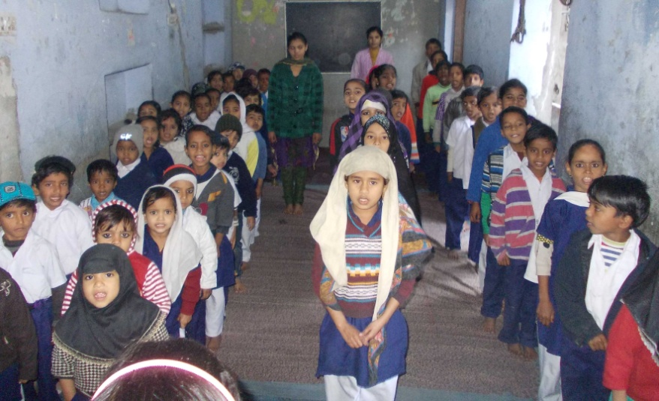
The ILM is a school for the urban deprived children residents of Bhistion Ka Mohalla Ramganj, Jaipur. Most of the children are belongs from the artisans those are involved in stone cutting & polishing. The community was not sending their children in the schools in the beginning due to lack of knowledge concerning the importance of education, poor quality of education in the schools and poverty is also issue for some of educational courses. Artisan's children are also working with their family to play vital role in income generation activity for food. School is far from the community; so enrollment of the children from area was less because community members don't want to send their children far in the schools.
The ILM School is a project initiated in 2009 under JJADe Project supported by Seep Network, USA for quality education to the children of artisans. After ending the project in 2012 Asha for Education, USA is providing its funding support for 100 children with the objective “to provide adapted education facilities to all working children of craft sector artisan of Jaipur”.
The project is generating the awareness in the community about education and it is providing quality education through non-formal way of education in a child friendly environment to the children. So children are attending ILM School every day. ILM School is playing major role to reduce gap between community, education and their children. The main aim of the project is to fulfill the gap of educational as per the age of children and after that ILM staff is admitting children in other schools for formal schooling. The ILM is breaking the briers in the community through enrollment of the children and show the model to community with their partnership. ILM School is ensuring community participation on all levels. All the children have role to rolling the plan for smooth studies and other activities. The ILM is more focused on community participation, quality education and enrollment of the children in the existing schools. The initiative of ILM is creating better environment among the community and other stakeholders. So many children are going to school and community is also sending them in the schools and discuss with other parents to ensure their children's education. The ILM is qualitative bridge between community, children and education. It is reducing dropout rates from schools with partnership of community and children.

Findings in figures
Children Details;
S. No. | Particular | Nos of children
 |  | Boys | Girls | Total
1. | Total Enrolled Children during the period (2013-14) | 71 | 76 | 147
2. | Children mainstreamed in other schools | 09 | 13 | 22
3. | Drop-out/shifted in another places | 25 | 06 | 31
4. | Children in ILM School as on 31st March 2014 | 37 | 57 | 94

ILM Staff;
S. No | Name of the Staff | Post | Period
1. | Mr. Narendra Kumar | Coordinator | 2012 to continue
2. | Mrs. Snehlata Pareek | Teacher | 2012 to continue
3. | Ms. Kirti Kumari | Teacher | April 2013 to continue
4. | Ms. Massrat Bano | Teacher | April 2013 to continue
5. | Mr. Narayan | Cleaner | April 2013 to continue
6. | Mr. Umesh Sharma | Accountant (Part Time) | 2012 to continue
7. | Mr. Ashok Kumar | Computer operator (Part Time) | April 2013 to continue

SMC (School Management Committee);
S. No. | Name | Sex | Status
1. | Mr. Narendra Kumar | Male | School Coordinator
2. | Ms. Massrat Bano | Female | Teacher from Community
3. | Mrs. Snehlata Pareek | Female | Teacher
4. | Mr. Saleem | Male | Community Member
5. | Mr. Vaheed Bhai | Male | Community Member
6. | Mrs. Mumtaaz | Female | Community Woman
7. | Mrs. Shabana Begam | Female | Community Woman
8. | Mr. Salaam | Male | Parents
9. | Mrs. Khatoon | Female | Parents
10. | Moh. Ayub | Male | Parents
11. | Mrs. Farha | Female | Parents
12. | Ms. Muskaan | Female | Student – ILM
13. | Ms. Shabana Nazmi | Female | Student – ILM

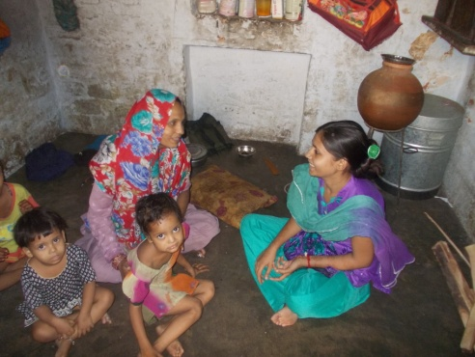
Meetings with community and Contacts on doorstep;
The community contact is very important to know situation of the children and their family, as well as to share progress of the children enrolled in ILM School with their parents. It helps to improve education of quality. ILM School teachers are making plan as per need of the child, because they know education level as well as situation of the family. The teachers discussing with the community during community contact and meetings to resolves issues rise on the community and school level issues. Community contact is a part of daily planned schedule of ILM School. On an average, each teacher is contacting minimum two families per day during community contact. And on monthly basis a community meeting was organized in ILM School, where on average 25 – 30 parents/community members are ensuring their presence.
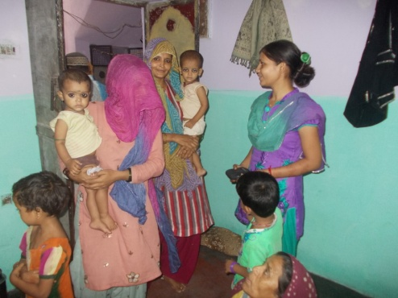

Finance Literacy (CDK);
Number of Associated Children | Total deposit | Total withdrawal | Saving (Balance) Amount in CDK
49 | 38,714.00 | 25,763.00 | 12,951.00

ILM School Schedule;
S.No. | Activities | Time (from To)
1. | Daily Planning | 08.00 Am to 09.00 Am.
2. | Arrangement and Prayers/Poems | 09.00 Am to 09.30 Am.
3. | Language | 09.30 Am to 10.00 Am.
4. | Mathematics | 10.00 Am to 10.30 Am.
5. | English | 10.30 Am to 11.00 Am.
6. | Environment Education | 11.00 Am to 11.30 Am.
7. | Stories and drawings | 11.30 Am to 12.00 Noon
8. | Games and Songs | 12.00 Noon to 12.30 Pm.
9. | Rearranging the school | 12.30 Pm to 01.00 Pm.
10. | Lunch | 01.00 Pm to 01.30 Pm.
11. | Community contact | 01.30 Pm to 02.30 Pm.

ILM school timings are decided by the community during meeting. The community decides school timings after discussion in the meeting. The time is based on the availability of children in the community because some children are working as apprentice at their home or nearby the home. Some children are taking care of their younger brothers and sisters at home. The school time is changeable according to the community and children, but it need to be decided by the community in the meeting. None of one can decide it individually. The decisions can be taken through democratic process during community meetings.

Capacity Building & Meetings
ILM Staff;
Capacity Building Workshop for Teachers (One Month) :-
Once in a year a one month capacity building workshop for the teachers is organized during summer period (June month). In this workshop, ILM School coordinator, Staff and subject experts are participating. This year from 1st June 2013 to 30th June 2013 workshop was held in JKSMS office. The aim of the training workshop was to develop pedagogy, curriculum, and empowerment of skills, understanding child psychology and community participation.

During the workshop each students work was evaluated for the whole year with their learning. Like; before one year what was learning level and now what is his progress. A detailed report of each student of ILM School was prepared and presented by the teachers. After that a yearly curriculum was developed for coming year with the support of experts to ensure quality education through non-formal way of education in the ILM. During the workshop, new poems, stories and work-books were also developed and practiced by the teachers.
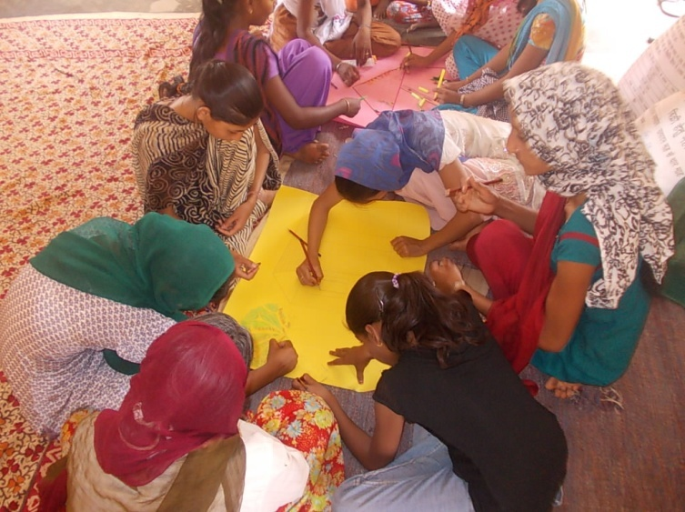
Out of developing curriculum for the year, problems and challenges faced by the ILM staff were shared and experts explained that how they can solve these issues related to community, children. It was most challenging for the teachers to make children stable in class rooms. So, some exercises were done by the experts on it based on when and why? New games were introduced to make curriculum more interesting and friendly according to environment of the area.
The workshop was designed based on “Learning by Doing” basis. After the workshop teachers and coordinator was in full of energy and equipped with tools of TLM.

Bimonthly (twice in a month) workshop for Teachers :-
The workshop/meeting held in the school to develop curriculum and ensure quality in the ILM. Bimonthly workshop organizes on curriculum development for the ILM School and to finalize the curriculum for next coming 15 days as per experience of previous 15 days according to learning levels & interest of the students. The teachers and coordinator is participating in the workshop for finalizing curriculum of coming days. During the workshops, first they share the progress of the students and experience. And then as per learning, they decides next 15 days curriculum. The curriculum is based on the activities, which ensure quality in the classroom. The teachers make fifteen days plan in the workshop with the activities. After that, teachers divide this plan day wise. Plan is influence with the learning levels of the students. After, fifteen days work with the children in next workshop teacher presents report of last fifteen days and discussed problems, innovation and implementation among the big group and formulate next fifteen days plan to ensure quality of work.
During the year 2013-14 total 24 workshops were organized.

SMC;
The SMC (School Management Committee) is in charge for management of school and to sensitize community about education. So it was necessary to organize a capacity building of SMC members concerning ruling the school, sensitization of community regarding education and there active participation in school management.
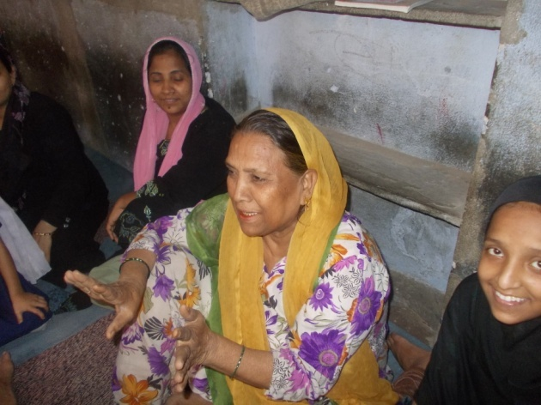
So, to build the capacity of SMC members for bearing there responsibilities a one day capacity building workshop was organized for them in the beginning of the year. There experts of community mobilization, school management and coordination took sessions for capacity building of SMC members. During the workshop SMC members asked several question related to management and community participation.
After the capacity building workshop for SMC members, SMC meeting were organized on regular basis as per requirement and issues to make assessment of the current situation and to plan the work of each organ of the project. Following issues are dissolved by the SMC;

- Water problem.
- Enrollment of children in ILM School.
- Discussion with community for mainstreaming their children in formal schools.
- Review school time table.
- Sharing the progress of children.
- Discuss with Mosque committee on the issue related to due school building rent, request to give time for payment of rent and due funding support.

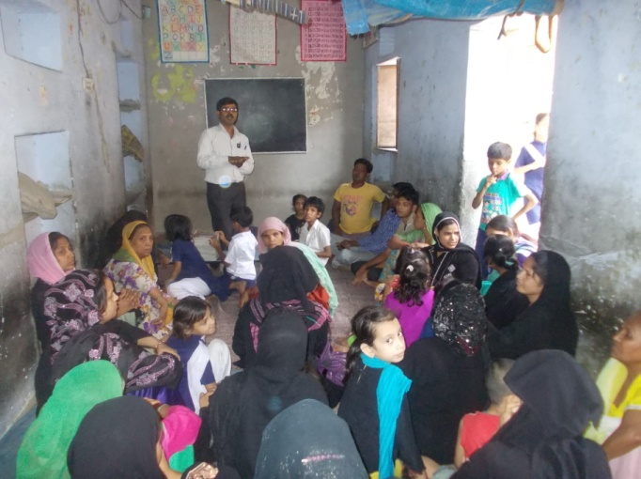
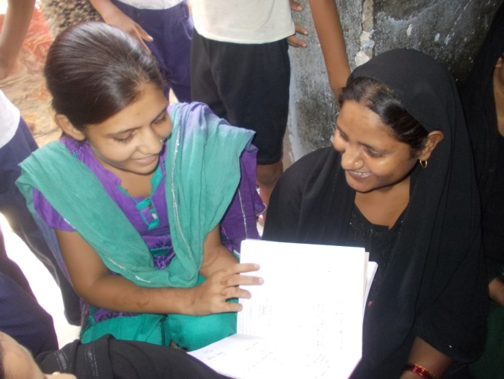
Community Meetings and contacts;
The community contact is very important to know situation of the children and their family, as well as to share progress of the children enrolled in ILM School with their parents. It helps to improve education of quality. ILM School teachers are making plan as per need of the child, because they know education level as well as situation of the family. The teachers discussing with the community during community contact and meetings to resolves issues rise on the community and school level issues. It is also has a major part to build community capacity and develop their interest concerning importance of education for their children. Community contact is a part of daily planned schedule of ILM School. On an average, each teacher is contacting minimum two families per day during community contact.
And on monthly basis a community meeting was organized in ILM School, where on average 25 – 30 parents/community members are ensuring their presence where refreshment is served by the ILM School as honor of community.
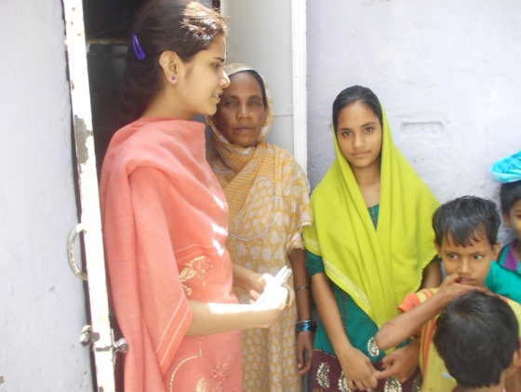
Issues of community contacts;
  - To regularize children at school, those irregular.
  - To ensure children's presence on time at school.
  - To motivate parents for the children's cleanliness.
  - To know about the children.
  - To involve new children in school.
  - To invite for community meetings.
  - To motivate community concerning their participation in school activities, importance of education, school building and other related issues.

Educational Development of Children
Teaching Learning Process;
As ILM School name; Interactive Learning Methods is showing its creative way of teaching, ILM School is following non-formal way of education for its students to provide them child friendly environment. There is no provision for books curriculum is developed based on NCERT syllabus. Curriculum is developed as per class levels of NCERT course.

Learning Levels;
Language : Hindi
Group | 1st Level | 2nd Level | 3rd Level
Titli Group | They know vowels very well in language and they can write six words sentence properly. | These children can pronounce vowels and working on reorganization. | Children of this level can recognize (cup, nal, bus and matar etc.) along with drawings. And poems with the help of teachers.
Dharti Group | Children of this level can do poems freely with the actions. These children are working on the first step of Hindi grammar "Aa" and they can write and read four vowels words. They can work by following the teachers very well and listening stories with their full concentration. | Second level children can copy properly in writing. Knows complete vowels and working on the sentences of six worlds in reading and writing. They can speak poems without any support, listening stories properly and participating in each activity. | Children of third level are repeats poems properly. They are working on reorganization of vowels and six familiar words. Level of concentration is not good.
Badal Group | Children of 1st level knows "Aa, E, and Eu" in Hindi Grammar. These children are working on further Hindi Grammar. They can sing poems properly without any support | Children of this level can construct words by using vowels. Like; Ka + Ma + L = Kamal.  They can recognize words by pictures. | Children of this level can construct the words of four vowels without Hindi grammar and can read.

Language : English
Group | 1st Level | 2nd Level | 3rd Level
Titli Group | Children of this level can write A to Z alphabets. And can recognize alphabets with their popular words of them with the meaning. Like; "A for Apple, B for Book etc." | Children of this level can pronounce A to Z alphabets but they can't write. | Writing and pronouncing level of children of this level are low. Because of that they can only read A to F alphabets.
Dharti Group | This level child in the group knows A to Z alphabets and they can write A to Z alphabets. They also recognize small letters of alphabets. And children are working on fruits, colors and vegetables name. | The children of this level can write A to Z alphabets in writing by coping and they can recognize alphabets only by watching. Work on recognition is going on. | The children of this level are unable in reading and writing of alphabets. So, work on recognition is going on.
Badal Group | All the children of this level know A to Z alphabets with their meanings. They know fruits names, flowers names, vegetables name, animals name, birds name vehicles name, body parts name, days of the week names etc. They can read and write too. | Children of this level can write A to Z alphabets in small letters. They can read fruit names, vegetables name and flower names, but they can only copy in writing. | Children of this level know properly A to Z alphabets.

Environment:
Group | 1st Level | 2nd Level | 3rd Level
Titli Group | Children of this level are participating in environment related discussion. They recognize vegetables. | Children of this level are participating in environment related discussion only sometimes. They know some vegetables and colors. | These children are not participating in group discussion.
Dharti Group | Children of this level know colors, trees and vegetables. And they know the importance of sanitation and hygiene. All the children of this level are participating in each environment related discussion and supports to the teacher for elaborate the discussion. | Children of this level also participate in the discussion, they are putting argues during the group discussion. Work to recognize colors, vegetables and fruits are going on. | These children are not taking interest in group discussion, so teachers are encouraging them to participate in the discussions.
Badal Group | Children of this level have knowledge of colors, trees, vegetables, sanitation & hygiene and other issues. They are participating in all concerning discussions. | These children can recognize colors and vegetables, also participating in group discussions. | These children are not participating in group discussions. So, we are encouraging them.

Mathematics:
Group | 1st Level | 2nd Level | 3rd Level
Titli Group | Children of 1st level can speak 1 to 50 numbers counting. But they can recognize only the numbers upto 30. | Children of 2nd level can speak 1 to 30 numbers counting and they can recognize 1 to 10 numbers. | Children of 3rd level can speak 1 to 10 numbers counting and can recognize also.
Dharti Group | 1st level children knows very well 1 to 100 numbers counting and can write 1 to 500 numbers. They can add (+) easy numbers. They can also recognize geometry shapes (squire, round etc.) | Children of this level knows very well 1 to 20 numbers, work is going on on further numbers. They can recognize squire and triangles. They can do also easy calculations (add "+") verbally. | Children of this level can speak 1 to 10 numbers. At present they didn't recognize numbers properly.
Badal Group | Children of this level knows adding (+), minus (-), multiply (x) of 2 - 3 digits. And they can solve questions related to adding, minus, multiply and divide. | All the children of this level can do easy adding (+) and minus (-). They are working on 2 - 3 digits calculation. | In this level some children know up to 50 numbers and some are up to 100 numbers.

Mainstreaming for formal schooling;
The teachers will have a strong knowledge about the community, children and school. They are mainstreaming children in government and private schools according to the level of the children and their readiness with the consent of their parents.
As ILM school is not the final step of our plan to educate children, it a part of the general process of education. The objective of ILM School is to develop interest of children in education and then to lead them to go in government or private schools by mainstreaming after developing their knowledge according to their age group. However there will be still need to homework support at ILM School for mainstreamed children.
The teachers will go in formal school where ILM students are mainstreamed to continue the work they initiated in ILM School. They will be in touch with teachers to make sure that atmosphere is good for the children and they keep interest in education.
Besides, they will assess there the pre-required knowledge of children to get in government school in good conditions.
During the year 2013-14, total 22 children (09 boys and 13 girls) were mainstreamed. The details of mainstreamed children are as follows;

S.No | Name of Child | Parents’ name | Age | Sex | Class/  Standard | Name of School
1. | Samina | Farid Mohammad | 12 yrs | F | 2nd | Govt. Primary School
2. | Gulafsha | Farid Mohammad | 11 yrs | F | 2nd | Govt. Primary School
3. | Tarannum Bano | Moh. Farid | 7 yrs | F | 1st | Govt. Primary School
4. | Naziya Bano | Moh. Javed | 6 yrs | F | 1st | Govt. Primary School
5. | Ibrahim (Salman) | Moh. Sharif | 7 yrs | M | 1st | Govt. Primary School
6. | Zuber | Moh. Javed | 7 yrs | M | 1st | Govt. Primary School
7. | Danish | Moh. Iqubal | 6 yrs | M | LKG | I.M. Middle School
8. | Kushnuma | Moh. Iqubal | 10 yrs | F | UKG | I.M. Middle School
9. | Alima | Abdul Vahid | 6 yrs | F | LKG | Pinkcity public School
10. | Saniya | Abdul Vahid | 7 yrs | F | LKG | Pinkcity Public School
11. | Nida Bi | Shakil Ahemad | 5 yrs | F | 1st | Govt. Primary School
12. | Karishma | Abdul Aziz | 12 yrs | F | 1st | Ikra Public School
13. | Samir | Abdul Aziz | 11 yrs | M | 1st | Ikra Public School
14. | Ayan | Abdul Aziz | 9 yrs | M | Nursery | Ikra Public School
15. | Sana | Sazid | 5 yrs | F | 1st | Islamic Mansoori School
16. | Harish | Althamash | 9 yrs | M | LKG | Islamic Mansoori School
17. | Sameer | Abdul Aziz | 12 yrs | M | 1st | Islamic Mansoori School
18. | Rani | Babudeen | 14 yrs | F | 5th | Govt. Primary School
19. | Tarannum | Rafiq Ahemad | 12 yrs | F | 4th | Govt. Primary School
20. | Rashid | Rafiq Ahemad | 13 yrs | M | 4th | Govt. Primary School
21. | Husnain | Rafiq Ahemad | 14 yrs | M | 6th | Govt. Upper Primary School
22. | Nawazish | Rafiq Ahemad | 11 yrs | F | 2nd | Govt. Primary School

Finance Literacy (CDK);
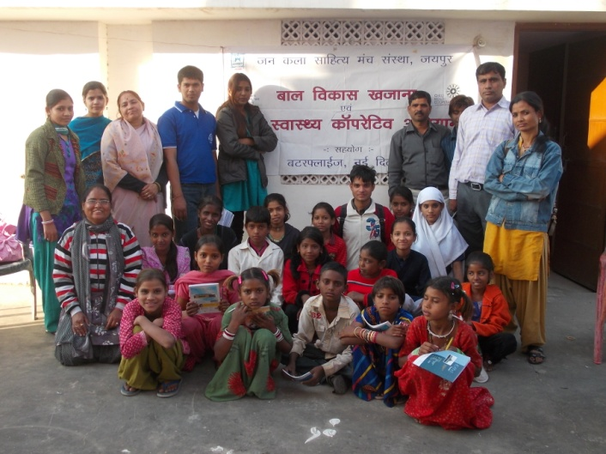
ILM School is also accumulating financial management experience of children through Child Development Khazana (CDK). Where children deposits money from their pocket money and time to time they withdraws as per their requirement. Also they receives advance too. The Child Development Khazana provides two type of advance one is for welfare and second for business. Children got money from the Kazana for fulfill the need of the business, education, health and other family work. The initiative to aware children concerning to improve their saving habits and make familiar with banking system. It is initiated for the children, by the children. Through this initiative children become manager of the finance. It is first generation, which is familiar with the banking system. The CDK members elect their volunteer manager and assistance manager through democratic process children cast vote for both posts in every six months.
Total deposit – withdrawal, saving amount and number of children associated with CDK from ILM School was as follows as on 31st March 2014;
Number of Associated Children | Total deposit | Total withdrawal | Saving (Balance) Amount in CDK
49 | 38,714.00 | 25,763.00 | 12,951.00

Health Care (CHC);
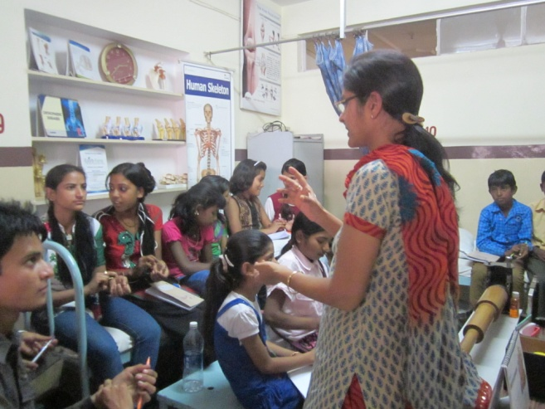
Child Health Cooperative is an initiative based on the principle that children can collectively advocate for quality and timely health care services from concerning agencies/persons. The cooperative also has the primary role of educating its members on issues of nutrition, hygiene and prevention of most illnesses. So, a Child Health Cooperative was formed in ILM School also as functioning in other slum centers of JKSMS, with the objectives of; to increase the awareness of children on their health needs, strengthening child health cooperative as a forum of children to access health entitlements, establish a cadre of child health educators equipped to assist their peers in any emergency.
Children of ILM School are member of this CHC. JKSMS organized an exposure visit of hospital for the members of CHC. Where they learnt whole process of hospital and a First Aid Training was provided to them. An interaction meeting was also organized with the doctors.

Record Keeping;
The ILM School has been a lot of records to ensure the indicators of activities done in the school and outside the school. Some records are maintaining on daily basis and some are on monthly/yearly basis. Each activity has separate records for clear view of ILM School. Teachers are very touching with activities as well as records of the school.
- Student Attendance Register
- Staff attendance Register
- Community Meeting register
- Evolution Note book for every children
- Duplicate Diary for experience writing
- CDK; Cash book, Ledger, Pass book (separate for each child)
- Visitor Register
- Individual Files for children
- Curriculum Register
- Enrollment Register
- Survey file and Register
- Monthly Report files
- Record of mainstream education
- Staff meeting Register
- Stock Register (Consumable & Assets)
- Teaching Learning Material

Celebration of events/days in ILM School
- Birth Day Celebration of Dr. Ambedkar on 14th April 2013.
- World Environment Day – 5th June 2013
- Independence Day Celebration – 15th August 2013.
- Mahatma Gandhi Birth Day Celebration – 2nd October 2013
- Children’s Day – 14th November 2013.
- Republic Day Celebration – 26th January 2014.
- Sahid Diwas (Mahatma Gandhi’s Death Anniversary) – 30th January 2014.
- Women’s Day – 8th March 2014.

Challenges/Problems
- To prepare parents for mainstreaming their children for formal schooling.
- Regularize children in ILM School.
- Less strength of children during festival seasons.
- Due funding support.
- Due school building rent.
- TLM on credit.

List of children

Total Beneficiaries during the year – 2013-14;
S.No | Name of Child | Father’s name | Age | Sex | Remarks
1. | Adil | Shakur | 13 yrs | M
2. | Moh. Faze | Zabbar | 7 yrs | M
3. | Salman | Anwar/Annu | 6 yrs | M
4. | Sohel | Anwar | 5 yrs | M
5. | Muskaan | Khalil | 7 yrs | F
6. | Simran | Saleem | 7 yrs | F
7. | Noshida | Mazeed Sha | 5 yrs | F
8. | Saniya | Islamuddin | 4 yrs | F
9. | Joya | Sattar Bhai | 5 yrs | F
10. | Moh. Saddik/Sazid | Ikram | 7 yrs | M
11. | Toshin | Mosin | 4 yrs | F
12. | Tofeeq | Meharaj | 4 yrs | M
13. | Kaasif | Sattar Kha | 4 yrs | M
14. | Irfan | Imran | 4 yrs | M
15. | Kasiba | Mazid | 4 yrs | F
16. | Samrin | Abdul Hamid | 4 yrs | F
17. | Neha Bano | Moh. Shakir | 6 yrs | F
18. | Wazid | Abdul Mazid | 7 yrs | M
19. | Alfisha | Yusuf | 5 yrs | F
20. | Rehaan | Rahis Bhai | 5 yrs | M
21. | Tanu | Moh. Kaleem | 5 yrs | F
22. | Yashmeen | Moh. Umar | 9 yrs | F
23. | Nasirat | Moh. Umar | 7 yrs | F
24. | Moh. Armaan | Moh. Abid | 4 yrs | M
25. | Moh. Naved | Sahid | 4 yrs | M
26. | Alima | - | 4 yrs | F
27. | Sohel Vasim | Aziz | 12 yrs | M
28. | Muskaan Bano | Ikram | 13 yrs | F
29. | Arbaz | Muraj | 13 yrs | M
30. | Bushara | Kamruddin | 5 yrs | F
31. | Tarranum Bano | Moh. Tahir | 4 yrs | F
32. | Ayan | Alimuddin | 6 yrs | M
33. | Fezaan | Moh. Ayub | 6 yrs | M
34. | Alfisha | Ayub | 8 yrs | F
35. | Sonam | Afzal | 5 yrs | F
36. | Sofiya 338 |  |  | F
37. | Nargish | Asgar | 6 yrs | F
38. | Afsha | Wasid Ahemad | 7 yrs | F
39. | Farhaana | Israr | 7 yrs | F
40. | Sana | Salim | 7 yrs | F
41. | Shaina | Khalil | 12 yrs | F
42. | Muskaan | Zabar | 16 yrs | F
43. | Bushrabi | Shamil | 12 yrs | F
44. | Shaziya | Salim | 15 yrs | F
45. | Umera | Farid Ahemad | 11 yrs | F
46. | Nisha | Salam | 10 yrs | F
47. | Rizvana | Moh. Ikram | 11 yrs | F
48. | Muskaan | Mob. Ikram | 10 yrs. | F
49. | Uzma Khan | Jahid | 11 yrs | F
50. | Zoya | Parvez | 09 yrs | F
51. | Anam | Parvez | 10 yrs | F
52. | Tarranum Bano | Sarfarajuddin | 13 yrs | F
53. | Umra | Samir Ahemad | 12 yrs | F
54. | Nazma | Abdul Mazid | 11 yrs | F
55. | Mantsha | Mustufa | 11 yrs | F
56. | Sohel | Abdul Aziz/Bablu | 11 yrs | M
57. | Salman | Salam | 09 yrs | M
58. | Fezaan | Farid Mohamad | 10 yrs | M
59. | Sameer | Guddu | 12 yrs | M
60. | Arbaz (Jahid) | Jahid | 10 yrs | M
61. | Azim | Allauddin | 10 yrs | M
62. | Yasin | Munitiyaz | 12 yrs | M
63. | Shoyab | Imran | 9 yrs. | M
64. | Zahid | Sultan | 11 yrs | M
65. | Simmy | Mh. Sharif | 10 yrs | M
66. | Imran | Kadir Ahemad | 11 yrs | M
67. | Vasim | Mustufa | 13 yrs | M
68. | Afsana | Yasin | 12 yrs | F
69. | Samreen | Moh. Tahir | 13 yrs | F
70. | Farhaan | Moh. Tahir | 14 yrs | M
71. | Rajjaq | Zabbar | 14 yrs | M
72. | Sabana | Moh. Yusuf | 14 yrs | F
73. | Rukhsaar | Abdul Aziz | 11 yrs | F
74. | Sofiya Bano | Moh. Kamruddin | 10 yrs | F
75. | Momeen | Mumtiyaz | 09 yrs | M
76. | Sadiq | Murad Kha | 11 yrs | M
77. | Jishan | Abdul | 5 yrs | M
78. | Tahira | Noor Bano | 8 yrs | F
79. | Neha | Mh. Aziz | 10 yrs | F
80. | Tahir | Imran | 10 yrs | M
81. | Rabiya | Hassan | 12 yrs | F
82. | Riyan | Imran | 8 yrs | F
83. | Tahira | Umar Bhai | 10 yrs | F
84. | Kafiya | Hassan | 09 yrs | F
85. | Sazid | Ikram | 07 yrs | M
86. | Wazid | Mazied | 11 yrs | M
87. | Mussaraf | Hassan | 16 yrs | M
88. | Nisha | Shakir | 13 yrs | F
89. | Farhana | ILSAR | 8 yrs | F
90. | Fiza | Salim | 09 yrs | F
91. | Saba | Abdul Gaffar | 6 yrs | F
92. | Nida | Shakil Bhai | 07 yrs | F
93. | Aman | Rasid | 07 yrs | M
94. | Tahira |  |  | F
95. | Aman | Zabbar | 09 yrs | M
96. | Sonu | Bablu Kha | 14 yrs | M
97. | Amir Beg | Rahees Beg | 14 yrs | M
98. | Mehanaz | Mandi Hassan | 12 yrs | F
99. | Sharukh | Ikramuddin | 18 yrs | M
100. | Salman | Majid Mohammad | 17 yrs | M
101. | Ashif Ali | Allauddin | 18 yrs | M
102. | Irfan | Moh. Asrar | 18 yrs | M
103. | Abid | Shakur Ahemad | 18 yrs | M
104. | Soni | Mumtiyaz | 17 yrs | F
105. | Nargis | Jakir | 16 yrs | F
106. | Nilofar | Altaf | 17 yrs | F
107. | Rani | Babudin | 16 yrs | F
108. | Muskaan | Mumtiyaz | 18 yrs | F
109. | Sohel | Moh. Sharif | 18 yrs | M
110. | Farman | Guddu | 17 yrs | M
111. | Mobin | - | 17 yrs | M
112. | Daud | Farid | 18 yrs | M
113. | Farman | Sazid | 18 yrs | M
114. | Arman | Sabu Hassan | 18 yrs | M
115. | Adil | Altaf | 18 yrs | M
116. | Aamir | Sabu Hassan | 16 yrs | M
117. | Aftab | Abdul Rasid | 18 yrs | M
118. | Aman | Safru | 17 yrs | M
119. | Mustufa | Ramzan | 15 yrs | M
120. | Sohel | Vasim | 12 yrs | M
121. | Nazim | - |  | M
122. | Samul | - |  | M
123. | Firoz | - |  | M
124. | Farman | Sabu Hassan | 17 yrs | M
125. | Samir | - |  | M
126. | Samina | Farid Mohammad | 12 yrs | F
127. | Gulafsha | Farid Mohammad | 11 yrs | F
128. | Tarannum Bano | Moh. Farid | 7 yrs | F
129. | Naziya Bano | Moh. Javed | 6 yrs | F
130. | Ibrahim (Salman) | Moh. Sharif | 7 yrs | M
131. | Zuber | Moh. Javed | 7 yrs | M
132. | Danish | Moh. Iqubal | 6 yrs | M
133. | Kushnuma | Moh. Iqubal | 10 yrs | F
134. | Alima | Abdul Vahid | 6 yrs | F
135. | Saniya | Abdul Vahid | 7 yrs | F
136. | Nida Bi | Shakil Ahemad | 5 yrs | F
137. | Karishma | Abdul Aziz | 12 yrs | F
138. | Samir | Abdul Aziz | 11 yrs | M
139. | Ayan | Abdul Aziz | 9 yrs | M
140. | Sana | Sazid | 5 yrs | F
141. | Harish | Althamash | 9 yrs | M
142. | Sameer | Abdul Aziz | 12 yrs | M
143. | Rani | Babudeen | 14 yrs | F
144. | Tarannum | Rafiq Ahemad | 12 yrs | F
145. | Rashid | Rafiq Ahemad | 13 yrs | M
146. | Husnain | Rafiq Ahemad | 14 yrs | M
147. | Nawazish | Rafiq Ahemad | 11 yrs | F

Children Drop-out/shifted in another places;
S.No | Name of Child | Father’s name | Age | Sex | Remarks
1. | Aman | Zabbar | 09 yrs | M | Shifted in his village
2. | Sonu | Bablu Kha | 14 yrs | M | Shifted in his village
3. | Amir Beg | Rahees Beg | 14 yrs | M | Shifted in his village
4. | Mehanaz | Mandi Hassan | 12 yrs | F | Shifted in her village
5. | Sharukh | Ikramuddin | 18 yrs | M | Above 18 yrs, Job.
6. | Salman | Majid Mohammad | 17 yrs | M | Job.
7. | Ashif Ali | Allauddin | 18 yrs | M | Above 18 yrs, Job.
8. | Irfan | Moh. Asrar | 18 yrs | M | Above 18 yrs, Job.
9. | Abid | Shakur Ahemad | 18 yrs | M | Above 18 yrs, Job.
10. | Soni | Mumtiyaz | 17 yrs | F | Shifted in her village
11. | Nargis | Jakir | 16 yrs | F | Shifted in her village
12. | Nilofar | Altaf | 17 yrs | F | Shifted in her village
13. | Rani | Babudin | 16 yrs | F | Shifted in her village
14. | Muskaan | Mumtiyaz | 18 yrs | F | Shifted in her village
15. | Sohel | Moh. Sharif | 18 yrs | M | Shifted in his village
16. | Farman | Guddu | 17 yrs | M | Job
17. | Mobin | - | 17 yrs | M | Shifted in his village
18. | Daud | Farid | 18 yrs | M | Job
19. | Farman | Sazid | 18 yrs | M | Shifted in his village
20. | Arman | Sabu Hassan | 18 yrs | M | Shifted in his village
21. | Adil | Altaf | 18 yrs | M | Shifted in his village
22. | Aamir | Sabu Hassan | 16 yrs | M | Shifted in his village
23. | Aftab | Abdul Rasid | 18 yrs | M | Shifted in his village
24. | Aman | Safru | 17 yrs | M | Shifted in his village
25. | Mustufa | Ramzan | 15 yrs | M | Job
26. | Sohel | Vasim | 12 yrs | M | Shifted in his village
27. | Nazim | - |  | M | Shifted in his village
28. | Samul | - |  | M | Shifted in his village
29. | Firoz | - |  | M | Shifted in his village
30. | Farman | Sabu Hassan | 17 yrs | M | Shifted in his village
31. | Samir | - |  | M | Shifted in his village

Enrolled Children as on 31st March 2014;
S.No | Name of Child | Father’s name | Age | Sex | S.R.No. /Remarks
1. | Adil | Shakur | 13 yrs | M | 141
2. | Moh. Faze | Zabbar | 7 yrs | M | 254
3. | Salman | Anwar/Annu | 6 yrs | M | 285
4. | Sohel | Anwar | 5 yrs | M | 326
5. | Muskaan | Khalil | 7 yrs | F | 270
6. | Simran | Saleem | 7 yrs | F | 290
7. | Noshida | Mazeed Sha | 5 yrs | F | 325
8. | Saniya | Islamuddin | 4 yrs | F | 323
9. | Joya | Sattar Bhai | 5 yrs | F | 341
10. | Moh. Saddik/Sazid | Ikram | 7 yrs | M | 272
11. | Toshin | Mosin | 4 yrs | F | 342
12. | Tofeeq | Meharaj | 4 yrs | M | 343
13. | Kaasif | Sattar Kha | 4 yrs | M | 344
14. | Irfan | Imran | 4 yrs | M | 345
15. | Kasiba | Mazid | 4 yrs | F | 346
16. | Samrin | Abdul Hamid | 4 yrs | F | 347
17. | Neha Bano | Moh. Shakir | 6 yrs | F | 348
18. | Wazid | Abdul Mazid | 7 yrs | M | 350
19. | Alfisha | Yusuf | 5 yrs | F | 351
20. | Rehaan | Rahis Bhai | 5 yrs | M | 352
21. | Tanu | Moh. Kaleem | 5 yrs | F | 353
22. | Yashmeen | Moh. Umar | 9 yrs | F | 354
23. | Nasirat | Moh. Umar | 7 yrs | F | 355
24. | Moh. Armaan | Moh. Abid | 4 yrs | M | 356
25. | Moh. Naved | Sahid | 4 yrs | M | 357
26. | Alima | - | 4 yrs | F | 358
27. | Sohel Vasim | Aziz | 12 yrs | M | 045
28. | Muskaan Bano | Ikram | 13 yrs | F | 309
29. | Arbaz | Muraj | 13 yrs | M | 046
30. | Bushara | Kamruddin | 5 yrs | F | 359
31. | Tarranum Bano | Moh. Tahir | 4 yrs | F | 360
32. | Ayan | Alimuddin | 6 yrs | M | 361
33. | Fezaan | Moh. Ayub | 6 yrs | M | 362
34. | Alfisha | Ayub | 8 yrs | F | 261
35. | Sonam | Afzal | 5 yrs | F | 364
36. | Sofiya 338 | - |  | F | 113
37. | Nargish | Asgar | 6 yrs | F | 212
38. | Afsha | Wasid Ahemad | 7 yrs | F | 365
39. | Farhaana | Israr | 7 yrs | F | 366
40. | Sana | Salim | 7 yrs | F | 367
41. | Shaina | Khalil | 12 yrs | F | 88
42. | Muskaan | Zabar | 16 yrs | F | 08
43. | Bushrabi | Shamil | 12 yrs | F | 251
44. | Shaziya | Salim | 15 yrs | F | 328
45. | Umera | Farid Ahemad | 11 yrs | F | 249
46. | Nisha | Salam | 10 yrs | F | 264
47. | Rizvana | Moh. Ikram | 11 yrs | F | 297
48. | Muskaan | Mob. Ikram | 10 yrs. | F | 298
49. | Uzma Khan | Jahid | 11 yrs | F | 172
50. | Zoya | Parvez | 09 yrs | F | 279
51. | Anam | Parvez | 10 yrs | F | 278
52. | Tarranum Bano | Sarfarajuddin | 13 yrs | F | 329
53. | Umra | Samir Ahemad | 12 yrs | F | 302
54. | Nazma | Abdul Mazid | 11 yrs | F | 117
55. | Mantsha | Mustufa | 11 yrs | F | 330
56. | Sohel | Abdul Aziz/Bablu | 11 yrs | M | 331
57. | Salman | Salam | 09 yrs | M | 332
58. | Fezaan | Farid Mohamad | 10 yrs | M | 193
59. | Sameer | Guddu | 12 yrs | M | 299
60. | Arbaz (Jahid) | Jahid | 10 yrs | M | 300
61. | Azim | Allauddin | 10 yrs | M | 301
62. | Yasin | Munitiyaz | 12 yrs | M | 238
63. | Shoyab | Imran | 9 yrs. | M | 173
64. | Zahid | Sultan | 11 yrs | M | 305
65. | Simmy | Mh. Sharif | 10 yrs | M | 127
66. | Imran | Kadir Ahemad | 11 yrs | M | 304
67. | Vasim | Mustufa | 13 yrs | M | 333
68. | Afsana | Yasin | 12 yrs | F | 296
69. | Samreen | Moh. Tahir | 13 yrs | F | 334
70. | Farhaan | Moh. Tahir | 14 yrs | M | 335
71. | Rajjaq | Zabbar | 14 yrs | M | 336
72. | Sabana | Moh. Yusuf | 14 yrs | F | 337
73. | Rukhsaar | Abdul Aziz | 11 yrs | F | 274
74. | Sofiya Bano | Moh. Kamruddin | 10 yrs | F | 338
75. | Momeen | Mumtiyaz | 09 yrs | M | 237
76. | Sadiq | Murad Kha | 11 yrs | M | 307
77. | Jishan | Abdul | 5 yrs | M | 349
78. | Tahira | Noor Bano | 8 yrs | F | 250
79. | Neha | Mh. Aziz | 10 yrs | F | 196
80. | Tahir | Imran | 10 yrs | M | 288
81. | Rabiya | Hassan | 12 yrs | F | 182
82. | Riyan | Imran | 8 yrs | F | 189
83. | Tahira | Umar Bhai | 10 yrs | F | 184
84. | Kafiya | Hassan | 09 yrs | F | 183
85. | Sazid | Ikram | 07 yrs | M | 272
86. | Wazid | Mazied | 11 yrs | M | 170
87. | Mussaraf | Hassan | 16 yrs | M | 107
88. | Nisha | Shakir | 13 yrs | F | 140
89. | Farhana | ILSAR | 8 yrs | F | 312
90. | Fiza | Salim | 09 yrs | F | 137
91. | Saba | Abdul Gaffar | 6 yrs | F | 287
92. | Nida | Shakil Bhai | 07 yrs | F | 322
93. | Aman | Rasid | 07 yrs | M | 289
94. | Tahira | - |  | F

