Site visit Sep 2015 - SHED (Assam)
Satyajit Nath, Asha for Education, Seattle chapter
I visited SHED (Society for Health & Educational Development) on September 9th, 2015. SHED is a residential school for disabled children in Sonapur, Assam. It also caters to orphans and other children at risk. SHED started in 2007 and was founded by Lanu Aimol, a mental health professional.
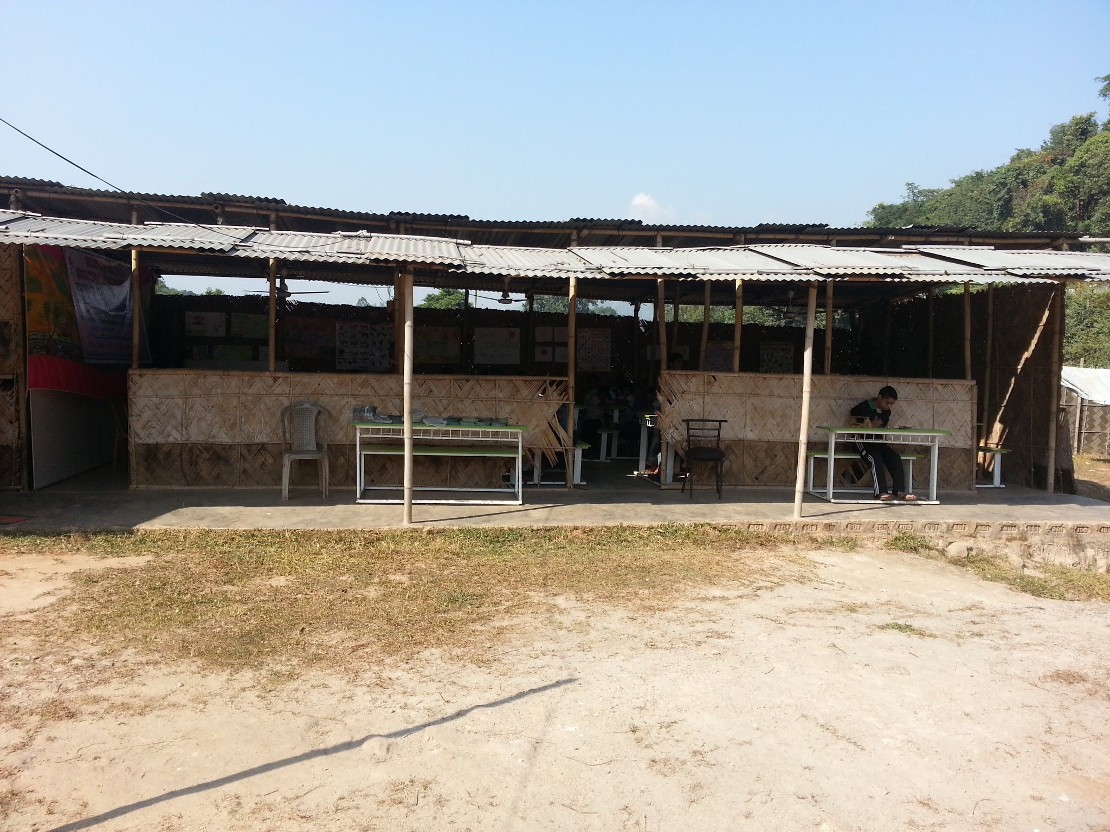
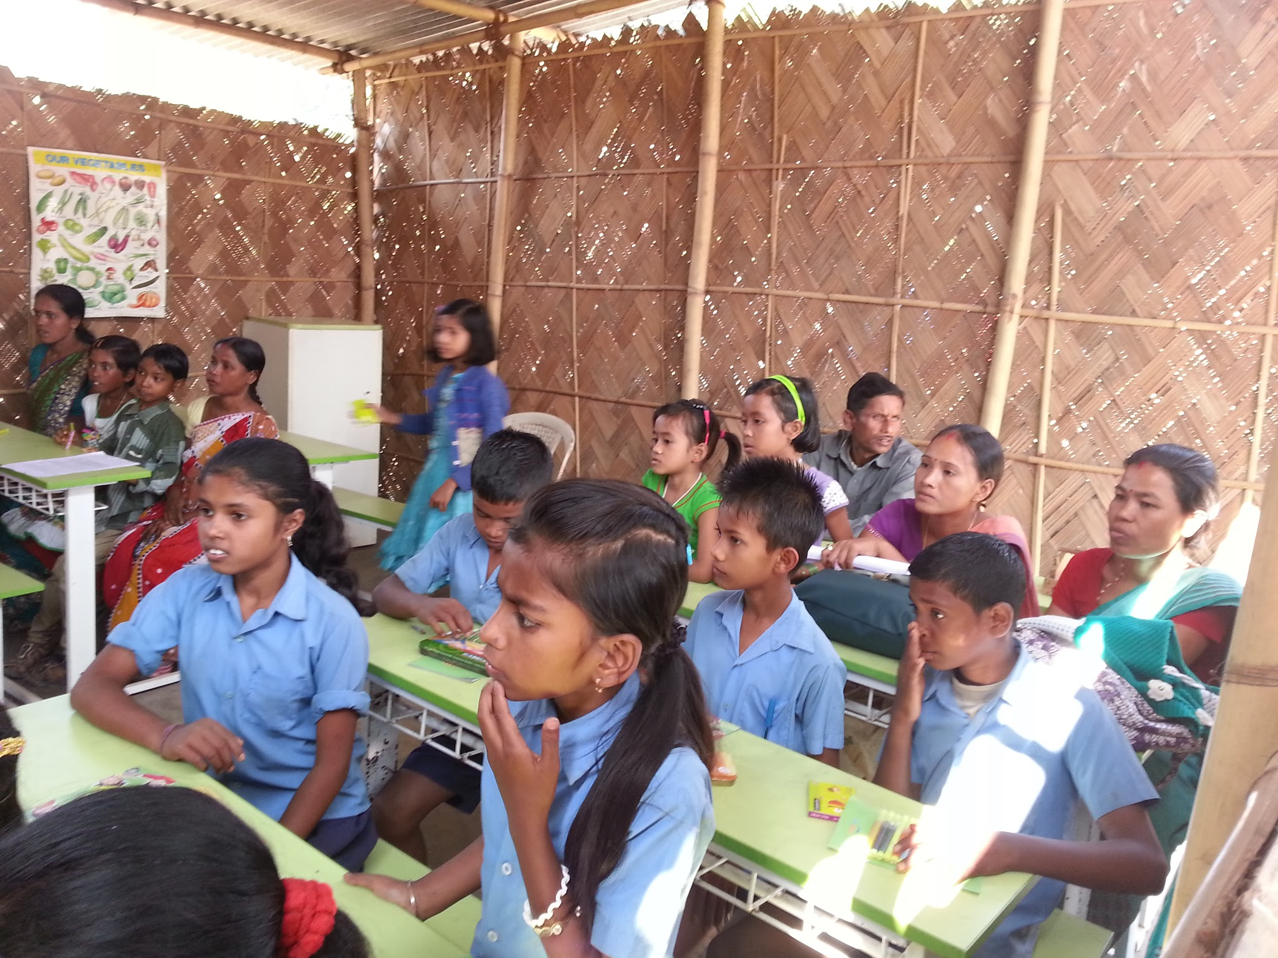
Asha for Education got involved in 2014 when there was a need for permanent classrooms, kitchen, and a dining room for the students and hostelers. Prior to that, classes in the SHED campus were conducted in a temporary thatch building. During the rainy season and in winter, it was challenging for the students and staff to continue classes in that environment. Preparing and having meals in the thatched kitchen and dining hall were also uncomfortable.
With support from Asha for Education Seattle chapter in November 2014, SHED constructed five permanent classrooms and a permanent kitchen cum dining hall. This work was completed in May 2015 to make it timely for everyone in SHED to have a safe and comfortable 2015 monsoon season which runs from June to September. Asha also supports the staff of SHED with teacher salaries.
I got to see the new construction and got a chance to interact with the children, Lanu and his team, and villagers nearby.
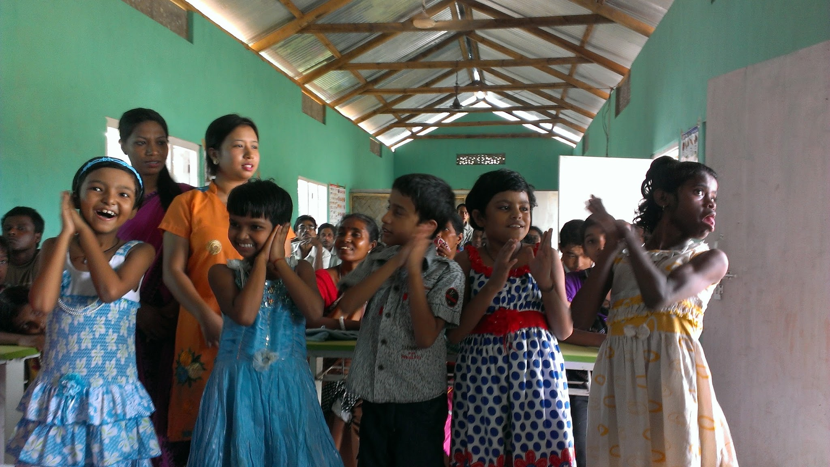
SHED kids breaking out into a Bihu dance in a newly constructed classroom: (from left to right): Dibyarani, Rima, Rishabh, Olympika, and Arati.

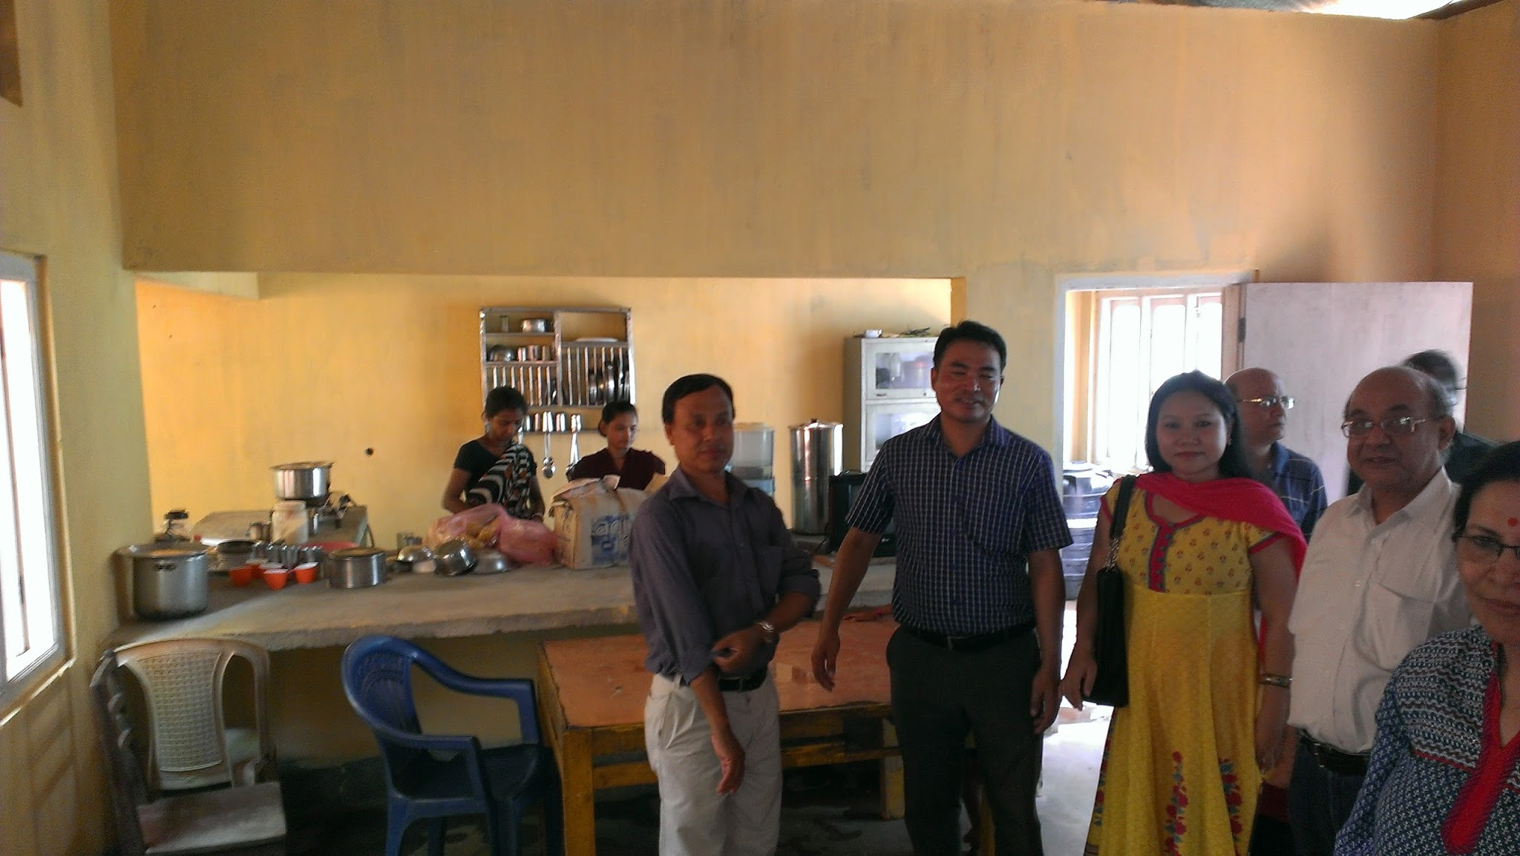
The newly constructed kitchen cum dining room

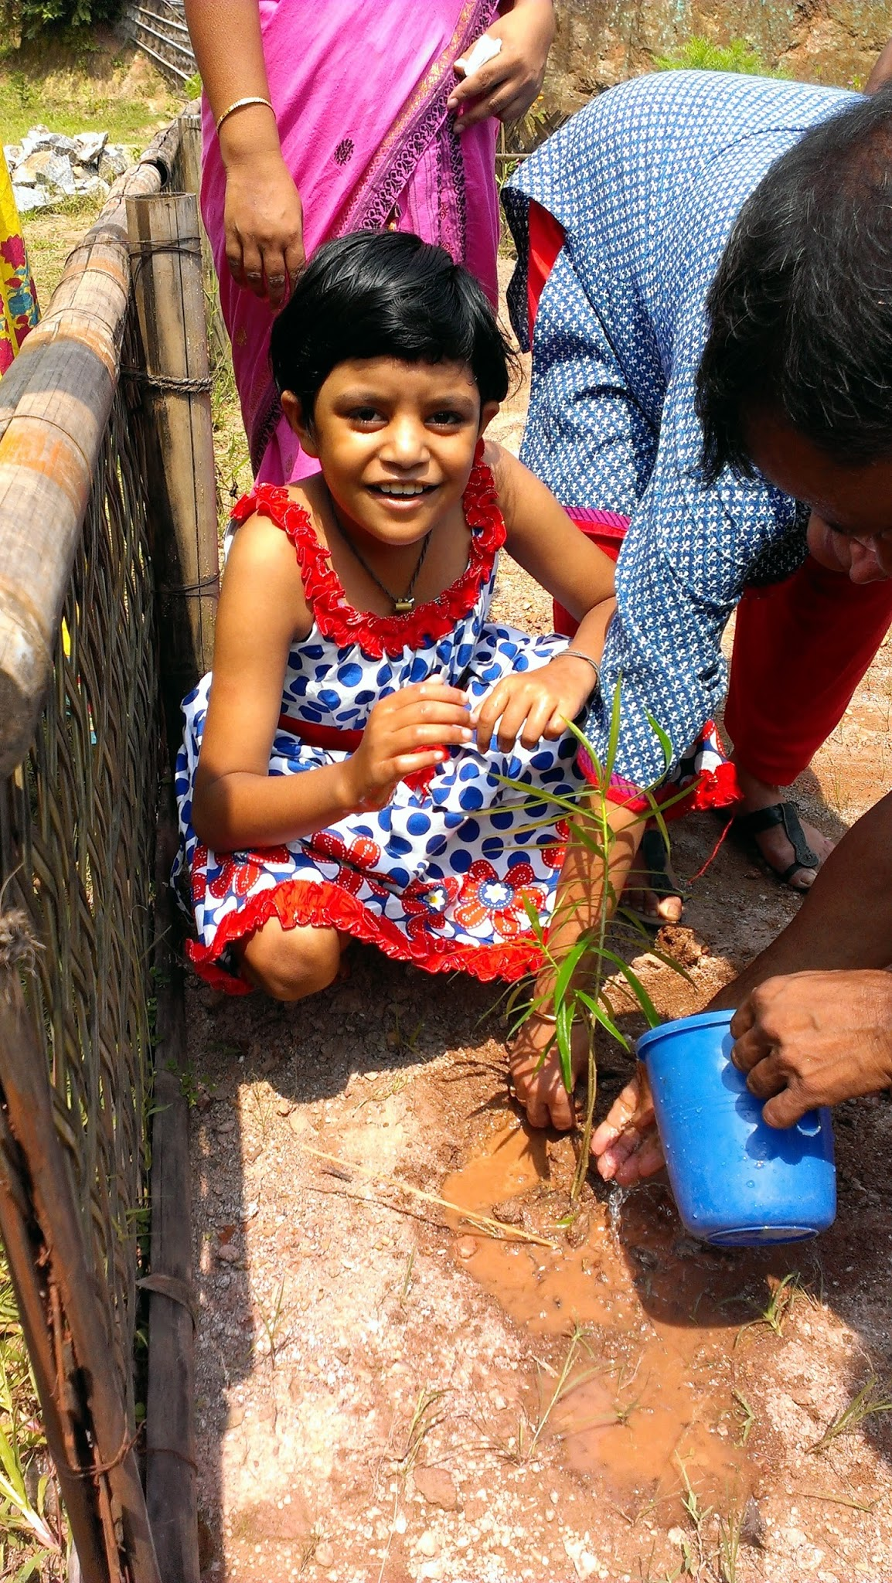
Olympika - one of the children involved in the tree planting event

The children also took active part in a tree planting effort in the school ground on that day. Hostel students at SHED - Arati, Olympika, Yubraj, and Dibyarani - took part in the planting and associated celebrations. Now each of them is a custodian of the plants and they water them regularly. Asha for Education is proud to be able to support these children and see them grow to be educated and self-reliant in the safe and nurturing environment of SHED.

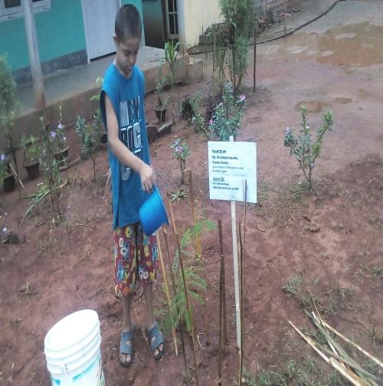
Yubraj Acharya, of 12 year/m, differently abled child of SHED, who was diagnosed as a case of down Syndrome. He comes from a poor family background from the Indo- Myanmar-border town called Moreh, Chandel, district Manipur. He is the first student and first fruit of SHED, he stays in the hostel; he is showing tremendous improvement in the area of speech & language, physical and mental development. He is happy in watering the tree in the beautiful new campus of SHED.

