A Site Visit Report to the Chaksu Brick Lane Schools

The Organization Contact :

KIGS,
Dr. Amit Kumar,
B190, University Marg, Bapu Nagar,
Jaipur, Rajasthan 302015

Site Visit Contact and Date: Natalie Shew,
Date visited site February 27, 2015; April 9, 2015 and April 13, 2015

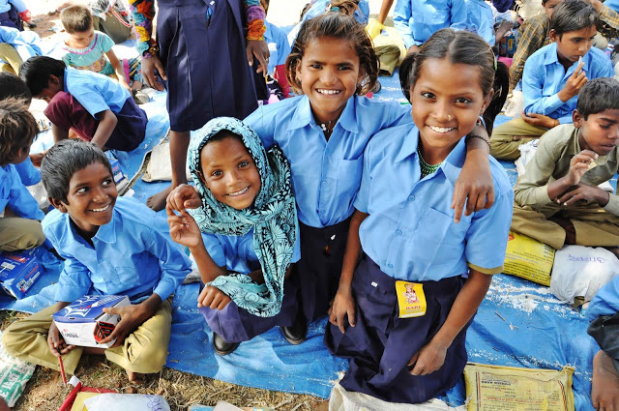

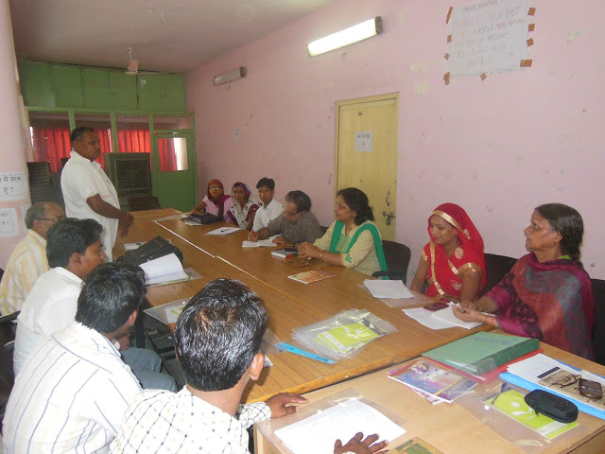

Experience sharing with State Resource Centre, Sakshar Bharat Abhiyan-RAEA, Jaipur Officials

Achievements:
With the kind initiatives of friends and well-wishers, five schools (informal learning centres) were opened in five brick kilns in the Chaksu area of Jaipur district in Rajasthan, between December 2014 and May 2015. The five brick kilns where the schools were open are as follows:

1. Mahadev Brick Kiln, Thikariya Gujaran, Kothkhawada, Jaipur
2. Komal Brick Kiln, Badh Murlipura, Garudwasi, Kothkhawada, Jaipur
3. Maya Brick Kiln, Badh Murlipura, Garudwasi, Kothkhawada, Jaipur
4. LBT Brick Kiln, Ralavata, Thikariya Gujaran, Kothkhawada, Jaipur
5. LBU Brick Kiln, Ralavata, Thikariya Gujaran, Kothkhawada, Jaipur

Seven teachers were posted in these schools depending upon the no. of students. One teacher was available for approximately 25 students. The details of teachers appointed are as follows:

S. No. | Name of Brick Kiln | No. of students | Name of Teacher | Teaching since
1. | Mahadev Brick Kiln | 36 | Sh. Ravi Shankar | December 2014
2. | Komal Brick Kiln | 34 | Sh. Manoharlal Sain  Smt. Asha Devi | February 2015
3. | Maya Brick Kiln | 38 | Sh. Vinod Kumar Bairwa  Smt. Samodri Meena | February 2015
4. | LBT Brick Kiln | 35 | Smt. Foranta Gurjar | February 2015
5. | LBU Brick Kiln | 32 | Sh. Pramod Kumar Bairwa | February 2015
6. | Total | 175

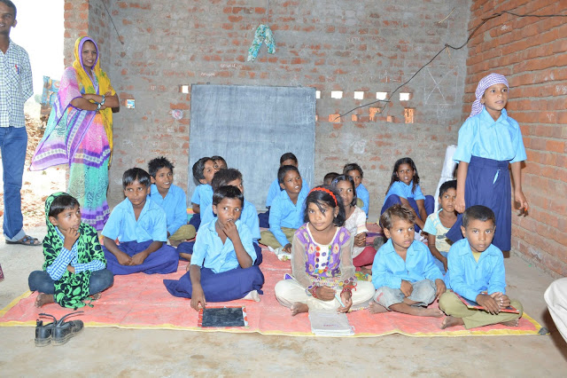
Students learning at LBT Bricks School

Facilities made available at all the schools are as follows:

S. No. | Name of Brick Kiln | Facilities made available | Status of shelter / tin shed
1. | Mahadev Brick Kiln | Uniform, books, stationary (copy, pencil, rubber, sharpner), black board, sitting mats, solar lights, alphabet/numeric charts, table, chair | Tin shed shelter constructed
2. | Komal Brick Kiln | Books, stationary (copy, pencil, rubber, sharpner), black board, sitting mats, alphabet/numeric charts, chair | Tin shed shelter constructed
3. | Maya Brick Kiln | Books, stationary (copy, pencil, rubber, sharpner), black board, sitting mats, alphabet/numeric charts, chair | Tin shed shelter constructed
4. | LBT Brick Kiln | Books, stationary (copy, pencil, rubber, sharpner), black board, sitting mats, alphabet/numeric charts, chair | Tin shed shelter constructed
5. | LBU Brick Kiln | Books, stationary (copy, pencil, rubber, sharpner), black board, sitting mats, alphabet/numeric charts, chair | Tin shed shelter constructed

The experience of giving education to the children of migrant brick kiln workers was very encouraging and the following observations were made:

· During the six months (in Mahadev Brick Kiln) and four months (at Komal, Maya, LBT, LBU Brick Kilns) of non-formal schooling at the brick kiln, about 175 children in the age group 6-10 participated in 3 hours class (2-5 pm).
· Most of the students were illiterate and during the short span of four months they were able to read and write Hindi and English alphabets, two letter word in Hindi, counting from 1 to 100, tables 1 to 10.
· The children who were literate were provided with books for their grade level and continued their education at the brick lane schools. The books from class 1 to 7 were provided free of cost from Rajasthan Primary Education Association under Serwa Shiksha Abhiyan campaign.
· The parents showed interest in sending their children to the class.
· The students also responded positively to the classes.
· The adults have also shown some interest in educating themselves. They are ready to spare one hour from their busy work schedules.
· One of the main hurdles was the difference in the dialect of the teacher and the student. The teacher spoke local/Hindi while the children spoke their local dialect. But this was overcome shortly with Hindi immersion and consistent class attendance.
· We tried to build a shed of size 30 x 15 feet, but it took lot of time as the owner of the kiln was not able to decide the place for the shed to be put up. Meanwhile the school had to run in open space under the shade of the office of the kiln or under a tree. Most of the kilns do not have any type of shade in their premises. This reduces the no. of hours children can attend school comfortably.

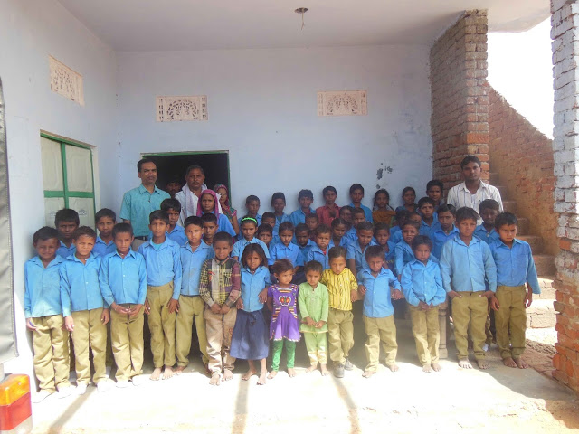
Students with new school uniform at LBU Bricks School

Major Lessons Learned:
Based on our experience this year, we have learned important information about these migrant children’s education.
- Learning Centre has to be set up at each kiln to associate children with education. They are not ready to go to local school for education.
- The education has to be free, the parents are not in a position to pay for the fees or arrange for books, stationary and uniform. All the students should be provided with books, pen, pencil, slate, copy, uniform, shoes, etc. from the project.
- Giving uniform increases the no. of students. This has to be given every year as the uniform won’t last more than a year.
- Temporary shelter preferably 30 x 15 feet of shade has to be erected by the organization to be used as classroom.
- According to an estimate each learning centre will have around 40 students for study in the age group 6-10 years.
- The parents are not sending their children more than 11 years of age. They all work at the kilns.
- Not all the children are coming for class; special drives have to be organized to motivate all the parents to send their children who are more than 5 years of age.
- Considering the time schedule of the parents and conditions at the kiln approx. 3-4 hours of class is possible per day.
- The course curriculum adopted would be the one used by Sarva Shiksha Abhiyan in the Bridge Course for class 1-5.
- Special worksheet/course has to be made to make children practice alphabets. Once they are familiar with letters then the books can be used.
- Weekly course curriculum has to be made to monitor the progress of the teacher as well as students.
- Two teachers per brick kiln should be appointed for teaching who will take 3-4 hours class per day. One for illiterate students and one for literate students.
- Gradually adults of the age group 15-25 have shown interest in reading and writing. The teacher can take one hour class after the children class is over. For this the reference material developed by RAEA (Rajasthan Adult Education Association) can be used.
- For new schools the shelter should be constructed before the labor comes to the site i.e. it should be ready by Diwali. It takes lots of time and coordination.
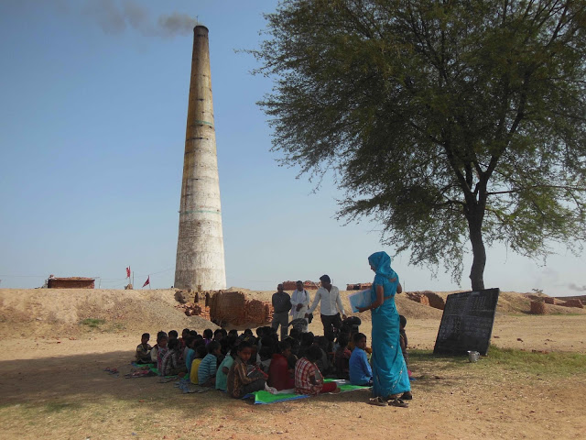
Class in Progress at Komal Bricks School

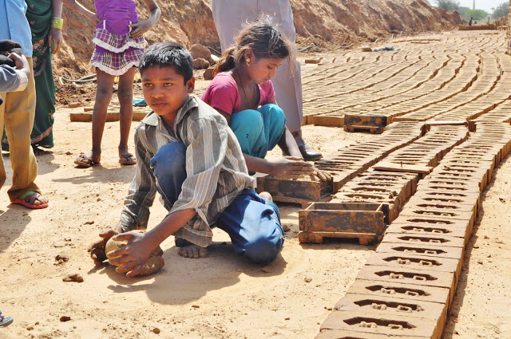

Constraints and Problems:
- Children are working, issues in bringing them to classroom.
- Little family support for children’s education.
- Students are from different educational backgrounds and are at different levels of learning.
- Lack of availability of space to hold classes near brick kilns.
- No social work organization is working in the area.
- Due to work and environmental conditions, sometimes small children feel sleepy and want to go home early or sleep in the class.
School will be back in session after Diwali, around October-November.

What we need:
Continued donations for schools supplies, uniforms, shoes, teacher salaries, and school buildings. Contact Natalie Shew if you are interested in giving at natalieshew.npi@gmail.com

