Navjyoti site visit report by Sourav Chakraborty (Date – 8th Dec 2006)

After around 12 hours of traveling by train I reached Benaras around noon. My parents also went with me. They also went with me to visit the project. I had earlier contacted Vallabh. But the Asha general meeting was also scheduled for the same week. So Vallabh had to go Mumbai for the meeting. He told me that Pradeep will take care of us. Once I reached Benaras I contacted him. He helps Vallabh with the Asha related works. In exchange he gets only Rs. 500. He complained about his salary. I also feel it is really low.

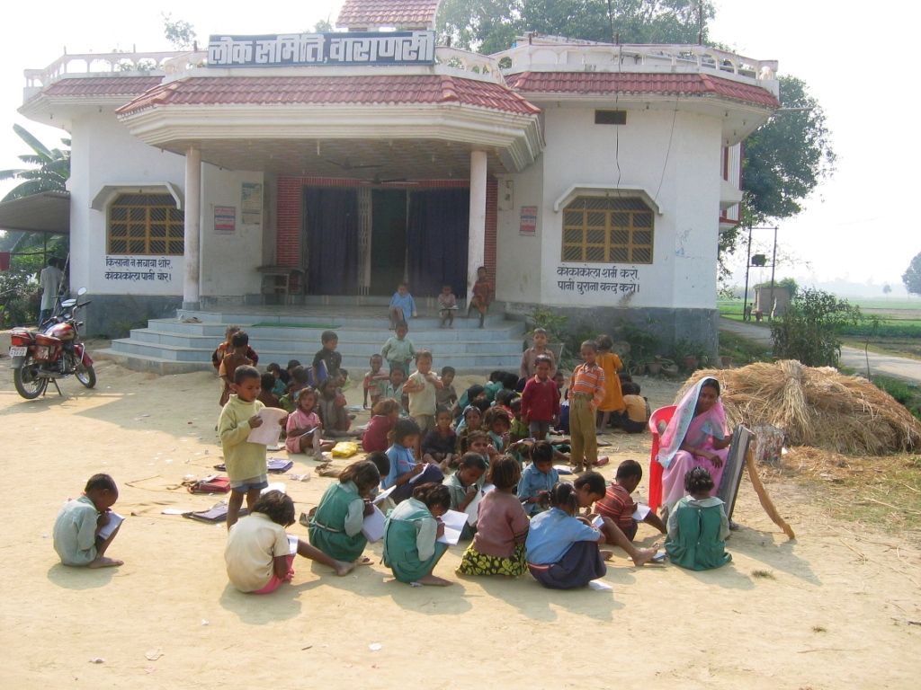
On the next day morning I and my parents left for visiting the Navjyoti project. It was supposed to be a surprise visit. But Pradeep could not accompany us and going there alone was impossible. So Pradeep had informed Nandalal the night before about our coming. Nandalal is the coordinator of the Project.

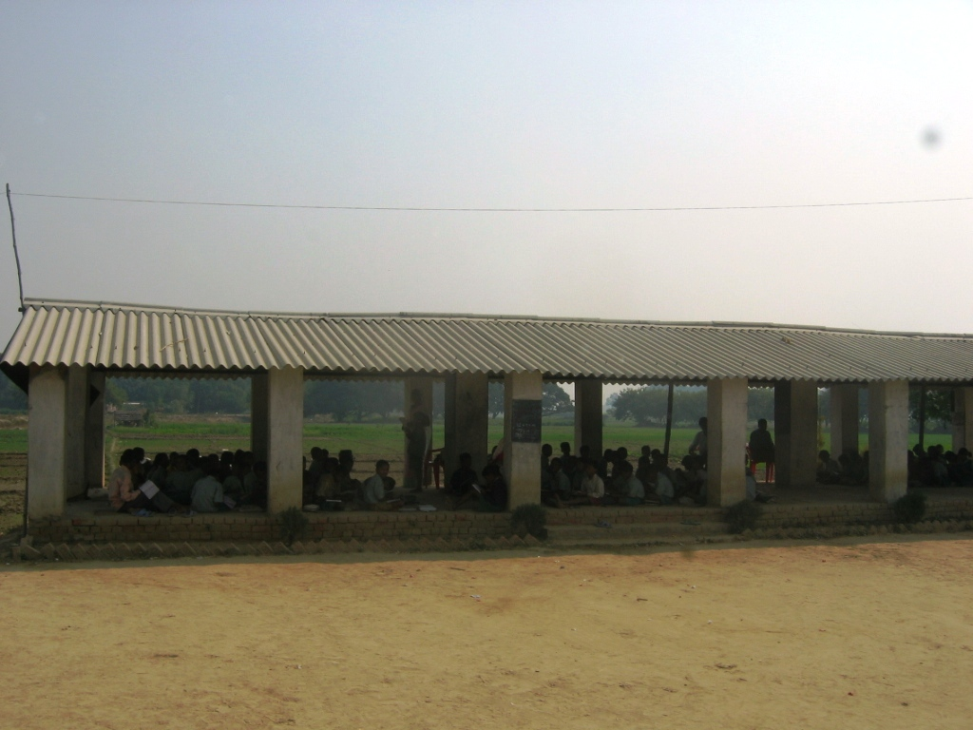
Our car stopped at a small town - Rajatalab. Rajatalab is about 40Km from Benaras. The Navjyoti project is based in villages around the Rajatalab area. At Rajatalab we met Suresh. He is the educational coordinator of Navjyoti. They have a shop in Rajatalab from where they rent out mattresses and other things. This gives them some source of income – an attempt to become self sufficient. Suresh took us from to Nagerpur Permanent Center.

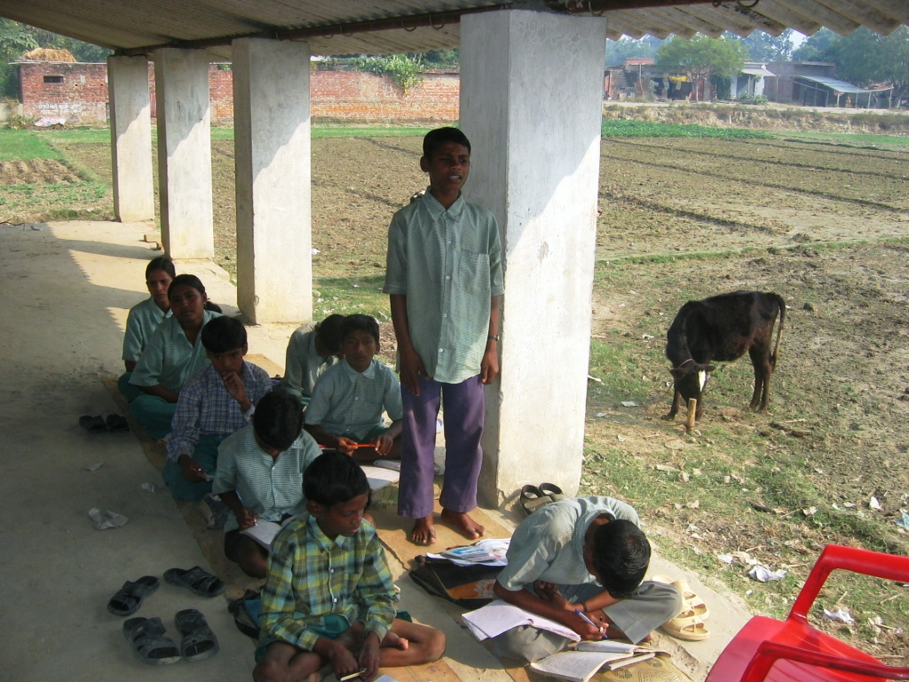
The building in the Nagerpur Permanent Center has been build using Asha’s financial assistance. It has 5 rooms. Currently one of them is being used as a office and Nandalal and Suresh stays in two other rooms. The other two rooms are quite small. They claimed that when it rains or in extreme heat the classes are held in the two rooms and in the verandah. Usually the classes are held outside. When we reached the center in the morning the classes had just started – it was around 9AM. There were classes from KG to class 5. KG-I, KG-II, 1, 2 and 3 had around 15 to 20 students while classes 4 and 5 had around 10 students. There is a shade (see the picture) which has been build for holding classes. The classes 4 and 5 were being held below the shade while the remaining was taking place under the open sun. I met the students and the teachers. There are 6 teachers. Four of the teachers are from nearby places while couple of them comes from far away places like Beneras and Sarnath. We asked some sample questions and the students answered.

The most puzzling thing that I found was why do the students come to this school when there are government schools just 2 minutes walk. I even visited the government school near that place. It has a nice school building. It provides mid-day meals to the students and one set of clothes every year. When I asked the students at Nagerpur and the teachers and Nandalal why do these students prefer Asha’s school over the government school I got vague and unsatisfying answers.
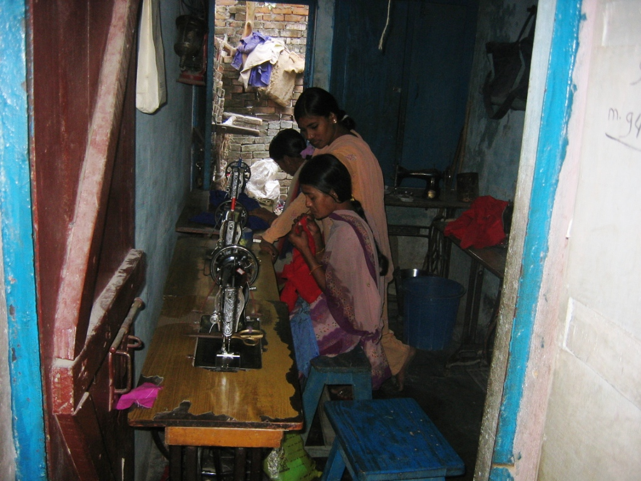
The next stop in my trip was the NFE center at Rajatalab. It is a sewing center. Every day it seems one lady comes and teaches them sewing. Since that day was Friday the lady had gone to mosque. So I could not meet her. There were three girls sewing in the center. They were too shy to talk with me. So my mother asked them some questions. It seems that they bring their clothes and use them to learn sewing. They told that a few girls of their villages have already learnt sewing and use their training to earn.

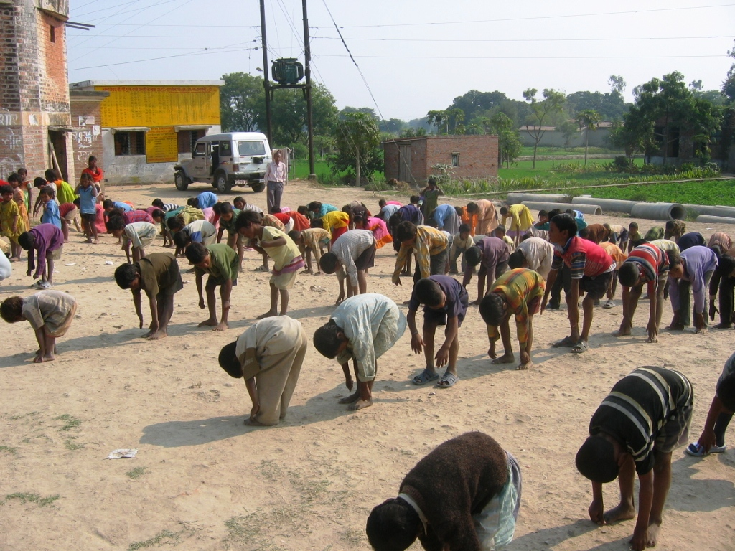
The third stop was at the Harsos Permanent Center. There classes were going on. They use some panchayat building as their class room. I went to class 3 and 4. The students were eager to sing some song. After I had listened to their songs their physical education instructor wanted to show me their drill. The whole school did their drill for around 10 minutes. The total number of students was around 120. There the teacher had a complaint. It seems that the teachers in this center get very less money ranging from Rs. 300 to Rs 700. All of them complained that the amount was too little. I fully agree with them.

Then I visited a couple of weaver’s house. These villages in this area are famous for making Benarasi silk sarees. In almost every house they make these sarees. Unfortunately in recent years the demand of these sarees has gone done drastically causing economic problems for the people. This is a serious problem and something should be done to help these people and save this art from dying out.

On the way back to the Nagerpur Permanent Center I saw lots of children returning from schools – well dressed in uniforms. It seems that there are quite a number of “convent” schools in that area. As I understood “convent” school means private schools. So there are lots of schools in this area – both private and government. In this situation the need for Asha”s school becomes questionable. Nandalal and his team have done a really good survey of each village in the neighborhood. They told that the total population in the villages is around 1,000 households to 7,000 households depending on the village. Their survey clearly showed that over one-third of the kids in the villages in the neighborhood don’t go to schools. But surprising only a very few of the students in the Asha’s School are first generation school goers that is kids whose parents are did not attend school.

When I returned to Nagerpur the school was still going on. It was around 1PM. The sun was too hot then. So all the classes had shifted below the shade. I seriously doubt how many times has classes been held inside the building. After lunch I discussed with Nandalal and Suresh for a couple of hours. Nanadalal’s marriage was in a couple of weeks. So building was being used for the reception. Preparations were going on regarding that.

In the evening we tried to go to another NFE center. But unfortunately the father of the teacher had died that day. So the center was closed.

After the end of the tour the question that I was asking myself - how useful is this project at this time when there are so many schools in the neighborhood? When the project started there was very less number of schools in this area. Thanks to the good work of Nanadalal , Mukesh (the current Mukhiya in the village and also a Asha worker) and others the shortage of schools is not a problem as such in this area. May be the project should change its focus and try to get more students who are currently not going to any schools rather than just be another school.

