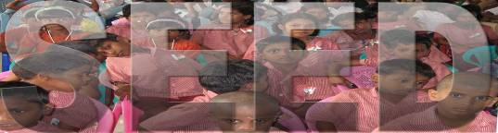

SOCIETY FOR THE EDUCATIONAL AND ECONOMIC DEVELOPMENT (REGD) SRIPERUMBUDUR – 602 105

ANNUAL REPORT FOR THE YEAR 2007– 2008

OVERVIEW :

The Institutional Based Rehabilitation Project ` SEED ‘ for the welfare of the children of LIFE PRISONERS, VICTIMS OF SERIOUS CRIMES LIKE MURDER and LEPROSY PATIENTS commenced in Jan. 1982 The project provides service to an approximate number of 270 Socially Disabled Children of 4-20 age group in the target area in which 76 are the children of LIFE PRISONERS, 18 are the children of LEPROSY PATIENTS , 5 are the Children of Tsunami Affected Families, 15 children are the Orphan children , 86 children are the children of Single Parent Families, 15 children are deserted by their parents, 3 children are the children of handicapped parents and parents affected by prolonged illness and 67 children belong to the families living under poverty line and runs its activities in two villages of Sriperumbudur Taluk, Kancheepuram District namely Venkatrangam Pillai Chatiram and Irungattukottai and one village in Poonamallee Taluk, Thiruvellore District namely Utkottai village in Tamil Nadu State. The project works with the direct support of 23 Professional and 7 non professional staff members who carry out grass root level, supervisory and managerial jobs. The project also takes support of the well wishers, Local Community, , State Bank of India , Indian Overseas Bank, Ramachandra Medical College & Hospital, Rotary & Lions Clubs, Rajasthan Youth Association – Food Bank ( Metro ), Social Welfare Department, Tamilnadu Social Welfare Board, Directorate of Employment & Training, Friends Association for Social Service (FASS), Ramakrishna Mission , Friends City Welfare Association, Education Department – Tamil Nadu, Educational Institutions, other NGOs and Government Institutions in the target area. The Project has the partnership with ` CANARA BANK CENTENARY RURAL DEVELOPMENT TRUST , CANARA BANK , LES AMIS DE SEED – France, , LES AMIS DE SOEUR IMMANUALLEE , France , ASHA – ST. LOUIS, ASHA – SANTA BARBARA – CALIFORNIA, Association of India’s Development. (AID ),Charity works - cyprus, Charity aid foundation at london, funding net work – uk & Children for seed trust, uk.

HIGHLIGHTS OF THE YEAR 2007 –2008

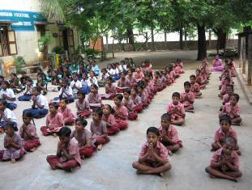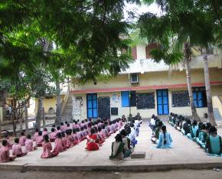
The Major activities of SEED is to provide institutional care which will enable the children of Life Prisoners and Leprosy Patients to free themselves from their existing way of Life and lead a simple life with dignity.

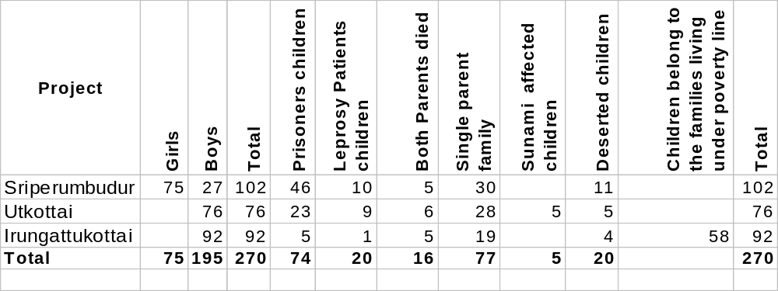
EDUCATION:

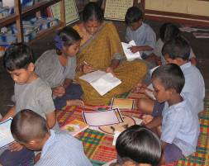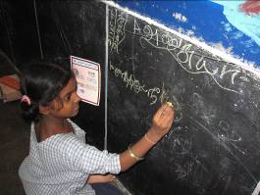
- In our Residential Primary School Project at Sriperumbudur Main Centre,102 children were staying and studying during the
year 2007-2008
- - 46 Children belong to families of LIFE PRISONERS
- - 10 Children belong to the families of LEPROSY PATIENTS.
- - 5 Children lost both the parents.
- - 30 Children belong to the families of SINGLE PARENTS.
- 11 Children have been deserted by the parents 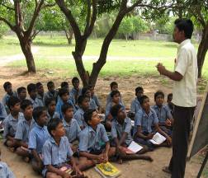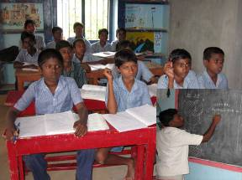
- In our Residential High School project at Utkottai Centre, 76 Children were staying and studying during the year 2007-2008
- - 23 Children belong to the families of LIFE PRISONERS.
- - 9 Children belong to the families of LEPROSY PATIENTS.
- - 8 Children lost both the parents.
- - 28 children belong to the families of SINGLE PARENTS .
- - 5 Children belong to TSUNAMI AFFECTED FAMILIES
- -5 Children have been deserted by their parents .
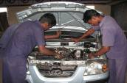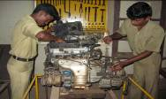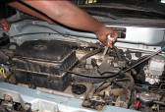
- -In our Special & Free Industrial Training Centre, 92 Children are studying now.
- - 5 Children belong to the families of LIFE PRISONERS.
- - 1 Child belong to the family of LEPROSY PATIENT.

- - 5 Children lost both the parents.
- - 19 children belong to the families of SINGLE PARENTS .
- - 58 Children belong to the families living under poverty line
- -4 Children have been deserted by their parents
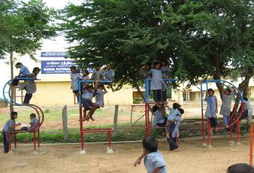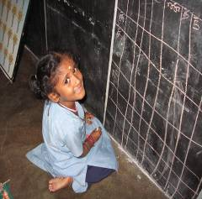

During this academic year 2007 –2008, 15 Children of LIFE PRISONERS , 16 Children of Leprosy Patients, 2 children who have lost both the parents, and 29 children of Single Parent families and 26 children belong to the families living under poverty line had been newly admitted in
` SEED ‘.

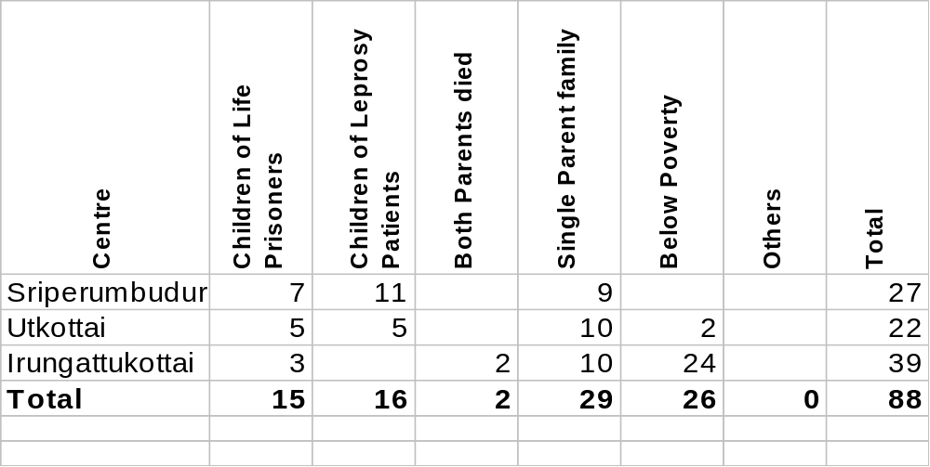

- In the Annual Examination held in April, 2007, 100% of Primary School children had been promoted to higher classes in which 46% belong to the families Life Prisoners and 10% belong to the families of Leprosy Patients, 5% belong to orphan category, 30% belong to Single Parents families and 11% are the deserted children. .

- In high School , 99% children had been promoted to higher classes
in which30% belong to the families of Life Prisoners , 12% belong to the families of Leprosy Patients, 8% belong to Orphan category , 37% children belong to Single Parent families and 7% children belong to the Tsunami affected families and 7 % are the Deserted children.

- 18 Children of Sriperumbudur centre had been Promoted to VI th. Std. in which 7 children are the children of Life Prisoners, 9 are the children of Leprosy Patients, one child lost both the parents, 1 child belong to single parent family and 1 child is an orphan child.
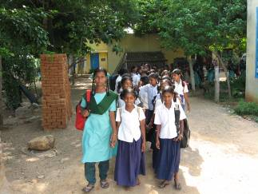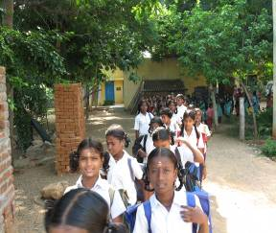

- All the 42 High School girls have been successfully promoted to higher classes in which 76% belong to the families of Life Prisoners, 10 % belong to the families of Leprosy Patients and 14 % belong to Single Parent families.

- 17 Children of Utkottai & Sriperumbudur Centres had been promoted to X std. (i.e.) School Final in which Ten children are the children of Life Prisoners , Two children are the children Leprosy Patients, Three children belong to the families of Single parents , one child belongs to Tsunami affected family and One child is an Orphan child.

- In Secondary School Leaving Certificate ( School Final ) Examination held in April 2007, 19 children have successfully passed in which Eight children are the children of Life Prisoners , Three children are the children of Leprosy Patients, Six children belong to the families of Single parents , one child belong to Tsunami affected family and one child belong to the poverty stricken family.

- P.Valli ( Father died ), studied in our Project from childhood onwards, promoted to Higher Secondary course ( 11th Standard ).

- K. Valli ( Both parents Leprosy Patients ) , studied in our Project from VIII std , promoted to Higher Secondary course ( 11th Standard )

- N.Punitha ( Father died ) , studied in our Project from 4th Std, promoted to Higher Secondary Course ( 11th Standard )

- S.Banumahi ( Father Life Prisoner at Coimbatore Central Prison ) , studied in our Project from 5th Std. , promoted to Higher Secondary Course ( 11th Standard ).

- J. Sathiya ( Father life Prisoner at Trichy Central Prison ), studied in our Project from 4th Std. , promoted to Higher Secondary Course ( 11th Standard ).

- M.Azhagulakshmi ( Father life Prisoner at Madurai Central Prison ), studied in our Project from childhood onwards, promoted to Higher Secondary Course ( 11th Standard ).

- M.Muniyammal ( Both parents Leprosy Patients ), studied in our Project from 6th Std, promoted to Higher Secondary Course ( 11th Standard ) .

- R.Rajalakshmi ( Father Life Prisoner at Madurai Central Prison ), studied in our project from 9th Std., promoted to Higher Secondary Course ( 11th Standard ).

- A. Ayyanar ( Father died ), studied in SEED from 5th std. , secured 408/500 marks in his School Final Examination ( S S L C ) and got admission in Diploma In Mechanical Engineering at Ramakrishna Mission Polytechnic College.

- S. Sundararaman, ( Father died ), studied in SEED from 6th std. , secured 362/500 marks in his School Final Examination ( S S L C ) and got admission in Diploma In Mechanical Engineering at Ramakrishna Mission Polytechnic College

- G.Karthick , ( Father died ), studied in SEED from his childhood secured 343/500 marks in his School Final Examination ( S S L C ) and got admission in Diploma In Mechanical Engineering at Ramakrishna Mission Polytechnic College.

- C.Sakthivel ( Father Life Prisoner at Coimbatore Central Prison ), studied in SEED from his childhood successfully passed his School Final Examination and got admission in Fitter Trade in our Special & Free - IndustrialTraining Centre at Irungattukottai.

- A.Thomas, studied in SEED from 6th std., successfully passed his School Final Examination and got admission in Fitter Trade in our Special & Free - Industrial Training Centre at Irungattukottai.

- N.Ravindiran (Father Life Prisoner at Madurai Central Prison ), newly admitted in our Special & Free - Industrial Training Institute in the beginning of the academic year 2007 –2008. in Mechanic ( Motor Vehicle) Trade.

- J.S.Praveen (Father Life Prisoner at Madurai Central Prison ) is newly admitted in our Industrial Training Institute in the beginning of the academic year 2007 –2008 in Fitter Trade .

- 65% of the children studying in various Trades in our Industrial Training Institute have successfully passed their final examination in National Trade Test, conducted by the Government of India in the month of July, 2007.

- M.Manikandan ( Father died ) successfully completed Diploma in Mechanical Engineering at Ramakrishna Mission Polytechnic College, Mylapore , Chennai and got appointment in Sona Koyo Steering Systems Ltd.

- K. Tamilarasan ( Father life Prisoner at Coimbatore Central Prison ) successfully Completed Diploma in Mechanical Engineering at Ramakrishna Mission Polytechnic College Mylapore , Chennai.

- J.Mahendiran ( Father died ) has successfully Completed Diploma in Mechanical Engineering in AMK Polytechnic College at Sembarambakkam

- Vinoth ( Father died ) successfully completed Diploma in Mechanical Engineering in AMK Polytechnic college at Sembarambakkam

- Poonkodi , ( Below Poverty ) successfully passed Higher Secondary Course ( 11th Standard) and joined Staff Nurse Training Course at Sri Ramachandra Medical College and Hospital, Porur, Chennai.

- Aruna ( Father Died ) passed Diploma in Nursing at Sri Ramachandra Medical college and Hospital at Porur , Chennai and,now, working in the same hospital.

- K.Kaaleeswari ( Father Life Prisoner at Madurai Central Prison ) has secured 2nd Rank in VI Std. in all examinations.

- R.Mohanapriya (Father Life Prisoner at Coimbatore Central Prison) secured 2nd Rank in VII std. in all her examinations.

- R.Prabadevi , ( Mother Life Prisoner at Vellore Central Prison ), has obtained 2nd Rank in VIII std. in all her examinations.

- R.Poolaandevi , ( Mother Life Prisoner at Vellore Central Prison ), got 3rd Rank in IX std. in all her examinations.

- Sampatah (Son of Leprosy Patient) – Mechanic (Motor Vehicle) Trade, J. George (Father Life Prisoner at Madurai Central Prison) – Mechanic (Motor Vehicle) Trade - P.Gnanamoorthy ( Mother Died ) – Fitter Trade, Rajesh Kumar (Poverty Stricken Family ) – Mechanic (Motor Vehicle) Trade, Manikandan ( Mother Life Prisoner at Vellore Central Prison for Women ) – Mechanic (Motor Vehicle) Trade, Jagadeeswaran ( Father Life Prisoner at Vellore Central Prison) – Fitter Trade, Balumahendiran ( Father Died ) – Mechanic (Motor Vehicle) Trade , Nagarajan (Poverty Stricken family ) – Mechanic (Motor Vehicle) Trade, Kannan ( Father Life Prisoner at Palayamkottai Central Prison) – Mechanic (Motor Vehicle) Trade, Ganesan ( Father Life Prisoner at Madurai Central Prison ) – Mechanic (Motor Vehicle) have successfully completed their respective courses in our Special & Free Industrial Training Centre at Irungattukottai.

- S.Sasikumar , (Father died) got 1st. rank in I Std. in all his examinations.

- M.Santhosh , (Father died & Mother Mentally Retarded) secured 2nd Rank in II std. in all his examinations.

- S.Sasikala , (Father Life Prisoner at Trichy Central Prison ) got 1st rank in III Std. in all examinations.

- V.Muthulakshmi (Father Life Prisoner at Trichy Central Prison ) secured 1st rank in IV std. in all his examinations.

- S.Elumalai ( father died ) got 1st rank in V Std. in all the examinations.

- LES AMIS DE SEED – FRANCE, ASHA – ST LOUIS AND AID - SANTIAGO CONTRIBUTED THEIR MITE TO PAY THE DEDICATED TEAM OF STAFF MEMBERS WORKING IN OUR PRIMARY AND HIGH SCHOOL PROJECTS APART FROM THE GRANT RECEIVED FROM THE GOVERNMENT FOR OUR PRIMARY SCHOOL.

VOCATIONAL TRAINING :
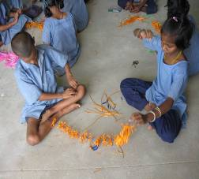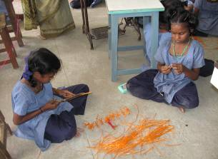
- In our Primary School , we are giving training in Mat Weaving, Plastic Wire Bag Making, Garland Making, Toys making, Flower Pot making, Tailoring, Computer Training, etc. apart from regular academic education.

- 11 children of Life Prisoners, 14 children of Leprosy Patients and 7 children of Single Parent families got training in plastic wire bag making, flower pot & toys making in our Primary School.

- 5 Children of Life Prisoners , 7 children of Leprosy Patients and 4 children of Single Parent families got Computer Training in our Primary School.
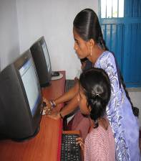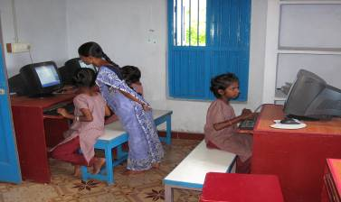
- Regarding high school girls staying in our Sriperumbudur Centre, 30 Children of Life Prisoners , 8 children of Leprosy Patients, 4 children of Single Parent families and one orphan child got Computer Training.
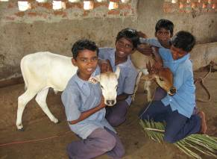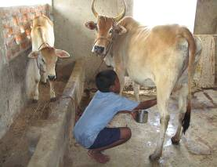
- In our High School project at Utkottai Centre , we are giving Vocational Training in Horticulture & Agriculture and Dairy Farm and also in Computer Programmes apart from their academic education.
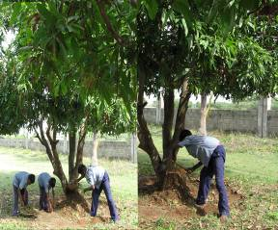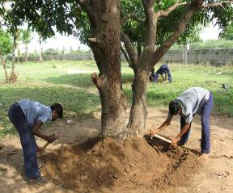

- In our Utkottai High School project,23 children of Life Prisoners ,9 Children of Leprosy Patients,33 children of Single Parent families, 5 Children, deserted by their parents and 6 orphan children got training in Horticulture and Agriculture.

- 23 children of Life Prisoners ,9 Children of Leprosy Patients,33 children of Single Parent families, 5 Children deserted by their parents and 6 orphan children got computer training. . 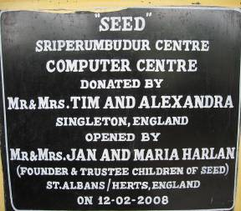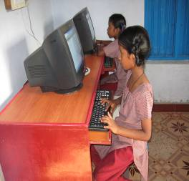
- MR. AND MRS. TIM AND ALEXANDRA SINGLETON HAVE CONTRIBUTED THEIR GIFT MONEY GIVEN BY THEIR FRIENDS AND RELATIVES DURING THEIR “SILVER JUBILEE WEDDING DAY CELEBRATION” TO CREATE A “COMPUTER TRAINING CENTRE” AND ALSO TO BUY THE CHILDREN’S PLAYGROUND EQUIPMENTS AT SRIPERUMBUDUR CENTRE.
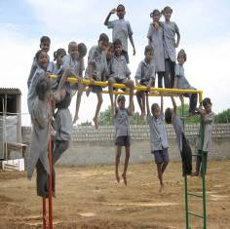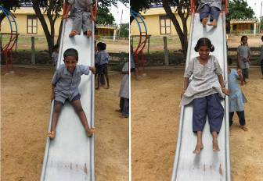

EXTRA CURRICULAR ACTIVITIES :
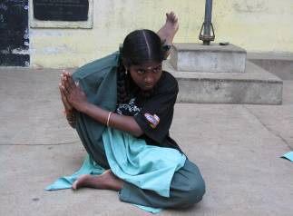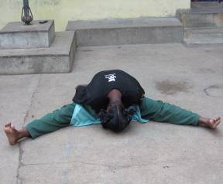

- For our High School girls , we are conducting Music classes , Karate and Yoga Classes apart from their academic education.
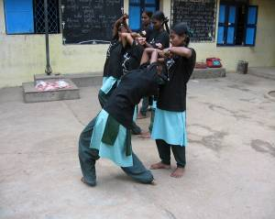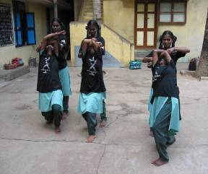
- 23 children of Life Prisoners ,9 Children of Leprosy Patients,33 children of Single Parent families, 5 children deserted by their parents and 6 orphan children got training in Karate and Yoga .

- 11 children of Life Prisoners and 3 Children of Leprosy Patients got training in Music .
- In our in our High School Project at Utkottai Centre, 23 children of Life Prisoners ,9 Children of Leprosy Patients,33 children of Single Parent families, 5 children deserted by their parents and 6 orphan children got training in Karate.

INDUSTRIAL TRAINING PROGRAMME:

- J.George , whose Father is a Life Prisoner at Madurai Central Prison, successfully completed his course in Mechanic ( Motor ) Vehicle Trade and working as Apprentice in HYUNDAI MOTOR ( India ) Limited. 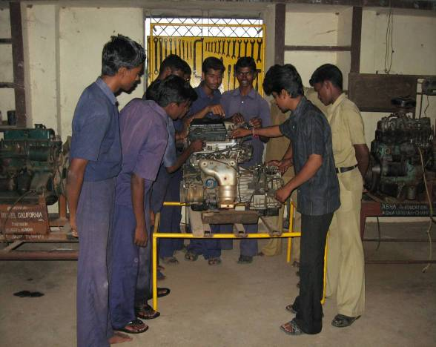
- Manikandan , whose Mother is a Life Prisoner at Vellore Central Prison for Women , successfully completed Mechanic ( Motor ) Vehicle Trade and working in his Native Place
- .Jagatheeswaran whose Father is a Life Prisoner at Vellore Central Prison successfully completed Fitter Trade and working as Apprentice in HYUNDAI MOTOR ( India ) Limited.

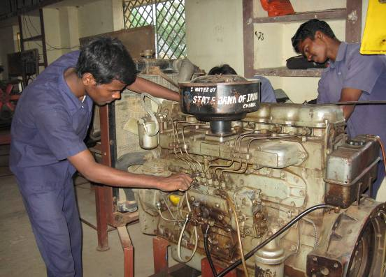

- Nagarajan, belongs to Poverty Sticken family , successfully completed Mechanic ( Motor ) Vehicle Trade and working in his Native Place.
- Kannan whose father is Life Prisoner at Palayamkottai Central Prison, successfully completed Mechanic ( Motor ) Vehicle Trade and working in his Native Place.
- Ganesan whose father is Life Prisoner at Madurai Central Prison successfully completed Mechanic ( Motor vehicle ) Trade and working as Apprentice in HYUNDAI MOTOR ( India ) Limited.

- Balumahendiran , father died, has successfully completed Mechanic ( Motor Vehicle ) Trade and working as Apprentice in HYUNDAI MOTOR ( India ) Limited.
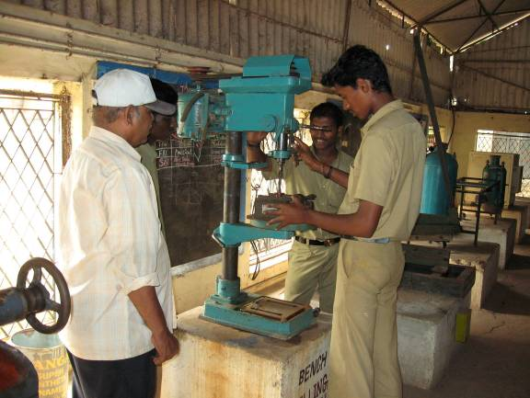
- Rajeshkumar, hailing from Poverty Stricken family , successfully completed Mechanic ( Motor vehicle ) and working as Apprentice in HYUNDAI MOTOR ( India ) Limited
- P.Gnanamoorthy whose mother died successfully completed Fitter Trade and working as apprentice in HYUNDAI MOTOR ( India ) Limite

ASSISTANCE RECEIVED FOR THE SPECIAL & FREE INDUSTRIAL TRAINING INSTITUTE:-
- CANARA BANK CENTENARY RURAL DEVELOPMENT TRUST HAS CREATED AN ENDOWMENT AND THEY ARE GIVING THE INTEREST DERIVED FROM THE ENDOWMENT TO PAY PART OF THE SALARY TO THE STAFF WORKING IN THIS SPECIAL & FREE INDUSTRIAL TRAINING CENTRE.

- CHARITY WORKS – CYPRUS IS SPONSORING 10 DESTITUTE CHILDREN OF THIS INDUSTRIAL TRAINING CENTRE FOR THEIR MONTHLY MAINTENANCE.

- MR. NAGARAJAN AND HIS FRIENDS FROM ALLAHABAD BANK, MR. KALIAPERUMAL FROM CHIDAMBARAM, MR. RAJAN FROM STATE BANK OF TRAVANCORE, “WE CARE” AND “ THE BRIDGE” HAVE CONTRIBUTED THEIR MITE TO MEET OUT THE FOOD EXPENSES OF THE DESERVING STUDENTS STAYING AND STUDYING IN THIS SPECIAL & FREE INDUSTRIAL TRAINING CENTRE.
. 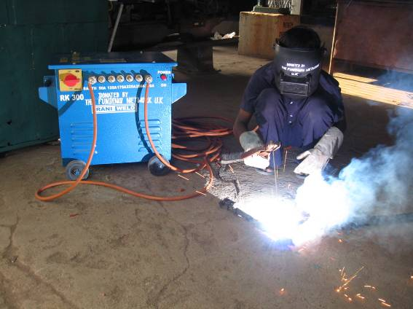
- THE FUNDING NETWORK , U K , HAS DONATED MACHINERIES, EQUIPMENTS AND TOOLS FOR THIS SPECIAL & FREE INDUSTRIAL TRAINING CENTRE FOR FITTER, MECHANIC (MOTOR VEHICLE) AND ELECTRICIAN TRADES TO MAKE THIS INDUSTRIAL TRAINING CENTRE AS A FULL PLEDGED TRAINING INSTITUTE AS PER THE GOVERNMENT NORMS.

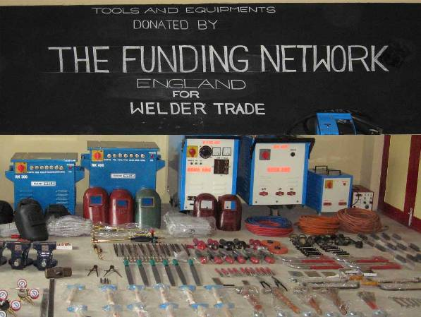
- THE FUNDING NETWORK , U K , HAS ALSO CONTRIBUTED TO PURCHASE THE NECESSARY MACHINERIES, EQUIPMENTS AND TOOLS TO START A WELDING TRADE WHICH HAS LOT OF DEMANDS IN ALL THE INDUSTRIES IN AND AROUND THE PROJECT AREA.

- MR. DELANEY FROM U K HAS HELPED SEED THROUGH “CHARITY AID FOUNDATION”, U K TO GET INFRA – STRUCTURE FACILITIES FOR SEED’S INDUSTRIAL TRAINING PROJECTS AND HENCE THE WELDING SHED CONSTRUCTION HAS BEEN STARTED WITH THE HELP OF “CHARITY AID FOUNDATION”, U K SO AS TO ENABLE SEED TO START THE WELDING TRADE IN THE NEXT ACADEMIC YEAR.

PLACEMENT:

- So far, 52 boys, who had successfully completed their Industrial Training Course in various Trades in our Special & Free Industrial Training Institute at Irungattukottai village, got placement under ‘ Apprenticeship Training Programme ’in HYNDAI MOTOR ( INDIA ) PVT. LTD. , L & T and Other Multinational Companies.

- Aruna ( Father Died ) passed Diploma in Nursing at Sri Ramachandra Medical College and Hospital, Porur, Chennai and now, working in the same hospital.

- M.Manikandan ( Father died ) successfully completed Diploma in Mechanical Engineering at Ramakrishna Mission Polytechnic College, Mylapore , Chennai now, working in Sona Koyo Steering Systems Ltd

- K. Tamilarasan ( Father life Prisoner at Coimbatore Central Prison ) successfully Completed Diploma in Mechanical Engineering at Ramakrishna Mission Polytechnic College, Mylapore , Chennai , now working in TVS Company, Salem .

- J.Mahendiran ( Father died ) successfully Completed Diploma in Mechanical Engineering in AMK Polytechnic college at Sembarambakkam , now working in a Multinational Company at Poonamallee, Chennai.

HEALTH:

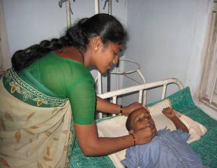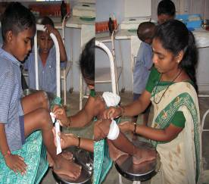
- Primary Health Centre of Maduramangalam had conducted General Health Check up on 11.11.2007 for our children at Sriperumbudur Centre.

- Lions club of Sriperumbudur had conducted Eye Camp in April 2008 for the children of our Sriperumbudur Centre.

- A team of Doctors and Nurses from Primary Health Centre, Nemam, visited our Mahatma Gandhi Residential High School at Utkottai Centre and provided medicines and conducted health education programme for the children.

- Savetha Dental College had conducted School Health Programme for the students of our Mahatma Gandhi Residential High School at Utkottai Centre.

- Sri Ramachandra Medical College & Hospital had sent a team of Doctors, Nurses and conducted Dental Camp & Dental awareness programme at our Sriperumbudur Centre for the benefit of our Primary & High School Children..

- G. Kavitha, affected by Leg problem , got admitted in Sri. Ramachandra Medical College & Hospital for 10 days and cured.

- Alagulakshmi , affected by Severe Head ache, got admitted in Sri Ramachandra Medical College & Hospital for 7 days and cured.

- S.Prakash, affected by tumor problem , got admitted in Sri Ramachandra Medical College & Hospital for 7 days and cured.

- Pileria Immunization Camp was conducted during the month of June, 2007 , September, 2007 & December, 2007 for the children of Sriperumbudur Centre by the Department for Prevention of Pileria.

- Polio Eradication Programme was conducted by the Primary Health Centre , Nemam in which our Residential High School - Junior Red Cross students R. Deepak, M. Ramakrishnan & R. Lokesh took part on 10.02.2008 & 11.02.2008.

- ASMAE, RAJASTHAN YOUTH ASSOCIATION ( METRO) – FOOD BANK AND SRI RAMACHANDRA MEDICAL UNIVERSITY HAVE CONTRIBUTED THEIR MITE TO PROVIDE NUTRITIOUS MEALS TO THE CHILDREN OF SEED APART FROM THE GRANT RECEIVED FROM THE DEPARTMENT OF SOCIAL WELFARE, GOVT. OF TAMIL NADU.

Meetings :
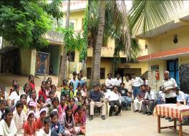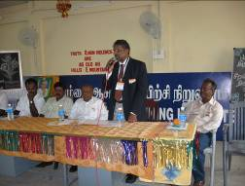

* Gandhi Jayanthi was celebrated in a grand manner on 02.10.2007.

- During the year 2007-2008, Parents - Teacher meeting was conducted on 03.06.2007 , 02.10.2007 & May 2008

- “ STAFF MEETING ” was conducted on Second Saturday of every month and discussed activities of all the projects of
‘ SEED ’

- Junior Red Cross meeting at Headmaster Level was conducted by the Chief Educational Officer and District Educational officer at Thiruvellore District in which our High School Head Master Mr .K. Sambandam & teacher C. Senthil took part on 16.08.2007

- Science Exhibition had been conducted by Aringar Anna Government Higher Secondary School, Poonamallee in which our students R. Lokesh,
G. Madasamy took part.

- On 5th September 2007, Teacher’s Day was celebrated and all the staff members were honoured with a beautiful pen-set.
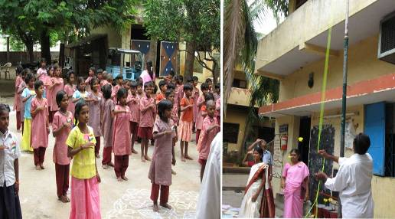

- On 15th August, 2007, Independence Day was celebrated in a grand manner, Smt. Selva Mary Arulraj, President, Sriperumbudur Town Panchayat graced the function as Chief Guest and distributed sweets .

- On 26th Jan, 2008, Republic day was celebrated in our Primary School at Sriperumbudur and High School at Utkottai in which President of Village Panchayat took part and distributed sweets to all the children.

- On 14th November, 2007, Children’s Day was celebrated in a grand manner, and prizes were distributed to the students who won awards in various competitions .

- Aid awareness programme had been conducted by DIET Teacher Training School at Thiroor in December 2007 in which our High School Teacher P. Muniyandi took part.

- School Adolescence Education programme was conducted by the Chief Educational Officer , Thiruvellore District on 25.02.2008 & 26.02.2008 in which our High School teacher C. Senthil took part.

Library :
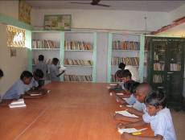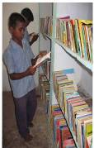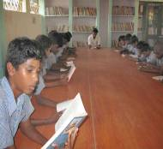
- Libraries at Sriperumbudur & Utkottai centre are being utilized by the SEED children. New books such as fiction, literature, moral stories, etc. in English and Tamil Language that would promote the habit of reading and expand the human mind are being added to the library .

- During the year 2007-2008, “DEEPAM TRUST”, Chennai a Non- profit service organization donated Library Books for our High school .

- During the year 2007-2008, employees from Flextronics India Limited, a Multinational Company donated Library books for our Primary School at Sriperumbudur Centre.

- During the year 2007 – 2008, well wishers from Poland donated Library books to our Primary & High School Children.

- At Utkottai Centre Library Table, Stools, Patrician , Library books & Computer Table were purchased with the help of Asmae.

Uniform :

4 Sets of School Uniforms were provided by us to our students at the beginning of the school year. The students regularly wear the uniform during the school hours.

SPECIAL EVENTS :

- CHILDREN FOR SEED, A VOLUNTARY SERVICE ORGANISATION, HAS BEEN STARTED AT ENGLAND BY JAN & MARIA HARLAN FOR MOBILISING FUND FOR SEED’S PRESENT AND FUTURE ACTIVITSIES.

- Lions Club of Madras Velachery celebrated Deepavali in a grand manner and crackers were fired by all the children with great joy and happiness.

- ‘Friends City Welfare Association’ organized ‘ SPORTS MEET ’
on January, 2008 for our High school children and conducted various Sports Activities and awarded prizes to the winners and runners in which “ ILAKKIYA SUDAR” and Asst. Secretary of SEED, Shri T. Ramalingam distributed the prizes.

- Educational Tour was organized to Trichy, Palani, Kodaikannal, Thekkadi & Vaikai Dam in which 150 children from our Sriperumbudur and Utkottai Centres took part. ‘ ASMAE ’, Lions club of Cumbum, Lions club of Theni , Canara Bank Trichy Circle office, Canara Bank-Cumbum Branch, Farmers Association-Cumbum and Builder’s Association-Cumbum contributed their ‘MITE’ to make the“Educational Tour” as a grand success.

- In the month of March, 2008 , employees from Income Tax Office, Chennai came and donated various items to the children of our Institution which was made possible due to the contributions given by the employees of Income Tax office.

- One day picnic for our children was conducted by the Rajasthan Youth Association – Madras Metro Project on 06.01.2008 to Khiskinda, an amusement park at the outskirts of Chennai.

- Christmas Festival was celebrated by the staff of Nokia India Limited, Sriperumbudur in our Primary school project at Sriperumbudur Centre.

- Shri K. Krishnaswamy, Member of Parliament, visited Utkottai Project and provided Special Feast on the occasion of his birthday.

- On 21st June, 2007, District Educational officer visited our Mahatma Gandhi Residential High School Project at Utkottai Centre.

- On 27th August, 2007, District Social Welfare officer, Thiruvellore District visited to our Children’s Home at Utkottai Centre.
- On 25th August, 2007, Anna University Students visited Utkottai project to conduct NSS programme.
Visits of important visitors/dignitaries during this year 2007-2008

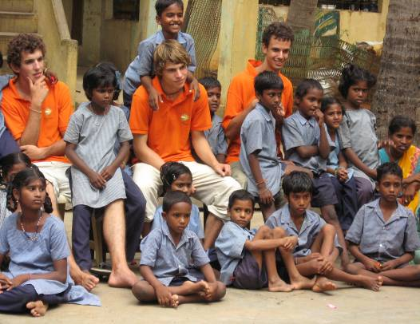

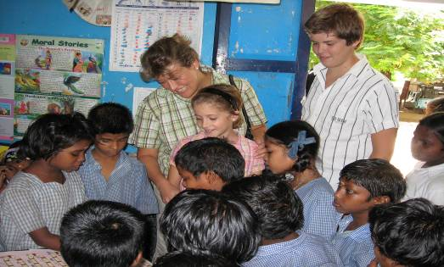

DATE | NAME | DESIGNATION | COMMENTS
22.6.07 | A. Thandavan | ACCOUNTS OFFICER (Grants)  Directorate of  Social welfare, Chennai -05. | SEED-CEYRAC HOME has been visited. Auditing has been done for the years 2005-2006 & 2006-2007. Account & records of the ‘HOME’ are kept properly. The meals provided to the students are enough & quality of the food is good. For the girls going to Government Girls High School, lunch is given in Tiffin Box. Evening Tiffin is provided to the children. ‘HOME’ is neatly maintained. Children are seen with happiness. We wish the ‘HOME CHILDREN’ to be prosper in education.  The efforts taken by the management for the progress in education and life of the ‘HOME CHILDREN’ is highly appreciated. My best wishes to the management.(S.d)  A.THANDAVAN,  ACCOUNTS.
27.07.07 | P. CEYRAC | RENOUNDED  SOCIAL WORKER  FROM  FRANCE | It was a great joy for me to meet again my old friend Palanisamy who is doing such a wonderful work for children and poor people. May the good lord bless him and his people and pour his love on him and his work.
05.08.07 | SHIV KUMAR | NO. 2, BISHOP WALLERS,  MYLAPORE,  CHENNAI -600 004 | Reminder to the society as to how we need to meet our obligations. Learnt a lot. All the best.
05.08.07 | Digvijay singh & SHAIK | WELL WISHER  FROM SWEDON & U.S.A | Full of love, Palanisamy’s place. He is on impression and we are the constructs.
15.08.07 | V. DHANARAJ, | DEPUTY GENERAL MANAGER,  NEW INDIA ASSU.CO.LTD,  CHENNAI REGION  28, D’ SILVA ROAD, MYLAPORE,  CHENNAI- 600 004 | God Bless all the children here. We have our love and blessings always for these children. I am overwhelmed by the wonderful human service of Mr. Palanisamy and his entire team.
08.11.07 | Kishore kumar | HEAD – HR  Flextronics technologies (1) pvt. limited | It’s been a real pleasure to have sport this Diwali with friends and children from SEED. We continue to look forward to the various occassions when we could be associated with SEED. We appreciate each and every member of this SEED Team for their exemplary work. All the best and God Bless! (sd.) Kishore Kumar
 | Hameeder rahman | DY.MANAGER,(PR & CSB)  STATE BANK OF INDIA,  LOCAL HEAD OFFICE,  CHENNNAI – 600 006 | It was a great pleasure for me for having visited this place. Mr Palanisamy is doing a yeomen service. My sincere prayers for the fast development of this noble cause. Hats off to him for this noble cause.
19.12.07 | Elise | REGIONAL REPRESENTATIVE,  ASMAE INDIA. | It has been a GREAT pleasure to work with SEED. I wish to all of you the best and good Continuation.
22.12.07 | Asian paints,Sipcot | WELL WISHER | Great things are being done by small people. Great day. It is really commandable initiative.
30.12.08 | Swami suddhananda | YOGA SATSANGA SOCIETY OF INDIA, DAKSHINESWAR, KOL0KATA | Wonderful to see the care and love being poured out to the children who are without any support. Praying deeply to the Divine for blessings to this institution.
30.12.07 | Students from uw-oshkosh in Wisconsin, | WELL WISHER , 800 algoma blvd, Oshkosh w1 54901, usa | Thank for the wonderful day of music, dancing, and lunch, this is a beautiful organization/project. Carol vetus Trisha Rivet Crystal petrie Lindsay bridich – Liz Haskey – Emily Feedan Jan Helgesen – Pattivanderloop – Maria Eiden.
30.12.08 | Patricia Vanderloop, | Uw. Oshkosh  W5930 kunesh road,  Plaski,  Wi 54162 u.s.a. | My heart is filled with love & prayers for this place & all the children, for peace & joy without ignorance or poverty. Thank you.
31.12.07 | Meena Subramanian, | 1250, Dorchester ln, hoffman estates,  il-60169 usa | An excellent Service for the needy ones in terms of making them excellent citizens. Our best wishes for successful continuation.
05.01.08 | Uw Oshkosh college of nursing, | 800 , algama blud, Oshkosh,  wi 54901 u.s.a | What wonderful work you are doing. Children have such a great and well rounded Education. Thank you.
08.01.08 | Amrita Rangasami | 68, patpanganj, delhi - 82 | Delighted to have met with children – with bright faces & capable of intelligent conversation. My gratitude to Shri A.R. Palanisamy for his selfless endeavours.
17.01.08 | Vidya Kamath & leah | well wisher,  370, greencedan drive, hamittan, on. l9c 7k4 | Great supportive programs for children.
17.01.08 | Denost Robert, denost mireille | 12 mmf de la renardiere, 94120 fontenas/s bou ,  france | We are very happy to see more children are beautiful and teachers very pleasant with us. Thank you for your help to children.
26.02.08 | HAYES CHAMTAL AND feam pue, | 227 RUE DU DESSOUS DES PRES, 78630 OREEVAL, FRANCE | Thanks a lot for your welcoming. We are happy to meet you and to share these moments at this time. In France, we will talk about the center and will tell how great in your action particularly to Mr.Palanisamy. .
26.02.08 | Milind mulay , | GENERAL MANAGER  state bank of India,  local head office,  16, college lane, nungambakkam,  Chennai – 600 001 | It was a wonderful and emotional experience for me to be amidst the children here, to see in the eager faces the future that India will be. The outstanding work that SEED and Mr. Palanisamy have been doing in indeed commendable.
11.04.08 | Dr.S.Venkataraman, | vice president – hr, Delphi tvs | Great efforts by Mr. Palanisamy, with the support of Father & Mr. Narayanan, It is seen to be believed the growth of this wonderful and unique organization. The enthusiasm generated by  Mr. Palaniswamy is commendable. The humility and service with which he has endeared himself to the society, is an envy of everyone. To serve the needy is service to god. I wish him and others, involved in this effort greater success and satisfaction that many may come forward to assist them, in all respects.
26.04.08 | Digvijay Singh, | Tundagatan 50a,  75230 uppsala, sweden | A brilliant staff. A dedicated staff. I’m really proud of this institution and the people who make it work. God bless you.

The above are the few drops in the ocean. We will continue our humble service activities to our less fortunate brethren with the help of donors, philanthropists, well wishers, Government, funding agencies, sister organizations and above all by the blessings of ALMIGHTY.

( A.R.PALANISAMY M.A.,M.Ed.,B.L.,M.B.A.)
FOUNDER AND SECRETARY.

