MAHILA ACTION
PRAGATHIKI BATA SCHOOL
ANNUAL REPORT 2009-2010
SUPPPORT BY ASHA WASHINGTON

CONTACT INFORMATION

NAME OF THE ORGANIZATION: MAHILA ACTION

ORGANIZATION DESCRIPTION:

Mahila action is a Woman headed Non-Governmental Organization established in 1995, registered under society’s Act 1860 in 1995 Visakhapatnam. The organization is also registered under 12(A) & 80(G) of income tax.

The main aim of the Organization is to work for the welfare and protection of the Rights of the Marginalized and Vulnerable women and children of the society.

Thus, MAHILA ACTION came into existence in the year 1995. MAHILA ACTION initiated work on the welfare of the women and children in the slums of Visakhapatnam District, The main target area of the Organization is to work for the eradication of child labors, school drop outs and promote gender equity and took as challenging issues of child labor education, collectivization and forming of groups in between women, promote gender equation and to bring awareness about the Rights of the women, sex workers civic rights, rehabilitation through income generative activities, eradication of trafficking, prevention of IInd generation into sex work.

The goal of MAHILA ACTION is to promote social justice and social development in relation to issues of crime and victimization. MAHILA ACTION focuses on the long-term social change goal within the context of promoting education to the marginalized sectors and to eradicate child trafficking and prostitution through promoting education and vocational trainings.

GENERAL INFORMATION:

Date of establishment : 6th May, 1995.
Contact person(s) : K.Swarna Kumari

Phone number : +91 (0891) 2732194

Email : ma_ngo@rediffmail.com,mahilaaction@hotmail.com
Address : #31-32-48, Dabagardens, Visakhapatnam,
Andhra Pradesh, India. PIN: 530 020
Location (village/town): Dabagardens, Visakhapatnam.

VISION:
Mahila Action strives for the empowerment one in which each women and children enjoys the right to life with dignity and develops their talents and skills and help to shape the future of our society.

MISSION:
To work with poor and excluded women, children to fight for poverty, rights, injustice.

AREA OF OPERATION:
Focus in Districts of Visakhapatnam Rural, Urban slums and tribal areas.
HOW “Ma” STARTED SCHOOL:
As Mahila action is working for the women in Madhurawada by forming self help groups for the sustainability, we noticed the problems of the people and concentrated on the children who are walking in wrong path and think to start a school to make the children to walk on correct path and proposed Asha Washing ton, Mr. Ravi Mundoli from Asha visited Mahila action for the site visit on 18 Dec 2006 and ASHA-WASHINGTON supported MAHILA ACTION to start a school named PRAGATHIKI BATA from June 2007.

STATISTICS OF 3RD YEAR:

Children continued from 2nd year: 22 children
No: of new enrollments: 28 children
No: of children joined in main stream school: 22 children
No: of children joined in main stream in hostel: 2 children
No: of drop outs children: 3 drop outs.
No: of migrated: 8
No: of children promoted to 4th year: 22

STATISTICS:

Number of children promoted in the project: 50 Children
Ages of the children: 6 to 14 years
Standards taught: 1st, 2nd, 3rd & 5th
Number of boys: 23
Number of girls: 27
Number of teachers: 1 in charge, 3 teachers, Ayah. Cum cook
Number of Male teachers: No
Number of Female teachers: 3 teachers
Current Teacher/student ratio: 1: 16
School staff salary per month: 1900.00 x 5 = 9500.00
School timings: 9.00 am to 4.30 pm
School days: Monday to Saturday
Over all school attendance percentage: 80 to 96% (First 6 Months) 70 to 80 % (Second 6 Months)
Medium of instruction: Telugu.
Economic background of the parents of the children: below poverty and daily wage labourers.
Is the school in a rural or urban area: Sub Urban area.
Is it a residential school? It is a day school.
How far away are the homes of the children? : Less than ½ Km.
How do the children get to school? : by walk.
FCRA Number: 010350068

TARGET GROUP:

Under deprived children.
- School drop outs.
- Child laborers.
- Children of single parent/ semi orphans.

OBJECTIVES:

- To ensure the Rights of the Children.
- To develop role models from the community through providing education and Vocational trainings.
- To re-join in main stream/regular schools.

SCHOOL FACILITIES:

- Two classrooms, one dining/vocational /indoor games room, kitchen and toilets.
- Providing mid day meal and nutritious food.
- Having 1 In charge, 3 school teachers and one cook cum ayah
- School is having required table and desks, cup board, teacher table and chairs, and black boards. Fans, tube lights.
- Sports material – Throw balls, tennicoit, skipping ropes, shuttle bats and indoor game materials.
- Simple kitchen, gas stove with two burners, mixie, pressure cooker and other necessary vessels.

DAY TO DAY ACTIVITIES:

Pragathiki Bata school activities start with the Morning Prayer, the teachers help in organize the students as soon as they enter the premise and make them stand in lines before the prayer. After the prayer the students go for their classes. The teachers collect the absentees list and fanned out immediately and go to their houses and bring back to school and speak to their parents to find out the reasons for their absentness.

At 10.30 am the school provides the children fruits and at 12.30 mid day meals with different menu each day, the school restarts the after noon session by 1.30 and the day ends by 4.00 pm by providing milk and eggs.

Every Saturday the classes conduct only in the fore noon session and in the after noon cultural activities like music, dance, games and vocational trainings.

SCHOOL ACTIVITIES:

- To conduct classes according to time table.
- Celebrated patriotic and integrated Festivals
- Conducted child rights work shops.
- Conducted periodical exams.
- Conducted Parent’s meeting.
- Joining children in Main Stream School.

DISCRIPTION OF THE ACTIVITIES:

STARTED REGULAR CLASSES:

The children are providing education with state syllabus which is usually practicing in schools as well as Govt and private schools , through the Primary Govt. books, the teachers are advised to prepare teaching notes to teach lessons to the children, “Ma” prepared a planned weekly time table to the classes and other recreation and conducing regular classes from Monday to Friday, Saturday weekly tests conducted to the children in the half day and in the afternoon session the children are taught G.K, moral stories and vocational skill trainings, recreation with games and sports.
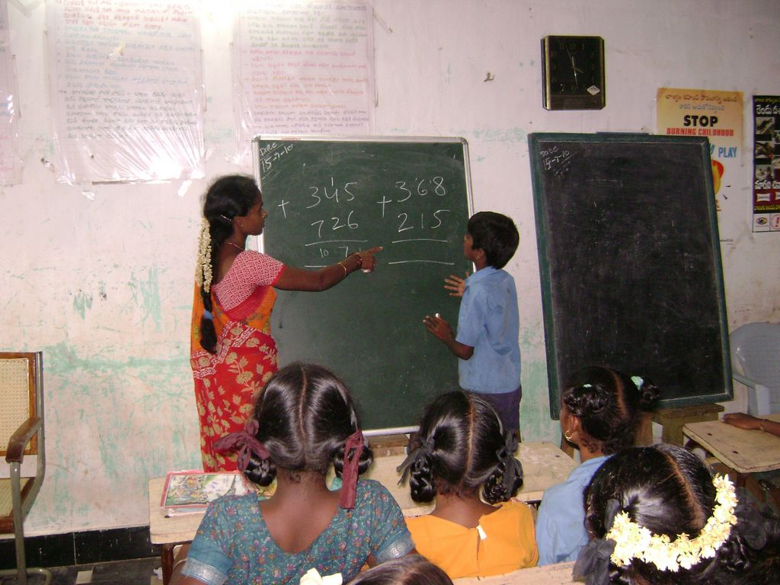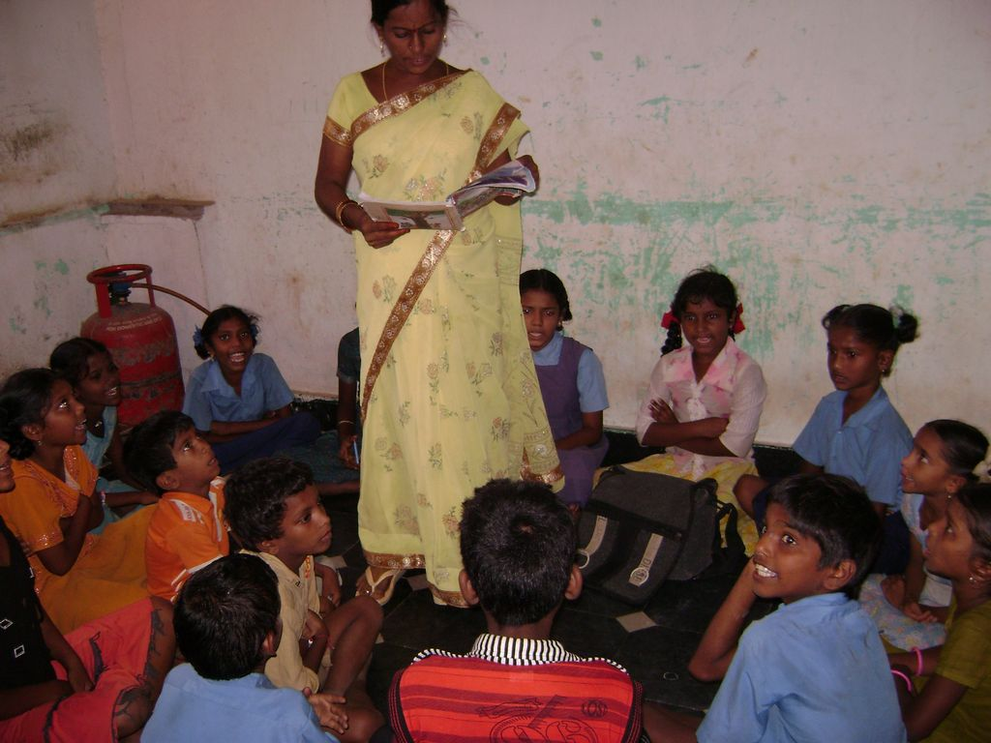

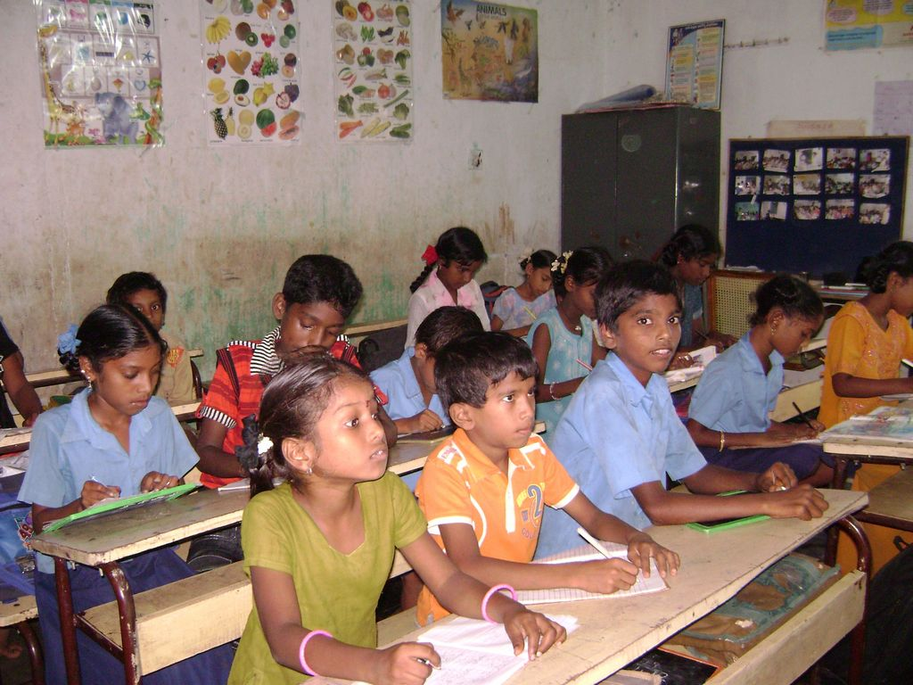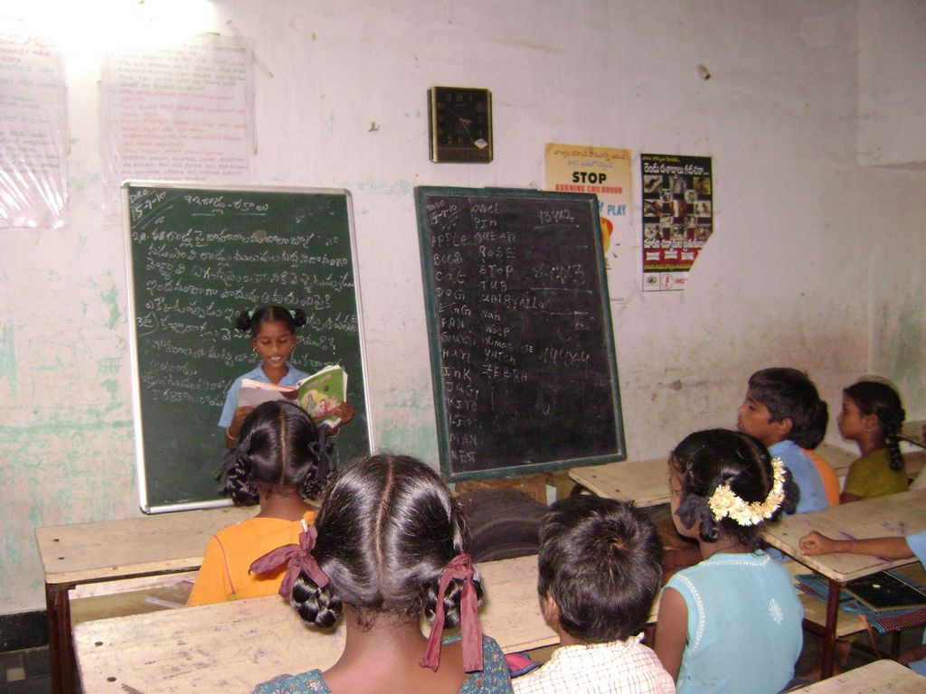
In the earlier stage of the school, the children didn’t pay attention on the studies, so, the teachers counseled them about the importance of the studies, then the senior children showed attention on studies but we struggled with the younger children, so to motivate these children, we conducted classes to the senior students in the class rooms and outside of the classes to the younger children
Through games, moral stories and made them stream line.
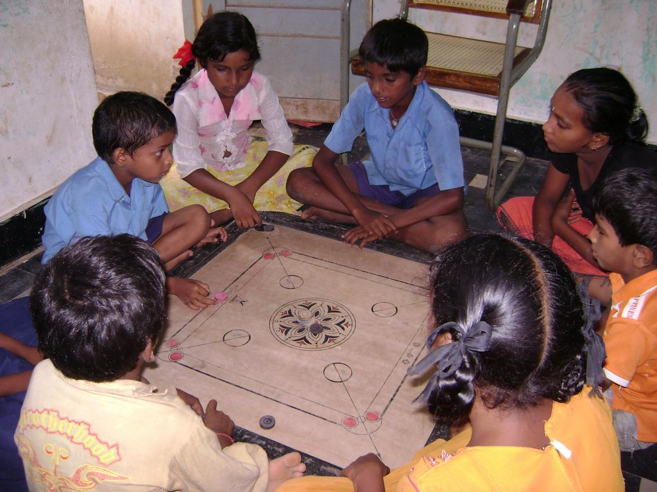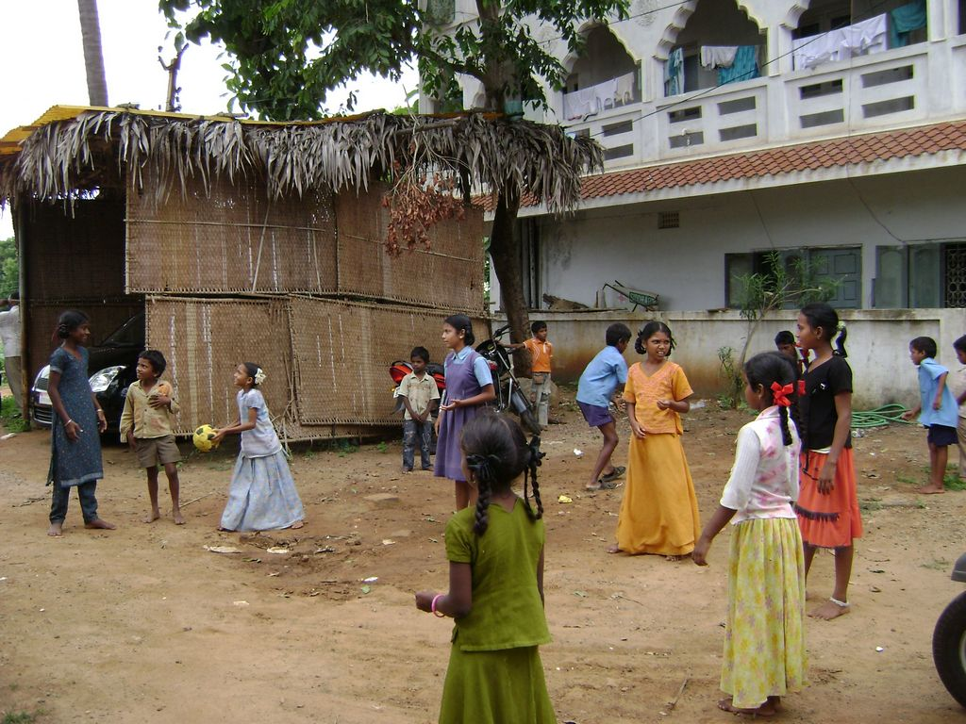

PROVIDING MID DAY MEAL &SUPPLIMENTARY NUTRIOUS

The school is providing mid day meals for school children recognizing the relationship between two most pressing problems—hunger and education—the service seeks to disrupt the vicious cycle that emerges: education is the long-term solution to poverty and hunger, but education is lost on starving children., We felt it is the great supporting system , the girl children are helping their parents in daily labor works only to get food daily, but after this system was introduced the children are coming to the school to have food in addition of education.

The primary objectives of this scheme are as follows:
1) Providing mid-day meal to the children in the school to supplement their diet and raise the standard of nutrition of the school children and thereby also to help in the poverty alleviation efforts. The meal 'is so arranged that it contains Rice, pulses, vegetables, eggs etc., and also other supplemtary nutrition like milk and fruits.
2) To prevent drop-out of students from schools and also to serve the dual purpose of attracting more students to the school and improve their general attendance level.
CELEBRATED PATRIOTIC AND INTEGRATED FESTIVALS
To help the children to know about patriotic and integrated festivals of all religion and national festivals, school celebrates all festivals of every occasion by inviting eminent people as guests to encourage children Ma” conducted quiz, games, and other competition and distributed prizes.
Patriotic festivals like Christmas, Sankranthi and other festivals will conduct in school to protect the religion equality in between the children.
The children are also done many cultural activities like singing songs, dances and every one participated actively on these festivals.
Cultural Programmes and games competitions like Essay writing, Kabadi, Running race, musical chair, Quiz, cricket, were conducted to children on various patriotic and integrated festivals and distribute sweets and prizes to the children.

Child rights convention week programmes:

MA conducted child conventional week from 14th NOV 2009.The Children were taught about their rights and aware them on their rights. Children prepared memorandum of demands and submitted to the ward cooperator, MLA and requested them to discuss on the demands with higher officials and also conducted various activities like debut on child problems, recreational activities, quiz etc.
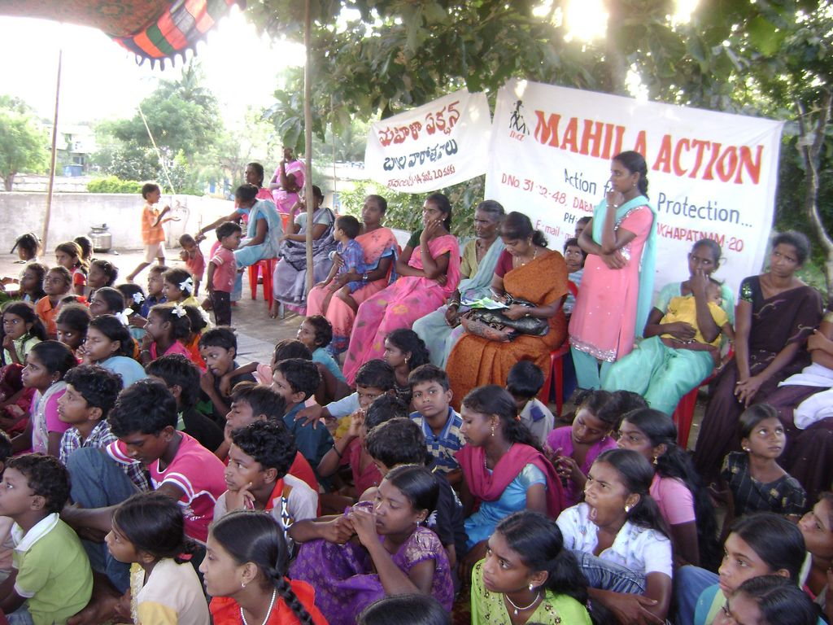

CONDUCTED AWARENESS ON CHILD RIGHTS WITH CHILDREN:

The purpose of the introductory of the child rights is simply to the children on creating awareness and information around the promotion of children’s rights Awareness programme on 10th DEC 2009 with 85 members.
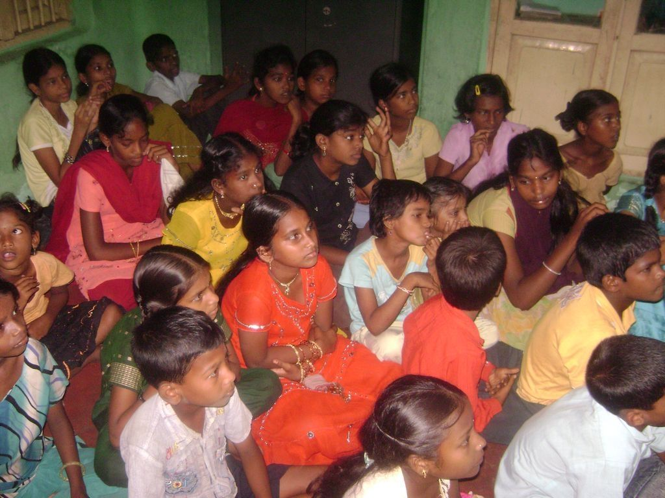
The children were taught 4 basic rights of children.
- The right to survival: to life, health, nutrition, name and nationality.
- The right to development: to education, care, leisure, recreation.
- The right to protection: from exploitation, abuse, neglect
- The right to participation: to expression, information, through, & religion.
In 1992, India sanctions the United Nations Convention on Rights of the Child. The agreement of Child Rights is built on the principle that "ALL children are born with fundamental freedoms and ALL human beings have some basic rights" and explained the Child Rights and their importance. As well children have the right to food and right to educate on 12th –APRIL-2010 with 65 members.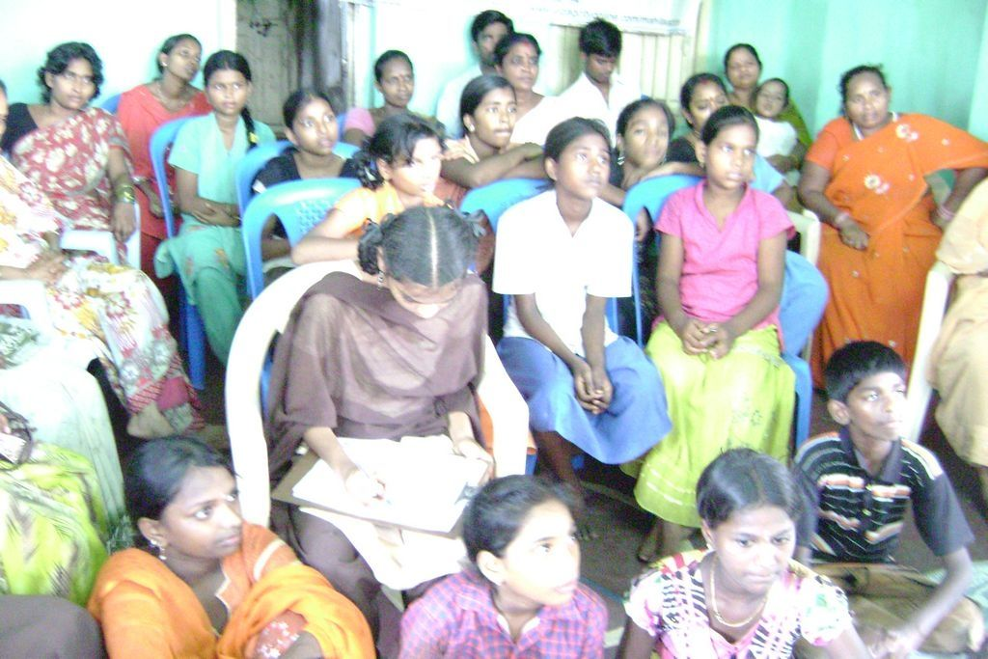
CONDUCTED WORKSHOP ON ANTI TRAFFICKING AND WOMEN RIGHTS:
To promote child friendly community systems through child led advocacy to combat child trafficking/abuse/exploitation. We celebrated “Child right Convention week” in the target area. Trafficking, abuse of children and exploitation on 11th JAN 2010, on prevention of child trafficking, abuse, sexual exploitation with participants around 95 members attended the program.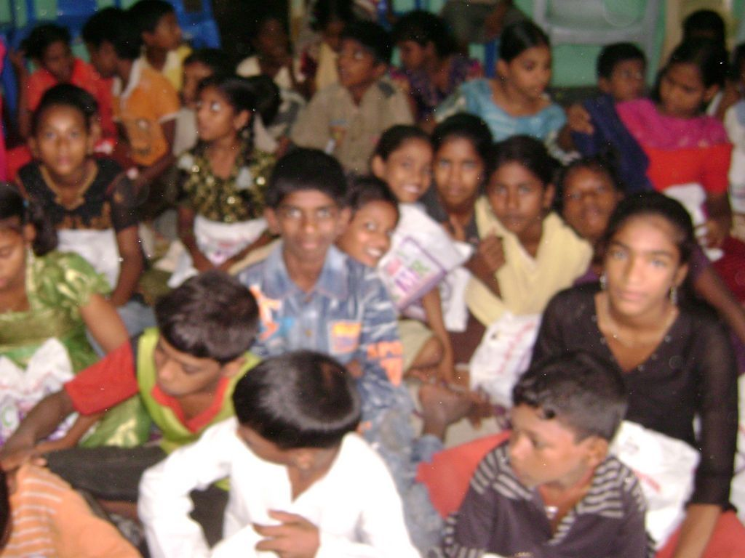
CHILD MARRAIGES:
MA conducted awareness programs on child marriages on 17th MAR 2010 with participants 80 members. Children were given awareness on child marriages and gave knowledge on the same, because the place were they live is a slum and child marriages takes place frequently over there
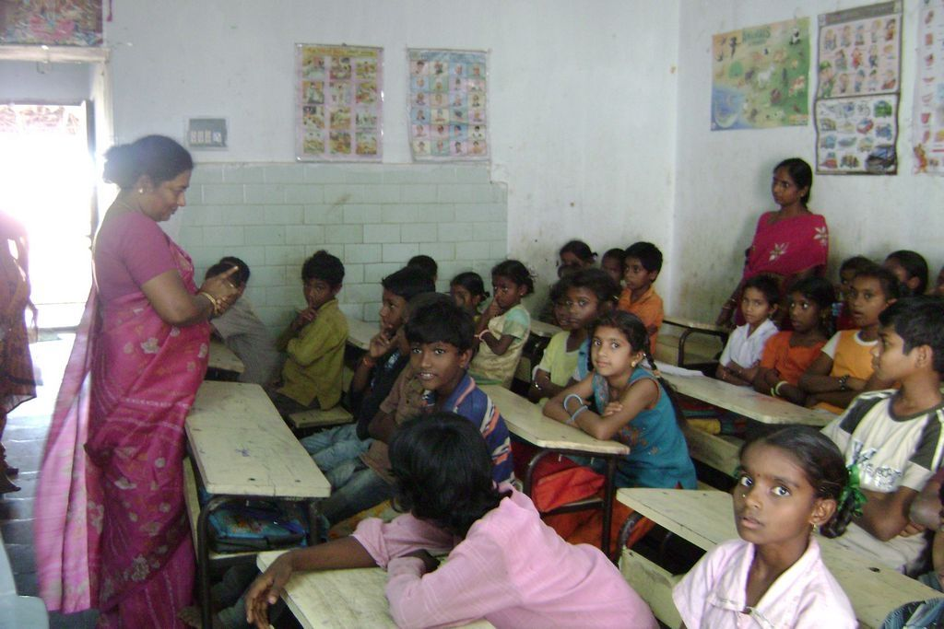
Seminar on Women Rights & Gender equality:
The Seminar on Women Rights and Gender equality is conducted at the Gandhian centre of Andhra University on 2nd MAY 2010, the chief guest for the program is Prof. B.Satyanarayana, Vice Chancellor of Andhra university, Prof. Ranga Rao, Dept of Social work, Andhra University, Pr. Sampth Kumar, Head of the Social work department, Andhra university,, Prof. Visweswara Rao, Dept. of social work, Andhra university, Prof.. Indira Rani, VMM College, Viskhapatnam and Dr. Mangavalli, Faculty of Dr. Vs Krishna Govt.College, Visakhapatnam and Mrs. K.Swarna Kumari, CEO of Mahila action has presides over the meeting, around 120 participants from community women, students, sex workers. PLWHAS, challenged has witnessed the program.Prof. B. Satyanarayana, vice chancellor of Andhra University has addressed the event the women are the status of women in India has been subject to many great changes over the past few millennia. The Constitution of India guarantees to all Indian women equality, no discrimination by the State, equality of opportunity, and equal pay for equal work. In addition, it allows special provisions to be made by the State in favor of women and children.
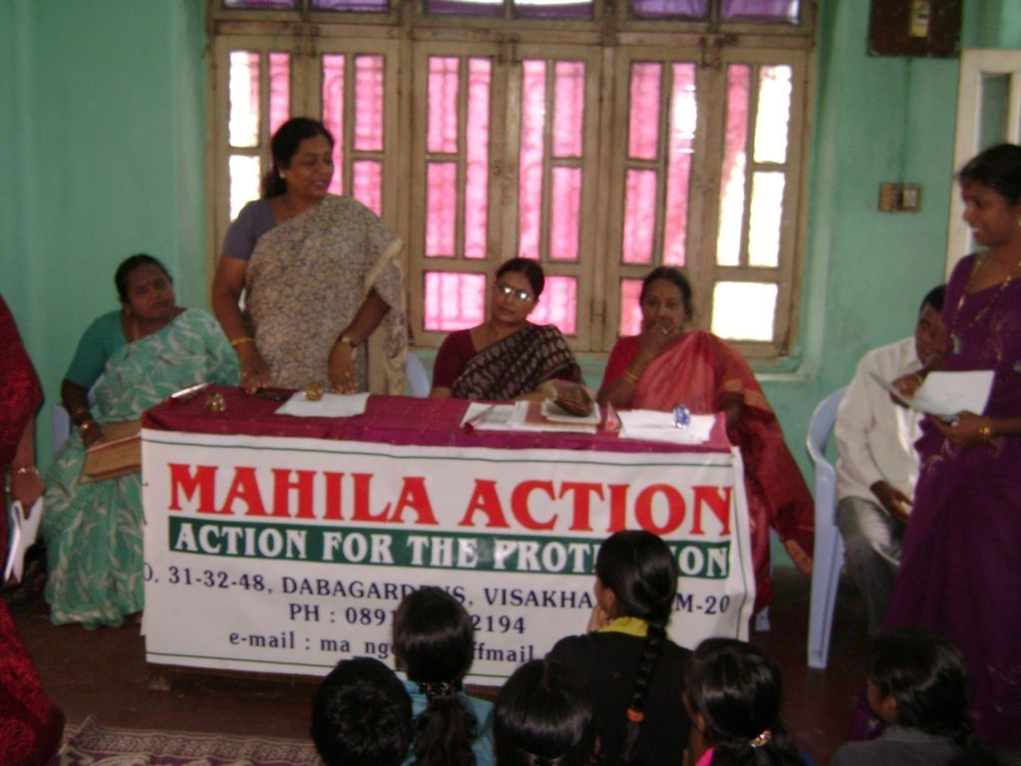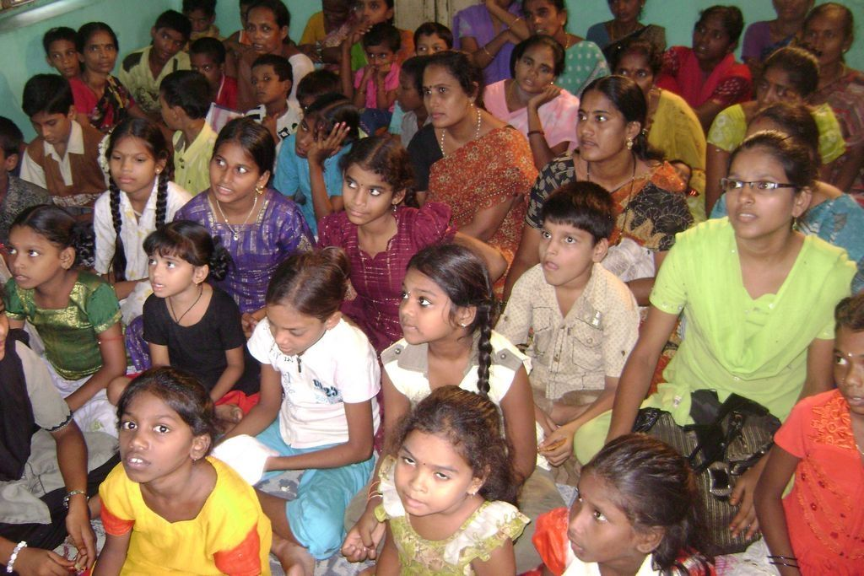

PARENTS MEETING:
The main objective to conduct parents meeting is to strengthen the relation between parents, teachers and children, know about the child behavior, standard of education and to motivate the parents to send their children to school regularly and to encourage them on education rather than works, to say the progress of the child and changes.
Conducted 10 parents meetings with average of 25 to 30 parents, first 4 meetings were conducted at school and other 6 meetings in the areas after 8 in the night because the parents come from the works at that time and continuing the meeting on every 1st Saturday of the month, the main intense to conduct the parents meeting is to aware the parents about the school, activities of the school, to motivate the parents to send their children to school regularly and neatly, to ensure the children to study and do home works, discuss objectives achieved, student progress and difficulties of the children.
EXAMINATIONS CONDUCTED:
Conducted unit test, quarterly, half yearly and annual examinations to the children based on state syllabus and progress reports were sent to their houses to know about the children improvement and for their notice and also the progress of the child will be explained in one to one session in parent’s interaction meeting.
ANNUAL EXAMS CHILDREN MARK LIST

STANDARD: 2ND, 3RD, 4TH, 5TH STANDARD CHILDREN WILL HAVE A TOTAL OF 500.
SUBJECTS: TELUGU, MATHEMATICS, ENGLISH, SOCIAL, and SCIENCE.

S.NO | NAME OF THE STUDENT | STANDARD | TOTAL | PERCENTAGE
 | S.VIJAYA LAKSHMI | 5TH | 366 | 73.2%
 | J.SANDHYA | 5TH | 404 | 80.8%
 | P.HIMA BINDHU | 5TH | 420 | 84%
 | R.GAUTHAMI | 5TH | 381 | 76.2%
 | G.LAVANYA | 5TH | 366 | 73.2%
 | M.JYOTHI | 5TH | 437 | 87.4%
 | K.DURGA PRASAD | 5TH | 159 | 31.8%
 | B.NAVYA | 4TH | 420 | 84%
 | G.SATYA VENI | 4TH | 326 | 65.2%
 | P.HEMA LATHA | 4TH | 368 | 73.6%
 | G.NAGAMANI | 4TH | 442 | 88.4%
 | CH.ANUSHA | 4TH | 259 | 51.8%
 | E.GAUTHAM | 4TH | 223 | 44.6%
 | K.PRAVEEN | 4TH | 229 | 45.8%
 | M.KAAMARAJU | 4TH | 175 | 35
 | SK.AMMULU | 3RD | 413 | 82.6%
 | G.KANAKA MAHA LAKSHMI | 3RD | 425 | 85
 | R.NIROSHA | 3RD | 374 | 74.8%
 | P.LOKESH | 3RD | 355 | 71%
 | CH.SAI RAMANA | 3RD | 207 | 41.4%
 | K.BHAVANI | 3RD | 203 | 40.6%
 | K.SANDHYA | 2ND | 331 | 66.2%
 | K.DHANA LAKSHMI | 2ND | 348 | 69.6%
 | B.TULASI | 2ND | 389 | 77.8%
 | SK.ASHINA | 2ND | 254 | 50.8%
 | M.PAVANI | 2ND | 364 | 72.8%
 | K.GANESH | 2ND | 190 | 38%
 | K.YERRAYYA | 2ND | 192 | 38.4%
 | K.RAMESH | 2ND | 218 | 43.6%
 | R.BHABHI | 2ND | 271 | 54.2%
 | O.KANAKA RAJU | 2ND | 246 | 49.2%
 | M.SATAMMA | 2ND | 322 | 64.4%
 | G.GAYATHRI | 2ND | 322 | 64.4%
 | CH.SAI LAKSHMI | 2ND | 235 | 47%
 | S.JYOTHI | 2ND | 354 | 70.8%
 | K.BHANU | 2ND | 297 | 59.4%
 | P.CHANDRA SHEKAR | 2ND | 334 | 66.8%
 | CH YERNICHUMARI | 2ND | 338 | 67.6%
 | P.DURGA | 2ND | 273 | 54.6%

STANDARD: 1ST STANDARD CHILDREN WILL HAVE A TOTAL OF 200. SUBJECTS: TELUGU and MATHEMATICS.

S.NO | NAME OF THE STUDENT | STANDARD | TOTAL | PERCENTAGE
 | P.SARALA | 1ST | 179 | 89.5%
 | M.SATAMMA | 1ST | 149 | 74.5%
 | K.CHINNARI | 1ST | 85 | 42.5%
 | K.USHA | 1ST | 74 | 37%
 | CH.MEMATH | 1ST | 137 | 68.5%
 | K.VAMSI | 1ST | 100 | 50%
 | K.CHINNA RAO | 1ST | 152 | 76%
 | SK.AYODHYA | 1ST | 81 | 40.5%
 | SK.VISAKHA | 1ST | 159 | 79.5%
 | K.ROHITHA | 1ST | 162 | 81%
 | K.BHANU | 1ST | 123 | 61.5%

JOINING IN MAIN STREAM SCHOOLS:
After the final (annual) exams, all the answer sheets were evaluated and according to the marks and knowledge, we had selected 22 children and prepared them for entrance examinations for main streams and joined in respective schools in respective classes, list is given below.
MAIN STREAM LIST:

S.NO | NAME OF THE CHILD | STANDARD
 | S.VIJAYA LAKSHMI | 6TH STANDARD
 | J.SANDHYA | 6TH
 | P.HEMA BINDU | 6TH
 | R.GOUTHAM | 6TH
 | G.LAVANYA | 6TH
 | G.KANAKA MAHA LAKSHMI | 6TH
 | K.DHANA LAKSHMI | HOSTEL
 | G.GAYATHRI | DROP OUT
 | P.DURGA | DROP OUT
 | CH.SAI LAKSHMI | 3RD
 | M.PAVANI | 3RD
 | K.CHINNARI | DROP OUT
 | P.SARALA | 6TH
 | M.JYOTHI | 6TH
 | K.DURGA PRASAD | 7TH
 | M.KAAMARAJU | 6TH
 | K.PRAVEEN | 6TH
 | CH.SAIRAMANA | 4TH
 | CH.YERNI KUMAR | 3RD
 | K.BHANU | 3RD
 | R.BHOBY | 4TH
 | K.GANESH | 5TH
 | K.CHINNA RAO | HOSTEL
 | S K.AYODHYA | 3RD
 | K.RAMESH | 3RD
 | K.YERRAYYA | 5TH
 | G.NAGAMANI | 6TH

DROP OUT LIST:

Three children were drop out, though we motivated their mothers they said that following reasons:

G. GAYATHRI: Her father left the family and went away, she is staying with her mother and grandmother, and she has a younger brother of 2 years old. Her mother goes to shop for job daily and so her grand mother asked gayathri to stay back in home and look after her younger brother.

P.DURGA: Durga got matured and every slum area believes that a matured girl is not supposed to go out of the house. So she is not allowed to go to school

K.CHINNARI: Chinnari’s parents are quarrelling with each other and no one is taking care of her and so she cannot come to school.

NEWLY JOINED CHILDREN:

S.NO | NAME OF THE CHILD
 | R.KRUPA PADU
 | V.SUDHA RANI
 | K.PRIYANKA
 | J.DURGA PRASAD
 | J.YELLAYYAMMA
 | G.LOKESH
 | SK.REHAMAN
 | V.BHAGYA LAKSHMI
 | V.SANYAS RAO
 | M.SRAVANI
 | P.NANI
 | K.VENU
 | K.KANAKA MAHA LAKSHMI
 | M.VIZAYA KUMAR
 | M.RATNAM
 | B.YESWANTH
 | D.KANAKA RAJU
 | CH.MAHESH
 | K.PAVAN
 | P.NARESH
 | C.RATNA KUMAR RAJ
 | V.HEMA LOKESHWARI
 | D.HARIKA
 | U.AKHIL KUMAR
 | D.HEMA BHAVANI
 | S.DIVYA
 | N.GANESH
 | N.DINESH

LIST OF THE CHILDREN WHO ARE OLD STUDENTS CONTINUING IN SCHOOL:

S.NO | NAME OF THE CHILD
 | B.NAVYA
 | G.SATYA VENI
 | P.HEMA LATHA
 | K.BHANU
 | CH.ANUSHA
 | SK.AMMULU
 | R.NIROOSHA
 | B.TULASI
 | M.PEDDHA SATTEMMA
 | K.SANDHYA
 | S.JYOTHI
 | SK.HASEENA
 | M.CHINNA SATTEMMA
 | E.GOUTHAM
 | K.VAMSI
 | P.LOKESH
 | P.CHANDRA SEKHAR
 | CH.HEMANTH
 | SK.VISAKHA
 | K.ROHIT
 | K.USHA
 | K.BHAVANI

FEED BACK:

- Asha Washington supported the school in a Right time when lot of children migrated from city to Vambay colony and remained as child labors and drop outs, with the help of this project we were able to reach the school to 50 children and providing education and nutrition and hope to continue the school.
- Community women are supporting the school and its systems by sending the children to schools and also sharing their problems and we are providing them for the referral services for the cause and also joined the women in the self help groups to sustain themselves.
- We were able to raise the confidence levels of the children through Awareness work shops and seminars.
- Identifying child abuse cases and giving special attention and counseling’s.
- Regular motivation and counseling to the parents to aware on the importance of education to their children and to send to school regularly.

OVERALL EFFECTIVENESS OF THE SCHOOL.

- Health improvement in the children after joined in the school because of the nutritious food.
- More than 80% of the children are anemic while joining in the school, but now with the nutritious food, these children improved their health.
- In the beginning of the school, all the children used to come to school very untidy without combing hair, bathing, without haircut, dirty cloths etc. but now after counseling and motivation above 95% of the children are coming neatly by girl children are plaiting their hair, bathing daily, wearing washed cloths.
- Participation skills and leader ship qualities improved through exposures, school visit.
- Few children knew about the child rights and have ability to speak on the issues regarding.
- The children of the school improvised their educational standards and regular to school.
- Most of the children are coming to school neatly, maintaining discipline, punctuality.
- The rate of joining in main stream is 58%.
- More than 70% of the children are punctual to school.

ASHA FUNDS USED IN THE YEAR:

INCOME & EXPENDITURE STATEMENT FROM JUNE 09 TO MAY 2010

INCOME | AMOUNT | EXPENDITURE | AMOUNT
Grant Received from Asha Washington for 3rd year.  Advance received | 2,52,225 INR  1,47,532 INR | Survey (TA & DA)  Stationary study material  School Rent & Electricity  Nutrition  Vocational material.  Salaries  Child Rights Programme  Seminars and workshops  Main stream | 630 INR  5120 INR  30,000 INR  1,90,527INR  4,980 INR  1,14,000INR  33,000 INR  19,000 INR  2500 INR
 | 3,99,757 INR |  | 3,99,757 INR

Signature


K.SWARNA KUMARI
Secretary,
Date: 15-07-2010

