Site Visit Report
Visited by:
- Satheesh Avvaru
Clinical Data Analyst, MaxisIT Inc, NJ
Email: avvarusatheesh@gmail.com
Phone: 203-804-3438
- Priya Desai
QC Associate, Regeneron Pharmaceuticals, NY
Email: priya.desai@yahoo.com
Phone: 203-675-4485

Preliminaries:
- Name and organization:
Project Steward
Mahila Action
Pragathiki Bata School, Visakhapatnam, Andhra Pradesh, INDIA.

Administrative office:
Contact person(s) : K.Swarna Kumari
Phone number : +91 0891 2732194
Email : ma_ngo@rediffmail.com,mahilaaction@hotmail.com
Address : #31-32-48, Dabagardens, Visakhapatnam,
Andhra Pradesh, India. PIN: 530 020
Location (village/town): Dabagardens, Visakhapatnam

School location:
Nagaram Palem road, Vamboy Colony, Madhurawada, Visakahapatnam.

Note: The administrative office is located 20km away from the school. Administrative staff includes Mahila Action Secretory K.Swarna Kumarie, Documents personal Mr. Raju and Accountant Padma.

- Date Visited:
Administrative office visit: 2nd Oct 2009
School visit: 3rd Oct 2009

- Details of arrangement of visit:
  - Was it surprise visit?
Surprise visit for administrative office and one day prior notice for school visit.
  - Accessibility of the location.
Basing on the project view, this school is located in slum area of visakhapatnam, 15km away from the city center. I believe this is in good location to educate the drop out children from poor families.

  - Attitude of the staff:
They were very helpful and excited to give maximum information possible about their organization. Also assisted me in going through various documents.
- Additional information about the objectives of the organization: N/A

Statistics:

  - Determine if the school is operating as stated (School timing: 9 am to 4.30 pm from Monday - Saturday)

Yes. We spoke to the children and confirmed the working hrs. It is same as stated.

  - Determine the number of students at the school (According to the 2007/08 report there were 50 children: 30 boys/20 girls of ages 6-14 years)

Yes. We checked the attendance register. There are total 50 students. 20 boys and 30 girls. (Attendance register photos attached)

Note: There is no differentiation of the class rooms basing on the standard of the students due to insufficient rooms.

  - Number of teachers/staff (3 teachers/ one ayah).

Yes. We checked the teacher’s attendance register and also met them at school. 1 Incharge, 3 Teachers and 1 Ayah/cook. (Attendance register photos attached)

K. Parvarthi, Teacher/Incharge
K Eswaramma, Teacher
B. Anuradha, Teacher
K.Venkatalaxmi, Teacher
P.Chinnammalu, Ayah/cook

  - Inspect the school building to determine if the following is accurate:
- Q. Having two classrooms, one dining/vocational /indoor games room, kitchen and toilets?

A. They have only one class room and one kitchen. They are using kitchen as class room by completing the cooking by 9am.
Secretery Ms. Swarna Kumarie stated that, they used to have two class rooms and one kitchen till Dec 2008 but house owner took over one of the rooms. So they are conducting classes either in the kitchen or in front patio when ever weather permits.

- Q. Providing mid day meal and nutritious food?

A. Yes. They are providing mid day meal. I checked the food they are serving also. It looks good.

- Q. School is having required table and desks, cup board, teacher table and chairs, and black boards. Fans, tube lights?

    - They do have required facilities for one of the class rooms but for the other class room/kitchen, no tables available.

- Q. Sports material – Throw balls, tennis court, skipping ropes, shuttle bats and indoor game materials?
- They have two caroms boards, skipping ropes and a volley ball.

- Q. Simple kitchen, gas stove with two burners, mixie, pressure cooker and other necessary vessel?
- Yes. They do have stove, mixies, pressure cooker and necessary vessels.

- Q. If possible, talk to students and ask them some basic questions (e.g., maths); observe a teacher teach a class; notice what books/charts/other meaterials are in the class?

A. I checked the note books of couple of students. All the notes are with good information according to state of Andhra Pradesh school standards. The teaching is in Telugu medium. As I am from Telugu medium background, I was able to assess the teaching quality basing on the notes. Very Impressive.

- If possible, talk to some parents and ask them how often the school has been open in the past month (if it was closed for certain days, why?); how often they send their children to school; how often do the children get food/mid-day meal; what is their opinion of this school and the teachers; etc.
Sorry. I didn’t get chance to discuss with parents.

Financial:

- Mahila Action organization running non-profitable projects with support of different organizations like Action aid, Groupee Development and ASHA.
- Documents verified reflecting the expenses for Pragathiki Bata school maintenance is supported by ASHA funding.
- Audit report of Mahila organization showing as Rs.3 lakhs per year the school total expenses (attached the document). We can clearly see the possible/estimated expenses as Rs. 3 lakhs due to teacher’s salaries, school rent, food, and other expenses.
- ASHA secretary Ms. Swarna Kumari stated that, ASHA funded Rs. 2,41,000 for the last year (May 2008 to June 2009). But due to the estimated total cost of Rs. 3,00,000 per year and as ASHA has not funded the project in 2009 yet, they had to take loans from individual supporters/people. I saw the document for total Rs. 90,000 loans. According to them, the same document is already sent to ASHA. I asked for the receipts issued to the individual people as a proof. They were able to show few receipts but not all (attached are the copies of receipts). When I asked for all the receipts, they told that, usually they take the loans on personal relations so they don’t issue receipts for the loans they take, which is not an impressive management. I believe ASHA has right to ask them to maintain receipts for the amount they loan from next time.
- Secretary Ms. Swarna kuamari requested for better communication to discuss the financial issues. She commented that ASHA representatives are not responding to her mails on regular basis and has sent bunch of mails but no response.
- I asked the incharge Ms. Parvathi about the school dress as there is no particular dress code assigned for the school. She told that each pair of dress costs Rs. 300 per student. Total cost will be Rs. 15,000 for 50 students. As school running on low funds, they couldn’t spare money for dresses.
- They showed some vocational work material i.e cloth embroidery, drawing pictures, art & painting on earthen vessels, and other activities performed by students.

Opinions:

- In the site visitor’s opinion, why should ASHA fund this project?
  - The Mahila Action is working as stated in the project.
  - Teachers are working hard to communicate with parents and convincing them to send their children to school and giving updates to the parents by conducting parents meetings.
  - As the school is in village I believe it is a good location to make the children come back to school after drop outs as well as convincing parents.
  - We saw that Mahila Action teachers are maintaining good standards of teaching, attendance tracking, & parents meeting minutes.
  - We should definitely support this project as 50 children are benefiting from this project and it is a good opportunity for them to go for mainstream schools after this schooling.

- What reasons if any, does the site visitor see for ASHA not to fund this project?
None

- What improvements, if any, would the site visitor suggest to the project?
  - Needs one more spacious class room for the students. Kitchen area is crowded & it is not a good place for teaching.
  - Providing school dress gives much better discipline for the students.
  - Mahila Action management needs to issue receipts for the loan amounts to the loaners and maintain loan clearance records with signatures.

Pictures:

Pictures are available at
http://picasaweb.google.com/satheeshavvaru/ProjectVizag#

Receipts issued to the loaners for the loan Mahila Action received:

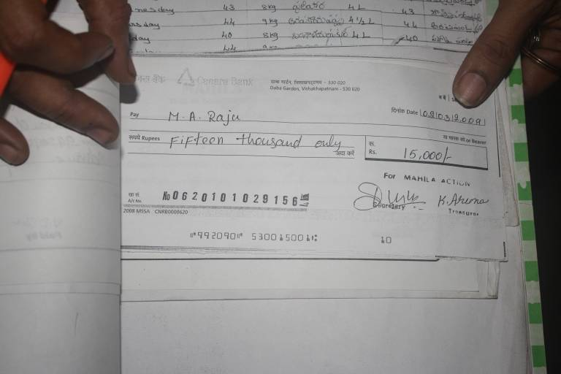
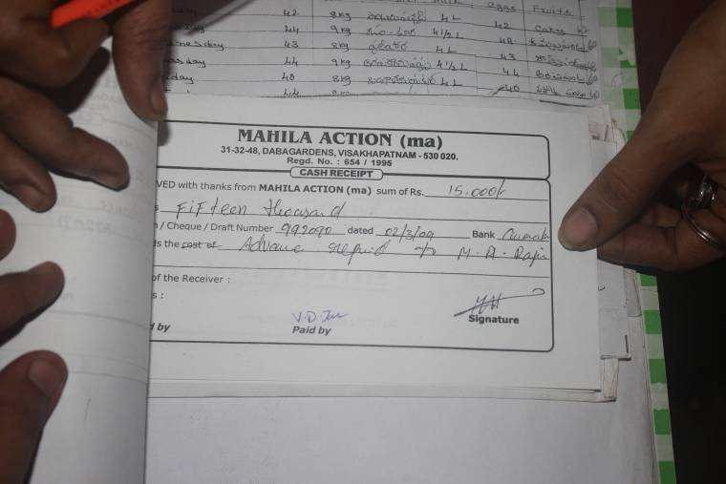
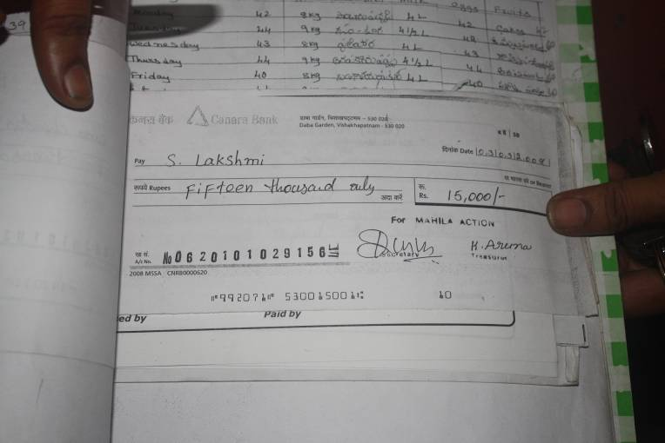
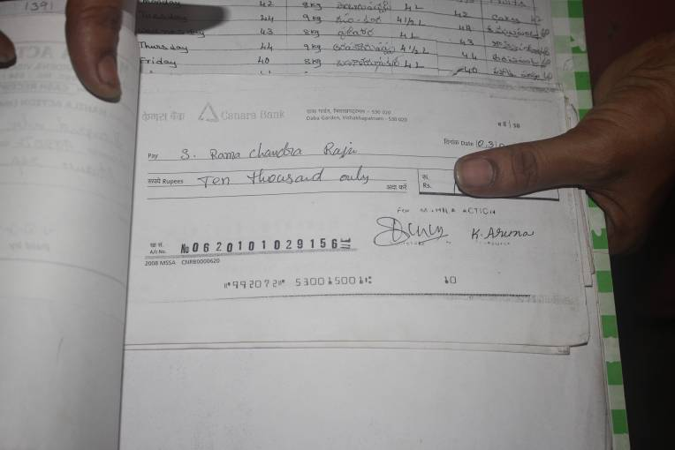
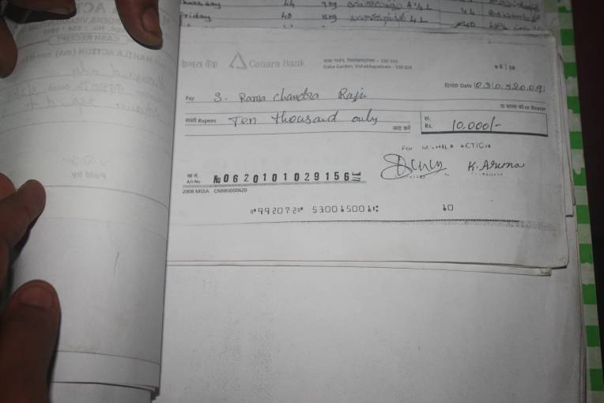

Administrative Building of Mahila Action Located in Dabagardens, Visakhapatnam:

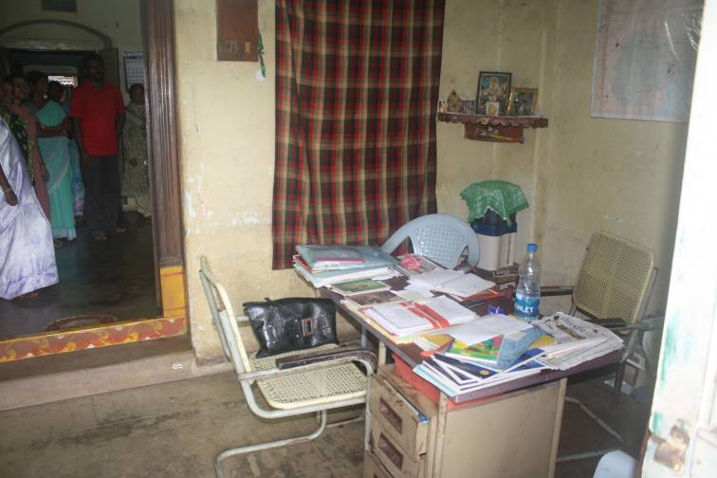
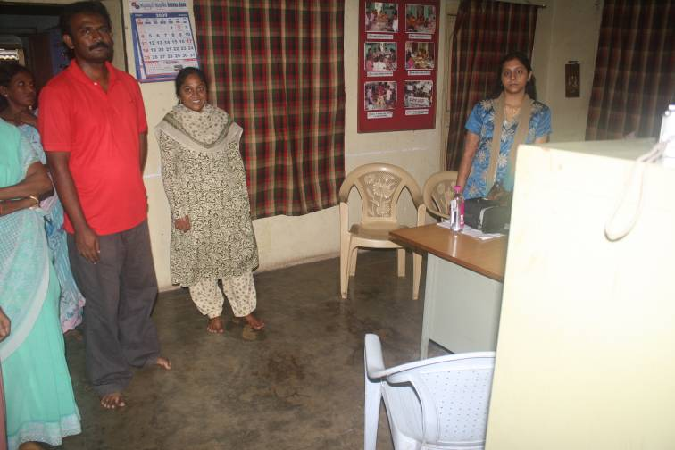
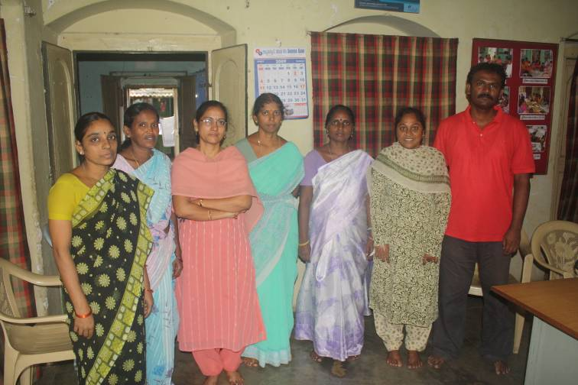
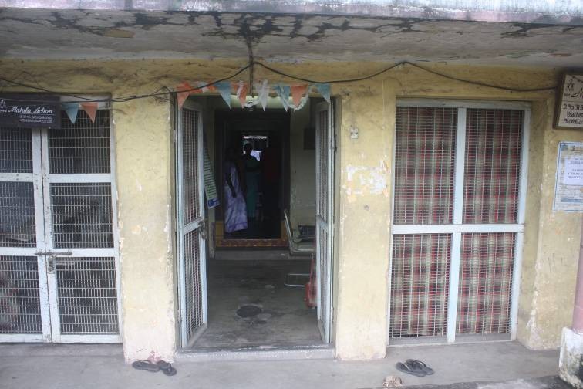
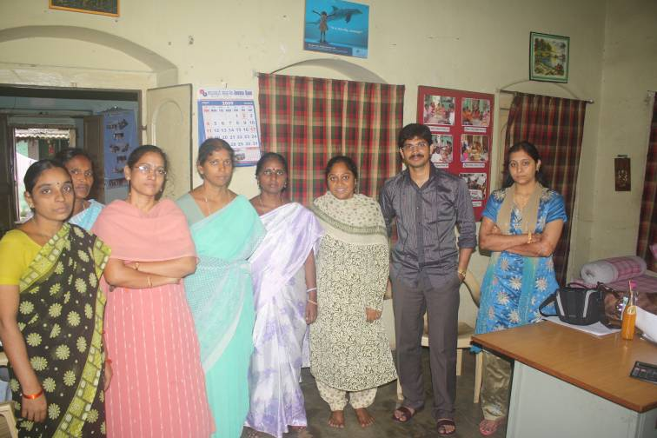

(Priya Desai and I with Mahila Action Staff)

Pragathiki Bhata School (Vamboy colony, Madhuravada, Visakhapatnam):
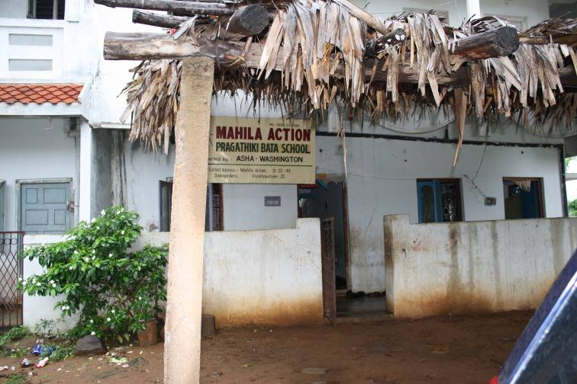
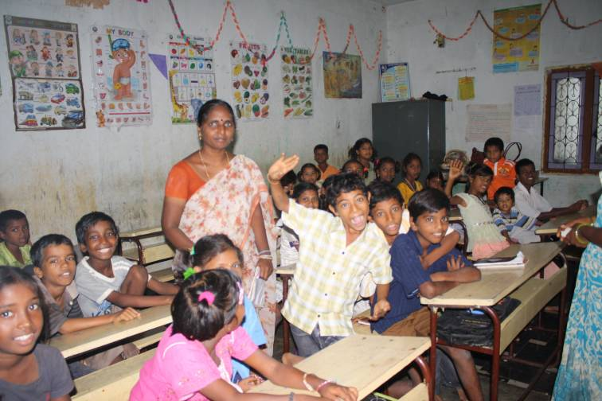
(School building/entrarance) (Class room)

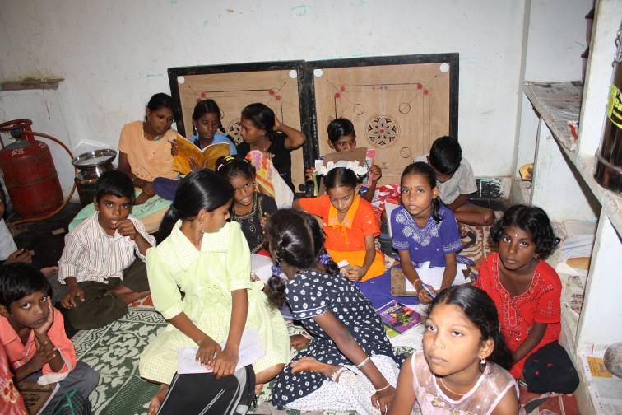
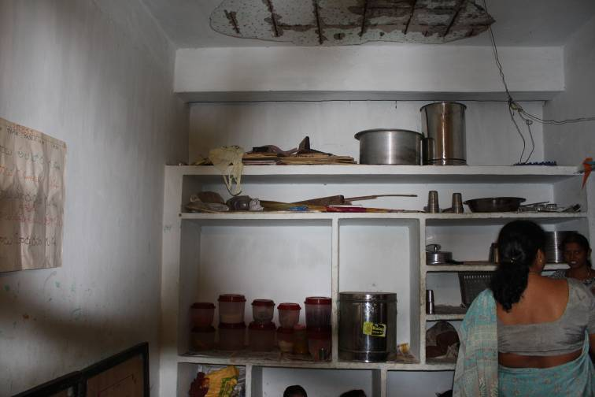
(Kitchen /class room) (Kitchen /class room)

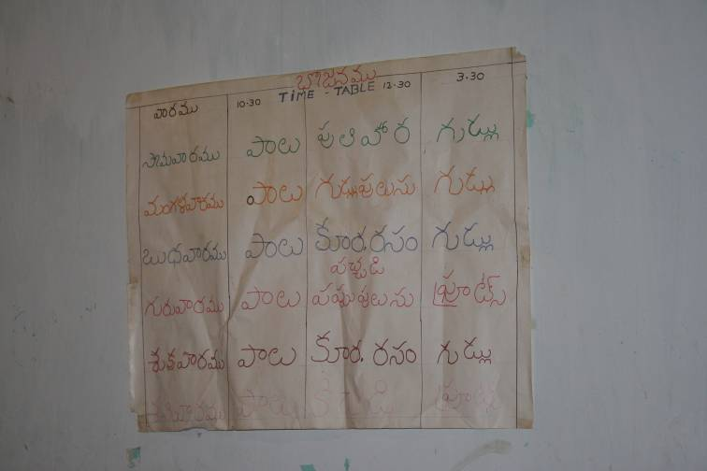

Student’s attendance registers:

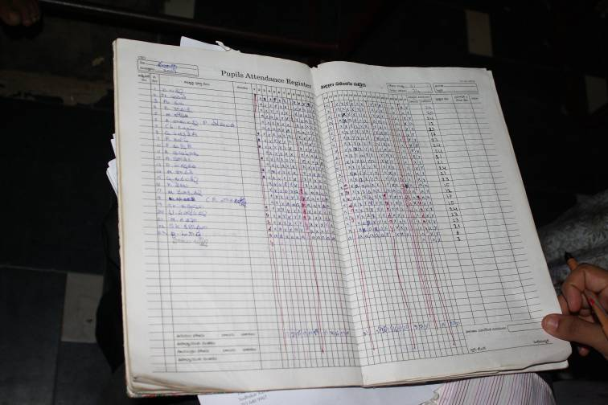
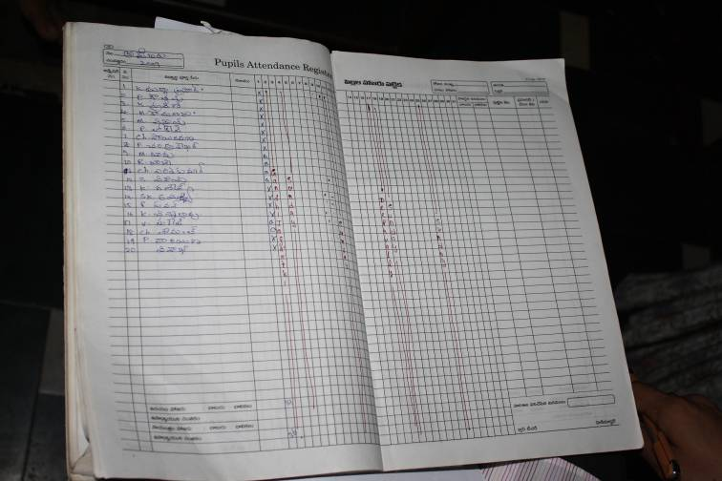
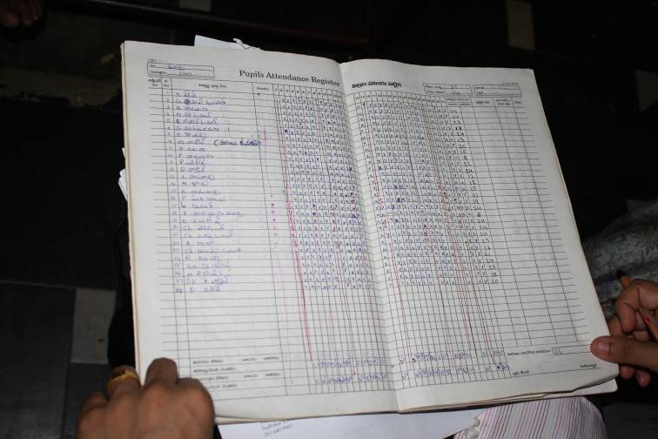
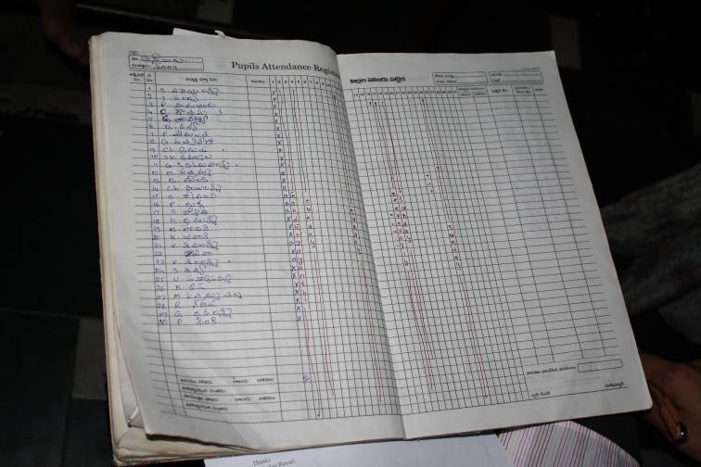

Parents meeting minutes:

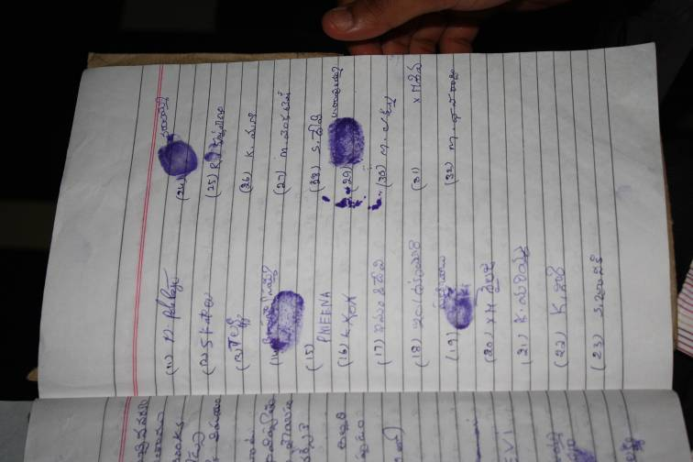
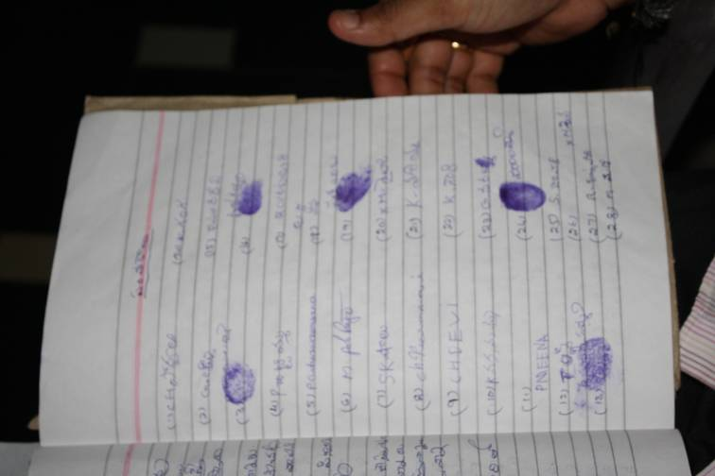

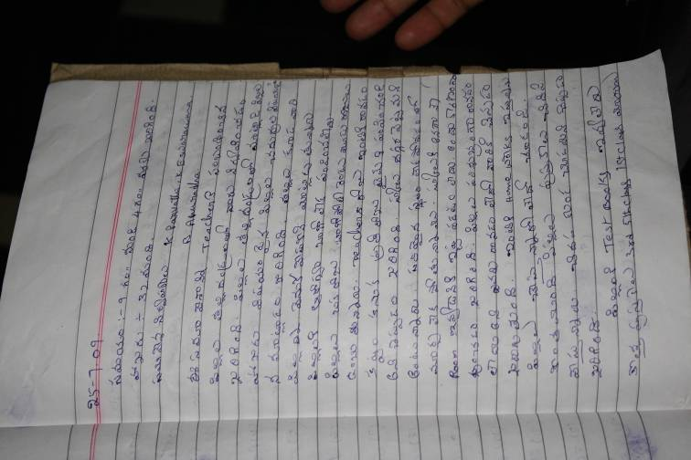
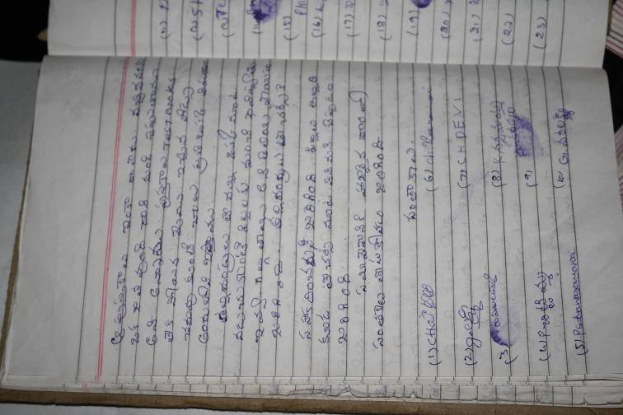

Teacher’s attendance registers:

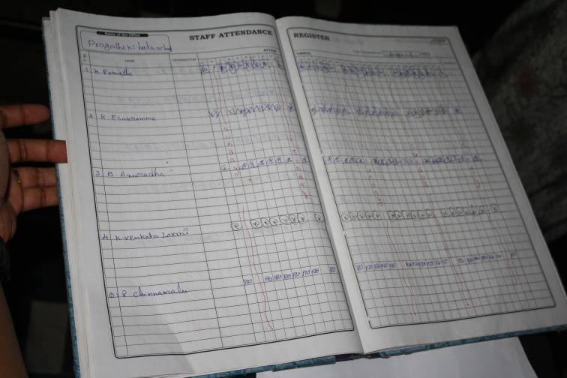
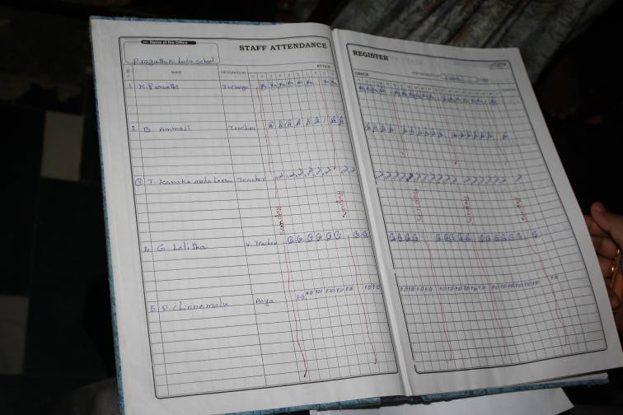

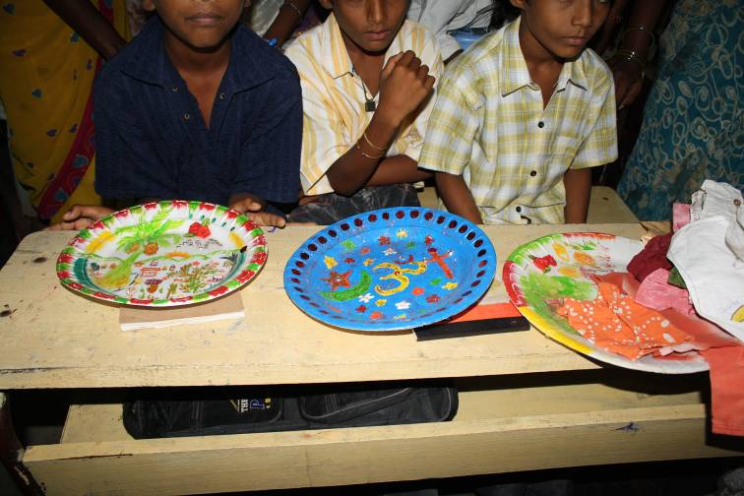
Vocational work:


