Baikunthapur Tarun Sangha (BTS) Project Report

Project: Baikunthapur Tarun Sangha (BTS)

Project visit by: Bikramjit Das, Tanushree Ghosh, Amrita Hazra

Date: 3rd- 4th Jan 2007.

Chapters associated with: Cornell, DC and St-Louis

Surprise visit: No.

The village and getting there: Baikunthapur Gram panchayat is located in the island of Kultali in the southern part of Sunderbans in West Bengal. Our journey to Baikunthapur was entirely by road. We went from Sealdah (Kolkata) to Baruipur by train which took about forty minutes. From Baruipur, we went to Baikunthapur by an ambulance (Maruti van), a three hour ride, accompanied by the secretary of BTS – Susanta Giri and other members of the BTS committee Pulin and Haripada. The ambulance has been donated to BTS by an organization, MIVA from Holland. This ambulance happens to be one of the very few motorized vehicles that are used on the brick roads connecting Kultali to the next bigger town.
We rode on brick roads built as replacement for the kuccha-mud roads for about 1 ½ hour before we reached the BTS Pathabhavan school. The condition of the roads is very bad, and the only motorized transport in that area is the motor-van. The roads are under the discretion of the Gram Panchayat, and they decide when they require maintenance. It took us about 4 hours to go from Kolkata to BTS.

Activities at BTS:
- BTS Hospital: The hospital has been built by funding from the Embassy of Ireland. The 1st floor construction is almost complete, though there were 1-2 rooms filled with more construction material. There is a X-ray lab, a pathology lab, a medicine storage/chemist’s room, rooms for different doctors like ENT, Gynecology, Pediatrics, Ophthalmology and Dental treatment. Free medicine is dispensed at the hospital, which was also provided by this fund by the Embassy of Ireland. The villagers who access this hospital are charged a minimal fee of Rs. 10 for the visit.

Just outside the hospital, there is a small pond where small-scale fish and shrimp cultivation is happening. Also, some small scale farming is being done in the land adjoining the hospital. The cultivated products are apparently sold and the money raised adds to the funds of BTS.

- BTS Patha Bhawan School: We were received at the school by the students and the teachers. The receiving ceremony, I think I need to mention here, was rather embarrassing for each of us. Given that we are also just students and don’t require such a flamboyant welcome needs to be communicated to them. Just because Asha is a funding organization, whenever a visit is a ‘non-surprise’ visit, the project officials get extremely prepared and tend to treat the visitors very specially. Atleast with Asha’s aims clear, we certainly donot require such overwhelming hospitality.
Over lunch, we discussed 1) The new self-help groups and use of microcredit that BTS had taken up to help out poorer people in Kultali and adjoining villages. 2) The area lacks electricity supply, as it is very far away from the developed parts of West Bengal and it may take quite a while to get electricity to the place. So, Susantada was planning to arrange for solar lights. A few solar lights at critical places in the school building and at parts of the village will take care of the problem of children not being able to study once it is dusk.
We also browsed through the BTS magazine which has updates on their school statistics and other activities.

We then visited the classrooms (Classes Infant A and B, Preparatory, and grades 1 to 6) and spoke to the students while the classes were on. The children all seemed very enthusiastic and have learnt a lot more than what is offered at that level in the government schools. It also seemed like each child was being given equal attention as all the children knew what was happening and were eager to participate. The number of students in the higher classes 5th and 6th were less (below 10) because those were the students who have been there since the school started. The school didn’t have too many students then. After the visits to each class, we saw the crèche, VIBHA that is also run by BTS to keep the smaller children when their parents are away at work. The teachers and children there too seemed to be very enthusiastic and well-behaved. The school then came together for their “Joyful Learning”, which includes a gamut of activities like yoga, music, drawing, recitation, physical training etc. It was an enjoyable experience seeing the children doing so well at all this too.

We then spoke to the parents of a few kids by going to their homes. The people in this area are very poor. They are either landless laborers or fishermen or earn their livelihood by picking wood in the Sunderban jungles. The parents seemed very satisfied with the school. They were happy to send their children there, but did complain about not having lights at home, such that the child could come back home and study. Also, in homes which had more than 1 child going to school, some of them were finding it difficult to pay the fees (Rs.20) each month for each child. For such cases, Pathabhawan does allow one child of the household to study free of cost.
We then visited the other govt. primary schools in that area which had been funded by WAH’2004 and saw the structures that had been built by WAH money. We then got back to the school building and had an intense discussion with the teachers regarding the work they are doing there, what they thought of the school, what were their difficulties and the direction they were envisioning for the school. The points that came up in accordance with the Site Visit Questionnaire were:
Part A:
- The focus area of BTS is 45%Community Development, 40%Education and 15%Health in the Kultali area.
- The administrative structure of the group is that it is a Non-profit, Non-political, Non-religious voluntary organization with a President, a Secretary, Asst. Secretary, Treasurer, and 5 other members. They also have a consulting person, who is an experienced elderly member of the school.
- No other organizations are working in the area.

Part B:
- No. of families in the area: About 3750
- Parents mainly are landless laborers, fishermen or collect wood and fruits etc. from the Sunderban woods.
- Just the father’s name is asked for during enrolment in school.
- The teachers meet the parents every week. The teachers are assigned villages specific villages where they hold parent-teacher meetings every week. At these meetings, they inform the parents about the daily actvities of the children, update them on any shortcoming of the child and also reprimand the parent if they feel they are not sufficiently interested in the child’s progress.
- The parents attend these weekly meetings to participate in the school activities.
- Yes, there are 12 other primary govt. schools and 2 higher secondary govt. schools in the area.
- They are in the adjoining villages that constitute the Kultali Gram Panchayat. However, due to the lax attitudes of the teachers and the huge amount of corruption in the pretext of the Mid-Day Meal program, these schools don’t seem to be running efficiently and the children from these schools are dependent on tuitions and other external aid a lot.
- BTS Pathabhawan has very good teachers and runs regularly without the irregularities of the other govt. schools. Also, it has a very high standard of teaching and so the students graduating out of the primary classes do very well in the higher secondary govt. schools.
- When we visited the classrooms, the attendance was full. The classes very crowded and the children were all studying together in the small classrooms. They seemed to truly enjoy the school.

Part C:

- The school provides textbooks and notebooks, stationery, bag, uniform and tiffin to the student. It charges a fee of Rs. 20 per student per month.
- The mode of teaching in the school is using some State Board text books and some non-standard text books. Also, there is some vocational training in the form of the “Joyful Learning” class where the students learn to draw and make some artwork.
- The school conducts classes up to grade 6.
- The staff is almost completely recruited from the community. The teachers all live in and around the BTS-Pathabhawan school in the nearby villages. Of the staff, 5 are female teachers and staff. Incidentally, none of the women teach any of the higher classes of grade 1 to 6. They take care of the children in the crèche and teach the Infant A and B and Preparatory classes.
- The teachers are all payed Rs. 1200 each per month. The secretary and the treasurer each get Rs. 3000 per month. The salary is certainly not at par with the govt. school salary. The govt. school salary is about Rs. 8000/month.

Other discussions/ comments:
- The children could have a common room in the school premise where they can come together and study in the evening when there is no light. The school has a generator, and otherwise too, one room could be provided with solar lights for this purpose. Also, certain other common places in the adjoining villages can be provided with solar lights for the same purpose. This has been proposed for WAH’2007.
- The teachers at the school should have exposure visits and teacher training courses to know the advanced and newer methods of teaching. The teachers themselves make up and use a lot of teaching aid. They will be able to do so better with some more training.
- Ideas about how to cut down on the recurring expenses of the books and school uniforms being provided to the children every year was discussed.
- Self-sustainilibility ideas like selling greeting cards, candles, paper bags made by the children, doing fish and regular farming and also back-yard farming in each household came up.

After this, we looked through their audit reports and other receipts and financial documents. We then had a sumptuous dinner and retired for the night were in 2 well-made rooms on the top floor of the school building.

The next day, we saw a few more govt. schools and then got back to the school to discuss with the teachers about other ideas for self-sustenance and teaching.

Some other activities in and around Kultali:

- Computer Literacy:

Computer training has been introduced in the school. BTS obtained some computers from an organization and got them repaired and is now conducting basic computer training classes for interested youth.

- Other primary govt. schools:

Binodpur 7No. Gheri FP School, Kishorimohanpur State Paln Free Primary School and
Baikunthpur State Plan Free Primary School were funded by WAH’2004 money. It has done a lot of good to these schools, which otherwise, under the policy of the State Government, cannot do repair work and can ask for grants from the govt. only if a new construction is to be made.

Conclusion:
- The funding that Asha Cornell has been sending in accordance to their budget seems to be utilized in a good way.
- The electricity being a problem in that area, good lighting is essential as soon as possible.
- Self-sustainability is a problem as usual, and the school needs to work out ways as their costs seem to be rising each year, due to addition of more classes and admitting more students.

Some pictures:

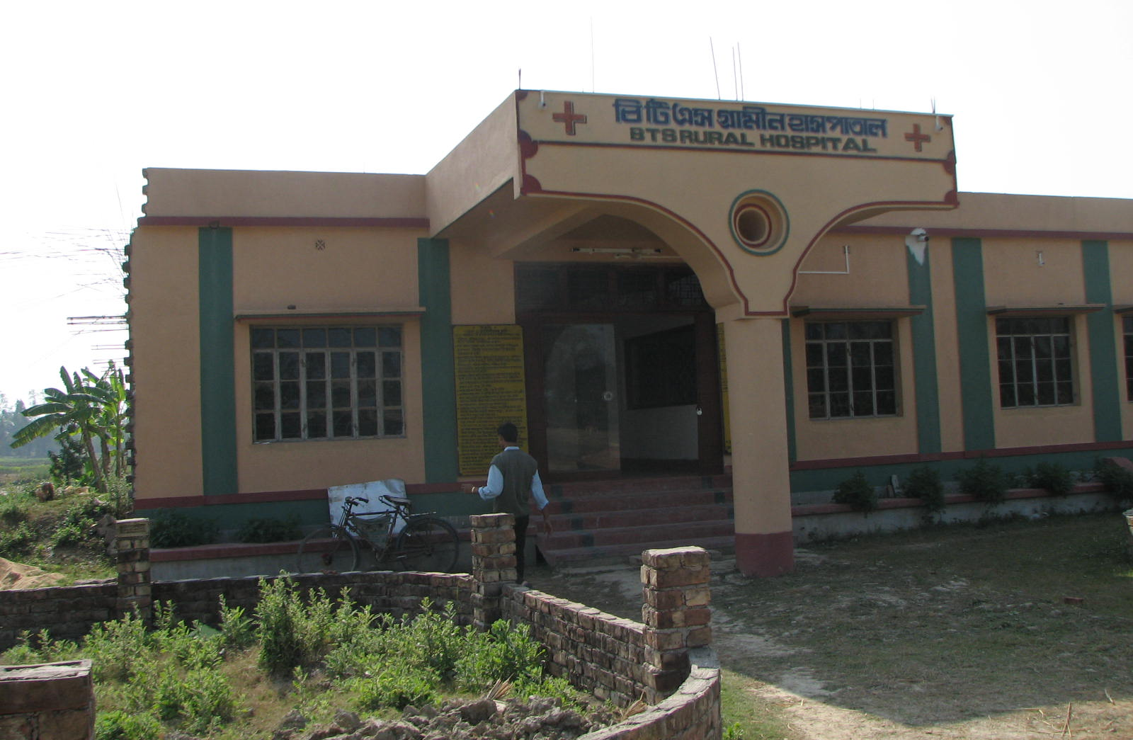

BTS Hospital

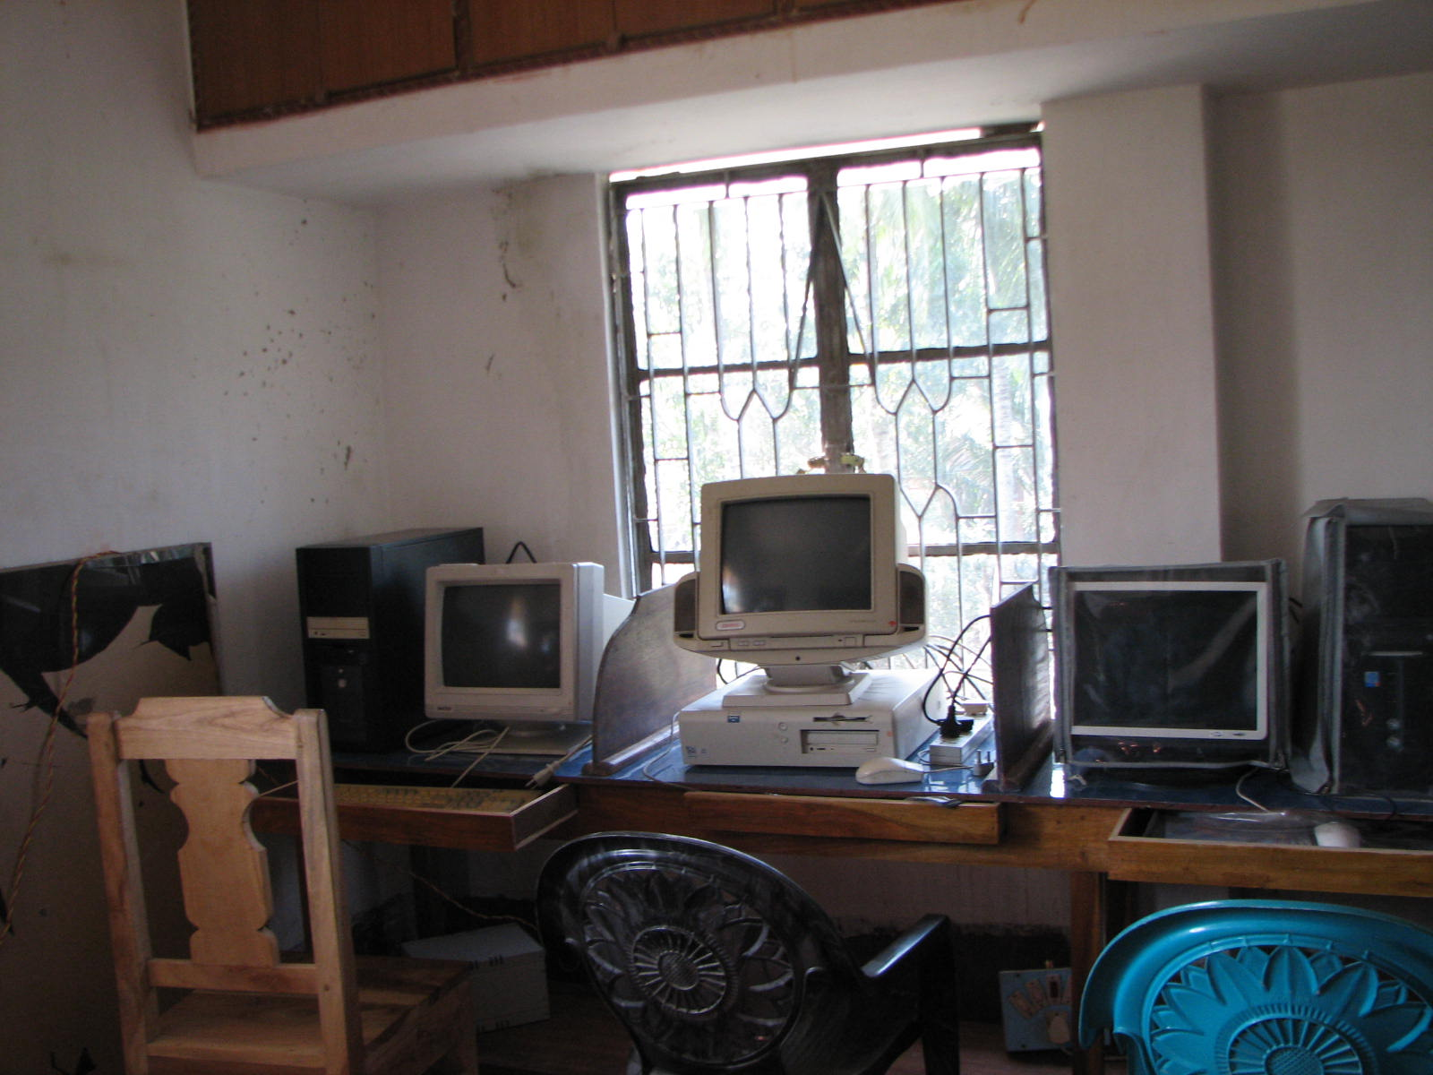
Computer Room
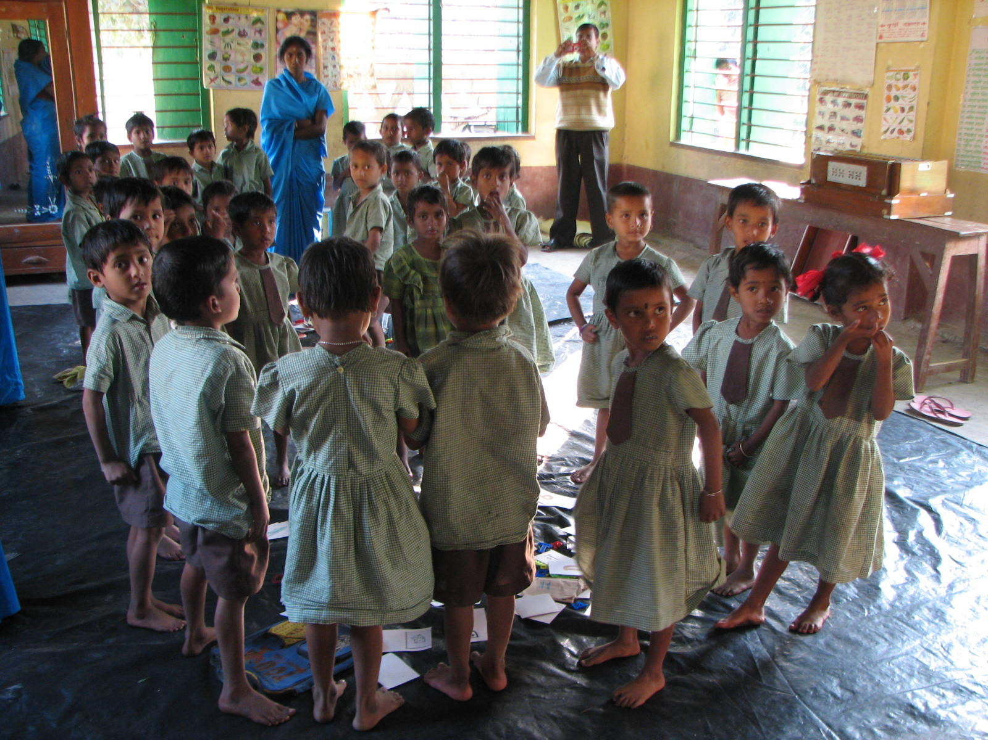
Creche funded by VIBHA

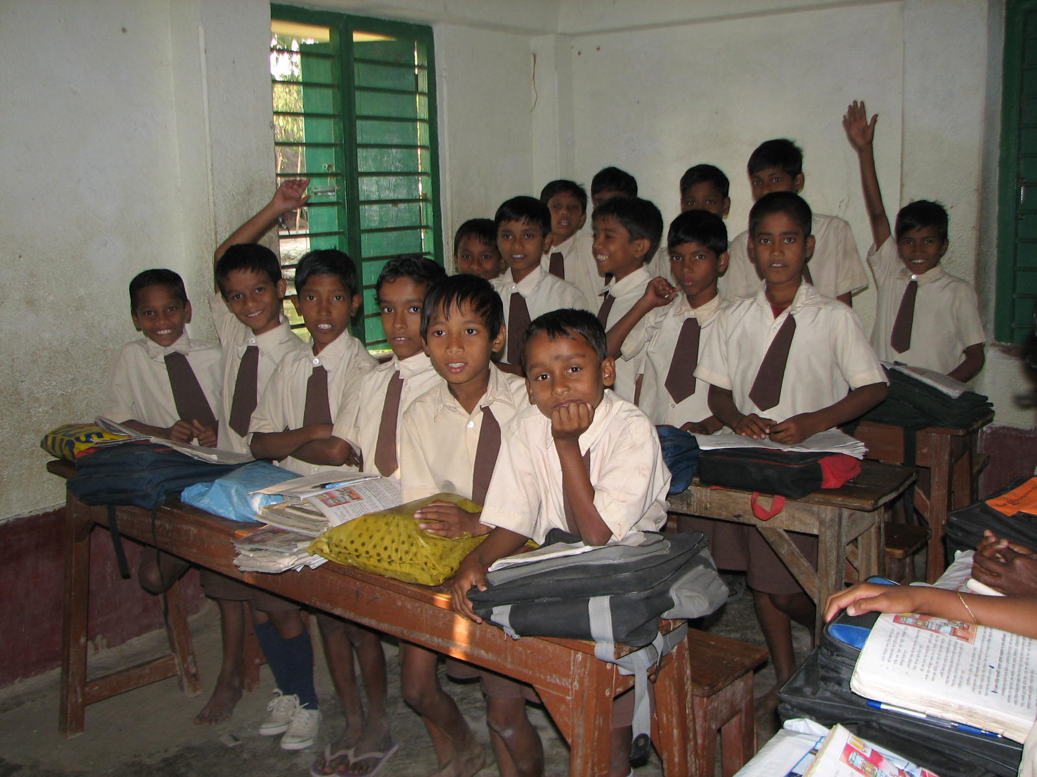

Children in the classes.

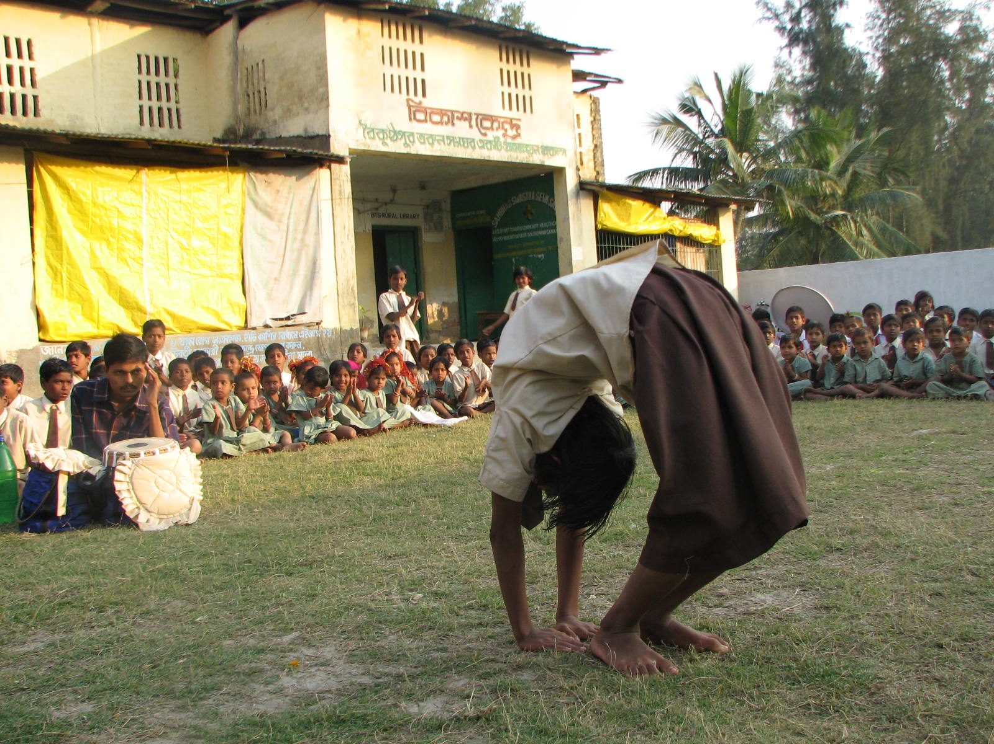

Children performing as a part of Joyful Learning.

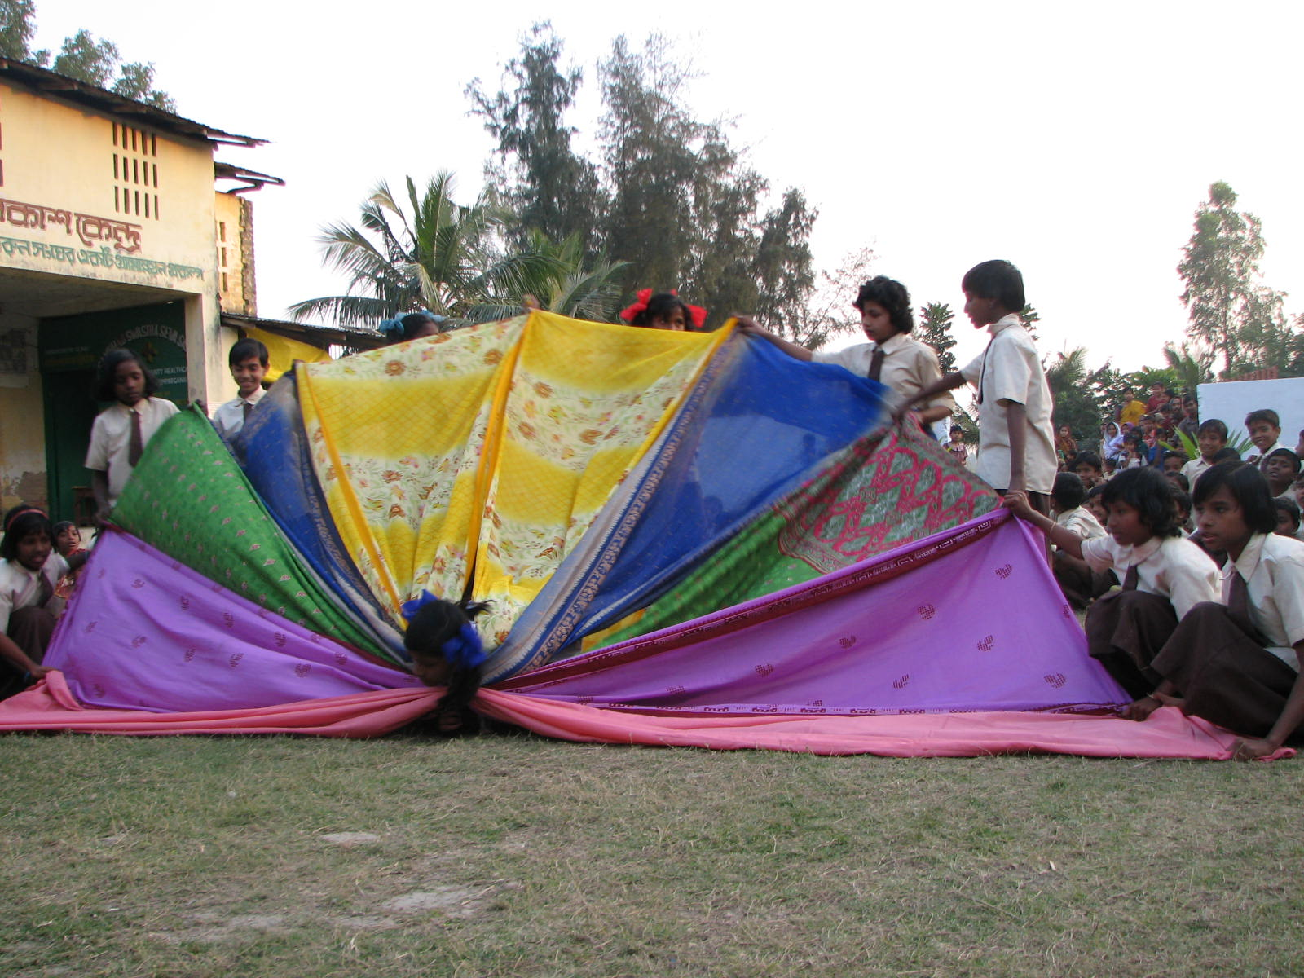

More performing by the children.

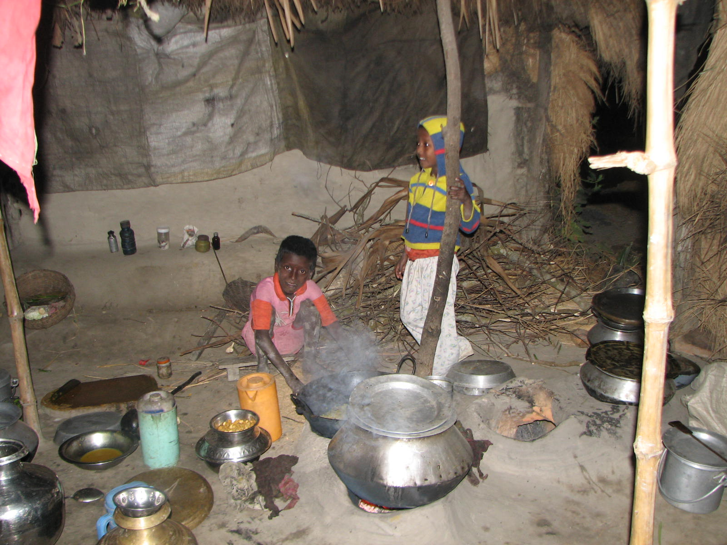

The school children at home

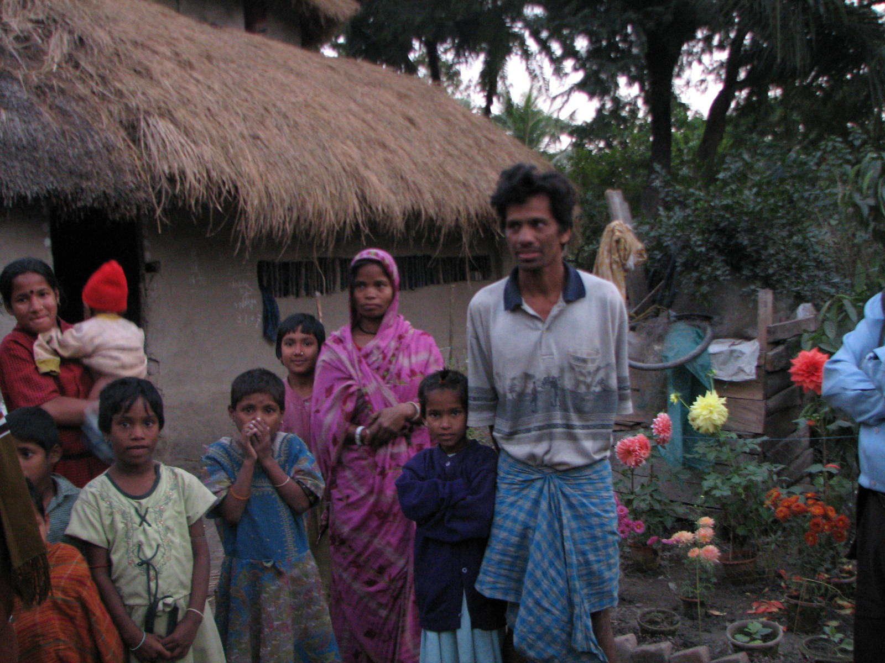

A parent at his home.

