My Trip to Sowbagya Educational Trust – June 15th 2004

I have just returned from a very satisfying summer vacation in Southern India. I was lucky enough to get a month off and I made full use of the time available to travel to Bangalore, Madras and my ancestral villages in Southern Tamil Nadu.

While in Madras, I set off one evening to meet Santhosh, a seventeen year old student who resided in Neelangarai, a fishing village on the outskirts of Madras. I was curious about Santhosh as I knew that he was different from the thousands of other students in the city. He had been adopted by the Sowbagya Educational Trust, a wonderful organization that I shall elaborate on later. My tie to Santhosh was via Asha Silicon Valley’s Support-a-child program. I was his sponsor.  We met in Mrs. Rajagopal’s house, the main driving force behind Sowbagya. Mrs. Rajagopal had briefed me earlier about Santhosh. He apparently was a fast talker, full of questions and was very intelligent. The Santhosh who sat in front of me was the total opposite. He was quite and did not want to make eye contact. | 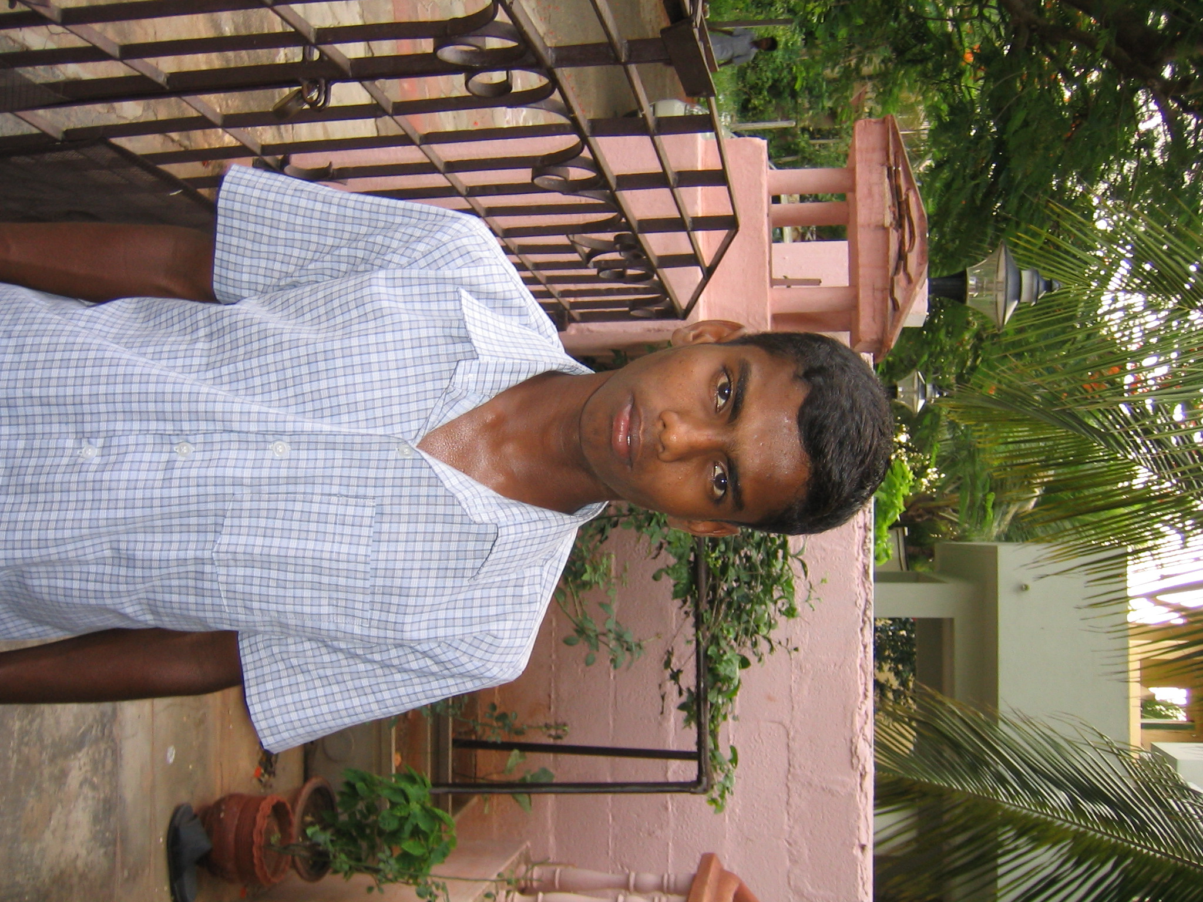 Santhosh
We met in Mrs. Rajagopal’s house, the main driving force behind Sowbagya. Mrs. Rajagopal had briefed me earlier about Santhosh. He apparently was a fast talker, full of questions and was very intelligent. The Santhosh who sat in front of me was the total opposite. He was quite and did not want to make eye contact.

We stepped outside and I cajoled Santhosh into talking about the latest Tamil movie. I asked him what he thought about the “gaana” songs (fast paced folk songs with funny lyrics that are popular among young people) and this seemed to break the ice. We went on to talk about cricket, life in America etc. Santhosh’s ambition was to become a computer engineer. He felt that this profession was well respected and would allow him to become wealthy. In return he would be able to help more people. We also spoke about his routine. After school, Santhosh and all the other kids at Sowbagya have a short break to freshen up before they get together for their evening tuition which lasts from 5 to 7pm. Sowbagya has hired three teachers to help the children with their homework and other assignments. After tuition, these kids go back home, rest and come back to do it all over again. They have only one day in a week to relax.

All this hard work has definitely paid off. Mrs. Rajagopal and Sowbagya have produced State rankholders consistently over the past few years. The lowest aggregate score among 67 students was 72%. Pretty amazing statistics considering the strata of society these kids are from.

At this point, Mrs. Rajagopal asked me if I could talk to a few more kids. I happily agreed and within the next ten minutes to my amazement there were forty kids at her doorstep! There were an equal mix of boys and girls and they ranged in age from 10 to 18. We all got comfortable in Mrs.Rajagopal’s living room and a long round of introductions started. Each child got up and announced his or her name, grade they attended and their ambition in life. The most desired professions were medicine (doctors and nurses) and teaching. A distant third was engineering (thank god!). There were also a few aspiring IAS officers, police inspectors and even a Chief Minister in the room. As we were chatting, I did observe that all the kids were smart and energetic. They all wore clean uniforms and appeared healthy. A few of the kids later sang songs, danced and even recited poetry for us. | 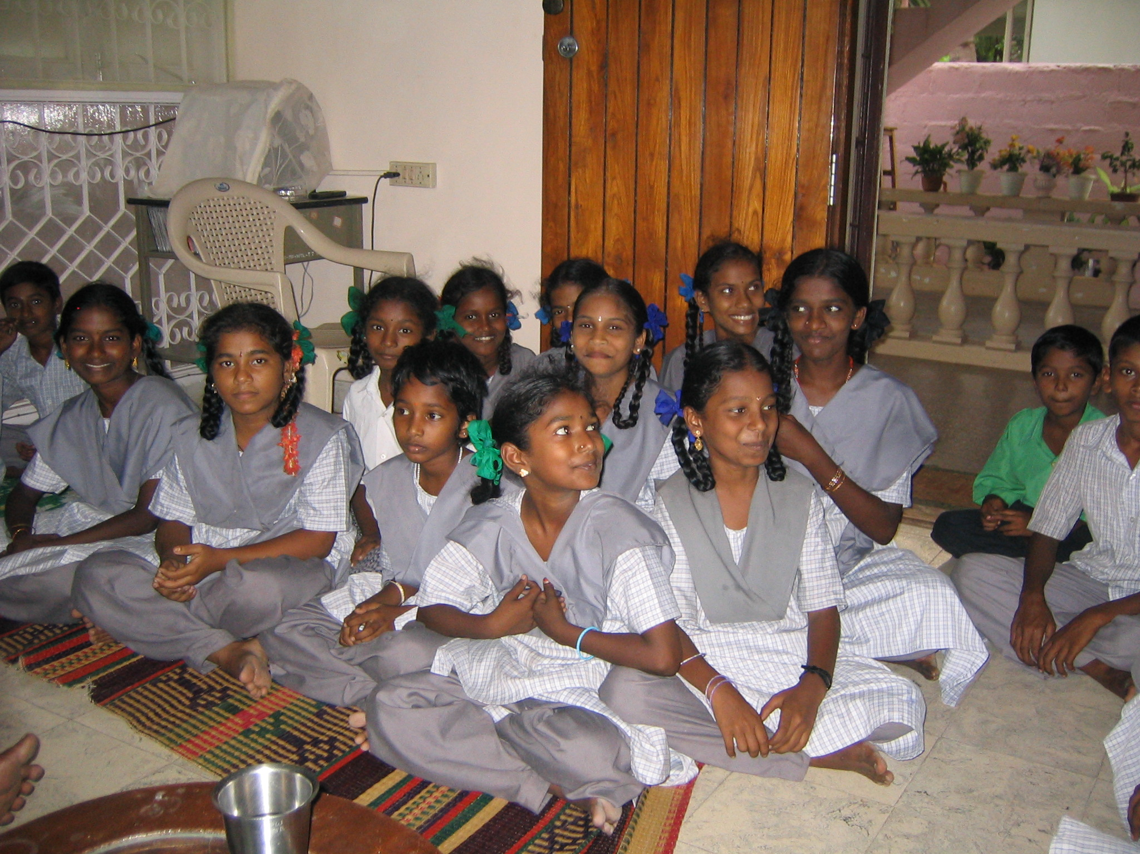
 | 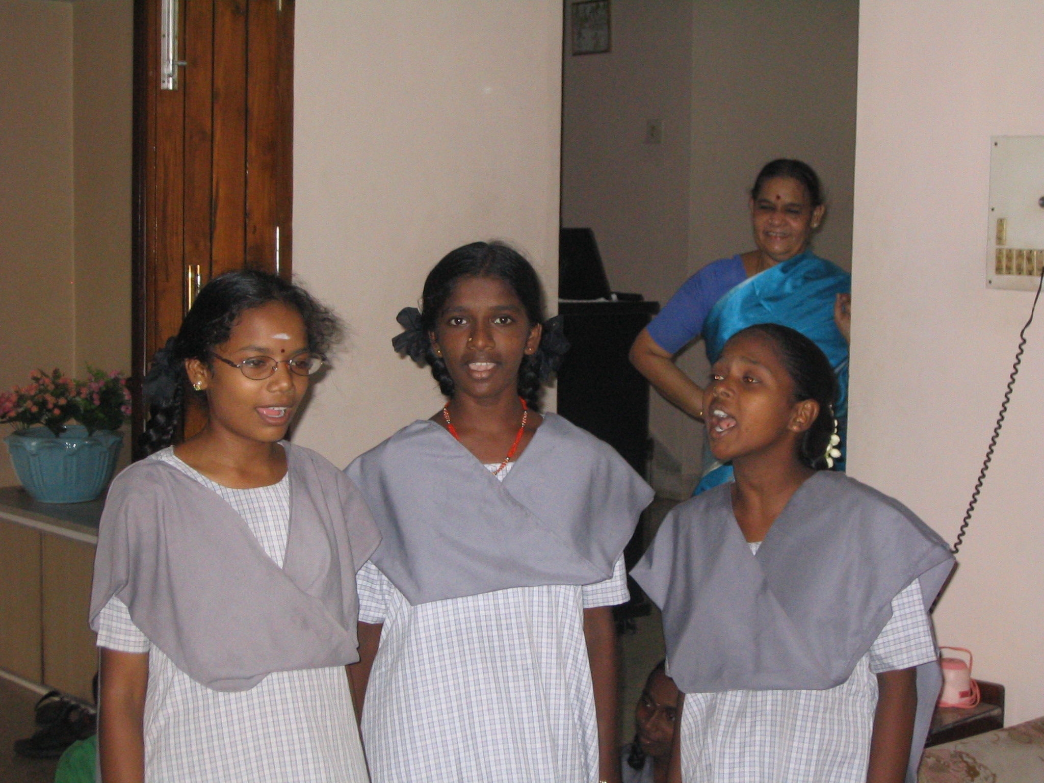
We had to cut short our-impromptu get together as were eating into the children’s tuition hour. The children politely said goodbye and returned to their books. I later had an interesting chat with Mrs.Rajagopal. Her organization (supported by Asha) paid the school fees, paid the teachers, sponsored uniforms and books for sixty seven students. Over the years, Mrs.Rajagopal had turned into a godmother for these kids. She knew each child’s name and family circumstances. In addition to all her work, it was obvious that she had dealt with challenges faced by the children’s families. She had to constantly encourage and motivate these children and their families to stay in school. Mrs.Rajagopal also mentioned that the kids were thrilled to receive letters from their sponsors, especially on their birthdays. So for you sponsors reading this, start writing!

On the drive back home, I experienced several emotions. I was amazed by the work that Mrs.Rajagopal and Sowbagya were doing. In ten years, the kids that I met would support at least two or three kids themselves. Mrs.Rajagopal, Sowbagya and Asha were laying the foundation for a mini social revolution. I also felt happy to have seen so many smiling and eager young faces. Last but not least, I was happy and proud to be a part of Asha. I had been involved only in fund raising programs (Asha HoH ’02 and ’04) and had never interacted with the other side of the organization. This unexpected site visit exposed me to the wonderful work that Asha was doing.

GO ASHA!

