IBT - Electrical and Computer Network project
Objectives:
Apart from the normal way of educating children, Viveka Tribal Centre for Learning has adopted its own criteria of teaching with the innovation of creative ideas to make children understand the subject experiencing the real time objects and learning things practically. The dream comes true by the formation of Introduction to Basic Technology (IBT) unit in the campus.
Teaching criteria:
Inspired by the Vigyan Ashram, Mumbai, our technical trainers prepared the bunch of syllabus in mechanical and electrical fields for the school fellas. Along with the daily academic activities, IBT is also included as routine learning. As a result we found the interest in students increasing day by day and their quick learning ability in technical aspects.
Implementations:
Analyzing their ability we began to assign the small jobs to solve the situations of mechanical and electrical things inside the campus along with their instructors. As a result, today we do not need technicians from outside to solve simple issues andmaintenance of campus.
Outcome:
After certain tests, today we are assigning the jobs to themselves as project works, here the group themselves design the needs of electrical and mechanical work, choose the materials and fix it without causing any damages and also by taking care about themselves.
Achievement:
This year we got an opportunity to work with Lokalexprogramme, Mr.Rajaram and Miss. Shashwati from Chennai approached the school and provided materials required for teaching through internet. We are supposed to arrange well furnished area to run this class. We gave this chance to students of class 10 as project work.
Students happily grabbed this opportunity and started working on it. They took the guidance from Mr. Byrashetty for solving electrical issues like grounding, wiring and designing the circuits. Then Mr. Ajay thought them about networking for computer systems. Within a mean time of less thanday students finished the job successfully and created the classroom for Skype based learning, Networking for office room, support service and D.Ed college.

Students Experience:
Students were very happy after this project, they say, even though they missed their regular academic classes for the day, they got the work experience of the particular area in which they are interested. They want to pursue their higher studies in the same field. Apart from all these they said they are capable of handling this type of issues at their daily life inside their homes and in their village. This avoids the waiting time for technicians from outside.
Glimpse of students work:
- Networking and LAN
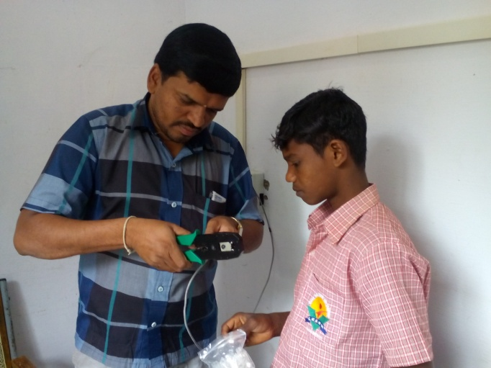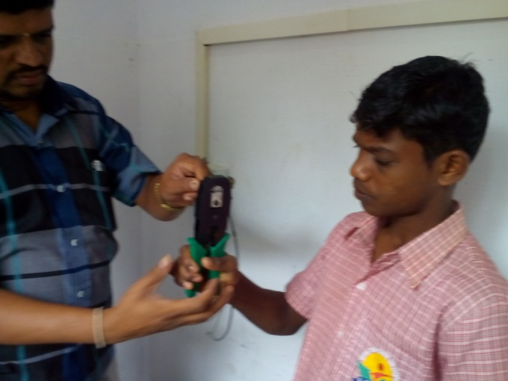

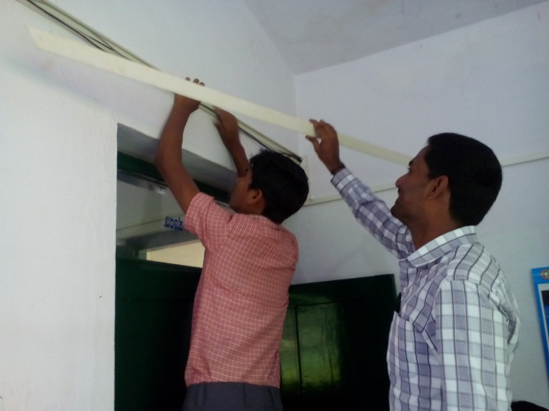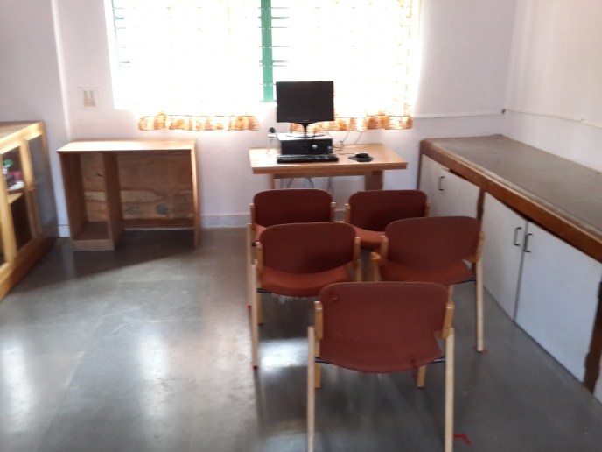

- Wiring and grounding works:
