BCT Tailoring and Garment Making Unit for Women Newly Launched

In Attendance:
Mr. and Mrs. Governor Rtn. M.C. Das (Dist 3020)
President, Rtn. Satya Murthy (Waltair)
Incoming President, Rtn. Praveen Sankhila (Waltair)
Secretary, Mrs. Kanaka Valli
Rtn. PHF. M.V. Soma Sekhar
Rtn. A. Srinivasa Rao (project in charge)
Past President, Rtn. Shiela Jackson (Waltair)
Past Governor, Rtn. PDG.G. Jaya Rao (Dist 315/3020)
Incoming Secretary, Rtn. D.V. Phanindra (Waltair)
Sreenivasa Rao, BCT Joint Secretary and Chief Liaison Chairman
Further Rotarian and BCT Staff
And the young leaders of BCT, Sanjeev Prasad and Sri Ram Murty
. . . . . . . . . . . . . . . . . . . . . . . . . . . . . . . . . . . . . . . . . .

On June 26, 2006, BCT launched its new Tailoring and Garment Making Unit for Women, with funding assistance of $10,000 by Toledo Rotary Foundation, Ohio, USA.

At the opening event, students from the BCT model high school presented a small skit to illustrate how they transform village members into responsible citizens, and encourage every child in the village to attend school. In addition to academic studies, these children also learn vocational skills to be used later in life. One of these vocational skills, the chakra (or spinning wheel), is a key step in "total process" tailoring, working from cotton to cloth, and was also presented by the students.

Mr. Sreenivasa Rao welcomed the gathering and explained the association between BCT, ASHA for Education, and the Rotary Foundation of Toledo, saying, "This is a unique program, a partnership of two great countries, working for the livelihood of the common man by giving appropriate skills." He complemented the AASHA team for their leadership and the warm hearts of the Rotarians. He explained to visitors that although the program is intended for women, on this day he also brought boys from the skill training program for the physically challenged. In this way, visitors could see how BCT is giving life skills to all people belonging to all classes, including those who are challenged.

Rotarian M.C.Das expressed his happiness both in inaugurating the program, and in seeing the Rotary play its part in giving life skills to the people. He congratulated the children's skit and announced he would donate Rs. 5000 and a Pentium computer system to the school.

Rotarian Srinivasa said it was an honor for the Rotorian club of Waltair to work with BCT, who has been doing commendable work in rural development for 30 years. He added that BCT leaders Dr. BV Parameswara Rao and Sreenivasa Rao left prestigious positions in the community to do the work of BCT, and are outstanding role models for all.

Rotarian President Satya Murthy added that the Rotarian Club of Waltair was honored to have become a partner with BCT.

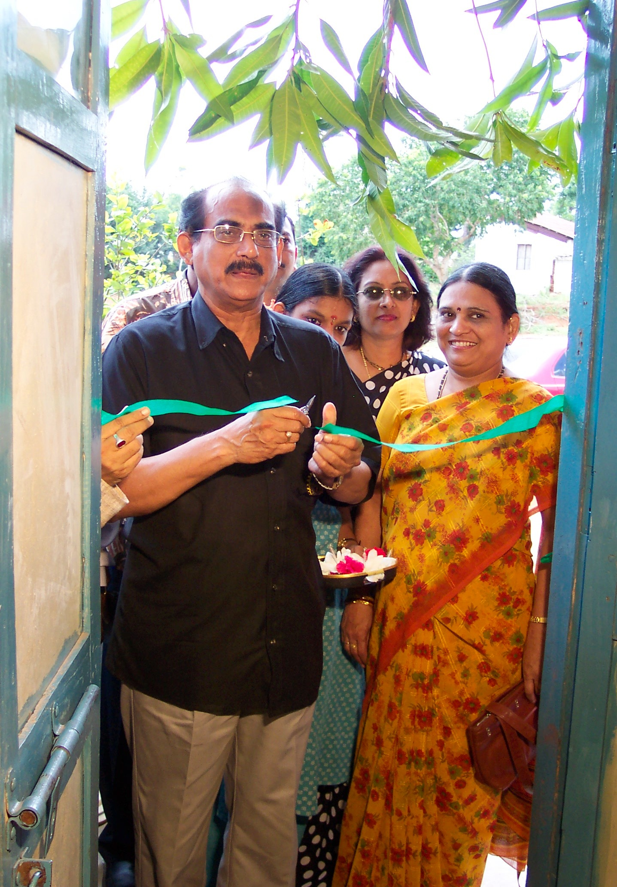

Rotarian M.C.Das inaugurating the tailoring and dress making unit.
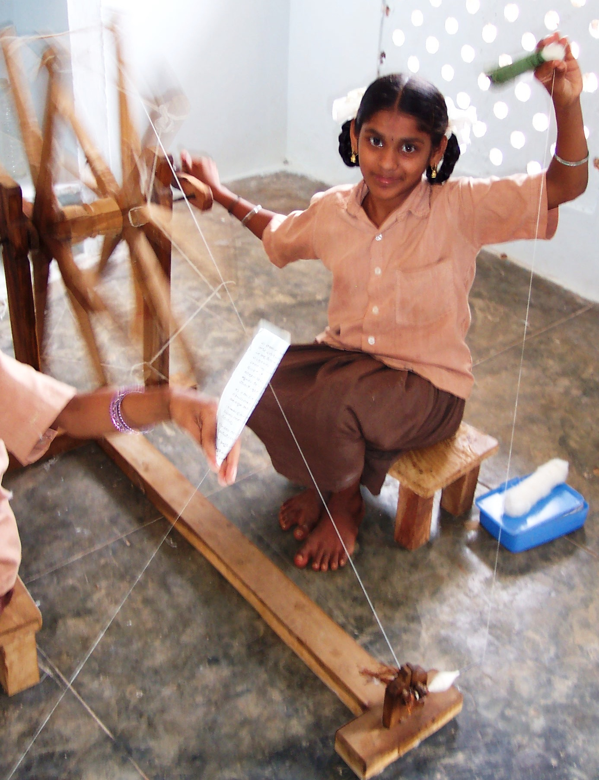

A girl demonstrating how thread is made from cotton using spinning wheels.
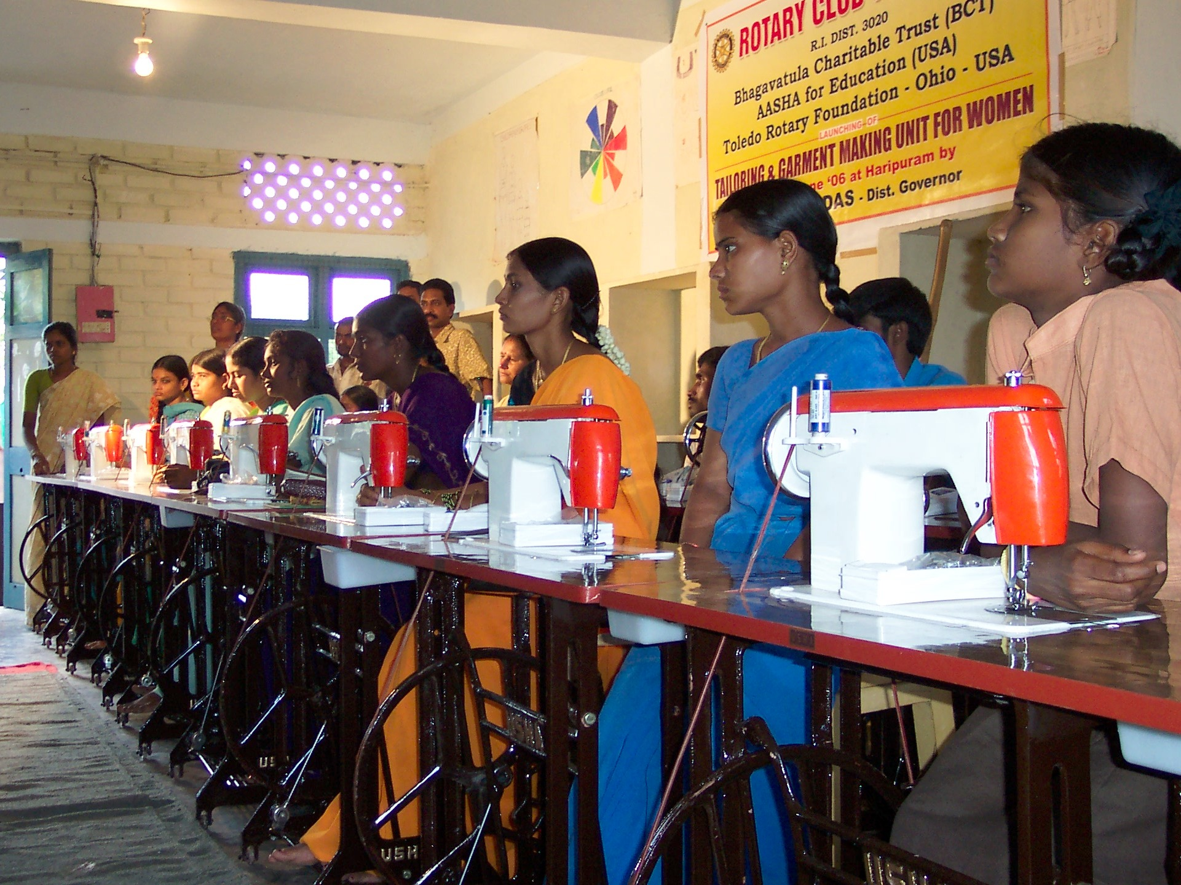

Young women of nearby villages and physically challenged men join the tailoring unit and are present at the inauguration.



