Public Announcement of Toledo Rotary Foundation’s Grant in Waltair.
11th March 2006

District Governor, Rtn., M. C. Das on his goodwill visit to Rotary Club of Waltair, gave his good wishes and announced Toledo Rotary Foundation’s grant of 10,000$ to Asha For Education, Toledo chapter for project ‘Confidence’ to be carried out in collaboration with Bhaghvatula Charitable Trust (BCT) and in association with Rotary Club of Waltair. This public meetinging took place on 4th March 2006, at Lazarus Hall, Hotel Executive Court, Vishakhapatnam. Approx. 100 people attended the meeting. Rotary Club of Waltair and other members, also thanked Sreenivasa Rao (BCT) for giving them this opportunity to work with BCT, which has national recognition. Both Rtn. Satya Murthy, President of the Club and Rtn. Srinivas, the contact person for this project spoke very highly of BCT's contribution for integrated rural development in the country and its pioneering projects, which have become examples for National Programmes later: the sacrifices and commitment of the Founder Dr. B.V. Parameswara Rao; and felt that it is a honour for the Club to become a part of a project of " Rotary - Asha for Education – BCT” for imparting Life Skills to rural brethern and their gratefulness to Rotary Foundation of Toledo.
The District Governor Rtn. Das felt extremely happy that the Toledo Rotarians gave the Waltair Club this privilege to help the rural brethern acquire life skills to lead a happy life ...he was all the more surprised the speed at which this entire programme is becoming a reality. He readily agreed to my request to be present for the inauguration of the programme ...he said it would be his pleasure to personally see the international brotherhood, in reality.
Attached is a photo of the same and a letter of appreciation from Rotary Club of Waltair.
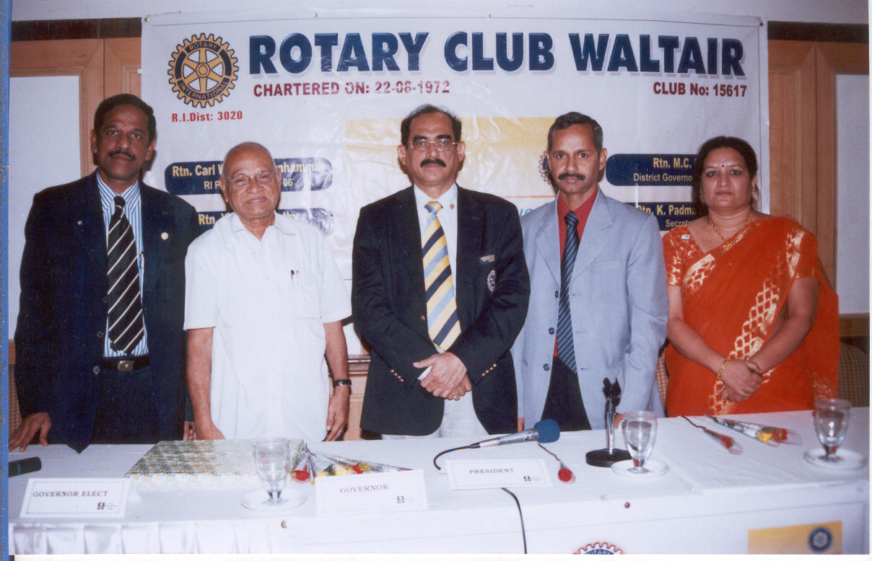

Left to Right: Rtn. A. Srinivas (Contact person of Rotary Club of Waltair)
Mr. B .V .Sreenivasa Rao ( of B.C.T )
Rtn. M. C. Das , District Governor , R.I. Dist. 3020
Rtn. Y. Satya Murthy ( President, Rotary Club of Waltair )
Rtn. K. Padma Sagari ( Secretary, Rotary Club of Waltair )



