Visit to Kuvempu Centers
A report by Srikanth Voorakaranam (Asha-Bangalore)

Aditya and myself from Asha-Bangalore visited Chitradurga on September 4.

Chitradurga is about a 4.5 hour drive from Bangalore, made longer by the long lines of trucks that are parked on the road-side eating up half the road area. We left early on Saturday morning and got to Chitradurga by about 10AM.

We met Prakash, Rudresh, Lokesh, Murthy and other friends at the Kuvempu office in Shivaganga. The group got formally registered as a trust a few yrs back. We saw the photographs of the activities of the last year which included tree plantations, exposure visits to teachers, cultural troupe performances, vocational units and teacher training programs.

The cultural troupe (Kala Jatha) has been practicing diligently and have so far put up 3 performances (on different social issues), which were apparently well-attended. The troupe is mostly comprised of the teachers of the Kuvempu centers, with some outside participation.

We first visited the govt school (Saturday being a half-working day for the school). This has classes till VII and is located quite close to the Kuvempu office. (Children passing from here go a few kilometers to the high school for higher studies). A good relationship has been established with the school. The school and Kuvempu had gotten the children to plant trees in the school ground. Each child now has a tree which they tend to. Kuvempu has also appointed a Hindi teacher for the school at the request of the school authorities and the children since there was nobody on the school staff to teach the subject. We were also shown some learning material (such as wooden alphabets, some boards to demonstrate place value). The teachers are apparently provided training on using them, but whether they are made regular use of in the classrooms is not very clear.

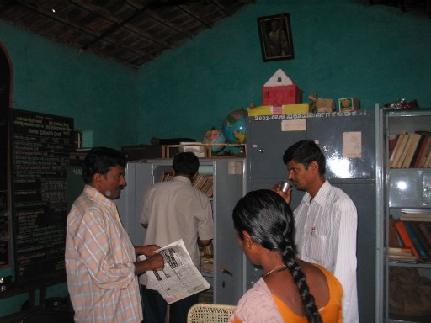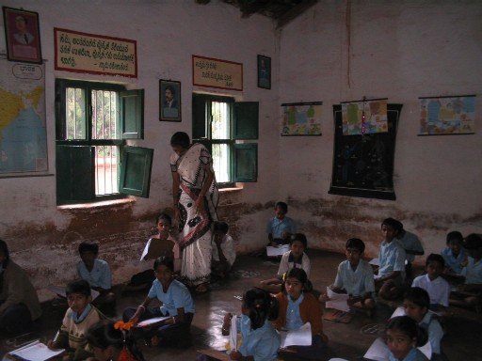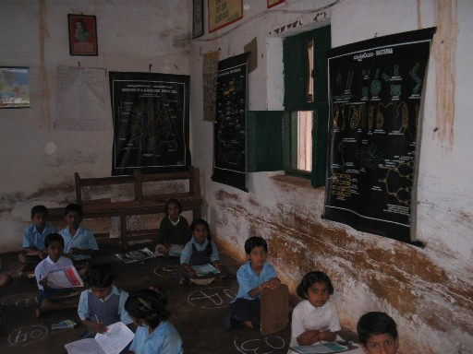

We also visited the house of 2 children (Rudra and Santosh) suffering from Haemophilia. Kuvempu had been helping them in different ways. A special vehicle has been provided that Rudresh uses to drive himself and Santosh to the school.

After the visit to the school, we visited Prakash’s farm and got to see his plantations of Areca Nut (this is areca country), Toor Dal, Corn and Coconut, and talked about the various crops, economics of agriculture, water availability etc (a very educational experience for city folks like us who have very little knowledge on much of these).

Vocational Training Units:
The tailoring unit seems to be going on smoothly. There are 40 women who come in different batches and get the training. One training session is of 6 months duration. One usually would have to complete 2 such training sessions to become reasonably proficient.

The candle making and agarbatti training hadn’t taken off. The screen printing unit had also been shut down recently. Rudresh who was handling the unit mainly will be joining Ravi Aluganti in Madanapalli to help out there.

Teacher Training:
The sessions that Ravi Aluganti had organized in the use of art and craft for the Kuvempu team are coming in handy I think. Rudresh had made several sets of alphabets out of wood, and then painted them with colors. The expertise with which these were made was fantastic.There is also a plan to have some of the teachers visit Madanapalli.

Children’s Picnic
In the afternoon, we went to a park located on the Chitradurga-Shimoga route. Older Children from 4-5 centers, along with their center teachers, had gone on a picnic there. Some of the games they were playing had some small aspects of learning (say, in Mathematics), incorporated into them. The close relationship between the teachers and children was quite apparent. It was quite touching when the children vied with one another to offer us a share of the food that they had brought along with them.

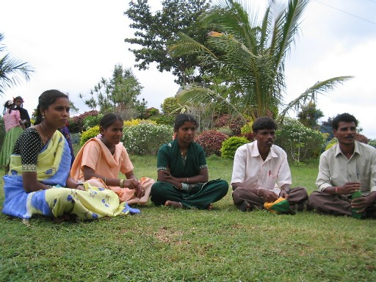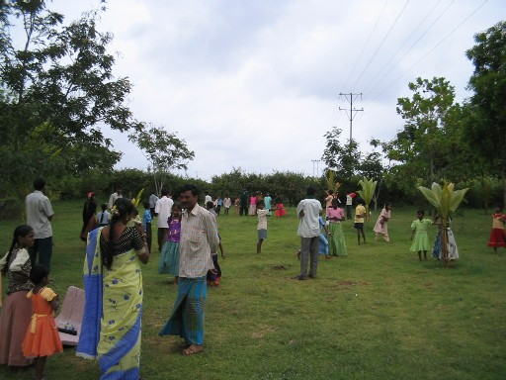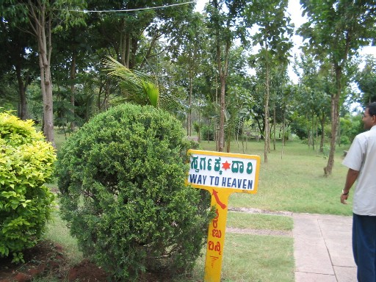

Some of the teachers also double up as community-organizers. They help people get old-age pensions etc.

Visit to Tuition Centers
In the evening, we visited a few of the after-school tuition centers, which is the focus of Asha and Kuvempu’s efforts. The teachers are mostly locals from those areas itself. The education coordinator travels every day to a few centers to take stock (apparently the motorcycle purchased recently is coming in handy for these).

Center 1: This seemed to be the biggest one, and had two teachers. The children put up a number of cultural programs (songs, dances, plays depicting social issues such as alcoholism, superstition etc). The lighting is through a connection from the electricity line. It is fairly reliable in the rainy season, but is subject to severe power cuts during the hotter months. Alternatives (such as solar lanterns) will need to be explored for that time
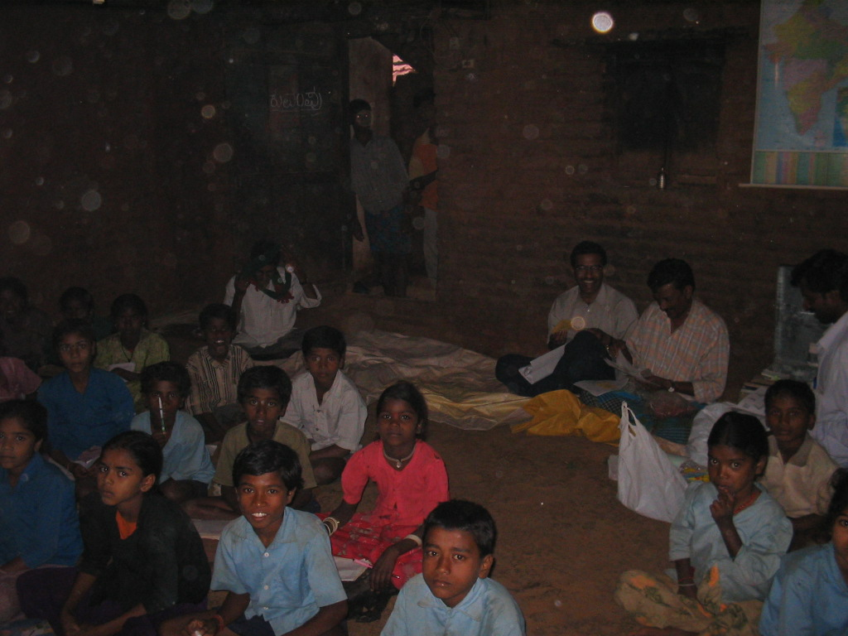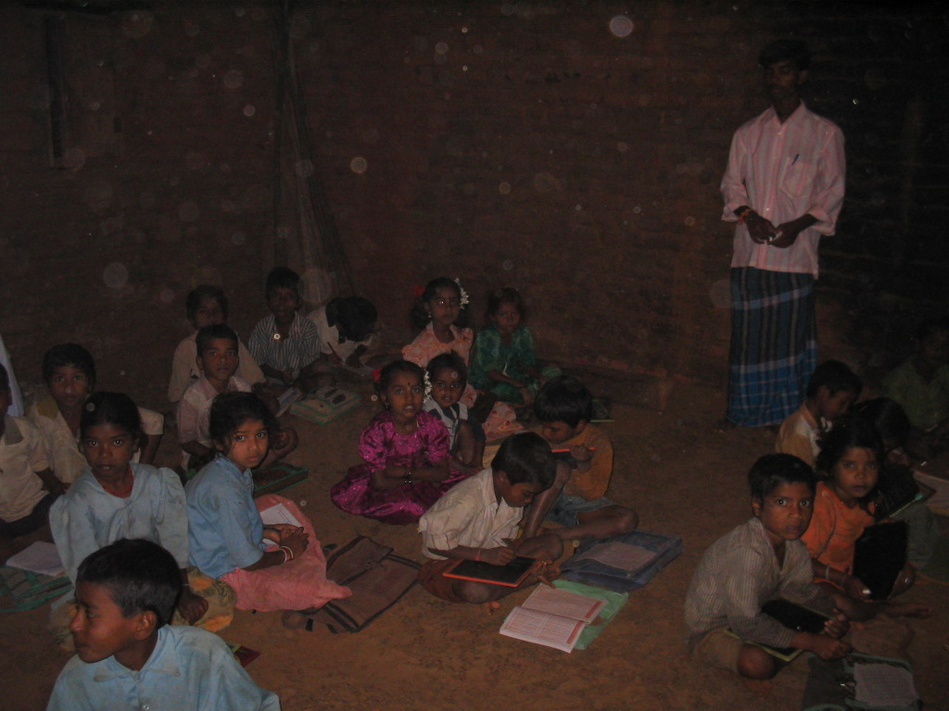

Center 2: Since this perhaps had greater strength, it was split up into two.

The teacher for the first group is on maternity leave. Her husband is taking the classes till the time she can get back. The attendance at this center was somewhat low. Apparently, many members in the community had gone on a visit to a famous temple for Shani in the vicinity (that being a Saturday). We spent some time with the children going over the India Map and correlating the different states with the words in the national anthem, which was sung a bit prior to that.

The second center was held in another teacher’s house. Most of the children here were of the smaller age group. The room appeared pretty cramped for space with the number of children there.

As we were leaving, several children stopped our car and tied rachis to our hands- again a touching moment.
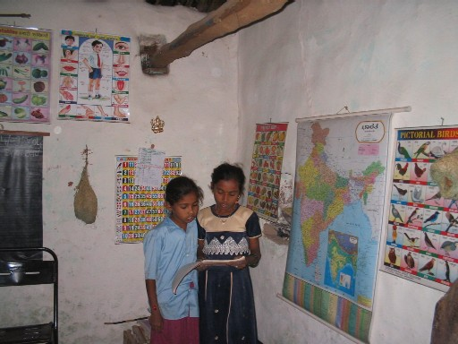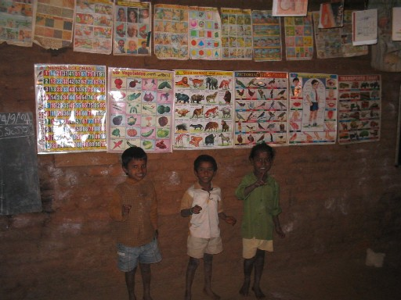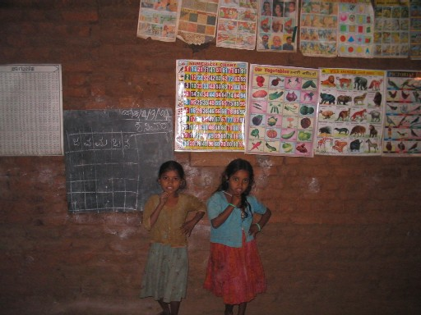

Center 3: This center was closed when we got there, the visit to the Shani temple again being the reason.

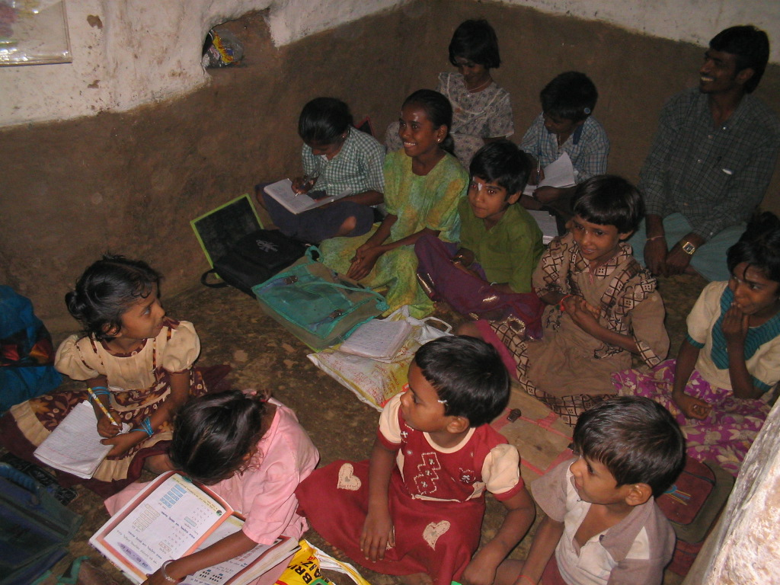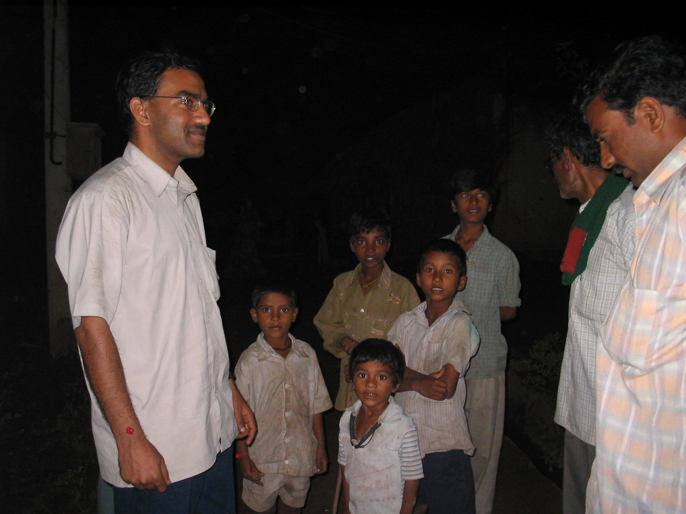

Center 4: We finally returned to the Kuvempu office at around 8 PM. There is a center located right next to it. Lokesh was taking this class. The class was covering the theory of vowels, consonants etc.

We also had a good discussion with the children on the relevance of various special days (such as Sept 5, Aug 15, Oct 2, Nov 14th etc).

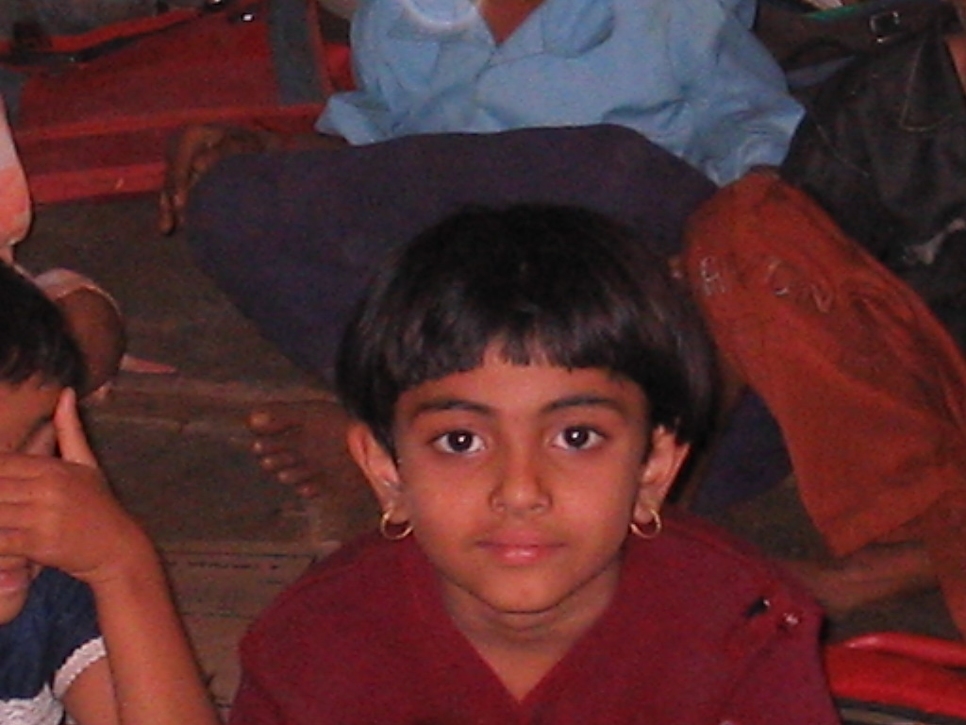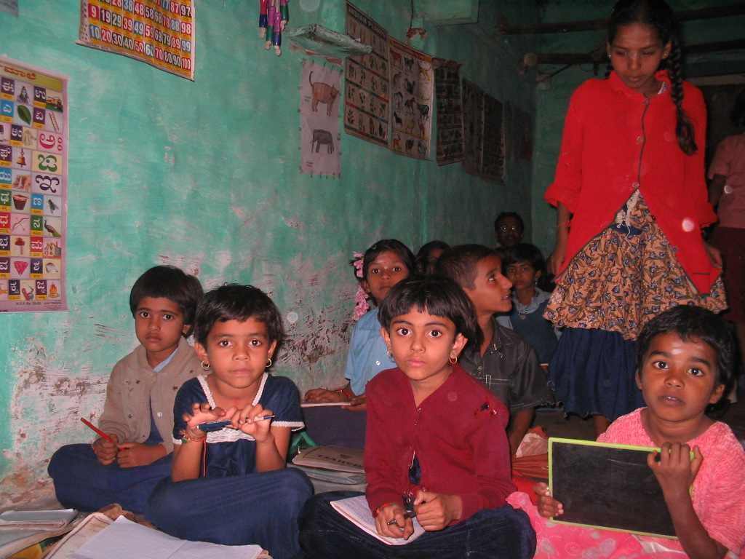

Conclusion
Providing provision for giving sewing machines to 5-6 women in the community can help them get started with their small businesses. They can be asked to repay a nominal amount every year which could add up over a period of time to get more of such machines.

Prakash also requested whether a support-a-child type of program can be instituted. There are several children who are orphans who could benefit through such a program.

The centers are playing an important role in nurturing a school-going and learning culture among the children from this area, many of them first generation learners. Their main strength is the empathy they share with the children (the teachers also being from the same community for the most part) and their motivation. Since the education levels of the teachers themselves is not very high, exposing them to as many training opportunities as possible would be useful.

We conveyed to Prakash that they should send a break down of the accounts just for the Asha-supported initiatives to the Silicon Valley chapter, and also the requirements for the next year. He will be following up on that.

Currently, funding is sourced to Kuvempu through Bharathi Trust. Depending on the need, they can look into getting their own 80 (G).

Infrastructure at some of the centers such as the rooms could use some enhancements to provide more space for the children. Options like Solar lamps should also be explored to provide lighting arrangements in the centers during power-cut months.

Recommendation
Asha should continue the support being provided to the Kuvempu tuition centers. Other aspects such as providing sewing machines to a few women in the community and augmenting the infrastructure (rooms, as well as facilities such as lighting) should be seriously considered.

