Sikshana Site Visit By Sudhi Gulur
Dec 22nd, 2011
I went along with Prasanna Vadayar, the CEO of Sikshana, to visit one of the Asha (Seattle) sponsored schools in the Kanakapura taluk near Bangalore. I am a big fan of continuous learning and giving back to the community and am hence was excited about this interaction with Sikshana team and the school kids. We first arrived at the Sikshana office in Kanakapura.
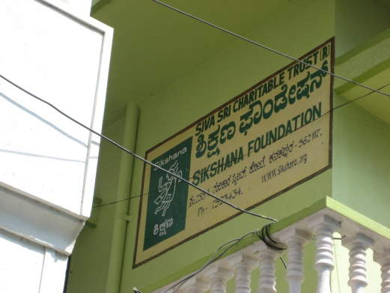
This is the office from where the local Sikshana volunteers and mentors serve the nearby schools. Prasanna pointed me to the school performance charts maintained by each mentor.
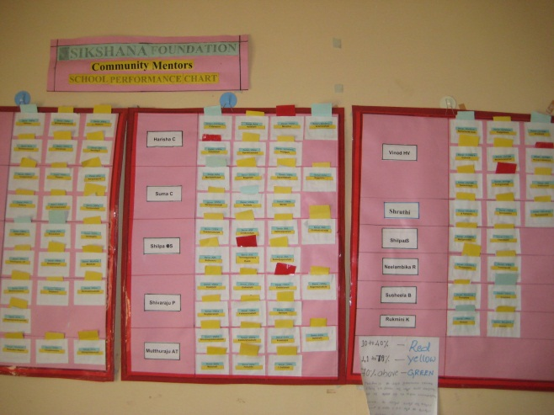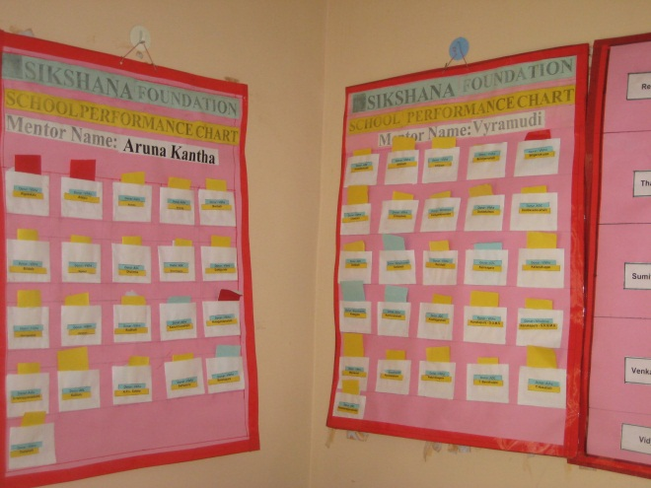
These visual charts (inspired by the Toyota Kanban system) with red, yellow, green status cards capture the health of the school as assessed by the mentor. The red, yellow, green status is actually a composite assessment and has been designed so to eliminate potential subjective assessments by the mentors. It also provides an opportunity for the mentors to have a conversation and share their assessment of the schools with other mentors. From the office we then went to a nearby building where the mentors were being trained on facilitation skills. The goal here was to impart the critical soft skills and empower the mentors to bring out the best in the situations they come across. The training was being offered by VSET, a Kerala-based non-government organization. Sikshana planned to train a core set of mentors and empower them to offer the same training to rest of the mentors. We were then joined by Kiran, one of the mentors and Aneesh, Sikshana team resource head. We then proceeded to the nearest school in Shivanahalli School in Kanakapura district.
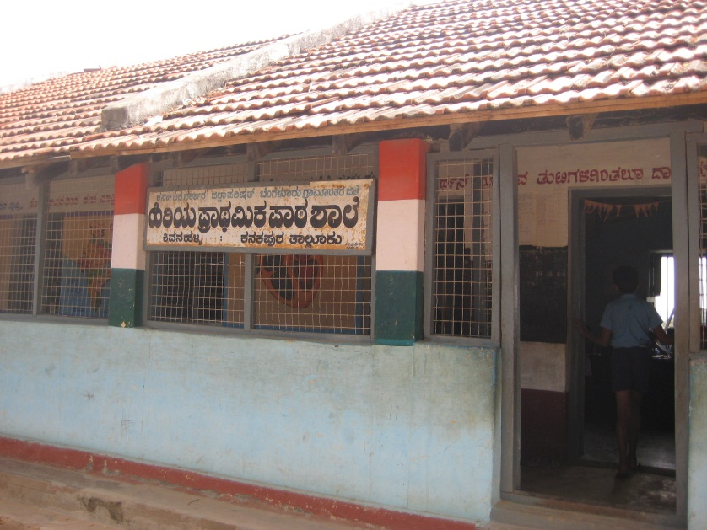
Kiran led us to one of the class rooms in the school. We watched from the back of the room as Kiran effectively engaged with the students with lively questions and activities that involved the students. The concept of mentors as role models was apparent in that interaction.
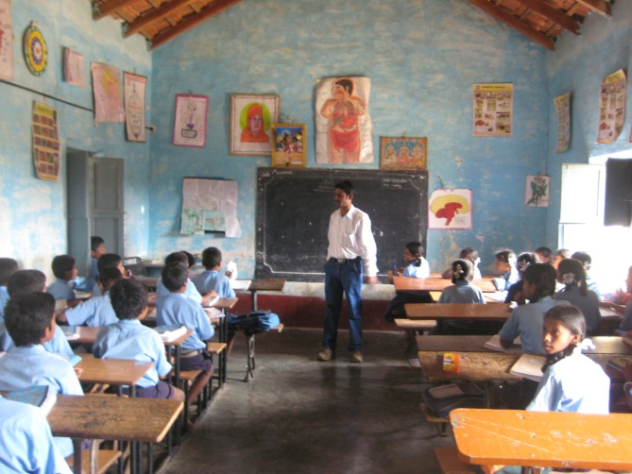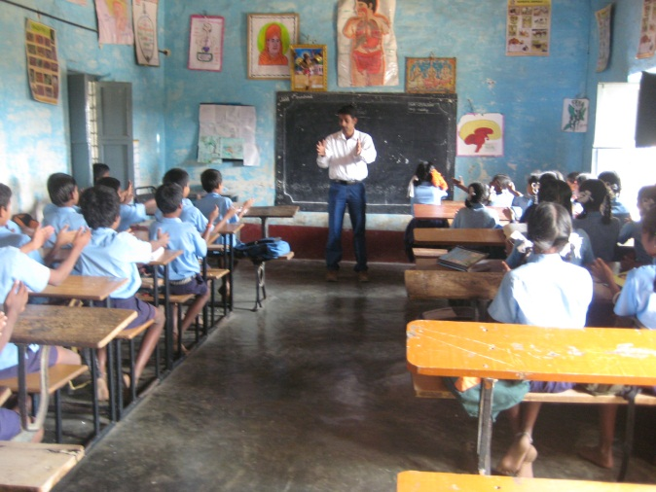
The teacher shared with us the progress and writings of few of the kids as captured in the student diary provided by Sikshana. In the class there were also postings of good handwriting and drawings from the kids on Sikshana sponsored paper.
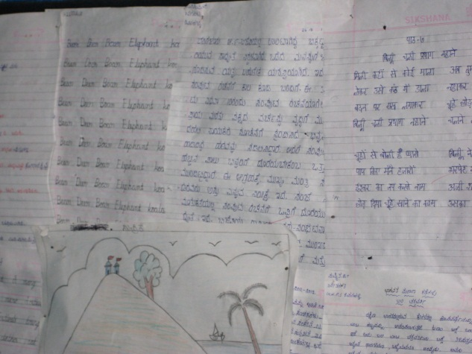
As this was my first interaction with the Sikshana team I asked them about the sustaining model. Prasanna’s vision for Sikhana is not to continuously provide supporting funds and supplies for “established” schools but instead build support from within the community (by reaching out to the village teachers, panchayat etc) to support the school efforts so that there is a more organic support system that sustains itself without Sikshana’s support. Prasanna then asked me to speak few words with the students and encouraged them to ask me questions about Boeing, airplanes etc. They were very inquisitive and wanted to know how airplanes fly, how much is the cost of an airplane, how much education must one have etc. I have to say I had a memorable time interacting with those kids for almost ½ hr.
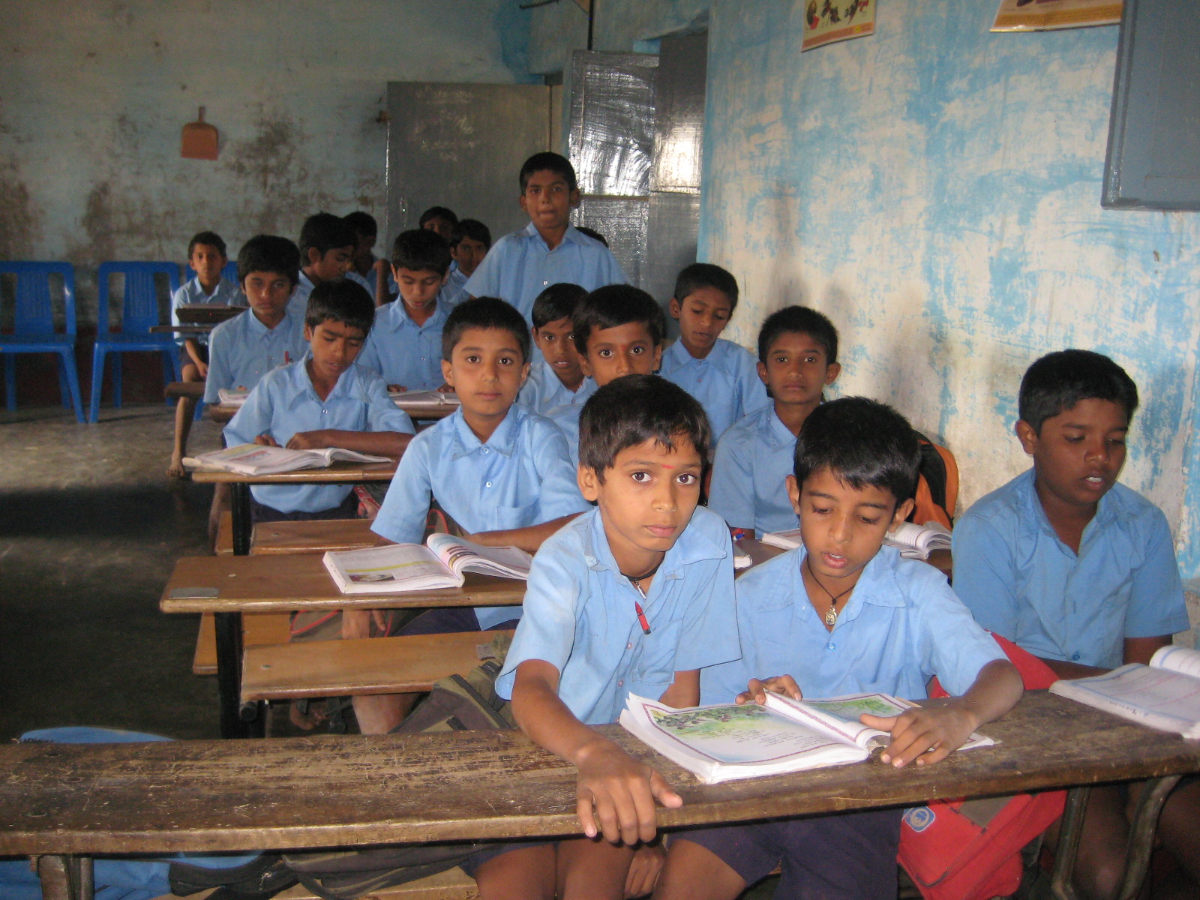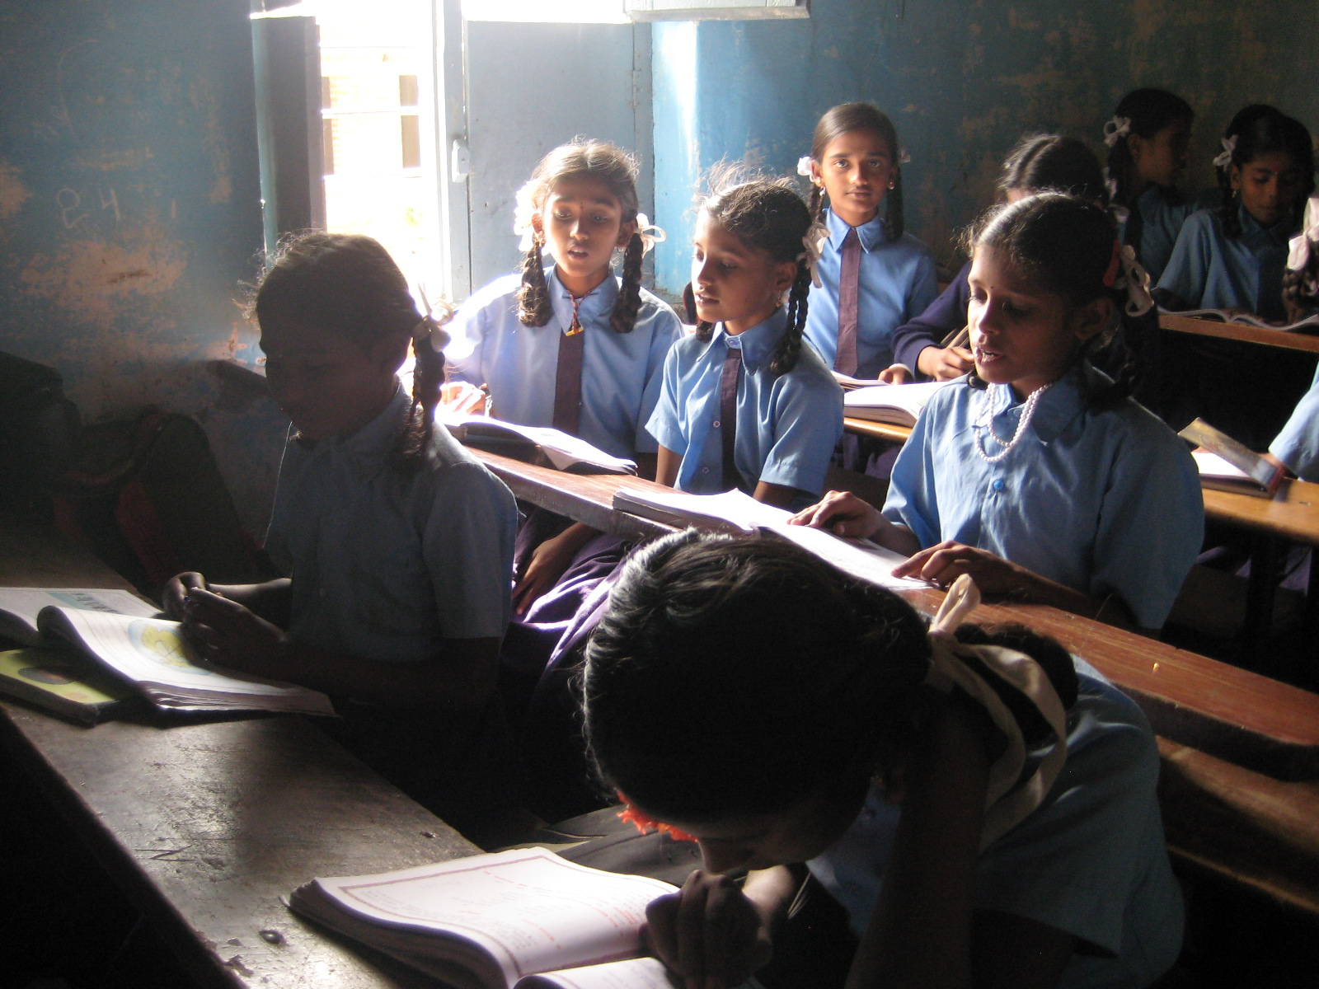
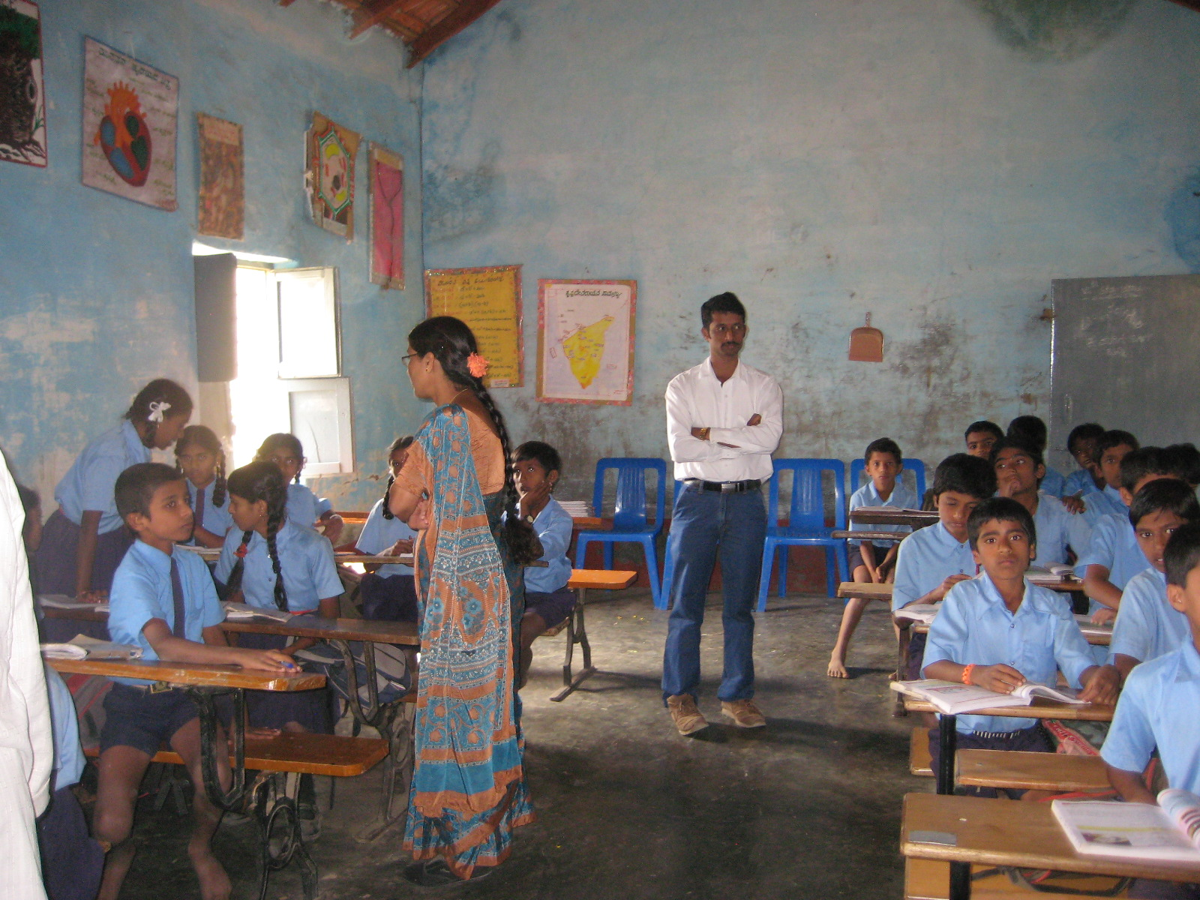
We then proceeded to the library where we found several children reading. Prasanna shared with me that children themselves had come up with the idea of “sharing” the synopsis of their readings by hanging them across the library room.
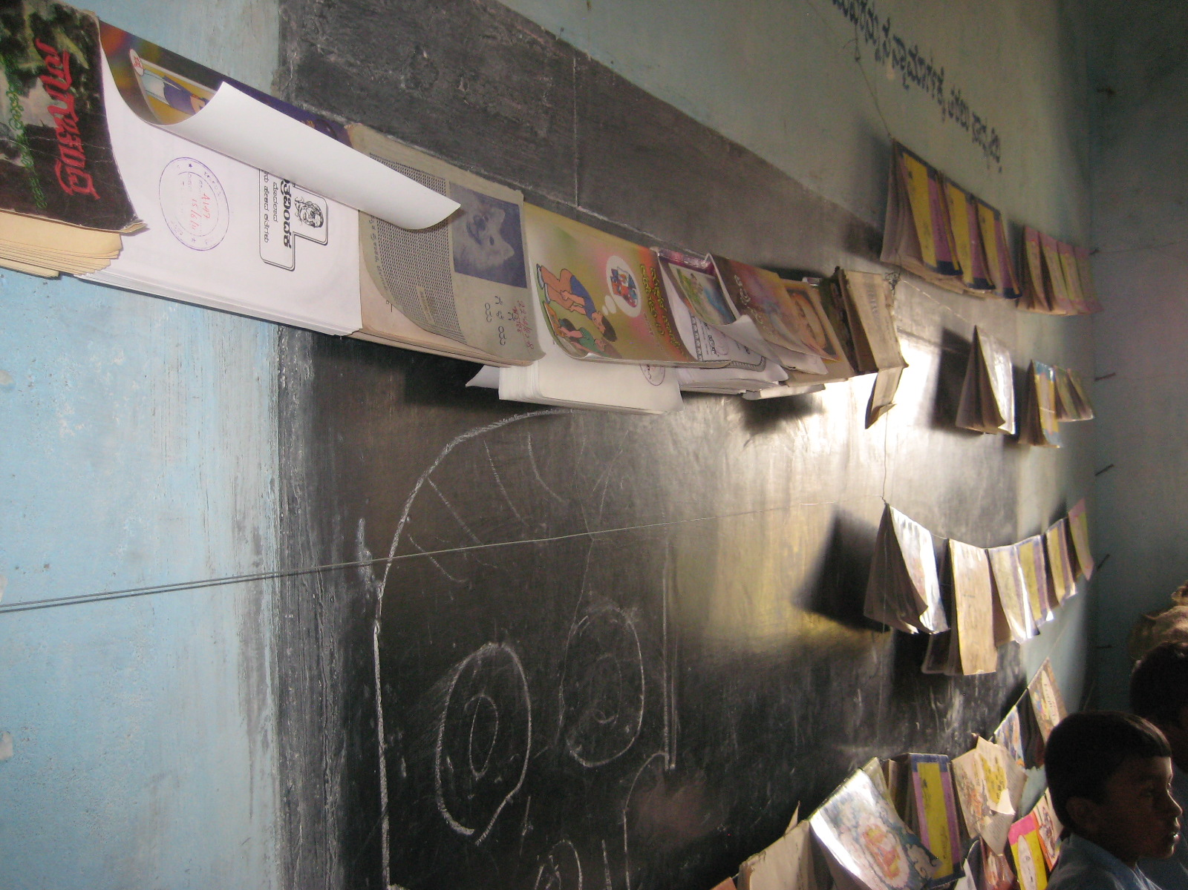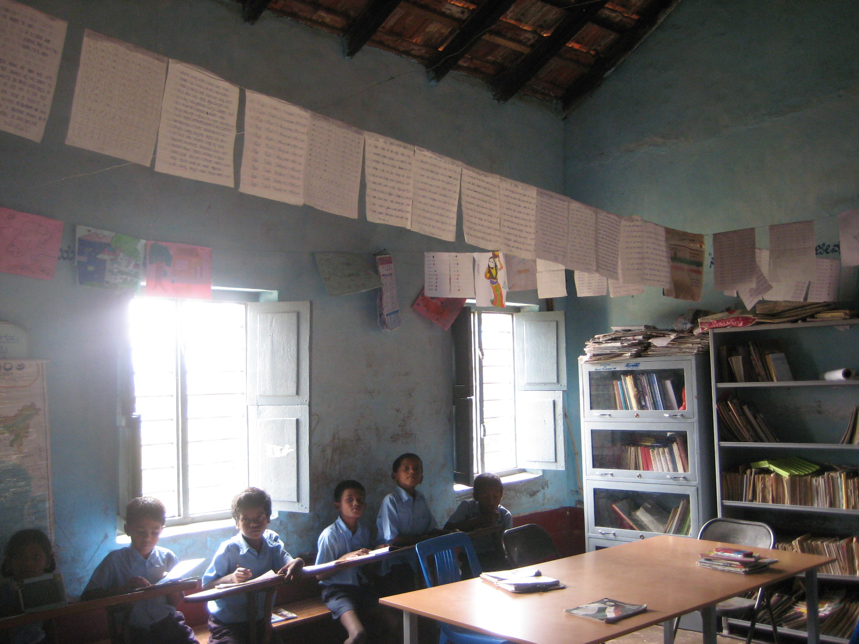
As we were looking at learning artifacts in the library the teacher introduced us to two girl students who then sang a wonderful song for us.
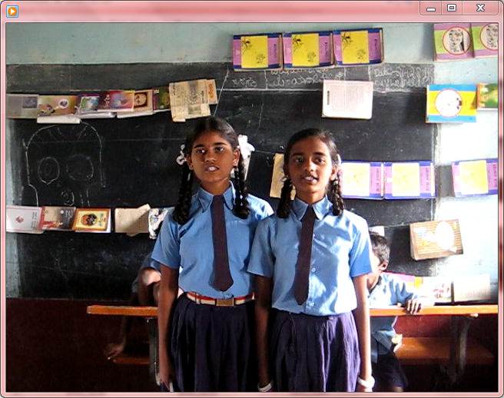
We then bid goodbye to the students and the teachers and as we were heading out Prasanna suggested to the kids the idea of setting up a video chat session with me in January after I return to the US. I immediately signed up for that interaction.
This trip to the school was indeed a rewarding experience and I sincerely thank Prasanna and his Sikshana team for coordinating this site visit. Kudos to Prasanna and the Sikshana team for all they are doing.
As of this writing on January 15, 2012 we are scheduled to hold the video chat session with Prasanna and the school kids on January 28th. I am eagerly looking forward to it.

