Annual Report for 2004

The project proposal was reviewed in depth by members of the Asha Stamford chapter during 2003. Asha Stamford decided to fund the project in 2003 with $3000 towards construction at the Bonpura school. Mr. and Mrs. Changkakoti were responsible for overseeing the construction.

A few pictures of the Bonpura school taken in Dec 2002 (before construction) are shown below:

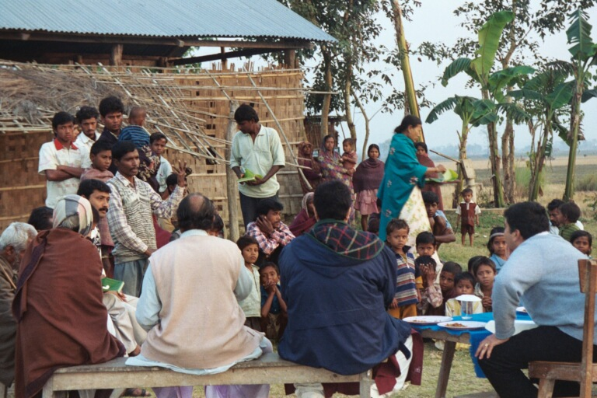
Sri Mondal (standing with his left hand raised) continuing his point. In the center of the picture is Sri Gouranga Mandal (light-green shirt) who helps as a teaching assistant. Note a portion of the school house in the background. The construction is mostly thatch work other than the tin roof. Also, in the background on the right, is a tube well installed for the community a few years ago, by a primary health focused NGO. The tube well has not been functioning.

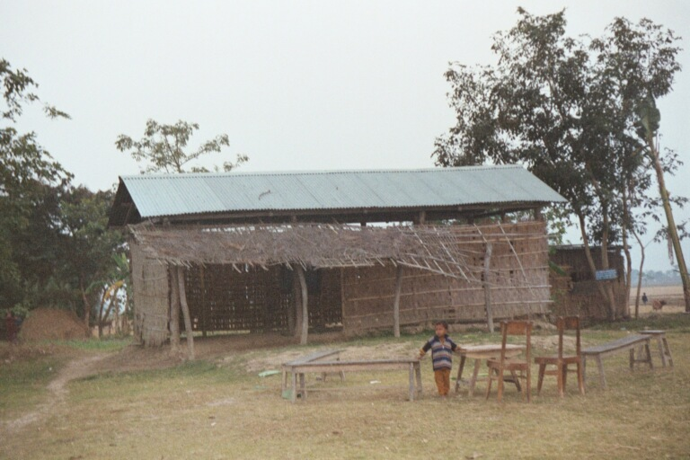
A more complete view of the school house. The teachers manage to seat about 60 students on the floor. The others sit in the yard outside. A rudimentary awning provides a little protection from the sun to the children outside.
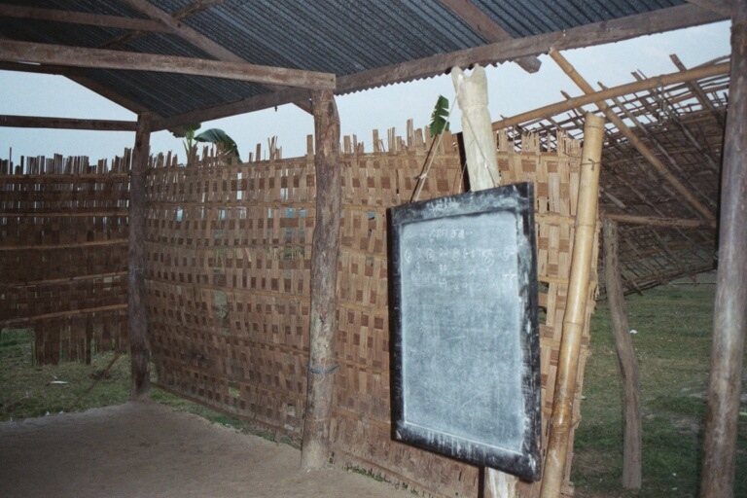
An inside view of the school house.

School construction began in late 2003 and was near completion in 2004. Some pictures taken in June 2004 during construction are shown below:

Photos received from ACRD on the construction of the Bonpura Lower Primary School on June 9th, 2004

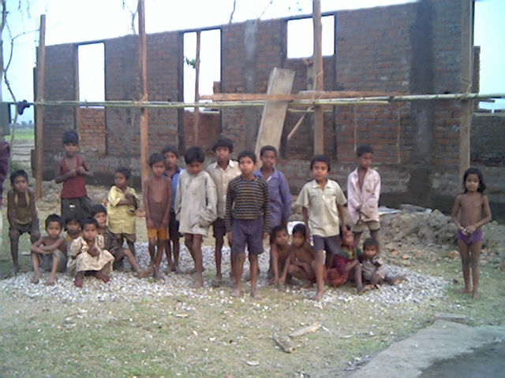
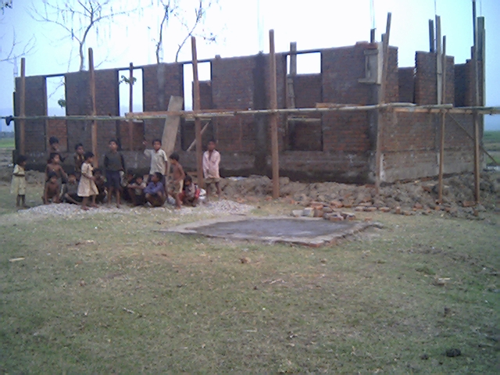

Funding in 2003/2004

2003 - $3000
2004 - $5600 (first installment - $3000 and second installment - $2600).

Major achievement in 2004:

1. The funds provided by Asha last year were used to build a new building and now there is a building instead of just poles and a roof.
2 Funds were also used to fix an old building and the old building is now in much better shape.
3 Previously there was no road or clear path to get to the school. People used to go through fields. Because Asha provided the funds for school, the village people thought that they should also do something for the school. Their thinking was that if people from America can send money to help the school, they should also do something, so they created a dirt path that comes to the school.

