ASHA Site Visit Report:

Site: Barkuchi High School, Dimoria Development Block, Kamrup District, Assam

Site Visit: Ami Ambani Baruah

Project Contact: Sunita Changkakati, ACRD

Visit Date: Dec 7, 2015

Description from ACRD:

Barkuchi High School was established in 2009. The school is in a remote place where all the students are very poor and belong to tribal communities. The school was set up by the villagers because there was no other high school in the nearby area. The teachers are qualified but the villagers have not been able to pay salary to them. So they feel that if the teachers are paid some salary, they will continue to teach and the students will be benefited

Building: The school building is recently constructed and is not of solid construction (not “pukka”). See pictures for the wood frame construction. Each classroom has a blackboard for instruction. There are no extra rooms for a library or other activities.
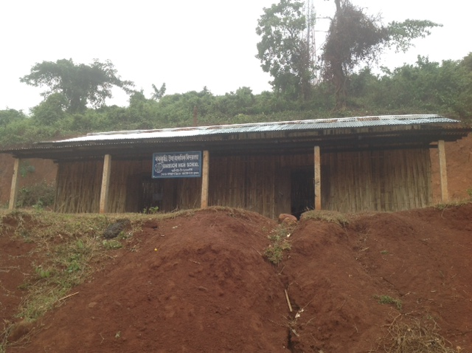

Students: During the visit, the two classes had about 35-37 students. There are more girls than boys in the school. Daily attendance is taken by the teachers, but attendance of students is not continuous.

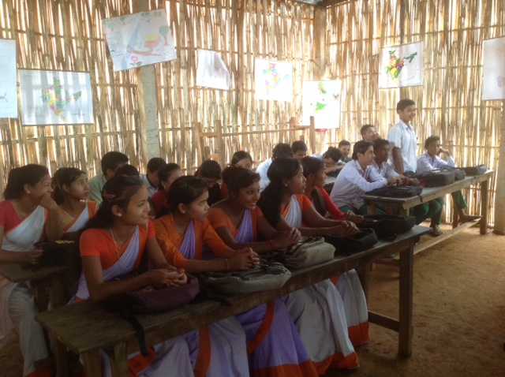
Teachers: The school has six teachers, three of whom are graduates of other ASHA sponsored schools run by ACRD.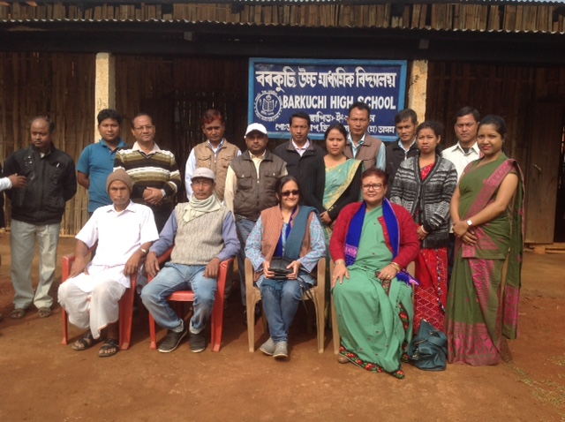

Parents: Did not meet with individual parents, but met with committee managing the school. The committee is very enthusiastic about the school and the students. Several students will appear for state exam for grade 12. Last year 6 students appeared for the test and 20 are planning for this year.

Toilet Facilities: There are no toilet facilities for the students at the school. This does lead to some degree of absenteeism, particularly for girls. One of our recommendations is to build toilet facilities.

Library: There is no library at the school. The teachers felt that this is not very useful at the moment as the students first need to study their textbooks. It is also felt that the students do not have extra time to read.

Additional Photographs:

