CDDP budget Discussion

Q1.So why there is consistent decrease in number of students each year? Also, I have an idea that before 2 - 3 years back there were many children who were waiting to join the school but due to small infrastructure or any other reason could not join that time, So what happened to them? Why are they not joining now?
Ans:
Three years back there was a proposal to find more of local sponsorship and also admitting the students into Government run hostel attached free schools. This was due a question from Asha, that if there would be any stoppage or reduction in Asha’s help, how the CDDP would run the schools. So they started finding local sponsorship and also admission to Government run hostel attached free schools.
Hence, the students who have left after plus two examinations are not replaced with new admissions. They started finding alternatives to the students in the waiting list. During the three years, 27 students found local sponsorship and 81 found admission to Government run hostel-attached schools. (from the waiting list).

Q2.How are we keeping track of students who have moved to government schools or for higher education?
Ans:
It is easy to keep track of the students as all the schools are village specific. Mostly the parents live in the same village, except few who migrate to distant locations for labor. Even after their migration, they visit the village once a year for yearly temple festival, besides having regular contact with their relatives in the village. Through these avenues, they can keep track of the students.

Q3. What is the qualification of Ms, Sujatha, who is coming for teachers training program?
Ans:
Ms. Sujatha is a postgraduate in education. She is a freelance education consultant, expertise in participatory/play way teaching and training methods. She is located in Chennai.

Q4. CA audited report for this year including FCRA?
Ans:
Audited report and copy of FCRA are attached here

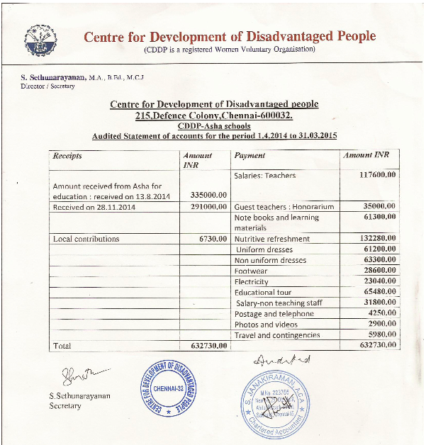
Attaching FCRA copy in the email.

Q5. Also, as I compared the funding from previous year, it has decreased from last year, is the number of students the only reason or CDDP trying to take limit their funding from Asha?
Ans:
Decrease in students, proportionately reduces the funding also.

