Site visit Report
Project: Shraddha Special School
Location: Benares, UP, India {Varanasi}
Date: January 2006
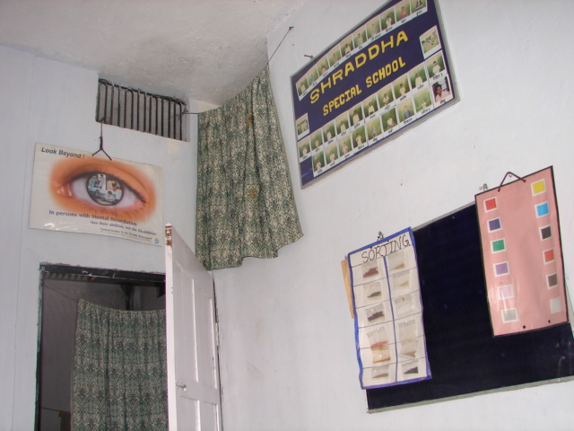

The Shraddha special school located in the heart of Benares {Varanasi} operates from the house of Mr. Anil & his wife who started this program with the intention of providing a sanctuary for the special children around the area.

The school comprises a few rooms on the ground floor of the house which includes a classroom, a break room for the children to play in, and a workshop where some of the older children can learn special skills.

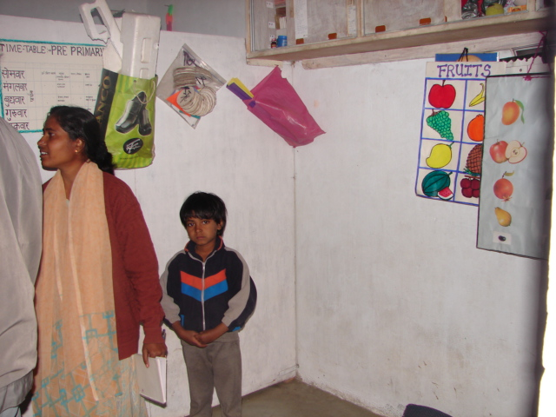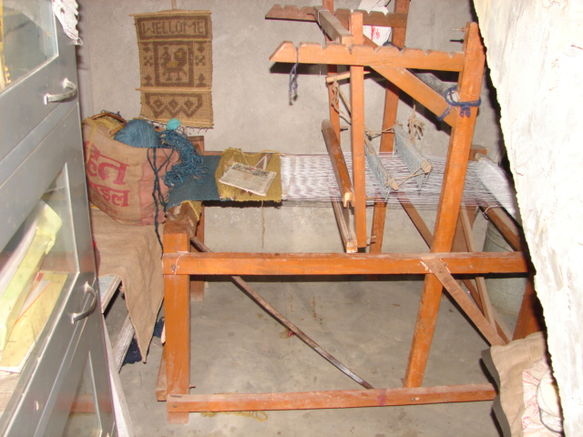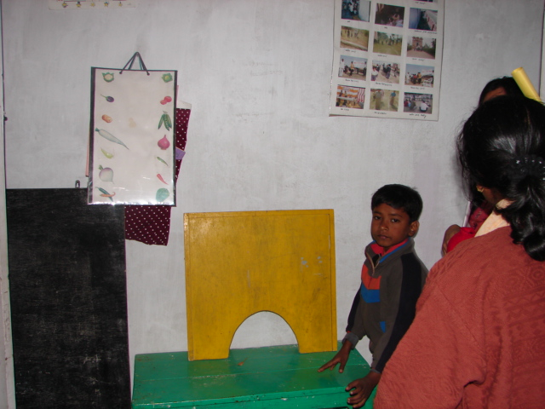

In addition to this, they have an open ground like space outside the house which serves as a playground / open air school area for the children, especially in the winter when the inside of the house is cold and the children can play and study in the bright sunshine. There are two teachers in addition to the couple who run this program, and one of the teachers is also the mother of a child who attends this school. All these adults in addition to being “teachers” have a very tender and beautiful way of dealing with these children as their friends and in many cases a substitute for a loving family.
Though they are not formally certified to teach these children, the teachers train themselves on special skills that are needed to teach these children and in most cases they are well aware of the each of the facets of the individual children and they focus their energies on those areas that the child most needs to make progress in. The classes are well designed with content that help the children learn school basics as well as understand some basic tasks such as personal management, hygiene and such other tasks that help them be independent and self reliant.
The program includes classes with Math, English, Hindi, Reading and Writing practice and general play time during which the teachers get to bond with the children and help them each individually with their specific needs. There are on an average not more than 10-12 children at the school with the number varying depending on whether the parents co-operate and are keen to send the children to school. The teachers have a system of categorizing the children and ranking them based on how severe their condition /disability is so that they can treat each child according to his / her individual condition.

There is also an auto rickshaw service that Shraddha strives to provide to bring the children to the school and drop them back to that those children are not prevented from coming to school whose parents don’t wish to bring the child to school.

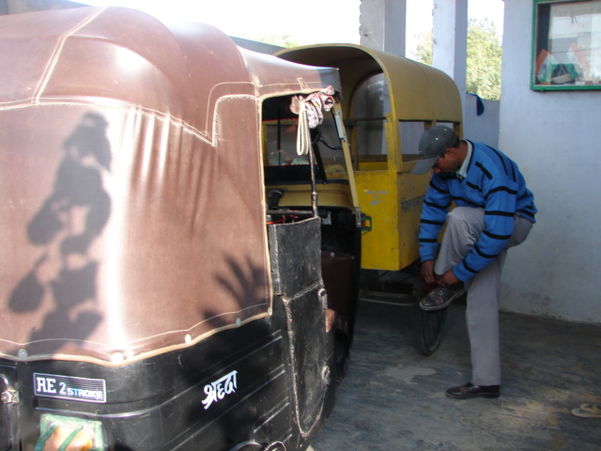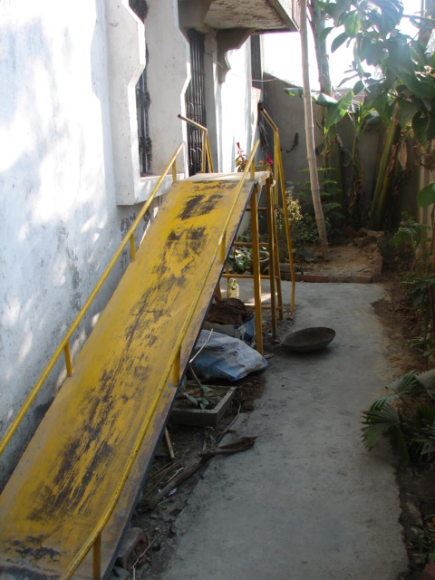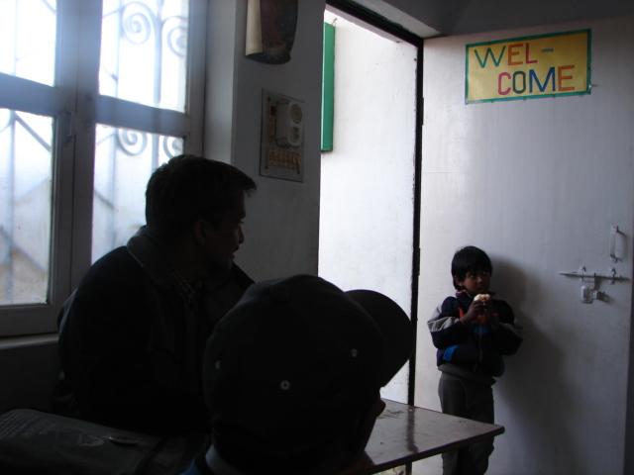

The children themselves are an absolute delight!! There are no words to describe their spirit – to say the least, they are happy; they are at first a little subdued but with one smile and a hug you can bring out the real carefree playful child in them!! They are confident, curious and bright like all children with just an extra special light around them that makes them absolutely endearing and unforgettable.

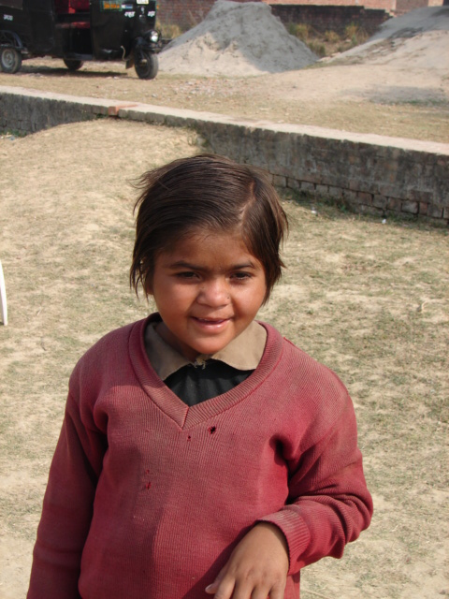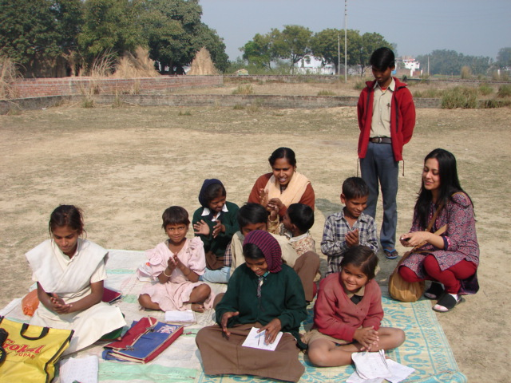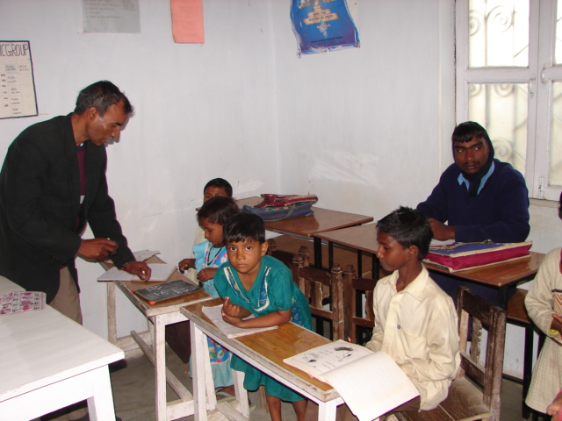

Their most exceptional characteristic is how they immediately accept even a stranger into their environment and how trusting and loving they are with everyone who just as much as smiles as them.
Perhaps this is why we need to take special care of each one of them because they are so much more vulnerable to exploitation because of their innocence. Though Shraddha is currently running as a project, it is critical that organizations like ours {Asha} that provide funding and objective project evaluation, should strive to ensure that each of these individual children should be a project in themselves. In the process of our project work, we should ensure that we don’t lose sight of each of these children – The success of this program then can only be evaluated if we can sustain the continuous and steady support we provide to the children and if we can see the change in them over a period of years. This is why it is imperative that we request details for each of the children, including their age, picture, description of their disabilities and a detailed progress report each year, in addition to which we should ensure that if possible we only add children to this program, not lose any.

While in this entire report I refer to “Children”, the fact is some of them are old enough to be counted as teens and in some cases even adults. And even when they are all several years older, they will continue to be children at heart more than at age.

The bitter truth is, many of our special children come from families that shun them for their “difference” and being ill treated at home, the only place these children are accepted and loved for just a few hours, is at this school; The irony is that most of the children in their oblivious state don’t even register the fact that they are being hurt by those who should love and care for them, that members of our society do not view them with kindness or compassion. If these special children feel pain, then it is only momentary -they cry and forget it instantly – We were all like that when we were children but somewhere in the process of “maturing” and “growing up”, the innocence was gone.

These special children however will retain their innocence forever; so, while we are attempting to solve their problems, perhaps we can ponder for a while on their blessings. For they have the gift of love, peace and forgiveness in their heart and in attempting to provide for them and teach them, we will discover how much we can learn from them.

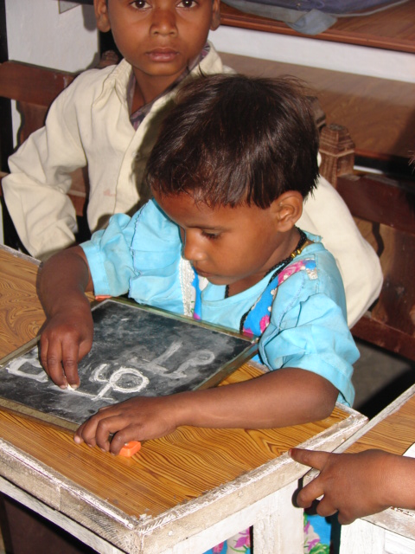

Prepared by – Kusum Kanwar
Photographs – Mehar Singh

