 | Asha for Education  Arizona  Application to request funding
#17, Student development Office, Box 873001  ASU, Tempe, AZ 85287-3001 |  | http://www.ashanet.org/arizona/

APPLICATION FORM TO APPLY FOR ASHA-AZ FUNDING
 | Project Contact | Asha Contact
Name | N. Krishnaswamy | Nirmal Govind
Address | 3, Tiruveedi Amman St, R.K.Nagar,  Chennai - 600 028. | 5448 S. Hurricane Ct.  Tempe, AZ 85283.
Phone(s) | (91) 44-4937926, 4936358 | (814) 360-4677
Fax
E-mail | umaks@vsnl.com | nirmalg@cal.berkeley.edu
Website: | www.vidyavrikshah.org  http://acharya.iitm.ac.in  http://acharya.iitm.ac.in

Background on the Organization Working on the Project:

Name of the organization: Vidya Vrikshah (in collaboration with IIT Madras)
Date of Establishment: 1998
Please give the following if available:
Registration Number (Public Trust Act): 149/4 of 1999 dated 09-02-1999 of the Sub-Registrar, Mylapore

Tax Exemption Certificate Number: u/s 12A(a) of the Income Tax Act in Ref No. DIT (E)
No.2 (15) / 1999-2000 dated 19-05-1999 of the Director of Income Tax
(Exemptions), Chennai.

Exemption Valid Dates: u/s 80G: Current validity from 01-04-2004 to 31-03-2006
FCRA Clearance: Vidya Vrikshah partners with Relief Foundation that has FCRA clearance. In addition, Worth Trust, the organization that manufactures the UBKs (see below) has FCRA clearance.

How the organization was created and what is the purpose and mission of the organization:
Vidya Vrikshah (VV) is an association of people drawn together, by devotion, to the free spread of knowledge, devoid of profit. VV believes in implementing these objectives through community mobilization and participation.

Describe structure of your organization (administration, field staff, teachers etc.):
VV has a strength of over 150 volunteers, contributing various services in pursuit of the above objectives. These volunteers are drawn from housewives, senior citizens and professionals, and include many persons who have retired from very senior positions in Government and Industry. The volunteers also include some who are visually impaired, but have overcome their disabilities in exemplary ways.
A small group constituted as a public charitable trust functions as a nodal point for handling the essential coordination and technical tasks.
List previous/current projects undertaken by the organization with names, location, goals, size of projects in terms of beneficiaries and funding:
VV’s Centre for Disability Research, Development and Training has designed and developed stand-alone and web-based IT solutions to reach out to persons with all types of disabilities throughout the country in the local languages. Details of these solutions can be seen on the Website www.intend2001.org.in/ (website of INformation Technology ENablers for persons with Disabilities (INTEND).
A brief description of the long-term objectives of the organization:
Vidya Vrikshah has spelt out it's objectives in terms of the following activities:

(a) Preservation and dissemination of ancient texts of the Indian heritage, in the Indian languages, from books, manuscripts and other sources, along with simple translations and commentaries, for the benefit of interested people across the world through the use of Information Technology and the medium of the Internet; and

(b) Developing solutions and and conducting training programmes for enhancing the quality and extending the reach of literacy, education and skills through the computer usage in local languages, especially to the socially and the physically disadvantaged in the country.
Details of the organizations annual budget (include an annual report if possible): Please see Appendix A.
Previous Funding Sources, if any:
Asha for Education, Seattle
Asha for Education, Colorado
Contact Person in USA (if any) Name, address, phone number, fax number and e-mail:

Krishnan Narasimhan,
203, Mainsail Drive, Cary, NC 27511, USA
Phone: (919) 467-2114
knn@mindspring.com

Contact Person in India - Name, address, phone number, fax number and e-mail:

N.Krishnaswamy
3, Tiruveedi Amman St, R.K.Nagar,
Chennai - 600 028
Phone: (91) 44-4937926, 4936358
umaks@vsnl.com

Details of the Project Proposal

Project title: National Initiative for the Blind (NIB)
Project contact address: Same as above for VV
Project location (urban, rural etc.): The kit is being sent out to organizations and schools around the country – primarily urban (need to check on this)
Does your school/schools already exist ? If yes, describe number of children, class-rooms, infrastructure etc. Not a school proposal.
What is the short-term and long-term goal of the project?
Short-term: Provide Universal Braille Kits (UBKs - see description below) to as many blind children as possible.
Long-term: Mainstream disabled: bring about socio-economic change!
Describe socio-economic background of the children to be educated and their parents:
Blind children from poor families.
What changes this project aims to bring about in the current conditions:
By employing a unique methodology that uses simple and inexpensive tools, and reaches out to the mother of the blind child, the NIB project attempts to enable the blind child at a much earlier stage. It also has a software component that accelerates the learning process of the blind child.
Beneficiaries of the project (how many children, number of males/females, age and other demographics, and other relevant details): This is hard to gauge and will depend on the number of kits that VV is able to send out, which is currently limited only by the amount of funds available. But, with 1000 kits, we can expect that a minimum of 1000 blind children will be impacted.
Describe the current local literacy conditions:
Blind literacy:
- ~ 4 Million Blind in India (~ 10% are kids)
- < 1% literacy rate among blind
How do you plan to accomplish your goals listed above? By trying to reach out to as many blind children as possible.
Describe planned teaching techniques: See the description of the Universal Braille Kit (UBK) below. Approach is as follows:
- Involve mothers of visually handicapped children
- Provide second level kit to the children
- Read real-life braille embossed on paper
- Software component
- Easy use of computers in all Indian languages and English
- Voice and braille computer output in all these languages

What is the current status of the project (number of people working on the project, resources such as land, buildings, books, tools etc)?
Using a Braille Embosser donated to Vidya Vrikshah by Asha Seattle, Dhrushti, a monthly children’s braille magazine in Tamil is being sent to 25 Blind Schools in Tamil Nadu since January, 2004. Trained two instructors of the blind of the Jawaharlal Nehru Memorial Institute for the Handicapped, Sikkim, at the instance of Asha Colorado.
Currently waiting on funds to manufacture the UBKs.

If possible, please provide with information on two individuals in your community who can describe the impact of your project: _______________________________________________________________________________
______________________________________________________________________________________
______________________________________________________________________________________

Funding Details

Details of the funding requirements:
Amount of money required: Rs. 30, 000
Duration for which funds are requested: One time support to meet immediate need
Detailed breakup of the costs involved along with details of money received from other sources, if any:
Amount requested is for 1000 Universal Braille Kits (UBKs) @ Rs. 300 per kit = 1000*300 = Rs. 30, 000 ~ U.S. $7000
Kits to be manufactured by Worth Trust, Katpadi, TN, at the subsidized cost of Rs. 300 per kit.
Contact info:
Worth Trust
48, New Thiruvalam Road, Katpadi - 632 007, Tamil Nadu.
Contact: Mr C.Antony Samy, Managing Director
Tel: 91 (416) 2242739,
Fax 91 (416) 2243939
email : worth@md3.vsnl.net.in

Other sources of funding (confirmed and anticipated), if any: None at the moment.

Proposed means of continuing the project after current funding (specially maintenance of structures being built):
Funding is being sought from Government of India. Also from TN Foundation, World Computer Exchange. Plan also exists to tap into local donors.
To what purpose would the requested funds be directed? An itemized split up of costs: blackboards, books, tables, chairs, toilets, buildings, teachers' salaries etc. for the next three years, showing recurring and fixed costs: Funds directed solely to UBKs - see above. UBK consists of:
- Vasantha Cube : to learn to read letters in braille
- Natesan Block : to learn to read words in braille
- Braille Slate & Stylus : to learn to write in braille
- Alphabet Block : to learn hand-writing in normal letters
- Abacus : to learn to count and calculate
- Geometry Box and drawing wheel : to learn to draw and measure
- White Cane : to learn mobility skills
- A simple Instructor’s Manual (in any desired language)

Will ASHA- Arizona be able to specify where the allocated funds should go? Plan already exists – list of organizations and schools the kit will be sent to. Please see Appendix B for the list of first set of 220 schools and organizations.
Provide name, address and phone number of the person who will be responsible to submit periodic financial reports on your projects to us: N. Krishnaswamy (see contact info above)

Project Schedule

Specify an approximate time schedule for the project: Manufacturing to start as soon as funds are received. UBKs to be distributed in November 2004.
Duration of the Project: Itemized description of the various phases in the project with their associated timelines. (There will be an evaluation at the end of each phase. ASHA requires an update every 3 months): One-time funding. Update to Asha AZ once UBKs are distributed. A second update to once feedback forms along with the UBK are received (1 month after kits are distributed).
Number of project personnel involved in the implementation of the project and their duties: ______________________________________________________________________________________
______________________________________________________________________________________
References of the lead people supervising the project, if any: ___________________________________
______________________________________________________________________________________
______________________________________________________________________________________

Other Details

Number of people reached by the program so far and how many have completed the literacy program (number of boys and girls): _______________________________________________________________
______________________________________________________________________________________
Standard Proficiency of the participants at the end of the project: ________________________________
______________________________________________________________________________________
Is there any governmental involvement in the project? If yes, how? Not yet. NIB is trying to obtain a government underwriting of future costs as part of the SADP scheme.
Specify nature of requested funds. Is this a one-time contribution or an annual request? One-time.
Can you include a copy of the syllabus? N/A
Please scan all relevant pictures and attach them to this proposal. Available on VV and IITM websites (see links at the top of this proposal).
Provide any other information pertinent to the project :
Appendix A: Vidya Vrikshah’s Annual Report/Budget

Audited statement of Accounts of Vidya Vrikshah for the Year Ending 31-03-2004:

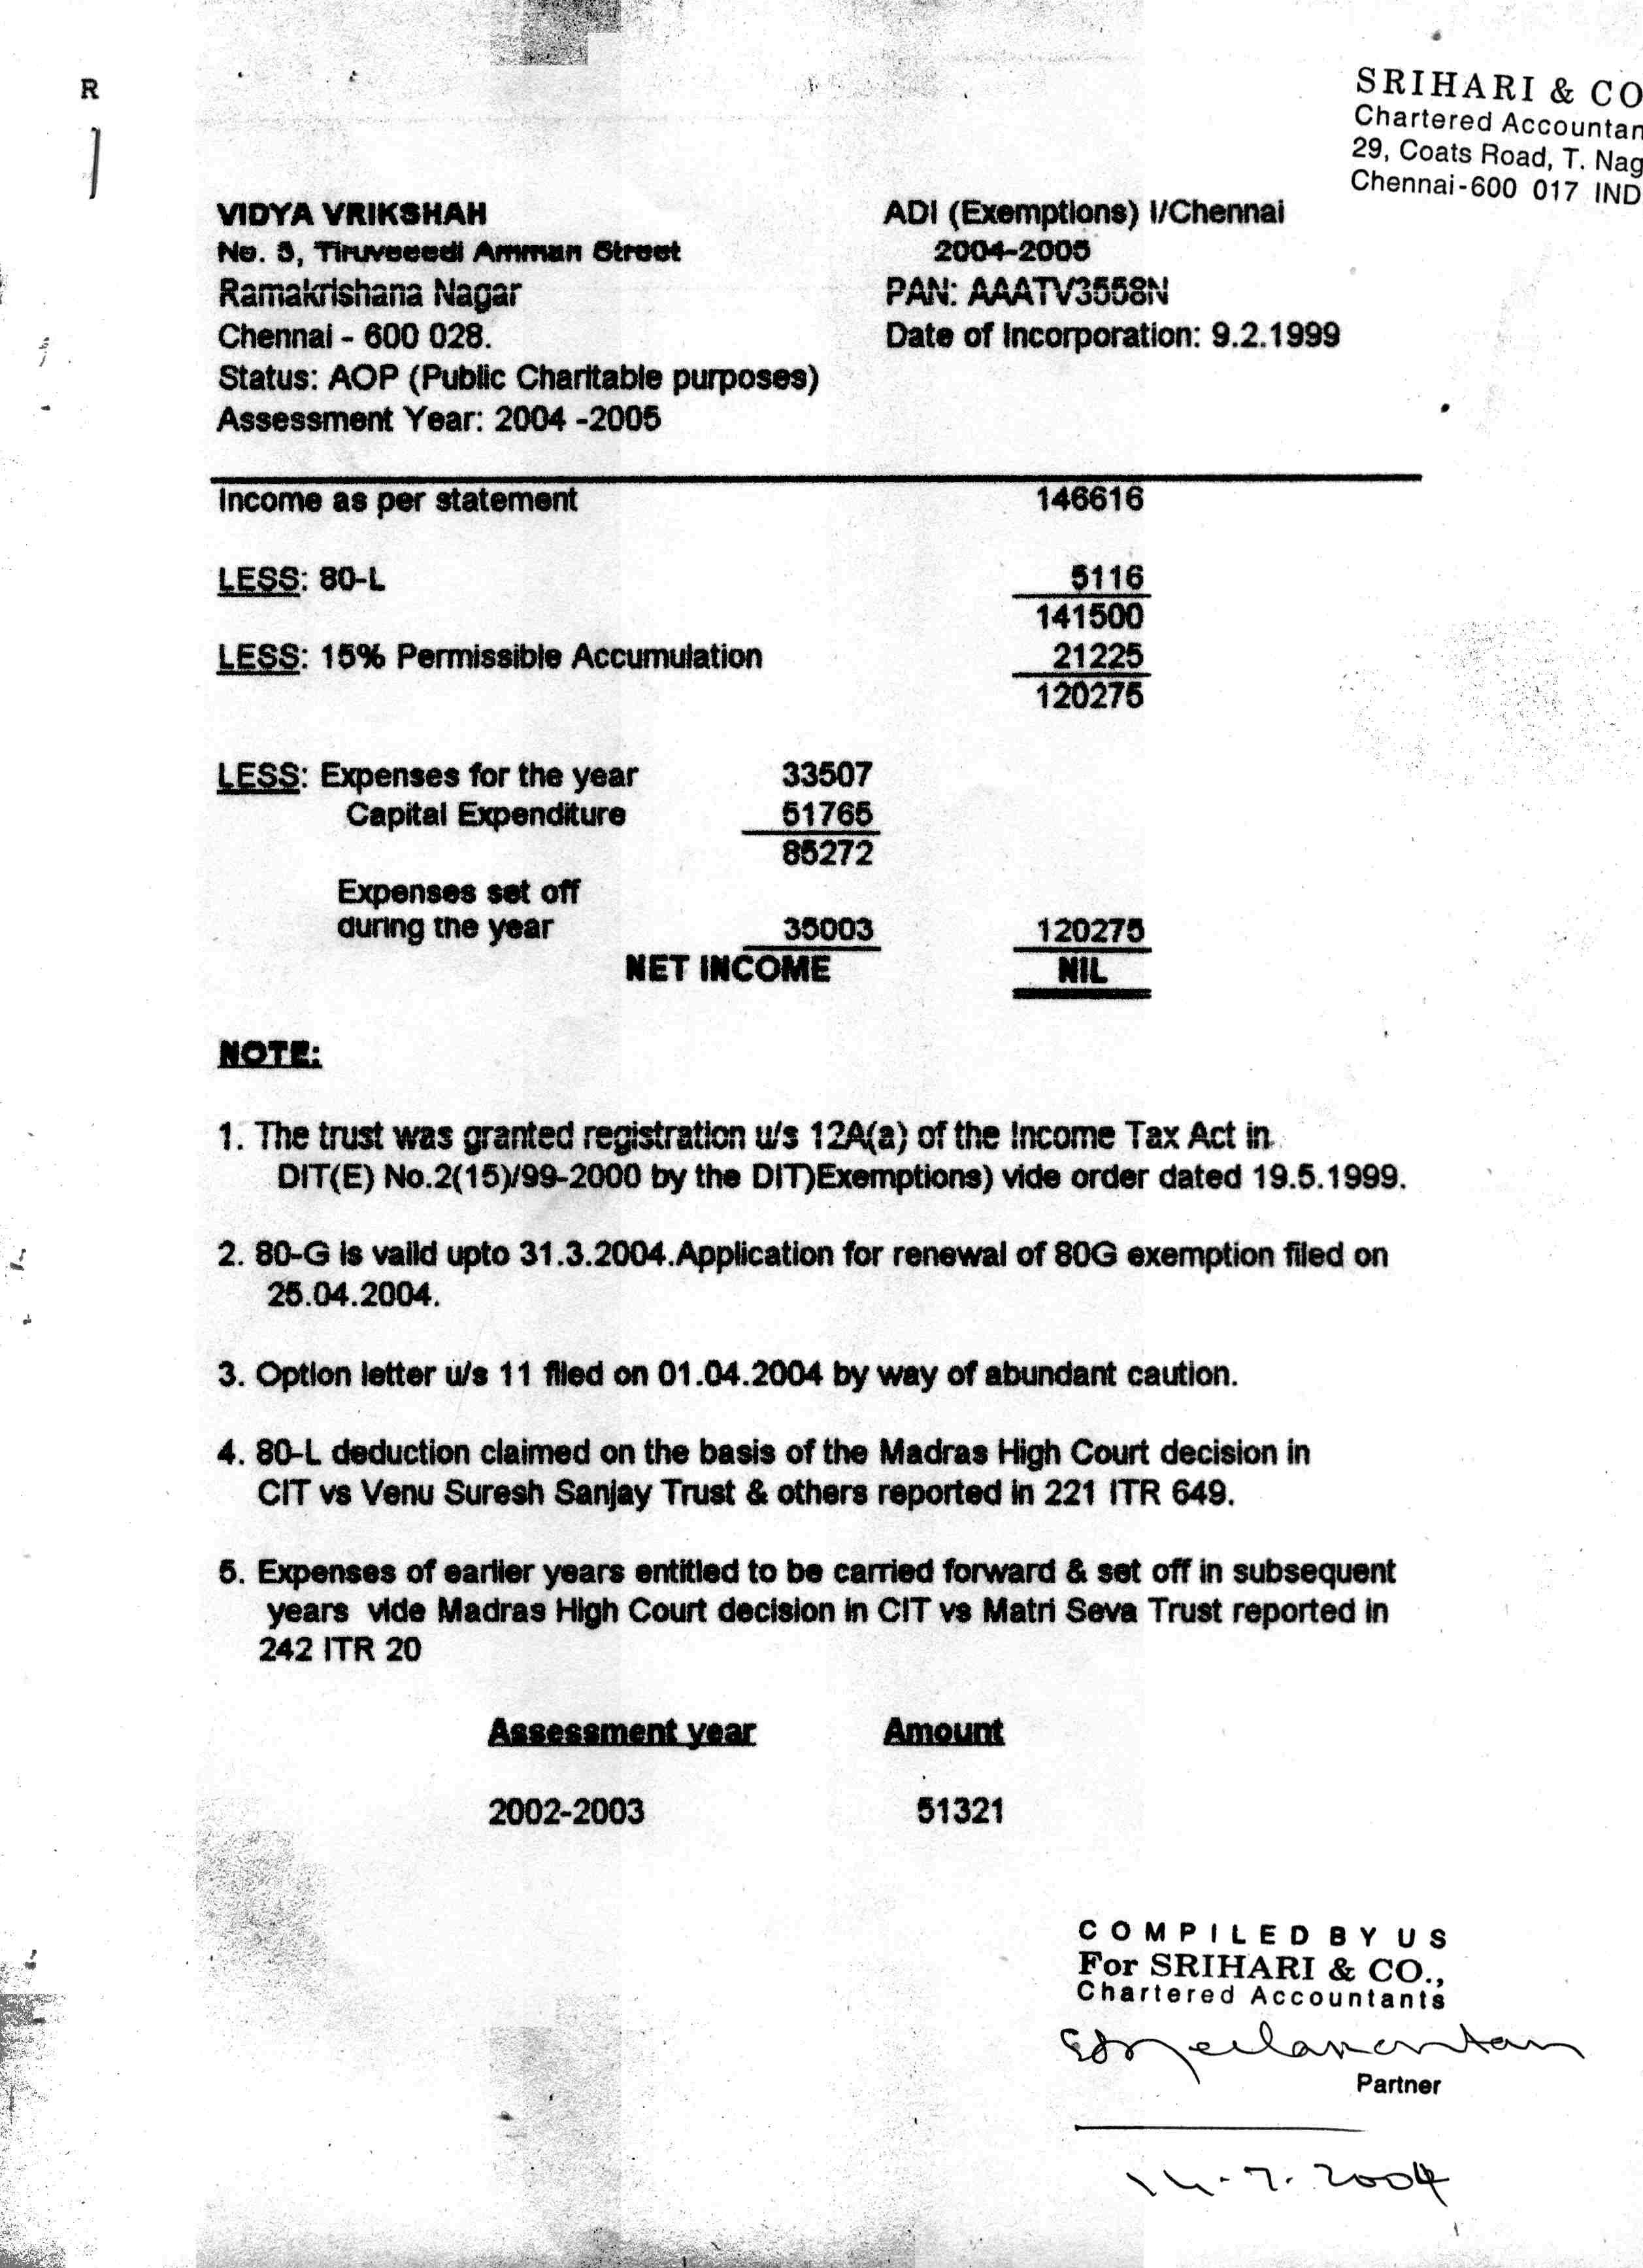

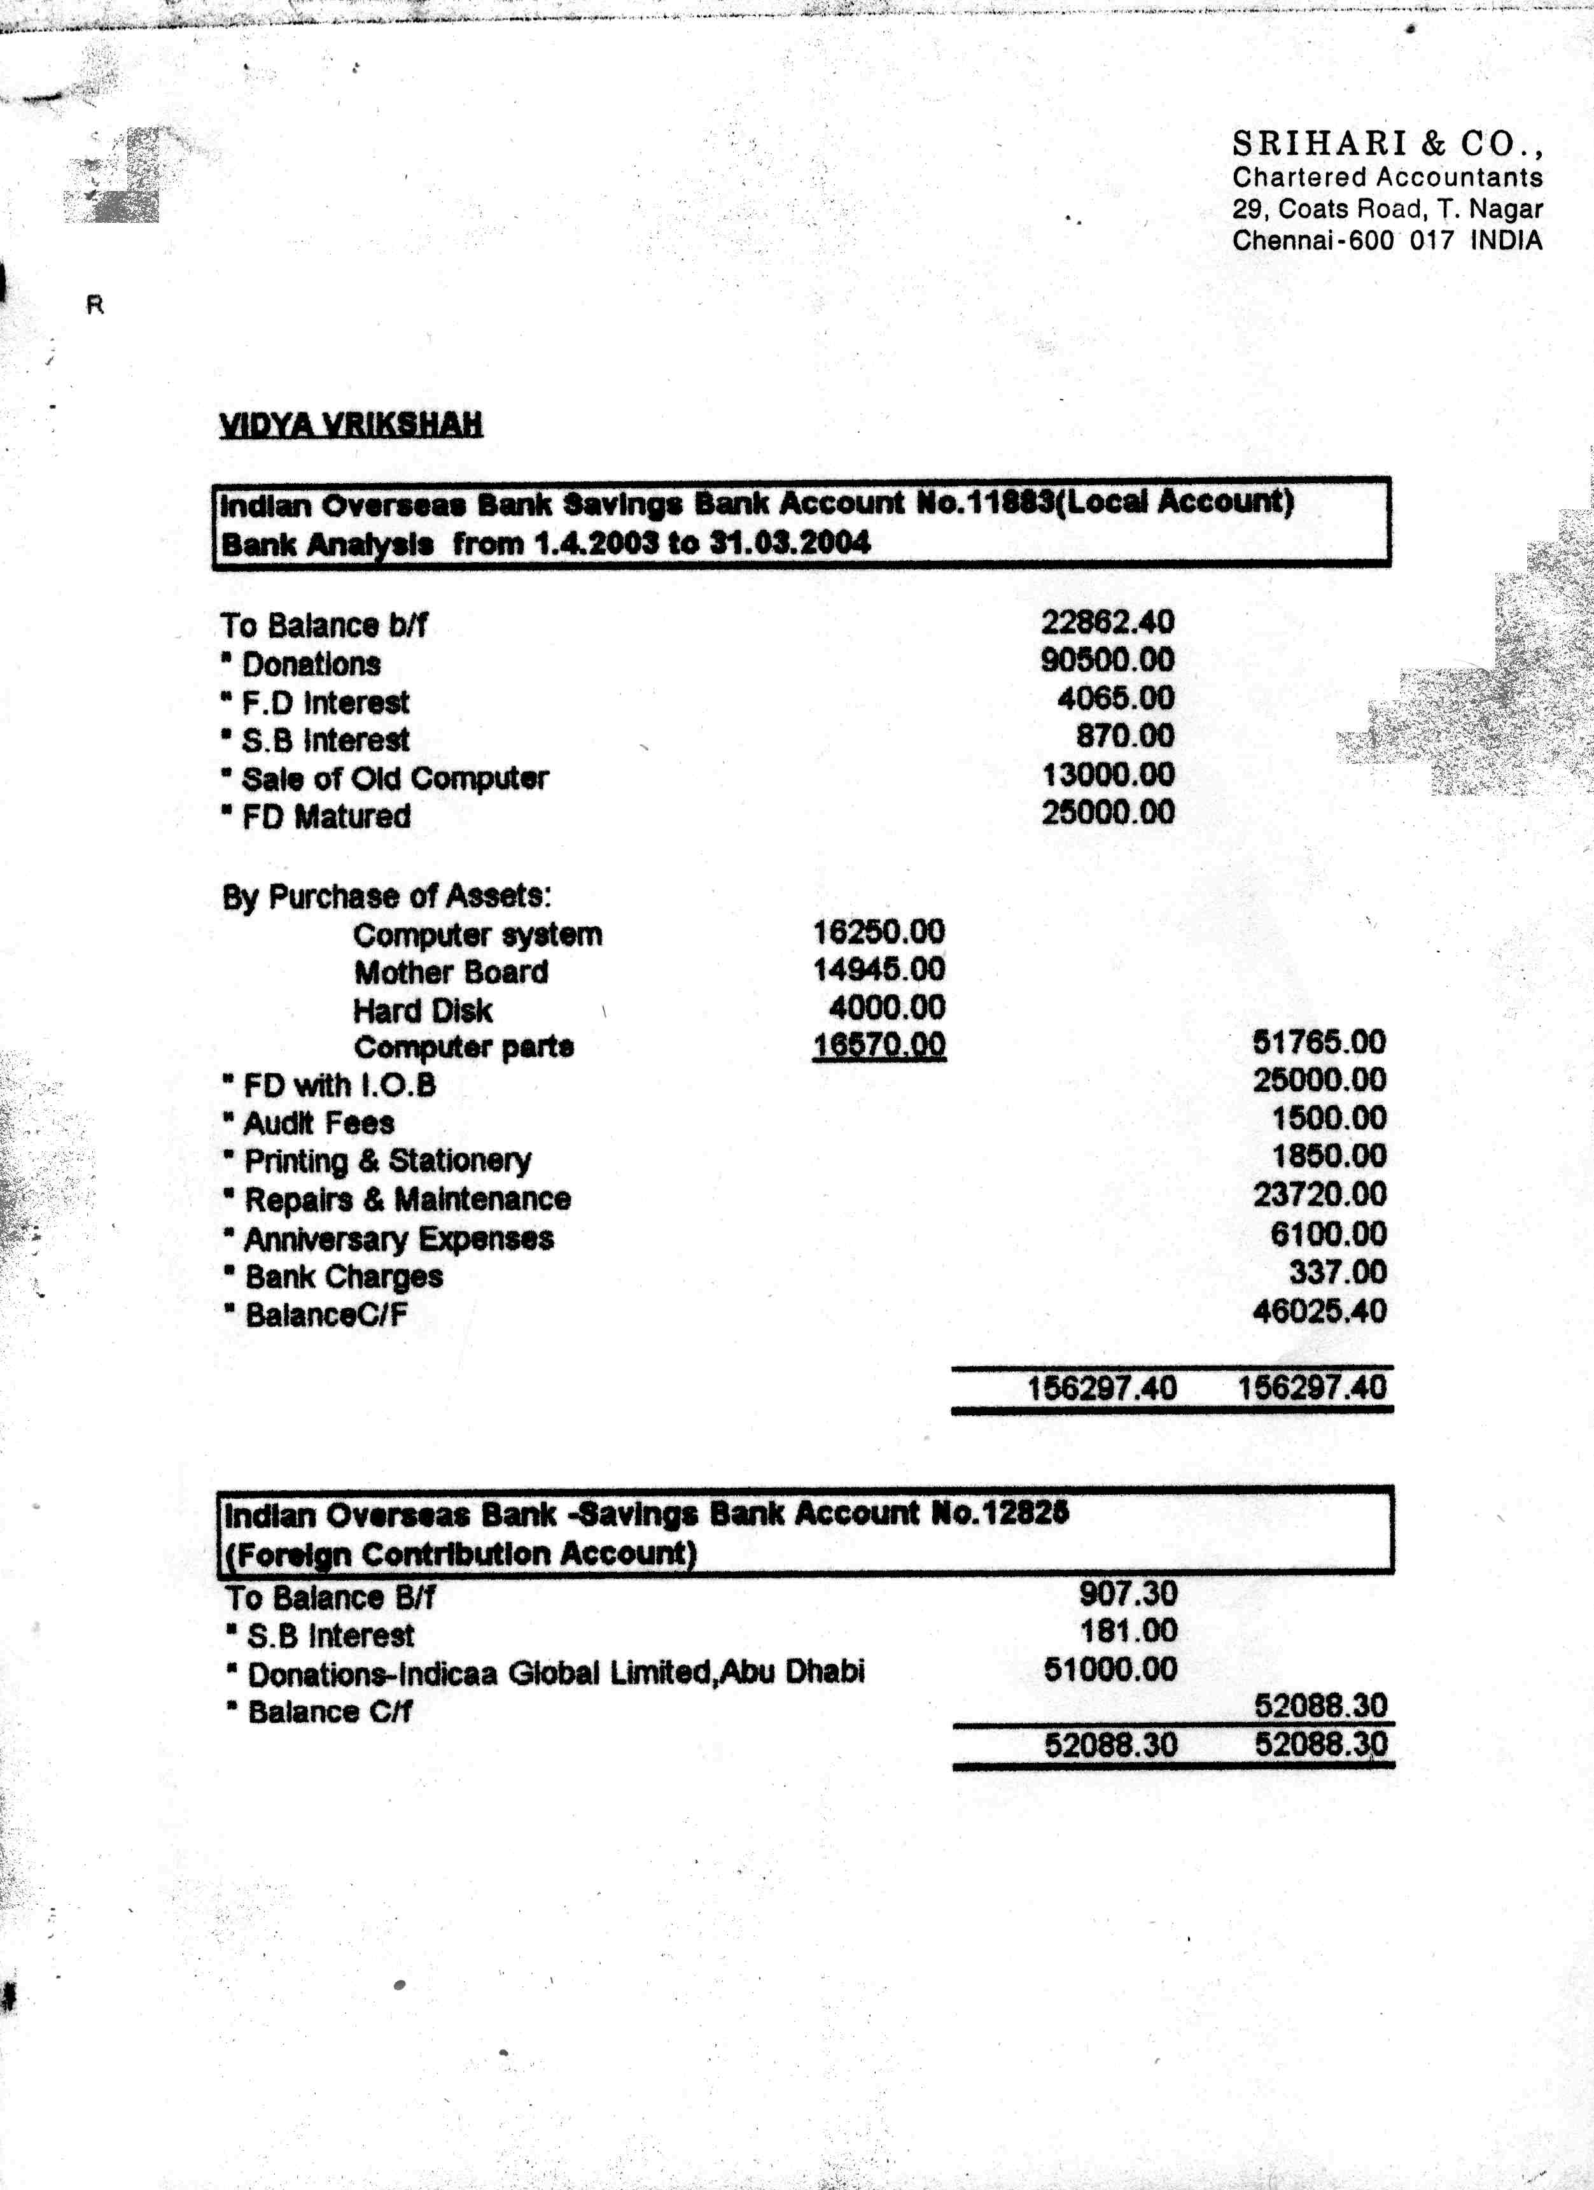
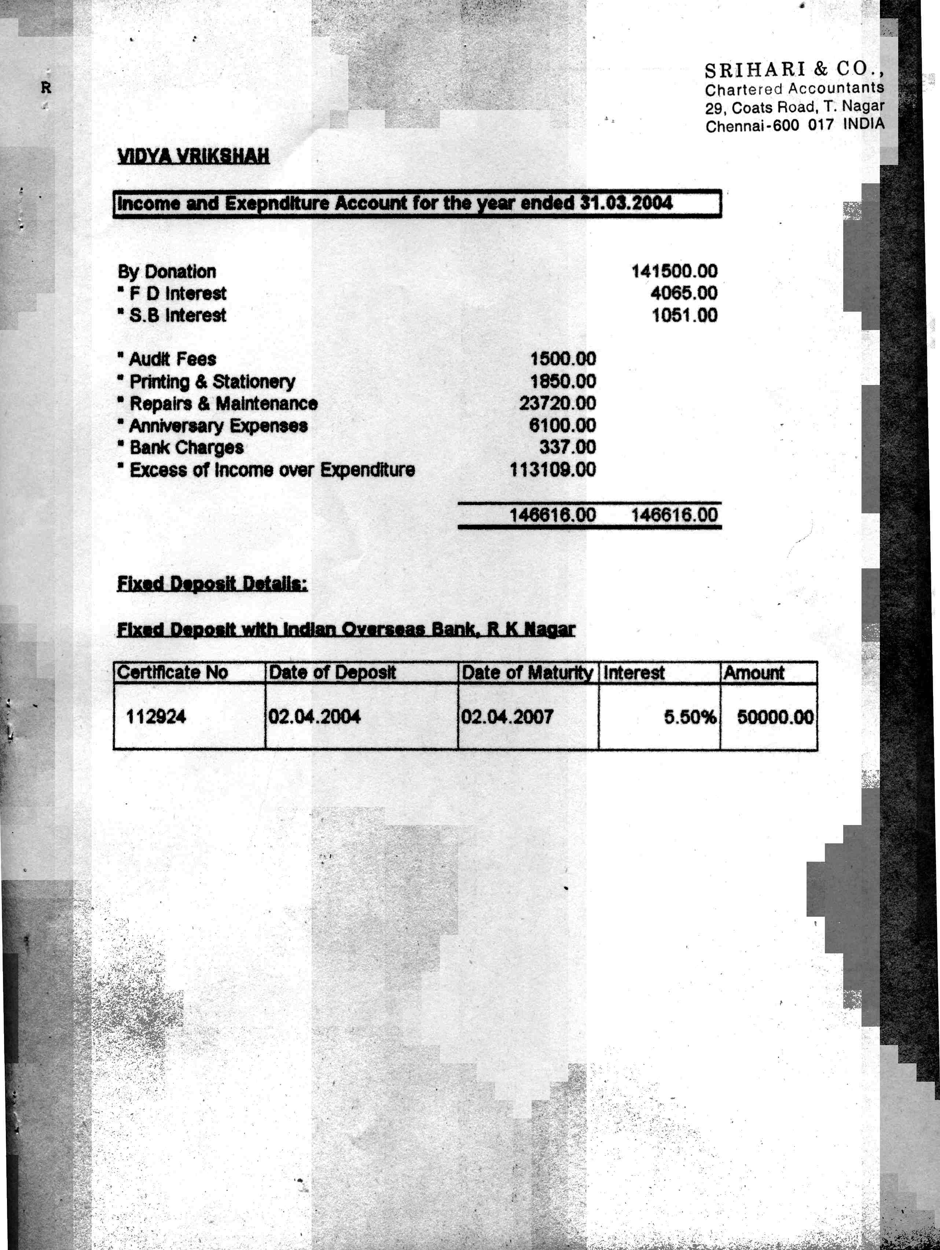

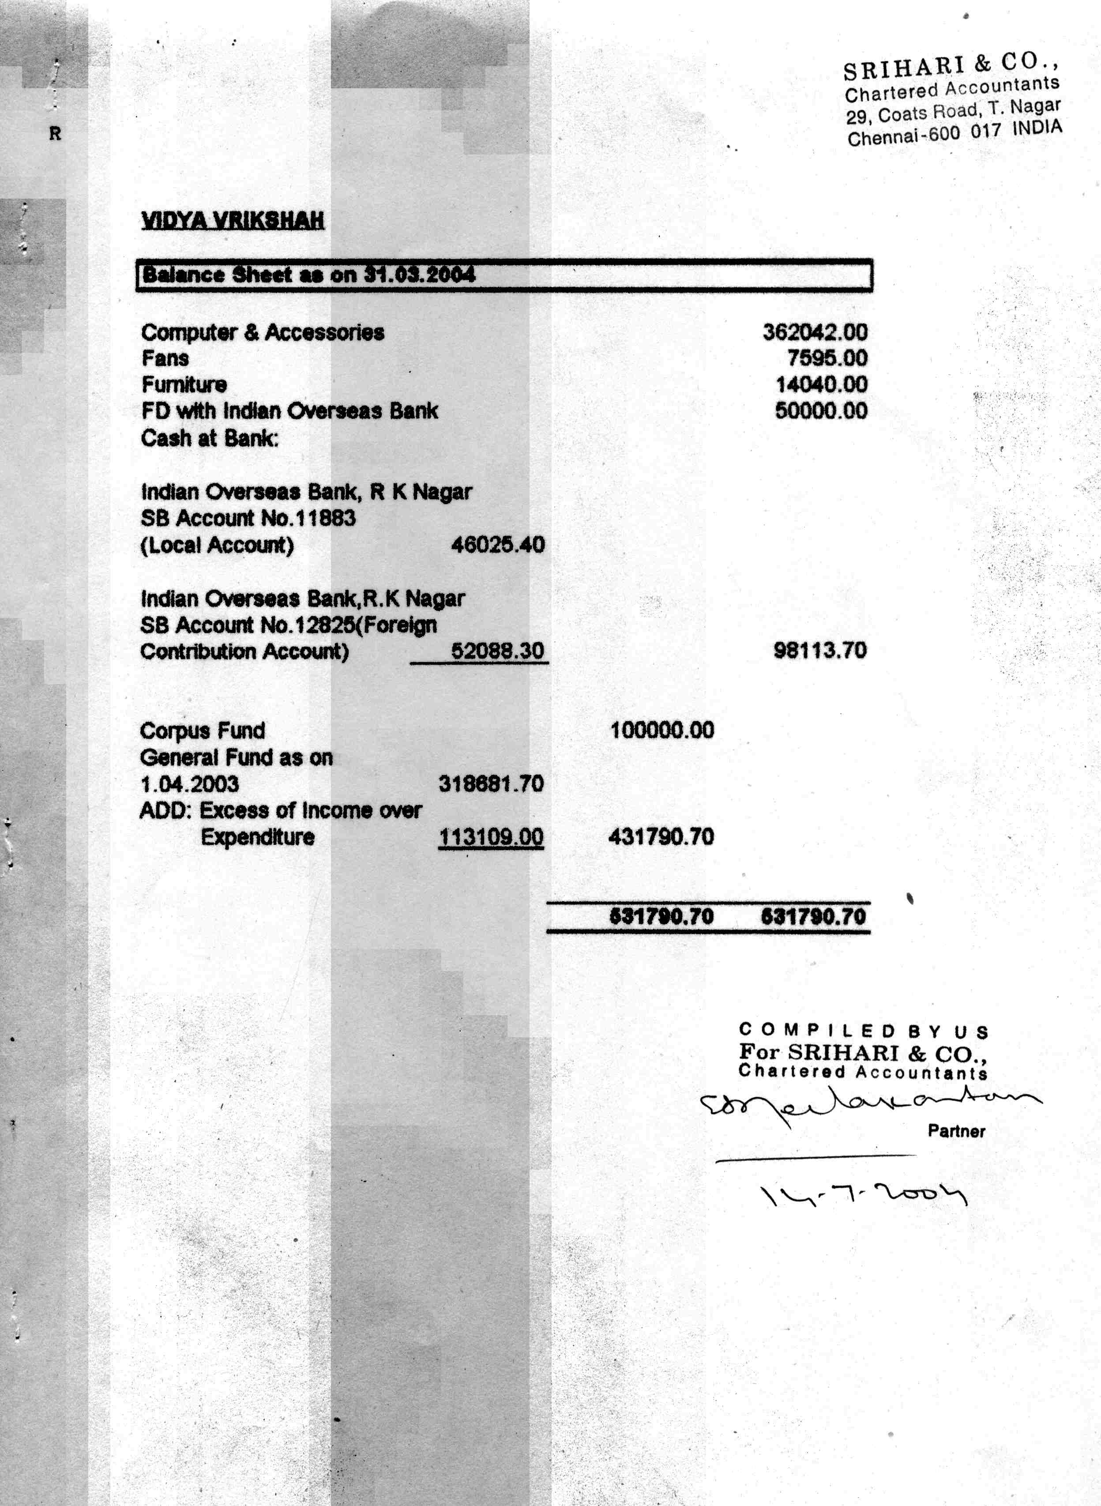

Appendix B: List of first batch of schools and organizations targeted for UBK distribution
INDIAN SCHOOLS FOR THE BLIND

ANDHRA PRADESH

- Andhra Blind Model High School *
Rajapet, Narsapur, West Godavari – 534275, A.P

- Government School for the Blind
Cuddapah-516 002. A.P

- School for the Blind & Hostel
Mandapeta, East Godhawari-533 308, A.P.

- Luthern School for the Blind
Narasaraopet, Guntur, A.P.

- Lutheran High School for the Blind
Narasaraopet, Dist. Guntur, A.P.

- Sudha Memorial School for the Blind
Brindavan Municipal Colony,
Guntur – 522 022, A.P.

- Govt. Higher Secondary Girl’s School for the Blind,
Block ‘C’ 137-140,
Malakpet Colony, Behind Nehru Memorial School
Hyderabad – 500 036, A.P.

- Government School for the Blind (Boys)
Dural Shafa, Hyderabad, A.P.

- Jeevana Jyothi C.S.I.School for the Blind
Vidyanagaram Via-Kondapalli
Krishna District, A.P.

- Saint Francis High School
Assisi Nagar, Venkatagiri Town (Post)
Dist. Nellore 524 132, A.P.

- Viswa Bharati School For the Blind
A. K. Nagar Post, Dhargamitta
Nellore – 524 004, A.P.

- D. M. School for the Blind
Near Law College
Visakhapattanam – 19 AP.

- Andhra Blind Model High School
Rajapet, Narsapur
West Godawari – 534 275 A.P.

- Viswa Bharathi School For The Blind *
A.K. Nagar Post, Dhargamitta
Nellore - 524004 A.P.

BIHAR

- Indira Gandhi Drishtiheen Balika Vidyalaya,
Near Circuit House,
Arrah – 803 201, Bihar

- Netraheen Chatra Vidyalaya
Bhikhanpur
Bhagalpur, Bihar

- Sri Adinath Andh Vidyalaya for the Blind
Dhampura
Arrah, Bhojpur, Bihar

- Kameshwari Priya
Government School for the Blind
Darbhanga, Bihar

- Smt. Gunjeshwari Netraheen Vidyalaya
Madhubani
Darbhanga, Bihar

- Mohalbani Blind School
Relief Society
P. O. Bhawra, Dhanbad, , Bihar

- Government High School for the Blind
Kadamkuan, Patna – 800 003, Bihar

- School for the Blind
Koshi Viklang Kalyan Sansthan
Kasba-Garh Banaili
Purniya, Bihar.

- Brajkishore netraheen
Balika Vidayalaya
C/o Hitesh Industries
Housing Colony, 60, Booty Road,
Bariatu, Ranchi

- Government School for the Blind
C/o District Welfare Officer
Ranchi Collectorate Ranchi

- St. Michael’s School for the Blind
Old Hazaribagh Road
PO Church Road,
Ranchi – 834 001

- Sewa Sadan Andh Vidyalaya,
Bara Telpa,
Chapara
Saran, Bihar

CHANDIGARH

- Society for the Care of the Blind,
Sector 26,
Chandigarh – 160 026

DELHI

- Andh Mahavidyalaya
Panchkuian Road,
New Delhi – 110 001

- Bharat Blind School
510-A, Circular Road,
Shahdra, Delhi – 110 032

- Blind Relief Association *
Lal Bahadur Shastri Marg
Near Hotel Oberoi
New Delhi – 110 003
- Government School for the Blind,
Kingsway Camp
New Delhi – 110 009

- Institution for the Blind
Panchkuian Road,
New Delhi – 110 001

- J.P.M. Senior Secondary School For The Blind
C/o Blind Relief Association
Lal Bahadur Shastri Marg
Near Hotel Oberoi
New Delhi – 110 003

- Rashtriya Virjanand Andh Mahavidyalaya
Senior Secondary School,
New Rajendra Nagar,
New Delhi – 110 060

GUJARAT

- Adult Training Centre for the Blind (School)
Dr. Vikram Sarabhai Road,
Vastrapur
Ahmedabad – 380 015

- Andh Apang Kalyan Kendra
Nandini Society, Sabarmati
D-Kebin, Railway Colony
Ahmedabad – 380 019

- Blind People's Association *
Dr. Vikram Sarabhai Road
Vastrapur, Ahmedabad – 380015

- Light House for the Blind
Near Manav Mandir
Memnagar, Ahmedabad – 380 052

- Secondary School For The Blind
Vikram Sarabhai Road
Vastrapur, Ahmedabad – 380015

- School for the Blind
Ashram Road
Navarangpura, Ahmedabad – 380 009

- Pukhtavaya Andhjan
Talim Kendra
Amareli, Gujarat

- Smt. M. K. Mehta School for the Blind
Mamta Mouri Vidya Mandir
Palanpur, Banaskantha, Gujarat

- Andh kanya Vikas Gruh,
50-B, Middle Class Society
Opposite Jayesh Colony
Fatehgunj, Baroda 390 002

- Government School for the Blind
Pensionpura,
Baroda – 2

- Krishna Kumar Singh Ji
Andh Udyog Sala,
Near New Filter,
Bhavnagar 364 002

- Andhjan Madhyamic Shala
Gandhi Nagar, Gujarat.

- Andhjan Vividhlaxhi
Talim Kendra
Aerodrome Road
Jamnagar – 361 006

- Meghji pethraj Government
Blind School
Mahatma Gandhi Road
Junagadh, Gujarat

- Shree Andh Vidyarthi Bhuvan
Visavadar
Dist. Junagadh, Gujarat

- Shri Pragnachakshu Vividh
Lakshi Vidya Mandir
Mangrol, Junagadh, Gujarat

- Sarkari Andh Shala,
Near Nagrik Society
Lal Bangla, Bhuj
Kutch, Gujarat

- Smt. M. B. Jain Andhjan Vidyalaya
4363, Hanuman Bazar
Dahod, Dist. Panchmahal 389 151, Gujarat

- Shri Bhartiya Pragnachakshu Gurukul
Vajreshwari Plot
Porbandar, Gujarat

- V. D. Parekh Andh
Mahila Vikas Gruh
Rajkot, Dheberbhai Road
Rajkot, Gujarat

- M. T. Doshi Andh Vidyalaya
Near Broad Gauge
Railway Station,
Surendra Nagar, Saurashtra, Gujarat

HARYANA

- Sanatan Dharm Institute for the Blind,
Jagadhri Road,
Ambala Cantonment 133 001

- Andh Mahavidyalaya,
District Red Cross Society
Railway Road,
Hissar, Haryana

- Government Institute for the Blind
Panipat, Karnal 132 103, Haryana

- Netraheen Kanya Vidyalaya
Kharkhadi, Narnaul
Dist. Mahendragarh, Haryana

HIMACHAL PRADESH

- School for the Blind
Shimla

JAMMU & KASHMIR

- Residential School for the Blind
Ved Mandir
Amphallah, Jammu 180 005

- School for Unsighted Children
Bar, Shah
Srinagar 190 001

KARNATAKA

- Shree Ramana Marishi Academy For The Blind
No. C-A 1-B,
3rd Phase, J. P. Nagar
Bangalore – 560 078
- School for the Blind Children
No 3488, Samadevigalli
Belguam, Karnataka

- The Maheshwari School for the Blind
Nehru Nagar
Belgaum 590 010, Karnataka

- Government School for the Blind Children (Girls)
Davanagere M. C. Colony, B, Block
Distt. Chitradurga – 577 004, Karnataka

- Government School for the Blind
Near Chandra Shekar Patil Stadium
I, Van-E, Shani Road
Gulburga, Karnataka

- Government School for the Blind
Siddharnadhamutt
Hubli, Dharwar – 580 024

- Government School for the Deaf & Blind
Thilak Nagar
Mysore 570 021

KERALA

- Calicut School For The Blind
Post Kolathara
Calicut, . Kerala

- School For The Blind
Post Thottumugham
Alwaye,
Ernakulam – 683 105

- Government School for the Blind,
Post Vidyanagar
Kasargod 670 123

- Government School for the Blind
Olasha
Dist. Kottayam, Kerala

- School for the Blind & Deaf
Assissi Mount Neerapara
Vadakara (P.O.) Thalayolamparampu (Via)
Kottayam 686605

- Rahmanaia School for Handicapped
P. O. Calicut Medical Colllege
Calicut, Kozhikode 673 008

- Kerala School for the Blind
Mankadapallippuram
Perunthal Manna via
Malappuram, Kerala

- Helen Keller Centenary Memorial School For The Blind
Kottapuram, Sreekrishnapuram (Via)
Palghat – 679 518

- Government School for the Blind and Deaf-Dumb
Thrichur Road
KunnamKulam
Thrichur 680 503

- Light to the Blind
Christugiri
P. O. Sinivasapuram
Varkala
Trivandrum 695 145

- Government School for the Blind
Dear and Dumb
Trivandrum, Kerala

MADHYA PRADESH

- School and Rehabilitation Centre for the Blind
Padhar
Betul 460 005. M>P>

- Government Deaf Dumb and Blind School
Kesar Bungalow
Parsi Bazar
Bhopal, M.P.

- Government Deaf, Dumb and Blind School
Opp. Santosh Lodge
Daagm Hosiptal
Juni Bilaspur, M.P.

- M. P. Welfare Association for the Blind
Drishitheen Kanya Vidyalaya
Yamuna Niwas
Bada Bazar
Dewas 455 001, M.P.

- Madhav Andhashram
Chandra Vandninaka
Jhansi Road
Gwalior 474 009

- Apang Bal Gruh (Disabled Child Home)
Vishesh Pathshala
Pardesipur, Indore, M.P.

- Deaf, Dumb & Blind School
Juni Indore
Indore 452 004

- Hellen keler Middle School for the Blind
Prakash Nagar,
Near Nawlakha Choraha
Indore 452 001

- Mahesh Drishtiheen
Balika Vidyalaya
1131-34, Sudama Nagar
Indore 452 009

- Blind and Deaf Dumb Children Home
Government Deaf Dumb and Blind Higher Secondary School
Bheda, Ghat Road
Jabalpur, M.P.

- Government Deaf Dumb and Blind School
Hikmi Para
Chitrakut Road
Jagdalpur 494 001, M.P.

- Chandra Shekhar Azad Adiwasi Gramin Drishtiheen Punarvasan Kendra
Bhabra
Dist. Jhabua, M.P.

- Chandra Shekher Azad Rehabilitation Centre and Schools for the Tribal Blind
Bhabra
Distt. Jhabua. M.P.

- Government Blind and Deaf Dumb School
Shailendra Nagar
Raipur 492 001, M.P.

- Government School for the Blind and Deaf
Shailendra Nagar
Raipur 492 001

- Mahesh Drishtiheen Kalyan Sangh Balika
Chatrawas, Abhinandan,
11-B Ravi Nagar, Opp. New Bus Stand,
Raipur, M.P

- Netraheen Avam Viklang Mahavidyalaya (Blind & Disabled School)
Topkhana
Rewa 486 001

- Government Blind, Deaf Dumb School
Cant Saugar 470 001

MAHARASHTRA
- School for the Blind,
P. O. Karanji Tal
Pathardi
Dist. Ahamadnagar

- School for Blind
Agashe Gurukul (Malkapur)
Gorakshan Road
Akola, Maharashtra

- Dr. Narendra Bhivapurkar Andh Vidyalaya
Wadali Road
Near Jail Quarters
Amravati Camp – 2, Maharashtra

- Taramati Bafna Blind Welfare Research Institute
P. B. No. 9
Plot A-7/A-1, MIDC
Industrial Area, Chikalthana
Aurangabad, Maharashtra

- Government Multipurpose Group Complex for the Physically Handicapped Children,
Ravivarpeth
Ambajogai
Beed, Maharashtra

- Government School for the Blind
Bhandara, Maharashtra

- Anand Andh Vidyalaya,
At Post Anandwan
Tal-Warora
Dist. Chandrapur 442 914

- School for the Blind
Ganpati Road
Dhulia, Maharashtra

- Shri Guru Ganesh Dristiheen Vidyalaya,
Ganesh Nagar,
(Near Shivaji Statue)
Jalna 431 203

- Blind School Chalisgaon
Bhadgaon Road
Dist. Jalgaon 424 101

- Government Multipurpose Group Complex for Physically Handicapped Children
Jalgaon, Maharashtra

- School for the Blind
Bhadgaon Road
Chalisgaon
Jalgaon, Maharahtra

- Government School for the Blind
Labour Colony Road
Latur, Maharashtra

- Dadar School For The Blind
160, Dadasaheb, Phalke Road,
Dadar,
Mumbai - 400014

- Happy Home and School for the Blind
Dr. Annie Besant Road
Worli
Mumbai - 400 018

- Helen Keller Institute For The Deaf-Blind
Municipal Secondary School
South Wing, Ground Floor
Near S'Bridge
N.M. Joshimarg, Byculla,
Mumbai – 400 011

- Nab Mata Lachmi Nursery For The Blind
218, East-Sion Road
Mumbai - 400022

- Blind Boys Institute
South Ambazari Road
Nagpur 440 022

- School for the Blind
At Post Bodhadi
Tal Kinwat
Dist. Nanded, Maharashtra

- Government School for the Blind
Ganesh Market
Nasik Road
Nasik, Maharashtra

- The Poona School And Home For The Blind
14-17, Koregoan Park
Pune - 411001

- The Poona School & Home for the Blind Girls
Kothrud
Pune

- Government School for the Blind
Malwan
Dist. Sindhudurga, Maharashtra

- Damani School for the Blind
Damani Nagar
140, Sukravar Peth,
Sholarpur – 413002

- Government Multipurpose Group Complex for Physically Handicapped Children
Umedpur
Sholapur, Maharashtra

- Blind Boys School
Wardha-Maneri
Tal-Arvi
Dist. Wardha, Maharashtra

- Government Multipurpose Group Complex for Physically Handicapped Children,
Rashtrabhasha Samiti Marg
Wardha, Maharashtra

- Blind Deaf and Handicapped Vidyalaya
Vasant Nagar
Post Popholi
Yavatmal, Maharashtra

- Vanstrao Naik Schook for the Blind & Physically Handicapped
Vadgaon
Arni Road
Yavatmal, Maharashtra

MANIPUR

- Government Ideal Blind School
Takyal
Social Welfare Complex
P. O. Imphal 795 001, Manipur

MIZORAM

The Salvation Army School for the Blind
Kolasib
Dist. Aizaol 796 081, Mizoram

NAGALAND

- Government Blind School
B.P.O. Pherima
Kohima 797 106, Nagaland

ORISSA

- School for the Blind Handicapped Welfare Organisation
Mission Compound
Balasore 756 001, Orissa

- Lachman Jew School for the Blind
P. O. Chanchala
Via-Danpur,
Dist. Cuttack, Orissa

- S. N. U. P. School
AT/PO Rajkanika
Cuttack 754 220, Orissa

- School for the Blind
Noapada
P. O. Madhupatna
Cuttack 10, Orissa

- Red Cross School for the Blind
City Hospital Campus
Berhampur
Dist. Gamjam 760 001

- Red Cross School for the Blind
At/P.O. Banabasi Seva Samiti
Balliguda,
Dist. Phulbani 762 103

- Bhima Bhoi School For The Blind
Bhubaneshwar,
Dist. Puri – 751 007

- Blind, Deaf and Dumb School
P. O. Burla,
Sambalpur 768 017

PONDICHERRY

- Government School For The Blind, Deaf Dumb
Pallaichavady

P.O.Kottakuppam
Pondicherry – 605004

PUNJAB

- Institution for the Blind
Outside Lohagarh Gate
Sheetla Mandir
Amritsar 143 001

- District Council for Welfare
of the Handicapped
Home for the Blind
Makhu Gate
Ferozepur, Punjab

- Rashtriya Andh Vidyalaya,
Vasant Vihar Colony
Jalandhar City 144 001

- Government Institute For The Blind Girls
Jamalpur, Near Power House
Chandigarh Road
Ludhiana, Punjab

- Vocational Rehabilitation
Training Centre,
Rajpura Road,
Opposite Kitchlu Nagar,
Ludhiana – 141 001

- Home for the Blind & the Disabled
Near Bus Stand
Maller Kotla
Dist. Sangrur 148 023

RAJASTHAN

- Government Higher Secodary School for the Blind
Adarsh Nagar
Ajmer, Rajasthan

- Government Residential School for the Blind
Kuchil Pura Near GPO
Opp. Mahila Mandal
Bikaner 334 001

- Rajasthan Netraheen Kalyan Sangh Sanchalit Primary School for Blind Children
H. No. 3780, Langer Ke Balaji Ka Rasta
Gangoriji Ka Rasta
Jaipur 302 001

- Marudhar Andh Vidyalala
Sanchalak Netraheen Vikas Sansthan
D-Sector, Kamla Nehru Nagar
Jodhpur 342 001

- L.K.C. Jagadamba Andh
Vidyalaya, Hanumangarh Road
Sriganga Nagar 335 001

- Pragya Chaksu Sikshan Shansthan (Andh Vidyalaya)
Behind Charak Hostel
O.T.C. Scheme
Udaipur, Rajasthan

TAMIL NADU

- Government Higher Secondary School for the Blind
Poonamallee
Chennai

- Little Flower Convent School For The Blind
Cathedral Post, Teynampet
Chennai - 600006

- St. Louis Institute for the Blind
Adyar
Chennai 600 020

- Government School For The Blind
Uliyampalayam
Thenapalayam Post, Thondamuthur
Coimbatore – 641 109

- Government School For The Blind
38, Srinivasa Rao Street
Dharmapuri

- I.E.L.C. School for the Blind
Barugur
Dist Dharmapuri 635 104

- C.S.I. School for the Blind
Irenipuram
Kanyakumari 629 171

- Government School for the Blind
Konam, Nagarouil
Kanyakumari 629 004

- Government School for the Blind
K. K. Nagar
Dist. Madurai

- St. Joseph School For The Blind
Justin Nagar
P.O. Paravai
Madurai – 625404

- Amalarakini School for the Blind
Susaingar, Via Arani
Dist. North Arcot 632 336

- School for the Blind
Fort Round Road
Vellore
Dist. North Arcot

- Government School for the Blind
Govt. Hospital Campus
Sivagangai
Dist. Pasumpon-Muthuramalingam

- T.E.L.C. School for the Blind,
S. M. Hospital, Post Tiruppattur,
Dist. Pasumpon-Muthuramalingam

- Government School for the Blind
39, Kalif Nagar (Ist Street)
Pudukottai 622 002

- Government School for the Blind
Bunglow Street
Shevapet
Salem 636 002

- Government School for the Blind
Nellikuppam Road
Cuddalore
Dist. South Arcot

- Government School for the Blind
Municipal Compound
Thanjavur 610 001

- Government School for the Blind
Municipal Office Road
Puthur
Tiruchi

- School for the Blind
Palayamkottai
Dist. Tirunelveli

TRIPURA

- Institute for the Visually Handicapped (Boys)
Vill. Narsingarh
P.O. Bimangarh
West Tripura 799 015

UTTAR PRADESH

- Ahmadi School For The Blind
Shamshad Marg
Aligarh Muslim University
Aligarh – 202 001

- Government School for the Blind
Katra
Dist. Banda 210 001

- Government School for the Blind,
Laldiggi
Gorakhpur

- Swami Ajranand Andh
Vidyalaya
Supt Sarover
Hardwar

- Government School for the Blind
P. O. Alamnagar
Lucknow 226 004

- Bhartiya Netraheen
Vidyalaya, Khalasi Line
Saharanpur, U.P.

- Government Blind Girls School
Saharanpur, U.P

- Indumati Andh Shishu Sharanalya
Tehri Garhwal 249 001

- Hanuman Prasad Podar Andh Vidyalaya
Durgakund,
Varanasi 220 005

- Jeevan Jyoti School for the Blind
Aktha, Sarnath
Varanasi 221 007

UTTARANCHAL

- Model School For The Visually Handicapped
National Institute for the Visually- Handicapped
116, Rajpur Road
Dehra Dun - 248001

- Sharp Memorial School for the Blind
P.O. Rajpur
Dehra Dun 248 009

west bengal

- Government School for the Blind
P. O. Nilkuthi
Dist. Coochbehar

- The Salvation Army
Mary Scott Home for the Blind
9th Mile, Kalimpong
Darjeeling 734 301

- Anand Bhawan
Vill. Jagatpur
P.O. Brindabanpur
Howrah 711 315

- Louis Braille Memorial School for the Sightless,
(Organised by Blind Persons
Associaton)
Birla Road
Makhla, Hooghly W.B

- Calcutta Blind School
Behala, 24 Paraganas
Kolkata – 700 034

- Light House for the Blind
174, Shyama Prasad Mukherjee Road
Kolkata - 700 026

- Vivekananda Mission Ashrama School for the Blind
P.O. Chaitanyapur
Dist. Midnapur 721 645

- Helen Keller Smriti Vidya
Mandir, Raja Road
P. O. Krishnanagar
Nadia, W.B.

- Blind Boys Academy
Ramakrishna Mission Ashrama
Narendrapur
24 Paraganas 743 508

- Naihati Apex Blind School
P. O. Naihati
24 Parganas North, W.B

CENTRES FOR TRAININIG TEACHERS OF THE VISUALLY-HANDICAPPED

PRIMARY LEVEL

ANDHRA PRADESH

- Campus of the Government Institute of Electronics
10-3-60, Nehru Nagar
East Maredpally
SECUNDERABAD – 500 026

BIHAR

- Government School for the Blind
Near Buddha Murti
Kadam Kuan
Patna-3

CHATTISGARH

- National Association for the Blind
“Prerna, Veer Savarkar Nagar, Slice-III
Hirapur Tatiband
RAIPUR – 492 099

GUJARAT

- Training College for the Teachers of the Blind
Ashram Road
AHMEDABAD – 9

- Smt. Parsanben Nandas Ramji Shah Pragnachakshu Vidyalaya
K. K. School and Home for the Blind
Opposite New Filter
Vidyanagar
Bhavnagar – 364 002

KARNATAKA

- Directorate of Welfare of Disabled
Ground Floor, Padium Block,
Vishveshwaraiah Centre
Dr. B. R. Ambedkar Veedi
BANGALORE – 560001

- Shree Ramana Maharishi Academy for the Blind
3rd Cross, 3rd Phase
Near Ragi Gudda
J. P. Nagar
BANGALORE – 560 078

KERALA

- Kerala Federation of the Blind
Kunnukuzhi

Thiruvananthapuram – 695 037
Kerala

MADHYA PRADESH

- Mahesh Drishtiheen Kalyan Sangh
Atmalochan Parisar, Scheme No. 54
Behind Satya Sai Vidhya Vihar
- B. Road
INDORE – 452 010

MAHARASHTRA

- National Association for the Welfare of the Physically-Handicapped
Near Amravat University
Gate No. 3, Mardi Road
Camp Amravati
AMRAVATI – 444 602

- The Poona School and Home for the Blind
14-17, Koregaon Park,
Dr. S. R. Machave Road
PUNE – 411 001

- Helen Keller Institute for Deaf and Deaf Blind
Municipal Secondary School, South Wing
Ground Floor, Near S Bridge
N. M. Joshi Marg
Byculla (West)
MUMBAI – 400 011

- National Association for the Blind
Rustom Alpaiwalla Complex
124-127, Cotton Depot
Cotton Green (Near Reay Road Rly. Station, East)
MUMBAI – 400 033

MEGHALAYA

- Montfort Centre for Education
Danakgre, Arimile P. O.
West Garo Hills
TURA – 794 101

ORISSA

- Training Centre for the Teachers of the Visually-Handicapped
S. I. R. D. Campus
Unit – VIII
BHUBANESWAR – 751 012

PUNJAB

- Government Institute for the Blind
Braille Bhawan, Jabalpur
Ludhiana, Punjab

RAJASTHAN

- L. K. C. Shri Jagdamba Andh Vidyalaya Samiti
Hanumangarh Road
Sri Ganganagar
RAJASTHAN – 335 001

TAMIL NADU

- Regional Training Centres for the Teachers of the Blind
Poonarnallee
CHENNAI – 600 056

- The Clarke School for the Deaf and the Mentally Retarded
3, 3rd Street, Dr. Radhakrishnan Salai,
Mylapore
CHENNAI – 600 004

UTTAR PRADESH

- Handicapped Welfare Department
10th Floor, Indira Bhavan

Lucknow

WEST BENGAL

- Vivekananda Mission Ashram
Viveknagar, P. O. Chaitanyapur (Haldia)
District Medinipur – 721 645

PRIMARY LEVEL

ANDHRA PRADESH

- Campus of the Government Institute of Electronics
10-3-60, Nehru Nagar
East Maredpally

SECUNDERABAD – 500 026

DELHI

- Blind Relief Association
Lal Bahadur Shastri Marg
Near Oberoi Hotel
NEW DELHI – 110003

GUJARAT

- Blind People’s Association
Dr. Vikram Sarabhai Road
Vastrapur
Ahmedabad - 380015

WEST BENGAL

- Ramakrishna Mission Training Centre for the Teachers of the Visually-Handicapped
(Eastern Region),
South 24 Parganas
NARENDRAPUR – 743 508

