SACSAS Academy Site Visit Report by Shantikumar (July 2013):

Dear Asha Houston Team,

Thank you all for the continuous help, support and encouragement. We are glad that everything is going in the right direction with the help of all the supporters. My only worry remains of the effort in making sure that these schools become 100% self-sustainable in the days to come.

Please find pictures of the schools in the following pages. The teachers, the guardians and the parents conveyed heartfelt appreciation to all the supporters. It took me a day each to cover each school since the village was remote and most of the time we had to go by motorbike. These local roads do not support four-wheelers.

I am proud to be a part of these schools by the dedication, simplicity, sincerity and the level of commitment of the team at the grass root level, in spite of all the challenges the team face and social/political disturbances in the area.

The biggest request I got from all the teachers and the parents is if the funding be sent earlier as the SACSAS committee faced problems with timely payment of teachers' monthly salary since SACSAS does not receive the funds on time.

There are about a total of 500+ students in five remote villages waiting to get quality education. I am positive that we can help their dreams come true. As the Chinese proverb goes “If you are planning for a year, sow rice; if you are planning for a decade, plant trees; if you are planning for a lifetime, educate people”.

If there is anything else I could answer/clarify your questions, please feel free to call/email me.

Thank you!

Shantikumar
An Asha Houston Volunteer

SACSAS Academy - 3 (Wangoo branch) Pictures:
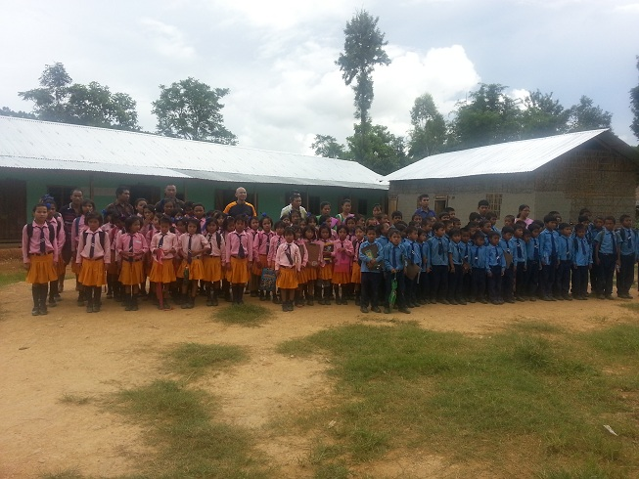(School Kids parade in front of the School building)
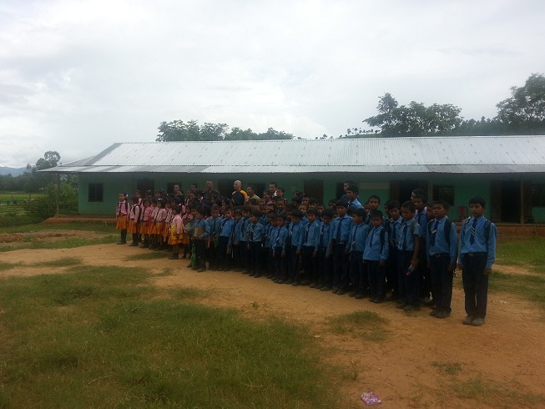(School kids, teachers and SACSAS team falling in line)
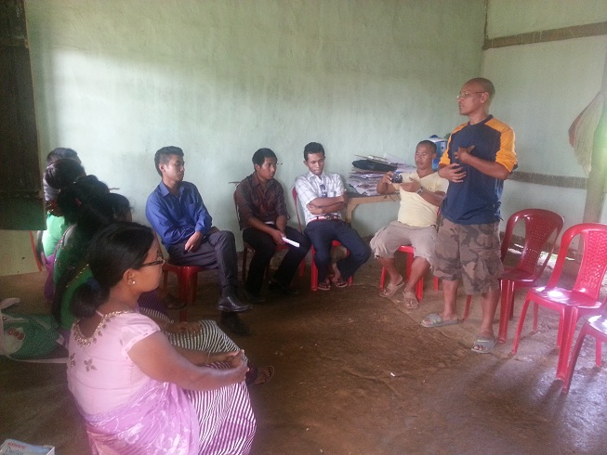(Surjit and Shantikumar meeting with the teachers)
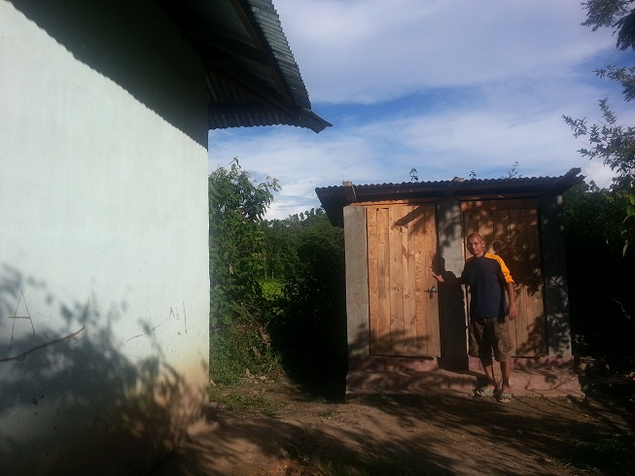(Newly built Urinal and Toilet)
SACSAS Academy - 4 (Loilamkot branch) Pictures: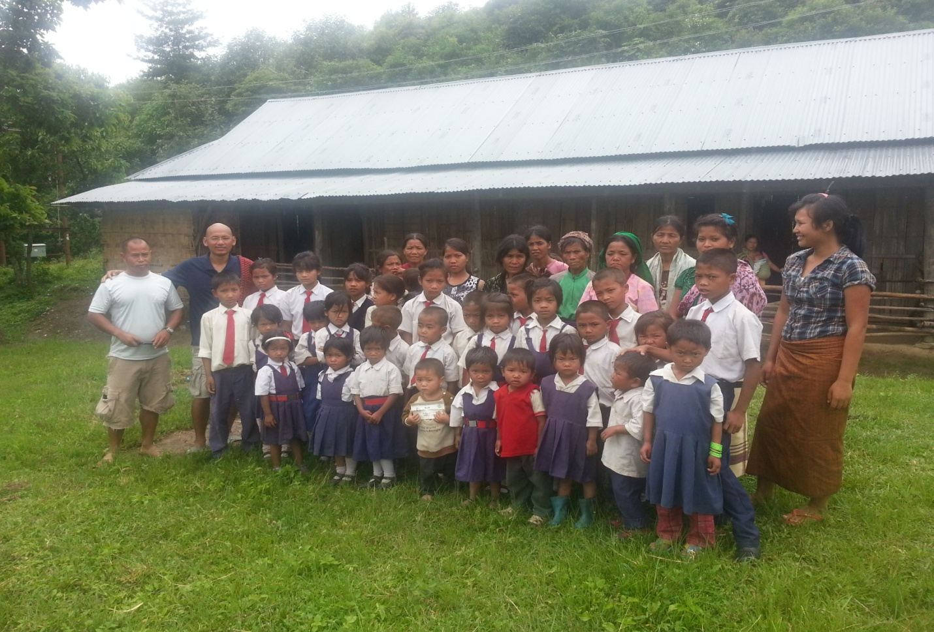(School Kids, teachers, Surjit and Shantikumar parade in front of the School building)
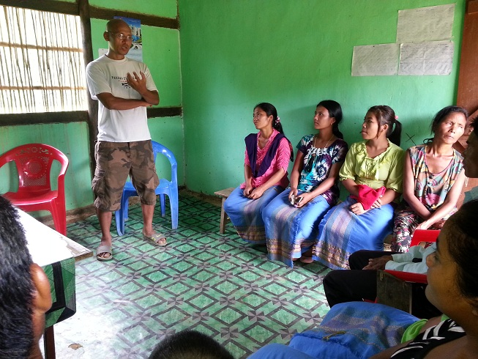(Surjit and Shantikumar meeting with the teachers and the guardians)
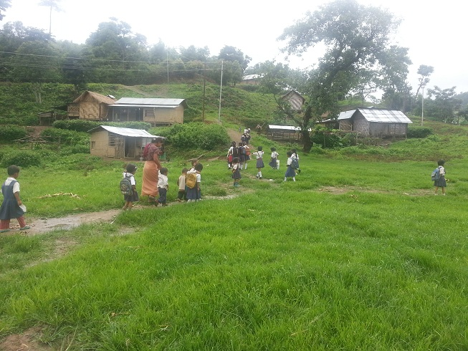(School kids returning to their respective homes after the classes)
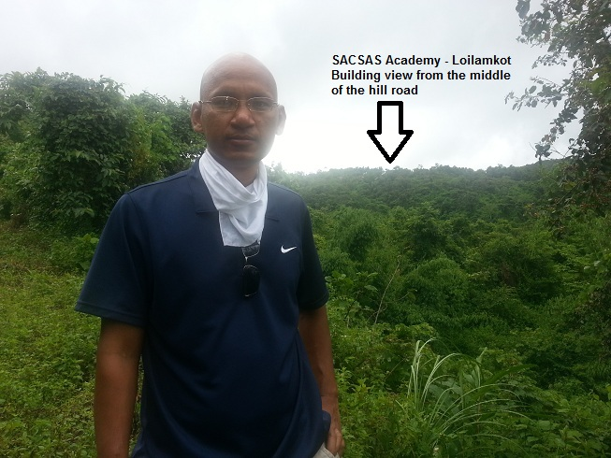(SACSAS Academy - Loilamkot School building view from the middle of the hill road)
SACSAS Academy - 5 (New Dampi branch) Pictures: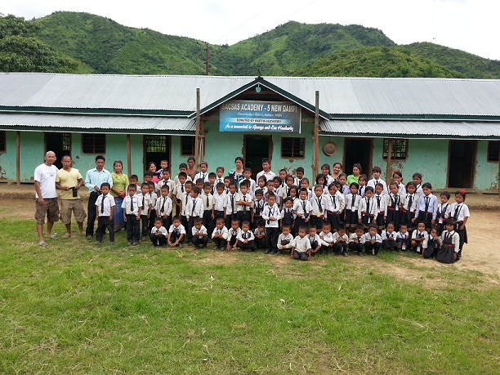
(Surjit, Shantikumar with the school kids, teachers and the village king)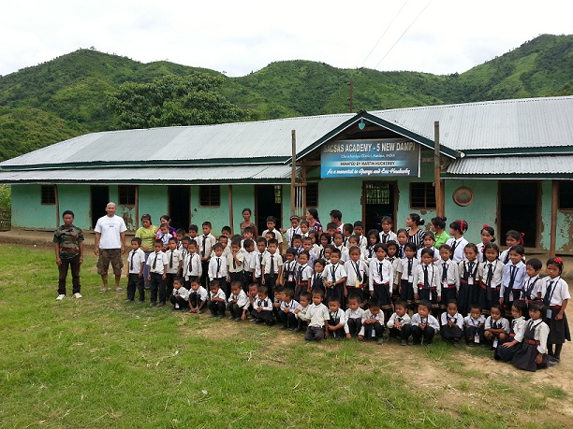
(Shantikumar with the school kids, teachers and the village king)
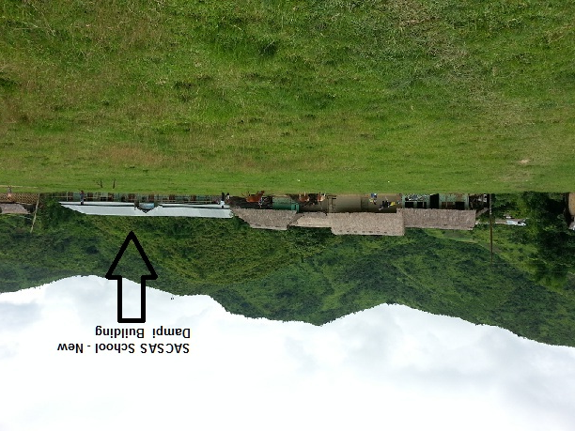
(New Dampi School Building from a distance)
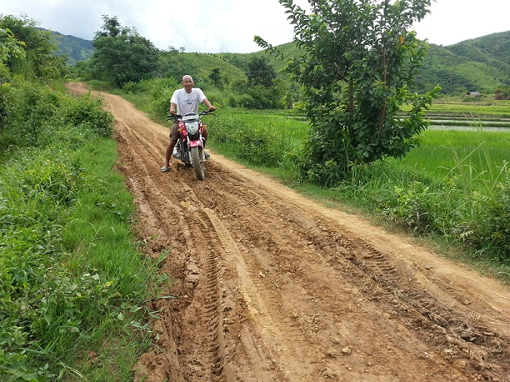
(Bumpy, mud road to New Dampi village)
SACSAS Academy - 1 (Laishoi branch) Pictures:
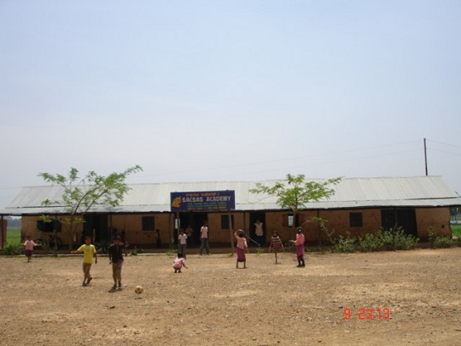
(Village kids playing soccer in front of school building)
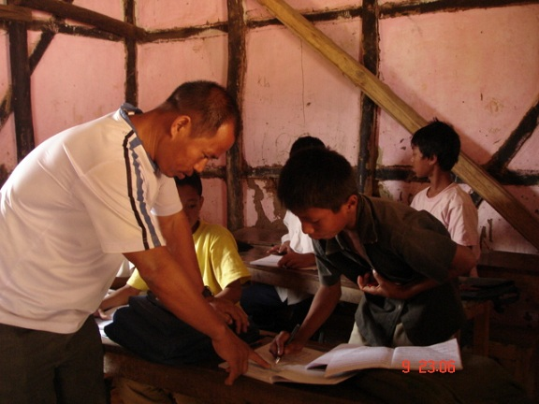
(Surjit, SACSAS Academy General Secretary testing the kids)
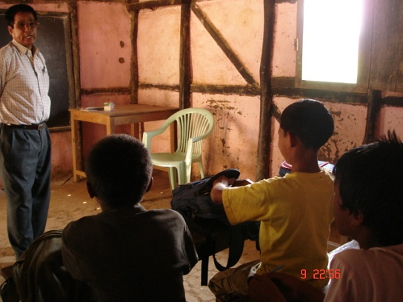
(School teacher interacting with the kids)
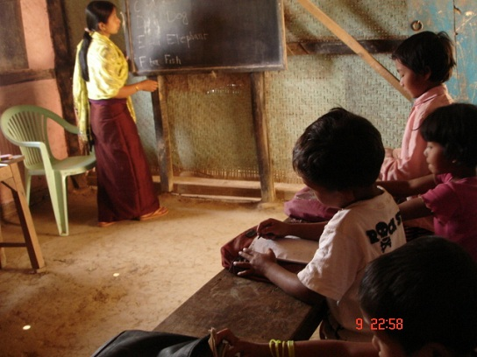
(Class in Session)
SACSAS Academy - 2 (Maobam branch) Pictures:
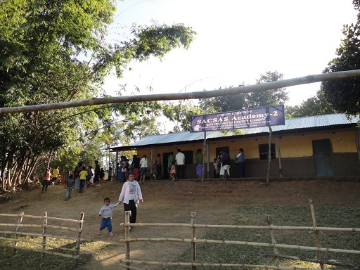(Kids coming to School for a function)
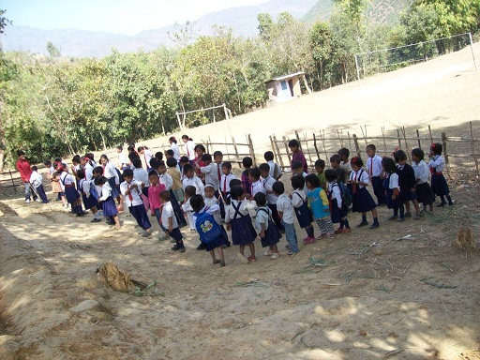
(Kids on morning parade in front of the School)
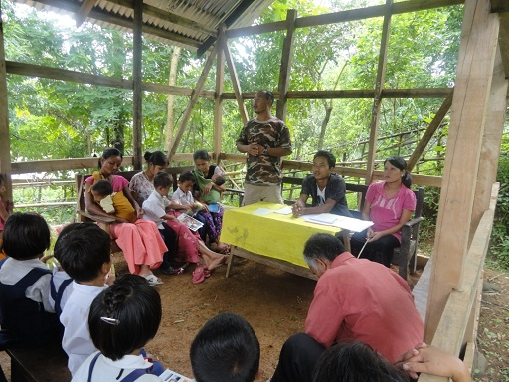
(Surjit giving a speech to the kids and village guardians)
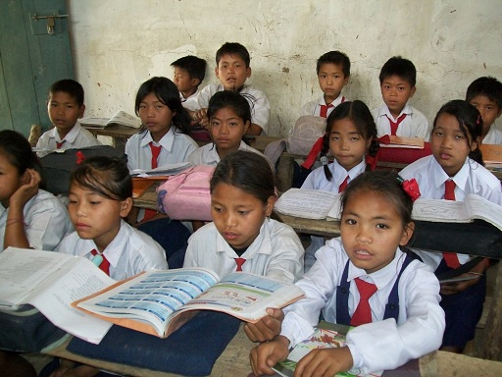
(School kids in the classroom)

