In January 2006, I spent a morning with Dr. A.K. Banerjee Choudhury, founder of AHEAD. I was very impressed by the work the school was doing. The key takeaways for me were that:
- Funding is a time-sensitive issue for Project AHEAD
- There was a sincere need for the school and a new facility
- The school appears to be well managed
- Project AHEAD is committed to finding sustainable ways to finance itself

Time-sensitive nature of their request for Asha
I wanted to impress upon Asha that March 31, 2006 is the target date for the completion of the school. The only way the school will be able to fund its construction is if Asha Seattle can get the money that it has committed prior to that date. This will allow the management of the school to focus on setting up the curriculum and drawing in students, not on raising money in the short-term.

Status of the construction
As I approached the construction site, the school is clearly a work in progress. At this point two stories have been built up and the focus in the next few months will clearly be on decorating the interior of the school. Dr. Banerjee Choudhury gave me insight into the layout of the facility.
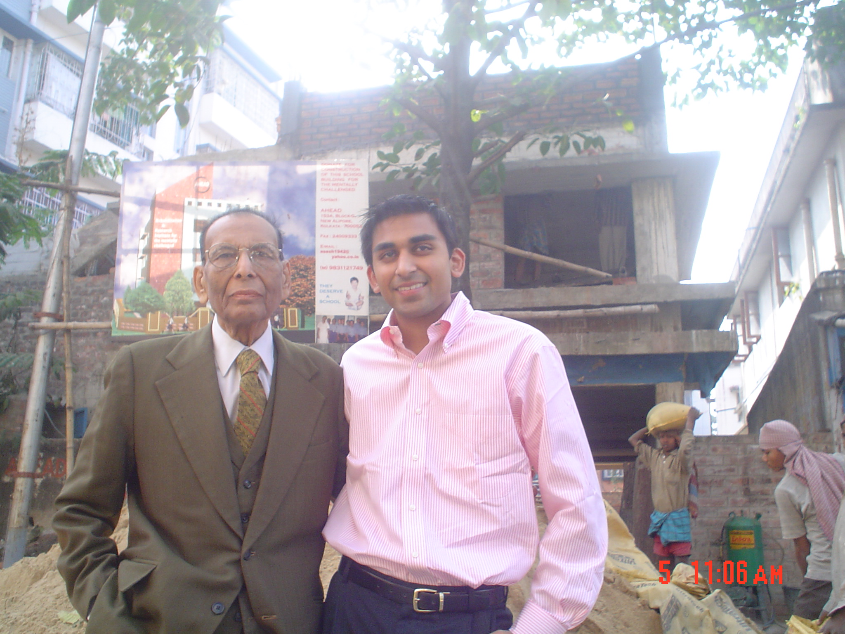
My grandfather and I in front of the construction site.

The bottom floor or basement is an open space that will be used for morning class exercises, presentations and parent meetings. There is a lift for wheelchair bound students or stairs that will take students to their classrooms. The classrooms are large and fifty students can comfortable sit on a floor.

Dr. Banerjee Choudhury intends to run the school in two shifts, so that means 100 students can be accommodated in a given day/floor. Therefore, the school has the capacity for 300 students. Of course, the expansion to capacity will be a gradual process as there are only 25 students currently enrolled in Project Ahead. By this March, one floor of classrooms and the ground floor will be completed.

The land itself was purchased at a concessional price from the government. It is in a relatively central location, which makes it convenient for parents. It is also opposite a small park and Dr. Choudhury has secured the permission to use that area for the school.
Status of the current facility
After visiting the new school, I visited the clubhouse where Project Ahead has been since 1979. It was evident how constrained the school is in terms of space. The clubhouse in New Alipore has rolled back the area the school can operate in. In fact, after 27 years, the school has been asked to move as the clubhouse wants to use this space for commercial purposes. There is no way that Project Ahead could grow its program given the classroom limitations. In fact, students are asked to attend on only select days of the week because all twenty-five cannot sit comfortably. When I was there, there were approximately fifteen students.

Need for Project Ahead
The government of India has implemented a new policy encouraging the integration of mentally disabled students with traditional students in its public schools. Unfortunately teachers are not trained to deal with the special needs of the students. Therefore, many government schools are turning down mentally and physically handicapped students that do try to attend. Therefore, there is a real need for specialized schools. Currently there are a handful of schools similar to Project Ahead that cater to the mentally disabled in Kolkata, however they are at capacity. There is a real need for another and Project Ahead will begin to address that problem.

Daily instruction and management of the school
After visiting the current school site, it became readily apparent how important it is for students to have a customized education. Each student is at a different stage and individual goals – therefore has to be taught as such. When I met the students they were working independently across various subjects. One student was drawing and another was reading. At the same time, the school offers opportunities to interact in groups – through art activities, dancing and sports. Unlike traditional schools, teacher have to be able to deal with students on not only a classroom wide basis but also one to one.

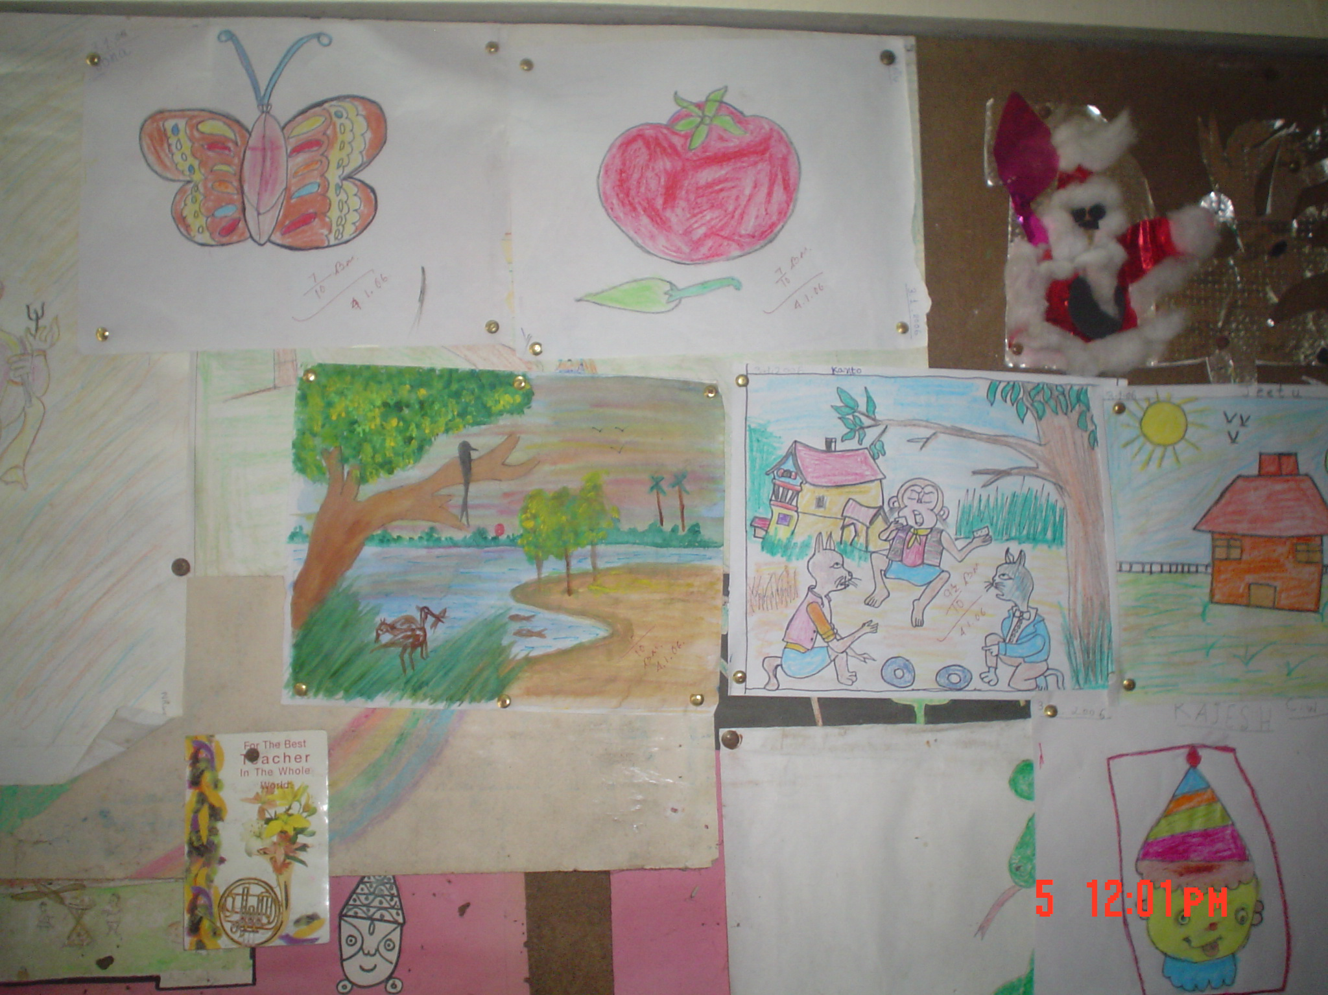
Some of the students’ artwork

Some of the teachers described how rewarding it was but also how at times it could be frustrating to work with mentally challenged students. One week a student might make progress and the next they might regress. That said, students seemed to be comfortable around the teachers and when I asked if they enjoyed schools, there were smiles across the room.

Vision of the school
Dr. Banerjee Choudhury described how his ultimate vision for the physically and mentally handicapped is that they would be integrated into public schools. Unfortunately, until India’s government education system has the infrastructure to accommodate that change his school and those like it will play a critical role. The focus of his school right now is to:
- Finalize the first two floors of the construction
- Plan out its first year and launch the school in April
- Gradually build the school upwards and in the process increase enrollment
- Make the school self-sustainable

How the school could be self-sustainable was the focus of much of our conversation. Currently Dr. Choudhury is thinking about reserving half the seats for economically disadvantaged children and opening the other half for those families who are able to pay tuition. Those that can pay tuition will essentially pay the way of other students and the day to day operations of the school.

In addition, the school has considered renting out its space after school for local meetings and collaborating with local clubs, companies and organizations to sponsor various projects.
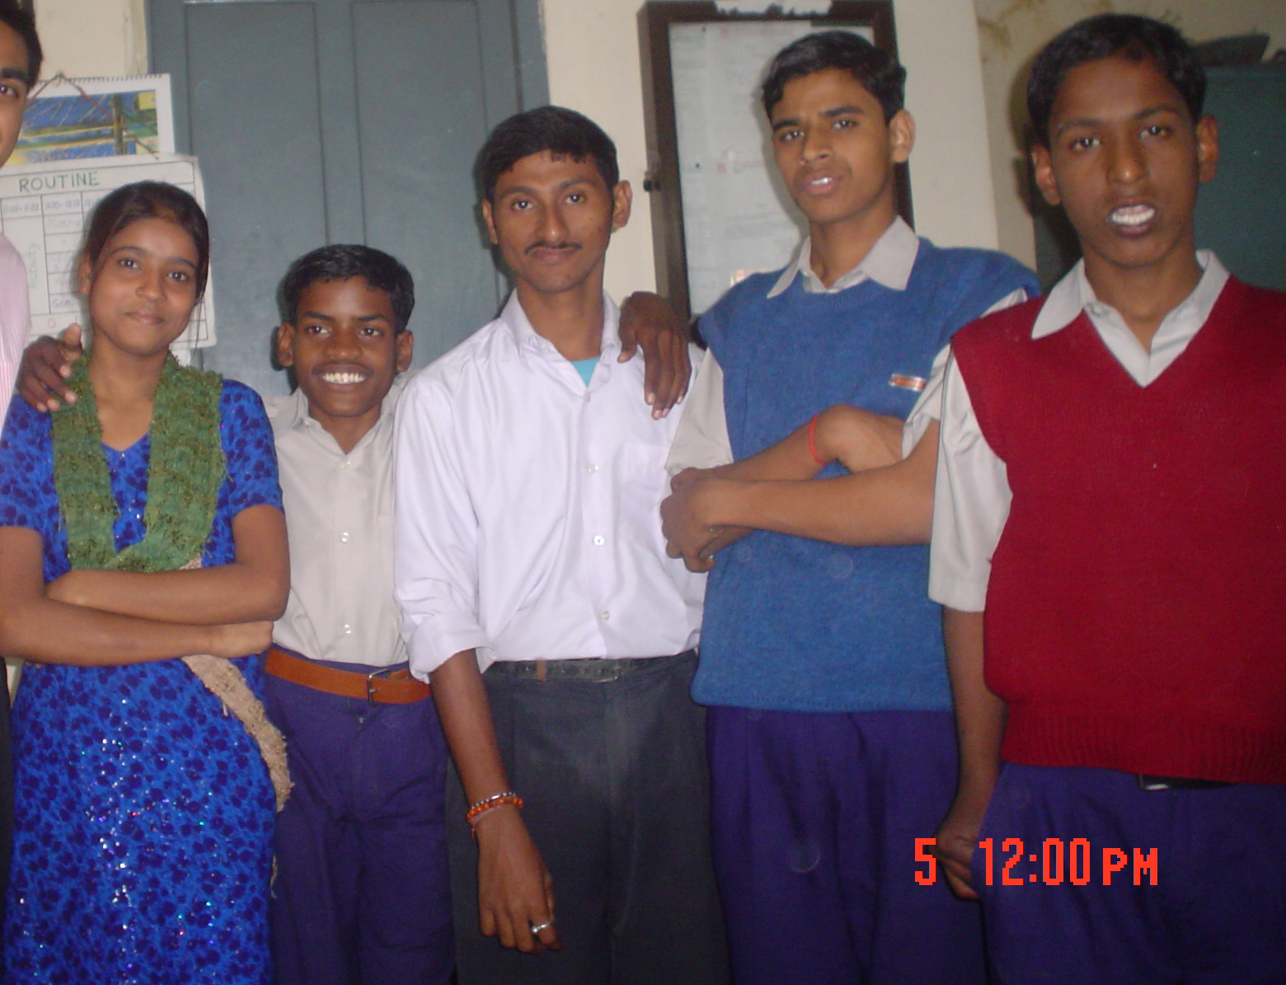

Kids at the current clubhouse school in New Alipore

Please see the photos attached.

