Review of Project AHEAD for ASHA NYC-NJ

Date of final review: 19 September 2007.
Location: Calcutta , West Bengal
Scope: Special education for the mentally challenged and rehabilitation and vocational training for physically handicapped students.
Total Requested amount: USD 24000.
Reviewers: Prashanth Kovvuru (prashanth_ise@yahoo.com)
Kalpendu Pasad (kpasad@gmail.com)

Last site visit: Swati from ASHA - Seattle will be doing a site visit in the week of 09/17. Prior to that Dipa Bhaumik visited Ahead in Feb 07.

Project website: http://www.aheadindia.org/

Website on ASHA: AHEAD (WEST BENGAL)

Past review reports: Please refer to the hyperlink 21st June 2007 which has the information about the proposal and the review information until June 21, 2007.

At the upcoming projects meeting on Sep-22nd, Project Ahead will be brought to vote for the following:
- One bus to amounting to Rs. 1 Lakh (~ USD 2.2k)
- Library amounting to Rs. 50,000 (~USD1.2k)
- Possibility of considering support for second bus once the school admits and/or receives good number of applications based on the response.

Transcripts of the email/phone conversations with the fellow volunteers at the Asha NYC/NJ team and Ahead between June 21 and Sep 19, 2007 can be reviewed below. Balance sheets for 2006-2007 are a part of transcripts dated September 12, 2007.

Brief notes from the Phone conversation on Sep 17, 2007

- Dr. Banerjee is extremely confident about the strength of the students going up atleast by 30-35 once the bus services are introduced.
- Ahead is going to advertise the introduction of bus service (on the assumption that it receives financial support) in the local newspapers, which would trigger interest in the local area.
- Some of the parents are even planning to withdraw their students from Ahead if the school does not introduce bus services in the next 3-4 months.
- The 2 regions proposed for the introduction of bus service have a demand of atleast 20 students each.
- Currently out of the 35 students, 10-12 of them are planning to utilize the bus service as they hail from far off places.
- As a part of the long term plan, Dr Banerjee sought a quotation to buy the buses from TATA. He is soliciting grants from various agencies towards the purchase of the buses.
- Admissions will be open throughout the year as long as the capacity permits.
- 4 new teachers have been added with the idea of starting a 2nd shift. This shift would primarily be focused on running physiotherapy and vocational programmes. That will make it a total of 8 full-time paid teachers and 4 volunteer teachers at Ahead.

Transcripts from the Email conversation on September 13th,2007

1) Could you please clarify what a trip means ? Your proposal was requesting 2 lakhs per year. We need to understand if it is for running a) 1 or 2 buses, b) single or 2 shifts. We weren't completely clear on the structure of this expense.

A trip means to and fro journey for one batch of students. In other words, one bus will collect students from their home and drop them down to school. Then, again the bus, after school hours, collect the students from school and drop them down to their home. This will complete one trip or one batch. Two buses will ply in different directions in the morning shift, say, one bus will cover Behala, Kidderpore, Alipore, New Alipore, Chetla etc. The other bus will cover Tollygunge, Garia, Jadavpur, Dhakuri, Ballygunge etc. After dropping down the students to school, they will go to collect students for afternoon shift. After dropping them down to school, the buses will pick up students of morning shift from school for the return journey. After coming back to school they will pick up students of afternoon shift from school for the return journey. Thus two buses are to be hired and they will be deployed for two shift.

2) Do you currently run single / multiple shifts

A) We are currently running one shift. But we have recruited 4 new teachers recently and made arrangements for starting second shift for vocational training. We hope to start this after Puja vacation, i.e. in Nov. 2007.

3) Can you please confirm that the fuel costs and the salary for the driver/attendant is all included.

A) Yes it covers all expenses. It is a package rate from the transport contractor, the quotation is
already sent to you.

Notes from the Conf call on Sep-08 2007

A conf call was held on September 8th 2007 to status of the proposal from AHEAD. The participants were Mazin, Lakshmi, Prashanth, and Kalpendu.

The following were the outcomes of the meeting
- We needed clarification of the definition of a bus-trip, whether it is a single way or to and from the school
- Is fuel cost included in the estimated expenses (Rs.1 lakh per trip)

The agreement was that Asha NYC/NJ can support one bus for one trip at the moment. We would then closely follow through with Ahead re: the hike in the admission rate and the demand for further consideration of additional bus rental services. It was agreed to fund the library as well. The auditorium will not be considered at this time because the expenses are primarily focused on air conditioning and advanced audio system. Asha NYC/NJ deems expenses on these components as not directly related to education in that these components do not have a material impact on schools ability to impart core education.

Transcript of Email on: September 12,2007

Q 1) Can you provide us info on where do the usually students go/work after completing the school...Do you have any statistics that you can share with us.

Ans 1) After completing school, the students are to take up some vocational courses in consultation with their parents. The next step is to motivate the parents and the student to form some self-help group for entrepreneurship in which case soft loan is available from Govt. In the past there are 9 cases of self-employment, employment, engagement in family work etc.
Four (male) are employed ( one in tailoring job, one as unskilled labour and two self-employed in leather goods/handicrafts ).Two (male) are continuing in our adult curriculum. One(girl) of our adult curriculum who was employed as dance teacher in our school is presently taking advance dance lessons for a career.Two(girls), though unemployed, are assisting in household jobs. Recently one speech & hearing handicapped girl (Muslim), after finishing education and good dance training, is awiting marriage as informed by their parents.

Q 2) Could air coolers be a viable alternative to air-conditioning for the auditorium.

Ans 2) It may not be advisable for health and other reasons. In other NGOs in Kolkata, air-cooler concept is not there for auditorium. Further, if the auditorium (multi-use training room) is also planned to be used as an income generating project to recover the running expenses by letting it out during holidays and evening time, it is to be properly equipped.

Q 3) What is the impact on the school student and teacher strength after moving to the new building? Can you provide the numbers indicating growth inline with the financial statement? (99000 in ’05 to 264000 in ’06) .Also would you be able to send us scanned copies of the audited financial statement

Ans 3) Student strength is increased to 35. Paid and qualified teachers (including experienced speech therapist) have been recruited raising the number of paid teachers to 6. There is also one teacher-in-charge. Physiotherapy Unit with appointment of a professionally qualified Physiotherapist has been started. Vocational Unit is about to be started and many equipments are already procured. School environment and quality of teaching and infrastructural facilities are improved. We are progressing for starting OPD. We have already created infrastructure to admit upto 75 students. We are eagerly waiting for starting hired school bus service.
Scanned copies of audited Annual Accounts for 2006-07 including figures for the previous year 2005-06 are already mailed.

Q 4) How many students can he mostly guarantee would join Ahead by Dec-07 if
Asha- NYC/NJ were to provide funds for school buses and/or library and/or auditorium set-up. Would that vary if we are not able to support some/all of it

Ans 4) Once fund is released and received at our end, we are very hopeful to raise student strength to raise upto 75 within 4 months.
The infrastructural facilities requested are essential for making progress as per plan and ensuring quality of services as well as level of operation..

Q 5) Will the recruitment for staff commensurate with the number of students or will the school be staffed to the maximum irrespective of the admitted numbers? Also what is the fee structure ?

Ans 5) Our most immediate plan is to increase student strength to 75 and accordingly we have recruited qualified teachers and specialists very recently. The Govt. approved teacher-student ratio is 1 : 7 and accordingly we are proceeding. We can confidently say we are progressing in the right direction and we are never over staffed. Rather we move very cautiously before increasing any expenditure. We try to manage many affairs through voluntary efforts. But we must make provision for specialists like Physiotherapist, Speech therapist, Occupational therapist, Psychiatrist etc. as required for the challenged students. Such provisions were not previously there.
Our full tuition fee is Rs.300 per month which is much below our actual cost. The fees being charged by other similar NGOs are also much higher. Many students are free, and some pay much lesser than Rs.300. The fee is judged on economic capacity of parents.

Q 6) what is the typical duration of a child's education at Ahead ? Could you explain in detail about the structure of each program you have ?

Ans 6) Typical duration will be about 8 years of which 6 years in education (pre-primary, primary, secondary, pre-vocational) and 2 years in vocational training. Duration in each sub-division will depend on the extent of handicap. But the general overall duration is likely to be so.

Q 7) % breakup of families who are/not willing to pay fees to send their kids to Ahead ? and how do you see it helping overcome the possible deficits in the future.

Ans 7) About 50% of the families suffer from economic problem. As explained earlier, we will manage the deficit through sponsorship, and growth of corpus fund which will give us interest income. Some donors specify their donation to be kept under endowment and utilize only the revenue earning therefrom. This will also be helpful for us in the long run.

Q 8) How do you measure the success of the school ?

Ans 8) There will be a number of yardsticks viz. increase in student strength, number attending OPD, teachers being trained in our training dept., specialist services and equipments available, students passing out and finding occupation, number of self-help groups formed by parents, number of students mainstreamed in general schools, parents counseling and information-referral services etc.

Q 9) Do they regularly monitor the health of the students...Are there local physicians who are willling to offer this service ? Could you explain your school’s healthcare activities

Ans 9) Health-care activities will be started when we start OPD when physicians, psychiatrist will attend. Now there is regular physiotherapy under a professional physiotherapist appointed by us. We have a child specialist in our Executive Committee who has agreed to come for a check-up. We have contacted some more Doctors for joining OPD and giving voluntary services.

Q 10) What is the avg work experience of a teacher at Ahead ? Could you please share their background (All we need is just their degree related information), their experience with Ahead ?

Ans 10) Teachers are qualified in special education and work experience is in-built in the course. Further, after completing examination, they are to undertake internship for 3 months compulsorily. Our new teachers recruited have the requisite qualification. Our paid existing teachers (three) have more than 10 years work experience in our school. One new teacher-cum-speech therapist has five years work experience with reputed NGOs. They are having Graduation Master’s Degree and Diploma/Degree in Special Education with RCI Registration as required by the law.

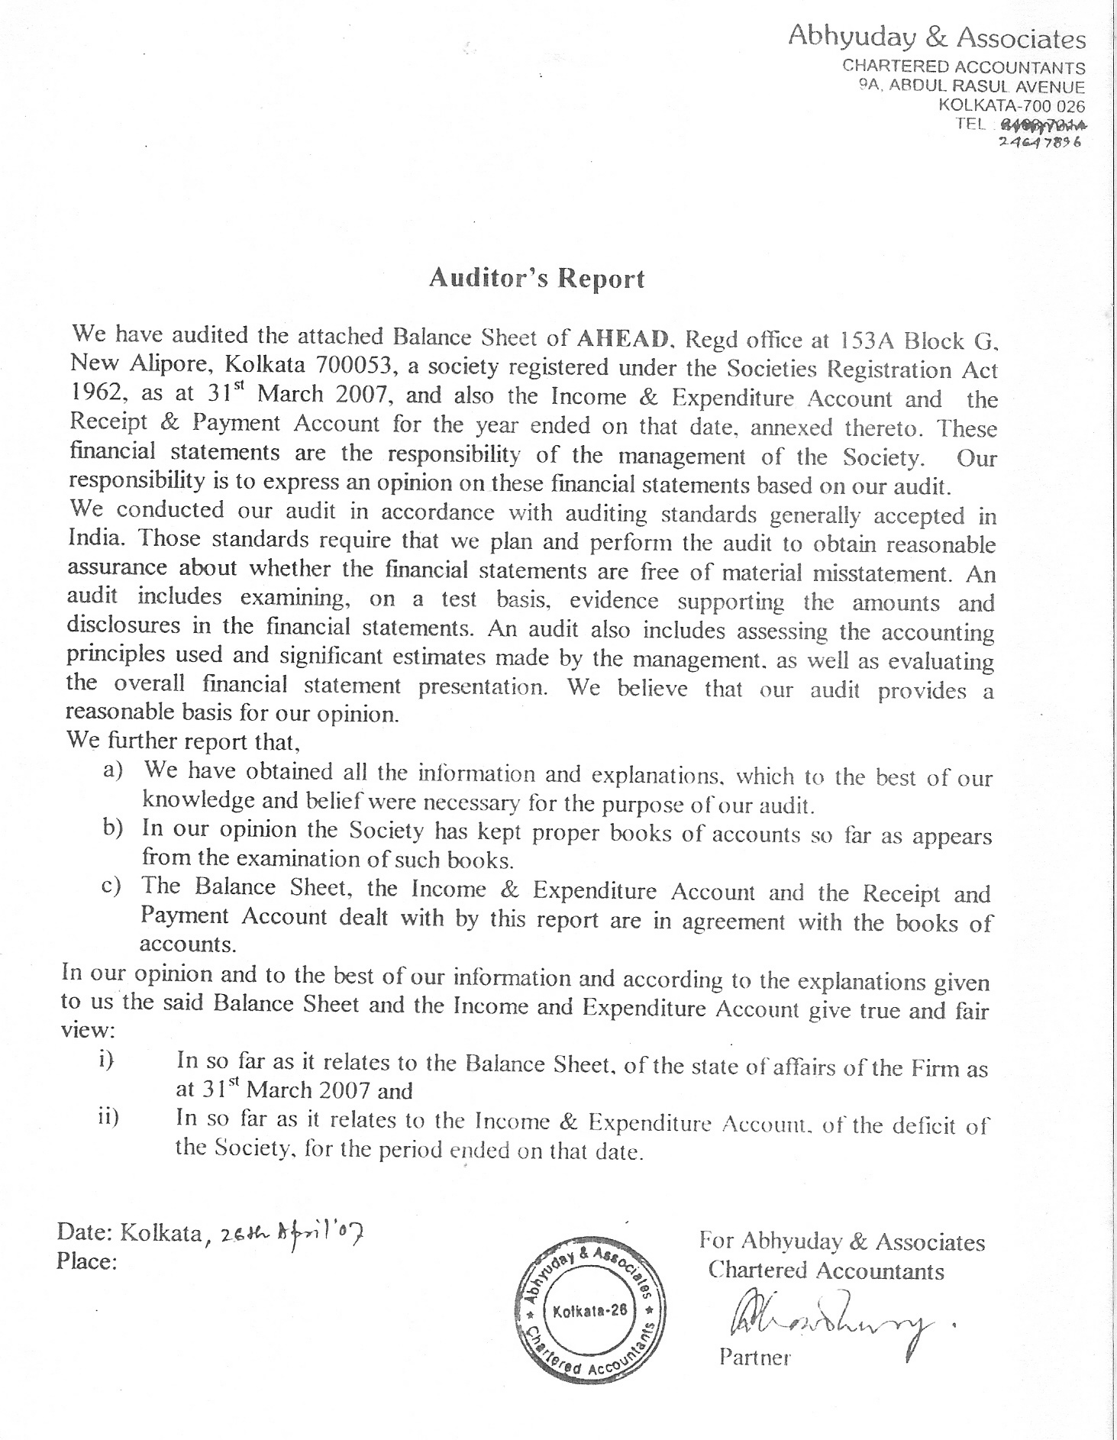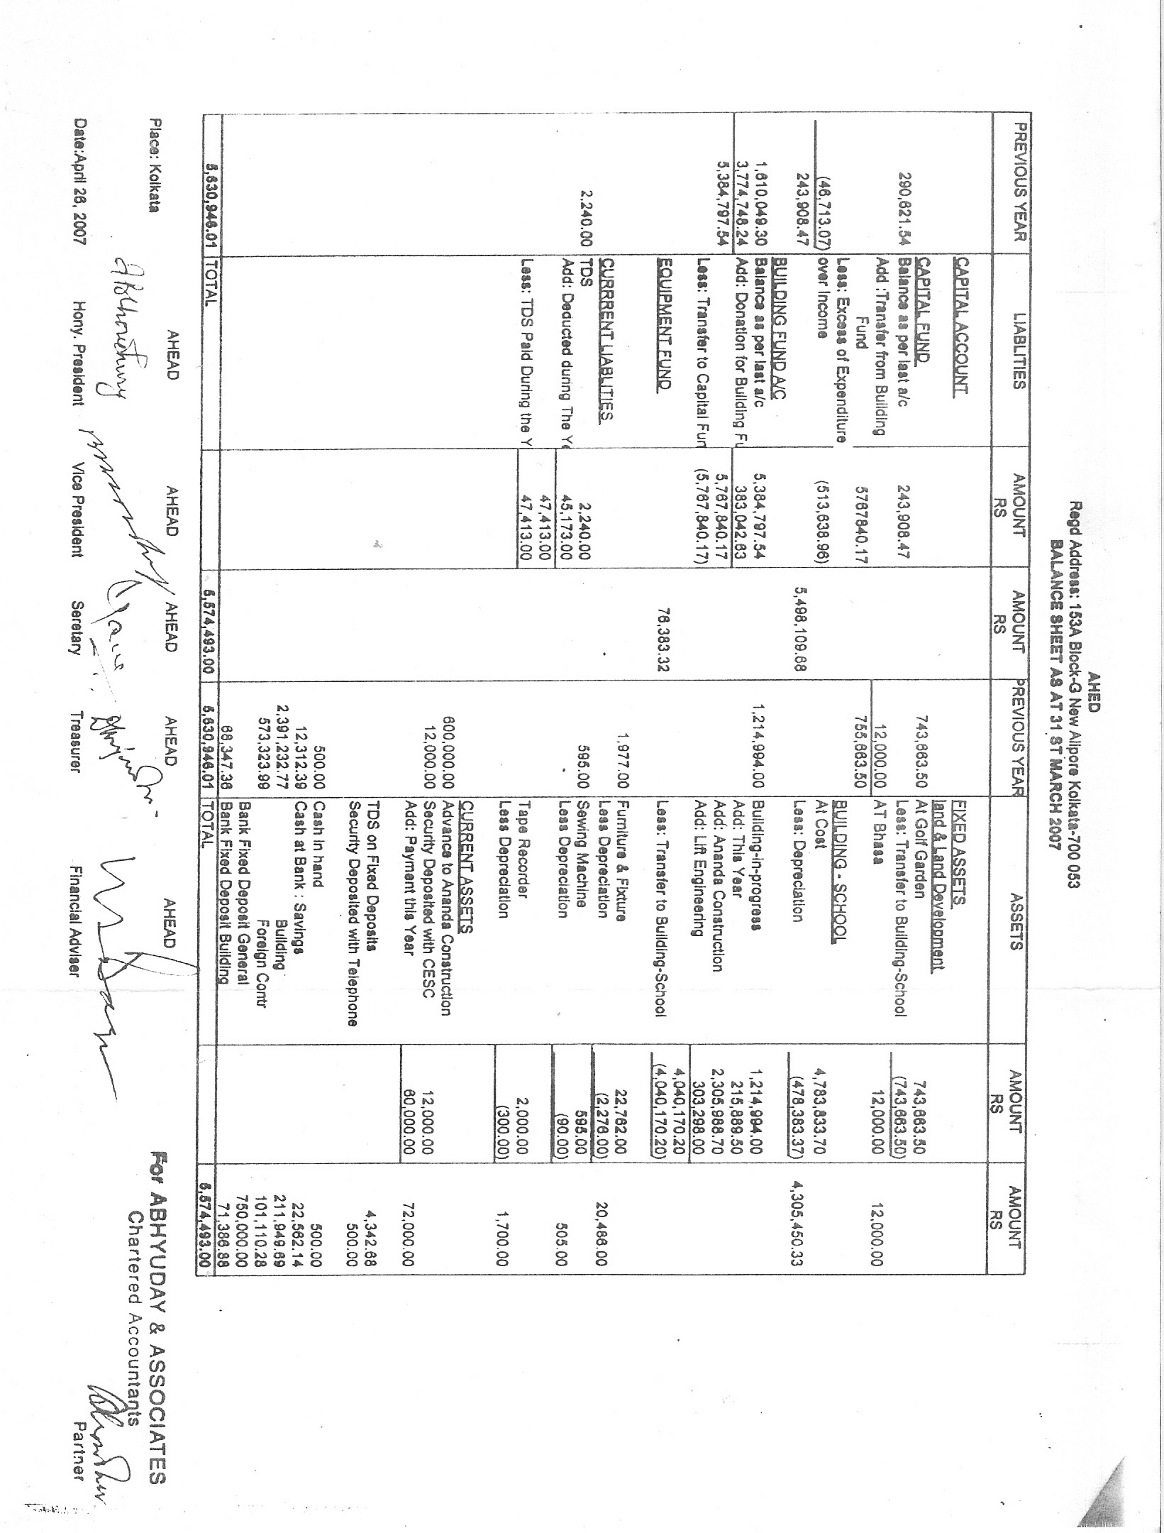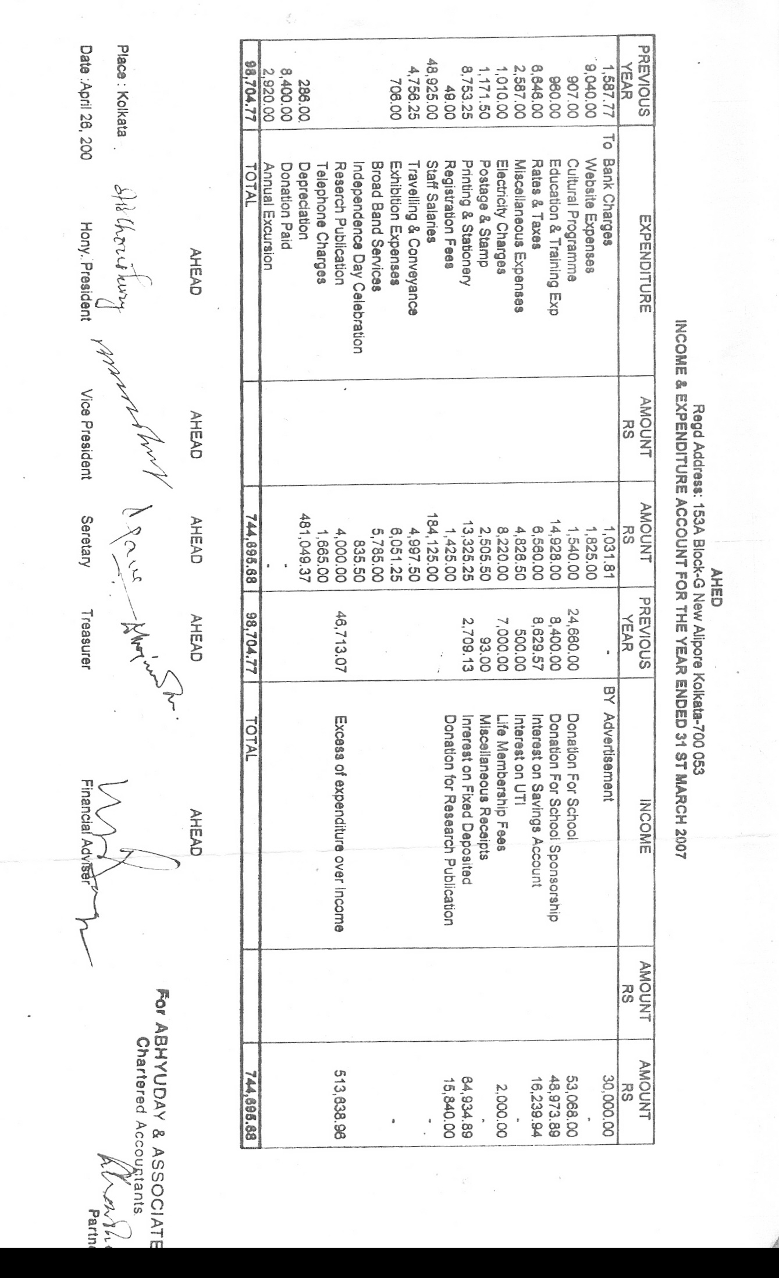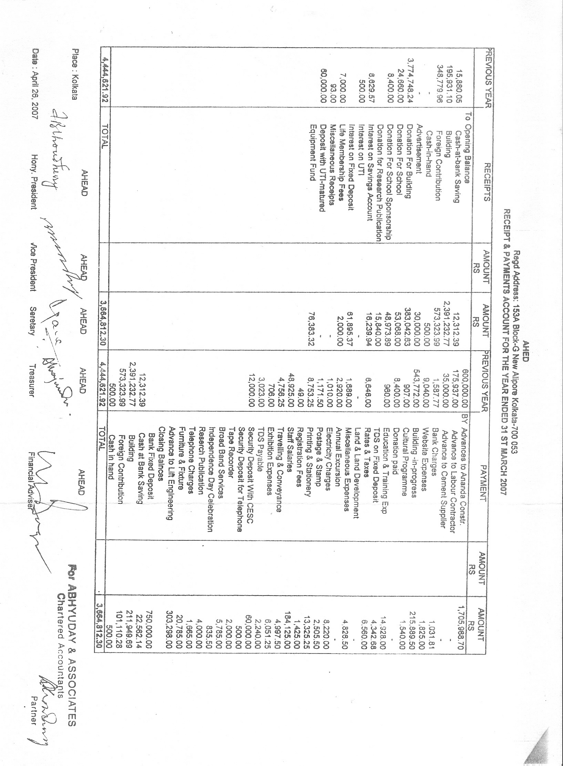

Transcript of Email on: July 30th,2007

QUERIES FROM ASHA NYC | ANSWERS FROM AHEAD
1. Could you provide us with the financial statements for the last 2-3 years? This is usually requested every time we begin funding a new project. | Based on audited accounts  Expenses 2005-06 2006-07  Rs. (‘000) Rs.(‘000)  Salaries 49 184  Educational  Materials 1 15  Internet Expenses 9 7  Printing-Stationery 9 13  Electricity 1 8  Conveyance 5 5  Research - 4  Telephone - 2  Curricula 4 8  Postage 1 3  Municipal Taxes 7 7  Rent 8 -  Miscellaneous 5 8  TOTAL (A) 99 264  INCOME  Charity show - 30  Life Membership Fees 7 2  Fees from Students 25 53  Donations &  Sponsorships 8 50  Donation for  Research Publication - 16  Bank Interest 12 81  TOTAL(B) 52 232  Shortfall (A – B) 47 32  Note : Shortfall met from internal resources.
2. Could you provide the list of recurring and non-recurring expenses anticipated over the next 1-2 years? This will help us determine how best we can structure our funding to you. | Expenditure planned  2007-08 2008-09  (Rs. ‘000) (Rs. ‘000)  Non-recurring  Equipments for  Physiotherapy 25 50 (1)  Equipments for  Vocational Training 75 125 (2)  Class-room Furniture 125 150  Computer &  Communication 200 200  Auditorium 300 200  Library 25 25  TOTAL 750 750  Notes:  - OPD planned in 2008-09  - More trades planned in 2008-09  Assumed, receipt of grants and donations takes effect in the later half of current year. As a result there will be spill over in the beginning of next year i.e. 2008-09.  Recurring  Expenses 2007-08 2008-09  Rs. (‘000) Rs. (‘000)  Salaries 290 380 (1) Educational  Materials 25 30  Internet Expenses 10 10 Printing-Stationery 20 20  Electricity 15 18  Conveyance 8 10  Research 5 10 Telephone 5 8  Curricula 15 15  Repair & Mtce. 5 10  Postage 5 7  Municipal Taxes 7 7  Miscellaneous 5 5  Hire of school  Bus services (for one  year w.e.f. 2nd part of  current year) 100 100  TOTAL 515 630  Note:  (!) We have already advertised for vacancies for Principal, Special Educators and Office Executive. Recruitment process is on. Hence, part year’s effect in 2007-08 and full year’s effect in 2008-09
3. Can you provide us with the break up of your current funding source? If there are too many, Can you please send us a brief breakup (in terms of %) from various funding sources/groups. | Fees from paying students 30%  Sponsorship & Donations  (Indian & Foreign Sources) 40%  Bank Interest from Corpus/  Endowment Fund 10%  Miscellaneous Income  (Charity shows/Exhibitions) 10%  Support from members  Towards deficit 10%  TOTAL 100%
B. Training and education
4. Please elaborate on vocational training, e.g
a) What are the different vocations the students are trained at? | We have planned the following vocations for training purpose, which will be introduced gradually:  A. Major Areas  Gardening, Lamp shade making, Machine knitting, Packaging of grains, spices, etc, Paper bag making, Seasonal items like greeting cards, rakhi, national flag, Dia lamps, etc., Photo Lamination, Tailoring and embroidery, Canteen & Kitchen – preparing tea, coffee, snacks, meal etc.’ Jute Bag making, Candle making, Papiar Mache items, Leather Goods, Use of computer, Block & Screen printing, Educational and soft toy making,  B. Minor Areas  Kite making, Handicrafts (wall hanging, pen stand, painting, gift wrapper, decorative pieces etc.), Binding of Books, Exercise Books, Scrap Books, and Drawing Books etc., Dry Flowers.  At present arrangement/equipments for following vocations are there:  Gardening, paper bag making, spice grinding & packeting, lamination, Canteen & Kitchen, greeting cards, handicrafts.
b) Do they pass through various levels?  Can you explain the structure? | Aged students or students passed out from other Institutes may take direct admission for vocational training in selected trades decided in consultation with parents, if found suitable for training.  In-house students may take admission after passing our various levels viz. Pre-primary, Primary, Secondary, Pre-vocational.
c) Is the training program developed in  house? Or is the program developed by  the government/other institute | Vocational training programs are developed in-house. Expert consultations / visits of Govt. / other Institutes are also done.
d) You mentioned about the government  approved training program that you  intend to introduce, could you please  give some details, e.g. how is it different  from your existing program | Govt. approved training program is intended for those who would like to qualify and take up the profession of Special Educator / Teacher to educate and train challenged children in various special / general schools. The programmes are of various levels and duration e.g. Foundation courses, Diploma and Degree Courses, Special B. Ed. Courses, research work of Ph. D. level etc. University affiliation is also necessary.  Teachers of general schools also undertake such courses as a part Integration / Inclusive education.
e) Does the government/any other institute  certify the program that you offer? | The above courses are conducted under the control of Rehabilitation Council of India (RCI), a Govt. of India organisation with affiliation from Universities.  Rehabilitation Council of India issues RCI Regn No. which is compulsory for taking up Special Teacher’s profession. Diploma, Degree etc. will be given by Universities on completion of training courses to be conducted by us.
5. Can you please provide a outline of the curriculum for the Mentally challenged students? | Academic : Pre-primary, Primary, Secondary, Pre-vocational, Vocational, Autistic (separately dealt), Mainstream education with National Open School / University.  Extra-curricular : Art & Craft, Dance & Music, Sports, Educational Tour, participation in competitions, workshops, various entertainment and social programmes.
6. Is project ahead associated with any other schools or programs e.g. does it seek assistance in designing curriculum or any other kind of assistance (non-financial) from any other schools/ project? | We follow the guidelines issued by the National Institute for the Mentally Handicapped (NIMH), Govt. of India and Dept. of Mass Education (Govt. of West Bengal). We also maintain close connection with and consult the Specialists of NIMH, Monovikas Kendra (reputed NGO working for the mentally challenged), and Indian Institute of Cerebral Palsy (IICP), a reputed NGO working for the CP children etc.
7. Is project ahead associated with government programs? Do you seek assistance from any other schools/ project? | We are registered with Persons with Disabilities (PWD) Act, National Trust Act. We have applied for registration with Rehabilitation Council of India (RCI) for conducting training courses and Dept. of Mass Education. All of our existing paid teachers and voluntary teachers have RCI Registration.  We take assistance from NIMH, Monovikas Kendra and IICP.
8. How would a typical working day schedule for AHEAD student look like? | Settling down, assembly, Prayer, lessons according to lesson plan and goal plan, art & craft, break for tiffin, physiotherapy, music.
C. School bus
9. How do the students commute currently? | By Public transport, Own / hired transport, and by walk (neighbourhood students)
10. Where are the prospective students geographically located, in that:  a) Do they tend to be localized in small groups in a particular geographic area or are they geographically scattered?  b) What is the average distance a student has to commute to get your school? | a) Some of our current students come in a group, as they are parentless and stay in two different homes run by the Missionaries of Charity - one in Kidderpore and the other in Entaly. Others students are scattered.  b) 6 KM on average. We have planned to pick-up students upto 10 KM distance from the school when bus services will be introduced.
11. Have you explored the option of teachers traveling to the students. E.g. if the students come from the same locality, a teacher can possibly visit the students instead of the other way round. | School environment, education/training under different expertise, peer group activity etc. are not possible at home. (e.g specialist teachers for different aspects, Physiotherapy and vocational training equipments and expertise, music, dance, group activity, visiting specialists etc.). Poor students from slum areas have hardly any space at home. It is desirable for those who are able to come to school. For stray cases with profound handicap, there may not be any alternative but to arrange home visit (not within our plan). In remote villages (which is not applicable for us) where commutation is difficult, home visit may be thought of.
12. Have you explored the option of renting auto rickshaws for ferrying students? In our experience, auto-rickshaws are a cheaper means if the students are geographically scattered. Multiple autos could be employed in various directions to provide the required coverage. Please let us know your thoughts on this. | In hired or owned buses, there will be trained attendant to look after the challenged children of different categories. Parents will not be required to accompany. Some children are restless. Safety is an important aspect. Buses will pick-up students from as nearest to their home as possible. Neatness and cleanliness, time schedules and control aspect are other factors.  Therefore, all Institutions maintain school bus services only, either owned or hired.
13. Could you please elaborate on your estimate on the number of students that you anticipate over the next year? We would like to understand how you arrived at the estimate. Any statistics on the geographical distribution of the students available that you can share with us?  a) Do you already have the census of number of student who would seek admission with AHEAD?  b) Did you interact with the families of the student to ensure that the parents/families are willing to send the students (assuming transportation facilities are available). | We estimate, by September 2008, we may have 100-125 student strength. If two buses (25-seater each) are deployed for two trips each, there will be 100 students. Neighbourhood students or students who will maintain their own arrangement will be about 25 (some of our existing students will switch over to buses. Their parents are eagerly waiting for this.). There is no available published statistics, but our experience is that students are scattered and fairly distributed surrounding our school, consisting of urban, and slum areas.  a & b) Based on the Census and the survey conducted by the National Sample Survey Organisation, it is estimated that there are about 50,000 mentally challenged children in Kolkata Municipal areas. Considering the age group and other criteria, if we presume 50% of them as educable and trainable in the special institutes, the number would be 25000. The capacity of the existing institutes at best would be around 3000 to 4000. There is a substantial gap leaving aside the aspect of quality and infrastructural facilities.  Our experience is that as soon as we advertise for intake of students, we will be flooded with applications. Even without any publicity, we are already receiving personal requests from many parents for school bus services for admission of their children. Our student strength is gradually going up. We have already advertised for vacancies of Special Educators and will soon recruit Special Educators to take in more students.
D. Building and Auditorium
14. Could you please elaborate on the utilization of the building:  a) How many rooms/floors are being utilized  b) How is any unused space intended to be utilized? | Our building is 4-storied (G + 3). As per municipal laws, we cannot have class rooms in ground floor. We are utilizing the ground floor covered open space for dance training, cultural activities, exhibitions, vocational training (kitchen, mixer-grinding, packaging), and will effectively use the large space in future for OPD.  First floor (all 3 rooms) and part of second floor (one big room) for school, physiotherapy, school-office, vocational training.  b) One medium-size room in second floor for office & meeting purpose. In third floor, there is one big room reserved for multi-use training room and one medium-size room reserved for research & library.
15. Can you begin with a basic auditorium structure?  a) Is air-conditioning requirement for basic operations?  b) Is sound system a requirement for basic operations? | The building being on main road, there is traffic and neighbouring sound. There is summer & rainy seasons. If 75 persons are to be accommodated, and various curricula/training courses/educational film etc. are to be held throughout the year, it is necessary to have air-conditioning and sound system.

