A
Report for the Period
(March 2008 to June 2008)

T.E.A.C.H

(Train and Educate Adolescents with Community Help)

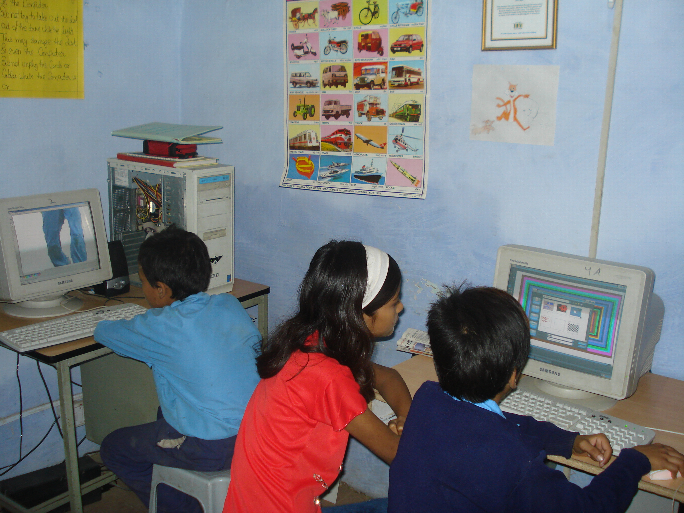

Girls Interest Centre
Report By
ABHAS

T.E.A.C.H Project is running to support by Asha Stanford in Tughlakabad Village. The project module of integrated education (Education with Vocational Trainings & life skills) is giving them the opportunity to take part effectively in their future roles as adults. The project is helping to mainstream the drop out girls, never enrolled girls to complete basic education, support and motivate girls to complete higher levels of education and empower them to access livelihood opportunities by skill and capacity building through vocational and life skills program.
This report presents the activity done during the months of March 2008 to June 2008.

Vocational Training Center

Beauty culture:
Teach project is basically focused to develop the capacity and skill among children. During the month of May 40 students of Beauty Culture appeared in the practical exam which was conducted by J.S.S. PRAYAS. In the month of May all the three batches were conducted regularly. Currently we have 45 girls in beauty culture. Till now we have introduced mehendi, manicure, pedicure, wax, bleaching etc. for in our second batch.

Dress designing and stitching:
In this 38 girls are enrolled. The second batch is on completion. All the girls are ready for examination which will took place in the month of August.

Computer Lab:
Currently we have 61 (39 girl and 22 boys) children in our computer learning program. The entire students were divided in four batches. The concept of computer, note pad, word pad, paint and MS Office package were taught to them.
Other than this educational software such as Azim Premji CD pack & Kid pix were also shown to the students of different batches.

NIOS :
Right now we have enrolled 15 students in our NIOS class. Currently we have 08 girls in class III, 06 girls in class VI, 01 girl in class VIII. In the month of June we registered 12 girls for class 10th and 06 girls in class 12th .During this month parent meeting, community meeting were held regularly to create awareness among parents and community. Keeping consideration of final exam revision of whole syllabus was a basic activity in NIOS project with regular teaching of student.

A brief about beneficiary of TEACH Project:

Activity | Total No. of student in last batch | Students appeared in  Exam | Drop out Students | Total no. of student in current batch
Beauty Culture | 45 | 40 | 05 | 38
Cutting & tailoring | 28 | 22 | 06 | 38
Computer | 100 (55 Girls & 45 boys) | 19 (6 Girls & 15 boys) | 81 did not appear in the exam | 61 (39 Girls & 22 boys)
NIOS  III  V  VIII  X  XII | 12  03  01  07 | 04  01  01  04 | 08  02  - | 08  06  01  12 (Registered)  06 (Registered)

Child Right Workshop of current batches:

“Train and Educate Adolescent with Community Help (TEACH)” project started with the aim of developing the skill and confidence of adolescent girls and their mother to participate in the development of their community and demand for their rights through community participation.
TEACH focused on empowerment of girls by providing them vocational trainings and capacity building. In the on going process of capacity building of girls there is a need to make them aware about their rights. To achieve the goal of capacity building of the girls by making them conscious about child rights a work shop was organized by ABHAS on 27th May 2008 and 28th May 2008 at Shiv Mandir Community Center.

Objective of the workshop
“Create awareness about child right among the girls.”
Participants
- 29 girls of 16th to 18th age group from Tailoring Center have participated in the work shop.
- 03 Staff of ABHAS has also attended the workshop.

Resource Person
Dr . Archana Dassi lecturer at “Jamia Miliya Islamia University” was the resource person.

Key activity of work shop

Memory Game-
Work shop started with the memory game. The purpose of this game was general introduction of group member and brain storming. Other objective of the activity was to see the level of concentration and memory of trainees.

Open discussion -
After seeing the openness and intimacy among group members trainer raised many issue for the open discussion. As
- Who is child according to children point of view and parent’s point of view?
- What are the differences in childhood age and adolescent age? (Before starting the discussion on this issue trainer divided whole group in 03 groups and give 15 minutes to all group to write down all the physical, mental and emotional changes on charts which they feel or observe.)
- What are the changes comes in the behavior of our parent and society and why?
- How these behavioral changes effect the girls?
- What is the child’s right? Or what is your need? ( As trainers ask this question girls answered that we need right information about our mental and physical during this age, we need believe , love of our parents, we need right of education , right of equality by parents and society, we need freedom , security , permission for job and participation in decision making.)

Rights of children –
The trainer has concluded all the rights in four major categories.
- Right of Survival
- Right of Development
- Right of Security
- Right of Participation.

How we can get our rights –
Trainer told the participants how they can get their rights
- Knowledge about the rights
- Self judgment about the issue
- Judge the place and situation
- Never be aggressive
- Try to understand other point of view also.

Feed back –
At last trainer has concluded all the points and tries to know the level of learning of group members individually.

“This workshop provide us a space to know the parents view about adolescent security and why.”
Seema
Out put of work shop
This work shop was very fruitful for the participants. The major achievement of the workshop was:-

- Girls become aware about their rights
- Girls has participated enthusiastically share various issues which they feel shy to share.
- Memory game was a good exercise to improve the cohesiveness among group.
- This training helps the participants to understand the various issues in the point of view parents as well as society.
- The workshop helps the girls to know each other very well.

Questions unanswered
Due to time constraints many quarries of girls was unanswered. As

- Why girls have to bear these things?
- Why we become the victim of discrimination?
- Why boys do not apply any type of marriage sign?

Life skill workshop of Girls Interest Center (GIC)

“Train and Educate Adolescent with Community Help (TEACH)” project have different dimension as to trained the children and the girls. Girls Interest Center (Vocational center) has been started with the aim of developing the skill and confidence of adolescent girls. In the on going process of capacity building of girls there is a need arises to make them aware about Skills of life. To achieve the goal of a success full professional as well as a person they need to be conscious about skills of life. Keeping the objective in the mind work shops was organized by ABHAS on 21st June 2008 for both cutting and tailoring & Beauty Culture (Current batch) and 28th May 2008 for both cutting and tailoring & Beauty Culture girls (pass out batches) at Shiv Mandir Community Center.

Objective of training:
The basic objective of the training is “to make the girls conscious about importance of life skills in the lives so that they can lead a success full professional and personal life.”

Resource person:
Ms. Rohini and Ms. Mayanka from Modicare Foundation were invited as a resource person to address the training.

Participants:
ABHAS has organized 3 different training for the student of Girls Interest Center on different dates.
26 girls of Beauty culture and 24 girls of Cutting & tailoring have attended the workshop on 21st June in different groups. 17 pass out girls of both the vocational course have attended the training on 30th of June.

Key Proceedings of workshop:

Introduction:
All the participants have introduced themselves with each other and each one has share the name of one thing which they like and dislike.
Rules of training:
Before starting the session trainer and trainee have formed some rules for training:
- Attentive listing
- Speak timely
- Open discussion with out hesitation
- No body will laugh on other
- Participation of every one is must

About the Life Skill:

What is life skill :
In this session trainer explain the both life and skill words separately.

Types of life skill and how to use it in our life:

- Self realization: To know about self behavior, strengths and weakness.
- Sympathy: To realize other’s problem and happiness.
- Effective talking: Correct listing, speaking and understanding.
- Mutual relationship: To make and maintain the relationships.
- Creative thinking:
- Analytical thinking: To think about both positive and negative side
- Decision taking ability:
- Problem solving skill:
- Dealing with emotional situation:
- Dealing with stressful situations:

Group presentation:
The entire group of trainees was divided in three sub groups. Each group was given charts and topic for presentation.
The topics of presentation were :
If human being had 3 hands? (Group 1)
If human being does not have hair on their head? (Group 2)
What would be the situation if world is without women? (Group 3)

Each group has to present there topic on the basis of benefits of the given condition, loss of the given condition and interesting things of given condition.

Feedback:

In the feedback session trainer has provided a chit to all the participants to write down there doubts and query on that paper. All the participants has shared their experience and learning about training. Some query which they asked are as follow:
- Why girls want to meet boys and why our parents deny us?
- How a person became the victim of HIV/AIDS?
- Why the physical changes come during in this age (12 - 16)?

Exposure Visits:
Objective:
The basic objective of exposure visit is “to give an exposure to the student of Girls Interest Center so that they can they know about the latest trend and demand of society.”

Exposure trip:

In the month of June we organized two exposure visits for the vocational training students. On 16th of June we organized exposure trip for our beauty culture trainers. 35 girls of beauty culture with 03 ABHAS staff have visited Delhi hat , Raj ghat , Veer bhumi and Shanti sthal.
Another exposure visit took place on 24th of June for cutting and tailoring students. 29 girls with 4 ABHAS staff visited Akshardham temple and “Dilhi haat”.

Feedback of visit:
As an outcome of exposure visit most of the student visited these place first time and for some of them it was first chance when they put their steps outside from their village. The visit of “Dilli haat” was very fruitful for the girls as they got new ideas from there.

Home visits:
As per the demand of girls we are interested to start advance course in our vocational center. We have designed the course for these classes also. In other hand a demand of NIOS center in Kangar Mohalla also came in to focus. As per home visit 12 girls showed their interest for NIOS center in the Kangar Mohalla.

Monitoring:
For the monitoring of project we organized surprise visits, surprise test and planned tests for the students. Instructors were directed to maintain daily diary and monthly reports. Every working Saturday we organize a meeting of instructor to discuss the progress and problem of the project.

Staff meetings:

Staff meetings:
3 Staff meeting took place during in this quarter. The major points of meeting are as follow.
First meeting (2nd May)
Meeting with Program Manager and tuition teachers of scholarship programme.
Discussed on these points:
- Time increased for tuition classes.
- Daily classes compulsory for all subjects for better results.
- Requirement of tutors.
- All tutors give their weekly lesson plan as per syllabus and monthly report.
- Weekly test organize in all classes. All tutors demand subject wise test copies for TEACH boys and girls.

Second meeting (30th May)
Discussion points
- Student performance
- Requirements of teachers
- Submission of monthly report
- Submission of year plan

Third meeting (21st June)
- The discussed point of the meeting is as below

- Organizational rule:
- Leave rule
- Office timing
- Staff meetings
- A brief introduction of all our projects with scholarship teachers.

- Discussed changes and challenges of new session scholarship project.

- Shared monthly report format and children performance sheet

- A brief discussion on how we can improve girls’ performance and attendance in the class

Capacity Building of teachers:

Three days training was held for the teachers of during the month of June 2008 when the MCD schools of the area were closed for the summer holidays. Mrs, Mamta has attended the workshop.
Date: 23rd to 26th June
Venue: Hamdard convention Hall
Jamia Hamdard, Hamdard Nagar
New Delhi-110062
Resource person: Ms Nuzhat Ali and Mr. Ashok, from Prayas.
Objective:
Broader Objective of this workshop was to help the teachers understand the mind of a child and its processes better, so that they can then design their lesson plans according to the needs of the children, and hence deliver better and more effectively.
Specific objectives were:
- To prepare lesson plan and learning continuum
- To learn Innovative methods to teach children

Out put of the Training:
As the out put of training all the participants learn about lesion planning, task and climate management, in the class whole mind theory etc. What is the importance of education in our life and how we should do teaching with multi grade students? These are the basic learning during the workshop.

