

ABHAS
“Action Beyond Help And Support”

T.E.A.C.H
(Train and Educate Adolescents with Community Help)
Narrative Report for the period March 2006- February 2007


Report By:
ABHAS
C-202 Kauvery Apartments
New Delhi-110019
Phone Number- 26024597, 9873090939
E-mail: abhas.india@gmail.com
www.abhasindia.org

Report Contents

T.E.A.C.H
(Train and Educate Adolescents with Community Help)

- Introduction about ABHAS.
  - Our Mission
  - Objectives

- About Project (T.E.A.C.H).
- Objectives of the T.E.A.C.H Programme.
- Activities under the Project.
- Linking dropouts Girls with NIOS
- Coaching Classes for School Going Girls
- Vocational Training
- Beauty Culture
- Computer Education
- Child Rights workshop
- Life Skills Training

- Achievements.
- Observations and Learning.
- Case Studies.
- Lata-under NIOS programme
- Gudya-under Cutting and Tailoring programme

Introduction about ABHAS (Action Beyond Help And Support):
ABHAS- in Sanskrit means 'Brilliance' and stands for ‘Action Beyond Help and Support’. It was registered as a Public Charitable Trust by a team of professional social workers and development experts working towards social upliftment and facilitating community action for economic and social development, ABHAS strives to be a catalyst, to motivate people towards self-reliance. ABHAS is committed to working towards the empowerment of underprivileged, practicing a participatory, process oriented and people centered development approach, addressing women, youth and child development, economic development and institutional building at the grass root level.
The thrust of ABHAS is to promote social justice by advocating for the rights of women, youth and children and creating greater opportunities for them to enjoy better quality of life. In this pursuit ABHAS is running different programmes which aim to create a conducive environment which supports the completion of elementary education by all the children especially girls.

Our Mission:
“To empower women and adolescents by promoting their partnership so as to help them lead a better quality of life by addressing critical issues of Education, Gender and Health”.
Objectives:
- To work with people so as to enable them as partners and change agents in their economic self-reliance and socio-cultural empowerment.
- To undertake programs to enhance the quality of life of adolescents by promoting youth adult partnership and expanding their life options and livelihood opportunities.

- To undertake programs to better address women and youth health needs especially in the context of sexual and reproductive health and rights, violence against women and gender sensitive health policies and programs.
- To support organizations of the poor both by creating and strengthening community based organizations through advocacy and lobbying for their rights, with and for them.

About T.E.A.C.H project:
The T.E.A.C.H project supported by ASHA Stanford is helping in developing the skills and confidence of adolescent girls and their mothers to participate in the development of their community and demand for their rights through community participation. The project module of integrated education (Education with Vocational Trainings & life skills) is giving them the opportunity to take part effectively in their future roles as adults. The project is helping to mainstream the drop out girls, make never enrolled girls to complete basic education, support and motivate girls to complete higher levels of education and empower them to access livelihood opportunities by skill and capacity building through vocational and life skills program.

Objectives of the Programme:
With support from the ASHA Stanford last year ABHAS started a Girls Interest centre In Tughlakabad, Delhi to provide adolescent girls with an integrated delivery of “Vocation with Education so as to support them, both in their productive and reproductive roles. The program also:
- Provide educational guidance to adolescents to complete basic levels of learning.
- Supports them move to higher levels of education in the form of information, guidance and coordination.
- Trains girls in vocational skills so as to build their capacities to use the skill for income generation.
- Impart life-skills training to girls to empower them take responsible decisions.

Activities under the Project:
ABHAS received a grant from ASHA Stanford for the second consecutive year in March 2006 to implement the TEACH Program in Tughlaqabad village. The following activities are being conducted under the program:
- Linking dropouts Girls with NIOS
- Coaching Classes for School Going Girls
- Training on Cutting and Tailoring
- Training on Beauty Culture program
- Computer Education program
- Child Rights workshop
- Life Skills Training

Linking dropout girls with NIOS - National Institute for Open Schooling
Through the NIOS programme ABHAS took initiative to enroll drop out as well as economically backward girls by helping them with their educational expenses. ABHAS has formed a good rapport in the community which is reflected by the number of community people’s interaction and number of girl’s enrollment in the programme. Community mobilizers played a crucial role in spreading the information about the NIOS bridge course programme. Our concerned population was mainly the girls who were dropouts or who didn’t get the opportunity to gain education. Thus we selected the girls on the basis of following criteria as:
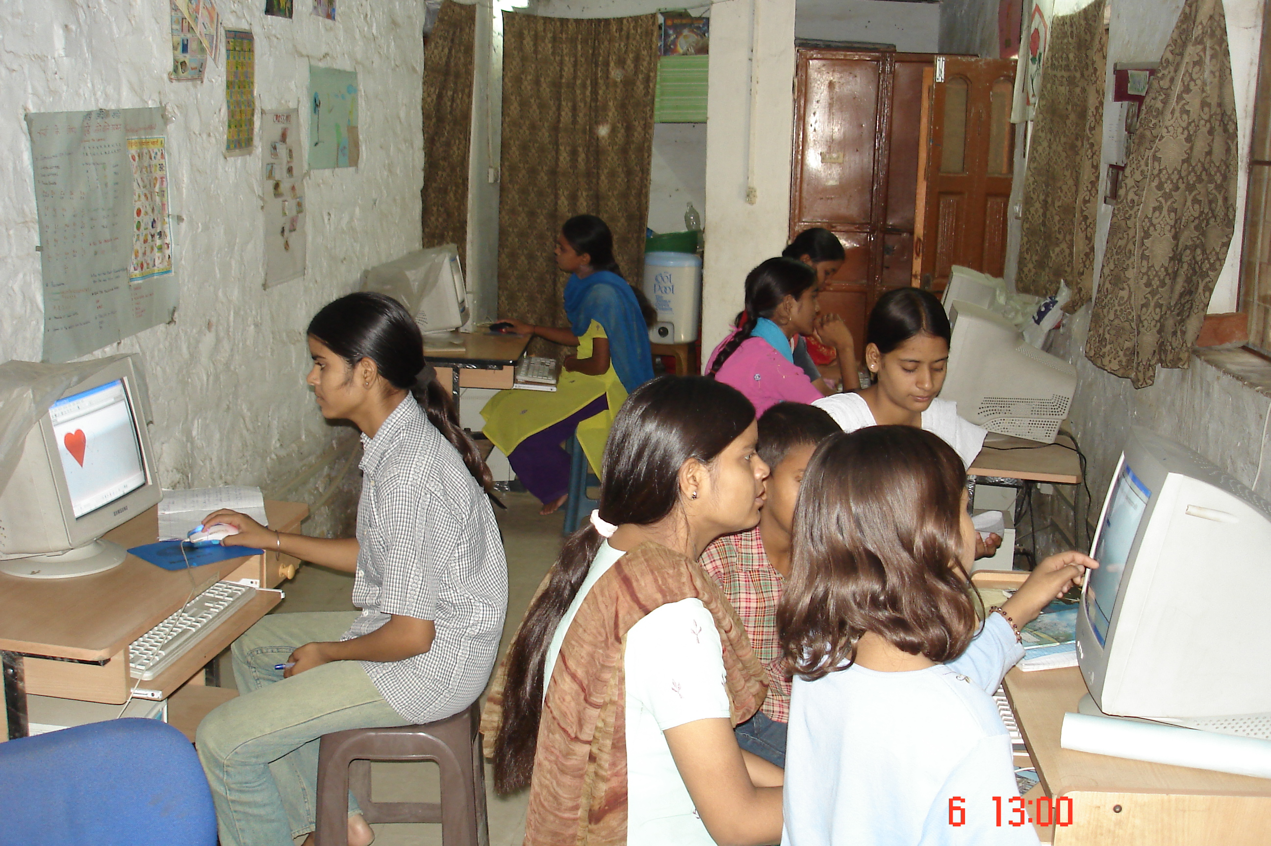
- Girls who are above age who cannot join formal primary school.
NIOS girls learning computer
- Availability of mark sheet of last class attended.
- Address proof.
- Demonstrate financial need.
NIOS girls learning Computer
- Parents willing to educate their daughters.
- Be a resident of Tughlakabad.
- Given preference to the elder girls from the family.
- First generation learner.
- There is no working member in the family.
Procedure of selecting Girls:
It’s a challenging part of the programme where a question arises that to whom we select and how we select. This challenge has been faced boldly by our trained teacher by conducting a test for checking the learning levels of these girl’s. On the basis of their learning abilities these girls were enrolled for different classes as for class 6th, 8th, 10th and 12th. Now after their selection the teacher took the classes according to their standards. Monthly tests held for these girls again to check the level of improvement and after each monthly test a parent teacher meeting is held to discuss the progress of the girls and also to raise their involvement in the program. Girls of class 10th and 12th have opted for the following subjects- Basic English, Hindi, Social Science, Home Science, and Economics. Girls appearing for 6th and 8th will appear for General Science, English, Hindi, Drawing and Social Studies.
Progress of Girls
As we have reported earlier that the progress of the girls has been commendable , considering the fact that some of them are first generation learners in their families and many have to work hard at home to look after their siblings and do the other household chores. The NIOS tutor is very well trained and manages the multi grade teaching very well. She sits with one grade, explaining them the lesson and then asks them to do a group discussion on the subject. The girls then do some written work and the teacher in the meanwhile teaches the other grade. After her class she makes some home visits in the community to meet the parents and apprise them of their daughter’s progress. She also tracks the girls who were absent for the class, explaining their parents to ensure that their ward attends the tuitions daily. She also takes keen interest in counseling the girls who have face various difficult situations at home or with peer groups. The girls share their problems with their teacher and also with other program co-ordinators. At one instance, the brother of a student of NIOS created a ruckus about his sister coming to the centre to study and even came to the centre to warn the teacher. It was a heartening to see all program coordinators and teachers at the centre got together to make him understand that it was important for his sister to study.

The NIOS teacher works hard to make the girls understand the basic concepts. This time we have arranged for another teacher from our scholarship program to lend a helping hand to the NIOS teacher. She takes subjects like English , Economics and Social Studies as the syllabus needed to be covered before the exams start in April. She also conducted weekly and monthly tests and maintained progress record registers. Every month, the progress of the girls was discussed through a parent - teachers meeting which also helped in raising their involvement in the program. Daily attendance registers, lesson and activity plans and daily progress record and registers were maintained to monitor the progress of the girls. In this regard we also took some counseling sessions with the girls who feel fear or stress during or before their examinations. Therefore we took some sessions on how to cope with exams stress, helped them to develop the timetable and how they have to prepare for their exams. The girls had also solved the model papers of previous exams with the help of the teacher who also tested the preparation of girls for the exams.

The girls of class 10th and 12th will appear for Basic English, Hindi, Social Science, Home Science, Economics while girls in class 6th and 8th appear for General science, Maths , English, Hindi and Social Studies. These girls will be giving their examination in April 2007. They attend their classes regularly and moving towards gaining strong commands on their subjects. Apart from their academic performances these girls are also acquiring the skills of working on computer which they practice during the summer vacations in ABHAS computer lab. Many more girls are keen to enroll themselves in the courses at the centre since many girls who do not have the proper school pass certificates they are presently not able to register under NIOS. These girls have taken admission in our vocational training class.

List of the girls enrolled in NIOS Programme.
Table 1.1
S.No | Name of the Child | Age | Father Name | Address | Time of Admission | Admission for Class
 | Asha | 17 | Mr.Ram Babu | F-78 Balmiki Mohalla Tkd Vill. | May-2006 | 10th
 | Anju | 16 | Mr.Satveer Singh | 352 Kuan Mohalla Tkd Vill. | May-2006 | 10th
 | Reena | 16 | Mr.Sukhvir | 266 Kuan Mohalla Tkd Vill. | May-2006 | 10th
 | Aarti | 19 | Mr.Gautam Rishi | 352 Kuan Mohalla Tkd Vill. | May-2006 | 10th
 | Priyanka Choudhary | 16 | Mr.Jaga Ram | 257 Kuan Mohalla Tkd Vill. | May-2006 | 10th
 | Kanchan | 18 | Mr.Uday Kumar | 89 Kanger Mohalla Tkd Vill. | May-2006 | 10th
 | Kirti | 17 | Mr.Ravinder Kumar | 1819 Kanger Mohalla Tkd Vill. | May-2006 | 10th
 | Anjum | 18 | Mr.Mohd Yameen | G 1/24 Churiya Mohalla Tkd Vill. | May-2006 | 10th
 | Shama | 18 | Mr.Mohd Jasish | G 1/23 Churiya Mohalla Tkd Vill. | May-2006 | 10th
 | Diksha Shukla | 18 | Mr.Parmanand Shukla | 1816/1 Pandit Mohalla Tkd Vill. | May-2006 | 10th
 | Preeti Kamal | 17 | Mr.Manga Ram | F-380 Jatav Mohalla Tkd Vill. | May-2006 | 10th
 | Sheeba | 17 | Late Mr.Irfan Khan | Churiya Mohalla Tkd Vill. | May-2006 | 10th
 | Jyoti | 19 | Mr.Mahavir | 349 Kuan Mohalla Tkd Vill. | May-2006 | 12th
 | Lata | 17 | Mr.Subhash Chand | Street 1 Churiya Mohalla Tkd Vill. | May-2006 | 10th
 | Saba | 12 | Mr.Mohd Rahim | 426 Jatav Mohalla Tkd Vill. | May-2006 | 6th
 | Monika | 17 | Mr.Ashok Kumar | 9 Churiya Mohalla Tkd Vill. | May-2006 | 8th
 | Sweety Kuman | 13 | Mr.Sikander Singh | B-23 Churiya Mohalla Tkd Vill. | May-2006 | 6th
 | Anita | 14 | Mr.Gopal | 490 Sardar Mohalla Tkd Vill. | May-2006 | 8th
 | Renu | 16 | Mr.Dharamveer Singh | 429-A Jatav Mohalla Tkd Vill. | May-2006 | 8th
 | Champa | 13 | Mr.Prem Bhallab | Churiya Mohalla Tkd Vill. | May-2006 | 6th
 | Bimlesh | 13 | Mr.Chota Lal | 34 Master Colony Tkd Vill. | May-2006 | 6th
 | Afsana | 16 | Mr.Mohd Hashim | 3191 Churiya Mohalla Tkd Vill. | May-2006 | 10th

Record Maintenance:
There are certain records maintained by the teacher/facilitator to check the progress, achievements and problems if occurs. Through these records it also becomes easier to trace the performance of the girl’s. The records that are maintained by the teachers are as follows:
- Daily attendance registers
- Individual student profile.
- Daily activity teacher’s diary
- Lesson and activity plans
- PTA meetings record
- Home visit record

It is encouraging to see the response of the community in the program and most of the girls are between the ages of 14 to 19 years. Usually girls complete their household chores before coming to the class, which is held from 10 A.M to 2 P.M. Most girls and their mothers supplement family income through home-based work of quilt making, embroidery and sequin work for export houses. After interaction with girls we found that alcoholism, violence against girls in school, discrimination and poverty were the main reasons for dropping out.

Workshop with the Parents:
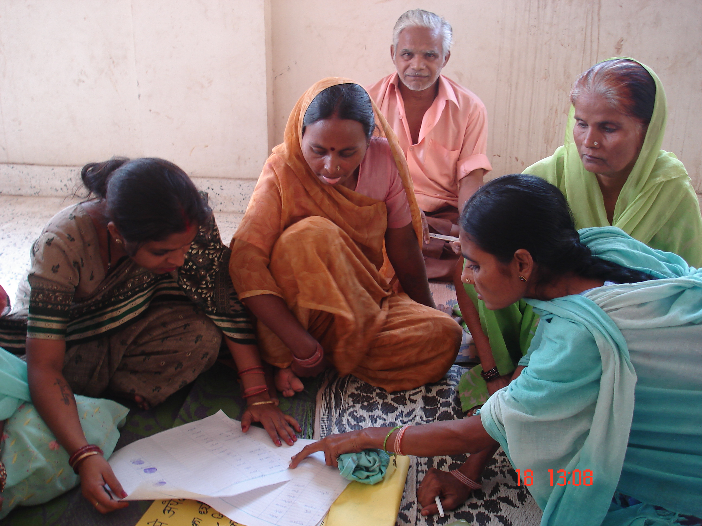
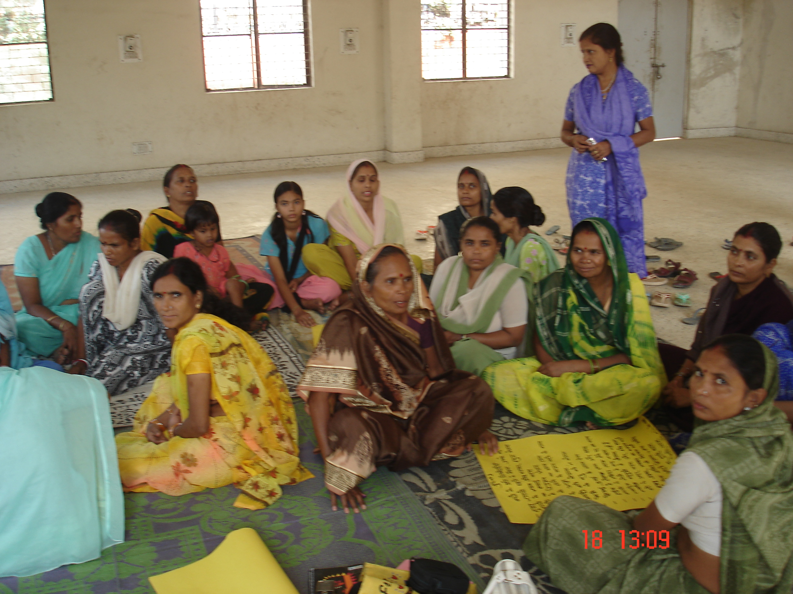
While taking the initiative of implementing the NIOS programme we also faced some problems due to which girls cannot attend the classes because of sibling care, work at home, early girl marriage etc. Some of the girls have no time for their studies at home because they have to help their mothers at home for completion of house hold chores, and some even work to supplement the family income. We observed that these problems are the reasons for increased dropout from schools. We therefore organized a workshop with the parents to apprise them of the problems that girls generally do not share with their parents and also told them of some effective measures to deal with them. The parents were therefore requested to take interest in their daughters education and were also sensitized against gender discrimination in the family.
Coaching Classes for School going Girls:
We observed that many girls drop out from schools because they are unable to cope with studies due to lack of academic guidance and due to other problems as discussed. Last year under this project ABHAS identified school going girls who needed coaching. ABHAS tutors visited the schools and houses in the area to select deserving and needy girls.
One groups of 25 girls received coaching at girls’ interest center in the community. Girls of classes 1 to VII of MCD and government schools attended these coaching classes. The regular guidance, individual attention and monitoring through weekly tests helped us to get 100% results as all girls passed their classes, and moved on to the next class.

The brighter girls were grouped with those weak in studies and they were given the responsibility of helping them out. This arrangement has worked out well and many girls are motivated. Home visits were made repeatedly to those girls who were not regular to the tuition class. The main reasons were illness at home and household chores.

Vocational Training- Cutting and Tailoring

The Jan Shikshan Sansthan (Ministry of HRD) has done the final evaluation of 21 girls enrolled in cutting & tailoring program for the batch July to Dec. All 21 girls successfully completed the course. ABHAS is encouraging them to join self-help group so that we can link them with the market. ABHAS is also encouraging these girls to start up some earning ventures.

The current status of the enrollment can be seen in table 1.2 that gives us a picture about the different batches also.
List of the girls enrolled in Cutting and Tailoring Programme
Table 1.2
S.No | Name | Age | Father/husband Name | Batch
1 | Pinky | 18 | Mr. Ramdass | 1st
2 | Munish | 23 | W/o Mr. Mukesh | 1st
3 | Gaytri | 17 | Mr. Mirajilal | 1st
4 | Madhu | 16 | Mr. Mirajilal | 1st
5 | Poonam | 16 | Mr. Vitthal Ray | 1st
6 | Pherol Kumari | 17 | Mr. Shiv ji Sharma | 1st
7 | Swati | 17 | Mr. Prempal Gupta | 1st
8 | Promila | 19 | Mr. Kartik Vishvaas | 1st
9 | Raybala | 30 | W/o Mr. Manoj | 1st
10 | Sheela | 35 | W/o Mr. Pappu | 1st
11 | Rehana | 16 | Mr. Taffazul Ansari | 1st
12 | Antima | 19 | Mr. Tarkeshawar | 2nd
13 | Nasreen | 18 | Mr. Yaseen | 2nd
14 | Anita | 15 | W/o Mr. N.K Bharti | 2nd
15 | Ravindri | 22 | Mr. Rohatesh Singh | 2nd
16 | Meenaxi | 16 | Mr. Indra Sharma | 2nd
17 | Rani | 16 | Mr. Anil Kumar | 2nd
18 | Afroz Bano | 14 | Mr. Mahmood Ali | 2nd
19 | Neetu | 17 | Mr. Prasad Dived | 3rd
20 | Sofia | 18 | Mr. Moinulhak | 3rd
21 | Aaliya | 17 | Mr. Fida Hussain | 3rd
22 | Rukhsaar | 15 | Mr. Rafi Ahmed | 3rd
23 | Tabassum | 22 | Mr. Mahmood Ali | 3rd
24 | Naaz | 17 | Mr. Akeel Ahmad | 3rd
The course content is as follows:
- Hand Needlework and hand embroidery
- Drafting
- Pattern Making theory
- Garment Construction
- Colors and fabric Study
- Introduction of Fashion design
All the above said skills are imparted by a professional teacher and the teacher also use to take a monthly test of the participants to check their learning levels.

Computer Education:
Computer education is imperative for all age groups, class, and sections of society. So apart from the above said trainings ABHAS also imparting computer literacy through its computer lab program. Not only does it enhance the enthusiasm and interest of the girls towards their curriculum, the NIOS girls have started to understand their curriculum well through CAL program. Girls are earning to use the WORD, POWER POINT and use the internet to enhance their knowledge and skills.

Jan Shikshan Sansthan (Ministry of HRD) has done the final evaluation of 25 girls enrolled in computer education program and 17 girls successfully completed the course and received the certificate from Jan Shikshan Sansthan. Some of the girls had final exams of their regular class of 12th and graduation and so could not appear for the computer exams.

Girls participation in the INDIA SOCIAL FORUM
We have regularly involved NIOS girls in many programs of ABHAS directed towards promoting child rights and provided them the platform to share their ideas and voice their opinion. Now girls are more confident and aware about issues related to them.

The NIOS girls, have been regularly been participating in the forums and consultations that make the children aware of their rights, and have used this as a platform for articulation of their problems that they face daily in schools and community. One such opportunity was the consultation meeting at the India Social forum.

REPORT FOR CHILDREN CONSULTATION PROGRAMME - ABHAS
“MERE SAPNON KI DILLI” (Asserting Children’s Rights and Aspirations)
About the India Social forum

The World Social Forum process in India has, in the last 4 years, been successful in bringing together different political and social streams on a common platform to oppose and resist the onslaught of Imperialist Globalization. The aim of this ISF was to showcase the richly textured vision produced by the wide spectrum of social and political movements in India, Asia, and Africa today, with special emphasis on the role of children, youth and women in taking forward the aspirations. An estimated 60,000 people participated, representing diverse movements and organizations from India, Asia and Africa.
It was the matter of great pride to us that for the first time, children sectoral process was included in the WSF process in India. The children's sectoral process was committed to bring child rights to the attention at ISF, by highlighting the issues of children's right to equal access to development, the challenge of discrimination, education, security, health, labor, justice for girl children, housing and shelter, violence against children, female feticide and child marriage. The fallout of displacement and eviction on children's lives were also discussed in the light of impending Common Wealth
Orientation Workshop on Child rights
The objective of the seminar ‘Mere Sapno Ki Dilli’ was to have an open discussion and interactive session between the children and the govt. functionaries, where children can raise their aspirations and put forward their problems in schools and community. A preparatory meeting with 120 children and 10 facilitators from SAKSHI, PRAYAS and ABHAS was conducted on 8th November 2006 at Shiv Mandir Complex Tughlakabad Village. The meeting was conducted to prepare children for the programme which was to be held on 11th November 06 with India Social Forum at Jawaharlal Nehru Stadium. It was heartening to see that all girls worked together and formed a strengthened group to put forward their needs and thoughts in front of the Government. The children expressed their thoughts and aspirations by drawing charts which were displayed on 11th of November 06. The charts reflected several issues and problems as related to education, school infrastructure, female feoticide, child labor, displacement, housing and shelter, gender disparity and violence related to children. The questions raised by these children were also related to these issues.

The session was planned for the whole day where children were also entertained with different games and activities. It was the session with fruitful and enriching experience for the children. It helped them in building up a confidence to raise their queries regarding development with the govt.

Children’s Process at India Social Forum- 11th Nov.06
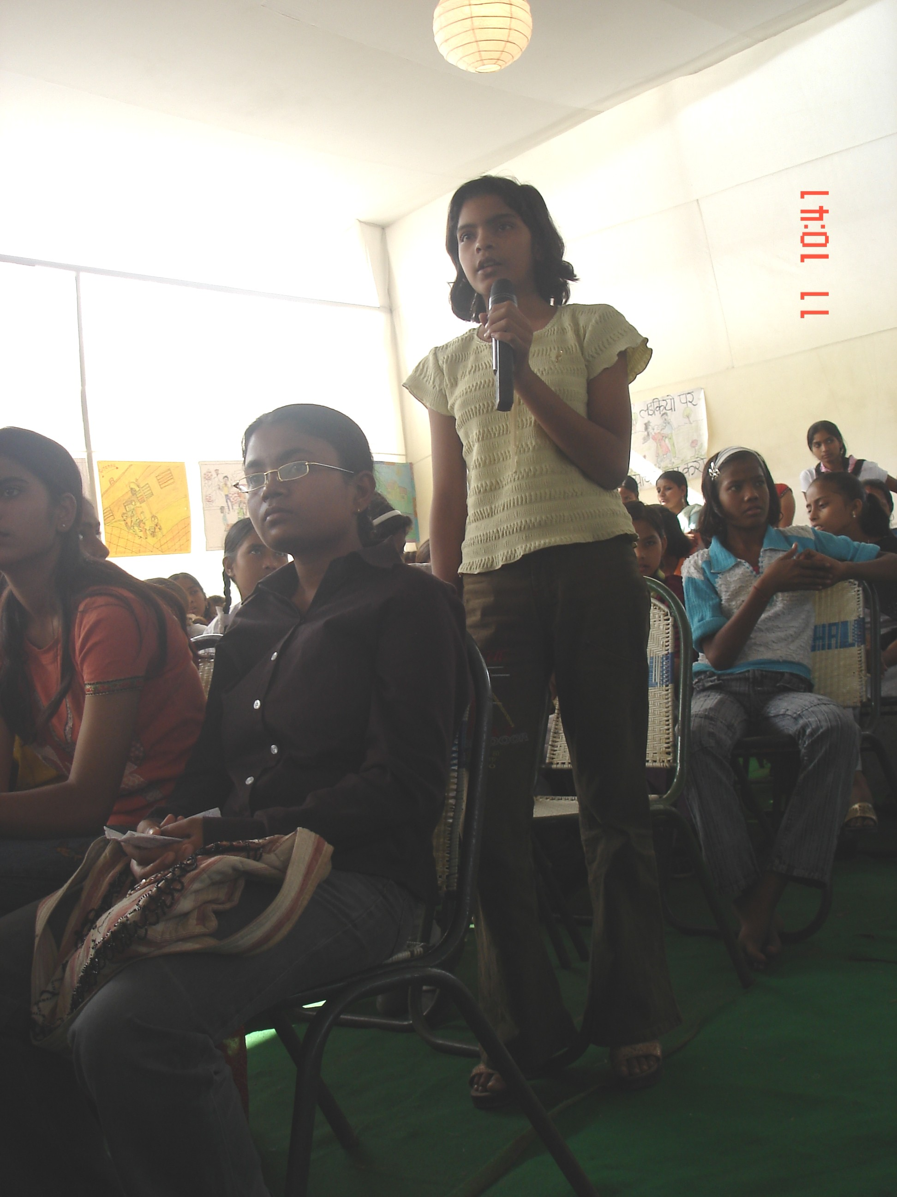
On 11th nov.06 the programme ‘Mere Sapno Ki Dilli’‘Bachhon Ke Liye Bachhon Ke Saath’ was organized from 10:00 am to 01:00 pm. The process included 80 children and 20 facilitators, from ABHAS. All the children came forward to interact with the stake holders from the Govt and the development sector and social sector.

List of Invitees from the Govt .
S.No | Names of the Participants | Designation
1 | Dr I.S. Suri | Secretary (SCERT)
2 | Dr.Janaki Rajan
3 | Dr.A.K Mehta | Director (Health Service)
4 | Ms. Indira yadav | Director (MCD Education)
5 | Dr. Vivek Ramchandaran | UNICEF (Education Officer)
6 | Prof. K.K Vashishtha | NCERT (elementary Education)
7 | Dr. VP Singh | Program Officer UEE Mission
8 | Mr Farhad Suri | Mayor MCD
9 | Mr. Mangla | Dept. Commissioner Karolbagh
10 | Mr. Arvind Kajriwal | Social Activist
11 | Mr. Ashok Aggarwal | Social Activist
12 | Mr. Sushil Sethy | Head ( WasteManagement)

The charts prepared in pre-consultation meeting were displayed in the hall. The children raised their questions with lots of hope and confidence. Issues covered by the children were related to education, environment, electricity, sanitation, displacement, school infrastructure and other facilities (teachers, classrooms and play grounds, fee structure etc.), child labor, gender discrimination, female infanticide, electricity, water, and parks.

For example- Why children do not get computer facilities in Govt. schools? Why there is sanitation problem in the communities and who will look after this problem? Roads are un-metelled due to which water store in it and produce disease but this problem is not taken in consideration so who is responsible to look after it? Etc…

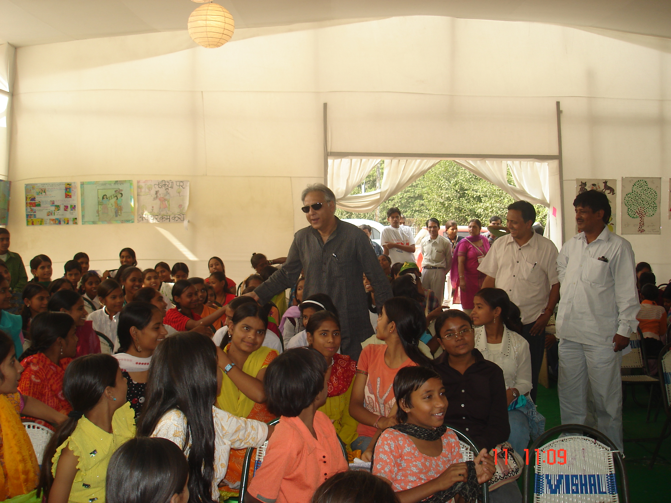
All the questions raised by children were answered by the govt. representatives. Mr. Farhad Suri, hon’ble mayor took very keen interest and heard patiently the children’s voices and anger against the govt. system .He assured the children that his office will give take initiative to form a childtren’s cell where they can lodge their complaints and expect immediate attention.

Mr. Ashok Aggarwal, from social Jurist gave a very inspiring speech about the general apathy in the govt schools towards the infrastructure and the quality of education. He gave examples from his own initiatives where he has fought a lonely battle against the system and was successful in getting justice to a no. of students for their education. Mr. Augustin from UNICEF gave an account of what initiatives are being made at UNICEF for the well being of children.

Thus it was a very interactive and a participatory interaction among children and the honorable guests. The message which the children received was that “all the children togetherly, need to come forward with their problems and have to raise their voice against the violence and if once they will understand and unite, they can find the solutions of these problems and then these will be taken into consideration by the authorities”. The children felt happy with the suggestion and idea of bringing up change in the scenario of Delhi according to their aspirations.

The programme objective was fulfilled as it provided a platform with enriching experience to the children of interacting with the authoritarian members of the society. Participation of the several NGO’s made this programme a great success

Life skills training:

ABHAS has been able to create a good network with the organizations like FICCI-Socio Economic Development Foundation to conduct life skills trainings and CII to impart business development skills among adolescents. In this regard we have been able to organize five such workshops in the year 2005 to train a group of girls as peer educators. Recently these girls also attended such a workshop on life skills at Prayas. It had been a great opportunity availed by the group. The workshop was conducted by the trained social workers from FICCI-SEDF. The workshop dealt with the problems of social evils (early marriage, gender discrimination etc). The adolescents also spoke to the counselor personally after the end of workshop to seek her advice on their concerns and issues.

Achievements:
The NIOS program proved to be extremely beneficial for students and they have shown a sharp progress in their academic as well as extra curricular achievements. The program has helped us in developing understanding about academic as well as other needs impacting education of the individual girl child.
We have observed that most girls have become very confidant and out going. They have become more regular in their schoolwork and are also regularly participating in other developmental activities of ABHAS. Now they seem more capable in allocating their time to study, household work and other activities, judiciously.
During the program period of two years we have been able to reach out to approximately 366 girls through the NIOS and vocational programs.
- NIOS – 51
- Cutting and Tailoring – 140
- Tuition class – 50
- Beauty culture – 100
- Computer course - 25
- The Girls Interest Centre (GIC) is a focal point for girls both in Tughlakabad, especially those girls who are school dropouts and worked from home to supplement their family income.
- The centre has become popular because of the range of vocational and educational services available and has opened a world of knowledge and information for the girls.
- A variety of gender friendly activities like life skills trainings, mother daughter workshops, theater and participation in the activities of ABHAS and other NGOs working with adolescent girls, celebration of important events and days saw the adolescents coming to the centre very regularly.
- The GIC has grown into learning, meeting; participation and recreation center for adolescent girls as well as their mothers to discuss real problems and build their self-confidence and esteem.
- The centre has been instrumental in giving a boost to the educational rights and activities of girls and increases the participation of parents in their education.
- The thrust of the programme is to mobilize young and adults alike, promote their partnerships and develop community plans for action to address education and developmental needs of girls.

Problems/challenges in implementing the program

During the course of our work with girls and their families, we have come across several problems and challenges being faced by the girls themselves and along with the challenges encountered by our team,
- Illness in the family requiring monitory support, referral, regular monitoring and follow up.
- Parents illness and both parents working- affecting the child’s education i.e. no. of hours she can devote to study.
- Growing age of girls and their coping mechanisms.
- Migration to other areas since family is dependent on casual work.
- Lack of financial support towards administration and professional services (program requires professional counseling, networking, referral, documentation and many other administrative inputs etc.

Future strategies for effective functioning
- Introducing life skills workshop for girls.
- Family counseling intervention.

About some of our students
Lata -a student of NIOS program
Lata is one of the many students of the National Open School at ABHAS. Open school is a facility for all the school drop- outs to study, give exams and get a chance to be mainstreamed into a formal education system once again. Lata is currently studying for 10^{th grade} through these classes. Her family, which consists of her father and her mother, along with 1 elder brother and 2 younger sisters, have been living in Delhi since a long time.

When Lata was a child they owned a house in Chirag Delhi (South Delhi), and where Lata and her brother went to school. Her father used to assist his sister in pottery, and clay modeling. They made various handicrafts which they sold further and earned a small amount of money. But their good time was short lived , as her father gradually got into habits such as drinking and gambling, and left working completely. Lata’s mother was forced to go to work, which she didn’t find easily, being an uneducated woman. Eventually, the financial conditions of the household got worse, and the family was drowning in debts. Unable to come up with any other solution, they were forced to sell their house. With that money, they paid off their debtors and the little surplus was used buy a new house in Tughlakabad Village.

Six to seven years have passed since Lata’s family has been living in Tughlakabad. Her sister Madhuri who is studying in class 10th stays with her aunt in Chirag Delhi itself as the family cannot support her education. Her youngest sister Anu is studying in Class 7. She is doing well in school and is even a part of the scholarship program at ABHAS. However, her father is still an alcoholic, and refuses to take on any kind of responsibility of the family. Lata’s mother works hard as a tailor and earns about 1500-2000 rupees a month. Even that does not make ends meet for the family, as the father forces the mother to give him the money, which he further squanders in gambling and drinking.
Lata had to drop out of school in class 8, because she had to take on the responsibilities of her house. Through her younger sister Anu, she came to know of ABHAS, and the NIOS program. For her, NIOS is a blessing and an opportunity which she could thrive on. She was able to continue her studies, just by being away for a couple of hours a day. Also, because of all that she has learnt at ABHAS, she has recently been able to get a part time job in a private nursery school in the area. Now, not only will she lend a helping hand in the household chores, but will also be able to add to the family income and study as well.

GUDIYA-(a student of Cutting and Tailoring program)
Gudiya is one of the fortunate participant who joined the cutting and tailoring programme. She came to know about this programme when she was appeared for 9th standard. She expressed that she was not aware of such facility but she came to know through her friends she said “mujhe meri doston se is course ke bare mein pata laga to maine turant hi iska pata kiya” (I came to about this course through my friend and soon I tried to find out). She also expressed her feelings “I am very happy to gain skills of cutting and tailoring. I got this opportunity to gain these skills in my summer vacations. I was not aware of such kind of services being provided in my community (Tughlakabad village). Soon I got to know about ABHAS and I explored such a wonderful place where I can learn a lot.”
It was a happy moment for her as she got registered under the Programme of cutting and tailoring as she was interested in the course. She is studying in class 9 at that time and it was a great time to achieve a fruitful training during the vacations. Gudya said that “isse mujhe kafi madad mili hai ab mai apne aur apni family ke kapde aaram se sil sakti haun” (It helped me a lot that now I can stitch clothes for myself as well as for my family; it could be a male or a female dress). She liked the progaramme and was also given knowledge about the swing machines as she says “I was also given some technical skill such as to keep the swing machine in use. Now I can handle all its part and screw as I am aware of it. I availed the training for six months and finally I was appeared in examination after which I was certified by Jan Shikshan Sansthan. Whenever I use to stitch at home, my family members appreciated me and showed their happiness. I feel very good and proud of my skills in tailoring. I am thankful to my teacher in ABHAS who made me learn stitching.”

Observations and Learning’s:
While implementing the programme objectives we have observed the impact of the overall initiatives taken under this project and what are the learnings. ABHAS has been able to promote the better quality of living standards socially and economically among the ABHAS participants, through the above defined activities and trainings. To know about these observations and learning’s the points are defined below:
- During the course of the project at Tughlakabad we have observed that once the centre was set up girls from the entire area including the historical village started coming and enquiring about the program.
- The GIC was not only frequented by drop out girls but also working and non-working adolescents and youth who showed interest in trainings and continuing education.
- Our regular contacts with the families helped us to realize that traditional and cultural bias has resulted in gross neglect towards girl’s education without the parents even realizing that it is a discriminatory practice. The centre has increased the credibility of the organization in the area. The community has come forward to support the programs by motivating their daughters and participating in the programs.
- The mother daughter workshops which were organized to impart life skills trainings to girls and discuss issues related to health and education proved to be excellent icebreaker and raised the active participation of out of school adolescent girls and the community women.
- Many girls showed interest in acquiring further education relevant to their age and status. Working mothers were worried about the opportunity costs involved in educating girl children.
- There is a marked change in the attitude of girls enrolled in both programs they look forward to coming to centre they are slowly becoming more confident there is a change in manner of speaking, the way they dress and the way they conduct themselves. They finish their household work early and come to the centre. It is encouraging to see young mothers attend classes with their infants.
- Many girls attending NIOS program at centre are also enrolled for vocational training. The response is very good from the community and the quality of training is attracting more and more girls to join the course.
- Girls from the neighboring communities have got to know about the programs and are requesting to enroll them in the courses.

