New Project Proposal Template to Asha for Education

Project Name: REWARD Trust | Date: 04/22/2011

 | Project Contact Information | Asha Contact
Name | Reward Trust (Rural Education Welfare And Resource Development Trust ) | Subashree Rajagopal
Contact | Mr. V. Sridhar | Subash_asha@yahoo.com
Address | 3, Bhairavi  Department of Atomic Energy Township,  ANUPURAM 603 127  KANCHIPURAM DISTRICT,  TAMIL NADU
Phone(s) | 044 -274 82090 / 9865 605 199 (cell)
Fax
E-mail | kalasridh@yahoo.com

Name of the group/organization requesting funds.
Reward Trust (Rural Education Welfare And Resource Development Trust)
REWARD Trust is a zero overhead, all volunteer group.

When was the group established?

Has been working since 1990. Registered as a trust in 2004.

Briefly describe the motivation for the starting this group.

Many a times, many of us have succeeded to reach a comfortable living station in life mostly due to the correct and enabling ambience given to us by parents or friends or philanthropists at the formative ages. This fact of life is the motivating force that has persuaded us to at least to ensure that such ambience is made available to as many as we can humanly achieve. The target population is chosen from villages where a priori inhomogeneities exist for no fault of the people inhabiting the village. A priori inhomogeneities at the formative stages of human development invariably eats away the drive, ability and tenacity of the students and hence hits on the vitals of a nation. Providing for a homogeneous educational, welfare and entrepreneurial ambience can, in the long run, unleash a potential that can make the nation robust, strong and enterprising. Expecting the Government to do everything towards this end would entail waiting times tending to infinity and as a consequence the nation would be saddled with a young population whose potential has not been realized, with emaciated bodies, dulled brains and disillusioned spirits.
Our current activities:
We, the trustees of Reward, along with Asha for Education, are working on strengthening the government school system in the rural villages of Kancheepuram district in the state of Tamilnadu in India.
Circa 2003, the government schools in the local villages had student teacher ratios of around 1:100, lacked teachers for individual subjects, had thatched hut structures for classrooms and typically offered only primary and middle school education.
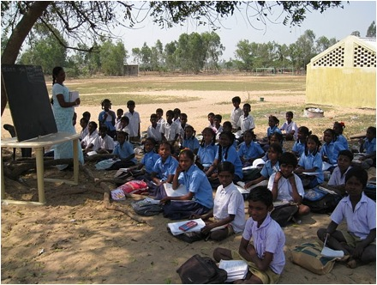

To address these issues, we work with the government and the community to upgrade the local government schools to the middle, high and higher secondary levels. Along with the village, and the Village Outreach program of our Employees Association, we raise the application fee. Currently, the Tamilnadu government requires (approximately) a Rs 2,00,000 fee to upgrade a High School to a Higher Secondary school and a Rs 100,000 fee to upgrade a Middle school to a High School. We then lobby the local district and state educational officials to get the government order issued to upgrade the school. In our experience, the government has taken anywhere between one to four years to issue this order.
The following schools have been upgraded so far:
- Sadras High was upgraded to Higher Secondary School in 1999 after being a high school since 1970.
- Vengapakkam govt middle school was upgraded to a High School in 2003 after being a middle school since 1980.
- Vayalur Middle was upgraded to a High School in 2004, it had been a middle school since 1969.
- Kuzhipanthandalam Middle was upgraded to a High School in 2008 after having been a middle school since 1960.

Along with the PTA and the school principals, we recruited qualified teachers and paid them salaries commensurate with their experience and training. While we could not match government benefits that include pension, health and other benefits, we were able to match the base pay that the government offers to it's teachers. (However, with the govt’s recent 6th pay commission, we are back to a higher wage inequality between the teachers.. this is regrettable.) . We hope to raise the pay of teachers so their salaries are again on par with the base pay of the govt appointed school teachers .
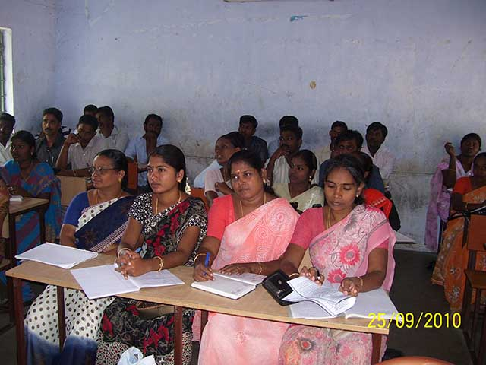
We have added 52 teachers to 17 government schools over the last 5 years and reduced student teacher ratios from 1:100, 1:80 and so on to around 1:40, 1:50. And after the addition of these teachers, we have seen outgoing pass percentages improve dramatically, from 10 – 30% to 60-100%, in the State administered High and Higher Secondary examinations.
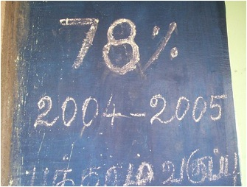
Another consequence is that more girls are going on to complete higher secondary education. It is important to note the demographic of the population being served. The communities are predominantly Dalit, and the government schools are designated “Adi Dravidar Welfare Board” schools – the “Adi Dravidar” tribal community (a Dalit community) is considered one of the most socially and economically underprivileged communities in the state. The families are typically employed as agricultural farm labourers, or are seasonally employed.
Another indicator of the poverty of the students and families, is that prior to us appointing the teachers, the PTA would occasionally try to raise funds to appoint teachers. They would typically have funds to appoint no more than one teacher, and at a salary of Rs. 500 per month. Compare this to the salary of Rs. 13,000 per month + benefits which is the normal salary of a government employed teacher.

In the years since we upgraded the schools and added the teachers, hundreds more students are graduating every year from this set of 25 villages. Significant numbers of graduates are seeking out higher education and joining colleges and polytechnic degrees.

The educational level in this set of 25 villages has increased dramatically.

Teacher Training
Our teacher training sessions are the heart of our program. We make sure that we recruit qualified teachers, pay salaries commensurate with govt salaries (to the extent that funds are available), and hold rigorous monthly teacher training sessions. We demonstrate the use of teaching aids, demonstrate experiments and inculcate a culture of learning and problem solving rather than rote memorization that is usually the norm in most schools. (not just govt schools).

Results:

There are 3 measurable goals of this intervention, besides the immeasurable benefits of raising the educational levels across an entire set of 25 villages..

- Improve teacher student ratios in government schools to 1:40 and ideally 1:20.
- Increase graduation rates in rural govt schools
- Improve quality of education.

Improved Teacher Student ratios to 1:40 and then 1:20

Most schools now have close to a 1:40 student teacher ratio, from an average of 1:77 before we added the teachers. Most teachers have teachers to teach specific subjects.

Improved graduation rates in rural govt schools

As a result of adding 52 teachers from Aug 2005 till the present, the outgoing pass percentages have doubled, tripled and sometimes quadrupled as measured by performance in the State wide Public examinations. In addition, pass percentages in individual subjects have tripled and quadrupled in subjects taught by Reward teachers.

Venkampakkam Govt High School

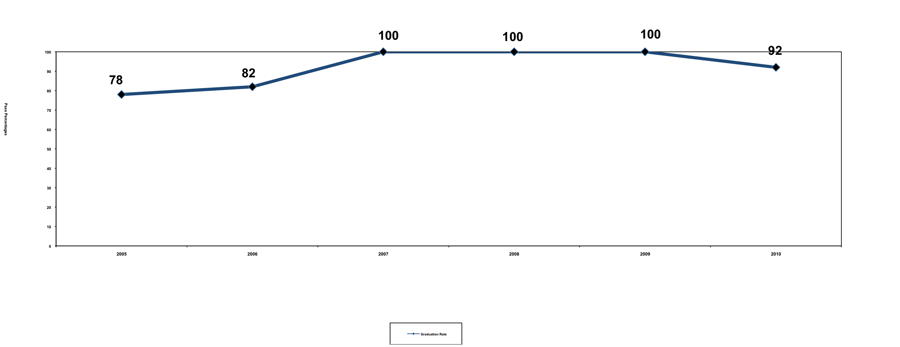

Vayalur Govt High School Graduation Rates

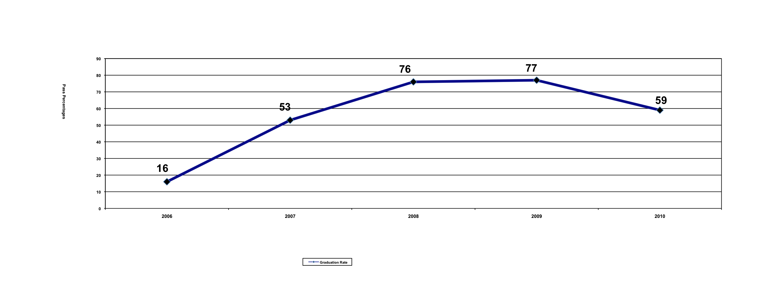

Natham High School Graduation Rates

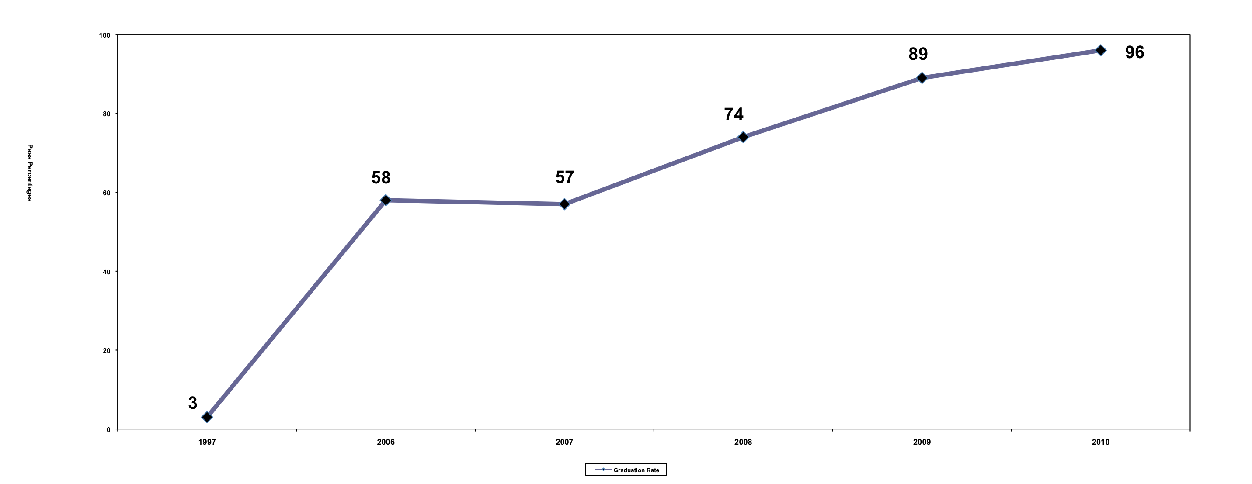

Paiyyanoor Govt High School Graduation Rates

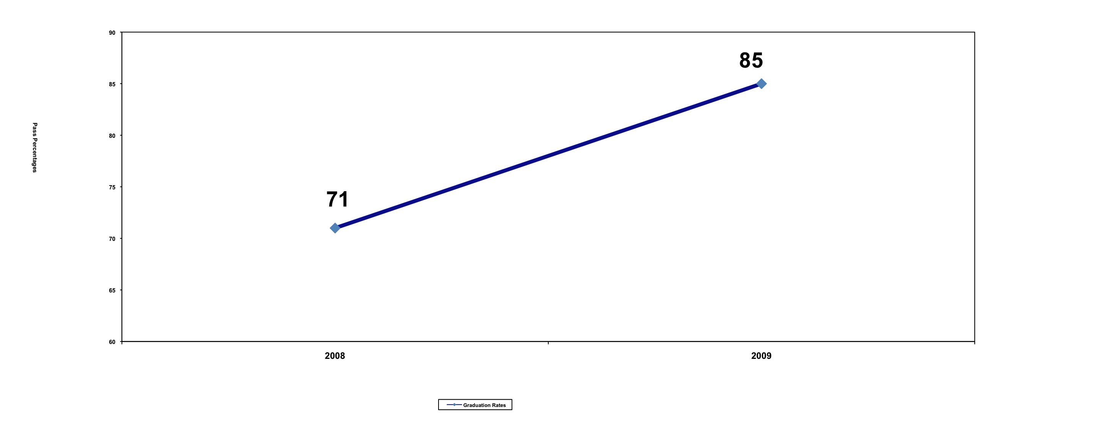

Manamai Govt High School Graduation Rates

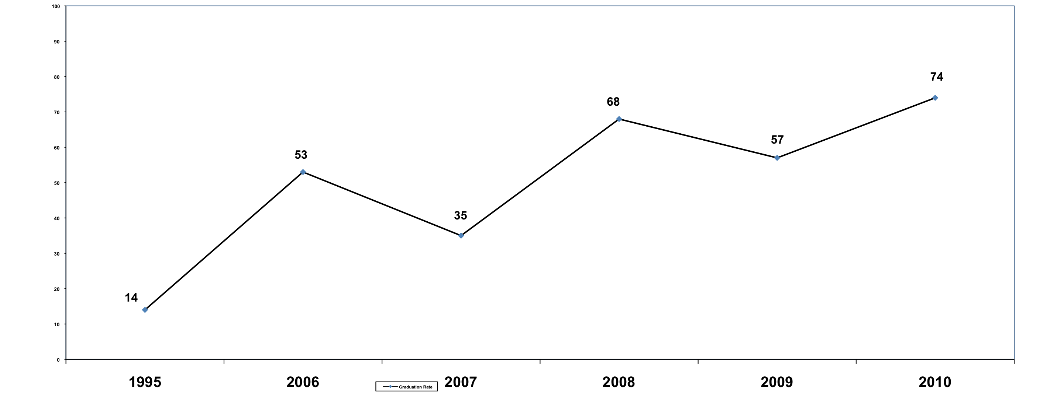

Koovathur Govt High School Graduation Rate
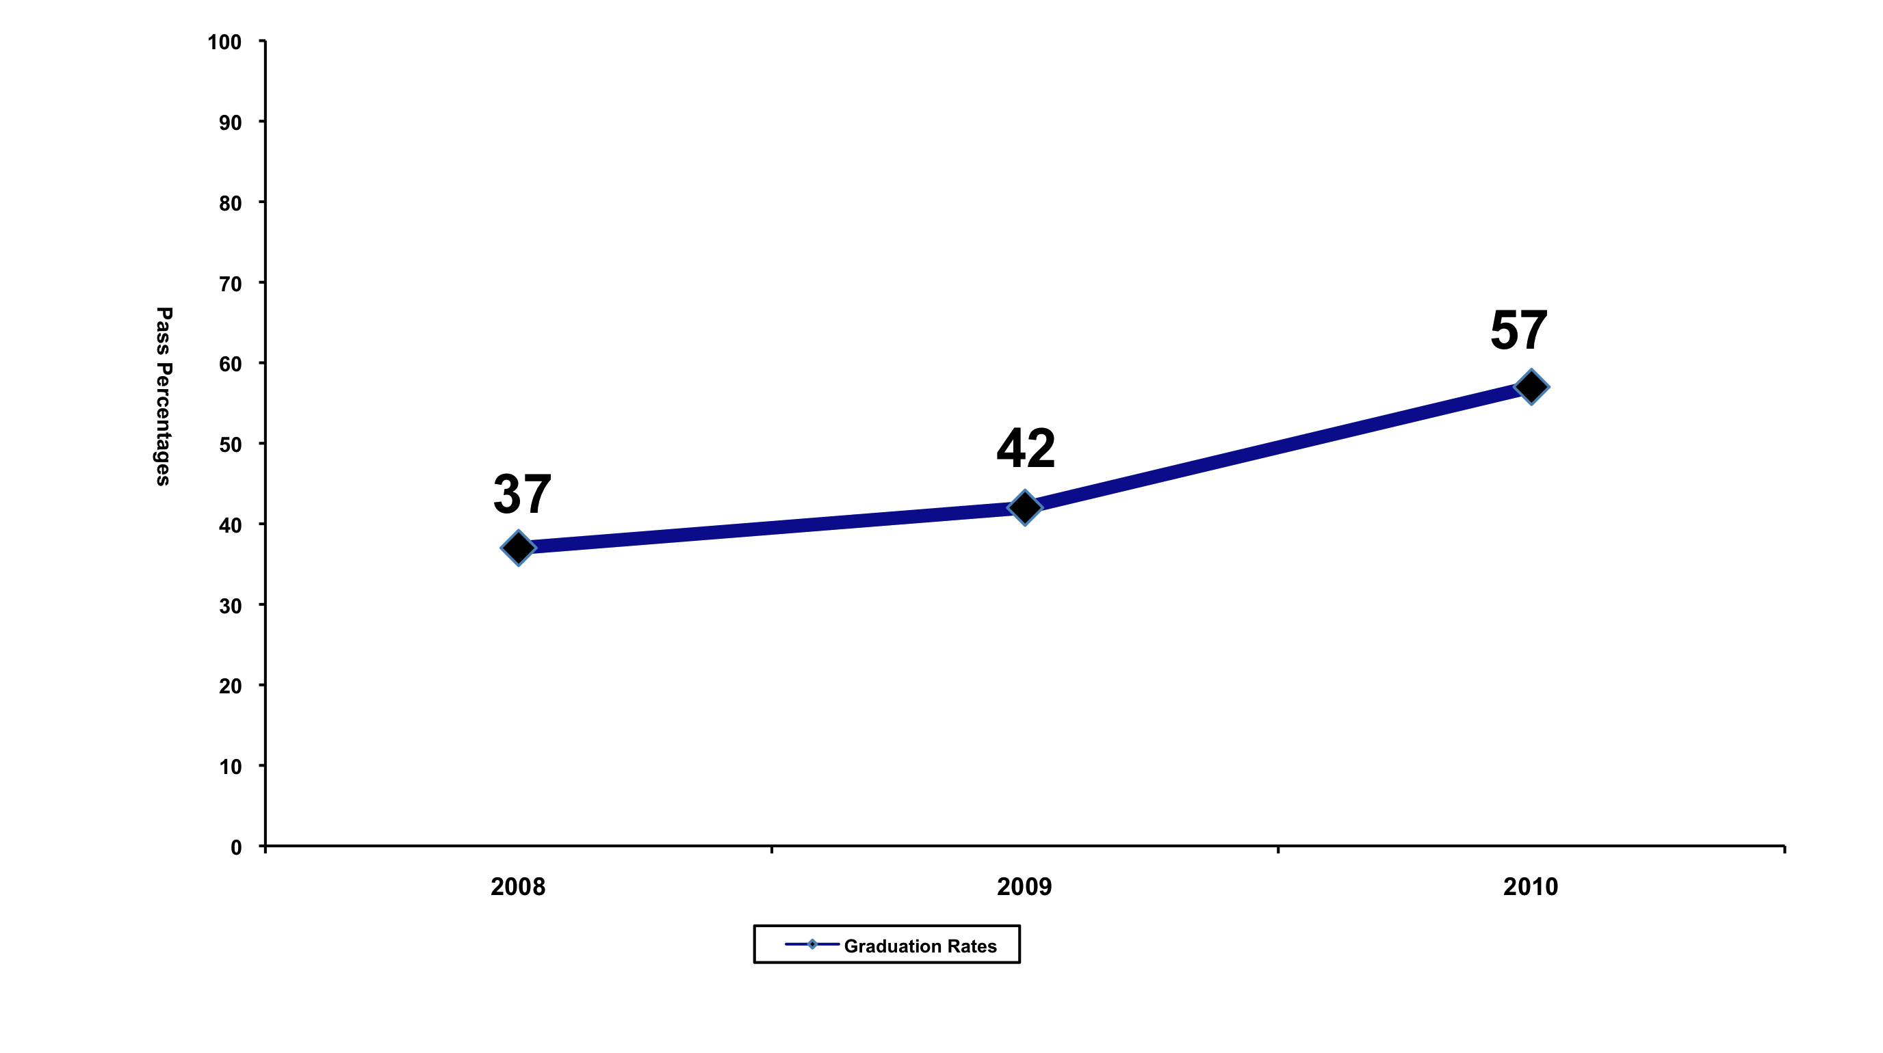

Pandur Govt High School

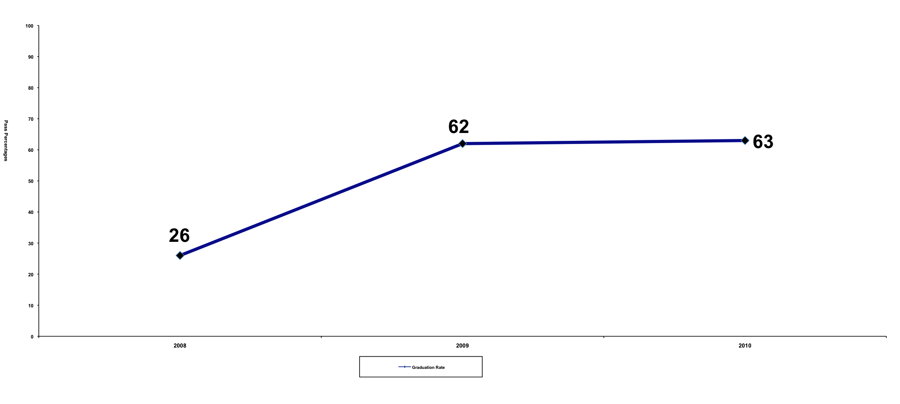

Manamai Govt Higher Secondary School

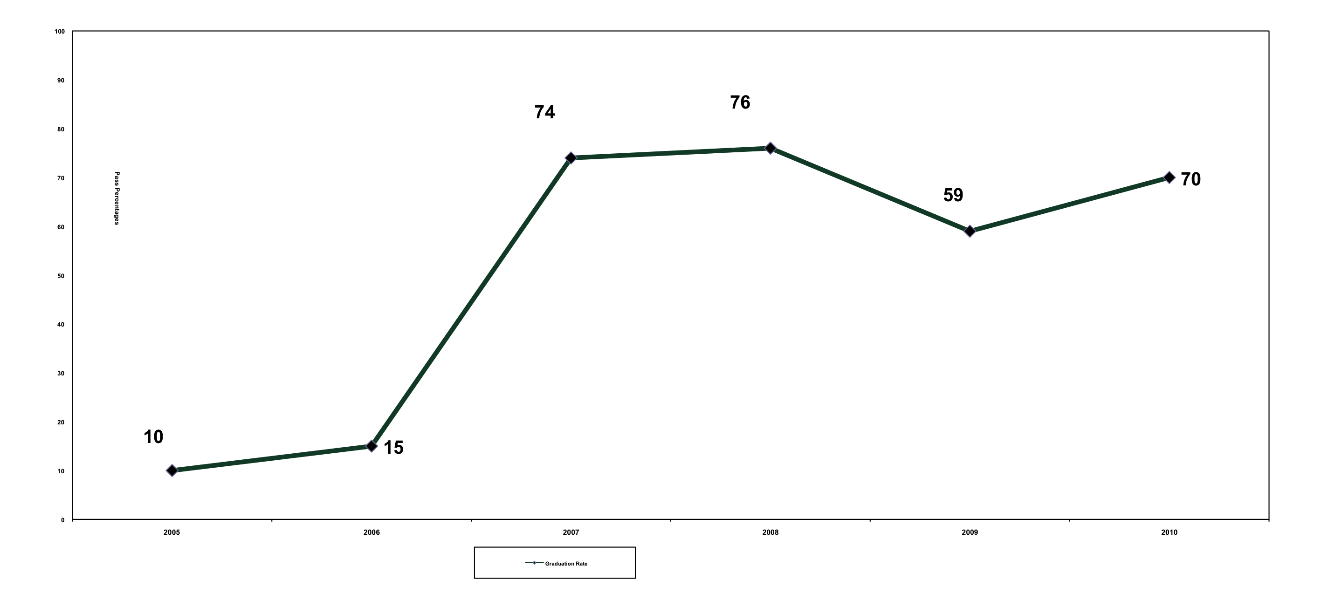

Improved quality of education

Teacher training sessions are held every month – these sessions are conducted by the trustees as well as outside experts / educationists who are invited to train the teachers on pedagogy and on different subjects, including teaching children with special needs. Teachers then undertake tests that assess their understanding of the subject matter. Their delivery and teaching technique is assessed and improved by means of sessions where the teachers teach to an audience of their peers and trustees. The teachers are assessed based on their performance in the teacher training evaluations. In addition, at the end of the year, there is an annual bonus paid based on the teacher’s performance, based on how their teaching has improved over the year. The incentive is also tied to the performance of the students in the Class X and Class XII examinations. Teachers are trained in using teaching aids, experiments, problem solving techniques and content delivery.

The quality of teaching has steadily improved as a result of these monthly training sessions, as evidenced by the steady improvement in the performances of the students year over year.

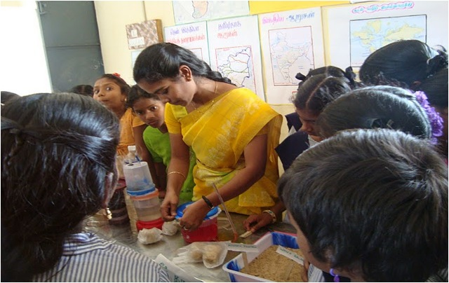

Please feel free to attach any additional sheets and/or information such as brochures, press reports etc.

4. Name the key people running the organization and describe their background

V.Sridhar, Physicist, Indira Gandhi Center for Atomic Research (IGCAR) Kalpakkam, Former Teacher
S Kalavathi, Physicist, IGCAR, MS Education
DV Natarajan, (Retd.) Physicist, IGCAR Kalpakkam, MS Education
Dr SVM Satyanarayana, MS Education, PhD Physics, Senior Lecturer, Pondy University
Dr. T Sengadir, Professor of Mathematics, MS Education, PhD IIT
B Anandhi, B. Commerce, Teacher, Primary Education Specialist, experience in alternative education, Auroville.

REWARD Trust is a zero overhead, all volunteer group.

Briefly describe the aims of your group.

Ensure that government schools up to higher secondary levels are available within walkable distance of every student in the village.
These government schools should be on par with those in the urban area if not better. They should have good libraries and laboratories.
Improve graduation rates in rural govt schools
Improve teacher student ratios: 1 teacher for every 30 students
One teacher for every subject

Improve quality of education in govt schools

6. Does your group have any religious or political affiliation? If yes, please describe the type of affiliation and the reason for it

None

7. What non education-related community development activities is your group involved in?

Health care and agriculture.

WELFARE:

Parallel to this activity on education we are also carrying out, since 1990, Health Care activities with the help of Dr. V. Pugazhendi, MBBS, a gold medalist from Madurai and an excellent homeopath and Dr. S. Murugesan, DHMS. ( Vide te Newspaper Outlook, June 21, 2004) .We have built a small clinic under the banner of Makkal Nala Vazhvu Pani by buying a piece of land. The clinic ensures availability of affordable health care in the village. It also trains people in Primary Health Care. At present there are four trained personnel manning the Vayalur and Sadras clinic. After the coverage in the Outlook, small contributions are also trickling in from various parts of the country. A brochure released on the day of the inauguration of the clinic in our own building is attached.

http://maruthuvan.blogspot.com/2007/11/pugazhendi-is-fool-and-so-are-his.html

RESOURCE DEVELOPMENT:

We are also working on helping landless farmers own a piece of land and working the farm for their self sustenance. We encourage natural farming so as to reduce the input burden for the farmer. The scheme works as follows. A couple of us pool up our savings and buy up the land in our name. The chosen farmer is given the land for cultivation on his terms and he is encouraged to pay back our investment with the savings bank interest at his pace. Once he pays up the land is transferred to him and we buy the next piece of land for the next chosen farmer. The real estate appreciation and all the profit thereof belongs to the farmer. In the unfortunate event of any failure to cultivate from his end we dispose of the land at the prevailing rate and recover our investment so that we can continue with our activity for the next farmer. The idea is that instead of our savings for the future remaining idle in the bank, we circulate it within the village to aid landless farmers become landed, one farmer at a time. We have already embarked on this activity with the purchase of about 1.5 acres of land. The successful flowering of this activity is awaited.

Does your organization have FCRA (Foreign Contribution Regulation Act of 1976) clearance from the Indian government? This is required for you to receive foreign funds. If yes, please provide FCRA details. If no, have you applied for Prior Permission (one time acceptance of foreign funds)? If yes, when was the application submitted?

We have applied for a permanent FCRA and our application is In process. So far, we have obtained 3 one time permits to receive funds from Asha SV.

Part II: Details about your educational project/s

- List the school/s run by your group, and their locations. If you are requesting funds for only a few of several schools, please specify which one/s.

We are seeking funds to add teachers to existing government primary and middle schools where the teachers have not yet been appointed by the government. The funds will be used to pay for teacher salaries for primary and middle school teachers.

ABL Teachers:

Activity Based Learning is a new teaching methodology introduced in all government primary schools in Tamilnadu. This is a self paced learning method in which the child learns at her or his own pace. Children learn in a multi-age environment. There are no exams. There are no textbooks to take home. The children use educational material presented in the form of colorful activity charts. A child sits with a set of peers who are all at the same activity level. Once they complete all the activities in say Level 1 Maths, they can proceed to taking up the “ladder” for Level 2 Maths and so on. So the children learn at their own pace. This is a good learning methodology but one important prerequisite for this method to work is a small class size. In the traditional method, a teacher could teach to a class of 100 students, the same lesson and move to the next lesson at the teacher’s pace, not the students pace. This change of learning methodology requires a high degree of interaction between the teacher and the student, which requires small class sizes. Several studies have recommended that the ABL methodology needs class sizes of 30 or smaller to be effective.

We have added 10 ABL teachers to 2 AdiDravidar Welfare Board (Dalit) govt primary schools. This proposal is to support the salaries of these 10 ABL teachers as well as the salaries of 11 middle school teachers in the same set of village schools.

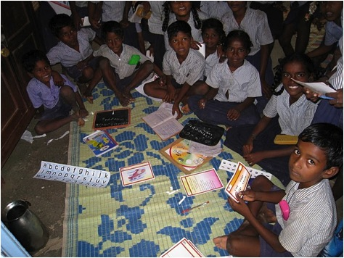

WAH Budget:
MS = Government Middle School, PS = Govt Primary School, HSS = Govt Higher Secondary School, HS = Govt High School
ABL = Activity Based Learning, Primary School Teacher

Current Teacher* | Current School* | Salary range | Max Salary | Max Annual Salary | Max Incentive | Max Annual Pay
Sivakumar A V (ABL) | Manamai HSS | 4000 - 4500 | 4500 | 54000 | 4500 | 58500
Anitha A (ABL) | Nerumbur HS | 4000 - 4500 | 4500 | 54000 | 4500 | 58500
Jayalakshmi K (ABL) | Nerumbur HS | 4000 - 4500 | 4500 | 54000 | 4500 | 58500
Sujatha V (ABL) | Nerumbur HS | 4000 - 4500 | 4500 | 54000 | 4500 | 58500
Lalitha P (ABL) | Parameswar HS | 4000 - 4500 | 4500 | 54000 | 4500 | 58500
Kamatchi M (ABL) | Koovathur PS | 4000 - 4500 | 4500 | 54000 | 4500 | 58500
Logambal D (ABL) | Koovathur PS | 4000 - 4500 | 4500 | 54000 | 4500 | 58500
Mahalakshmi K (ABL) | Koovathur PS | 4000 - 4500 | 4500 | 54000 | 4500 | 58500
Elakkiya K (ABL) | Pulikundram PS | 4000 - 4500 | 4500 | 54000 | 4500 | 58500
New Teacher (ABL) | Pulikundram PS | 4000 - 4500 | 4500 | 54000 | 4500 | 58500
New Teacher | Sogandi HS | 5000-5500 | 5500 | 66000 | 5500 | 71500
Bhuvaneswari D | Vayalur HS | 5000-5500 | 5500 | 66000 | 5500 | 71500
Bharathidasan K M | Kadambadi MS | 5000-5500 | 5500 | 66000 | 5500 | 71500
Angayarkanni | Lathur MS | 5000-5500 | 5500 | 66000 | 5500 | 71500
Kannan A | Neelmangalam MS | 5000-5500 | 5500 | 66000 | 5500 | 71500
Kumaresan P | Neelmangalam MS | 5000-5500 | 5500 | 66000 | 5500 | 71500
Ezhilarasi V | Paramasivam MS | 5000-5500 | 5500 | 66000 | 5500 | 71500
Sri Devi C | Paramasivam MS | 5000-5500 | 5500 | 66000 | 5500 | 71500
Thanuja Devadoss | Paramasivam MS | 5000-5500 | 5500 | 66000 | 5500 | 71500
New Teacher | Thenpattinam MS | 5000-5500 | 5500 | 66000 | 5500 | 71500
Revathi P | Thenpattinam MS | 5000-5500 | 5500 | 66000 | 5500 | 71500
 | TOTAL SALARY (RS) |  | 105500 |  |  | 1371500
 | TOTAL SALARY (USD) |  | $2,344 |  |  | $30,478

It is important to note that this is a representative budget. The actual teacher salary will be determined by a formula that includes teacher qualification, experience, teacher performance and student performance. Similarly, the actual number of teachers will vary. As the govt appoints teachers, these teachers will be moved to a different school where the govt has not yet appointed teachers. Teachers may leave and will be replaced by new teachers whose starting salaries will be lower, as they are fresh hires. Schools may change depending on the urgency of the need and the teacher shortage on the ground. The maximum expenses will not exceed the $30478. The actual salaries, number of teachers and schools will be published yearly along with the audit report.
Any unutilzed budget will be carried forward to the next year.

Who owns the school legally? Is it the organization or trustees or an individual. Please provide details.

These are 17 government schools in Tamilnadu.

Location of school Urban Rural Other

These schools are in 25 rural villages around Kalpakkam, Chennai.

Specify the type of education provided (e.g. basic literacy, vocational training etc.).

TamilNadu State Board Curriculum.
For Primary schools, the methodology used in the government primary schools is Activity Based Learning.

Please tell us about your teaching techniques (conventional vs. alternative).

Conventional for the middle, high and higher secondary schools + ABL for the primary schools as defined by the TN state government.

What is the literacy rate in your local community? Please give a breakdown between boys and girls if possible.

The majority of the students attending these 17 government schools are first generation learners. The families are engaged in agricultural labor or are seasonally employed. So literacy rates will mirror that of rural TN.

Describe the socio-economic background of the children and their parents (e.g. education, occupational). If any of your students are employed, please tell us about that as well.

The communities are predominantly Dalit, and some of the government schools are designated “Adi Dravidar Welfare Board” schools – the “Adi Dravidar” tribal community (a Dalit community) is considered one of the most socially and economically underprivileged communities in the state. The families are typically employed as agricultural farm labourers, or are seasonally employed.

What is the admission criteria for the students to join your school? Have you ever turned away students? If so, why? How many children attend your school currently? How many teachers do you have? How many full time students? How many part time teachers? How much is the fees? Is there an admission one time fee?Do you have parent teacher meetings (parent involvement)?

Any student who applies will be admitted to the local government school. No fees. Around 7500 students study in these 17 schools.

In addition to education, does your group provide any other services to the children in your schools (e.g. food, health care, clothing, etc.)?

We provide health care services to the general population in the area via the rural health clinic we have set up.

How do you perceive that education will improve the lives of the children in your village?
The educational level of the 25 villages have improved dramatically. Hundreds more students are graduating every year with High School and Higher Secondary school degrees. Since pass percentages of the Class 12 students and Class 10 students have significantly improved in a short span of 3 – 4 years, there was a tremendous demand for higher education and no means to attend college. So with Asha SV’s help we created 12 Higher Ed scholarships for students from these schools to attend college. This is a very small drop in the bucket.

Even prior to starting the higher ed scholarships with Asha, Mr. Sridhar and Mrs. Kalavathy used to, and still sponsor children (2 – 3 every couple of years) at the 9th class level from the local villages in their homes .. the children live with them till they complete their Class XII and start college. This is a kind of experiment to expose a different domestic demagoguic space to the children. In 4 years, the students typically show dramatic improvements in learning and performance outcomes and have all gone on to attend college and become well employed. The couple takes care of their fees, food and shelter, books and notebooks and dresses of about Rs. 40 to 50 thousand rupees per year. 17 children were sponsored by the couple with their salaries, but this personal activity could not be expanded without external support. (Vide Newspapers Dinamani 28-7-03, Eenadu 30-7-03 ). So a small ad hoc fund RSWF (Rural Students Welfare Fund) was created on the basis of monthly voluntary contribution from fellow scientists. RSWF would then select about three to five students annually on a means-plus-merit basis and provide financial support for their study beyond 10th for a maximum period of five years. About 60 students have benefited from this program and three of them have been employed in the Department of Atomic Energy units at Kalpakkam at scientific assistant level. Some of them have taken employment elsewhere and some have taken up contract jobs. A couple of Engineers, teachers, diploma holders (two have gone abroad) and four girl degree holders are some of the salient outcomes of this activity. This activity expends about Rs 250,000/- every year.
Does your school have: Its own building(s): √ Yes No Number 08Number and type of classrooms (e.g. Pukka): Pukka Yes No Yes No Yes No Toilets √ Playground √ Toys √ Chairs & Tables √ Blackboard √ Library √ Drinking water Electricity √ Computers √ Laboratory Teaching aids (e.g. books/slates) √

Most of these govt schools have buildings, some in better shape than others.
Toilets are mostly dysfunctional. Some schools have no toilets.
Water is generally a problem. Some schools have water tanks but most schools do not have a regular supply of water.

What is the age group of the children currently enrolled in your school(s)?

All the way from govt primary schools to govt higher secondary schools (Class XII)

How many staff are employed at your schools?

We have added 52 teachers to 17 government schools via the PTA. These teachers work as full time govt school teachers but their salaries are paid by Asha.

Average distance the children travel to attend your school

If a govt primary school, max of 2 km.
If a govt middle school, 3-5 kms
If a govt high school – 5 – 7 kms
If a govt higher secondary – 8 kms

Please answer this if your school has existed for atleast 5 years. How many children have gone through your program in the past five years and what are they doing currently? Please tell us about their future education possibilities. How would you visualize their future employment possibilities?

As mentioned earlier, there are hundreds of new high school graduates from this set of 25 villages. There is increased interest in higher education and a large number of students are pursuing colleges or diplomas in various fields including Arts, Science, Engineering, Medicine and others.

Do you help your students with their future education efforts after they have completed school? If so please describe your efforts.

Yes, as described earlier.

Do the students who have studies or graduated get involved in the school afterwards and help the next batch?

Yes, in some schools. In Venkampakkam government high school, the alumni of the school have started a night school for the younger classes via a youth club called Annal Iravu Padasalai. This club coaches students on their school curriculum.

Are there any other schools (Kindergarten/Balwadi, Elementary school, High school) in the area? If so, please list the schools and the range of classes each of them offers.

In an area of around 25 villages, there are roughly 25 govt primary schools, 10-15 govt middle schools, 2-5 govt high schools and 1 govt higher secondary school.

Is your program different from that provided at these schools? Please explain.

Our program is to add trained qualified teachers to government schools where the government has not yet appointed the teacher . We also add teachers if the class sizes are too large or if there is no teacher say, to teach a specific subject, such as Biology, Math, Tamil, etc.

Why are the children in your school/s not attending government/other schools in the local area?

They are attending the govt schools.

- Do you try to involve the parents of the children in the running of the school (e.g. in setting the syllabus etc.)? Please specify

The teachers are selected with the help of the PTA. PTAs are formally created only in the high and higher secondary schools. In the middle schools, there are educational committees of parents and concerned citizens. Both tehse groups are involved in selecting the teachers we place in the schools.

- What are your expansion plans for the future (e.g. adding more classes or schools)? How do you see your school impacting the village five years from now?

The number of teacher vacancies were approximately of the order of 20,000 in 2004. And so far about 15000 teachers have been filled across the state in the last one and a half years - these are against the 2004 vacancies. So there has been a 3 year lag to fill just the 2004 vacancies. Add to this the 2005, 2006, 2007, 2008 and 2009 vacancies that were created due to school upgradations, teacher retirements etc. There is also expected to be a large number of school upgradations as the RTE act starts getting implemented.

The approximate vacancy figures, as of now, for the Higher Sec & High school in the Kanchipuram District is of the order of 100. This should be true for all the 50 or 60 educational districts in TN.

So there should be approximately 5000 to 6000 vacancies in the state.

New posts will have to be created at the rate at which schools are being upgraded. This rate is independent of the Govt, and is about 2-3 high schools and 1-2 higher secondary schools in each educational district every year. So a total of 300 schools may get upgraded a year. My guesstimate would be around 250 to 300 new posts would be needed per education district as on date.

So approximately 15000 new posts would need to be created. Creations of new posts in old schools may also be needed.
One has to make appropriate additions to the above figure on the basis of the number of primary schools upgraded to Middle school.

All these figures are on the basis overall 1:40 consideration. There can be a lot of variations at each school level. Eg. VII class can have 80 students requiring two sections, while 3rd & 4th may have just 25-30 students each.

Overall 1:40 cannot takes this variations into account. At plus two level in each specialization there may be 10 or 20 students each demanding a separate teacher beyond the 1:40 global consideration etc etc .

REWARD's goal is 1:20 in all schools, as there is general consensus among educators, that the desired student teacher ratio for effective learning in a first generation learner community is actually 1:10.

The number of schools within REWARD’s reach in this taluk of this district alone needing such a support is very, very high. The daily call to us for support is on the increase.

Any additional details you would like to provide to us.

Yes. Since these are teacher salaries and also because we work within the govt school system, we need some certainty of funding for at least 3 years for each teacher working in the govt school. We need to be able to assure the principal that the teacher will be there minimally for 3 years or hopefully until the govt appoints the teacher. Also, we would like to honor the principle of equal pay for equal work and raise the salaries of the teachers to be commensurate to atleast the base pay of govt school teachers.

If possible, please provide us with the contact information of two individuals from your community (not related to the school) who can describe the impact of your program.

Any Principal from any of the govt schools we work with. Names and contacts provided on request.

Asha for Education requires reports from its projects every six months to continue funding. Please provide the contact information for the person from your group who will be responsible for these reports.

Mr. Sridhar kalasridh@yahoo.com.

Part III: Financial Details

- What sources fund your group’s activities at present? List the sources and the current and future funding from each of them. If these funds are meant for a specific part of your group’s activities, please describe those restrictions.

Asha SV has funded our activities from 2005 to March 2012.

Please provide us with details of your projected budget for the next 3 years:

We have 52 teachers on payroll working in all classes from govt primary through govt higher secondary. We have submitted the salaries of the primary school teachers and the middle school teachers for the WAH budget. The rest of the budget will be submitted to Asha SV as the primary funding chapter, and to any other chapters who want to participate in this program.

REWARD TRUST BUDGET 2011-2012
TEACHER SALARIES
Expense Detail | Ave Monthly expense | Annual expense | Salary Range
Teacher Salaries for 40 - 50 teachers in 18-20 government schools(based on last audited expense) | 227200 | 2726400 | Rs. 3000 per month to Rs. 6900 per month depending on primary, middle, high or HSS, experience, qualification and performance. Please refer to 10-11 payment details sheet for actual salaries.
Performance Based Incentives for 40 - 50 teachers for 2009-2010 and 2010-2011 | 95000 | 95000 | Upto Rs. 2500 per year per teacher
Auditor, Resource persons for training, Stationery, Postage, Travel, Exhibitions, Distribution function | 4167 | 50000
Total | 326367 | 2871400

Teacher salaries are raised by 5% per year, so we expect our budget to increase by around 5-7% each year to keep up with inflation.

