Project Freedom
Freeing Children of Bonded Laborers in Rice Mills, Tamilnadu

Site Visit Report

N.Raj Jeba Durai, Dhanalakshmi, M. Sathyapriya, Siddhamma*
Volunteers, Asha Honor focus group, Mission UQE 2047
Oct 15, 2004

*Asha Fellow

Abstract
On Sept 12th 2004, we presented a site visit report highlighting the plight of rescued bonded laborers from the rice mills in the Red Hills region of Tamilnadu, and their urgent need for support beginning with basic nutrition. A month later we made a followup site visit to document progress and begin working on a long term plan for educating the children of bonded laborers. In this report we present a proposal to begin education of 80 rescued children, along with updates and media reports in THE HINDU. When we interacted with the children, now relocated in three villages, we received the same message – that children are very interested in education and their parents are fully in support of education. The children are free to go to school and study now instead of wasting away as bonded laborers in rice mills. Asha Fellow Siddhamma needs Rs 4.62 Lakhs ($10,500) to educate and begin mainstreaming 80 children of bonded laborers. Interested Asha chapters are invited to support this project at the earliest opportunity.

Background
Our earlier report “Freeding children of Bonded Laborers” is documented at http://www.ashanet.org/toledo/Bonded_labor.htm

Oct 12th Site Visit Findings
On 12th October Jeba Durai, Dhanalakshmi and Siddamma visited several villages in Tiruvallur district, including Rajapalyam, Kottangulam and Senjiagaram, to distribute rice sacks and to know the current situation of the bonded laborers. Rescued bonded laborers and children are hosted in the Asha supported Irula schools here. With help from Asha volunteers including those from Toledo, Arizona and Seattle, 23 rice sacks of rice have been provided to date.

At 10 AM some bonded laborers visited Siddhamma’s office and expressed sadness that in some rice mills the owners are still pressurizing the laborers to repay the loan. Siddamma replied them that soon steps will be taken to rescue the other laborers too. In the afternoon, we started to visit the places where the rescued laborers are staying.

Senjiagaram:

In this village, more than 20 families of rescued bonded laborers are residing. During interaction with the people, Siddamma asked about their future plans for their survival. Few are planning to go for coolie work. In this case, they need some digging materials. Few are interested in selling milk, if they get help in buying cows and goats. Siddamma insisted that all children should attend the Asha School. Food is also given to the children. Children are already showing interest in studies.

Kottangulam:

Around 4.00pm, we visited this place where more than 27 families of rescued bonded laborers are residing. The local village members supported the people by giving 1kg of rice and Rs.5 to every family. Like Senjiagaram, these people also suggested the similar occupations for their survival. Nobody is interested in going back and working in rice mills again. When Siddamma explained the plans for placing the children in the Asha School that already exists, the parents expressed support and seemed relieved. The parents’ response was totally good and we feel full support will be forthcoming from their side towards their children education. In this place, it must be noted that the Government has taken over support for the Asha School – so this is a successful case study for Asha which initiated the school years ago.

Rajapalyam:

Around 6.30pm, we visited this place, where more than 30 families of rescued bonded laborers are residing. The men are going for Ccolie work. The parents’ response towards children’s education was once again very good. Siddamma emphasized that all children should attend the Asha School. Food is also being given to the children.

Quotes

“I felt very depressed after seeing the situation of the people. But the village support is strong. It made me very happy seeing the unity of the villagers” Dhanalakshmi

“I am very unhappy seeing the condition of bonded labourers. Education is important for the future of these children. I strongly feel Asha should take a stand and help the needy children pursue education. Asha should support the proposal at the earliest opportunity” N.Raj Jeba Durai

“We are creating a historic change in the lives of the bonded laborers. An entire generation will benefit from this work. I am so glad Asha is supporting this rescue and rehabilitation effort. Asha’s role is critical here.” Siddhamma

Budget Proposal for the year 2004-2005:
The following proposal indicates the funds requirement for the year 2004-2005 of freeing bonded laborers project. It covers three schools in different villages---Rajapalyam, Kottangulam and Senjiagaran. There are eighty children among the bonded laborers
who are now staying in these three different villages where Asha school is running already. The support needed for these children to continue their studies because children
are affected more than others without education.

S.No | Work Item | Rajapalyam | Kottangulam | Senjiagaram | Total
1. | No of children | 30 | 30 | 20 | 80
2. | Teacher Salaries | Rs1500 per month (1500x1x12)= Rs18000 | Rs1500 per month (1500x1x12)= Rs18000 | Rs1500 per month (1500x1x12)= Rs18000 | Rs.54, 000
3. | Helper Salaries | Rs600 per month (600x1x12)= Rs7200 | Rs600 per month (600x1x12)= Rs7200 | Rs600 per month (600x1x12)= Rs7200 | Rs.21, 600
4. | Nutrition | 30 children x 30 days x Rs.8 per child x 12 months = Rs86, 400 | 30 children x 30 days x Rs.8 per child x 12 months = Rs86, 400 | 20 children x 30 days x Rs.8 per child x 12 months = Rs57, 600 | Rs.2,30,400
5. | School repair work | -Nil- | -Nil- | Rs20, 000 | Rs.20, 000
6. | Teaching materials |  |  |  | Rs.20, 000
7. | Health Care |  |  |  | Rs.15, 000
8. | Children Tour |  |  |  | Rs.15, 000
9 | Teacher Training Programme |  |  |  | Rs.20, 000
10. | Audit fee |  |  |  |  | Rs.8000
11. | Uniforms |  |  |  |  |  | Rs.48, 000
12. | Miscellaneous |  |  |  |  |  | Rs.10, 000
 |  | Grant Total |  |  |  | Rs4,62,000

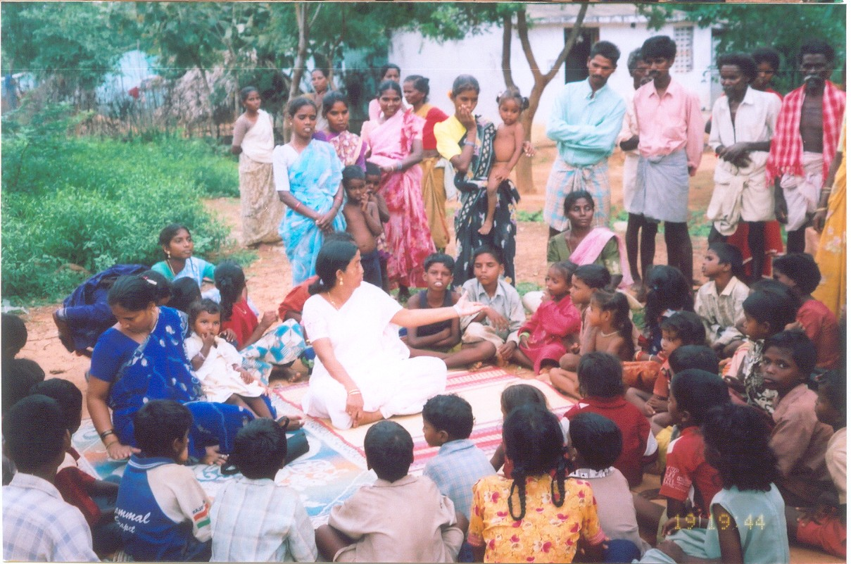
Siddhamma counseling the children & parents
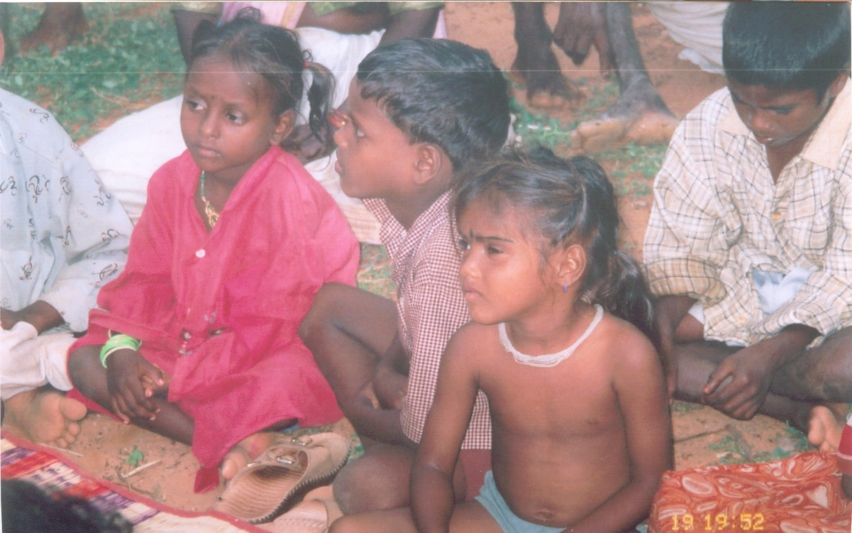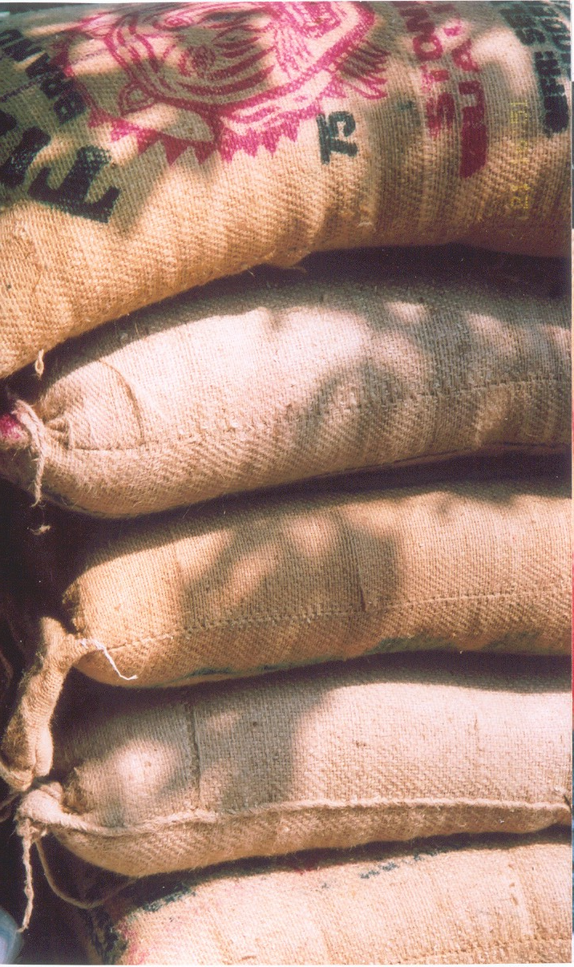
Children of bonded laborers, now have a brighter future. Asha volunteers supported expenses for basic nutrition and prevented starvation.

References

1. Article in The Hindu, Oct 4, 2004
`Release families of bonded labourers from rice mills'
http://www.hindu.com/2004/10/05/stories/2004100506200400.htm
CHENNAI, OCT. 4. A five-member panel, at the public hearing on bonded labourers in rice mills at Red Hills, today called on the State Government to release all the families involved in bonded labour and rehabilitate them.
Led by the chairperson, National Commission for Women, Poornima Advani, the panel demanded the release of the bonded labourers (numbering nearly 12,000) in the rice mills in the area, under the provisions of the Bonded Labour Act, the Factories Act and secure arrears under the Minimum Wages Act. Speaking to presspersons here, Dr. Advani said the panel members were convinced that there was debt bondage, physical bondage, violation of the Minimum Wages Act, sale of labourers, physical and sexual harassment. "The NCW has concluded that it is a case of serious violation of human rights and labour laws."
After labouring through 20 representations from those who managed to escape from bondage, the panelists found that the labourers were over worked, underpaid and forcibly confined to the premises of the mill, apart from being held to sums of money they could never hope to repay. Long working hours and exacting nature of work that led to exhaustion and frequent illness were also documented.
"We were told that the women are not even allowed to leave the mill for delivery. They are forced to work merely days after childbirth," Dr. Advani said.
Testimonies of children
She said the testimonies of children who deposed at the public hearing was moving — they complained they were beaten up, forced to work and denied access to education, weeping bitterly. The panel, in its recommendations, also said the State should provide compulsory education for about 5,000 children living in the rice mills at Red Hills.
The labourers claimed that they were paid around Rs. 15 for nearly 19 hours of hard work, while the stipulation as per the Act was Rs. 86.28 a day for eight hours of work. Providing an insight on this aspect, Swami Agnivesh, president, Bonded Labour Liberation Front, said as per the Supreme Court judgment of 1983, even non-payment of minimum wages amounted to bonded labour.
He further urged the National Human Rights Commission to constitute a special cell comprising eminent retired judges, social workers and bureaucrats to address the issues of bonded and bonded child labourers.
The panelists, including Vasanthi Devi, chairperson, State Commission for Women; Sarala Gopalan, retired bureaucrat, and A. Ramamoorthy, retired judge, expressed unhappiness at the attitude of the district administration at the public hearing. "The lower level staff are even unaware of the provisions of the law and its interpretation, indicating that an orientation programme should be organised for the Government staff on laws relevant to bonded labour," Dr. Advani said.
"It is unfortunate that we should notice such grave violations and reluctance to implement the law to benefit the weaker sections, a few weeks short of the 29th anniversary of the promulgation of the Bonded Labour Act (October 25)."

2. Article in The Hindu, Sept21,
Rice mill workers allege `inhuman conditions'
http://www.hindu.com/2004/09/22/stories/2004092215420300.htm
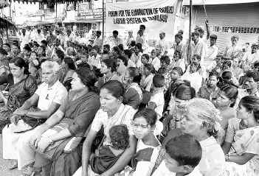
Rice mill workers of Sarpam Irular Thozhilali Sangam staging a demonstration near the Red Hills bus stand on Monday. — Photo: S. Thanthoni
CHENNAI, SEPT. 21. Hundreds of rice mill workers in Red Hills staged a demonstration yesterday to protest against what they called ``inhuman conditions at their workplace and the apathy on the part of officials of the Tiruvallur district administration.''
Men, women and children working in over 500 rice mills in the area attended the demonstration, organised by Sarpam Irular Workers Association at the Red Hills bus stand. The demonstrators wanted urgent steps taken by the district administration to release more than 10,000 persons working as bonded labourers in the mills.
Most of the labourers belonged to Irula tribal families and many of them have been working in the mills for generations. Apart from meagre wages, the labourers were working in unhygienic conditions with little access to basic amenities.
Callous employers
D. Sekar (28), working in a rice mill on the bypass of the Grand Northern Trunk Road, said his wife Valli (23) died as she was forced to work three days after she gave birth to their third child. ``I was not even allowed to complete the final rites until I finished the day's work,'' Mr. Sekar said and added that subsequently, he was severely assaulted by his employers. He was unable to lodge a complaint with the Red Hills police.
``I have not gone to school and I am unable to remember the exact date when my wife died. I hope to give a better life for my children at least,'' he said.
The labourers said they had to work more than 18 hours a day. Their work included soaking paddy, boiling and drying it and finally removing the rice. The entire process lasts four days and they are paid between Rs. 15 and Rs. 20 only for this period.
K. Krishnan, State president of the Sarpam Sangam, said the workers want working hours regularised, wages fixed in line with Central guidelines, educational facilities for their children and amenities for their parents.
E. Siddhamma, advisor to the sangam, said that though government agencies had inspected the mills several times, it was surprising that not a single violation had been noted by them.

