EK KADAM - A report

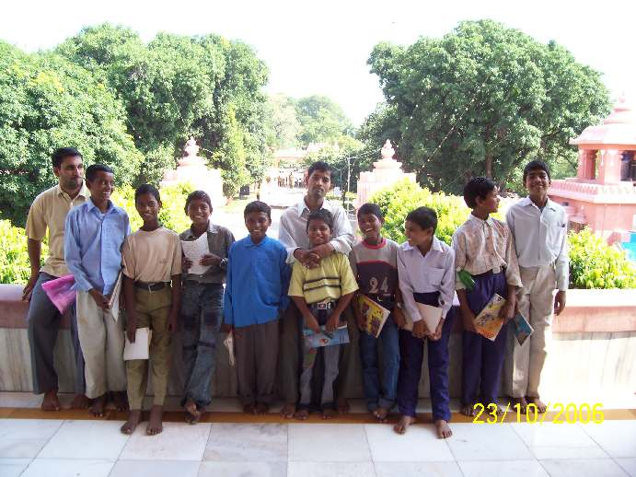
Little Angles of Apana Ghar

October 14, 2006

Ek Kadam is a residential educational project for migrant workers’ children. Jagriti has been working for providing educational environment for these children for the last many years. The peculiar characteristic of moving to and fro from the native place to the cities in search of work diminishes the educational possibilities of the children. Jagriti has been facing this problem with the children. We are not sure when the children will move from the work site. It is all the same, very difficult to keep track of these children and to continue their study. Apart from it there are very many problems as well which includes the issue of child labour, financial condition of the family, etc.
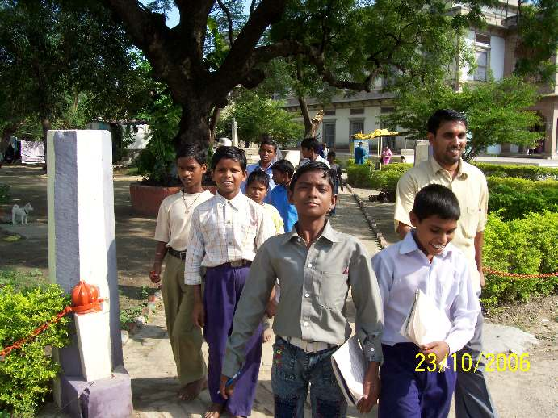
Asha has taken up the issue and the result is Ek Kadam. It was thought earlier to select 10 children to start with the programme. Currently there are 9 children who live in a rented house at Nankari near IIT. These are all the children of migrant workers who work at brick kilns. The average age of children is 10-14 years. All these children were child labour working in the brick field helping their parents in their work.
It began with two children (Sagar and Lavkush) joining the foster home on June 3, 2006 and one more (Jitendra) joined them on 15th June and the rest of the children on June 25th. While we were searching for a place where we may locate the hostel, they stayed at the Jagriti Bal Vikas Samiti office until July 7th before they moved to the current home at Nankari village near IIT Kanpur campus. On 5th of July they got formally admitted to the Swami Vivekanand Vidyalaya at Lodhar village (run by Jagriti Bal Vikas Samiti, with aims to be a model school in primary education) and got the taste of going to a regular school for the first time in their life. There are three children each in the fifth (Sonu, Mahesh and Mukesh), fourth (Sagar, Ashok and Lavkush) and third class (Gyan Chand, Jitendra and Hans Raj).

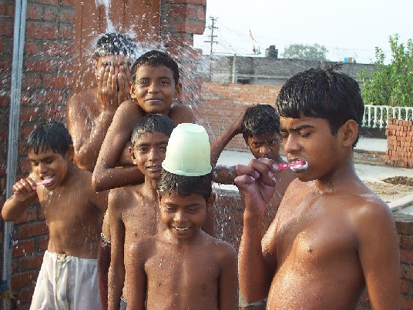
A typical day in the hostel starts at 5 AM with jogging for about 15 minutes followed by Yoga and physical exercises. Shri Pradeep Yadav, appointed as a warden cum cook fotr the hostel starts breakfast proceedings in which the children provide the assistance. The children help Pradeep in all the housecleaning and maintenance activities at the home and this help them develop a sense of belonging to the Institution, which they have named Apna Ghar.

The school starts at 7.45 AM and continues until 2 PM.

The evening activities include:
- training by Jan Chetna Kala Manch (a theatre group involved in spreading useful social messages and awareness of the physical and attitudinal environment.) for two days a week;
- Tailoring skills by a fellow teacher (Gunjan didi) on some days;
- Chalk making and Candle making skills provided by the staff of the project;
- Music and Painting classes
- Games and Sports
- Educational Videos from time to time.

On August 15th the children (together with other children of the village) staged a natak in the Community Independence Day Celebrations. An audience of about 2000 appreciated and encouraged their performance.

With the approaching Diwali festival, they spread the message of the objectives of Ek Kadam by taking part in the sale of Candles that they helped make, to the households in the Village Nankari.

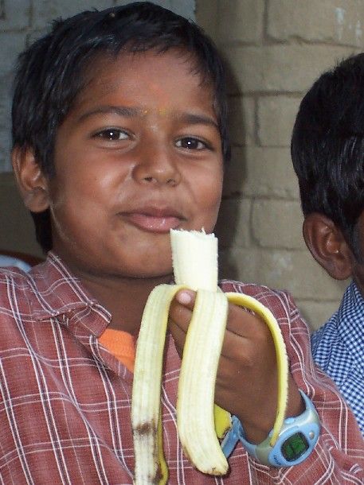
We try to ensure that their diet is healthy and nutritious, such as sprouted beans, milk and fruits in addition to the traditional roti, dal and sabzi.

Main advantages of Ek Kadam have been to realize that the children are not victims of child labour any more. Since the personal expenses of the children are borne by the project, the parents are quite reconciled to the fact that they are not anymore additional income earners. Children are indeed happy with the restoration of the pleasures of being a developing child – not having to work (in often hazardous environment) for their living. Parents are happy that their children will have a proper education and look forward to a better living opportunity.

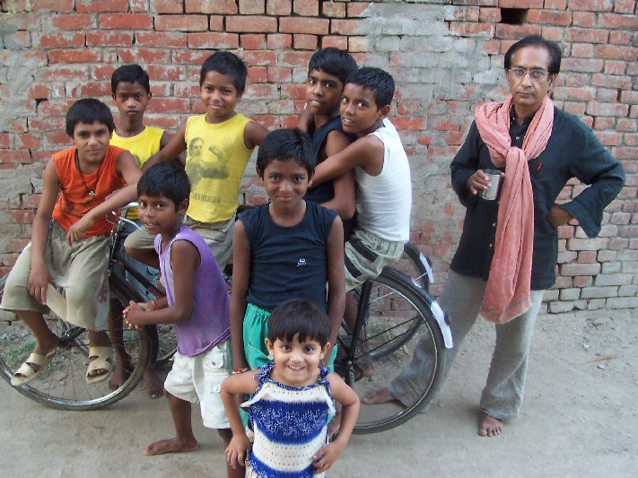
We are trying to ensure that there is no alienation of the children from the family. While it may be tempting for the children to strongly identify themselves with Apna Ghar (which provides them all basic necessities) and try to shield themselves from the hardships of living at their own homes, we make special efforts to strengthen their bonds with their own family and develop their responsibility towards them.

Our experiment in saving these children from the hazards of child labour has been possible due to the efforts of many from Jagriti Bal Vikas Samiti and Apna Skool project. Prominent among them are Sunita didi, Sharmaji, Shuklaji and Mahendra Dwivedi.

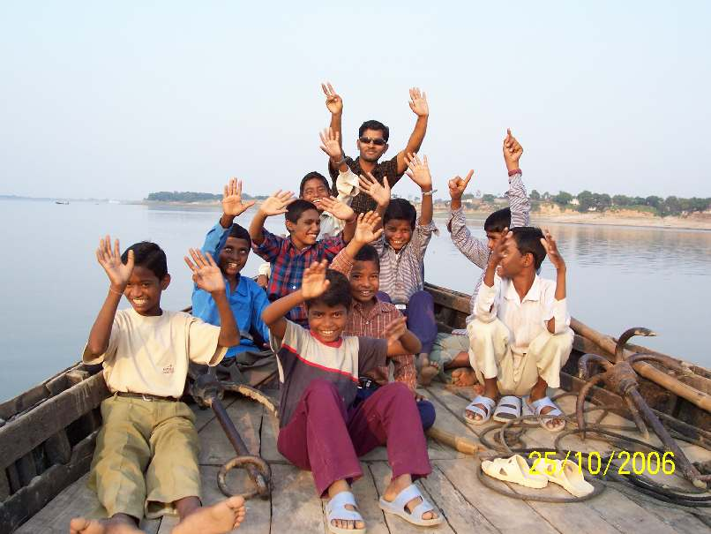

Mahesh Vijaya Didi
91 9838546900 91 9415307196
91 9936003676 (hostel) rvijaya26@yahoo.co.in
apanagharknp@yahoo.com
maheshballia@yahoo.com
all_aman@yahoo.com

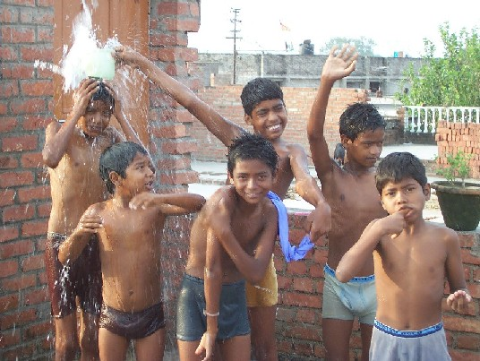
Beginning of the Day

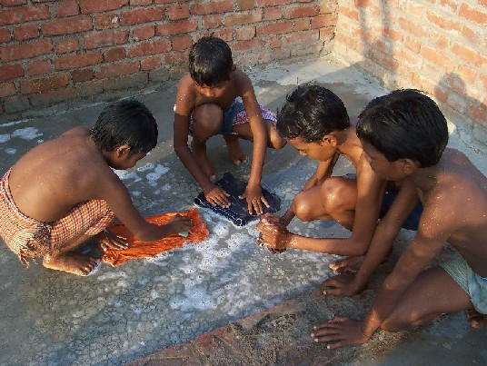
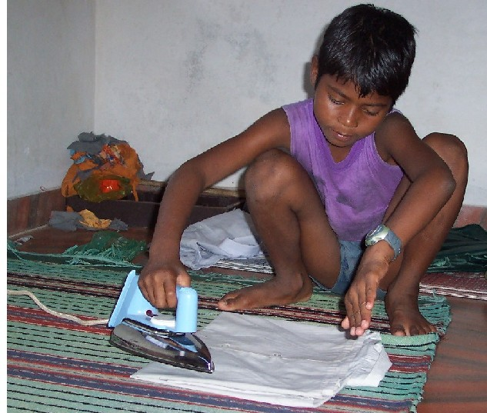

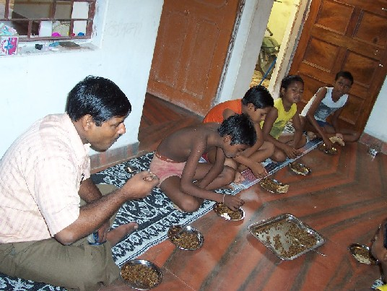

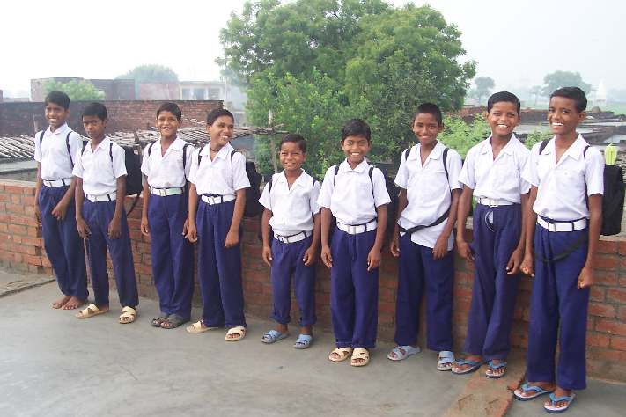
Ready for going to School
Educational tour of historical place at Bithur, Lucknow and Varanasi.


