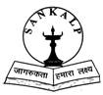Sankalp Welfare Society

A Soldiers Pledge
Dear Friends,
Sankalp comprises children from the poorest of the poor background. What began as a soldiers dream ten years back on the roadside is today a multi locational school benefiting more than seven hundred children belonging to the “below poverty line” category.

Our objective is making our children self sufficient Sankalp with a view to inculcate better moral values encourages respect, responsibility, integrity and independence amongst our children. Exposing them to various interactions with corporates and community members is essential. It builds up their self esteem and makes them more effective citizens Besides education we emphasise on art and music. Health initiatives include regular medical tests. Talks on nutrition and basic hygiene are a part of our curriculum.

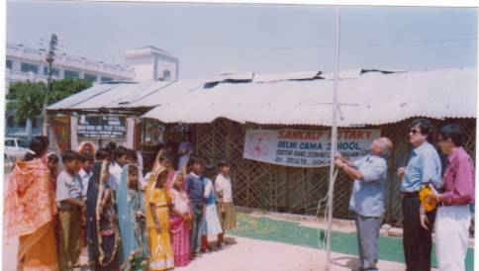
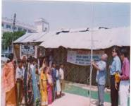

We have completed ten years and this is a landmark year for us. The aim is to make the organisation sustainable, efficient and effective.
Commander K K Choudhary

About Us
Sankalp Welfare Society (Sankalp) is a non profit registered NGO based at Gurgaon. Sankalp runs non formals schools, skill training centres and a utility bank.
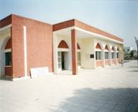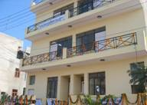
Commander Choudhary, a retired naval officer started the first school in 1996 in association with Rotary Club, Delhi Cama Place. The school with an initial strength of thirty children functioned first in the corridors of a shopping arcade and then moved into a temporary tin shed on the roadside in Sushant Lok from where it operated for almost eight years.
In March 2004, Sankalp entered into a Joint Venture with the District Child Welfare .the District Child Welfare Council, Gurgaon and was allotted a primary school building in DLF Phase IV. January 2005 saw the inauguration of Sankalp’s own building in E Block, Sushant Lok, marking another milestone in its history. In April 2005, the Mobile Schooling system was introduced and in April 2006 sixty vidyarthis have successfully moved for higher studies to the government schools.

Literacy
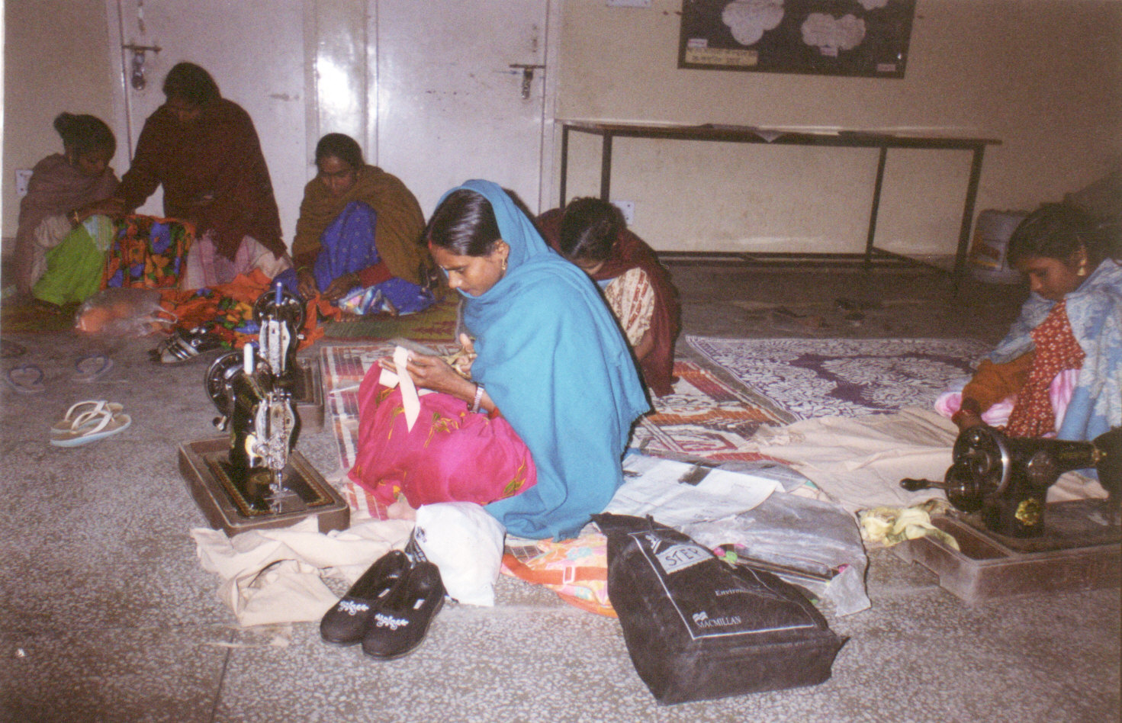
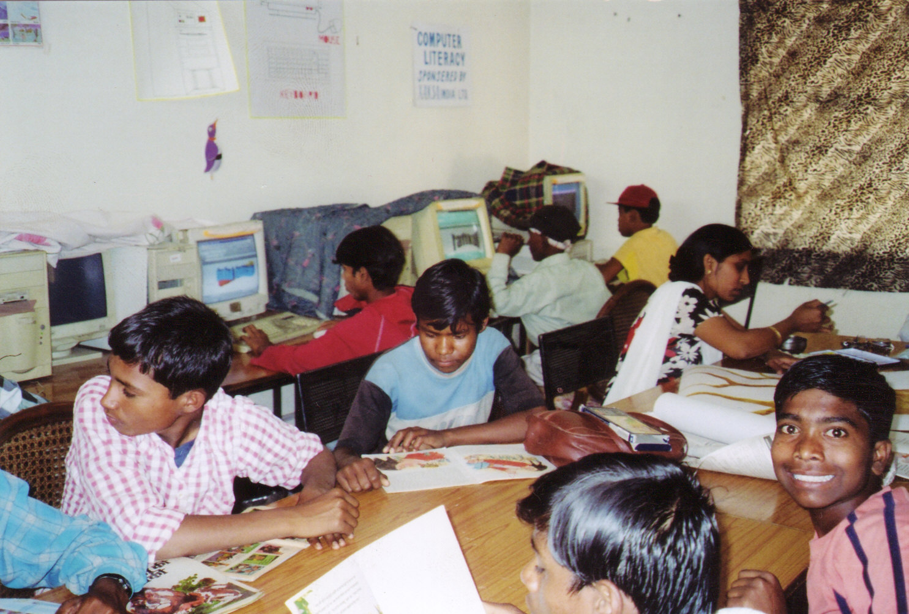
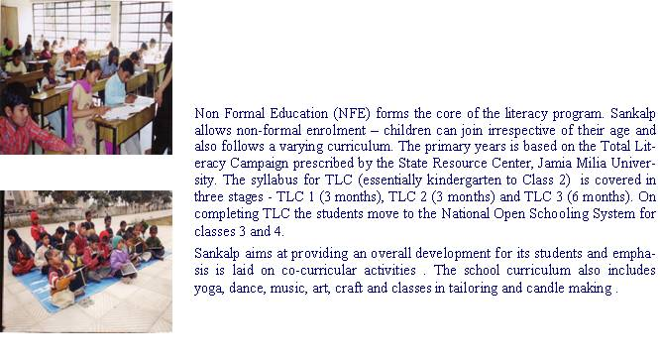

Skill Training

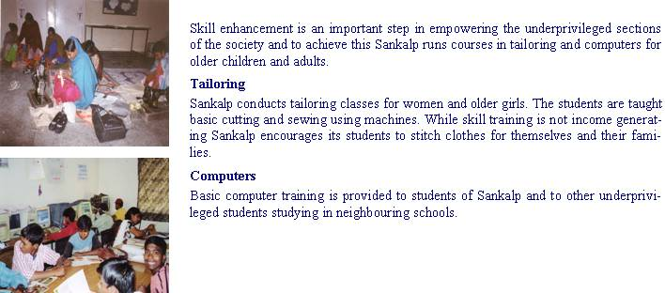

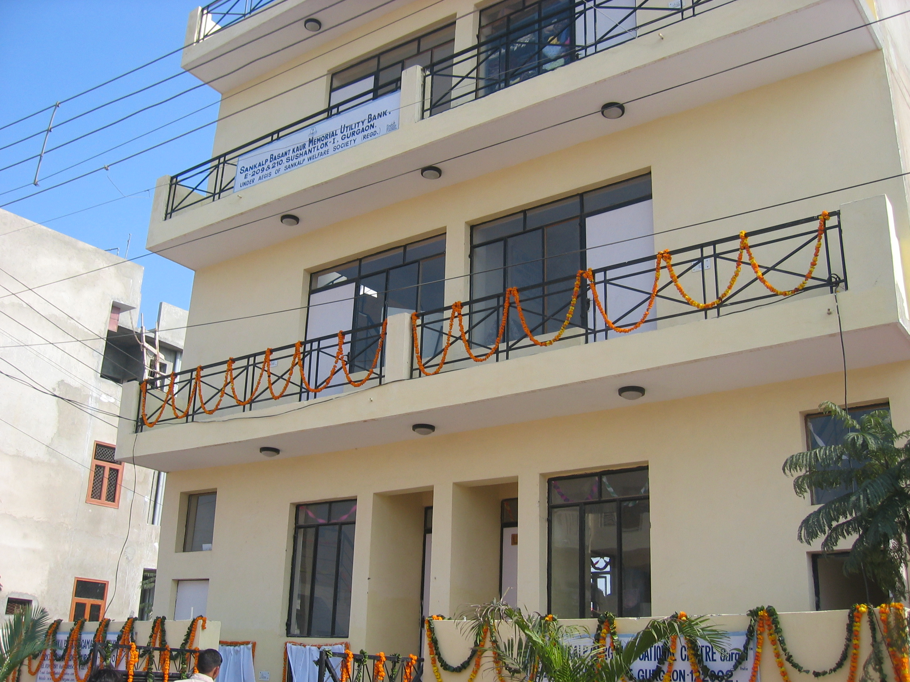

Utility Bank
The Utility Bank the first of its kind in Haryana, collects old items for which the community may not have a use, sorts them and distributes them to the needy. The items that are collected are primarily clothes, footwear and toys. The bank also gets household articles, furniture and books. The items which are collected are first distributed to the school students and their families and surplus is then shared amongst the residents of nearby slums.

New Initiatives
Health & Nutrition
Healthcare is a new initiative in Sankalp this year. All the students will have regular general health check ups and any follow up treatment will be arranged for.
A mid day meal comprising dal and rice is given to all the students of Sankalp.
Project Megha Barse.
This is a joint initiative of Sankalp, the team at Max Devki Devi Heart and Vascular Institute, Saket, New Delhi, India, and philanthropists from the society to help facilitate underprivileged children to recover from ailments of the Heart and Vascular systems treatment that adversely impact their lives. Megha Barse envisions treating patients in the most cost effective manner and to provide them with the best possible treatment and facilities.

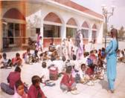

Sankalp Vidyarthis
Vidyarthis are the children who have completed class IV in Sankalp. These children are admitted to schools run by the state government in neighbouring localities. The entire cost of education i.e., fees, books, uniform and transport is borne by Sankalp. Currently there are 67 vidyarthis in Classes 5, 6, 7 and 9 in the government schools in Chakarpur, Kanhai Gaon and Nathupur in Gurgaon.

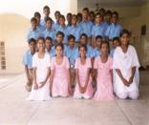

Outreach Programme
The Sankalp outreach programme aims at opening literacy centres at construction sites and rural areas where the population does not have access to any kind of schooling. These centres which maybe semi permanent in nature will follow the TLC programme and will also take care of health and nutritional requirements of the children. The first outreach school has been set up in a construction site in Sector 57, Sushant Lok 3 with strength of thirty children.

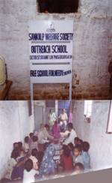

Milestones
July 13 1996 – Sankalp in association with Rotary Club, Delhi Cama Place starts a school on the roadside with thirty children
July 1998 – Commencement of tailoring classes
June 2000 - Registered under the Societies Registration Act, 1860
March 2002 – First batch of four children appear for the Haryana Primary Board Exam
May 2002 – Land acquired in Sushant Lok for school building
February 2004 – JV with District Child Welfare Council , Gurgaon and allotted a primary school building on lease
March 2004 – Sankalp school shifts from tin shed to a primary school building in DLF IV
March 2004 – Registration under Section 80G of Income Tax Act
January 2005 – Sankalp inaugurates its second school at Sushant Lok, I
April 2005 – Commencement of skill training courses in computers at school 1& 2
April 2005 – Sankalp introduces the mobile schooling system
May 2005 – First surgery under Megha Barse
March 2006 – Sixty children appeared for elementary, primary and middle board examinations under the National Open Schooling system
April 2006 – Fifty Sankalp vidyarthis admitted in Government schools for higher education
July 2006 – Bharti library opened in school 1.
July 2006 – First outreach school opened at Sector 57, Sushant Lok 3
July 13, 2006 – Sankalp celebrates its tenth anniversary with a strength of 700 children

A Community Partnership


