Please see first report of 2011 for complete overview of this project.

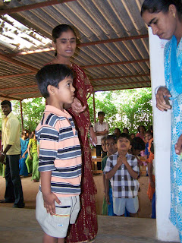
A site visit was carried out in December 2013. Personnel at the Rishi Valley Rural Health Center remain essentially constant. Dr. Kartik Kalyanram and his wife Dr. Kamakshi Kartik have been the primary motivating force. On the day we visited, activities were proceeding as we had observed in 2010, with scores of patients lined up to be seen by the doctors, or waiting for medications to be dispensed or other services.
The setting is off the main road from Madanapalle and just outside of the Rishi Valley school campus. Patients appear to be arriving from an increasingly extensive surrounding area.
A breakdown of statistics by age and gender is available here: http://rvrhc.blogspot.com/
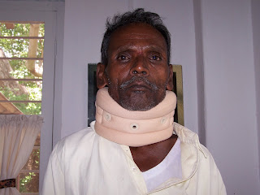
and discloses around 2,000 patient visits a month with a combination of chronic diseases, tuberculosis management, antenatal management, healthcare for seniors, under 15's clinic and eye care. Dental care and support for 30 children treated in tertiary care centers was also carried out in the year.

Dr. Kalyanram observed that the burden of diabetes care has increased substantially in the surrounding rural population, and he has sought to improve this care. To this end he achieved completion of a distance fellowship in Diabetes management from CMC Vellore, presenting a paper on the possible risk factors in the epidemiology of diabetes, and has expanded these services.
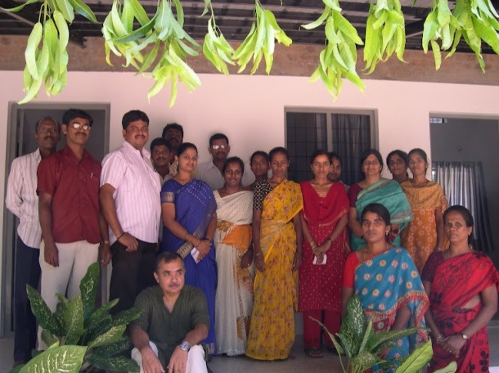
Patients prefer to come to the RVRHC over surrounding facilities even if they have an ability to pay for a private physician, since they feel the quality of care is very high.

In summary, the Rural Health Center continues to provide a level of high quality medical care that is rare to find, to a rural population, and has been sustained that engagement over a prolonged period of time, now 11 years. Funds are used extremely efficiently. ASHA donations represent the only donations from the US, and are used as general funds for subsidizing operations across center activities.

site visit completed by Kavi Duvvoori and Sumana Reddy, MD, California, USA.

