Asha Site Visit Report
Dattawadi Study Centre – Asha Star Project
7th August, 2009
Introduction
The Dattawadi Study Centre (Dada Paranjpe Abhyasika) has been run by Door Step School since 19XX. The activities there have grown to now include reading classes, study classes, computer classes, adult library and science laboratory along with special classes for English and Mathematics. It is also used a coordination centre for study classes operating in the vicinity and for other activities such as the community library.
The centre is run in a community hall rented from Tapobhoomi Housing Society, Dattawadi.
The Dattawadi Study Centre main location
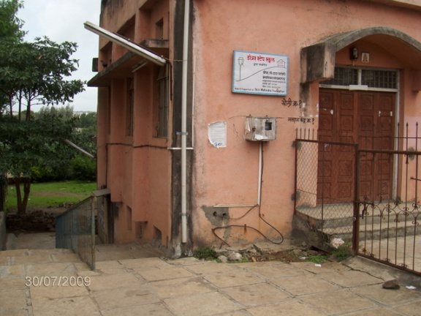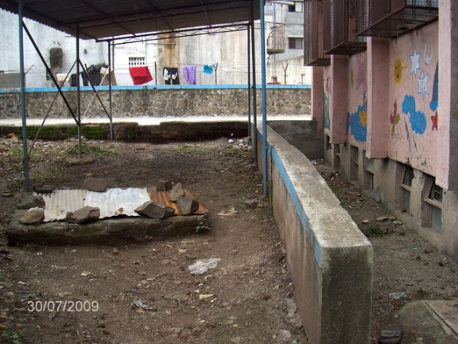
The project has been supported by Asha Stars (Vinay Awasthi, Malati Gadgil and Ranjit Gadgil) for 3 years. It will now be supported by Tech Mahindra. This is the final report as far as Asha is concerned.
Site Visit
The site visit was conducted by Ranjit Gadgil (ranjit.gadgil@gmail.com).
30th July, 2009 (Thursday)
I met with Ms Jyoti Adsul, who is the new coordinator of the center at 11:30 am. There were very few children present; this was because the school tests were going on and the children had been left a bit early.
Reading class
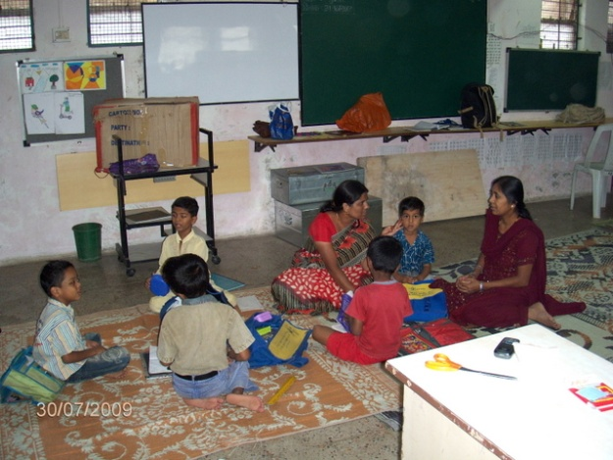
A parent meeting was in progress. It was observed that often older sisters attend the meetings in lieu of the parents.
I asked about how the “drop outs” are counted, since some of these numbers (see Status Report) seem quite large. It was not clear if the students of 2nd standard (since there is no study class for 3rd standard) are counted as drop outs for the next year.
Some other data were explained as follows
- Two NFE classes at nearby construction sites have been closed. One site closed and there were too few children at the other to be able to continue.
- Reading Room numbers saw a marked increase (double). This was achieved by visiting the local Municipal school to get enrolment.
- Computer classes are now running at almost full strength of 150. 10 batches are conducted (each batch meets three times a week) and has a strength of ~5 students. A class lasts 3 months and three such cycles happen each year (10 x 5 x 3 = 150).
- 2 students from Panmala who were enrolled in school are doing well and now attend the study class.
- The science practical (a new initiative) is taught by volunteer Ms Awantika Lawate. This is supported by Tech Mahindra and will be formally inaugurated on 15th August.
- Enrolment in Community based library has also increased substantially. Children are trained to run the book exchange program in the different communities and maintain the registers. The come to the center to refresh their stock of book. The library coordinators are paid a stipend of Rs 50 per month.
Problems at the Study Centre
The hall that is being rented has had issues with water for quite some time. This causes hardship as it is difficult to keep the toilets clean. Attempts to have the society fix the underground water tank and install a pump have been delayed.
The underground tank is also open but has now been covered by Door Step School. There is also another open chamber which was opened due to excessive water during the recent rains, but should be covered since it is unsafe.
Second Site Visit
Due to the lack of children on Thursday and classes being mostly in the afternoons a second visit was arranged on the 3rd of August (Monday) at 2:30 pm
Dattawadi location
About 14 children were in the reading class.
Reading Class on Monday
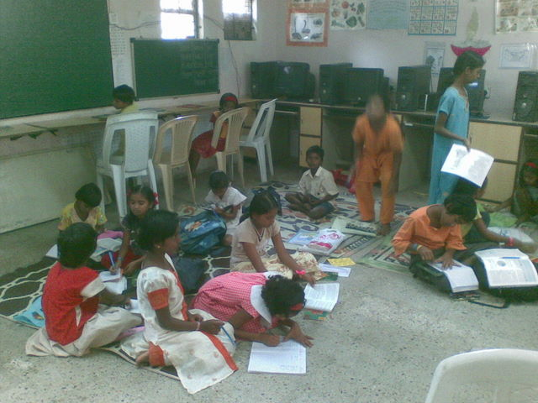
The 2nd standard and 1st standard study class was being conducted on the first floor. Due to restrictions by the society of having any permanent material on the first floor the room is bare, but adequate for the study class.
Study Class 1st and 2nd standard
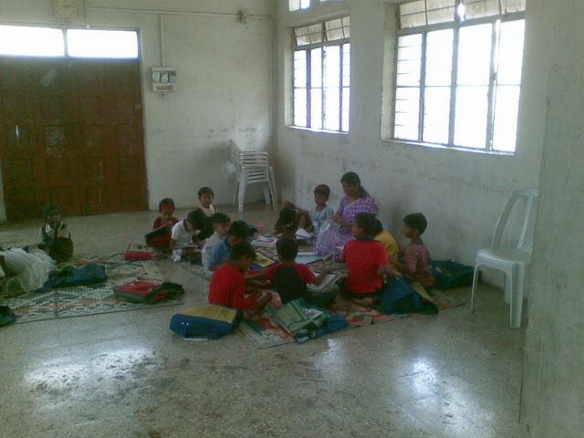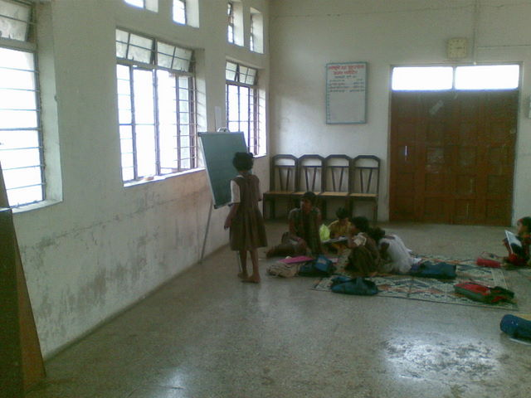
Ganeshmala location
Ganeshmala is a low income community adjacent to Sinhagad road, about a kilometer from the Dattawadi study centre location. A room has been rented (Rs. 500) for conducting a study class. There is a single teacher who manages both the 1st and 2nd standard students, since numbers are small (there were about 12 students in total when we visited).
Ganeshmala classroom from outside and inside
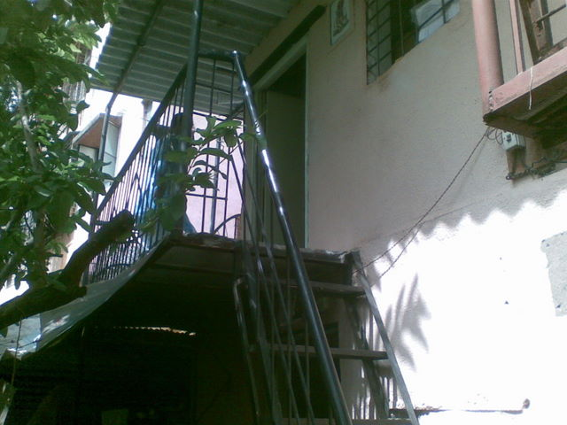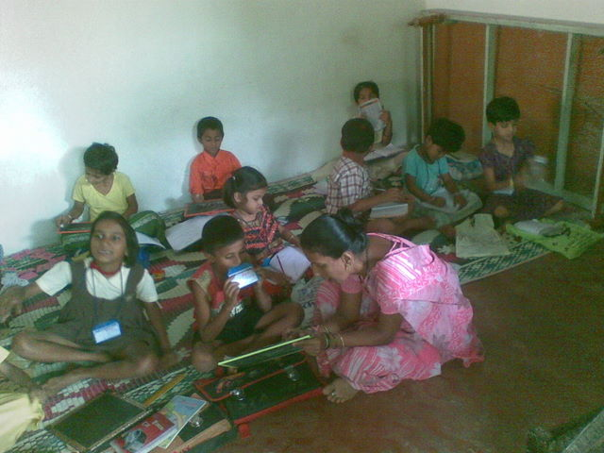
One of the problems faced by Door Step School is finding space in the community. In this case an attempt has been ongoing to get space in the local samaj mandir and anganwadi. However local groups who have a vested interest in controlling these spaces do not allow genuine groups like Door Step School access to them. The local corporator has not been cooperative. Some pressure needs to be created, perhaps by other persons, since these public buildings are meant for such activities but due to a lack of transparent process in the Municipal Corporation are hijacked by others.
The classroom rented by Door Step School was clean, airy and had good light.
Panmala location
We then proceeded another kilometer on Sinhagad road to the Panmala community. This is a fairly large low income settlement. Door Step School runs their study class in a small Samaj Mandir room. Large numbers of students make this room extremely crowded and teachers have hardly any space at all.
Panmala Community
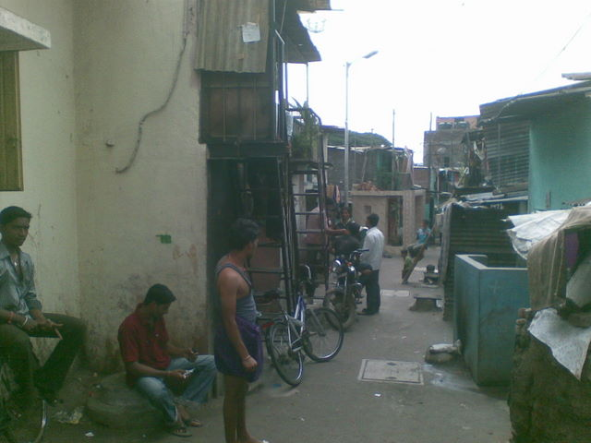
Most children study in the local Municipal school in Dattawadi (close to the main centre) but there are students who also attend private school. I was told that quality of teaching in private schools is probably no better than that in the Municipal school and all children display similar skill levels. A slightly older girl who does not go to school also comes to the study class.
Panmala classroom and crowded conditions inside
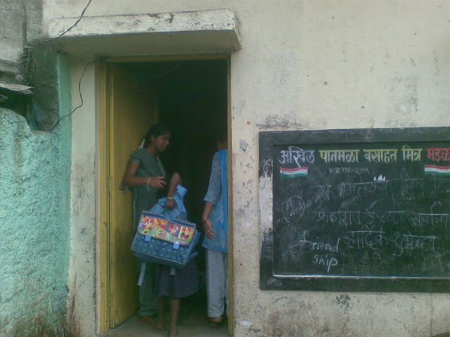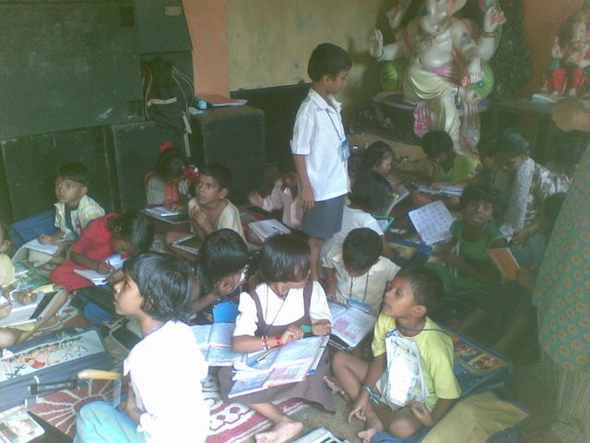
Local community is fairly supportive of the Door Step School activities.
Door Step School has always kept accurate records and the attendance register accurately reflected the students in the class and reasons for absenteeism. The early monsoon season is always a time when children fall sick and hence attendance suffers. This is seen throughout Pune. The poor levels of hygiene in the city (even a so called “better” city like Pune) are yet another impediment to better education.
The activity in the class was as per the activities schedule.
(See video on YouTube at http://www.youtube.com/watch?v=bjfJp3XQxMw).
Another concern is that children have to cross the recently widened and heavily trafficked Sinhagad road to go to school. So far the children have managed, but scant attention is paid by the authorities when planning these projects. If a child were to be involved in a mishap it may impact the attendance of children.
Conclusion
The Dattawadi Study Centre started with funding from the Asha Stars and has since grown in numbers and in activities. It plays an important role in furthering the goals of Door Step School in this region. It will now be sponsored by Tech Mahindra (which is also supporting many other activities of Door Step School). The Asha support thus played a key role in “incubating” this program and the fact that it will receive corporate support means that it will sustain and grow.

