PROJECT REPORT

Project : Sshrishti Learning Center
Date : 19th July 2012
Time : 8:50am
By : Sarika Malik (Sister of Viv Bhandari, Asha SV Volunteer)

My visit to Sshrishti Learning Center was a surprise visit. I called the centre 10 minutes before I reached. It’s inside Kishangarh village, so I took an auto to reach the site. When I reached there, I met Ms Roopali Singh, manager resource mobilization and Ms Sadhna, project coordinator.
The school has 5 classrooms, 2 for class 1 with around 20-25 students each, 1 for class 2 with around 10-15 students, 1 for class 3 with around 10 students and 1 computer room. The rooms were neat and clean with proper furniture. The students were in proper uniform and surprisingly well-behaved. They were conversing with me in English.
When I reached there, class 2 was going for their computer class. Then in the next class were class 3 students who were studying math at that time. The syllabus was apt for class 3 and they could manage to solve the sums given. Then I went to the computer room. There were 7 computers out of which 4 were working. So there were 12-13 students over 4 computers. Class 1 A was the cutest of all. The kids were interactive. Anjali and Jitesh sang a rhyme for me while Anjum Bano read a chapter in English.
The kitchen was neat. The kids are given milk and a mid-day snack there and the lunch is outsourced. Class 1B was upstairs on 1st floor. There are 3 washrooms. There were less students present in class 3, around 6-7, but I was told that some of them had gone for a holiday to their village, while others (around 8) have been promoted to Govt. or Municipal schools. The age group varies from 6 to 13 in this class. There is an inverter backup and a water generating motor.
There is also Sshrishti Ladli Centre nearby where younger kids come to kindergarten.T here is a library with an arrangement for audio visual programmes where kids from SShrishti Learning Centre also come.
Over all very nice set up. However, I feel that though some teachers seemed quite good, others could be a little more well versed. They also hold evening classes for the brighter students who wish to take some extra coaching. I’ve taken some pictures which I will send soon.
PS: Ms Roopali was looking for full sponsorship for Sshrishti Learning Centre and Sshrishti Laadli Centre. So she requested me to put across the message. Kindly consider.
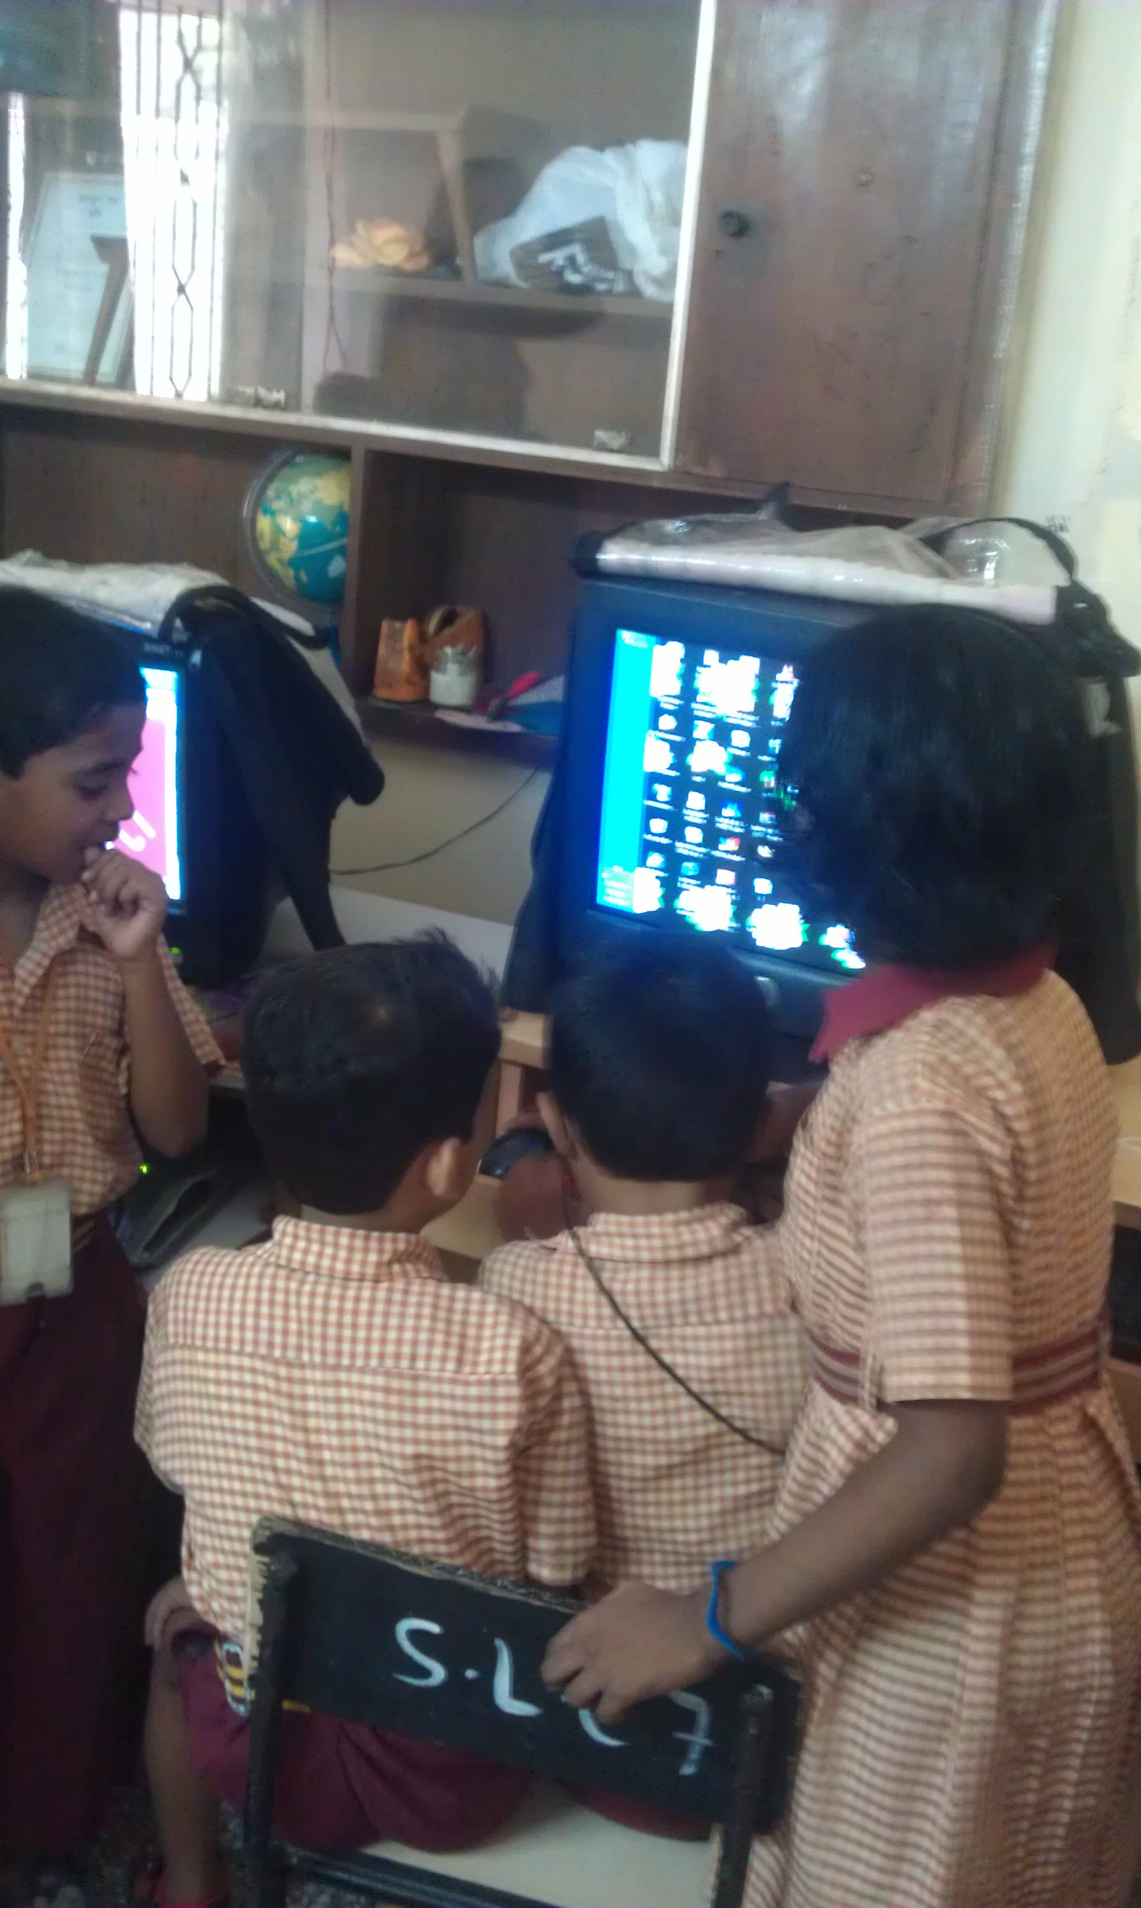
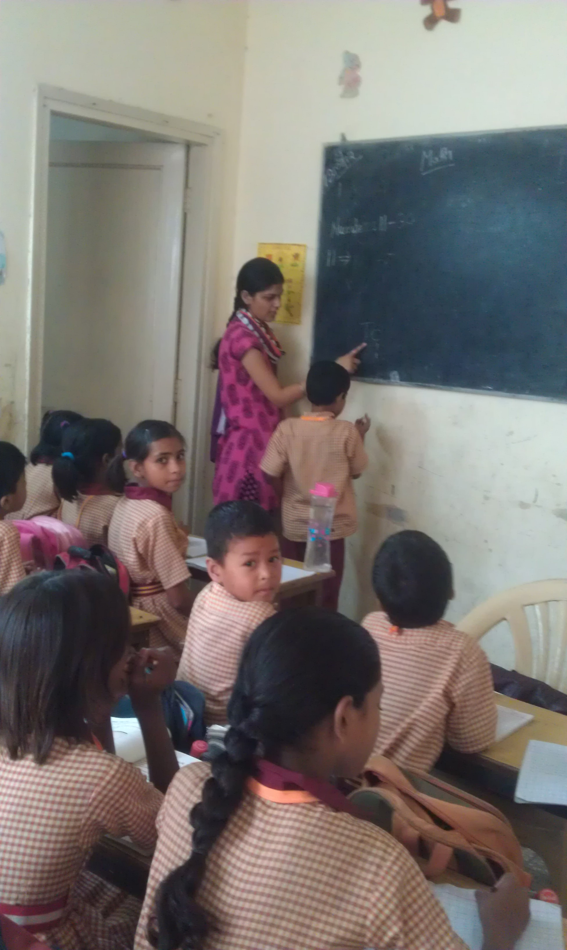

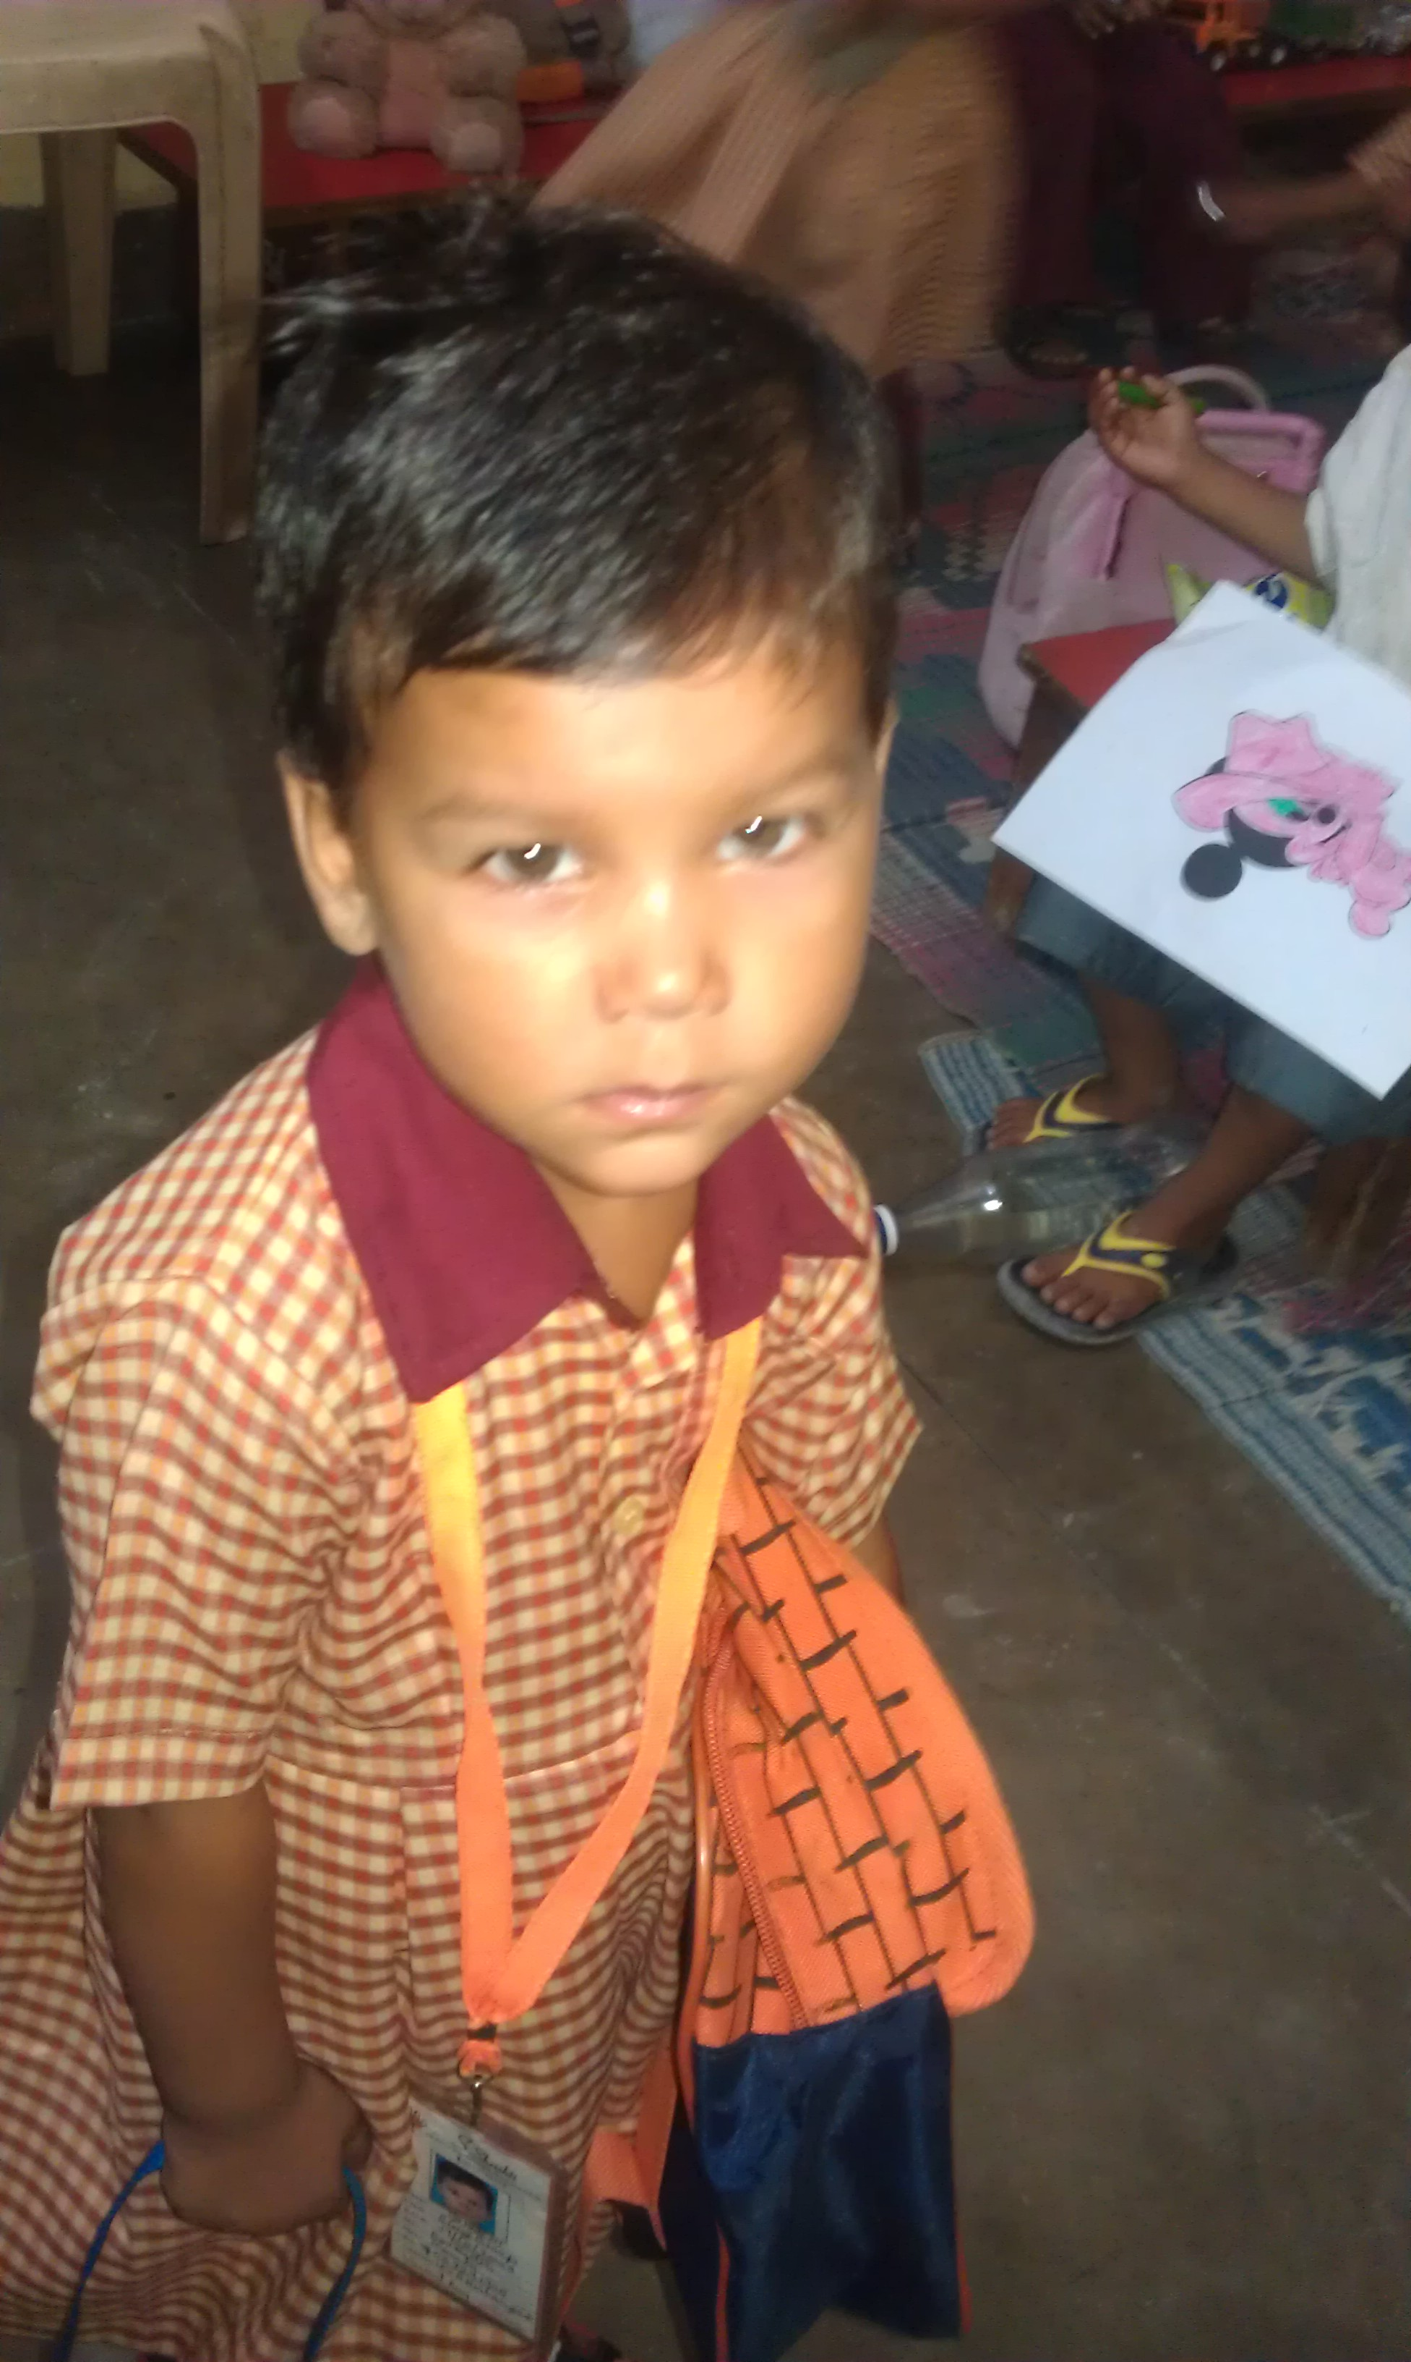 | 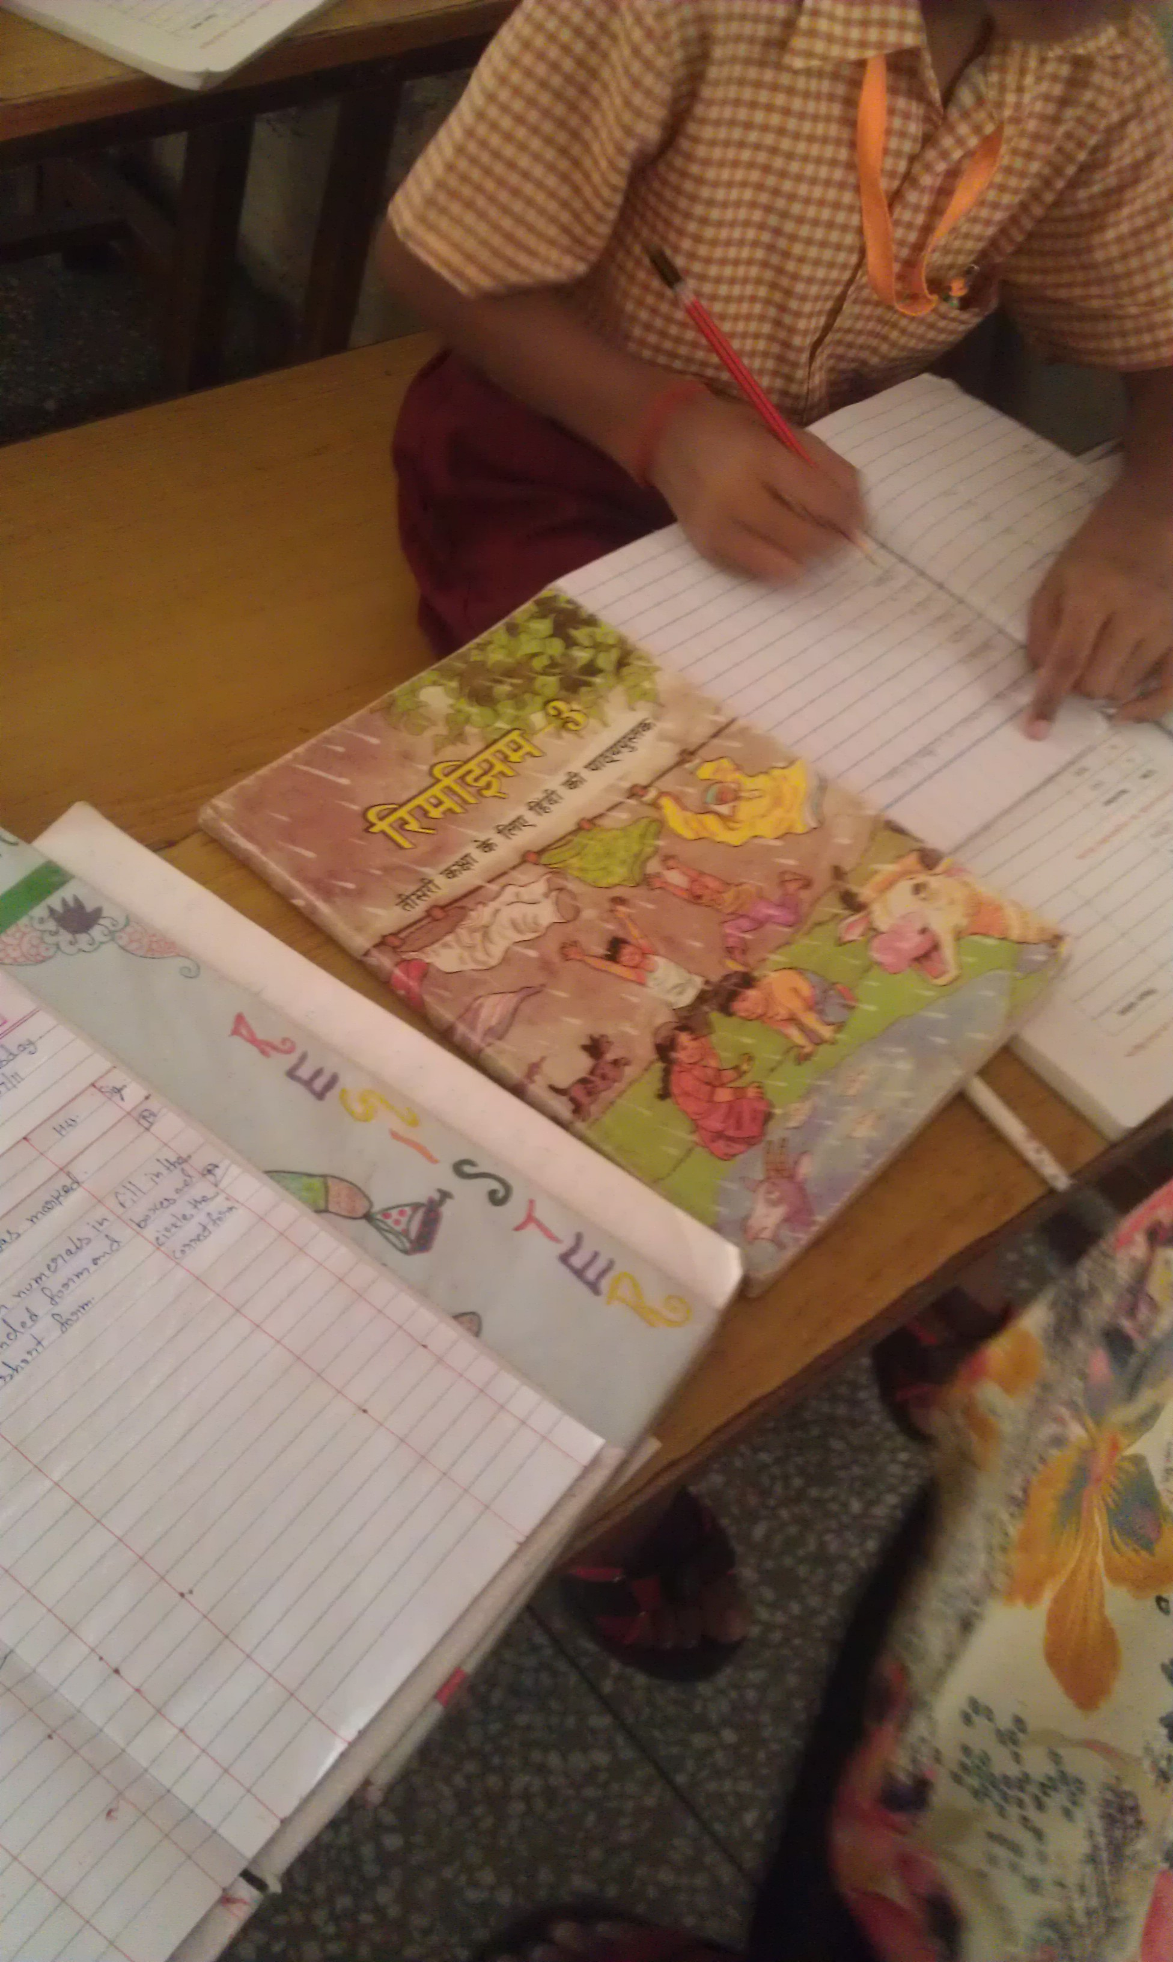 | 

