Betsy Elizabeth trust: Site visit Report

I landed in kodaikanal on Saturday morning, 13/05. The ride to Ann ‘s house was by taxi. Her house was situated atop the coakers’ walk, known for its spectacular view of the valley, well, the view was spectacular. Didn’t have much time to enjoy the spectacular view, because people were waiting for me at 3 of the crèches. Ann had made sure that I was going to be able to meet a fair amount of kids, teachers and even a few parents/grand parents. Ann and Hilda Isaac, an Indian lady who heads the board of directors of the Betsy Elizabeth trust, accompanied me. Ann is the only non-Indian board member.

The first crèche we visited was the Peach Tree crèche. This crèche is about a 15-minute hillside drive from the main kodai town. It was a small brick house that was being used as a crèche. The house was owned by one of the locals. She was also the cook for the crèche. This school had a dalit village adjacent to it, from which most of its students came. For students that stayed further away, the crèche’s jeep arranged for pick-ups.

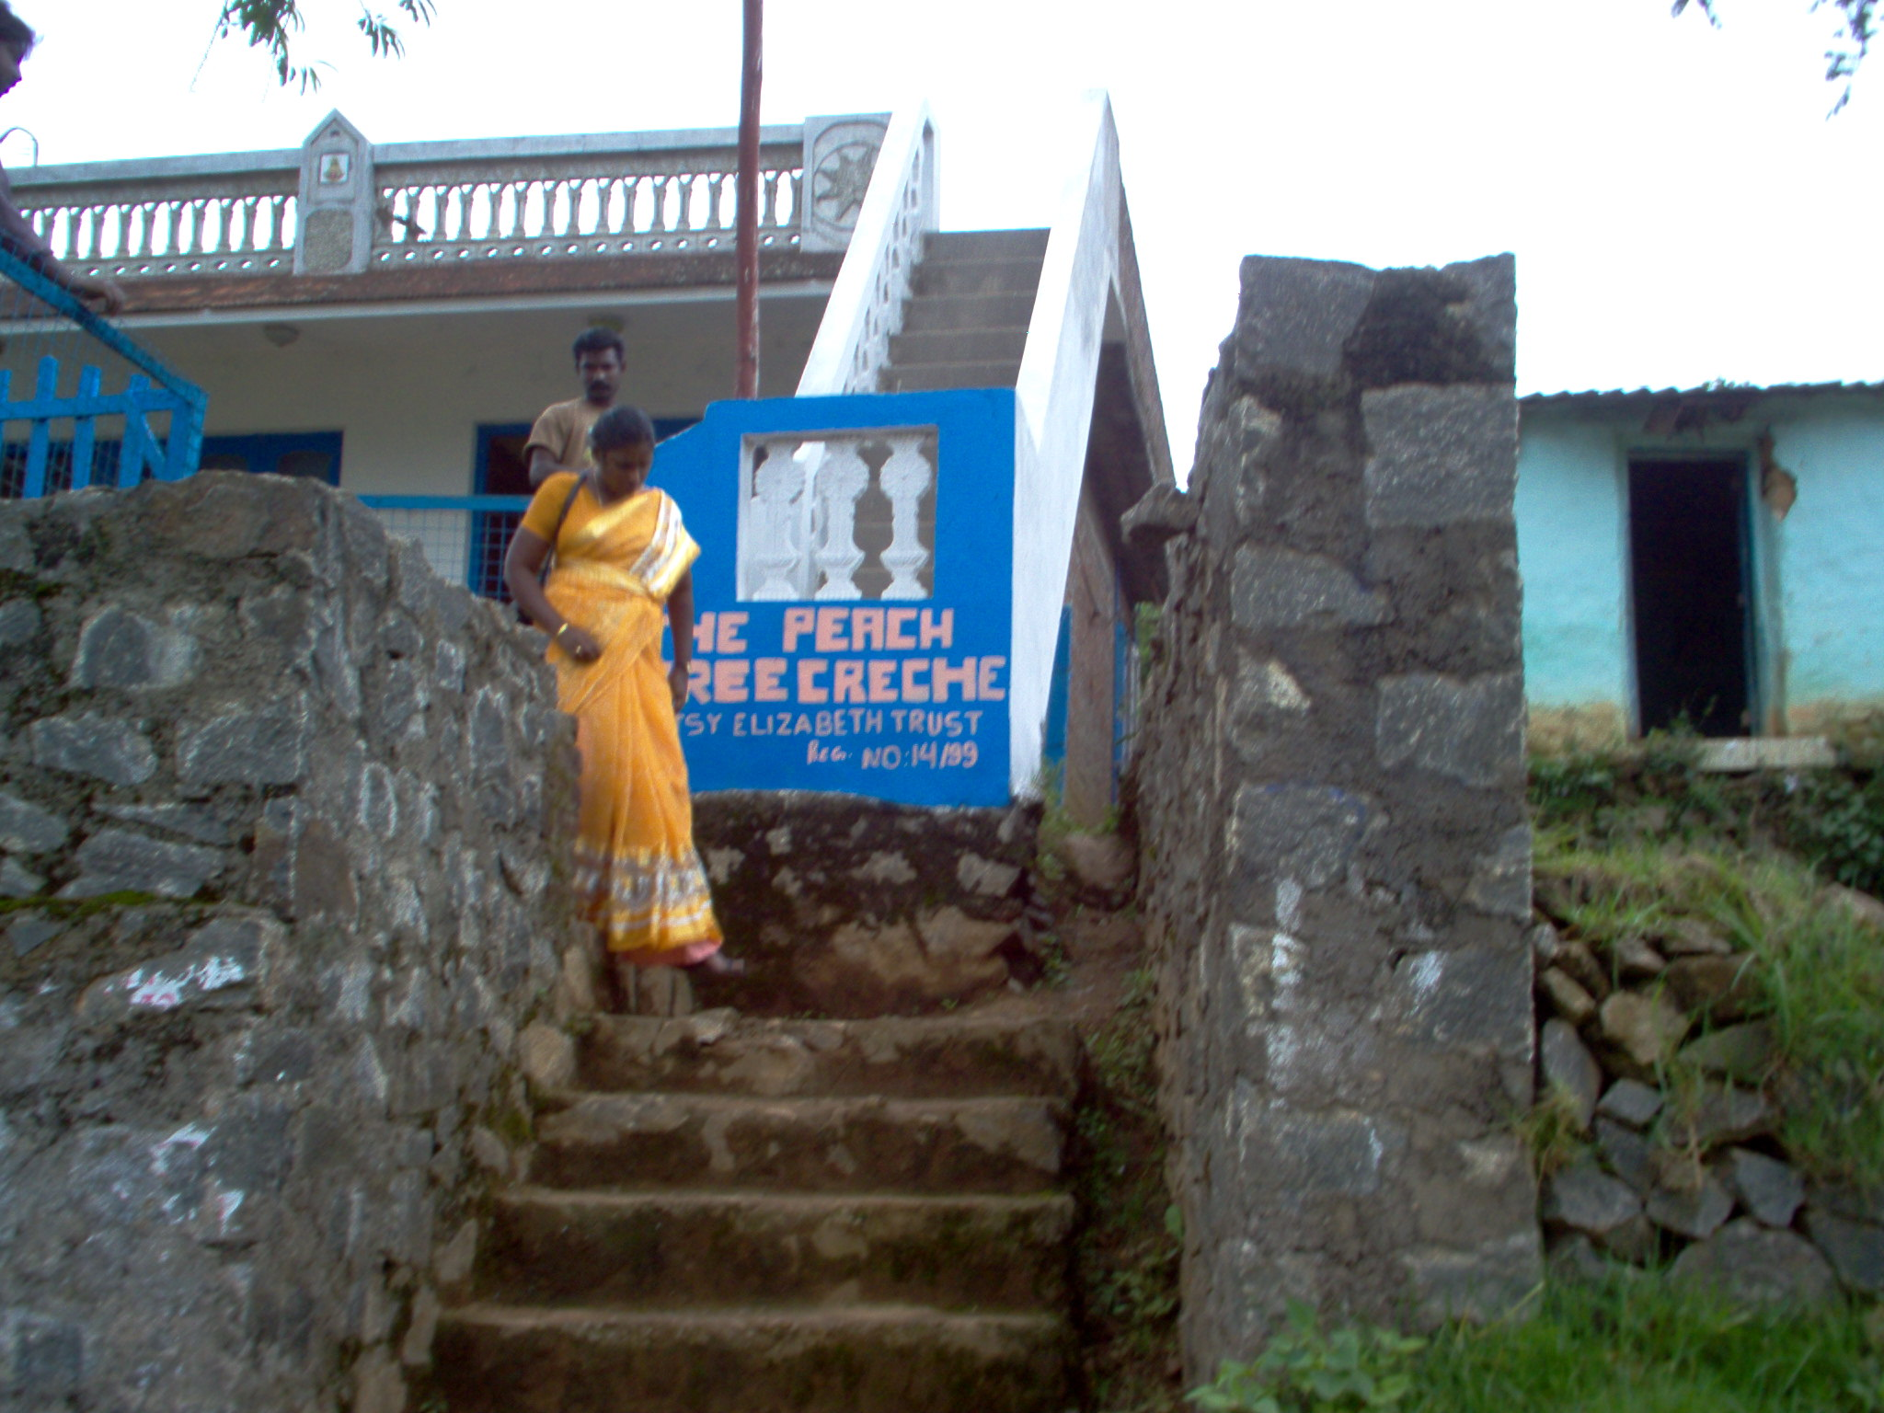

Next we visited the Little Lilies crèche, which was about 5 to 10 minutes from the peach tree crèche. This crèche had students from two villages, one adjacent and another one about a mile away. The crèche arranged to pick up kids from the second village.
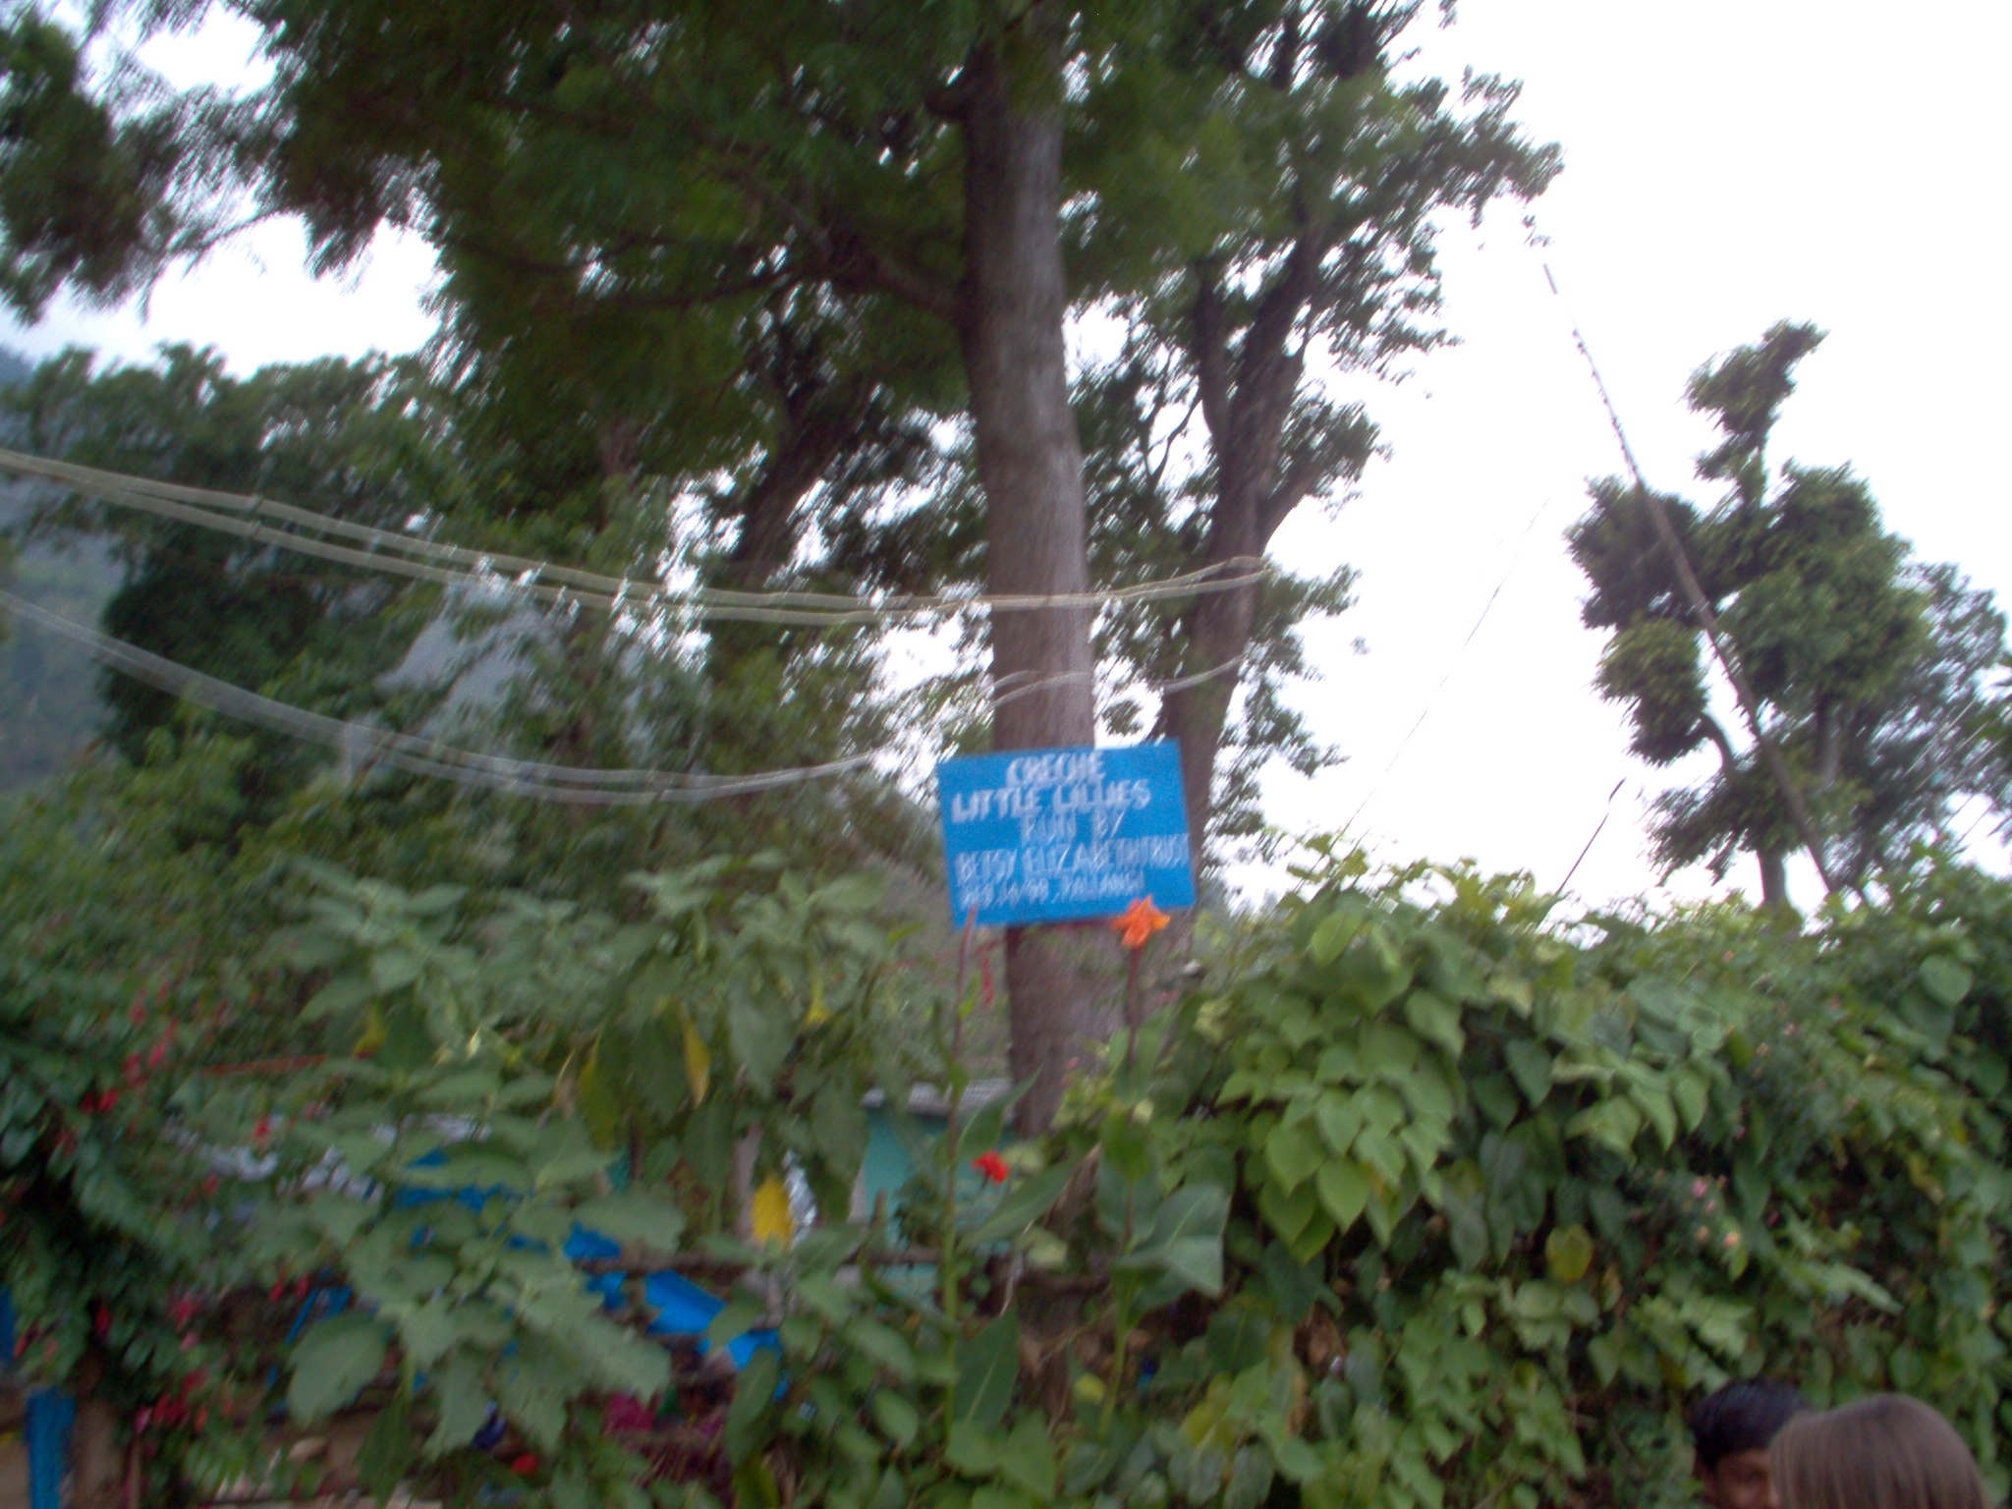

The third crèche I visited was the Grace kids centre in kodai. This was the first crèche that was established and by far the biggest of the three I visited. It had a large play area, with swings, seesaw and a slide.

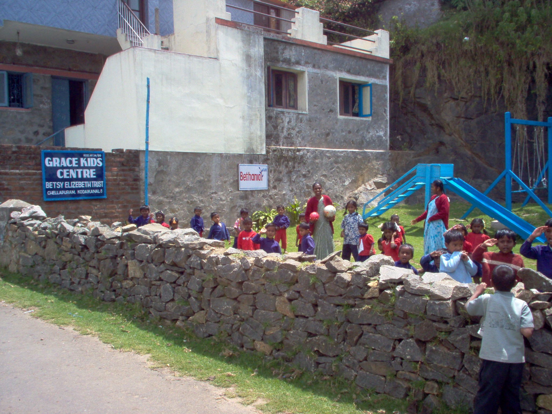

Ann had arranged for some of the kids and teachers to come for my visit. It was good to be able to see some of these kids playing, reading etc. There were also toys, such as a wooden pony for the kids to play.

There were some really impressive ideas that the crèche had implemented; I’d like to call them out here. (Most of these were applicable across the three crèches that I visited. In cases where it is specific to any one, I’ve mentioned it)

- The Health chart that was prepared for the whole class of students. They used this to monitor the height, weight and arm of each child, on a monthly basis. On this basis they took any kid who’s health was deteriorating (based on these parameters) to the doctor. The chart also gives an idea of the typical age group of the crèche , 3-5 years , although the have some children after 2 odd years in some of the other crèches.

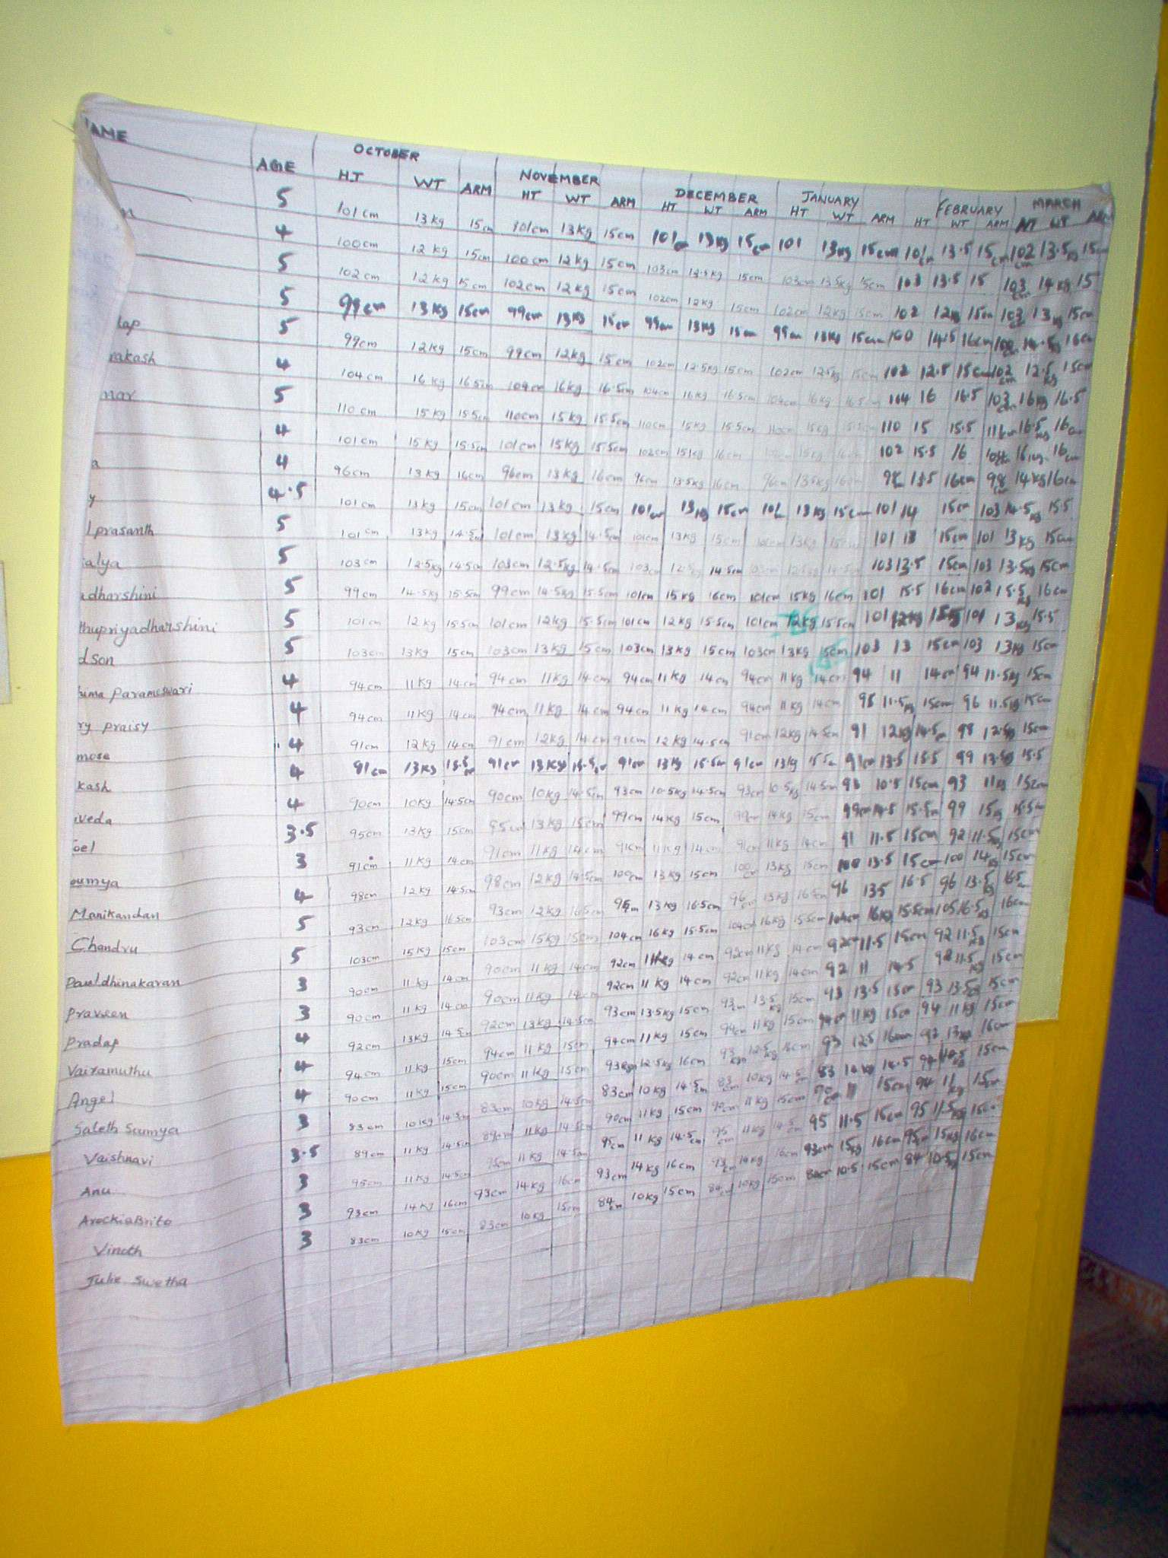

- Another novel idea was putting up fairly large sized pictures of all the children in their classrooms. This in my opinion was a very good confidence building measure among the children, making them feel important and wanted.
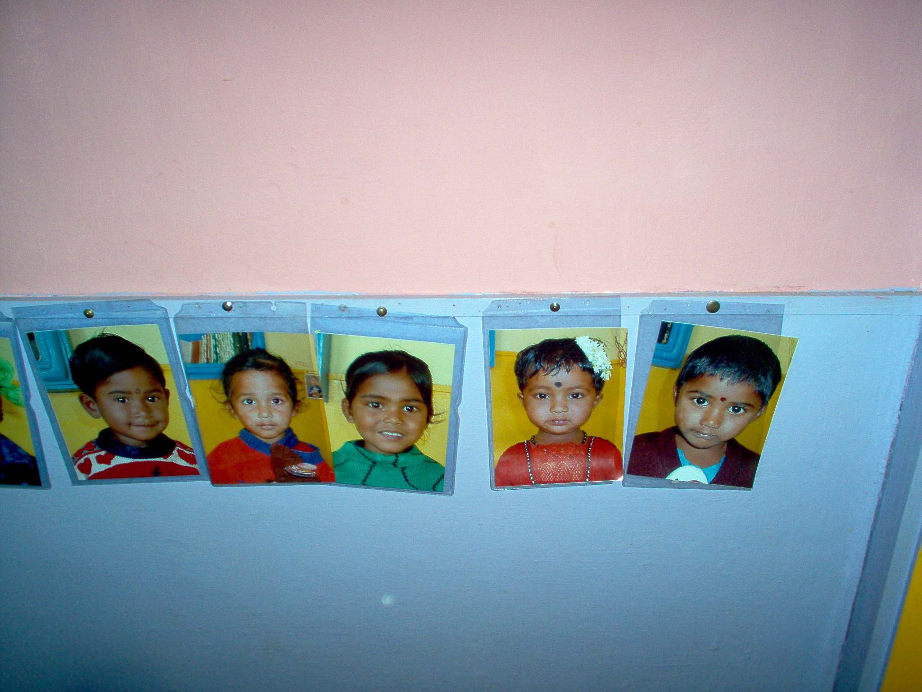

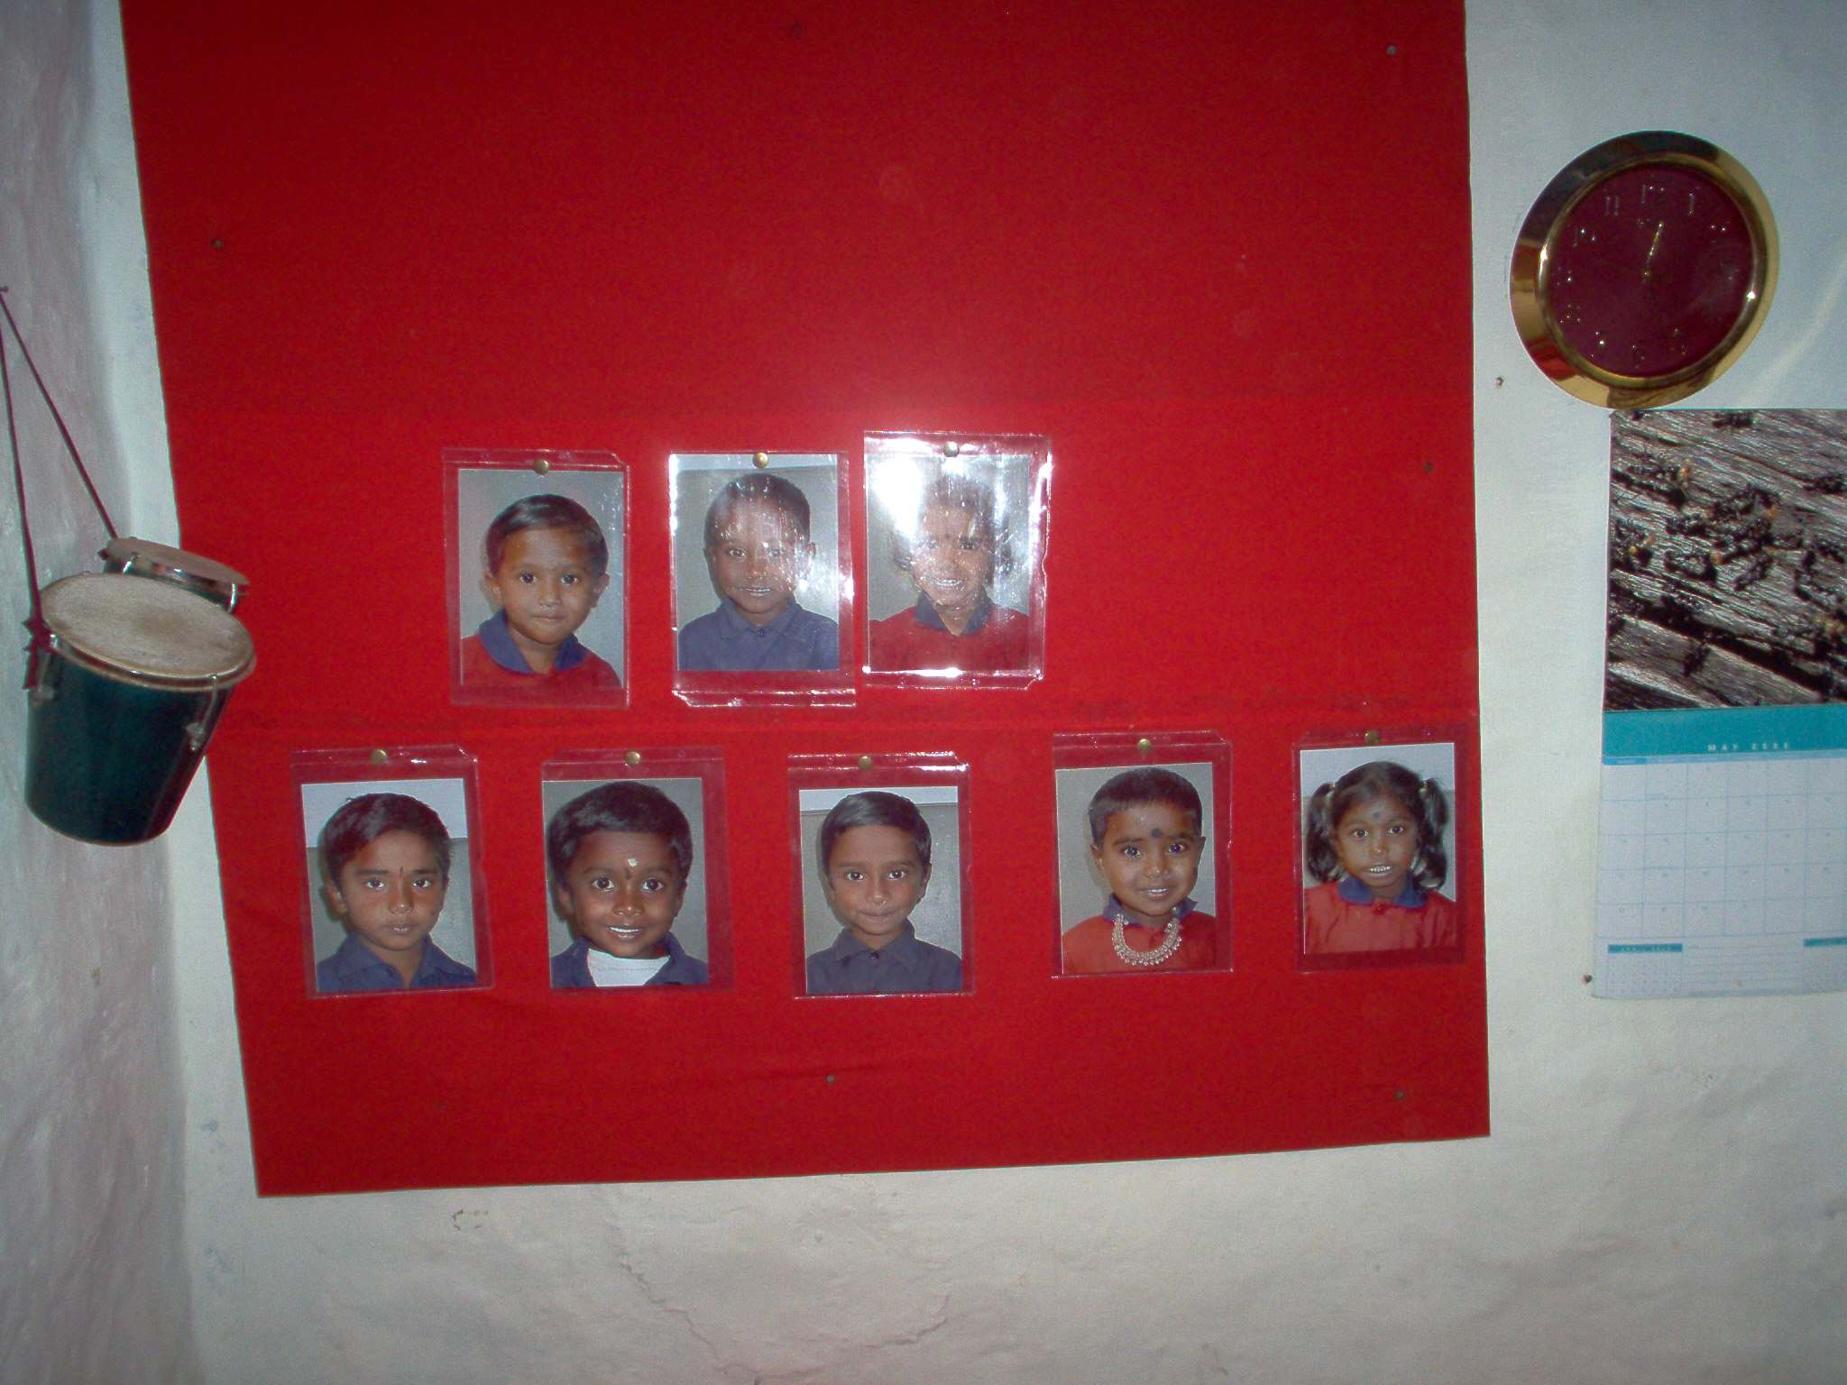

- The kids are provided neat newly stitched uniforms every year, which they would not be able to afford under normal circumstances.

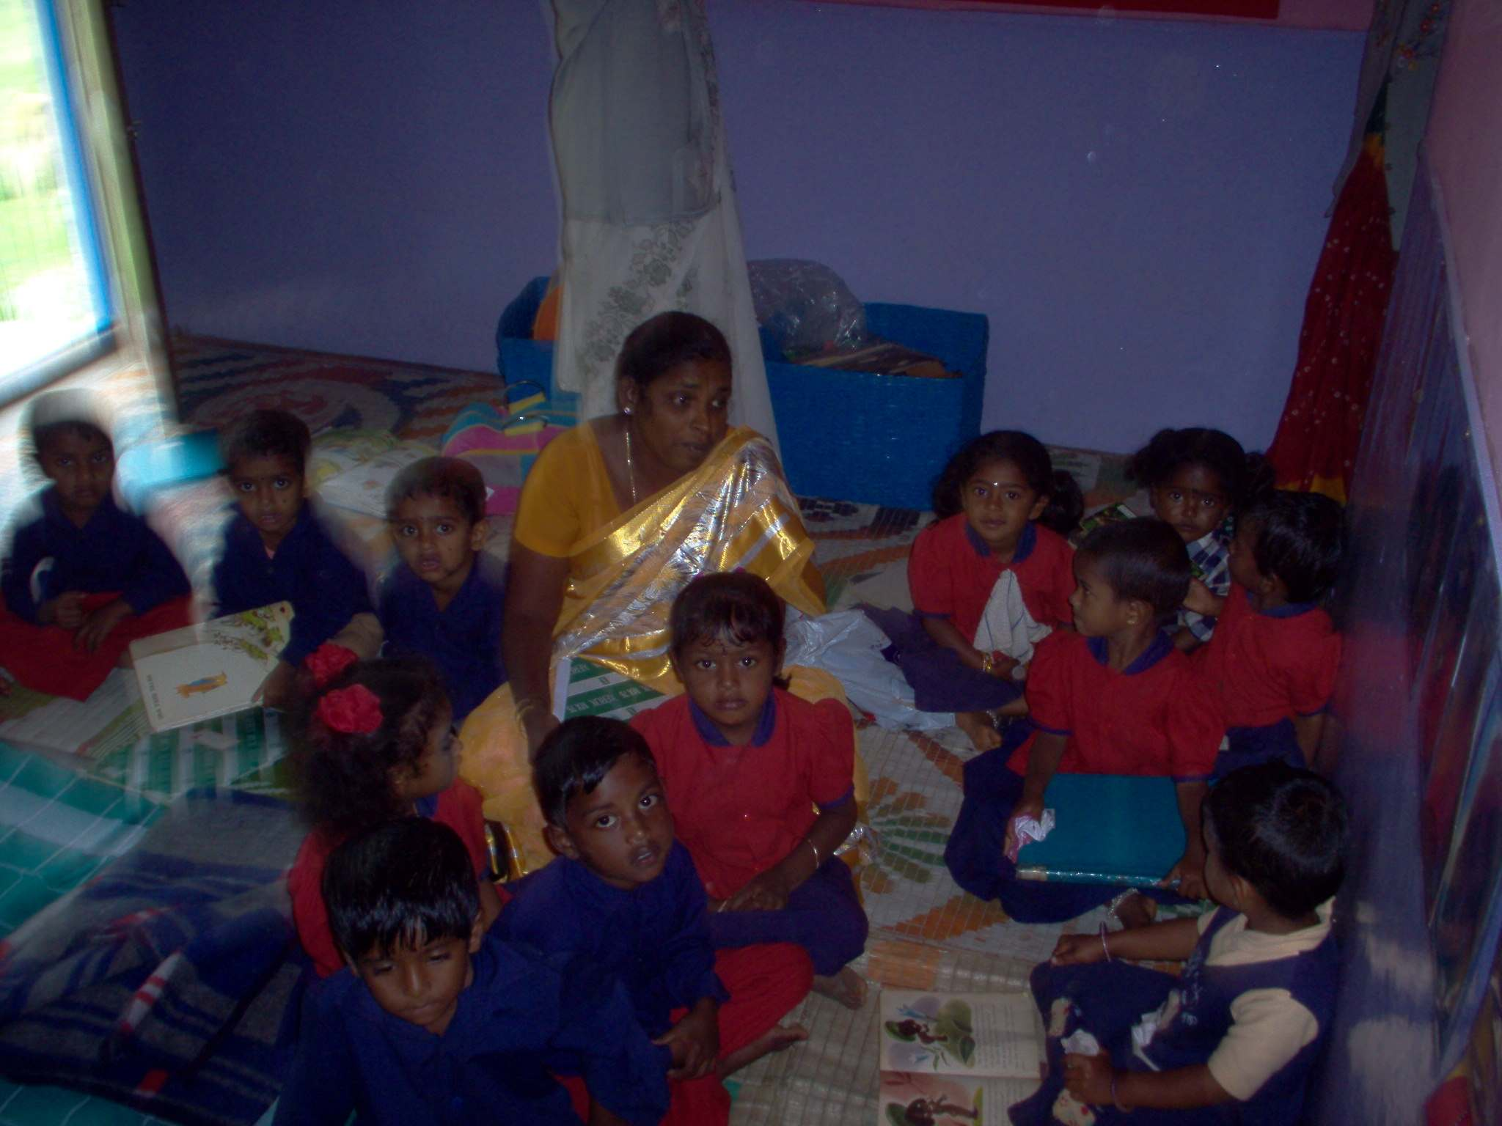

- All the centers had a very clean kitchen and the utensils looked new and clean. Of course since this was summer they may not be frequently used, but overall the kitchens were very good.

  - They use pressure cookers
  - They have recently purchased two gas stoves in the kodai centre, for faster cooking.
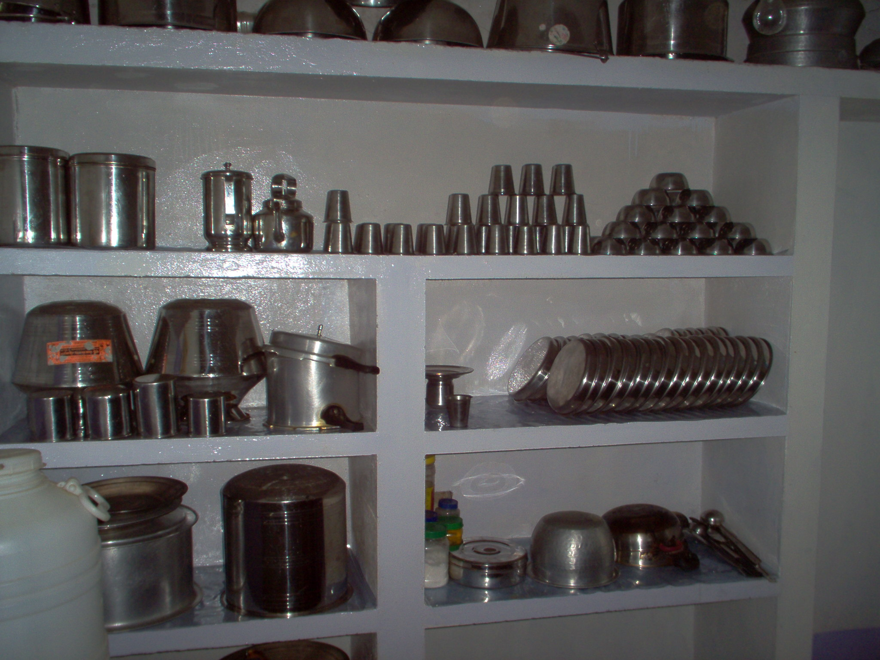
- The have a very good collection of learning aids. Most of them are wooden, and are pretty expensive. The quality and condition of the books was also very good.

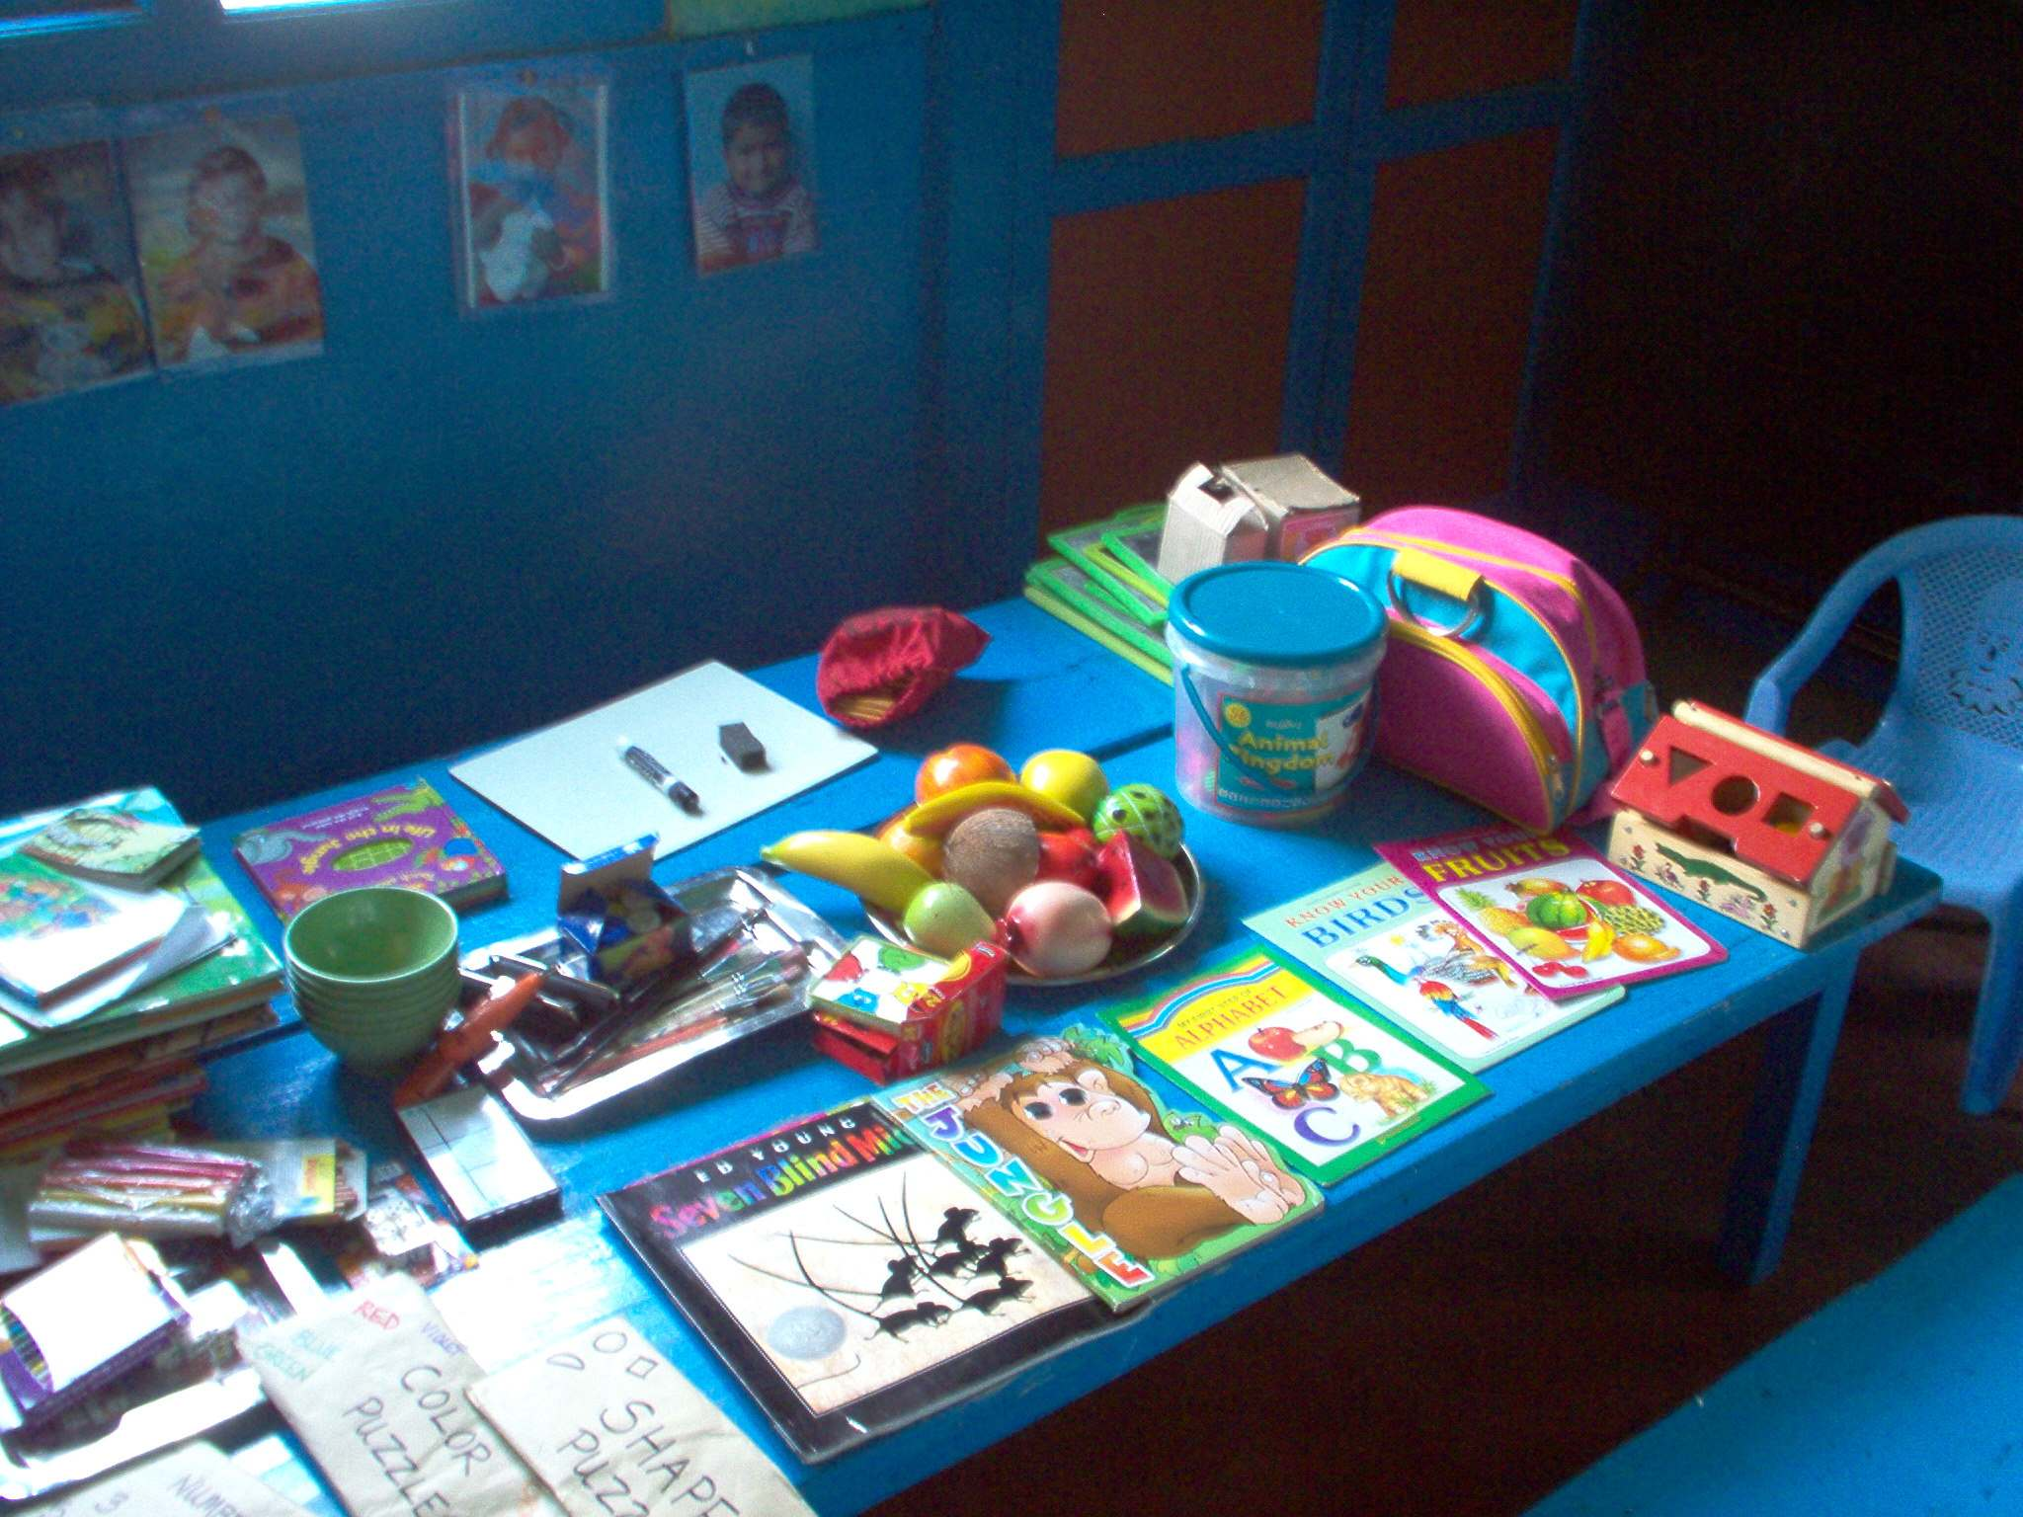

- The seem to lay good emphasis on General hygiene, the toilets were very clean , and had running water. All the kids had their own toothbrush , they come in the mornings and brush at the crèche.
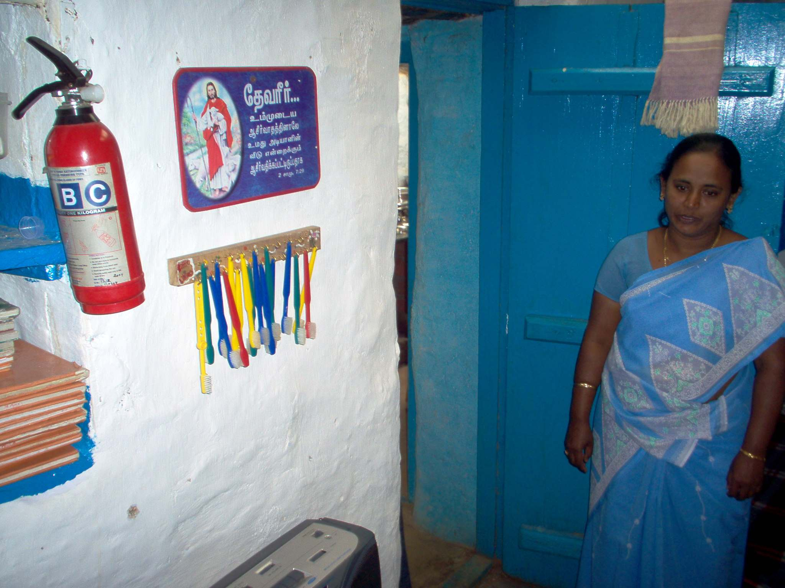
Some notable points: (I have put in stuff that I remember, I can add if more clarifications are required)

- They recruit kids from the nearby dalit villages. Hilda personally goes to the villages and handpicks the kids, mostly between 3 to 5 years. She tries to pick the most needy kids from the street into the crèche, but usually not at an infancy stage.

- Most children live with their parents/grandparents, who are not able to adequately provide food and clothing.

- The School provides 3 meals a day, with high protein content. Kids look quite healthy.

- The graduates from the crèche apparently top in the corporation schools, which they join for STD 1. This I heard from the teachers and the parents.

- The kids look very confident and smart, and were willing to talk freely and answer some of my questions (just general ones, like do you like to go to the doctor etc..).

- The family of Ann Peck (one of the trustees) goes to the same doctor that treats the kids. That means the children get good healthcare.

- One of the teachers is a certified nurse and is capable of basic health care of the kids.

- Hilda, the director of the trustee board, is certified in teacher training and trains all the teachers in the curriculum at the start of the academic year.

- The trust has ensured that there is clean water, even while some of the adjacent villages do not.

- Although majority of the teachers, seem to be Christian, I cant see a major affiliation to any religion,. The children are from all religions (a lot of Hindu kids, some Christian and a few Muslim children as well).

- There was some talk about hiring a Muslim lady for teacher/helper position.

- The curriculum has a prayer hour, which is from the bible. I don’t see this as a serious concern because every school has some sort of prayer, and it tends to be from some religion or the other.

- Some of the teachers also come from very similar backgrounds as the children, and these crèches have become a good source of livelihood for them.

- The crèche also has a center for women (with some 5/6 sewing machines) to stitch clothing, but it is not being used due to lack of funds for material such as cloth, thread etc. Such sort of activity involving the society is deemed a requirement by the government.

- At present they don’t have a way to ensure that kids who graduate from the crèche go to schools outside.

- There was talk of trying to extend the meal plan to summers when the school is closed, because the kids don’t get much nourishment at home during that period. I did see some kids, who had hurt themselves and hadn’t been attended to. The crèche in session does take care of that kind of stuff.

- I heard about one boy who actually had a variation of leprosy, and didn’t get any care in the villages. The crèche management apparently helped send him to hospital for treatment. (this is hearsay , I was told this when I was in one of the schools, can’t confirm).

- Generally the accounts seem to be very well kept; they were more than willing to show me all their accounts. I didn’t think I could anyway get much value/sense out of it, so I didn’t scrutinize. ( Hilda told me that the CBI visited them often, because the government is very vigilant on institutions with young kids in it. She said that they never had to pay a single penny as bribe because their operations were transparent and accounts clean. )

Overall I didn’t see anything that gave me a reason to be concerned about. It looks like they are doing a great job with the kids that they enroll. They want to enroll more, but have to turn some down due to inadequacy of funds. They seem to have space to accommodate more children.

The fact that kids graduate from here and TOP their classes in school is an amazing thing. They are able to impact the children at the right age and give them the confidence to face the world. Some of these kids may not go all the way to complete high school, but they take a lot out of this program. I believe there are some very good things here that we can learn from, and spread to other programs.

On a personal note, with all this debate on reservations, when I saw these kids, I realized there could be no better solution than empowering these kids at such an earlier age , and just watch them take on the world!

- Sairam Rajagopal

