Asha Samajik Vidyalay Deoria/Kushinagar, UP

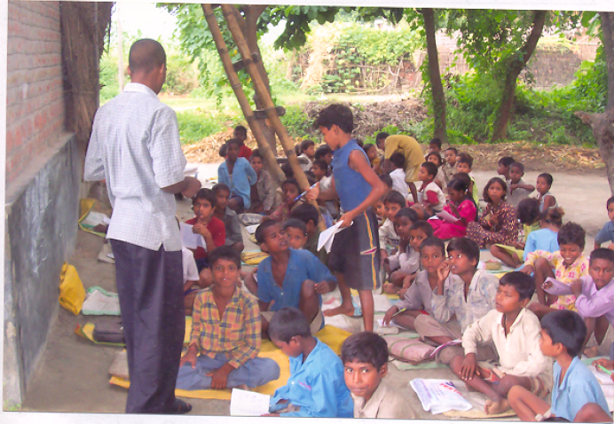

Asha Samajik Vidyalay Koiripatti, Deoria.

This centre is located at 39 km from the district headquarters on the border of Bihar and UP. The village has a primary school but located in a different block(?). The teachers don’t come on time there. The children coming to the ‘Asha samajik vidyalay’ belong to very poor family. Their family’s educational, social and economical condition is extremely poor. There is a junior highschool at 4 km from this center and an Inter college at 8 km. In the entire village there are 4 people with a graduation and 1 with a post-graduation degree. Among whom, 3 are volunteers in Asha school, the educational status of females in the village is negligible.

Condition of the school

Children from scheduled cast, scheduled tribe and backward class come to this center. The school runs from 6.00 to 10.00 am.

Economical condition of the village

People of the entire village are labors. They are farmers of low class. Wine is also made in the village. There is a section of the village (majra) where people make, sell and consume wine. Asha volunteers have been working to help them in getting rid of this addiction. The people of this ‘majra’ don’t have any other source of income. This is an extreme backward village.

Note
The center also includes one batch for those children who have discontinued education or can’t continue due economical pressure. There are 18 such children including few girls also. These children are being encouraged for further education. Basically, small children are being educated about human values. Girls of the age of 10-19 are being united and educated.

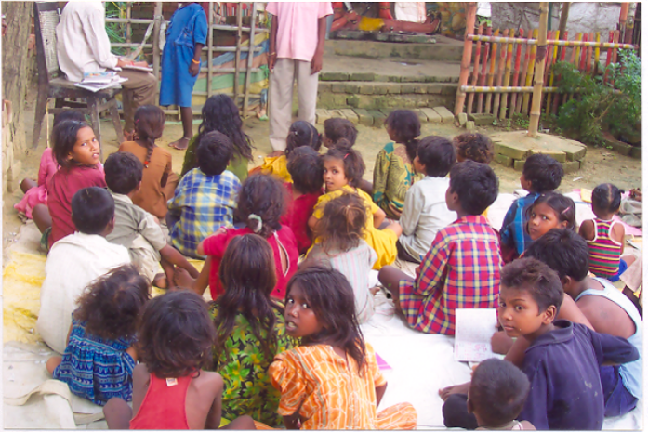
Koiripatti Center

The state of the teachers in the center

In this center, volunteers belonging to scheduled caste, scheduled tribe and OBC come to teach children who belong to extremely poor families. Agriculture is the main source of their livelihood.

Goals:

1. Bring about socio-economic change through education and self sufficiency.

2. To educate hundreds of illiterate girls in the age group 10-19 and admitting them into schools and atttempt to make them self-sufficient.

3. Giving technical and vocational training to three handicapped volunteers attached to the organization so that they can earn their own living.

4. Using Education and self-sufficiency as a medium to make the whole village educated and self-sufficient.

Village: Koiripatti
Development: Pathardeva
Constituency: Deoria, Uttar Pradesh

Number of families: 152
Total population: 1141
Number of males: 586
Number of females: 555
Families of scheduled caste: 20
Total population of scheduled caste: 142
Families of scheduled tribes: 25
Total population of scheduled tribes: 163
Families of OBC: 107
Total population of OBC: 136
Illiterates: 530
Children in the age group 3-5: 74
Children in the age group 5-6: 59
Girls in the age group 10-19: 112 (40: Literate, 72: Illiterate)

Class-wise distribution in the school:
- Children in the age group 3-5: 45
- Children in the age group 5-7: 53
- Children in the age group 7-10: 29
- Children in the age group 10-15: 18
Total number of students: 145
- Children are not charged any fees for their education.

Asha Education center near District Magistrate’s house in Deoria
People in Deoria, who don’t have any other place to live, live here. There are 31 families in all. All the families belong to scheduled caste, scheduled tribe or OBC category. Major sources of their livelihood are cleaning roads, selling vegetables or working as a laborer. They live on the floor of the Municipal Corporation with just a temporary roof over their heads. Most of the female members in these families work in rich people’s house. All the children in this place are far from any educational center. Still some children manage to go to primary schools provided by the government. Parents of these children are mostly illiterate. Two female Asha volunteers are trying to educate these children. This center works from 3 p.m. to 6 p.m. Women are also being educated in this center.

Total children: 73
Total families: 31
Boys: 40
Girls: 33
Behind the District Magistrate’s house

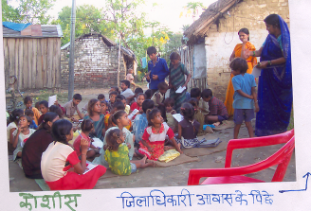
Center Behind District Magistrate House

Asha Educational Centre - Bhukampur Road and Badahara, Deoria

On the bank of the road between Deoria and Bihar and on the borders of Bengal, the people of Janpath Khagaria have established their make-shift homes (plastic ka chappar homes!!) from several years and live like refugees. Their main occupation is either manual labor or beggary. The number of families residing here = 17 and the total number of children = 37. The Asha centrer runs from 1:00 PM to 5:00 PM.

About 2 km from the Bhukampur centre, next to the drainage canal, residents of Samstipur, Bihar have make-shift homes. The number of families here = 47. These people make their living by lifting sacks of cement at the godawn at Deoria Railway Station. They are illiterate and have no means to get education. In order to educate the children of these residents and make them a part of the civilized world, two Asha volunteers run a centre. The centre is open from 8:00 AM to 12:00 PM. The total number of children receiving education here = 93.

- Bhikampur Road Centre: No. of children = 37
- Badahara: No. of children = 93

Asha Educational Centre – Sekhvaniya, Kushinagar
The Musahar community people live here. Their living conditions are far worse than Adivasis. Their food source is the fish and (Ghenga?) from the drainage canal. The Musahar people do not have any lands and are totally cut off from the world. Education is unkown to them. The total number of families residing here = 150. Through four Asha volunteers, 2 centres have been established. The first attempt of these volunteers is to kindle an interest and liking towards education among the children. The whole village is involved in brewing, selling and drinking alcohol. Most of the children are vulnerable to malnutrition.

With total number of children in the centre being 200, the Asha volunteers have taken the challenge of education is this village.

Ramanand Kanya Junior High School, Malhani, Deoria
(Very poor translation … Couldn’t understand much of it)
Children of Dalits and backward community attend this school. The parents of these children are primarily small farmers.
The total number of children here = 141
School runs from 8:00 AM to 1:00 PM
This center uses U.P. education board curriculum.
About 30 % of the children are from extremely poor families. About 40% of the children who are farmers are sometimes able to pay the school fees. Remaining children are not able to pay the fees. The financial condition of the teachers in the school is also pitiable. The paltry sum of Rs. 1000 which is the total fees that the school gets per month has to be spent on children’s supplies such as slate chalk and other needs of the school.
Classes from LKG to std 8
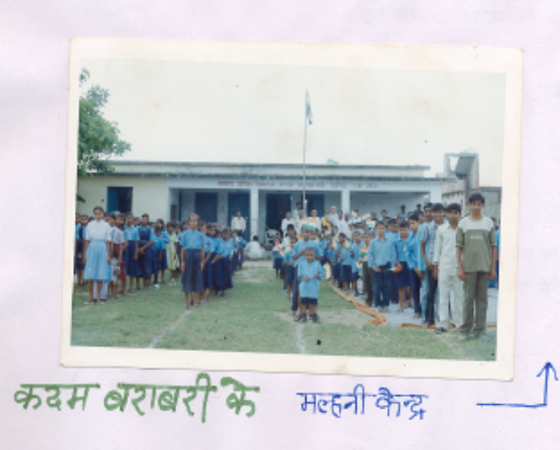

 |  |  |  |  |  |  | Annual (in Rs.)
# of teachers
Centre |  | # of teachers |  | Monthly |  | Total monthly
Koiripatti |  | 4 |  | 1000 |  | 4000 | 48000.00
Sekhvaniya |  | 4 |  | 1000 |  | 4000 | 48000.00
Deoria (3 centres) |  | 6 |  | 1000 |  | 6000 | 72000.00
Coordinator Salary |  | 2 |  | 2500 |  | 5000 | 60000.00
Teaching and Library materials |  |  |  |  |  |  | 40000.00
Children fairs and excursion |  |  |  |  |  |  | 10000.00
Black board, carpet and library furniture |  |  |  |  |  |  | 15000.00
Medicine |  |  |  |  |  |  | 10000.00
Play material |  |  |  |  |  |  | 4000.00
Coordinator travel and phone etc. |  |  |  |  |  |  | 10000.00
Salary for Girls junior high school teachers | 5 |  | 1000 |  | 5000 |  | 60000.00
 |  |  |  |  |  |  | 3,77,000.00

Number of teachers: 19
Number of centres: 7
Number of children: 609

Note: The number of children given above are those who attend the centres regularly. There are approximately 400 more children who are still not able to attend daily. We are trying to motivate them to attend the centres everyday.

