Progress report as well as the Site visit report of ASV as of April 1, 2008. Please note that all the information is merged here for review.
- Near DM’s Residence: Center Closed, all children are now studying at proper schools. Teachers are not teaching at nearby place in Mushar Basti. They are working on “Mid day meal” and “Eskimo” projects too.
- Mushar Basti (Sakhwania): Runs from 7 am to 10:30 am.
13 children have passed 12th standard, when they were taken in, they did not even know how to reply to simple instruction “bolo ka” , they would repeat the same.
They have also improved on clothing and living standards, it is a successful initiative as of now.
- Badi-tola (Anu-suchit Basti): Standards 1 to 5.
Children: Muslim, Scheduled cast and other backward cast.
Activities: Playgroup, Storytelling, they try to follow UP Syllabus.
- Mushar Basti (Doghara): One of the very backward villages, govt. help reaches here only in case of a catastrophe and/or death. Children suffer from malnutrition, there’s no education so there is one center running in the village.
Children are divided into three standards and are taught. (LKG+UKG, standard 1 and 2). They are taught counting, math tables, alphabets and simple words.
they study in winters under the sky, it’s quite cold then. Sangita Mishra maintains the center.
Out of 115 children, around 90 to 100 come regularly to center.
- Mushar Basti (Sisai Parastola): Children here are involved in grazing goats, catching “Ghengha” (fish like creature found in streams of water) and while their time around doing nothing.
Since the start of ASHA center, they have shown interest in the school.
Divided into four groups: LKG, UKG, standards 1 and 2.
LKG and UKG: Counting, math tables, alphabets
Standards 1 and 2: Addition, subtraction, recognizing alphabets and words in English and pronouncing them.
Some other activities are undertaken too.
Teachers: Harmendra, Krishna, Raaj-namdni, Radheshaym and Ramakrishna.
- Bhikhampur road: Children are now regular for school.
- Over bridge (Deoria): Children are involved in begging and picking up garbage. Their parents belong to state of Bihar. They are being taught.
- Ramanand Kanya Junior High School (RKJHS MALHANI): School is running regularly with standards 1 to 8. It is 30kms away from Deoria. This is a traditional school with benches, black boards and separate teachers for different subjects.
Time: 10 am to 4 pm.
Standard 1: Children were practicing mathematical tables on their own, with very little help from their teacher. (30 students)
Standard 2: Reading Hindi and pronouncing it properly. Addition and subtraction were taught.
Standard 3 to 8: Boy to girl ratio was around 60:40 in these classes. In all, there are 80 students distributed in these standards.
Teachers working here: Raghuvansh, Baby, Sumeet, Neelu, Seetu, Kusum, Ravindra, RaamPyaare Kushwaha and Barrister Sahani.
Activities: Painting, music, crafts (they are given home assignments which are submitted regularly) Students enjoy during meal time.
Students are being taught all subjects including History, Civics, Science, Math and languages.
This school was found to perform satisfactorily.
- Shivrajpur (Mushari-tol): Three groups: LKG+UKG, standards 1+2, standards 3+4.
LKG+UKG were taught counting, math tables, alphabets (Hindi and English)
Standards 1 and 2: These were reading books and improve upon their pronunciation.
Standards 3 and 4: They were studying Hindi, English, Social Sciences, Math and Science.
Teachers: Sangeeta, Rajmangal, Pushpa, Surendra and Premsheela.
Teachers were very enthusiastic and disciplined. Total 120 students at center.

News Paper Articles:
- Dainik Jaagran (December 18, 2007): One person died of hunger and similar reports are received from in and around Raibari area. Team including Keshav Ji went there and made some arrangements for grain and other necessary supplies for them.
- Amar Ujala: RTI filed by 30 people , combined effort of all the social service groups in region. (No date given!!)
- Reports showing the food and cloth distribution to the flood victims in Kushinagar area.
(3 reports of days around 24th October, 2007)
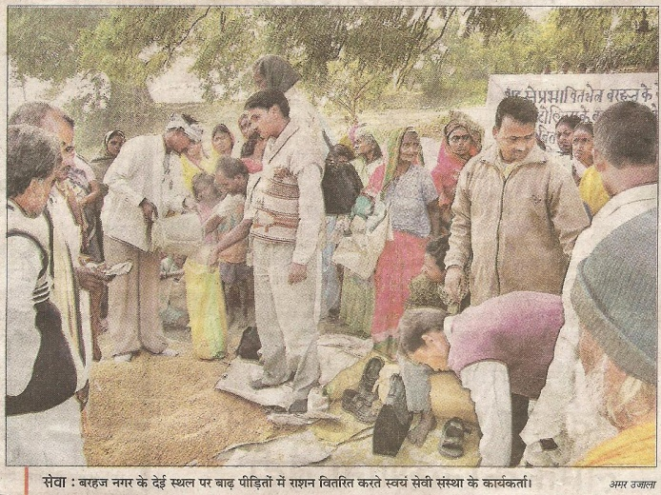

Some pictures showing schools in the Mushar Basti along with distribution of clothes from the funds released last year:



