Kids and Children list in Palanagars
Purak Poshak Ahar ( Palanagar) Project, Kotimal Tal. Jawhar started from 11.09.2008
Sr.No | Name of Student | Date of Birth | Age on Feb-2012
 | Newly Born child
1 | Asmita Ananta Lakhan | 11.6.2011 | 8 m
2 | Ashwini Navasu Achari | 15.2.2011 | 11m
3 | Prashant Vilas Bhowar | 23.2.2011 | 11m
4 | Balu Bandu Patara | 23.3.2011 | 10m
 | 6 month to 1 Years
5 | Balu Rustam Gotarana | 3.1.2011 | 8m
6 | Pinky Parshuram Gavate | 1.9.2010 | 1.5 Y
7 | Nandini Govind More | 22.6.2010 | 1.5 Y
8 | Prathamesh Manglu Chibhada | 20.7.2010 | 1.6 Y
 | 1 Year to 6 Year
9 | Bala Yashawant Baraf | 13.3.2010 | 1.11 Y
10 | Jagruti Babulal Savara | 9.3.2010 | 1.11 Y
11 | Bala Dilip Savara | 20.1.2010 | 2 Y
12 | Subhangi Suresh Hirakud | 10.8.2009 | 2.6 Y
13 | Pinky Ramesh Bhowar | 3.7.2009 | 2.7 Y
14 | Ajay Ananta lakhan | 9.3.2009 | 2.11 Y
15 | Sarika Santosh Pagi | 6.3.2009 | 2.11 y
16 | Haresh vishanu Surum | 14.2.2009 | 3 y
17 | Raman Vishanu Savara | 17.1.2009 | 3 y
18 | Pramod Vilas Bhovar | 10.12.2008 | 3.2 y
19 | Ravina Ramesh More | 31.12.2008 | 3.1 y
20 | Karina Babulal Savara | 26.11.2008 | 3.2 y
21 | Alaka Parshuram Gavate | 23.11.2008 | 3.2 y
22 | Dipali Kashinath Gotarne | 26.10.2008 | 3.3 y
23 | Gautam Govind More | 1.10.2008 | 3.4 y
24 | Karina Suresh Varatha | 5.9.2008 | 3.5 y
25 | Ranjana Vilas Gavate | 28.3.2008 | 3.10 y
26 | Manasi Yadunath Doke | 20.3.2008 | 3.10 y
27 | Nikas Soma Gavate | 29.12.2007 | 3.1 y
28 | Hritik Shantaram Doke | 4.7.2007 | 4.7 y
29 | Sujata Vishanu Suram | 17.6.2007 | 4.7 y
30 | Chetan Rustam Gotarana | 28.5.2007 | 4.8 y
31 | Pratiksha Mahadu Sathe | 20.2.2008 | 3.11 y
32 | Vikesh Ananta lakhan | 10.3.2007 | 4.11 y
33 | Mukesh Ananta Lakhan | 10.3.2007 | 4.11 y
34 | Chandana Ramesh More | 12.1.2007 | 5.1 y
35 | Ankita Yashwant Baraf | 12.1.2007 | 5.1 y
36 | Kunal Vilas Gavate | 17.12.2006 | 5.1 y
37 | Pratiksh Vilas Bhowar | 30.11.2006 | 5.2 y
38 | Pankaj Jayavanta Potinda | 28.8.2006 | 5.5 y
39 | Dyaneshwari Jayaram Gangode | 30.7.2006 | 5.6 y
40 | Shashikala Devaram Chibhada | 26.1.206 | 6 y
41 | Prema Vishanu Savara | 9.12.2005 | 6.5 y
 | Pregnant
1 | Ms. Shevanti Vishanu Savara
2 | Ms. Kala Suresh Hirakuda
3 | Ms. Shidavi Suresh Varatha

Purak Poshak Ahar ( Palanagar) Project, Dahavadpada Tal. Jawhar started from dt. 1.4.2008
Sr.No | Name of Student | Date of Birth | Age on Feb-2012
 | Newly Born child
1 | Karuna Manoj Dahavad | 15.7.2011 | 8 month
 | 6 month to 1 Years
2 | Ravina Gangaram Dahavad | 4.10.2010 | 1.4 y
 | 1 Year to 6 Year
3 | Rohini Chanrakant Dahavad | 23.4.2010 | 1.9 y
4 | Vaibhav Raman Lakhan | 6.4.2010 | 1.10 y
5 | Gangu Vishanu Bhoye | 22.10.2009 | 2.3 y
6 | Sulochana Monoj Dahavad | 17.3.2009 | 2.10 y
7 | Payal Dilip Kharapade | 22.5.2009 | 2.8 y
8 | Pragati chandrakant Dahavad | 15.6.2008 | 3.8 y
9 | Suvarana Manoj Dahavad | 20.7.2007 | 4.6 y
10 | Mohini Gangaram Dahavad | 23.6.2007 | 4.7 y
11 | Neha Dilip Kharapade | 24.4.2007 | 4.9 y
12 | Suchita Vishanu Bhoye | 17.1.2007 | 5 y
13 | Suvesh Inder Garel | 16.7.2006 | 5.6 y
14 | Vikas chandrakant Dahavad | 16.2.2006 | 5.11 y
 | Pregnant
1 | Ms.Rekha Sandeep Dahavad
2 | Vandana Raman Lakahn

Purak Poshak Ahar ( Palanagar) Project list , Pasodipada Tal. Mokhada started in 15 Nov. 2009
Sr.No | Name of Student | Date of Birth | Age on Feb-2012
 | Newly Born child
1 | Mahendra Madhukar Mahale | 1/18/2012 | 1m
2 | Dhiraj Gangadhar Mahale | 11/28/2011 | 2m
 | 6 month to 1 Years
3 | Girish chandar Kandade | 7/15/2011 | 8m
4 | Naresh sakharam Maule | 7/12/2011 | 8m
 | 1 Year to 6 Year
5 | Karan Madhukar Bagul | 11/4/2010 | 1.2y
6 | Hanuman Narayan Mahale | 10/28/2010 | 1.3
7 | Kalpana Vasant kandade | 7/26/2010 | 1.7y
8 | Riya Jairam Rade | 7/20/2010 | 1.7y
9 | Aditi Manohar Mahale | 7/6/2010 | 1.7y
10 | Shital Balavant Mahale | 3/29/2010 | 1.11y
11 | Sharayu kashinath Kanade | 1/16/2010 | 2.1y
12 | Nilam chandar Mahale | 1/12/2010 | 2.1y
13 | Puja Madhukar Mahale | 12/3/2009 | 2.2y
14 | Rahul Vasant Mahale | 11/15/2009 | 2.3y
15 | chetan Madhukar mahale | 5/19/2009 | 2.10y
16 | Jayesh Jaganath Mahale | 1/27/2009 | 3.1y
17 | Dhanashri Ashok Kamadi | 7/27/2008 | 3.7y
18 | Bagitara Dattu Bagul | 7/14/2008 | 3.7y
19 | Tushar Gopal Kandade | 7/14/2008 | 3.7y
20 | Rohit Gangadhar Mahale | 7/11/2008 | 3.7y
21 | Baluram narayan Mahale | 6/29/2008 | 3.8y
22 | Dipali Sakharam Maule | 5/2/2008 | 3.9y
23 | Yogesh Madhukar Mahale | 2/3/2008 | 4y
24 | Reshama Ramesh kandade | 1/2/2008 | 4.1y
25 | Sachine Kashinath kandade | 12/13/2007 | 4.2y
26 | Sagar Jairam Rade | 12/3/2007 | 4.2y
27 | Mayur Madhukar Mahale | 8/14/2007 | 4.6y
28 | Gayatri Manohar mahale | 3/23/2007 | 4.11y
29 | Rupali Parshuram kandade | 3/2/2007 | 4.11y
30 | Ganesh Vasant Mahale | 1/22/2007 | 5.1y
31 | Rukhamini Balavant Baraf | 12/12/2006 | 5.2y
32 | Dinesh Eknath Mahale | 11/3/2006 | 5.3y
33 | Neha Jaganath Mahale | 5/27/2006 | 5.9y
34 | Priyanka Madhukar Mahale | 4/12/2006 | 5.10y
35 | Dhananjay jairam Rade | 2/23/2006 | 6y
36 | Ashwini Vasant Kandade | 2/7/2006 | 6y

Documentation and pictures for Palanagars

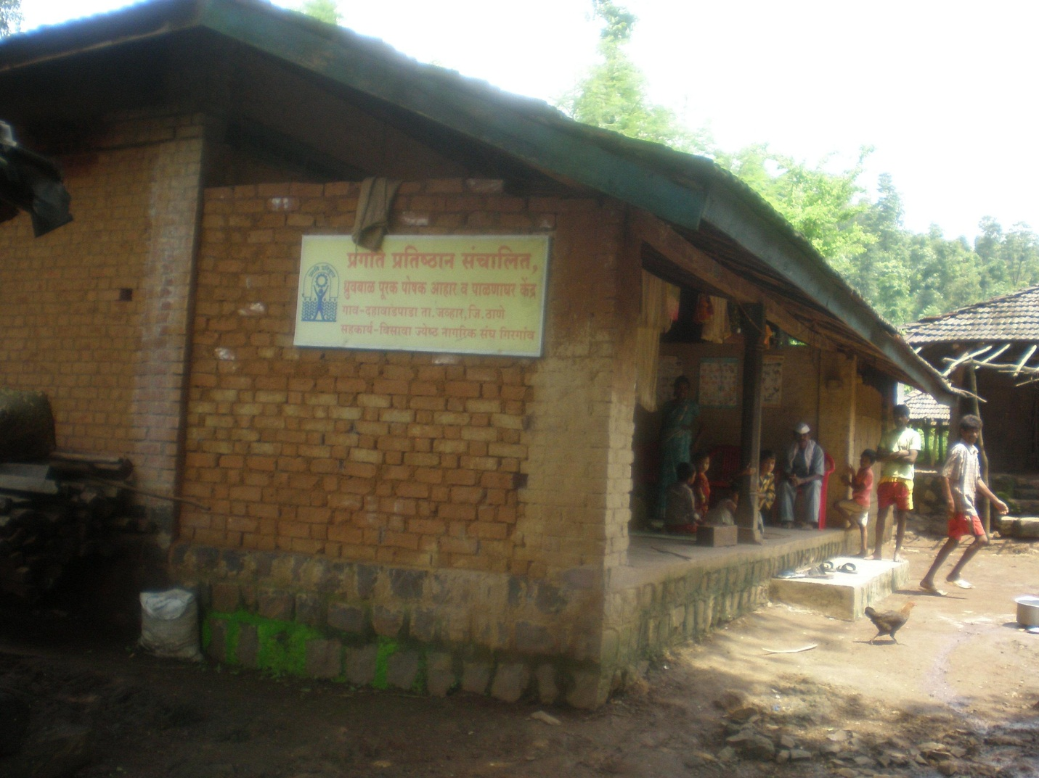
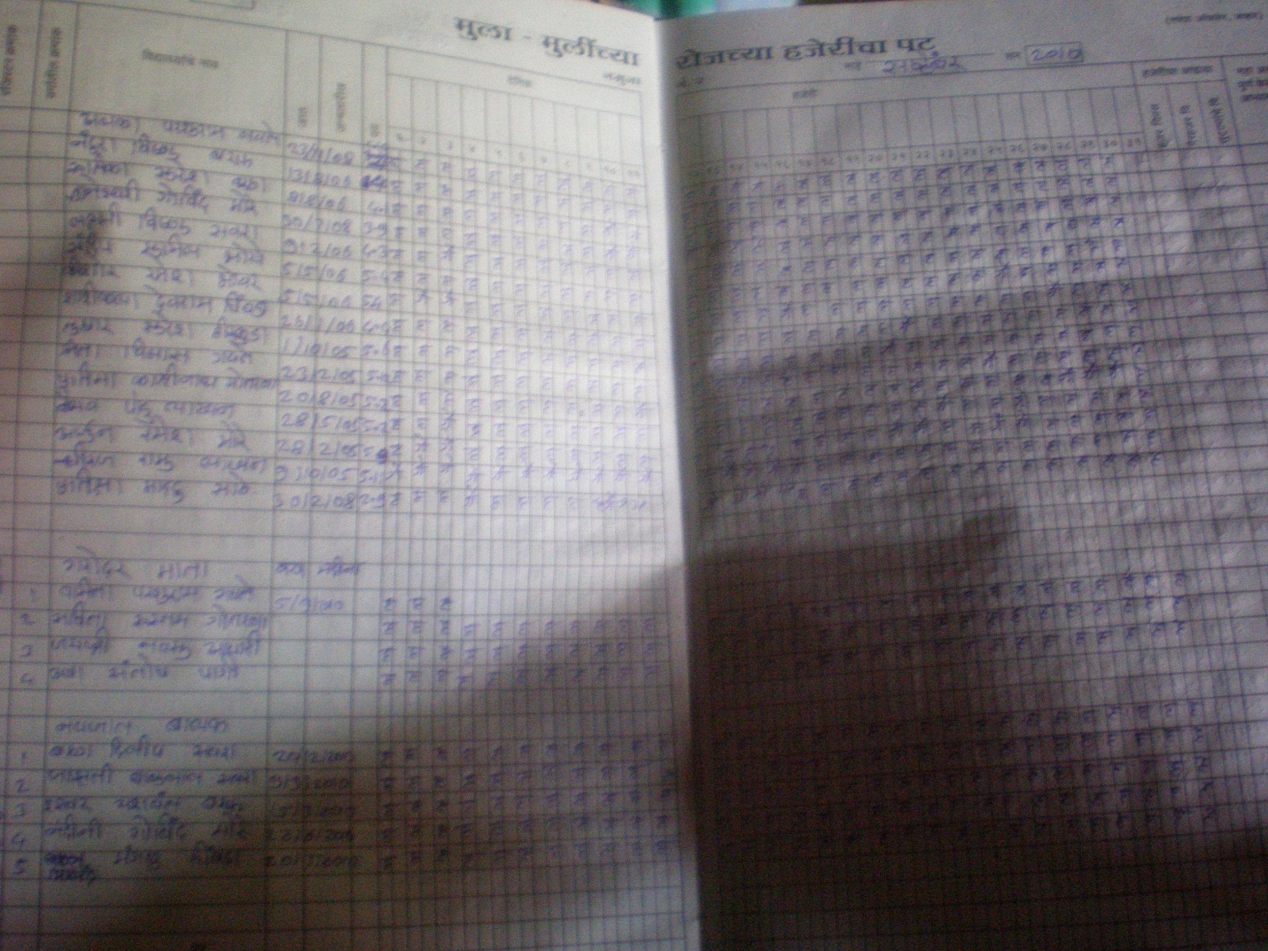
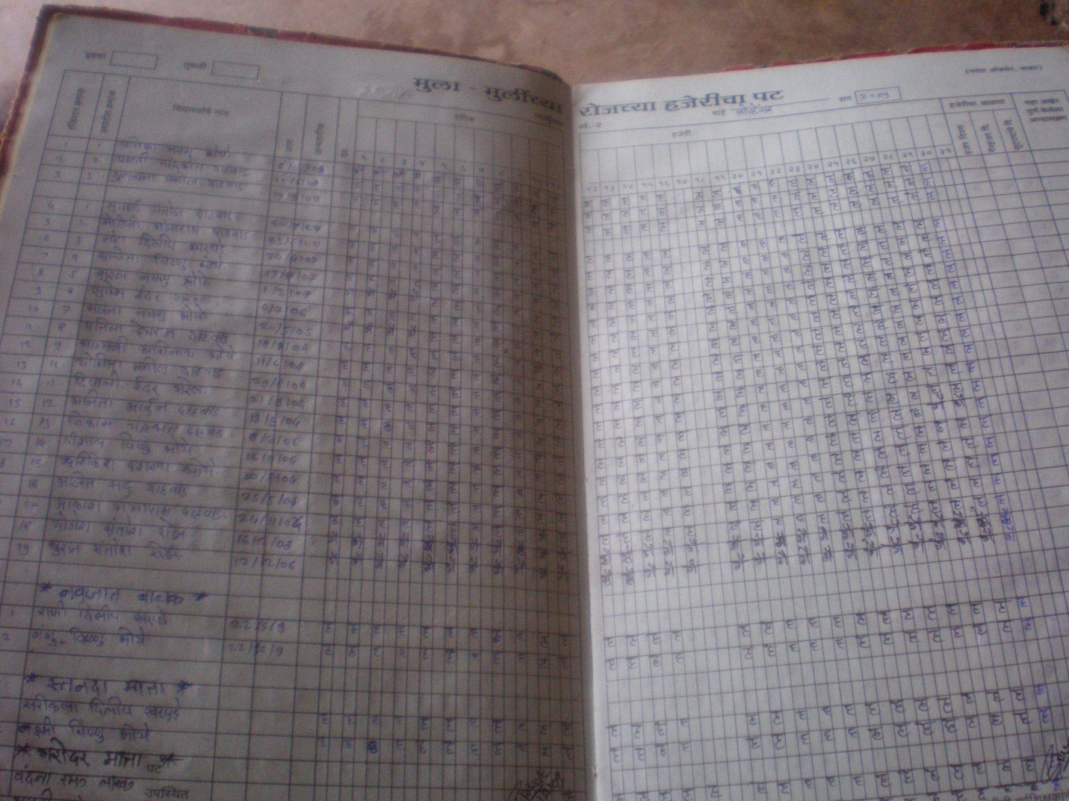
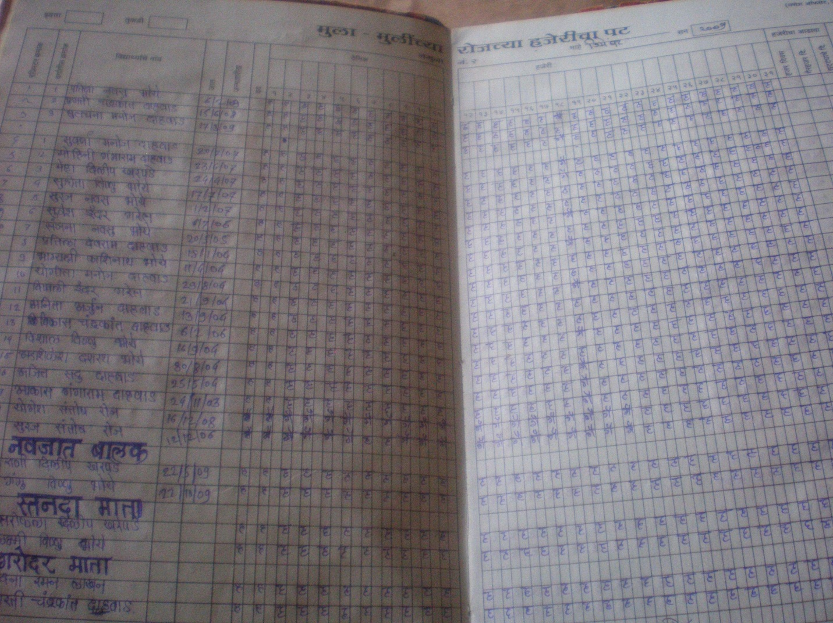
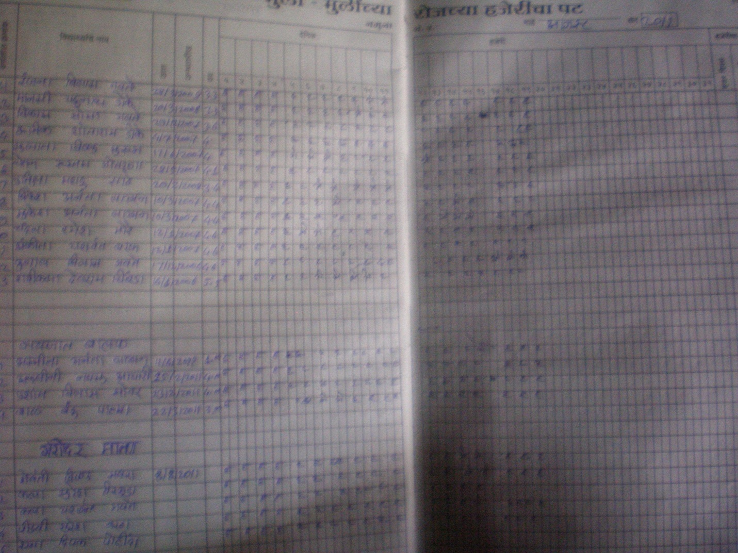
Hostel Pictures
