Site Visit Report
SES School, Vidyanagar, Hyderabad, Telangana, India
7/5/16

Background:
Subrahmanya Education Society (SES) School is a formal school established in 1994 dedicated to providing quality education completely free of cost to children from slums in inner city Hyderabad. The school has 280 students as of July 7, 2016, and has classes from LKG to Grade 10. The staff is well educated, with nearly every teacher holding at least a bachelor’s degree and the majority of the staff also holding master’s degrees. Twenty-five new students were admitted for the 2016-2017 academic year, though twenty-two students (mostly students between LKG and Grade 5) dropped out before the start of the year. All school materials, including textbooks, are free for the students.

Report:
When we arrived at SES School on the morning of Tuesday, July 5, we first met with Mr. Kanakaraju Adivikolanu, the founder and principal of the school. We briefly discussed the reopening of the school for the 2016-2017 school year and then visited the Grade X students. There were roughly fifteen students in the class, as a couple of students were absent that day; however, the teacher informed us that absences were quite rare. We first asked all the students to introduce themselves and asked a few about their family backgrounds and aspirations. Nearly all of them had uneducated parents, most of whom worked as day laborers or in professions such as masonry and painting. When asked what they liked about SES school, the students unanimously agreed that they were very grateful for the opportunity to go to school for free with excellent teachers. Their favorite subjects tended to be math, science, and English and their dream professions ranged from cardiology and science (one student was inspired by the late Abdul Kalam) to architecture and journalism. The students mostly spoke in Hindi, though all the teachers at the school strongly encouraged their students to use English as often as possible.
We then decided to test their academic strengths by asking them a few math and science questions. First, we asked them to solve math problems relating to roots, exponents, and algebraic equations. The students were extremely prompt and accurate with their answers. Next, we shifted to chemistry and asked a student to write the photosynthesis equation on the board. At first he had trouble understanding what we were asking him to do but was ultimately able to write the correct equation with some help from the teacher. Similarly, when we asked the class what the distance formula (d=v*t) was, they struggled to express their answer, though they were immediately able to come up with the correct solution as soon as they understood the question. The students also were more comfortable with the fundamentals of what they were learning than applying their knowledge. Overall, the students were very knowledgeable and talented but sometimes had difficulty expressing their answers, particularly in English.
We then moved on to the other grade levels, each in a separate room. We visited every classroom and asked random students a few questions – their names, their backgrounds, their favorite subjects (usually math and English), and their hobbies (often chess and skipping rope). We also chose one or two students to read out loud a passage from their textbook; it was evident that the students were clearly capable of reading English but had some difficulty with comprehension as they struggled to explain what they had just read. Most of the students had at least one sibling also studying at SES. The lower grades had more students, between 20 and 30 on average. However, not all the students had a seat in some classes – some students were seated on benches or chairs on the side of the classroom, rather than a desk. The students in Grade II did not have a classroom and were seated on the ground outside (see picture below). The school seeks to build three rooms on the first floor above the current schoolrooms but does not have adequate funding, as it must first pay the rent for the current rooms. The school would also benefit from additional funding to pay for facilities such as a library or computer lab, as students have requested, a teacher’s room to provide teachers access to a computer to print out teaching materials and correct papers, as requested by the Grade IX teacher, or lab equipment to supplement science classes.
What stood out most to me from the visit was an impassioned plea by the Grade X teacher as we were leaving to continue funding the school as much as possible. She told us how incredibly talented every student at SES was, how this education was truly changing their lives, and how these kids aspired to do very great things. We also noticed that more female students were planning to continue to go to junior college, rather than drop out. Additionally, it was evident that students that had at least one educated parent tended to thrive. For example, one student in Grade I was easily able to recite the English alphabet and the numbers from one to one hundred, a task that stumped many of his classmates; he revealed that his mother was educated and helped him study at home.
All in all, it was clear that SES School has continued to succeed at its goal of educating students that would not otherwise have access to quality schooling. However, it was also clear that the school needed funding to provide some necessary facilities for its students and staff, beginning with an extra classroom for Grade II students. With the support of Asha Silicon Valley, SES School has certainly come a long way since it was founded in 1994, and it will surely continue to produce successful and talented graduates.

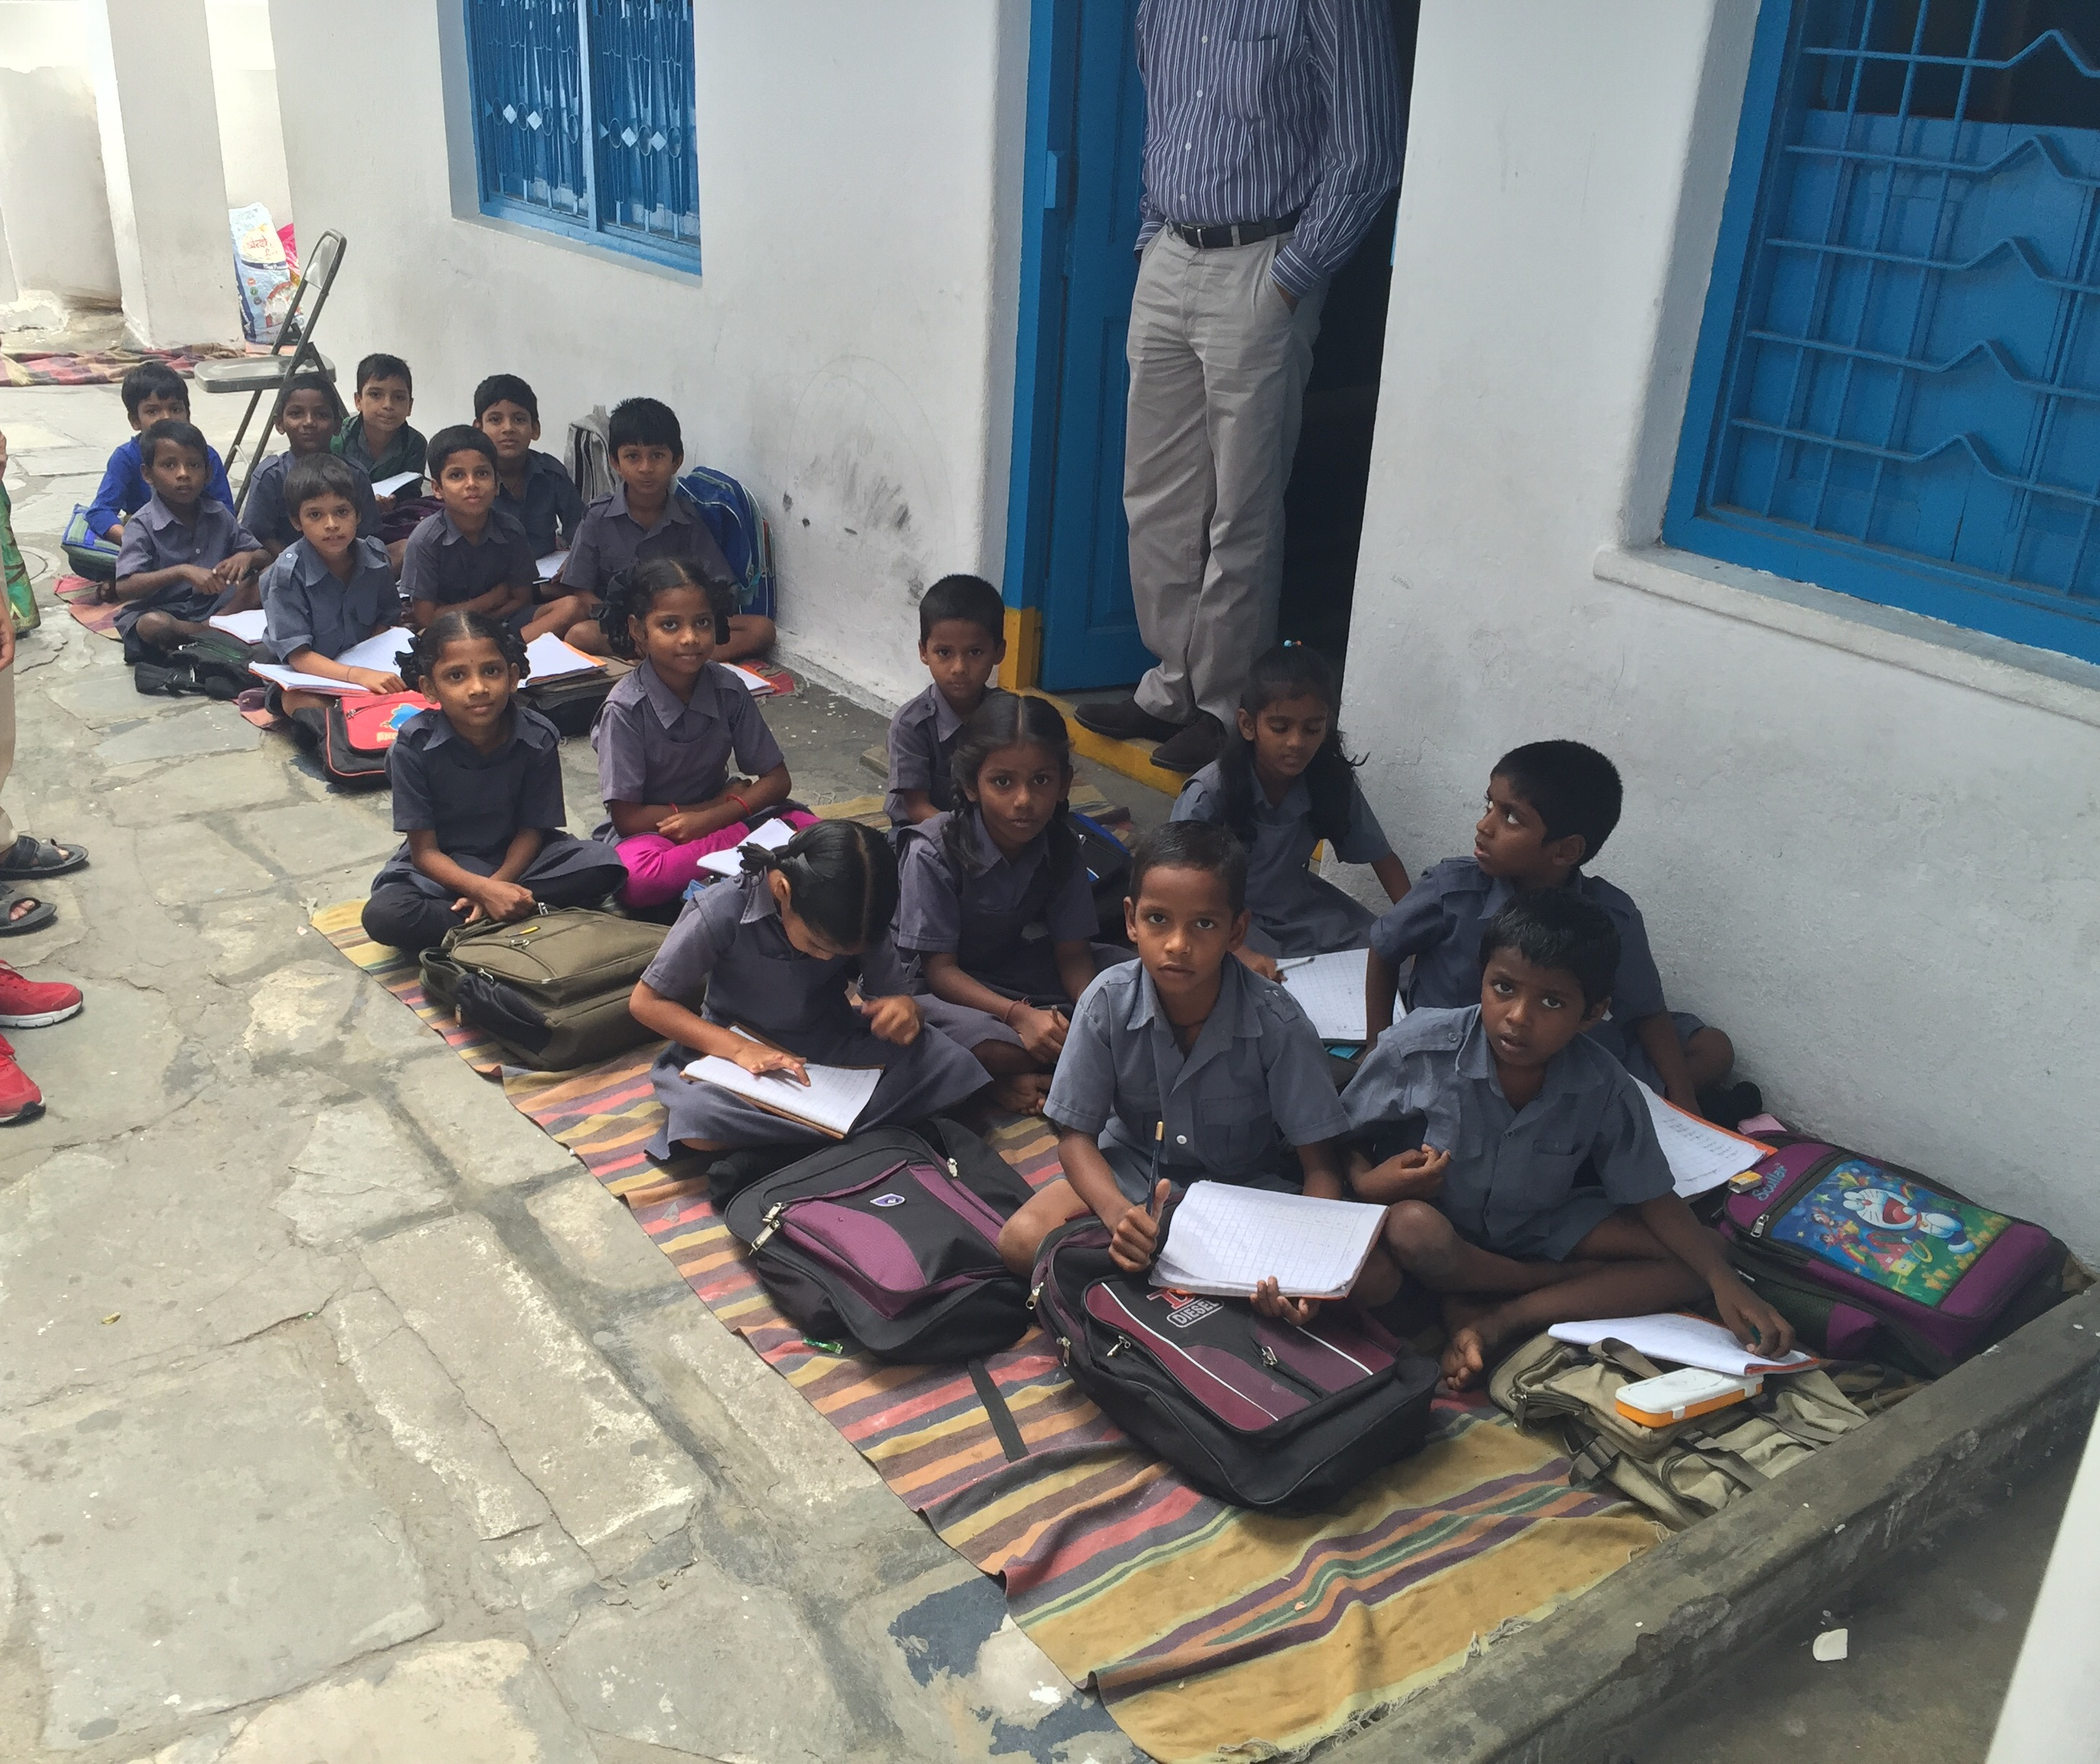

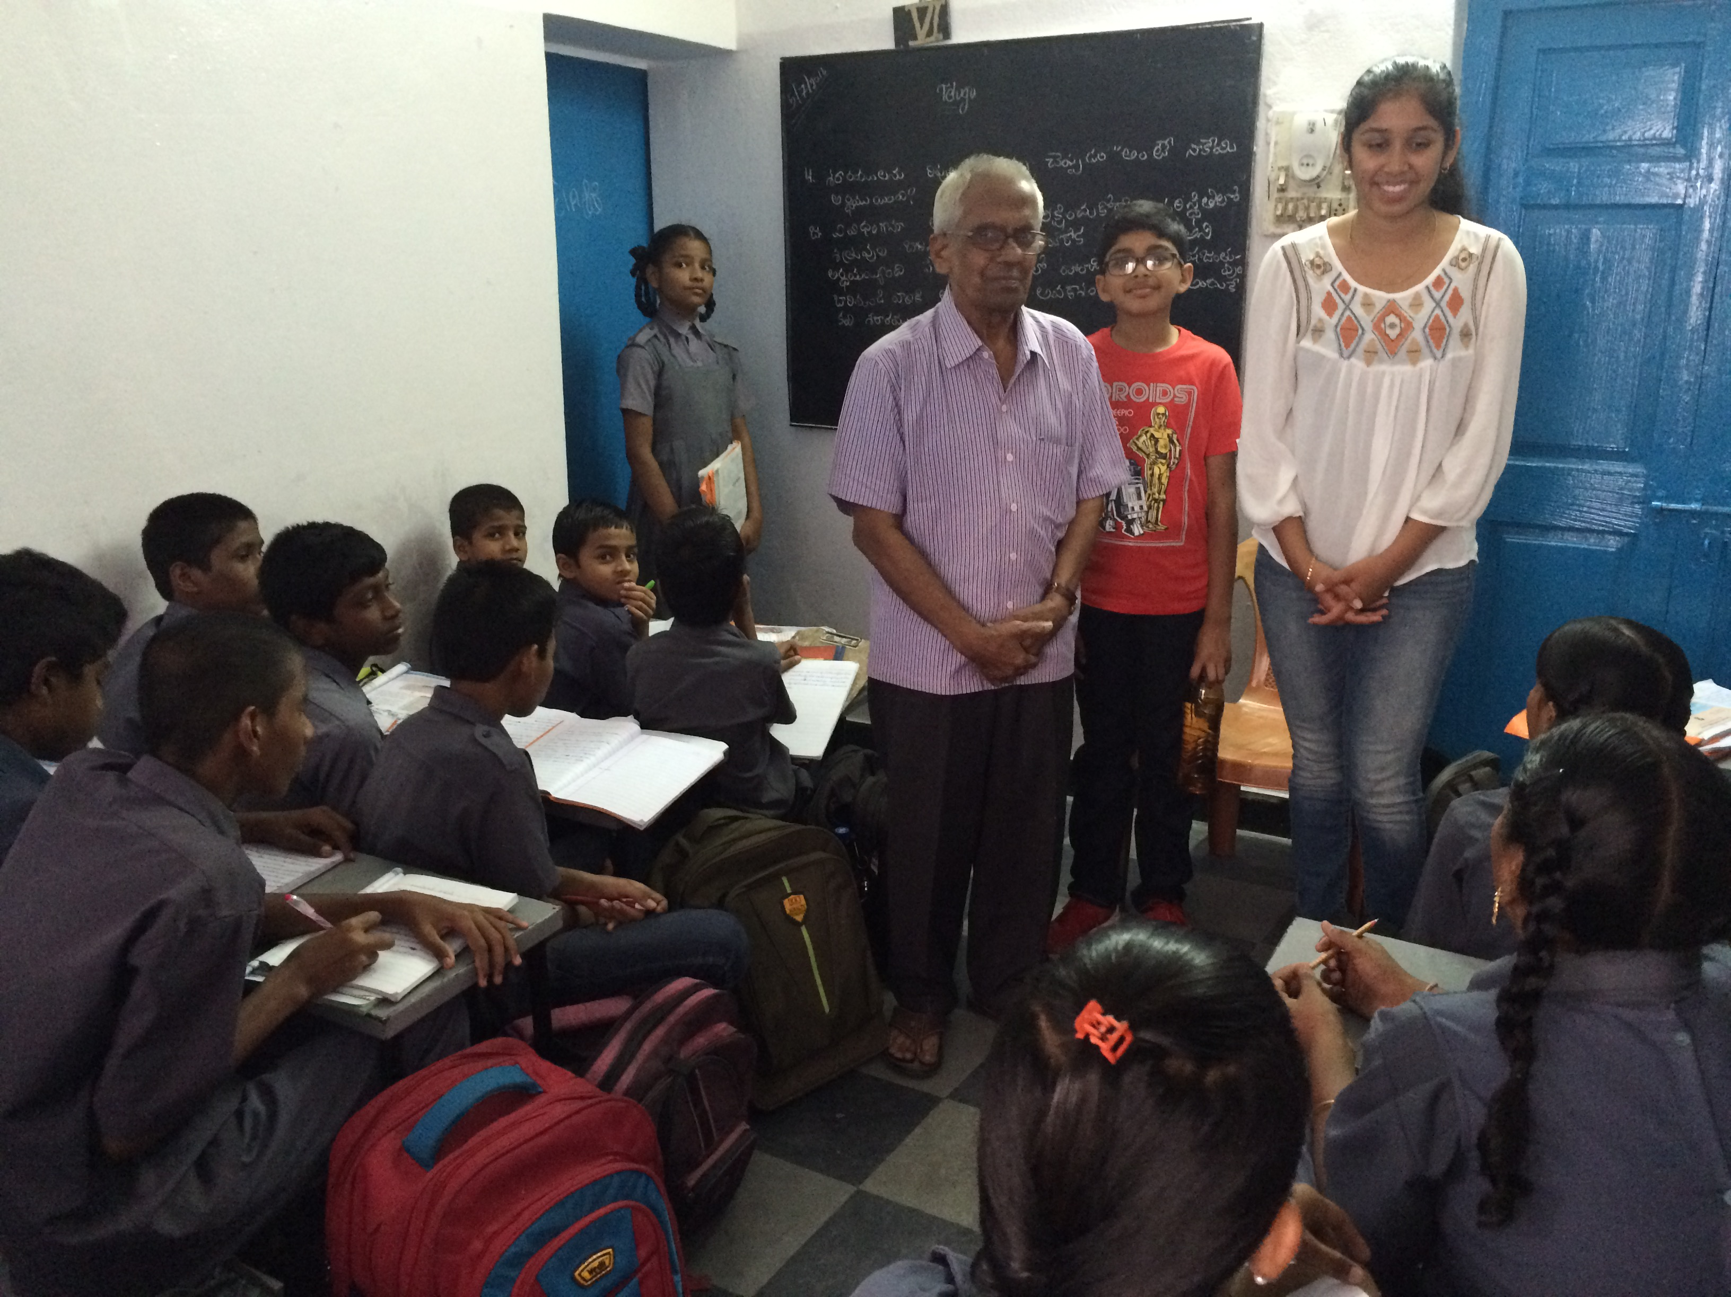

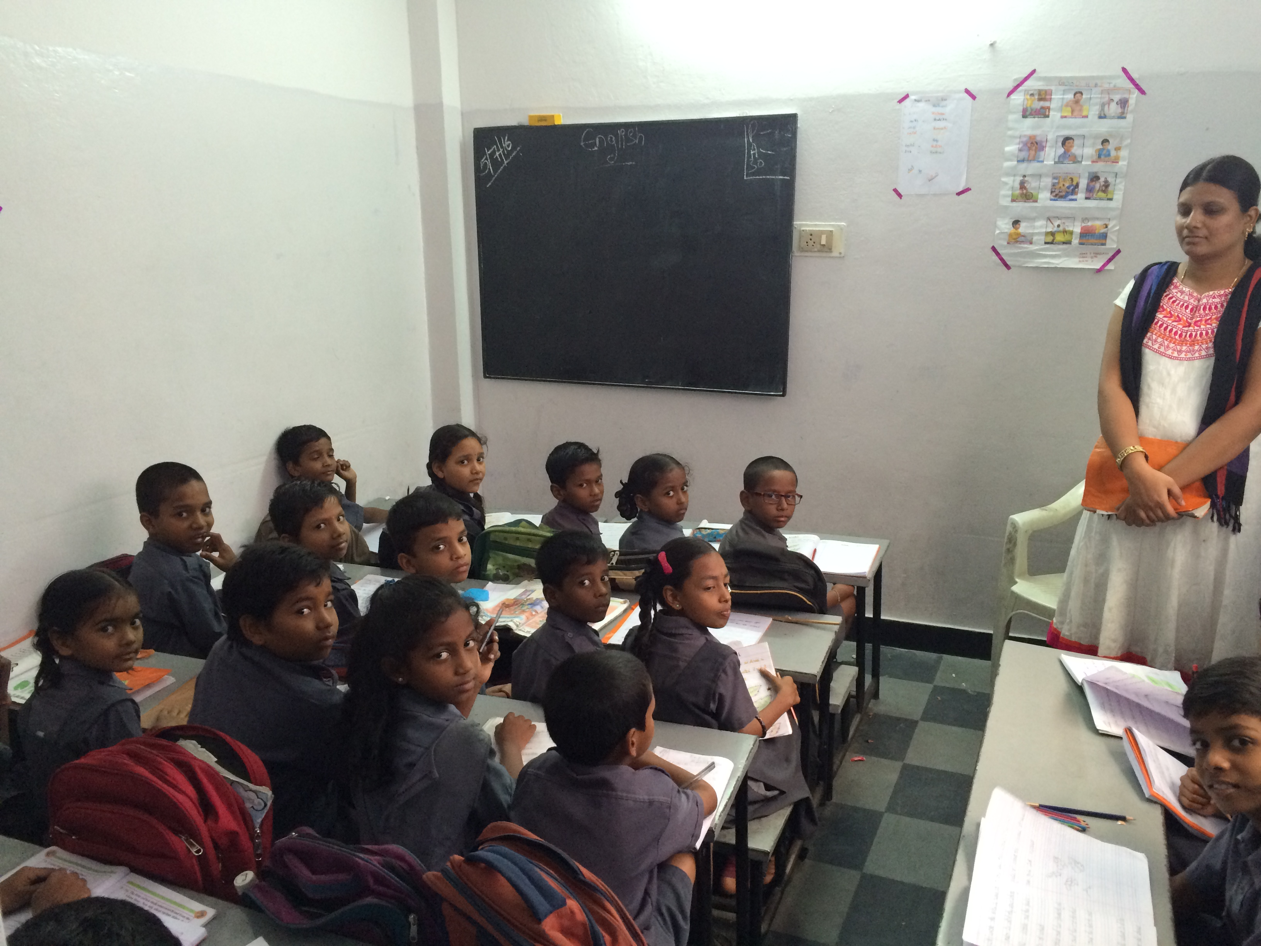

Appendix A
Following details received upon request following site visit on July 5th 2016 vide email dt. July 7th 2016.
S.E.S High School
Details of School Strength
Class | Strength during 2015-16 |  |  | Drop Out Students |  | New Admissions 2016-17 |  | Strength as on 07-07-2016
LKG |  |  |  |  |  | 19 |  | 19
UKG | 26 |  |  | 4 |  | 0 |  | 22
I | 17 |  |  | 1 |  | 0 |  | 16
II | 22 |  |  | 2 |  | 2 |  | 22
III | 27 |  |  | 2 |  | 0 |  | 25
IV | 31 |  |  | 3 |  | 0 |  | 28
V | 36 |  |  | 6 |  | 0 |  | 30
VI | 29 |  |  | 0 |  | 0 |  | 29
VII | 29 |  |  | 0 |  | 2 |  | 31
VIII | 19 |  |  | 0 |  | 2 |  | 21
IX | 24 |  |  | 2 |  | 0 |  | 22
X | 17 |  |  | 2 |  | 0 |  | 15
Total | 277 |  |  | 22 |  | 25 |  | 280
List of Staff

Staff Members as on 07.07.2016
Sl.No. | Employee Name | Qualification
1 | Mrs. Lavanya A,Head Mistress | M.A., B.Ed.,
2 | Mrs.K.R.Rose ,Incharge H.M | B.A(Tel), B.Ed
3 | Mrs.Sheelvanthi | B.A, H.P.T(Hindi Pandit Trained)
4 | Mr. Rajesh A | B.Sc., M.A(Economics)
5 | Mrs.Rani Prameela | B.Sc., M.A., M.Ed.
6 | Mrs. Meenakshi P | B.Sc., M.A.(English)
7 | Dr. Padmavathi K | B.Sc., M.A., Phd.
8 | Mr.Rajgopal K | M.Sc., B.Ed
9 | Mr.Ranga Reddy M | B.Sc., B.Ed
10 | Mr. Vasudeva Rao A | B.Sc
11 | Mrs.K.Padmavathi | B.A, T.T.C
12 | Mrs.Vijayantimala A | M.A, PGDCA,(B.Ed)
13 | Mrs.D.M.Radhika | B.Com(Computers)
14 | Mrs. Roopavani | B.Com, M.B.A, D.C.C.P
15 | Mrs. Sharada V | B.S.C
16 | Mrs.Jayashree | B.Com
17 | Mrs.Maheshwari | Under Graduate
18 | Mohan Reddy G | B A
19 | Sravanthi | Maid

