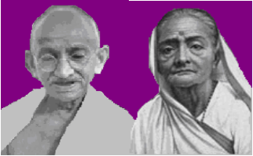
GANDHI KASTHURIBHAI VILLAGE DEVELOPMENT SOCIETY (GKVDS)
PULIAMPATTI VILLAGE, TIRUVANNAMALAI DISTRICT, TAMILNADU, INDIA

HALF YEARLY REPORT
(1-04-2007 TO 30-09-2007)

TO:
ASHA MIT,
USA.

GANDHI KASTHURIBHAI VILLAGE DEVELOPMENT SOCIETY (GKVDS)
PULIAMPATTI VILLAGE, TIRUVANNAMALAI DISTRICT, TAMILNADU, INDIA

HALF YEARLY REPORT
(1-04-2007 TO 30-09-2007)

Title of the Project:

“REHABILITATE DROPOUT CHILDREN OF AGRICULTURAL LABOURERS & LANDLESS FAMILIES AND PROVIDE LIFE EDUCATION THROUGH NON-FORMAL EDUCATION CENTERS IN CHENGAM BLOCK OF TIRUVANNAMALAI DISTRICT, TAMILNADU”.

AIM:

To empower children with the knowledge and skills necessary to protect their Rights as children, and provide them the necessary support and assistance for reinstatement in their families where possible, and help them develop as respected and productive citizens.

Short –term goal:

- To organize support services to help children in the fulfillment of his/her basic needs such as:
- Non-formal education
- Health care
- Recreation

Project location:
District : Thiruvannamalai
Block : Chengam
Villages : 1. Mannandipatti
2. Ramapuram Pudhur
3. Vellalampatti
4. Kurumbapatti and
5. Ayothi nagar

drop out Children enrolled in NFE Centers:

Sl.No | Name of Village | Boys | Girls | Total
1 | Mannandipatti | 14 | 16 | 30
2 | Ramapuram Pudhur | 13 | 17 | 30
3 | Vellalampatti | 09 | 21 | 30
4 | Kurumbapatti | 13 | 17 | 30
5 | Ayothi nagar | 14 | 16 | 30
 | Total | 63 | 87 | 150

Age group wise drop out children who are studying in the centers:

Sl.No | Name of Village | 7-8 |  | 9-10 |  | 11 & > |  | Total
Sl.No | Name of Village | B G |  | B G |  | B G |  | B G
1 | Mannandipatti | 6 | 10 | 7 | 3 | 1 | 3 | 14 | 16
2 | Ramapuram Pudhur | 9 | 10 | 3 | 5 | 1 | 2 | 13 | 17
3 | Vellalampatti | 2 | 07 | 7 | 12 | - | 2 | 09 | 21
4 | Kurumbapatti | 4 | 04 | 5 | 7 | 4 | 6 | 13 | 17
5 | Ayothi Nagar | 7 | 05 | 6 | 5 | 1 | 6 | 14 | 16

Children who studied in the schools and drop outs from the classes:

Sex | 1st std | 2nd std | 3rd std | Total
Boys | 28 | 26 | 9 | 63
Girls | 35 | 32 | 20 | 87
Total | 63 | 58 | 29 | 150

ACTIVITY REPORT:

- STAFF APPOINMENT AND TRAINING:

For the project GKVDS appointed 5 animators in the villages itself, 1 project coordinator and 1 office assistant appointed.
The following criteria were followed for selection of staff for the project:
For Project Coordinator:
Who must be a graduate;
Having at least 5 years experiences in the field of non-formal education projects run by either NGO or government departments;
Having experience in supervising and monitoring;
Willingness to work with GKVDS in the Project.

Based on the above criteria, GKVDS appointed Mr. S. Ramu, as a project coordinator, who is having 19 years experience in the NGO field and in Non-formal education programmes with various NGOs and government department.
For animators:
Who must be completed High School/Higher Secondary school education;
Residing at the respective villages itself;
Willingness to work with GKVDS in the Project.
List of Animators selected based on the above criteria for the Project:
Sl.No | Name of the Village | Name of Animator | Educational Qualification | Experience in the field
1 | Mannandipatti | P. Raja  S/o.Pattu | SSLC failed | 3 years in NFE
2 | Ramapuram Pudhur | P.Chennammal  W/o.Sankar | +2 passed  Dip.in Kindergarden teacher | NIL
3 | Vellalampatti | K. Rani  D/o.Kandan | SSLC passed | NIL
4 | Kurumbapatti | K. Padmavathi  W/o.Karthikeyan | SSLC | NFE teacher
5 | Ayothi Nagar | J. Jeyakodi  W/o/Perumal | SSLC | NIL

GKVDS – PROJECT STAFF TEAM
GKVDS Director Project Coordinator
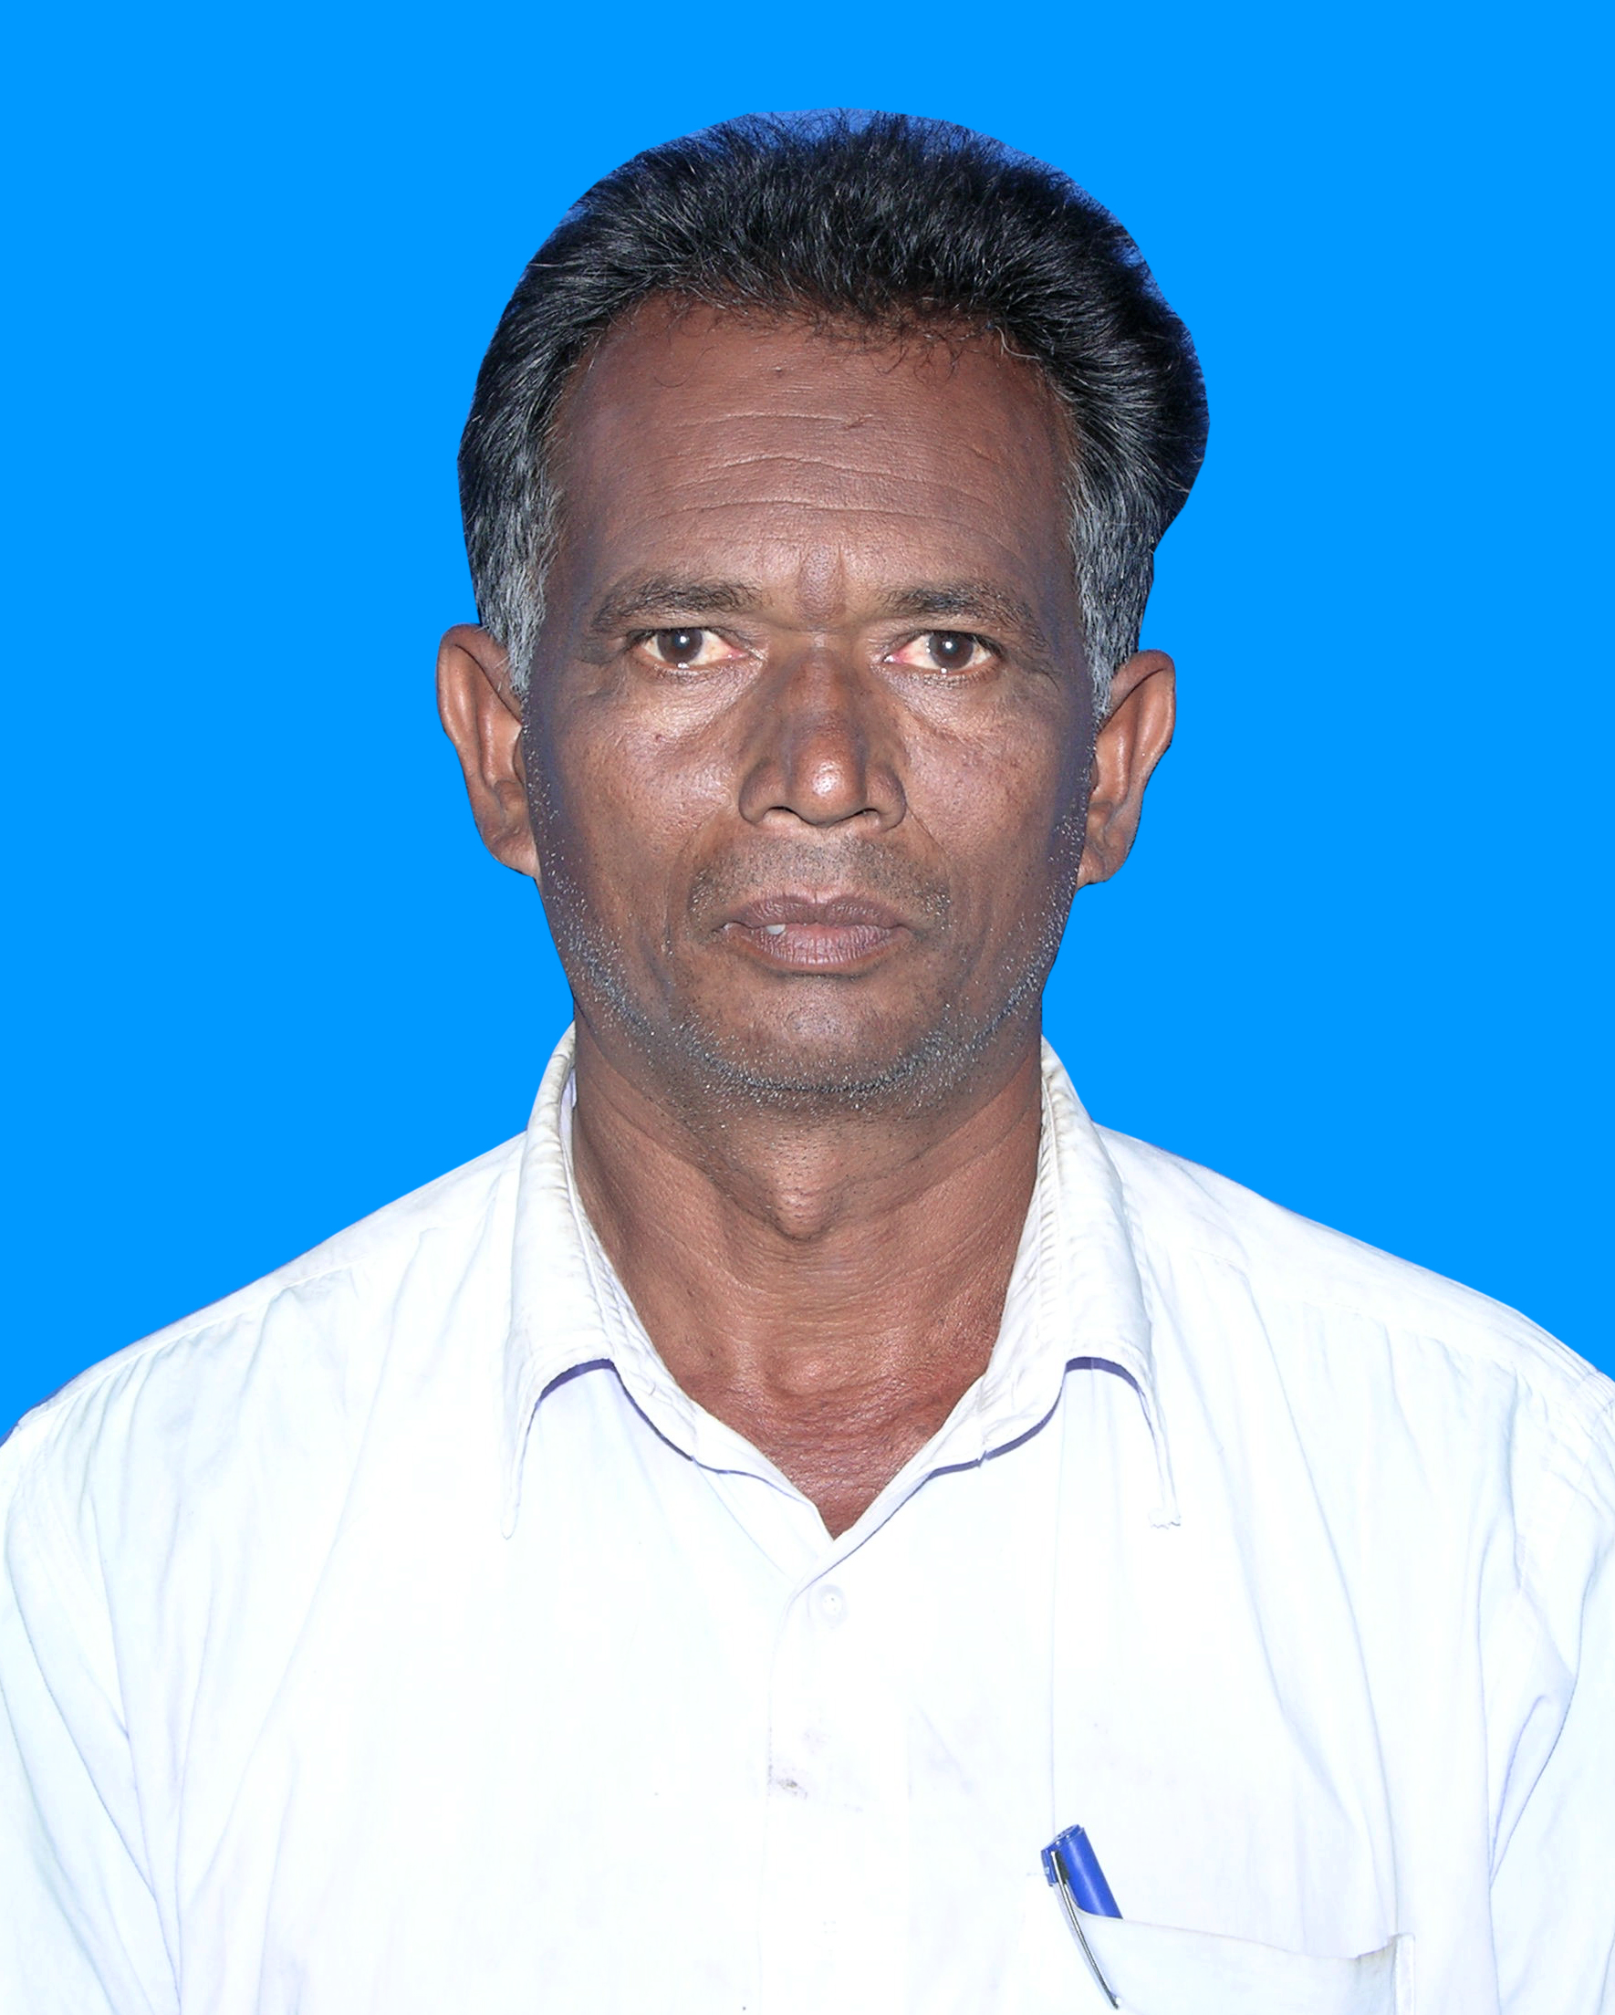
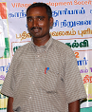
Mr. T. Devendiran Mr. S.Ramu
Animators:
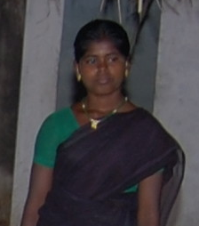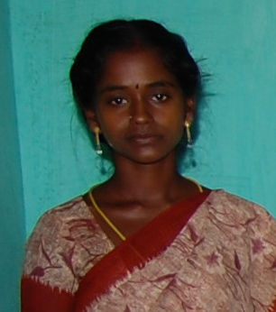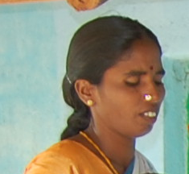
Ms. Rani, Mrs. Jeyakodi, Mrs. K.Padmavathi,
Vellalampatti Ayothi Nagar Kurubapatti
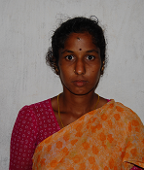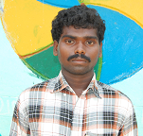
Mrs. Chennammal Mr.Raja
Ramapuram Pudhur Mannandipatti

PLACES FOR NFE CENTERS:

Sl.No | Name of the Village | Location of the Center | Time
1 | Mannandipatti | Mr. Subramani’s House | 6.00 PM to 10.00 PM
2 | Ramapuram Pudhur | Mr. Chandran’ s House | 6.00 PM to 10.00 PM
3 | Vellalampatti | Animator’s House | 6.00 AM to 10.00 AM
4 | Kurumbapatti | Animator’s House | 6.00 AM to 10.00 AM
5 | Ayothi Nagar | Animator’s House | 6.00 PM to 10.00 PM

STARTING NFE CENTERS:

Staff Training:

Before going to starting the NFE centers, GKVDS provided staff training to the selected animators and project coordinator.
Three days training conducted by Mr. S.Pradapan, Director of Sustainable Life Trust, Dharmapuri and Mrs. R.Mallika, President of Rural Mahalir Sangam, Harur to our staff team.
The following topics highlighted during the training:
- Syllabus to be covered during the first year.
- Preparation of Plan of action for the center
- Preparation of daily reports
- Preparation of monthly reports
- How to contact parents of the children and conduct motivational meeting to them
- Conduct the classes within the time frame
- How to conduct tests/examination
- Preparation of teaching aids
- Method of story telling/rhymes/acting etc.,
- Recreation activities conducted in the centers: fancy dress competition/games/story telling/acting/dancing/singing/ etc.,

MEETING WITH PARENTS OF DROP OUT CHILDREN:

Monthly meeting held at NFE centers after the class hours. Parents of the children and community leaders participated in the meeting. Approximately the meeting goes around one hour.
The following topics discussed during the parents meeting and it was resolved in the Parents Meeting Resolution Book.
Children performance in the center; children Credit union (savings & thrift); incentives to the children who attended fully in the center; participation in health check up camps; health & hygiene; children’s Rights; parents role in their children’s education, recreation, health and social activities.
Constraints faced:
Some of the parents who are unable to attend the meeting, because both father & mother went for seeking jobs to nearby areas (so, they didn’t know about their children’s performance in the center)
Some of the parents showing their interest to receive incentives for their children in hand and they are not interested to deposit the amount in the Post office or banks.
Like wise, they are interested to involve their children in the Credit union activities.
GKVDS try to eliminate the constraints and motivate them to involve in the project.

HEALTH CHECK UP CAMPS:

Once in a month health check up camps conducted with the help of private medical practitioners in nearby areas who are voluntarily provided their service for the neglected children.
During the reporting period, GKVDS conducted health check up camps in each center:
Date:

Sl.No | Name of the Center | April | May | June | July | August | September
1 | Mannandipatti | 13 | 22 | 22 | 25 | 24 | 21
2 | Ramapuram Pudhur | 16 | 14 | 21 | 10 | 12 | 17
3 | Vellalampatti | 16 | 21 | 18 | 23 | 18 | 19
4 | Kurumbapatti | 13 | 22 | 20 | 25 | 24 | 21
5 | Ayothi Nagar | 16 | 14 | 21 | 10 | 12 | 17

CHILDREN’S CREDIT UNION:

GKVDS motivating the parents to involve in their children’s credit union. Some of the parents come forward to join their children in the Union. From October, 2007 onwards the activities will be started.

Syllabus Covered:

During the reporting period all the animators covered the syllabus up to 3rd standard levels in all subjects (Tamil, English, Mathematics, Social Science and environmental Science) according to the Tamilnadu State Elementary Education Board.
In June and September, 2007, GKVDS conducted the examination for the children and evaluated the performance of the children in the centers. The question papers developed with the help of government school teachers and SSA, supplied to the children. Before GKVDS, conducted the examination, regular weekly test conducted and increase the level of education among the children in the centers.

Nutritious Food Provided:
According to the attendance GKVDS provided nutritious food through our animators.
Fried gram, milk and fruits supplied to all the children in each and every working days.

STUDENTS ATTENDANCE IN THE CENTERS:
Mannandipatti NFE Center Ramapuram Pudhur NFE Center
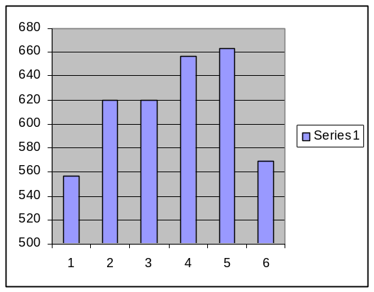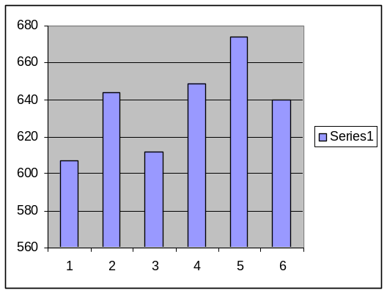

Vellalampatti NFE Center Kurumbapatti NFE Center
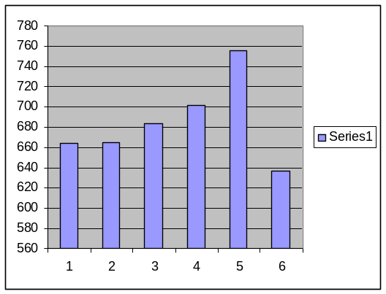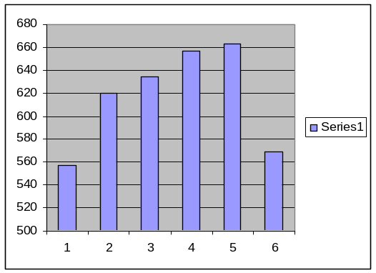

Ayothi Nagar NFE Center

RUNNING NFE CENTERS:

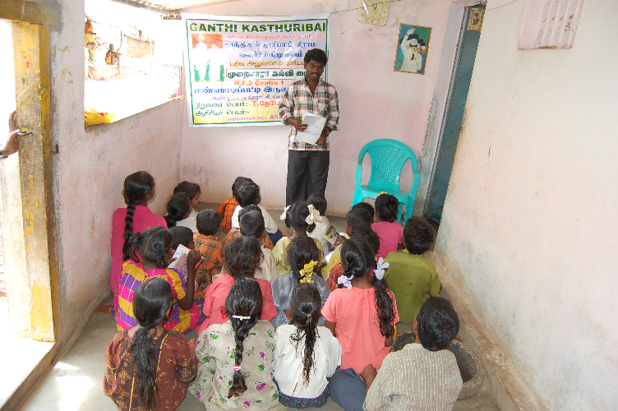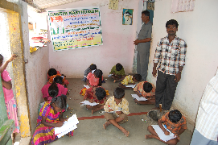
Mannandipatti
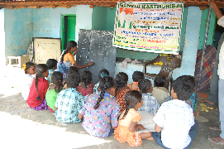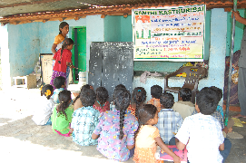
Kurumbapatti
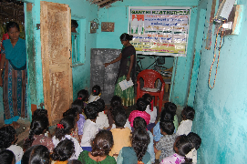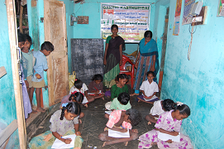

Vellalampatti
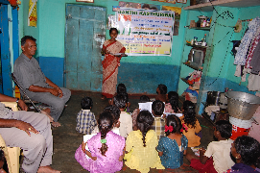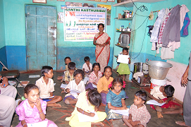
Ayothi Nagar
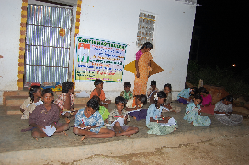
Ramapuram Pudhur

Parents meeting:

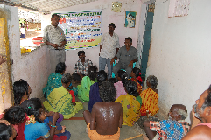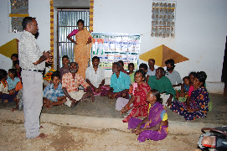
Mannadipatti Ramapuram Pudhur

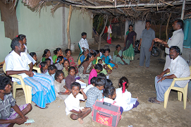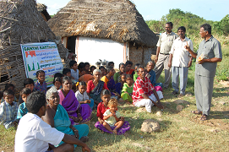
Vellalampatti Kurumbapatti

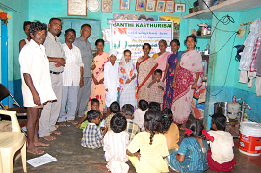
Ayothi Nagar

CULTURAL ACTIVITIES CARRY OUT DURING THE PERIOD:
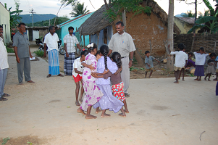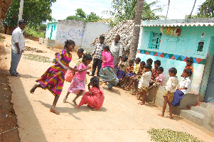

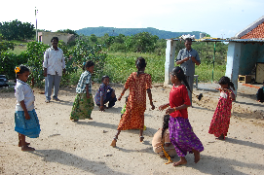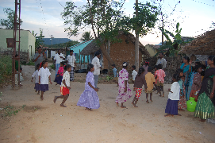

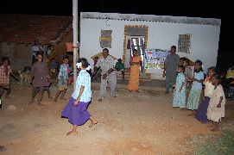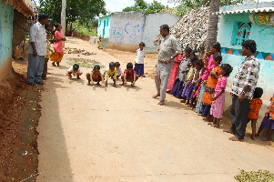

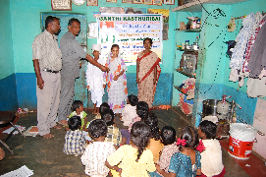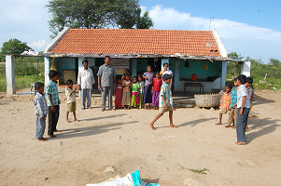

HEALTH CHECK UP CAMPS:

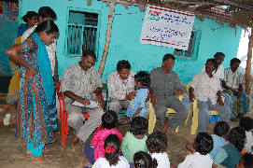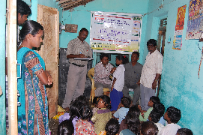

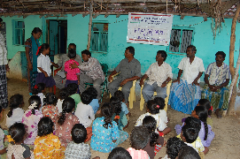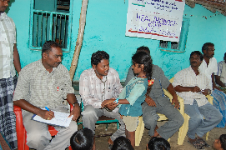

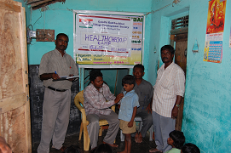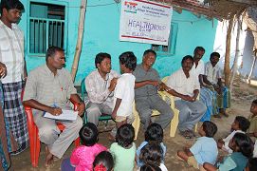

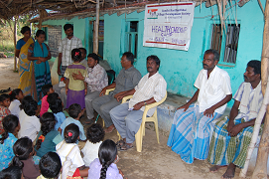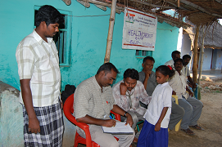

Test conducted by the animators:

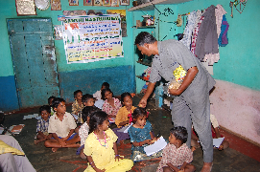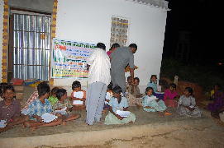

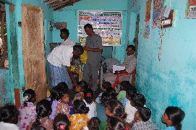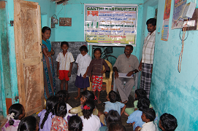
Staff Training


