Madurai Seed Narpanigal Update (2014-2015)
Madurai Seed strengthens the lives of underprivileged children and young people by providing curricular and extracurricular activities which otherwise they couldn’t get in schools and families. The children and young people undergo two types of disadvantages. One comes along with their birth; their family, economic and social background. Another one is the problems, complexity, and value erosion of modern society when they grow up. At this situation Madurai Seed serves as a space for learning, training, guidance, etc. The results of our works are incredible. The evidence is the profile of our out-going volunteers every year.
This year 12 of our young people who are engineers, teachers, post graduates, graduates are completing their volunteer ship, and enter to the big world. Congratulations to them, and we’ll find the adequate volunteers from the upcoming generation. That’s the specialty of Madurai Seed.
Asha plays a huge part by providing the continuous support. You are providing the stipend for volunteers, and rent and electricity for education centers. Two basic needs are covered. Now, we have the physical spaces and people to run the centers, two real strengths of Madurai Seed. All the curricular and extra-curricular activities are designed and executed by having these two major strengths.
Children Beneficiaries in the year 2014-15
Center | Boys | Girls | Total
Karumbalai Centers | 167 | 115 | 282
Sevalayam Hostel | 136 | - | 136
Total | 303 | 115 | 418

Number of Volunteers Received the Stipend
Male 12 + Female 08 = Total 20

1st standard to 9th std
- All children between these standard are promoted to the next levels. Schools for these students are reopening on 1st June 2015 after the summer vacation. We are planning to celebrate the day as “Educational New Year”, and going to provide sweets for school going children at the five entrances of Karumbalai.
10th standard Result:
- In Karumbalai centre, 26 children wrote the exam. Among 25 passed. 96% result. We have talked to the one who failed. He is going to write the supplementary exam.
- In Sevalayam Centre 17 wrote the exam. All passed. 100% result.
Top Five Marks
Kowsalya | 478
Subramani | 447 (Sevalayam Student)
Vijaya Lakshmi | 441
Ziniya | 414
Ramya | 413

- Kowsalya has scored centum in Science and 99 marks in Maths.
- Vijayalakshmi scored 99 in Science and 99 in Social Science.
- All the students are going to continue in 11th std. They have applied for various groups. Guidance was provided in selecting groups, and admissions. Schools for them will open after 15th June.
11th standard:
- All students are promoted to 12th std.
Std | Maths- Computer | Science | Commerce-Accountancy | Engineering | Total
XII | 2 | 7 | 4 | 2 | 15

12th standard result:
- In Karumbalai, 15 students wrote the exam. All Passed. 100% Result.
- In Sevalayam, 12 students wrote the exam. Among 9 passed.
- B.Girija is the topper with 1010 marks out of 1200.
- The students have applied for Tamil, English, Science, and Commerce subjects in various colleges. They are waiting for admissions.
- 5 people will continue as volunteers.
College Final Year Young People:
- 5 people are completing their college, 4 as undergraduates, 1 as post graduate. They are also completing their formal volunteer ship. Farewell program was conducted in March.
Karpaga Selvi | UG Commerce
Janaki Devi | UG Commerce
Bala Murugan | UG Commerce
Nagoor Raja | UG Tamil
Sadham Hussain | PG Commerce

- They’ve just written their final exams. Some are trying to fit in jobs, some thinks of further studies. Karpaga selvi is going for Bank Exam Coaching.
Professional Courses Completed:
- 7 completed their professional courses. (5 teachers + 1 Engineer + 1 M.Phil). Their formal volunteer ship is also completed. They all are trying for jobs.
Ganesh Kumar, M.Sc, M.Phil, B.Ed., (Maths)
Arun Kumar, B.A, B.Ed., (English)
Muthu Pandi, M.Com, B.Ed (Commerce)
Divya Bharathi, B.A, B.Ed (English)
Priya, B.A, B.Ed (History)
Parvathi, B.A, B.Ed (Tamil)
Maheshwai, B.E (EEE)

Summarizing the above
Students completed 10th std : 42
Students completed 12th std : 24
UG, PG completed : 05
Professional Courses completed : 07

We thank Asha for Education (Boston), Friends of Madurai Seed, KFR School, Laura Villger, John Potts, Clive Oxenden, other donors, and friends for their generous support for the education of underprivileged children and young people. We pledge our commitment to work towards Asha’s motto “Bringing Hope through Education”.

Below, we’ve listed only some highlights from February to May 2015
English Tutor Appointment: Mr. Sam Devanand is appointed as English tutor for young people. He has many experiences as the human resource trainer in corporate and schools. He not also teaches English, but incorporates some soft skills development during the sessions. He is also interested in theatre activities for children and young people.
Television and Equipments: Last year, there was a projector mounted in Vandugal Arangam to facilitate audio/video classes, and multipurpose uses. This year, Hotal North Gate has sponsored an LED TV. It was fit in the Vergal Arangam to facilitate children with visual learning. Another LED TV was sponsored by International Tamil Language Foundation to undertake SPARC science classes. It was mounted in Library. Each TV is connected to a CD player and audio system. The materials will facilitate classes, seminars, trainings, workshops, and cultural activities.
SPARC Science Project: On 24.02.2014, International Tamil Language Foundation based in USA, has created a Educational package to teach physics, and maths in Tamil. The package contains a book and CDs. The founder of the ITLF A.R.Rammohan along with his wife Meenakshi visited Madurai Seed and sponsored the package, a TV, a CD player to further facilitate the audio-visual part of the class. He introduced about the edu-pack, its benefits, need for scientific thinking to the children, etc. We are very eager to teach the lessons from next year 2015-16.
Sunday Skype” – Science Classes: It is the idea to utilize the over-seas volunteers to teach the children using internet. The knowledge of the experts is channelized to children through video conferencing. Mr. Hariharan Mani, who is working as a software engineer in USA took 10 hours of science classes for five weeks in the month February and March 2014 to 11th.10th, 9th, and 8th std children via Skype. Some of the topics discussed are gravity, laws of Newton, Light, forms of carbon, petroleum gas, science behind camera, and eyes, etc. He has cleared the student’s doubts from their school science lessons. Further students wrote to him their questions on general science through email, he prepared and answered in classes.
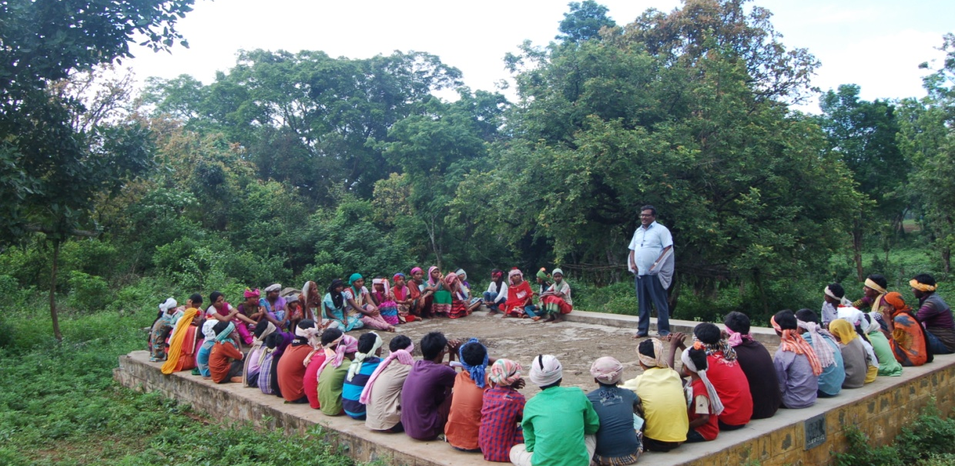
Vasantham Summer Camp 2015
Vasantham Summer Camp is the most anticipating event for the children and young people, because it is full load of excitement and learning blended together with surprising elements every year. This year the camp was conducted for 7 days from 14th May to 20th May. For 3 days, it held at Karumbalai. Another four days we’ve spent at Sirumalai, a forest near Madurai. We stayed in the simple, small village. It was a new experience for children and young people venturing the raw nature. They are emotionally attached to the place. Local village children, and youth also took part in the camp.
- Input Sessions were conducted by Intern Yogalakshmi, English tutor Sam Devanand, Elavarasi, and Karthikbharathi. It covered topics of Life Skills.
- Craft activities emphasized art from natural and eco-friendly materials.
- Green Walk was conducted at Sirumalai to instill the sense of nature loving.
- Village Walk was conducted to understand the occupations, and life style of the locals.
Input Sessions | Craft Sessions
Self Analysis | Paper Quilling
Self Worth | Stone Painting
Self Love | Coconut Shell Painting
Creativity | Flower Crown Making
Goal Setting | Leaf Crown Making
Problem Solving | Cob House Construction
Conflict Management | Turban Styles

CESCI Camp:
As a second treat, Our Children and Young People had the opportunity to participate in the CESCI organization’s Dreams Camp conducted by Karthikbharathi. It was conducted for three days in a rural ambience. The children of nearby villages took part in the camp. Our children enjoyed knowledge sharing and friendship with the village children. The camp emphasized on theatre activities and personality development activities. Children also directed short films in the camp.
Internship:
Ms. Yogalakshmi who is studying Bachelor of Social Work in Madurai Lady Doak College, worked as an intern as her summer placement. She took life skill classes for children, her approach included lots of role play, games, discussion, and pair work. She took three input sessions in Vasantham Summer Camp. She also learned about NGO management through interviews with Karthikbharathi and volunteers.

The core aim of all of our function is to make children and young people to hold on into education, and bring hope. Education makes them resourceful people, it gives them self-confidence and emotional balance. It helps to escape poverty. Second, during the course of education, they shouldn’t lack diverse learning experiences, resources, and skills because of their disadvantaged background. So, we provide experiences which they normally lack in schools and families.
Madurai Seed acts like a home away from home. The basic needs like food, shelter, and security are provided by the parents. But, they can’t provide the developmental needs like education, guidance and life skills. Madurai Seed intervenes at that point. Once their needs are fulfilled, they can fulfill another one’s need. We constantly stress the importance of this cycle to the beneficiaries.
Every year we put a further step ahead in our achievements, operational strategies, outreach, etc. This year our development includes the new venture at Sevalayam Boys Hostel, supply of audio-visual equipments in 3 centers, shifting of Vergal Arangam & Library, appointment of one English teacher, etc. We look forward to the new school year filled with new challenges, and achievements.
THANK YOU
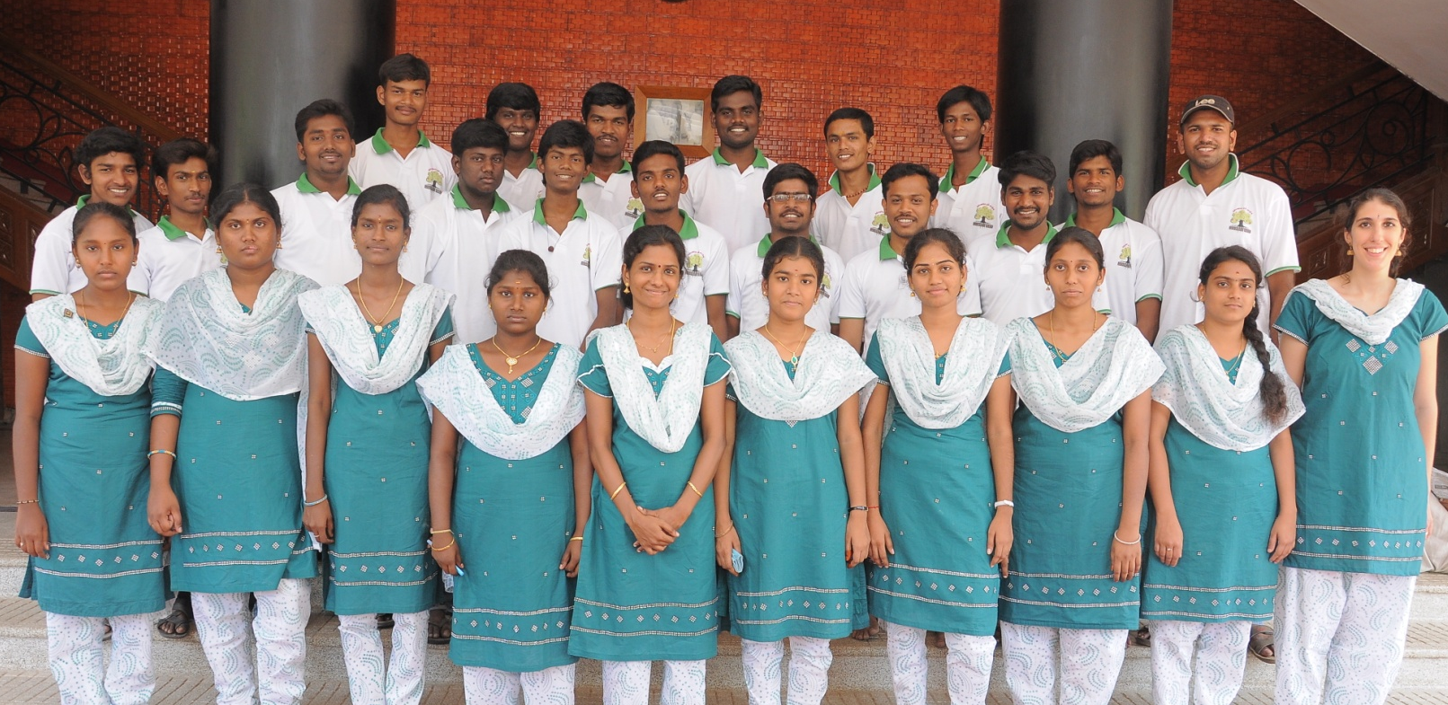

Budget Proposal 2015-2016
S.No | Purpose |  | In Rupees
1 | Karumbalai Volunteers Stipend | 15 * 1250 | 18750
2 | Sevalayam Hostel Volunteers | 05 *1250 | 6250
Total |  | 20 * 1250 | 25,000
1 | Vandugal Arangam | Electricity | 1500
2 | Vergal Arangam | Rent | 5000
3 | Vergal Arangam | Electricity | 1500
4 | Kanavugal Arangam | Rent | 5000
5 | Kanavugal Arangam | Electricity | 1500
6 | Thedalgal Arangam & Library | Rent | 5000
7 | Thedalgal Arangam & Library | Electricity | 1500
8 | Postal & Phone |  | 4000
Total |  |  | 25,000
Grand Total |  |  | 50, 000

