Site visit Report of SRI VIKAS BHARATI School of Kamalakar Memorial Charitable Trust conducted on 21st October 2013

The Vikas Bharati School managed by M/s Kamalakar Memorial Charitable Trust was visited by me (Smt. A. Lakshmi prasanna) on 21st October 2013 at the instance of Asha for Education. I have met smt. Bharati Devi the management representative and also various teachers and students in the school. The school is housed in the Nagole area which is in the outskirts of Hyderabad city and covers classes from nursery to 10th class. The school run from 8-30AM to 03-30 PM with 30minute lunch break from 12-30 to 13-00hrs The strength of the school is 185 and the class wise break up of students is as follows
Nursery 22
L. K.G 17
U.K. G 17
Iclass 24
IInd class 14
IIIrd class 21
IVth Class 15
Vth class 11
VIth class 14
VIIth class 09
VIIIth class 07
IXth class 06
Xth Class 08
Total strength 185

Up to Primary level CBSE syllabus is followed and for classes beyond Vth, State syllabus is followed. It is observed that more stress is placed on activity based learning in the syllabus due to which there is a need for providing laboratories for science subjects.

School budget: Detailed account statements pertaining to the trust are obtained and attached herewith. As seen from the school income and expenditure statements, the following are the details.
Table of Expenses and income of Sri Vikas Bharati School.

Salaries | 404,200.00
Rent | 288,000.00
Auto Charges ( Auto Rent) | 76,800.00
Uniforms Expenses | 36,355.00
Books | 97,043.00
Electricity Charges | 6,584.00
Functions & Seminar Expenses | 2,875.00
Printing & Stationary | 11,179.00
Fee Collections | 139,460.00
Donations | 797,185.00

Out of the total expenses of Rs 9,74,844/- the fees collections are only Rs 1,39,460/- ( less than 15% of total expenditure) and the school is largely dependant on donations since the students are mainly coming from the under privileged classes. Rent and salaries alone amount to Rs 6,92,200/-. Funds are needed for the additional infrastructure and the school is not able to generate the funds as most of the students are from poorer sections of the society and hardly 50 out of185 are in a position to pay the school fees. Despite all the difficulties and financial crunch, the trust is able to run the school ably for the noble cause of providing education to the under privileged children.

13 teachers are employed by the school. There are two post graduate teachers with B. Ed qualification. The high school classes are located in the old school building and the primary section of the school is housed in the ground floor of a newly constructed building opposite to the old school. The teachers were keen to actively interact with the students in the classes. Apart from regular curriculum they are taught singing, painting and are taken for excursion outside.
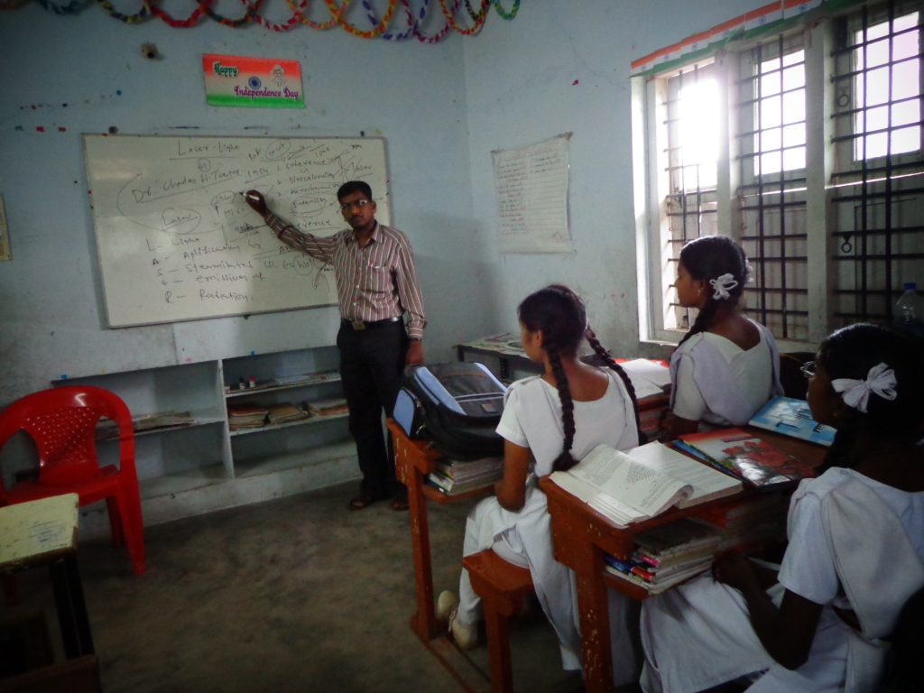

The school is having a computer lab with three desktops. It is informed by Smt. Bharati Devi that introductory classes on computers are conducted to students of primary classes on every Saturday. We are infomed that one institution by name "Pratham" offered soft copy of teaching material of the curriculam of the6th and 7th classes on Maths and english and one teacher by name Sri Shiva Prasad was also trained in delivering the content. They have also supplied a large screen monitor which is connected to one of the computers.
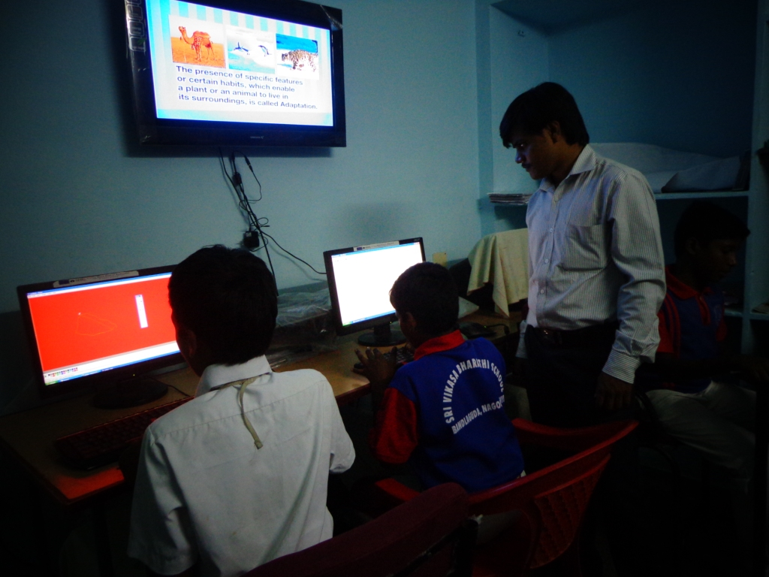

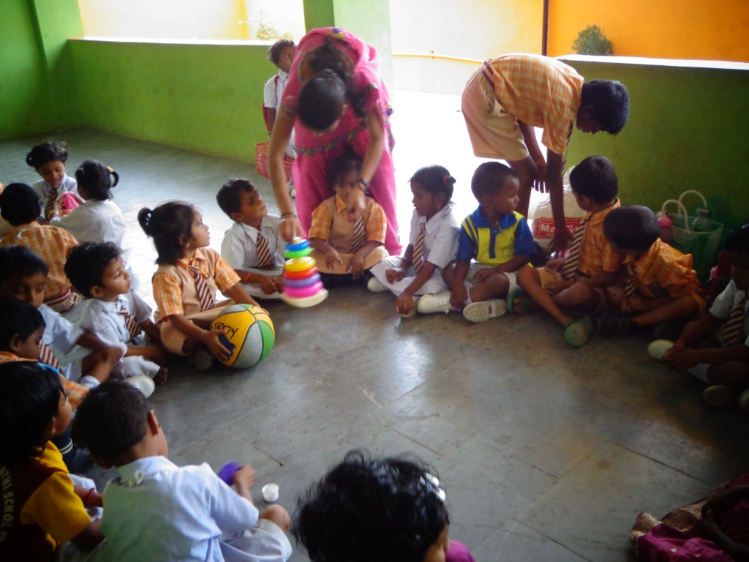

I had a lengthy discussion with the teachers as to how to improve the quality of education. One of the solutions that came out was since computers are there, we can show net based simulations/other e learning facilities to support activity based learning. The issue was discussed with Smt. Bharati Devi and necessary funds were given by me to immediately arrange one internet connection.
A detailed teacher meeting was held apart from class to class inspection. They were asked about the method of assessment of the children. It was indicated by them that they give assignments and also conduct examinations. They were impressed about the need for a continuous assessment of the child right from how neatly they wear the dress, their behaviour with the adjacent children, teachers, and enthusiasm in interacting with teachers while learning the subjects. They were advised to give priority in making the children aware of their town, state and such subjects that would make them self reliant in their daily life. The teachers have responded enthusiastically
The school is recently painted and is giving a neat and tidy appearance. There is no separate playground for the school. The children have to play with in the school compound itself. Parent meetings are reported to be conducted once in a month and the participation is low.Smt. Bharati Devi says since most of the parents are not paying the school fee of the children, they are worried that the school will ask for fees payment if they go. We have told her that it is necessary to have the parent meeting to have a clear understanding of the child at home and at school and identify the steps required for overall development of the child. I have also requested to depute some of the teachers to the student’s homes and explain the need of attending to the parent’s meetings.
The school is doing well and would need further support to setup science labs in some basic form addition to the funding normally provided.

