Jeevan Gnanodaya School for the Deaf - Site Visit
Date: Monday December 5th, 2011
Visited By: Mrs Shanthi Ravikumar and Mrs Vatsala Venkatesh
(Mother and Aunt of Asha Austin volunteer Charanya Ravikumar)

My visit to the Jeevan Gnanodaya School for the Deaf was made on Monday, December 5, 2011 with my sister-in-law Mrs. Vatsala Venkatesh. I have visited the school once before in the past with my daughter Charanya, in August 2009. We gave only a one-day heads up to the school that we were going to visit since we did not want any special arrangements made for us. We reached the school around noon-time and first met with Mr Devarajan at the school office. He gave me a general update about the school:
- All 9 ITI students had passed their exams. I was shown all the certificates along with the two employment order forms for 2 of the students who had already started working.
- On that day, some of the10th std. students had gone to Chrompet to collect their hall ticket for the upcoming March board exams. Others had already gotten it in a previous visit.
- In general, he said the school was fine, and the children were doing well, but he had some financial concerns.
- In regards to the wedding hall, he said that the hall would be finished by the end of the year. From what he said, he is getting a lot of inquiries, but I don’t think actual bookings have been made yet, but he seemed positive that they would soon.

We then set off to look around the school. Our guides were one of the 10th std. teachers and Mr Devarajan’s son Jeevan, since Mr Devarajan himself had some office work to take care of. A couple of the upper grade classes were going on in a large open space in the school’s front lobby itself. The floor above the office has 2 small classrooms and one big room in which typically 3 classes go on simultaneously. Students sit around in a circle so that all of them can see each other as well as the teacher since they still communicate largely via lip-reading. We were shown how classes typically are conducted. Students typically learn via reading/writing on the board and lip-reading what the teacher says. We also noticed that some amount of sign language was being used. I don’t think this is any official sign language like ISL, but more just signs that teachers themselves were making up – that defined shapes, numbers etc. We also noticed that ~90% of the students had hearing aids on.

In one of the classes in the big room, I noticed an interesting test that was happening. A couple of students were sitting on chairs and facing the wall. The teacher would say a word and the students would hold their hands up and sign what they heard. I think this was being done for the students who had partial hearing. We saw the teacher hitting a small drum – and for instance, if she hit it twice, the student would hold up 2 fingers.

In general, we felt that most of the students seemed to understand what was being taught and were able to answer most of the questions that were being asked. The students and teachers seemed to have a very good rapport. The smaller children especially looked to be very close to the teachers. We felt that were being well taken care of and the kids got the individual attention they needed in class as well. I noticed two students (one boy, one girl) in the 5th standard class who appeared to be mentally challenged. I asked the teacher about them. She mentioned that they had been admitted just recently. Apparently they did not respond to anyone or sit in the classes initially, but they now sit in the class and listen to what the teachers tell them, even though they don’t respond as much. They appeared to be wary of strangers. I am not too sure if they were deaf as well, this is something that needs to be clarified. I forgot to check with Mr Devarajan.

After that, we went to see the rest of school, located in a separate building, where most of the older children were having classes (classes 7 onwards I believe). We spent some time in each of the class. I got the impression that the older children in general seemed to hear better. There were smaller numbers of students in the higher standard classes. Students were still seated in a manner that they could see the teacher clearly and were able to lip-read. The content being taught was more complicated, but the students seemed to grasp it well. In one of the classes we saw, Tamil poetry was being taught – I was pretty impressed, since the poems were not simple ones, the language was pretty intricate.

We noticed that a couple of rooms had no lights – Mr Devarajan mentioned that the rains had affected them, and he was getting them replaced soon. We then went to see a class where an ITI session was going on. There is a separate building for the ITI, but some of the theory sessions go on at the school as well. We didn’t visit the ITI during this trip The school currently teaches upto the 10th grade, after which some of the children continue on to ITI. Mr Devarajan’s vistion is to include 11th and 12th grades, which will allow students to continue on to college as well and specialize instead of opting only for vocational education.

Mr. Devarajan said that he will send out a detailed update for the second half of the year. He also said that he will scan the Government order that allows him to raise the fees for the primary school and will email it soon. At this point, it was around 2pm. I then realized that it was probably past the lunch-time for the children, and asked when they typically have lunch. It completely slipped my mind to ask before. He said 1pm, but they had delayed it today to allow us to visit the classes thoroughly. I told him to please let the children eat and we can continue our discussions later. The children ate in a long corridor in the 2nd building seating on the floor on both sides.

While the children were having lunch, we visited the Kalyana Mandapam (wedding hall). The mandapam is about 10 mins away from the school, along the bypass road of the main state high way. The location is easily accessible from the state highway. The mandapam looked pretty spacious. He mentioned that the total area was 10 grounds. (1 ground is roughly 2400 sq ft.) He said that the hall can hold about 600 people. The mandapam is 2 floors high. Both floors looked like it had proper flooring done. The ground floor has 4 guestrooms, kitchen, bathrooms, as well as open space, which Mr Devarajan said he plans to use for 2-wheeler parking now, and then maybe for holding functions/events later when there is more demand.. We saw all the chairs/tables stacked downstairs as well. Everything looked complete except for the fittings in the bathroom. The 2nd floor has the main wedding hall and it looked mostly done also. Completion by December end looked feasible for me.

My Devarajan mentioned that the going rate for the mandapam in that area was around 50,000 Rs. I was wondering if people paid that much in Chengelpet, he said yes, especially due to the recent growth in Chengelpet in the last few years. It is no longer a small suburb town, but quite a bustling city of its own. There is another hall in the area that is smaller and charges about the same as well. Overall, I was very impressed with the mandapam and also with his initiative to create a mode for self-sustenance for the school. My daughter had mentioned that Asha has not been able to send as much funds in the past year and this mandapam would be very important to the school in the future, so it was good that he had done a good job for it. I did ask about how he was able to take on such a huge project given the financial challenges he has had. He mentioned that he was able to purchase the land, which was pretty much the biggest expense, at a pretty subsidized rate, and he did get quite a bit of donations from donors who appreciated the efforts. The rest, he had to take as a loan. He also mentioned that other than weddings, the hall could potentially also be used for other events, especially during the non-wedding season.

Due to time constraints we were not able to visit the Primary school this time. But in general, he mentioned that the school was doing well. After the mandapam visit, we drove back to Chennai. I had visited the school a few years ago with my daughter, but my sister-in-law Vatsala was visiting the school for the first time, so I asked her what she thought overall. She mentioned that she was pretty impressed overall. Her main questions had been regarding how the children were able to manage after the school, especially in their respective jobs. Mr Devarajan mentioned that most of the students have not had any major issues. They communicate mainly verbally, through signs, and if they really have trouble, they write down what they are trying to say. There is still quite a bit of emphasis on getting the children to say words, sentences, because of this very reason, and they have seen it help in the long-term. Overall, both Vatsala and I had a good trip to the school. I wish we could have gone for a longer time, but nevertheless, it was good to see the school and get to meet most of the students. A few of the pictures I took during the trip are attached in this document.

School Pictures
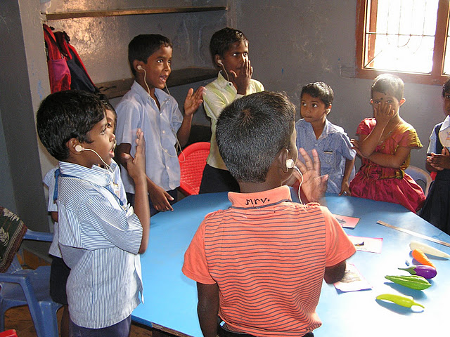

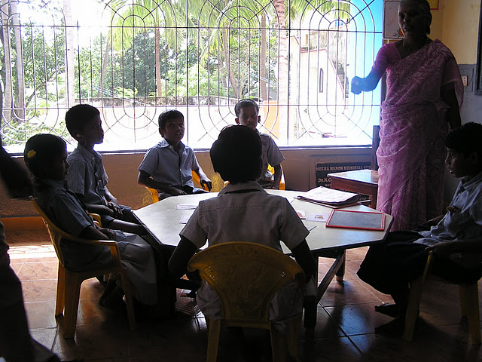
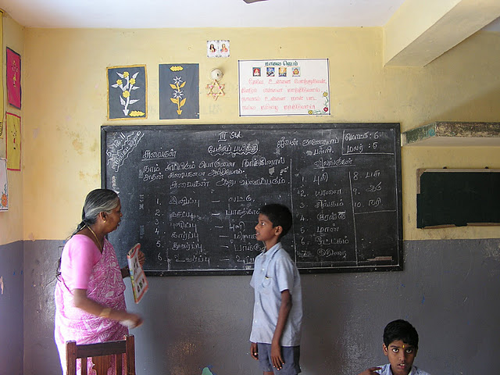
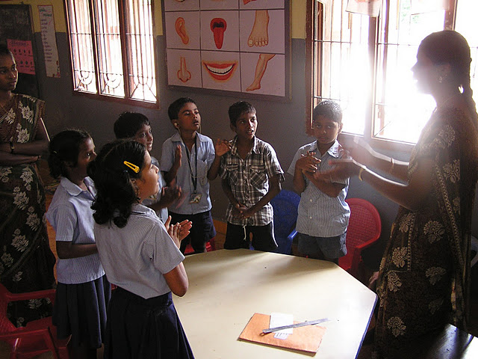
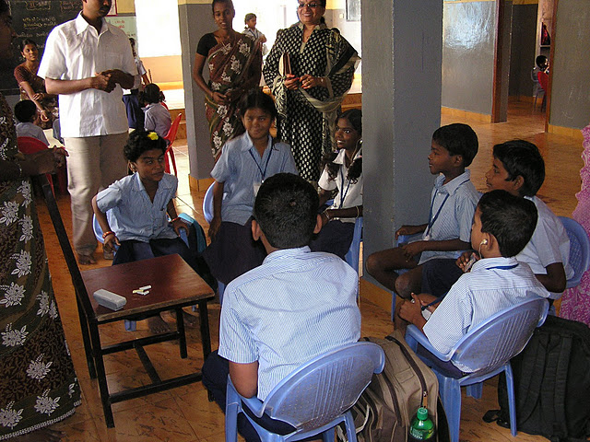
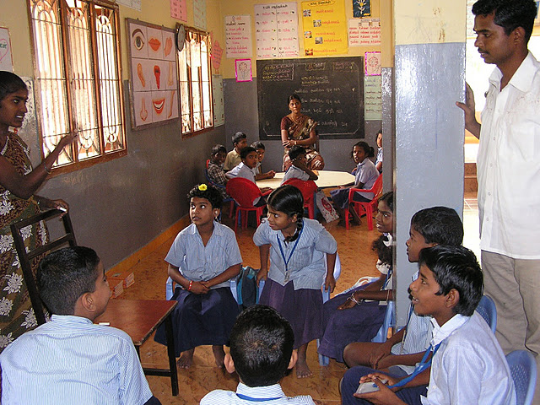
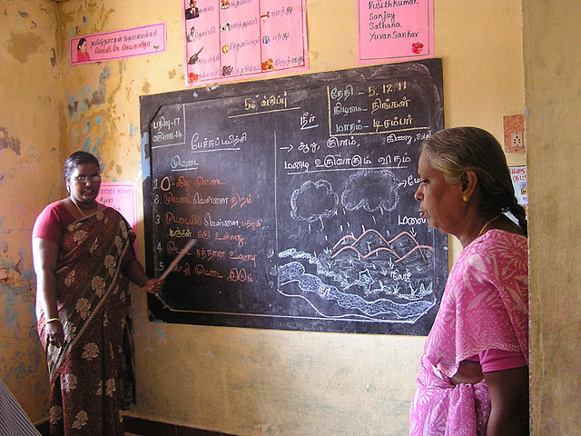
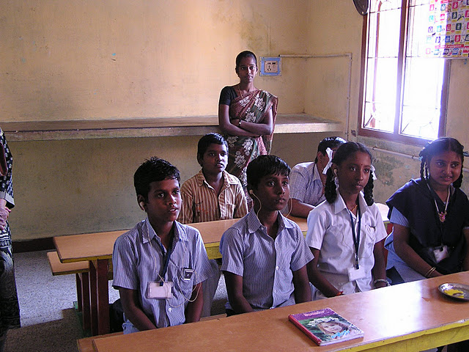
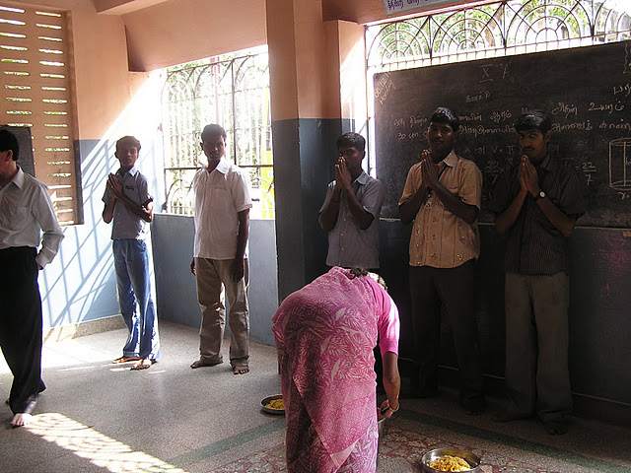
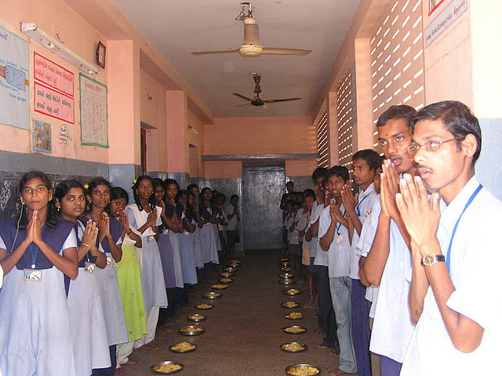

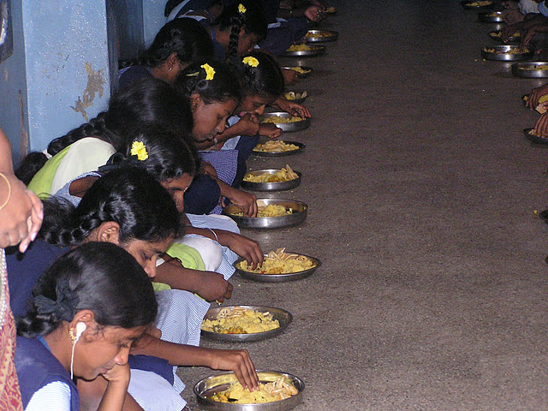
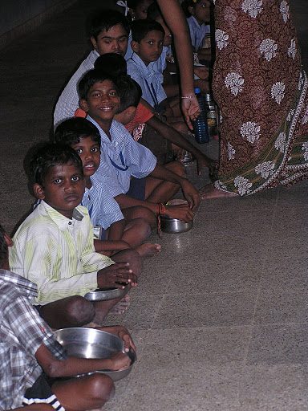
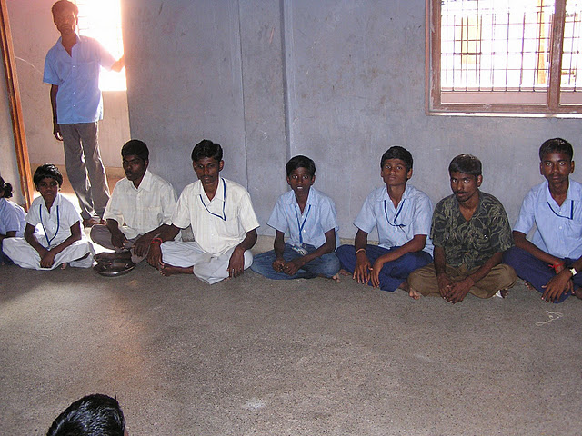
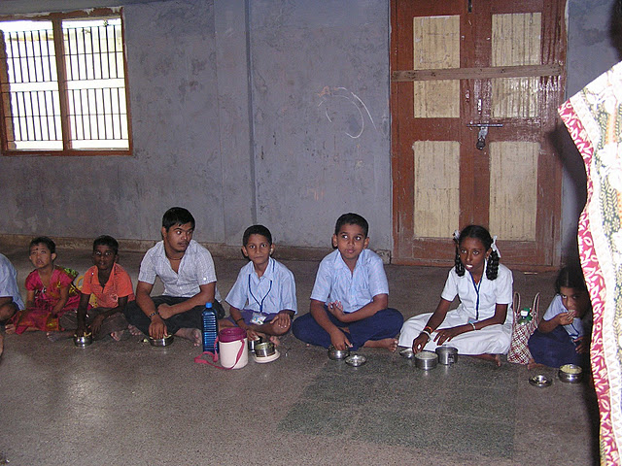
Wedding Hall Pictures
