Project Renewal Proposal 2015-2016
November 4, 2015
Name of the Project: Pranabananda Boy’s Hostel.
Address: Bharat Sevashram Sangha, Sahapur, Malda.West Bengal.
Project Stewards: Manoj Bhattacharyya, manoj_b@comcast.net
Short Description: Asha-SV has funded this project beginning 2007. This project provides complete room, boarding and educational facilities to local backward and poor students. Very young students get training at the on-site primary school and then attend local high schools.
The Bharat Sevashram Sangha in their Malda Ashram runs this boy’s hostel. Students from around Malda district, who would otherwise never attend any school, stay in this hostel and attend schools. Housing for the students exists in the premise and up to 130 students have been provided with free room and board in the past. The hostel has been functioning from 2007 with Asha-SV funding after staying closed for few years before 2007 for lack of fund.
About Bharat Sevashram Sangha:
Bharat Sevashram Sangha is a spiritual brotherhood of monks and selfless workers devoted to the service of humanity. It is a purely philanthropic and charitable organization with non-sectarian, non-communal and non-political character and outlook.
Bharat Sevashram has forty-three centers in India and ten outside the country. The only source of funding of this organization is donation from individuals and groups.
A collection of slides are available that shows the activities of this organization.
Without Asha-SV funding this hostel will have to be closed down. A variety of people have appealed to Asha and me for continued funding. The teachers have called and sent emails for continued support. The hostel in-charge has called repeatedly.
Some points worth mentioning:
- Currently, 50 students are provided room and boarding. Students also get medical attention, decent clothing and participate in variety of recreational activities.
- The on-site elementary school has about 100 students and more than half of them come from local area and pay tuition (albeit a very small amount). The tuition from non-boarding students provides a large percentage of teachers’ salaries.
- Have regularly submitted audit report, fund receipts and students’ mark sheets.

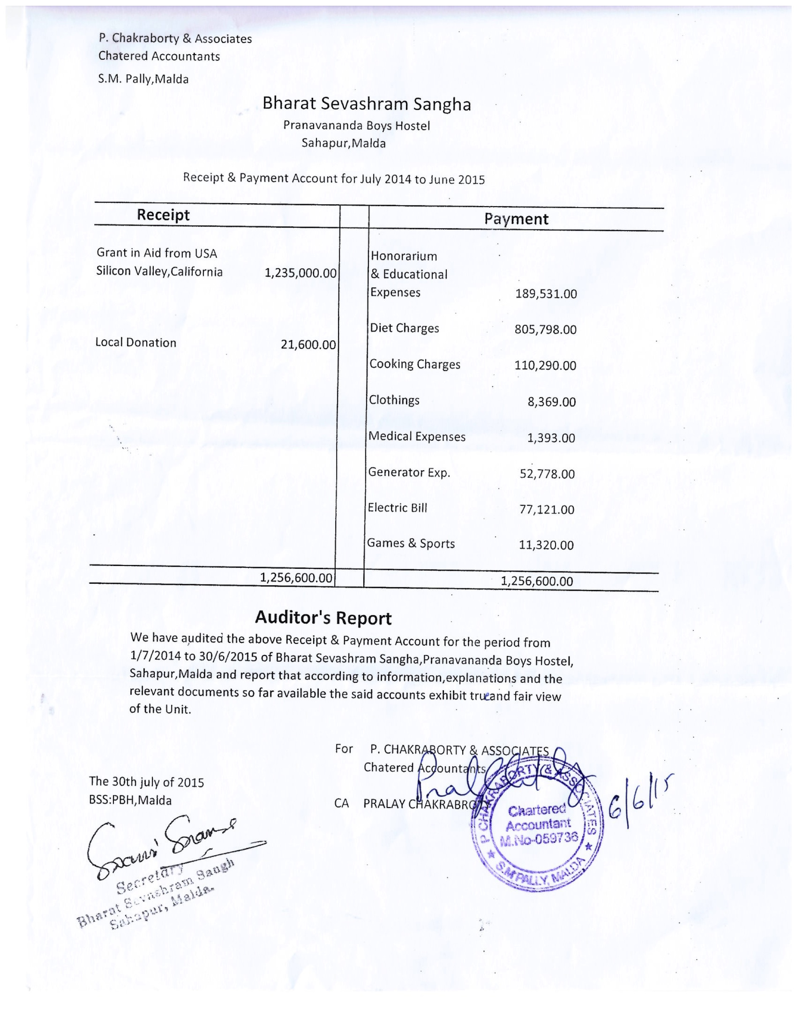

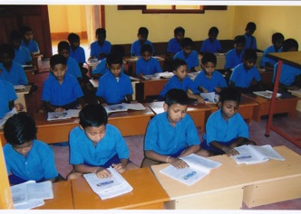
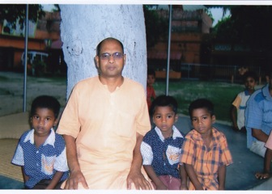
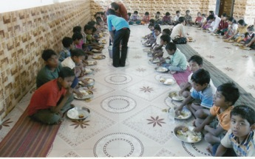
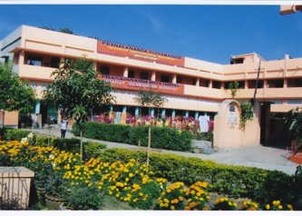

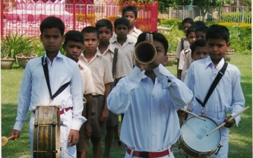

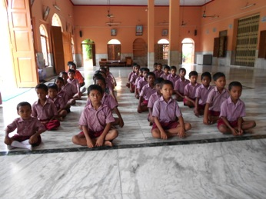

A reasonably good score and not so good score.

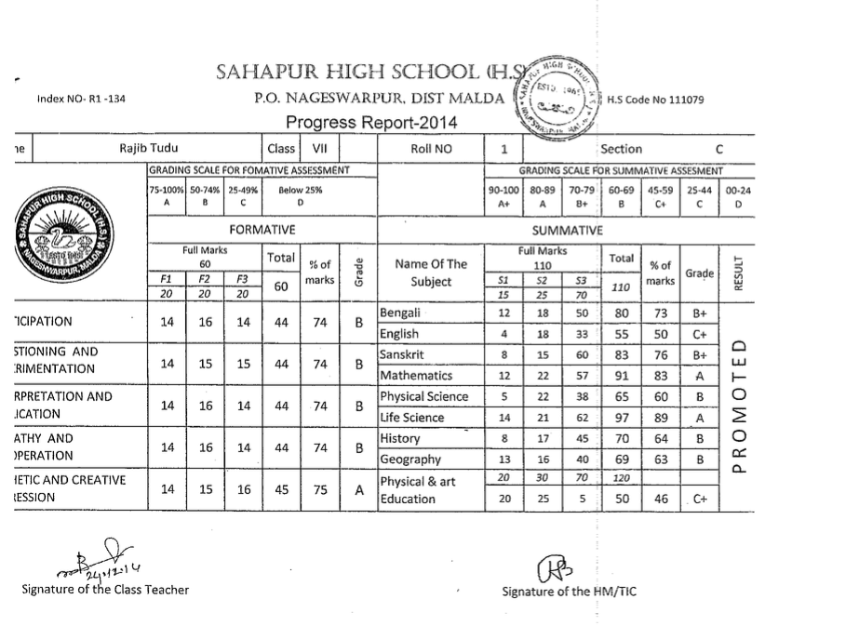

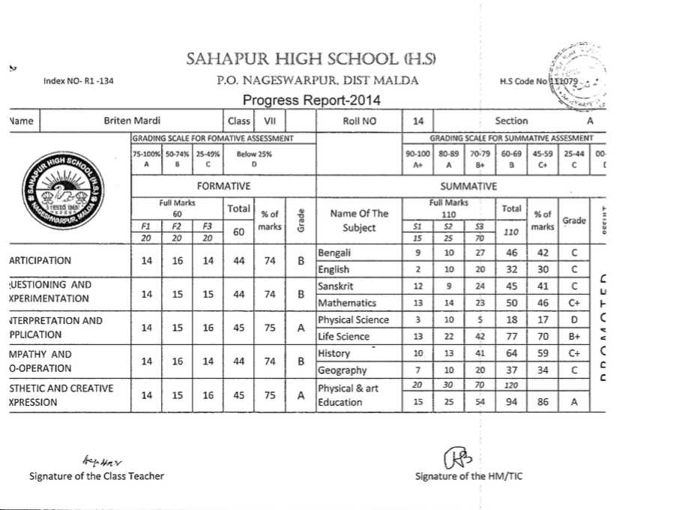

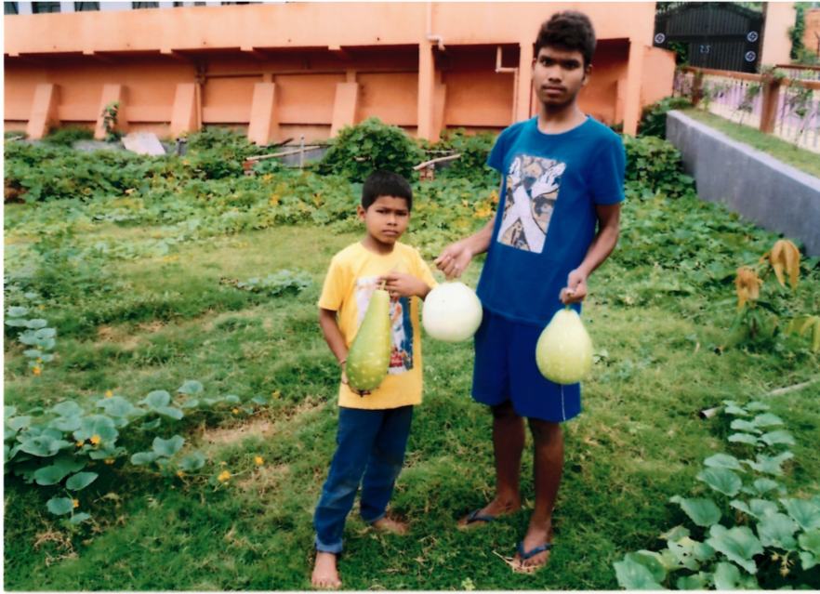
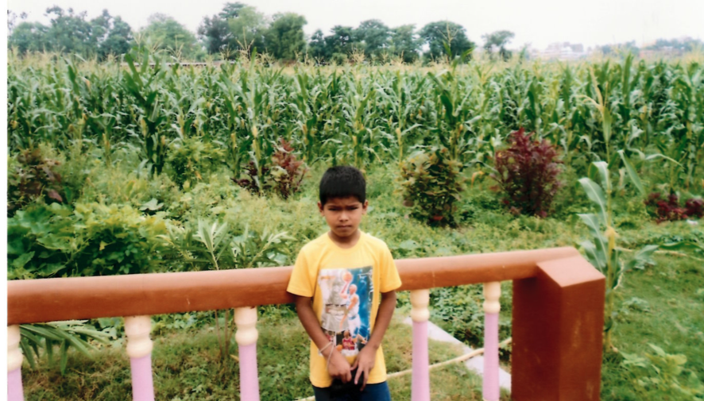

Budget for 2014-2015:
Item and description | Total Amount (Rs)
Food charges for 50 students; Rs 2000 per month*12 months | 1200000 ⁺
Salary for 3 cooks, Rs 4000 pm* 12 months | 144000
Driver salary (Rs 4000 * 12) | 48000
Hostel fulltime staff salary (Rs 5000 * 12) | 60000
One Gardener Rs 3000 * 12 | 36000
Medical cost total for all students | 20000
Cloth for 50 students Rs 500/student (mainly winter blanket) | 25000
Total donation sought from Asha-SV | Rs 1533000

⁺Actual food cost is much higher. We pay only this much.
The total amount translates to 1533000/(65.5*50*12) = $39 per student per month.
This compares with Rs 1233000 given in the year 2014-2015

Site Visit Status:
Last site visit done in March of 2015.

