
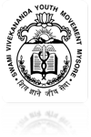
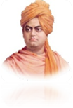




[Project period from 1st April 2011 to 31st March 2012]

Annual report
1st April 2011 to 31st March 2012

FUNDING AGENCY

ASHA FOR EDUCATION – Silicon valley- Chapter
United States of America

Submitted to
SWAMI VIVEKANANDA YOUTH MOVEMENT
Mysore

GOAL
The project is to support “Academically bright and economically needy students, who wish to continue their college education and become good human being”

OBJECTIVES
To encourage/ motivate parents to let their children continue higher education.

To assist their academic needs like coaching class and knowledge center, bus pass.

To provide information on professional courses and opportunities. (Education, Career Guidance and Counseling).

To develop student’s confidence level and handle their academic and personnel stress.

PROJECT DETAILS
Project Name | Vidya Kiran
Organization Name & Address | Swami Vivekananda Youth Movement  Hanchipura Road, Saraguru  H.D.Kote (T), Mysore (D)  Karnataka (S), INDIA  Ph: 08228 – 265412/413  www.svym.org.in
Project Area | Mysore District
Office Address | Vidya Kiran, # 248, B.N. street,  Near K.R.Hospital, Mysore.
E - mail ID | manojsebastien@svym.org.in  vidyakiran@svym.org.in  jyo.mysore@yahoo.com
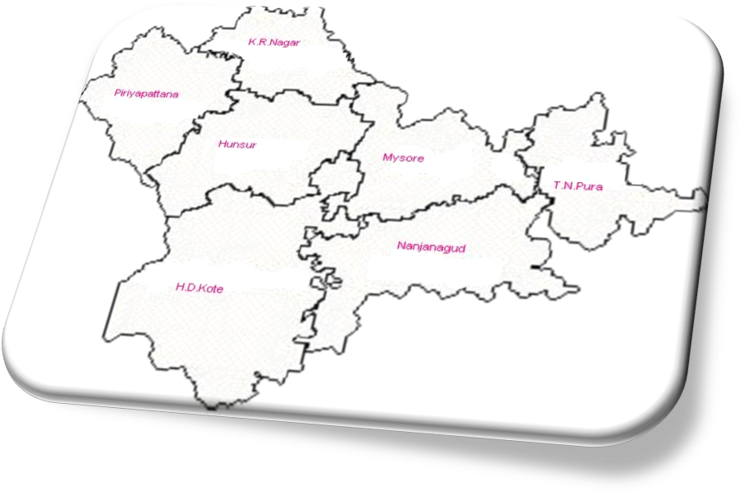
Geographical area of Mysore district

STAFF DETAILS

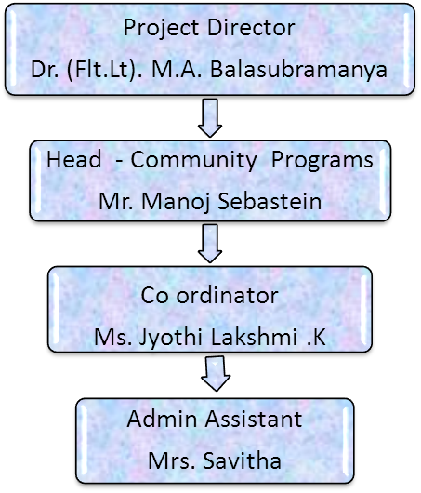
Report Highlights
- Successful Journey in II PUC Results.

- Career Guidance and Counseling.

- Bridge Course.

- New Students Selection Process.

- Coaching Class.

- Spoken – Grammar English.

- Motivational or Skill Improvement Activities.

- Parents Meeting.

- Exposure visit.

- Counseling.

- Case study.

- Donor/Well wishers visit.

- YUVA PAYANA – Annual Programme.

- Innovations.

- Meeting and Review.

- Opinion from Students/Parents.

- Capacity Building for staffs.

18. Challenges & Solutions.

19. Future Plan.

Successful Journey

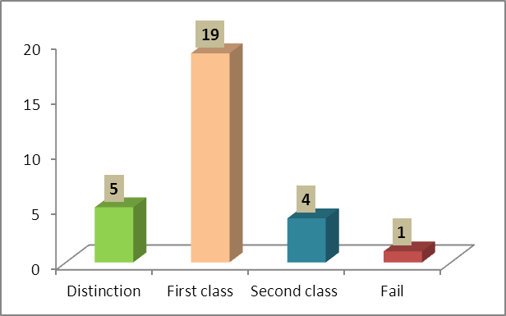
II PUC results were announced on 10th May 2011, out of 29 students, 28students were promoted; remaining one student is taking the supplementary exam in July - 2012. This year we have achieved 97% results

 | Boys | Girls | Total
Distinction | 05 | 00 | 05
First class | 14 | 05 | 19
Second class | 02 | 02 | 04
Fail | 01 | 00 | 01
TOTAL | 22 | 07 | 29

After the result, students have joined to various courses in various Districts of Karnataka state. Details are...
BE | 13
BSc | 11
BSc Agriculture | 02
B Sc Horticulture | 01
BAMS (Bachelor of Ayurvedic Medicine & Surgeon) | 01
Total | 28

Career Guidance and Counseling

We organized Career Guidance and Counseling for those who have passed 2nd PUC. Aptitude tests were given on the basis of the results. This has helped us to check their interest in various courses. As per their interest suggestions were also given. Counseling was given by Ms. Mamatha & Mr. Tavi Kumar (SVYM staffs) 10 students had participated in this activity and got awareness on professional course.
Bridge Course

This year we have introduced bridge course for slow learners and also who have scored below 65% in their I PUC. Some of our senior students (Shibu Andia, Chethan Kumar & Manjunath) who have completed II PUC this year; they are assisting in taking class for these students and help them understand subjects which are difficult to them. Students feel this method is good and they feel free to ask any kind of doubts and clarify on spot. This methodology has helped students to prepare their 2nd PUC course.

New Students Selection Process

- We started college visits from 28th to 29th June 2011 for student’s selection.
- We received 173 applications seeking our support.
- Entrance test was conducted on 30th June and July 1st 2011 for the students.
- Totally 140 students had attended the entrance test.
- We visited 76 students house and assessed their socio – economical condition with the help of PROBASE students (Masters in Social work), VHSC and Samastha staff (these are all other projects of SVYM) from 8th to 12th July 2011.
- We did individual parents meeting/counseling with the help of project director and Samastha team from 21st to 23rd July (35 students & their parents)

Observation period for newly selected students:
Out of 35 students 30 students were regular to the center and senior students handled seminars for them. On the basis of the seminar, the students were given tests and feedback was given for their improvement. Also we assess their interest, regularity, commitment and academic performances and also feedback given to them for their improvement.
Finally 30 students were selected for the year 2011-12. The selected students will be supported from ASHA For Education 20 students & 10 students from Dr. Rao (A Philanthropist). The details are....
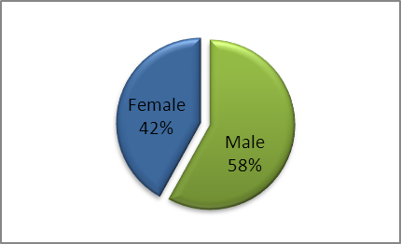
Gender wise
Boys | 18
Girls | 12
TOTAL | 30
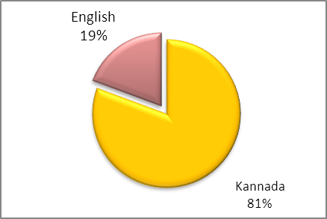
Medium of Instruction in 10th standard
Kannada | 24
English | 06
TOTAL | 30

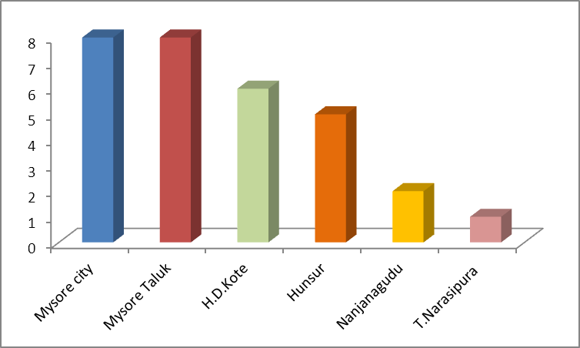
Taluk wise
Mysore City | 08
Mysore Taluk | 08
H.D.Kote | 06
Hunsur | 05
Nanjanagudu | 02
T.N.Pura | 01
TOTAL | 30

Coaching Class

Coaching class for II PUC-Science started from April and II PUC Commerce started from June 2011. I PUC-Science started from August 2011. Details are

Class | Name of the Lecturer |  |  | Subjects | No. of class taken during the year |  |  |  | Class started from  the date of
Class |  |  |  | Subjects | No. of hours |  |  |  | Class started from  the date of
Class |  |  |  | Subjects | Plan | Achievement | % |  | Class started from  the date of
II PUC – Science | Mr. J. S. Gowrachari |  |  | Physics | 127 | 177 | 139.37 |  | 18.04.2011 to 04.02.2012
II PUC – Science | Mr. B. S. Mahesh |  |  | Chemistry | 102 | 129 | 126.47 |  | 04.05.2011 to 27.01.2012
II PUC – Science | Mr. Uday Shankar |  |  | Maths | 159 | 162 | 101.88 |  | 06.05.2011 to 29.02.2012
II PUC – Science | Mrs. Nandini |  |  | Biology | 147 | 147 | 100 |  | 02.05.2011 to 30.01.2012
I PUC - Science | Mr. Rajanna |  | Physics |  | 80 | 100 |  | 125 | 25.08.2011 to 10.02.2012
I PUC - Science | Dr. M. G .Ramananda |  | Chemistry |  | 82 | 81 |  | 98.78 | 01.08.2011 to 13.02.2012
I PUC - Science | Mr. Ravishankar |  | Maths |  | 126 | 129 |  | 102.38 | 25.08.2011 to 10.02.2012
I PUC - Science | Mr. Raveendra |  | Biology |  | 95 | 95 |  | 100 | 01.08.2011 to 15.02.2012
II PUC - Commerce |  | Mr. Jagadish |  | Accounts | 113 | 138 | 122.12 |  | 07.06.2011 to 27.02.2012
 |  | Mr. Rajesh |  | Economics | 104 | 105 | 100.96 |  | 08.06.2011 to 02.03.2012

Spoken – Grammar English

Most of our students are from Kannada medium because of this student were not interested towards their education, lost confidence and scored low marks in their exams. So, we planned to provide English class for the students and searched for an eminent person. we received support from Mr. Dorai Krishnan, a retired scientist (specializes in Physics) wish to take an English class for students voluntarily. His approaching method is different, through subject basis he teaches English. Students are learning English and now they are understanding their subject very easily.

Motivational or Skill Improvement Activities

Date | Name of the program/activities | Details of the program /activities
22.04.2011 | Universal Earth day | All students discussed on how the Earth is being destroyed by human activities and what are the measures that we can take up to solve this issue. 30 students attended it.
27.04.2011 | Debate on “Mobile boon or curse for youths” | All students put forward their arguments to explain their point of view about the given topic in excellence. 31 students attended it.
29.04.2011 | Quiz | In this activity each students asked questions to other students. 30 students attended it.
06.05.2011 | Basava Jayanthi | Students spoke about Basavanna’s life history and his contribution towards the society. As a result of this program students came to know more about him. 30 students attended it.
09.05.2011 | Mother’s day | Every student expressed their thoughts about their  Mother in a pleasing way which showed their intimacy towards their mother. 31 students attended it.
11.05.2011 | Pick and Speak | To improve communication skills of students from this program activity. 30 students attended it
12.05.2011 | Concentration game | To check the students concentration and involvement  with respect to the given subject. 32 students attended it.
16.05.2011 | Candle Light Memorial Day | Students took part in the procession from K.R .Hospital to Town Hall. 30 students attended it.
19.05.2011 | Quiz and Word game | Helped to improve the general knowledge and word knowledge of the students. 31 students attended it.
21.05.2011 | Usage of e-mail ID | This session was organized to make the students aware of the usage of the E-mail ID and also to create e-mail ID.32 students attended it.
24.05.2011 | Common wealth Day | Students discussed about how this (Common Wealth organization) organization was formed and how it brought up a change in the world. 30 students attended it.
31.05.2011 | World Anti tobacco Day | We took part in the Jatha held from K. R. Hospital to Function Hall. 40 members attended it.
22.06.2011 | Interaction with senior students | Senior students shared their experiences and difficulties during their II PUC. From this activity, present II PUC students got information on how they cope with stress and motivated to concentrate on their studies. 32 students participated.
06.06.2011 | World Environment day | In this session we came to know about the origin of World Environment Day and also about how we can introduce new techniques to maintain good environment. 34 students attended it.
09.06.2011 | Quiz | Conducted on the topic of ‘Word Knowledge’. Students came to know about their capacity in accordance with the word knowledge. 29 students attended it.
14.06.2011 | World Blood donor’s day | The eligibility criteria for donating blood and what should be the state of the person while donating blood were discussed. The distribution of Rh +ve and Rh -ve throughout our country was also discussed. 30 students attended it.
15.06.2011 | World Child labor day | What are the measures to control child labor & who are child labors & why they are so were some of the topics discussed. 31 students attended.
17.06.2011 | Crossword game & Quiz | To enhance the word knowledge this program was conducted. The quiz was also conducted. 29 students attended.
18.06.2011 | Quiz | The quiz was conducted to check the general knowledge of the students. 30 students had attended.
20.06.2011 | Father’s day | All students shared views about their father & how they are going to help their father in future. 29 students attended.
21.06.2011 | Debate on “Believes/Myths” | Here students discussed the difference between belief and superstition and in the current world is there any need for us to have superstitious mind. 32 students attended it.
05.07.2011 | Management Fest | Participated and counseling done in the program of Management Fest at V – LEAD (A unit of SVYM). Here our two students got 7 prizes (each) in the quiz.
10.09.2011 | Teacher’s day | Our students celebrated Teacher’s day at CAVA College. The entire program was done by the students.  - Lecturers shared about their favorite teachers.  - Students organized games for entertainment to lecturers.  - Lecturers expressed their appreciation to all students, staffs and organization for giving wonderful experiences.  End of the program sweets and snacks was distributed. 77 students & 06 lecturers attended.
15.09.11 | Engineer’s Day & Debate on “Reservation for woman” | - Students recalled the memory of Sir. M. Vishveshwariah and his work efficiency and punctuality.  - Two groups were formed for debate on the issue of ‘reservation for woman’ was effectively discussed. 71 students attended.
03.10.11 | National Festivals | Celebrated Gandhi Jayanthi, Lal Bahudur Shastri Jayanthi and Valmiki Jayanthi. We recalled their lifestyle, thoughts and sacrifice for the nation. 66 students attended.
22.10.11 | Motivational class | Mr. Harish Gudari, a staff of Prema Vidya project, took class on ‘Way for better academic performances’ and ‘personality development’. He educated the students by giving case studies and through games. 58 students actively participated.  We appreciated 04 II PUC students for their good academic performances during this year on the same occasion.
19.11.11 | Celebrated Kannada Rajyothsava, Kanakadasa Jayanthi, Children’s day & STAR OF VIDYA KIRAN | On this occasion we rewarded 10 students as STAR OF VIDYA KIRAN for their excellent leadership for maintaining Library, classroom and organizing seminar, program. We also rewarded for their creativity, initiative and responsibilities. 67 students attended.
28.11.11 | Motivational class | Mr. Nagaraj, Administrator of Prema Vidya project, interacted with our students about their goal and academic performances. After the discussion with students he discussed with the staff about operational issues and next year plans. 60 students attended.
26.01.2012 | Republic day | Republic day was organized in V-LEAD. Students involved in quiz program and they gave a cultural performance on the stage. 45 students attended.
11.02.2012 | Interaction | Mr. Sudharshan .S, Director – Academics & Programs, V-LEAD interacted with students about their academic performances and growth on the 11th of Feb- 2012.
04.03.2012 to 07.03.2012 | Chemistry workshop at Jawaharlal Nehru Center for Advanced Science Research, (JNCASR) Bangalore, for II PUC students. | 19 students and one staff attended the workshop. The workshop helped students to develop their curiosity in Chemistry. Here they did Chemistry experiments practically and individually, after each experiment they were very excited.
30.03.2012 to 31.03.2012 | Workshop on ‘Skills for Personal Up-gradation’ for I PUC students | It was a wonderful experience and exposure for them. Students actively participated in each session and contributed their opinion, doubts. 26students one staff attended.

Spiritual Retreat

We visited the Rama Krishna Ashram as part of Spiritual retreat with students on 28th September. Swami Mukthidanandaji & Swami Veerashananda gave a talk on life skills, meditation and thoughts of Vivekananda. They distributed notebooks for 05 students and also distributed to all students a set of book on personality development.
After lunch we visited Vidya Shala, Knowledge Park and Dhyna Mandira. In the park students were practically doing their Science related experiments. 64 students and 02 staff attended.
Parents Meeting

Date | Class | No. of Students | No. of Parents | Discussed Issues
05.04.2011 to 19.04.2011 | II PUC | 36  (Out of 39 students) | 41 | - Academic results (I PUC).  - Student’s difficulties (identified).  - Regularity.  - Personality development.
10.12.2011  to 18.12.2011 | I PUC | 30  (Out of 30 students) | 45 | - Family support.  - Academic Performances.  - Strength & Involvement in studies.
23.01.2012 to 11.02.2012 | II PUC | 30  (Out of 39 students) | 30 | - Family support.  - Preparation of exams.  - Food habits, health & life style.  - Future plan.

Exposure visit

23.06.2011 | Vivekananda Express | We visited Vivekananda Express- train on the occasion of 150th birthday of Swami Vivekananda. The students got information on the Vivekananda’s life and thoughts. 34 students had participated.
10.10.2011 | Visit to Science Exhibition & Natural Science Museum | We visited, Science Exhibition organized by Mysore Medical College and Natural Science Museum. Students observed structure of human body, insects and animals. History of human age.....60 students visited.
26.11.2011 | Visit to Srirangapattana, Daria Doulat, Gumbaz, Melkote, Kartigatta and Krishna Raja Sagar (K.R.S.) | These are all historical places which were ruled by Tippu Sultan. Students were shared historical information with each other and enjoyed.

Counseling

Counseling is a main tool to understand students and support them psychologically by providing proper professional counseling. These adolescent boys and girls need regular counseling because they have a lot of disturbances from their peers. The common counseling issues are
- Inferiority complex – Students come from a poor family background and the majority of their parents are uneducated.
- Medium of instruction - Kannada medium.
- Academic results/performances.
- Memory loss/short term memory.
- Single parent or family issues, alcoholism, divorce.
- Lack of role model (They are not found in their environment).
- Lack of individual attention and identity.
- Different environment – They compare to rural and urban lifestyle.
- Hostel life or transportation.
- Socio – Economical issues.
- Students like sharing.
- Lack of communication and dress code.
- Lack of Affordability.
- Media/telecommunication influence.
Case study

1. MANASA – I PUC –PCMB – Maharani’s Junior College.

Manasa have scored 87% in SSLC (10th standard) and she studied in Kannada medium. Her father is a cook (catering) and mother is a daily wage laborer in plastic storage company. Her younger brother is studying in 5th standard. They are living in a rented house at Yaraganahalli, Mysore Taluk.

After selection by Vidya Kiran, she expressed confidently, ’I will improve my academic performances because now I’m a Vidya Kiran student’. Regularly she comes and attends the class but she scored low marks in unit tests.

During the counseling she cried and slowly expressed that nowadays she is not able to concentrate on her studies and not interested in anything. She said her parents are working, they come to home late night and they insist to study. She said she felt alone. We worked on her, to identify her strength and how to overcome stress by herself. Finally we gave some tips to improve academic performances and now she is slowly improving her performances.

2. SUNITHA – I PUC –PCMB – Maharani’s Junior College.

Sunitha scored 83% in SSLC (10th standard) and she studied in Kannada medium. She doesn’t have her father and her mother is an agricultural laborer. Her elder brother stopped his education and took over the family responsibilities, he is a construction laborer. Her elder sister married and younger sister studying in 8th standard. They are living in Dandiger village, Varuna hobli, in Mysore taluk.

After she was selected in Vidya Kiran, she regularly comes to the center and her performance is good. Meanwhile one fine day, she told I want to change my course from science to arts. Science is very difficult to understand, so I’m not continuing this course as she was also suffering from fever. Immediately her brother and uncle brought to our notice. In counseling, we focused on her strength and showed her marks in the test. We gave examples of other senior students and how they successfully continued their education and opted for professional courses. Slowly she changed her mindset. Presently she is concentrating on her studies and also actively involved in other activities.

3. NANDA KUMAR – I PUC –PCMB – Maharaja’s Junior College.

Nanda Kumar is excellent in his studies and he scored 92.16% in SSLC (10th standard). One year back his father expired because of illness and his mother is an agricultural laborer, she is the only person taking care of her family. He has an elder sister, she has completed her 12th standard and she stopped her studies because of economical problems. Now she is working in a provisional store and continuing her education through correspondence. They are having an un-constructed house and they don’t have any other source of income.
After 10th, in the summer holidays Nanda Kumar helped his family by working in a construction company and earned some money. This money helped his family and admission for college education . One of his high school teacher also supported him to join the college.
He was selected for Vidya Kiran support. His academic performances in I PUC was good, almost he was first in all unit tests. He was from Kannada medium but he is not hindered from the medium of instruction. He is perfectly using all the facilities and opportunities in the center. He is doing seminar well and helps to other classmates in the studies. He got 84% in I PUC.
Presently he is going to the construction work for his next academic needs and also preparing for II PUC.
Donor/Well Wishers visit

On 5th of April 2011 Dr. Rabin from USA ,visited our center and she interacted with our Students

students. She likes students' confidence while conversation.
YUVA PAYANA – Annual Programme

“150th birthday of Swami Vivekananda” and “Yuva Payana” was observed on 12th January 2012 at Doctor’s Community Hall in Mysore. (Yuva Payana means “Journey of Youth Students”. In this program we awarded our II PUC supported students as a sign of encouragement to their future and to the present students).
- On this occasion jatha was taken out on the main streets of Mysore city till District Health office by raising slogans of Swamiji. In jatha more than 350 students including parents and staffs had participated.
- The stage programme was completely led by our students from anchoring to vote of thanks.
- ‘Varshacharane’ a special activity for staff, was inaugurated in the memory of Swami Vivekananda on his 150th birthday.
- ‘VIVEKA YOUNG MINDS’ senior students' association was inaugurated.
- Local donors and volunteers were felicitated on the occasion. Mr. Pratap Kumar Simha, Proprietor of Hotel Indra Bhavan, he has provided midday meals to the needy students. Another volunteer Mr. Dorei Krishnana retired scientist (specialized in Physics) he is taking free English class to our students.
- “Pratibha Puraskar” and cash prize of Rs.1000/- (to each student) was given to 07 students who scored distinction (85%) in II PUC exams (02 special prizes) and our biology lecturer Mrs. Nandini B.T. rewarded to four students for their best academic performances in Biology. Students shared their experiences in Vidya Kiran & SVYM.
- The cultural performance was given by the students.

Innovations

1. SOCIAL PROJECTS:
This year we have initiated small social project to the students, the idea behind the program is students use their leisure time to involve in social and community awareness activities.
Students have also involved in the fund raising program for OVC (Orphan & Vulnerable Child) (Samastha project - Health - Community project of SVYM) from 3rd week of September to end of the month, they collected Rs. 10.747/- and the amount was used for the welfare children for their health, education and nutrition.
After this activity they expressed their feelings, ‘this is the first time we interacted with the community and asked contribution for Children. From this activity we got good communication skills and team work’.

Meeting and Review

The objective of the meeting and review is a good platform to update all the activities, and analyze the quality of activities and take suggestions/ help for improvement/quality of the project.
Every month we have review meeting with the concerned head project of SVYM, Mr. Manoj Sebastien and other program manager/ coordinator. In the review we share our achievements, challenges during the month and find solution. Also we present our monthly activities in SVYM staff meeting. In the meeting CEO of SVYM and all other staff will be present . Here we discuss on coordination and collaboration, which is one of the essential event in the project progress and keep a healthy relationship with each one of the staff.
The overall project review was done with Sri. Chamanlalji, Advisor,SVYM on 27th May & 26th September 2011. Below points were discussed in the review
- Students details
- Selection criteria
- Activities
- Result
- Drop out of students.
After the review Shri. Chamanlalji also interacted with students about their regularity, results and family situation. Based on his suggestion we have improved documentation.

Opinion from Students/Parents

Shibu Andia presently doing BSc in Yuvaraja College, has scored 87% in II PUC and he has been also selected for INSPIRE scholarship, which is being given by Ministry of Science & Technology, Department of Science & Technology (DST) yearly Rs.80,000/- for 05 years (only for basic science). He shared, ‘Vidya Kiran has supported a lot to me.... After 10th I was selected here......Here I got lot of inputs and knowledge in my life.... The center provided everything in my student life’.
Sudheendra D.V. presently doing BE in SJCE college, he scored 90% in II PUC and he is been selected for FFE (Foundation for Excellence) scholarship Rs. 25000/- per year until his completion of course. He shared, ‘I’m very proud to tell I am a Vidya Kiran student... Here we learnt different aspects curriculum through class,seminar, library and also we have computer facilities....... In the center we celebrate special events; it helped us to develop ourselves.... Last year we celebrated this program (Yuva Payana), after that I took as a challenge, next year I will should be rewarded on stage. Today I achieved’ he told to his juniors ‘doesn’t waste your time and focus on your goal’.

Tejas S.D. is presently doing his II PUC, he expressed ‘I am very happy to share about our Vidya Kiran. When I heard the name of SVYM for the first time, thought that it is only a tuition center. But when I came the center I got astonishment because I found that it is a center for all curriculum activities. The coaching facility helped me to score 547 out of 600 in I PUC. In school days I hesitated and feared to go on the stage. But now I have come out of my stage fear as I handle seminars. By doing seminars I developed my skill in English language. It gave me a good opportunity to express my opinions with my friends’.

Pushpa K. is presently doing II PUC, she expressed ‘Vidya Kiran has been providing us two years of coaching classes which helped me to get good score in my academics. It has given a chance to cultivate the practice of teaching my friends and make them understand the subject ,it has also helped me to improve my teaching skill which is the most important for my future as I am planning for a career as a lecturer in Mathematics. It has given me an opportunity to correct myself and become an ideal person to others ,who choose the path of mine. It is through Vidya Kiran I have gone to many exposures by which I came to know about the history of our ancestors, the science behind every action and the current status of the education , many courses like basic science, engineering’.
Madhu Shekar C. is presently doing II PUC; he expressed ‘Vidya Kiran is what? ....... We don’t know the value of ‘Diamond’, if it is in our pocket. When it is not with us or lost, that time we know the real value of the diamond. Also we come to know about the value of a single drop of water, when we are suffering from thirst or if we are in the desert. Why I gave these examples because Vidya Kiran is also like this.
I always thankful to all, who made me a small electron in a tone of matter that is SVYM and ASHA’

Capacity Building for Staffs

Sl. No. | Name | Designation | Date | Topic | Organized by | Resource person
1 | Jyothi Lakshmi .K. | Counselor cum Administrator | 01.04.2011 | Workshop on “ Human Rights” | ATI (Administrative Training Institute), Mysore | Mr. Sarveshwar Mr. Divakar Mr. Jagadish
2 | Savitha | Administrative Assistant | 16.06.2011 | “Vouchers management & Fund request” | V - LEAD | Mrs. Vani
3 | Jyothi Lakshmi .K. | Counselor cum Administration | 01.07.2011 | "Documentation" | V - LEAD | Mr. P.G. Bhat
4 | Jyothi Lakshmi .K. | Counselor cum Administrator | 23.12.2011 & 24.12.2011 | Civil society Consultation on Review of India Country CRC Report 2011 | Karnataka Child Rights Observatory (KCRO) & UNICEF | Dr. Padmini & Mr. Vasudev Sharma
5 | Savitha | Administrative Assistant | 09.02.2012 & 10.02.2012 | Heart & Science of stress management | V - LEAD | Mrs. Usha Vasthare & Mr. P.G. Bhat

Challenges & Solutions

I PUC girls – low academic performance, especially in Maths & Physics test.

Solutions: Arranged special class & seminar and also motivated to write more number of unit test.

Students take leave for illness.

Solutions: Counseling done on healthy lifestyle for students and parents.

Future Plan

- Improve skills to overcome all the obstacle and hidden qualities of the students.
- Organize personality development programs and handle their academic stress.
- Develop a network of volunteers/senior students handling/taking the classes for students.
- Identify and selected needy students for support in their college education.
* * * * * *

