Site Visit - Eureka QIP - Sivagangai Dist
02 to 04 july 2008
Vellayan

Details of Schools visited – Ariviyal Anandam

Sl No. | Block | Project - Schools | Visited – Schools | Schools picked by me
1 | Manamadurai | 30
2 | Sakkottai
3 | S.Pudur | 17
4 | Kannankudi
5 | Singampunari | 52 | 3 | 1
6 | Tiruppathur | 52
7 | Thiruppuvanam | 37
8 | Ilayangudi | 32
9 | Sivagangai | 49 | 4 | 2
10 | Kallal
11 | Kalayarkoil
12 | Devakottai
Total | 6 | 217 | 7 | 3

Graph

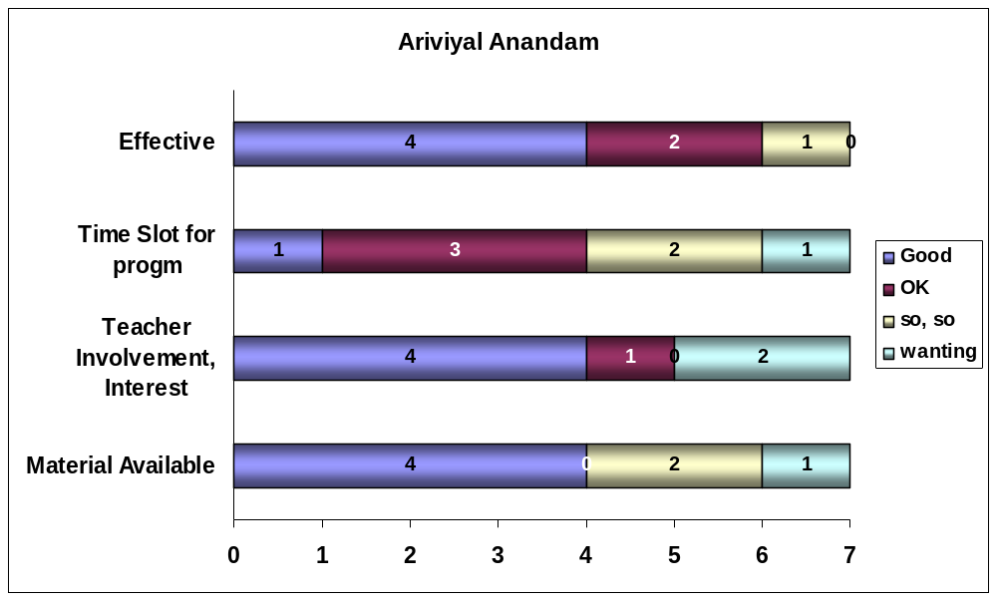

Ariviyal Anandam

Sl | Details | 21 | 22 | 23
10 | School | Panchayat Union Middle School | Panchayat Union Middle School | Sri KarpagaMatha Middle School
11 | Village | Annanagar,Okkur | Ammachipatti | Madhagupatti
12 | Block | Sivagangai | Sivagangai | Sivagangai
13 | Date | 03 July 08 | 03 July 08 | 03 July 08
20 | Primary / Middle / High | Middle | Middle | Middle
21 | Classes | 1 to 8 | 1 to 8 | 1 to 8
22 | Aided / Govt. | Govt. | Govt. | Aided
23 | Teachers Men / Women | 2 / 4 | 2 / 3 | 6 / 9
24 | Students Boys / Girls | 85 / 71 | 87 / 68 | 253 / 279
31 | Material Available  (A)more; (B) OK; (C) partly;(D) could not see | A | D | A
41 | Teacher Involvement/Intrst  (A)Good; (B) OK; (C) so so;(D) transferred- new | A | D | A
42 | Time slot for program  (A) Specific time; (B) With syllabus; (C) on & off;(D) no info | B | D | B
43 | Time Constraint  (A) No ; (B) Yes | B | B | B
51 | Effective  (A)high; (B) OK; (C) little;(D) cant say | A | B | A
61 | HeadMaster/HeadMistress | E.Shanmugasundari |  | P.Natarajan
62 | Teacher | Ganesamoorthi | Kalidasan | R.Porchelvi
63 | Teacher
64 | Aid India Chennai | Gomathi | Gomathi | Gomathi
65 | Aid India Sivagangai | Selvi | Selvi | Selvi
66 | Aid India Sivagangai

Ariviyal Anandam

Sl | Details | 24 | 32 | 33
10 | School | Municipal Middle School | Govt Girls High School | Govt High School
11 | Village | Hsg Board Clny | A.Kalappur | Selliampatti
12 | Block | Sivagangai | Singampunari | Singampunari
13 | Date | 03 July 08 | 04 July 08 | 04 July 08
20 | Primary / Middle / High | Middle | High | High
21 | Classes | 1 to 8 | 6 to 10 | 6 to 10
22 | Aided / Govt. | Govt. | Govt. | Govt.
23 | Teachers Men / Women | 0 / 6 | 0 / 10 | 1 / 3
24 | Students Boys / Girls | 62 /136 | 0 / 277 | 95 / 120
31 | Material Available  (A)more; (B) OK; (C) partly;(D) could not see | A | A | C
41 | Teacher Involvement/Intrst  (A)Good; (B) OK; (C) so so;(D) transferred- new | A | A | B
42 | Time slot for program  (A) Specific time; (B) With syllabus; (C) on & off;(D) no info | B | A | C
43 | Time Constraint  (A) No ; (B) Yes | B | A | B
51 | Effective  (A)high; (B) OK; (C) little;(D) cant say | A | A | B
61 | HeadMaster/HeadMistress | V.MariaSelvi
62 | Teacher | ShanthaPrabha | P.ShanmugaSundari | LawrenceEdward
63 | Teacher |  | TamilChelvi
64 | Aid India Chennai | Gomathi
65 | Aid India Sivagangai | Selvi | Shanmugavel | Shanmugavel
66 | Aid India Sivagangai |  | UmaMaheswari | UmaMaheswari

Ariviyal Anandam

Sl | Details | 35
10 | School | Panchayat Union Middle School
11 | Village | Vettayanpatti
12 | Block | Singampunari
13 | Date | 04 July 08
20 | Primary / Middle / High | Middle
21 | Classes | 1 to 8
22 | Aided / Govt. | Govt.
23 | Teachers Men / Women | 0 / 7
24 | Students Boys / Girls | 199 /168
31 | Material Available  (A)more; (B) OK; (C) partly;(D) could not see | C
41 | Teacher Involvement/Intrst  (A)Good; (B) OK; (C) so so;(D) transferred- new | D
42 | Time slot for program  (A) Specific time; (B) With syllabus; (C) on & off;(D) no info | C
43 | Time Constraint  (A) No ; (B) Yes | B
51 | Effective  (A)high; (B) OK; (C) little;(D) cant say | C
61 | HeadMaster/HeadMistress | B.Rajalakshmi
62 | Teacher
63 | Teacher
64 | Aid India Chennai
65 | Aid India Sivagangai | Shanmugavel
66 | Aid India Sivagangai

Village Library

My efforts to see the functioning of at least one Library on 2 July 2008 could not materialize. Resource Person accompanied me to 3 sites in Sivagangai Block. Librarians were not informed of my visit timing. They were away from library location with their preoccupation. In 2 sites neighbors reported that books are lent to children in the hamlet and they read story books.
Photos of AA:



