Asha for Education

Site Visit report for Non Formal Education Center Program run by Seva Mandir
Rajsamand/Udaipur, Rajasthan

Amit Sharma
May 24-25 2007

- Background
Seva Mandir, founded in 1969, is a rural development non-profit organization working in 583 villages in the rural areas of Udaipur and Rajsamand districts of Rajasthan. Since its inception, Seva Mandir has worked in the areas of children and adult education, natural resource management, health, women’s empowerment, and alternative income generating activities. Seva Mandir has been running Non Formal Education (NFE) centers in the rural (mostly tibal) communities living in scattered settlements in and around Udaipur district in southern Rajasthan.

I arrived at Seva Mandir office in Udaipur from Chennai on May 24th at 7:00 AM. I met Mrs. Priyanka Singh (Program Incharge) and Ms. Bharti from the Education Unit at Seva Mandir office in Udaipur. I got detailed overview of the NFE program in Badgaon block (the block that I was scheduled to visit). Priyanka described the challenges, and the initiatives that Seva Mandir has taken in the education unit. Although I have had prior interactions with her and program volunteers about the NFEs, I was very excited to hear details of the program and the success that the NFE centers have had over the years. We were joined by Mrs. Chandrakala (Progra, Executive), affectionately called Chandu Ji and Ms. Gunjan (Program Incharge) over breakfast and got a more detailed rundown of the program and the schedule for the NFE center visit.

Seva Mandir currently runs 171 NFE centers in Udaipur and Rajsamand districts. With each district divided into administrative blocks and zones, the Badgaon block in Delwara zone has 22 operational NFE centers, and I decided to visit NFE center of Valvaria and Ushaan villages. Although the original idea was to only visit Ushaan, we decided to take a de-tour through Delwara because I also wanted to spend some time at Nagarik Vikas Manch (commonly known as Manch), a Seva Mandir supported organization, working on grass root level health care and community building initiatives. (Work that Nagarik Vikas Manch is not related to the NFE project and neither is a part of the proposal for funding, but, I was interested in learning more about other aspects of the work that Seva Mandir has been engaged in).

- Traveling to Delwara
The trip to Delwara took us about 2 ½ hours from Udaipur. As Liaqat (our driver) drove us through the Aravali hills in a white Mahindra jeep, Chandu Ji went into the details of the NFE program and the specific focus areas of the program. I was able to get a lot of details on the demographics or the region, local issues, and problems that are plaguing the education system in general in the rural belt of Rajsamand district. Specific points that we discussed were:

- More than a third of students in 6-14 age groups are out of school or have never been to school
- Region is mostly tribal, and most children along with their parents tend to move to adjoining regions in Gujarat as migrant laborers.
- There has been increased awareness amongst the village community towards education and parents do want their children to get education
- There are government schools in the Delwara, but, the teacher at the school is mostly absent
- There is a high drop out rate form the government school(s) and children also report being beaten by the teacher as one of the main reason for their reluctance to attend school
- There is still affinity towards children working instead of attending schools; either as laborer or grazing and working in the fields, although this mindset is now changing with the community initiatives.
- Most families are very poor and a working hand to make ends meet is more important than attending full-time classes at school. There are a lot of instances of kids working in the fields before or after attending classes at NFE center.
- Quality of education in the government school is very poor and most students in class 4 and/or 5 cannot even read properly and have little or no math skills.
- NFE centers have consistently high attendance with little dropout rate, and more and more children with no primary education are able to graduate out of NFE to attend government school for continued education.
- Due to awareness campaigns, engagement with GVC, personal interactions with parents, there is increased interest and awareness about the quality of education in government school. Parents are now conscious of the teacher absenteeism and child abuse.
- Seva Mandir runs a bi-annual teacher training program for the instructors to improve the quality of education in NFE centers; focus is on instruction techniques to encourage participation, and generate interest amongst students.

- Pit Stop Nagrik Vikas Manch
In about 2 ½ hours we reached Delwara village, Rajsamand district, home to the [now even more famous] Devi Garh Resort – the famous tourist destination and now a eye candy of filmmakers. Despite of a lot of attention that this moderate sized village has received in recent years, a large size of the population still lives in abject poverty. In many ways, Delwara is in a unique position because its population size (of over 5000) that does not justifies its title of being a village. I guess its somewhere in the middle of being a village and a town in its own sense. The also has a high variance in the demographics, with almost 50% of the population living below, and about 20% just above the poverty line; And large section of the population are either laborers or farm workers.

We met Ms. Mamta a project volunteer with Nagrisk Seva Manch on our way to their office. I got a brief overview of the community and environmental work that Nagrisk Vikas Manch has been working on in the village and surrounding areas. At the modest premises of the manch, I met with Andre a full-time social worker that works with Seva Mandir for Nagrik Vikas Manch [project]. Andre is from UK, and has been working with Manch since last 7 months and with other project members, like Tarun and Mamta has been working on infrastructure building, education, and environmental programs initiated by the Manch.

Some of the interesting works that Nagrik Vikas Manch has been engaged in are:
  - Community building and sensitization program for infrastructure improvement through weekly meetings with village Panchayat
  - Encouraging people (and using RTI) to question the Panchayat and the BDO office for the infrastructure development work that in the village.
  - Installing waste disposal buckets in the village and constructing pukka drainage system
  - Constructed 2 septic tanks for sewage treatment; construction of 1 septic tank is underway (it is on-hold because of lack of funds)
  - Constructing public toilets close to the village center and a toilet at the government school
  - Opening a public library at the village center
  - Gender sensitization camps and programs
  - Field trips for children where they shoot documentaries with the help of volunteers on the problems that they face in their day-to-day lives
    - A very successful documentary making program, similar to the one above, was conducted exclusively for the girls

- Balvaria NFE
Balvaria is a small, remote village in Rajasamand district, about 3 ½ hours from Udaipur. Liaquat drove us through the gravel road to Balvaria and we finally reached the NFE center at around 11:30 PM. Chandu Ji mentioned that the total enrolled student count has swelled to 70 children since. The average age variance of children attending the NFE center is 5-13 years, with average attendance of close to around 50+ children.

The Balvaria NFE center runs out of a modest one room unit, with no electricity. Electricity is not needed for the most part, I’ve been told, because the centers only operate during daytime besides the fact that electricity is rather scarce in the region anyways. The center building has two blackboards, and a trunk full of books, notebooks, and flash cards. Children sit on the rug for classes and there were instructional posters and charts on the walls around the room. One room facility is hardly sufficient for the growing number of students that attend the Barvalia NFE center, and Seva Mandir recently got a philanthropic grant of Rs. 50,000 to construct another teaching room adjacent to the existing room. The construction was in full-swing at the time of my visit, and according to Chandu Ji the new room will be ready for use in about a month. However, due to construction work, the classes were being conducted outside under the shade of Neem tree just across the dirt road in the courtyard.

I met with Mr. Mohanlal who is the instructor at the NFE center since the center was started start in 2003. At the time when we reached the center, most students were beginning to trickle back to the center after lunch. And he was preparing for a Math class.
The class started with about 15 children. Some students has uniforms while some were wearing casual clothes; I was told that Seva Mandir collects a Rs. 5 token amount (not mandatory but recommended) called Shiksha Shulk from the families who send their childern to NFE center(s), and the collected money is spent on buying what the children show most interested in. All students were provided with a school bag, 2 notebooks, and some stationary (2 pencils, eraser, and sharpner etc.) though. We had a quick round of introductions and without wasting time Mohanlal started about giving a quick test to children in basic math. Mohanlal in my mind shows the importance of community engagement to the best. He’s a local, works full-time as an instructor in the NFE center, and has attended two annual training camps run by Seva Mandir and in many ways is one of the most experienced trainers. Mohanlal told me how he along with project workers from Seva Mandir visit individual houses in the villages and talk to parents and encourage them to send their children to the centers.

As Mohanlal started writing simple math equations on the blackboard and children diligently wrote down in their notebooks, it became apparent to me that it doesn’t take much of an infrastructure, forget extravagant, to impart basic education. Children seem to enjoy being with their peers, in open fun environment, solving out small puzzles, very inspiring! Out of my curiosity Mohanlal and I started inspecting their notebooks for answers to the test. It was very encouraging to find that most of the kids were quite good in basic math and were able to solve the puzzle. We discussed a bit more about the NFE project and ate our lunch under the Neem tree before leaving for the next NFE center. I left Balvaria NFE center with great admiration for the project and for the instructors like Mohanlal that are working everyday to change lives of these children.

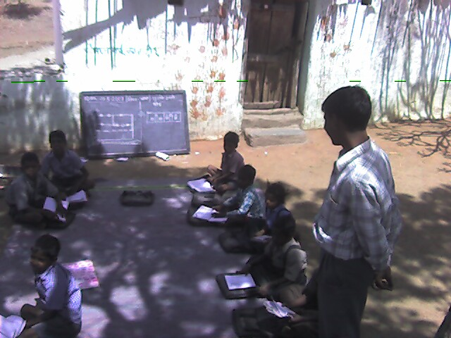
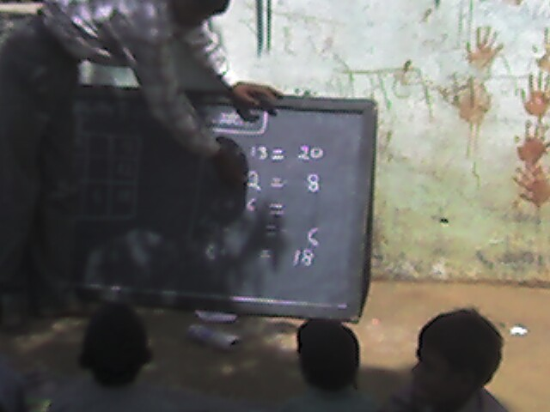
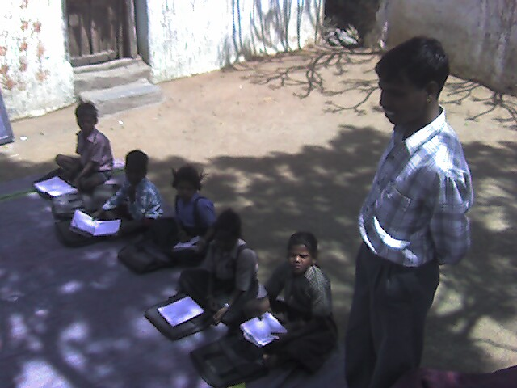
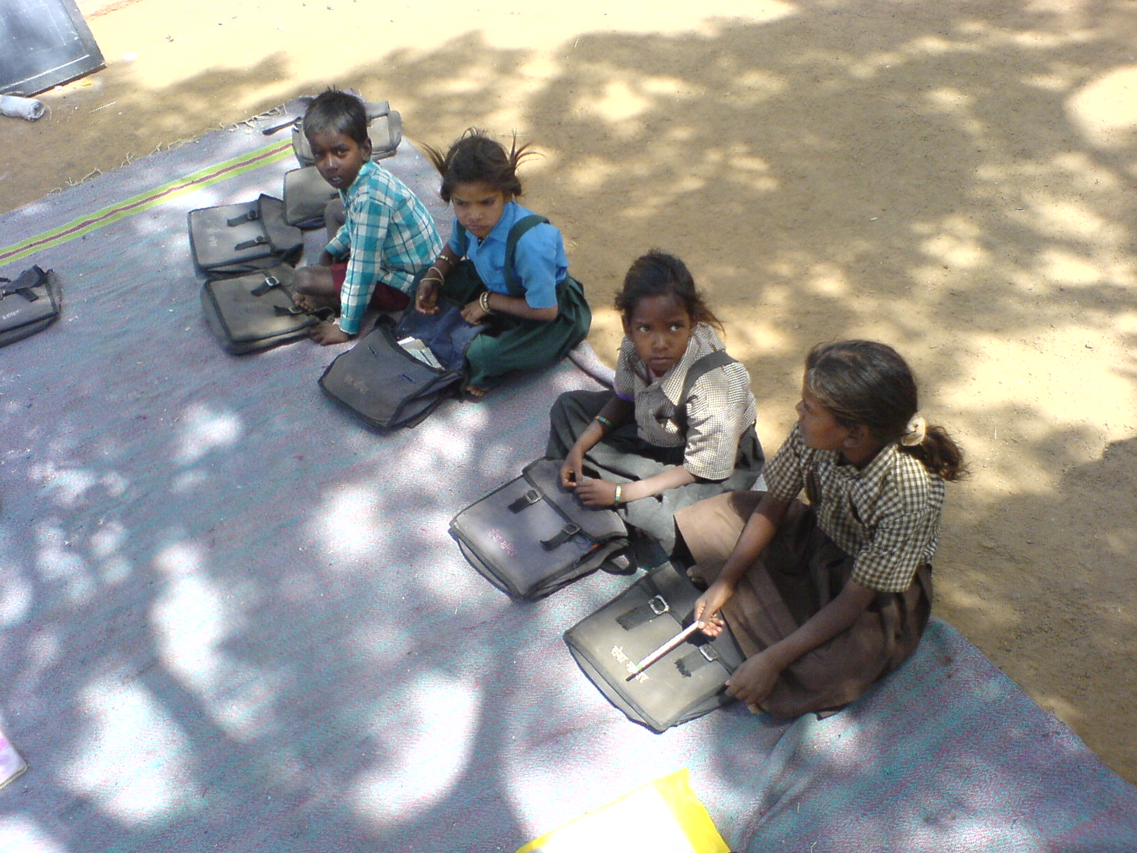
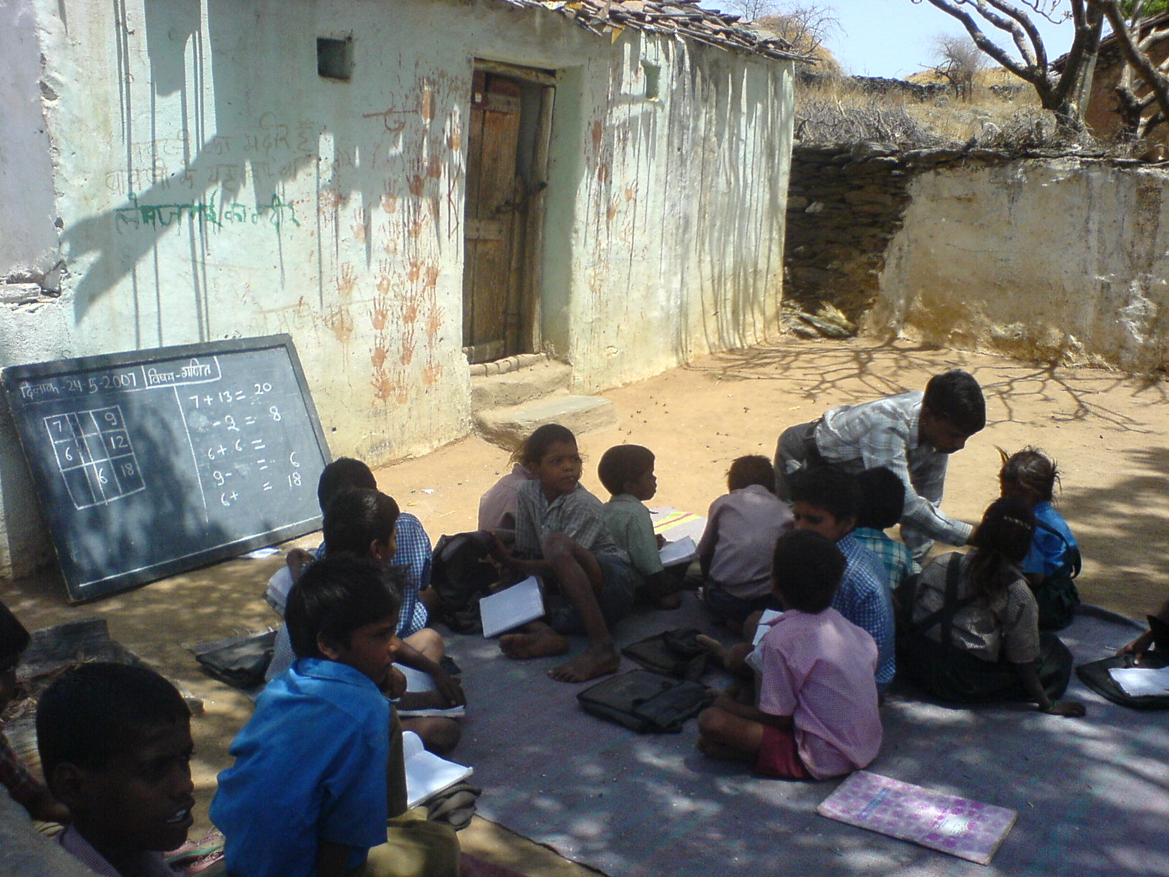
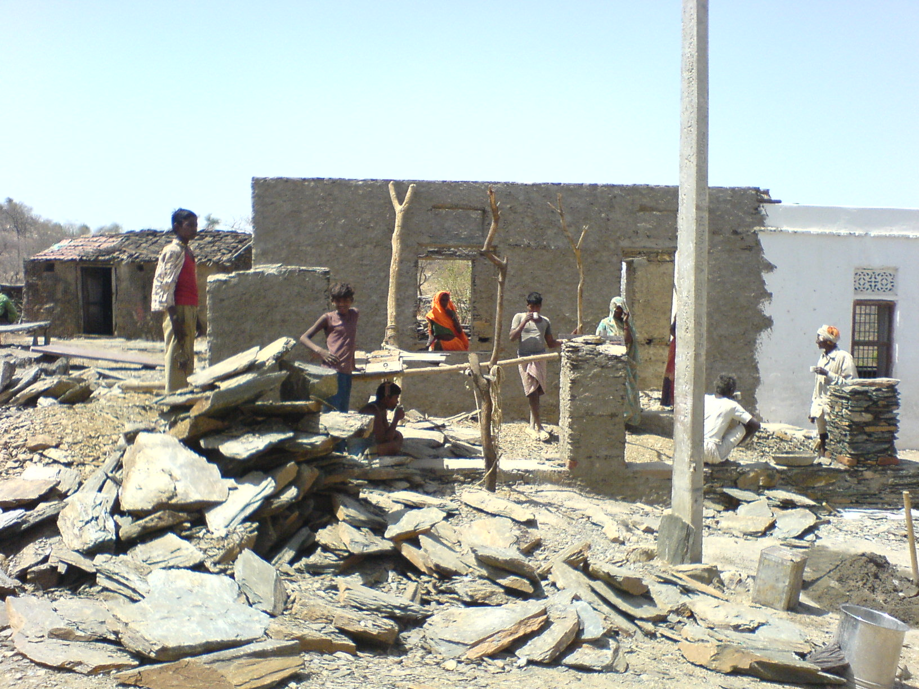
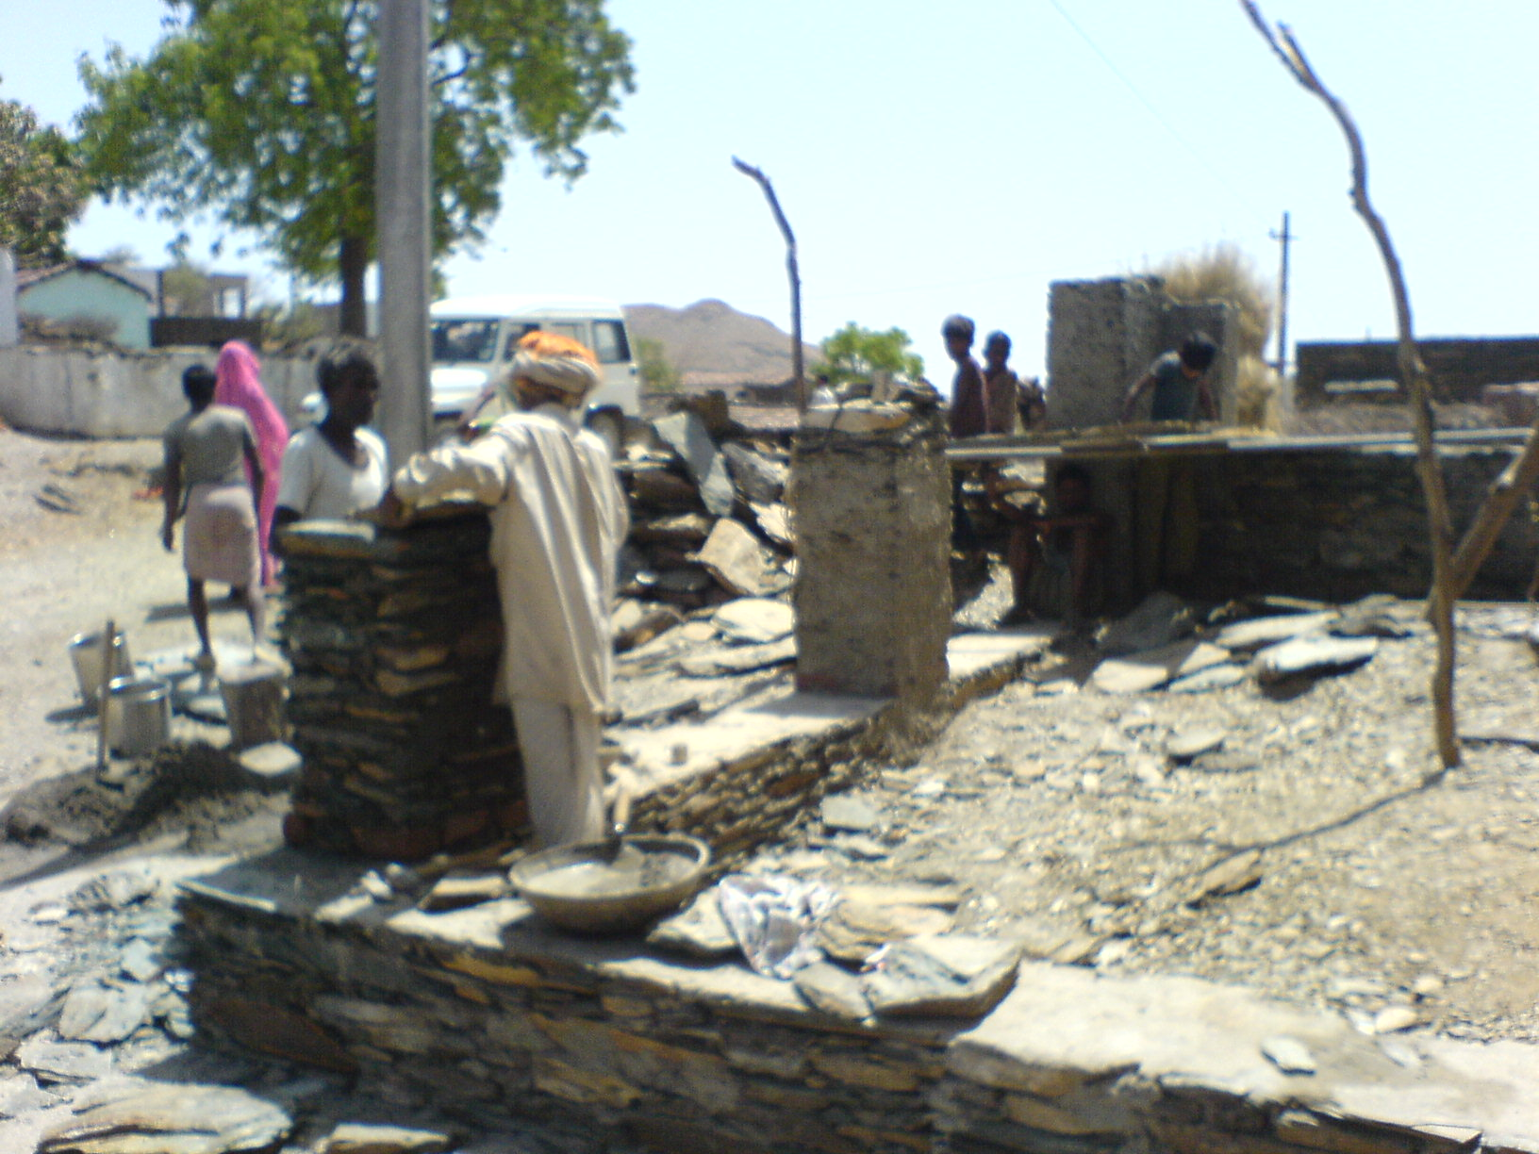

- Ushaan NFE
Ushaan is a very remote village in Badgaon block, about an hour away from Barvalia NFE center. Ushaan center is fairly similar to Barvalila NFE center; it’s a two room facility off the dirt road in the middle of the village. One of the rooms is used for running a poshahaar (mid-day meals) program for young kids where mid-day meals are provided to the children attending the NFE.

I was told that there are 35 children enrolled in the Ushaan NFE center and attendance is close to about 20 every day. (it’s important to note that not all children attend the NFE at the same time, some attend the morning session while others in the afternoon). The center has two blackboards, and the instructor was reading a story “chutki ulli” to the children when we arrived at the center. I sat along with the children for the story reading session, and saw the instructor, Kesar Meena, use the story told in hindi mixed with local language (Marwari) and examples from daily lives to encourage participation. I found it very interesting to note that there were two students (Ganesh and Dinesh) who also attend the government school were attending the afternoon class at the NFE. Although it’s not a bench mark to measure quality, but, was encouraging to say the least.

We did round of introductions as children called out their names. Ms. Kesar (the instructor at the NFE center), went on to ask a group of girls to recite a poem they learnt in their reading/writing classes. After much persuasion, a young girl names Durga started the recital reading from her notebook and in no time was joined by the rest of the bunch. The energy and enthusiasm was very contagious and inspiring. I was impressed by the fact that every one of these young kids was able to read out the poem and were able to identify specific items (like animals and fruits etc.) mentioned in the poem using the flashcards and charts.

I spoke briefly with Ms. Kesar about the center and the day-to-day operation of the center. I was impressed by her understanding of the demographics of the region and the level of personal interest she seemed to show with individual children. As with Mohanlal, Ms. Kesar is also a local and works full-time with Seva Mandir as an NFE instructor. Grooming and recruiting local instructors for running NFE centers has been a Seva Mandir policy from the start of the program and it did make sense to me because they have a very clear understanding of the local problems besides they are able to work with the parents directly on a very personal level.

Liaquat (our driver) drew our attention to the cracks in the walls of the room. Ms. Bharti and Chandu Ji told me that Seva Mandir has been working on getting these repaired. NFE center premises are not owned by Seva Mandir, but rented out instead its very hard to get them repaired by the owners. I personally believe that more needs to be done in improving some of the infrastructure at Ushaan NFE center and the potential of this center are immense. Also, the cracks in the walls and the roof need fixing especially considering the upcoming monsoon season. I was told by Chandu Ji that they are trying to get some intermediate repairs done.

After spending over two hours at the center, it was time to leave for the local Balwaadi. We said out goodbyes to the kids and left for a Balwaadi that Seva Mandir runs in Ushaan about 10 min. away from the NFE center.

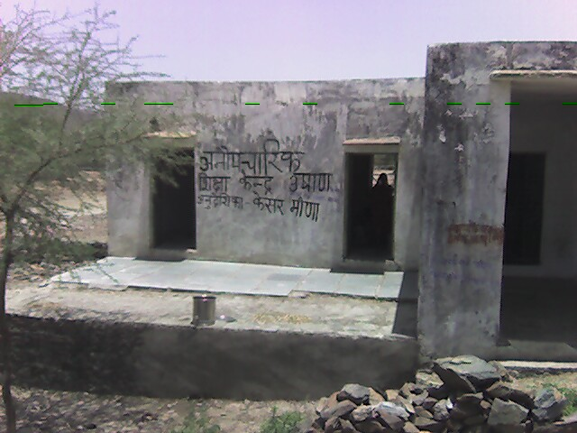
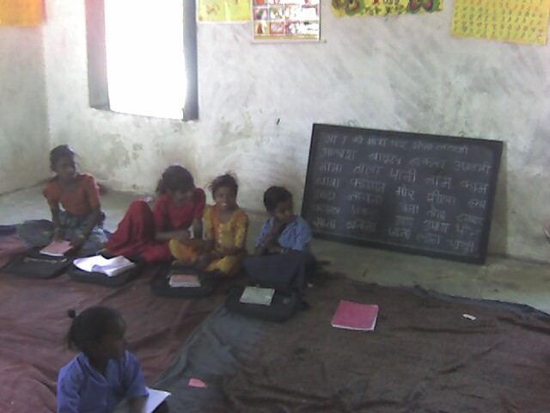
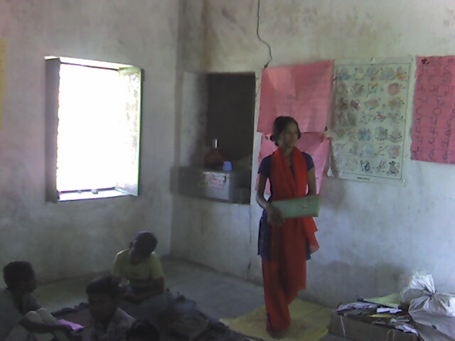
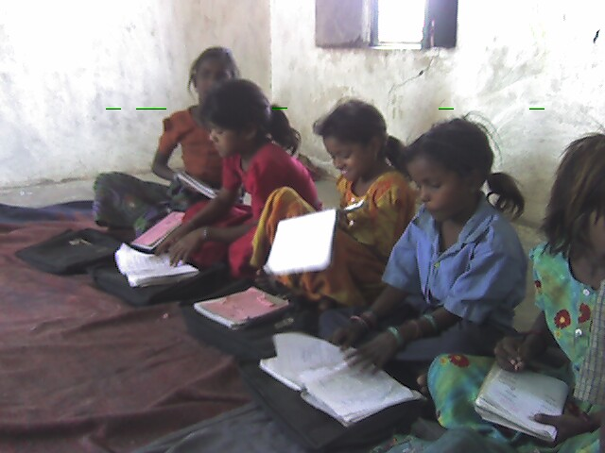
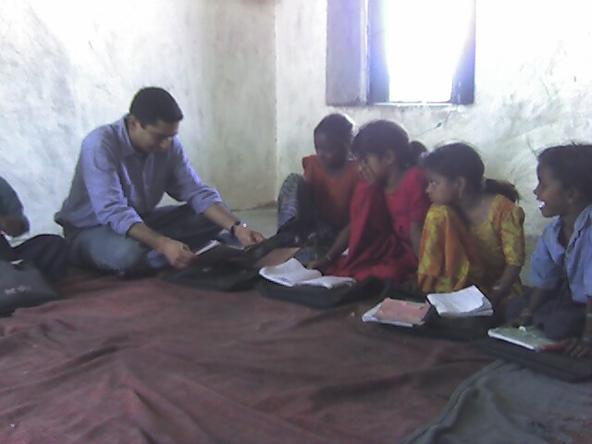
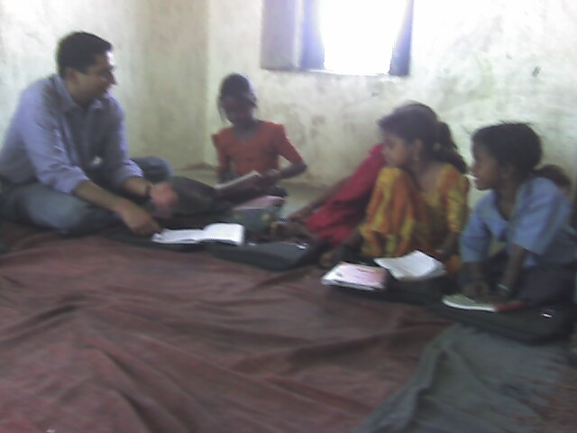
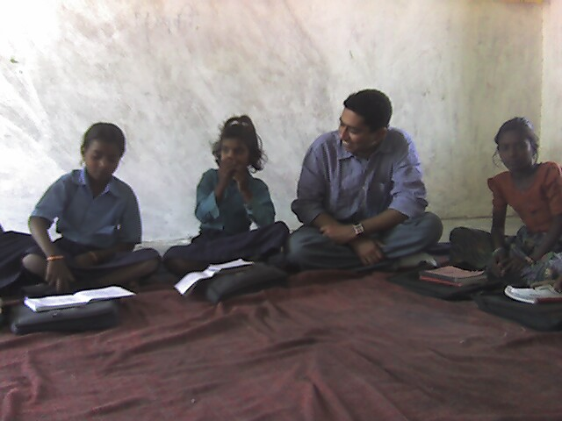
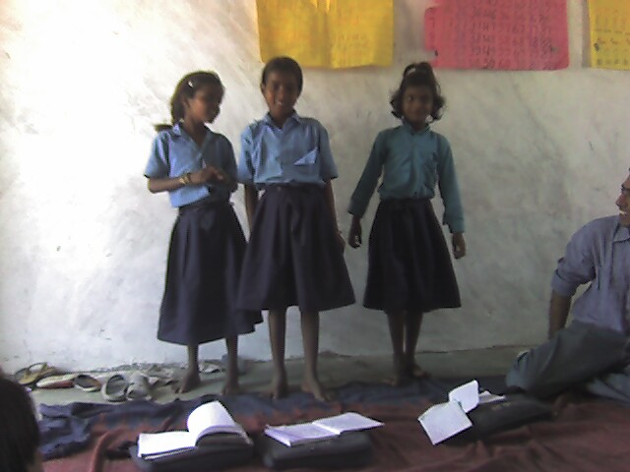
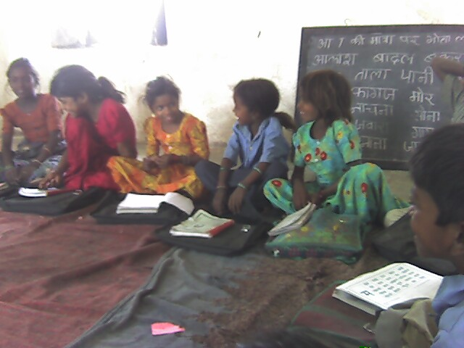
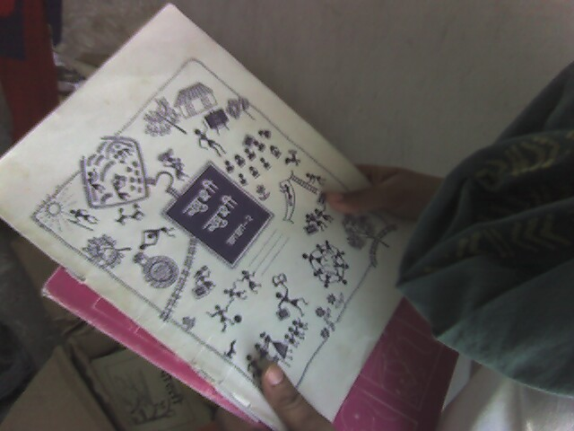
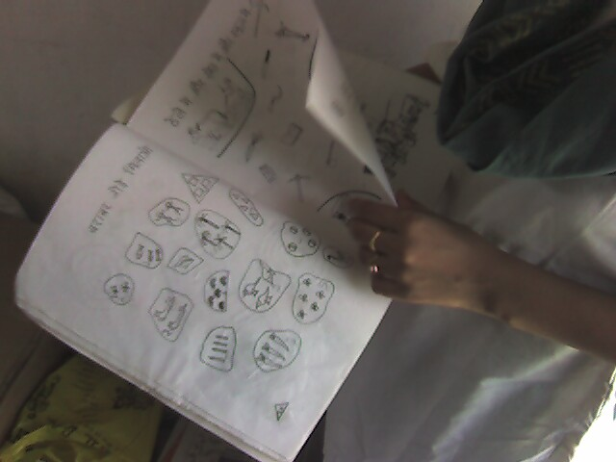
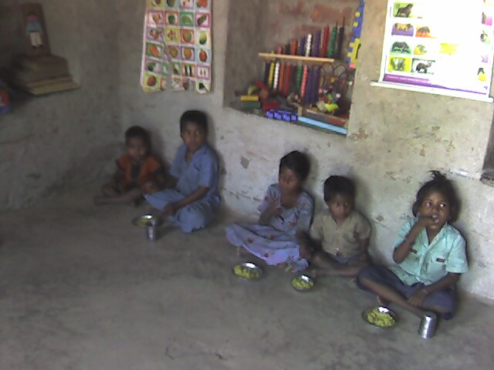

- Children Camp at Vidya Bhavan
On our way back from Ushaan, we decided to stop by at the Bal Mela (Children camp) that Seva Mandir has been conducting in Udaipur. Bal Melas are the annual summer camps for children that Seva Mandir conducts as a two month full-time, resident education camp/program for rural children. NFE instructors in villages bring young children that do not attend either the NFE centers or the government run schools, or are not regular in attendance, are braught to the Bal Melas.

It was later afternoon by the time we arrived at the summer camp. And we decided to call it a day and revisit the Bal Mela the next day, on the May 25th ‘07.

On May 25th, I was back at the Seva Mandir office at 9:00 AM for visiting the Bal Mela. Ms. Priyanka (Program Incharge) told me that Chandu Ji and Ms. Bharti have been instrumental in running these Bal Malas for past few years. And that each year the number of students that attend these Bal Melas has been increasing. This year, there were about 320 children from different villages of Rajsamand district, and 21 instructors at the camp. This year’s Bal Mela was hosted on the premises of Vidya Bhavan Socity (a local NGO) in Udaipur.

- These Bal Melas are designed as immersion program for children who are for two full months are imparted basic reading and writing training.
- Besides running classes, children are provided with free meals (thrice a day), illustrated reading material, notebooks etc. I found the camp as an interesting intervention technique in generating interest amongst children.
- The basic idea is to impart basic reading and writing skills amongst young children who have either never been to schools before or those who are new to the NFE centers.

- I inquired with Ms. Priyanka if a two month program is sufficient for the building basic reading/writing skills. As it turns out the Bal Mela is really an immersion program to maximize learning amongst these children and to encourage them to continue with their learning at the NFE centers after the camp.

- The instructors from NFE centers conduct classes at the Bal Mela and after the camp conclusion, follow up with the parents of the children to send them to the NFE center.

- Instructional techniques at the camp are very similar to the NFE centers.

- Although because this is [sort of] a residential program, the classes are interspersed with games and sports sessions, besides meal breaks.

- The facilities and infrastructure at the camp was impressive; we ate at the Bal Mela with the children and the quality of the food served was pretty good.

