Palash Trust Site Visit Report
On Dec 8th 2011, three of us from Microsoft Research India – Kapil Vaswani, Srividya Narayana and myself (B. Ashok) visited Palash Trust. We visited three locations where they work – Luminary School in Magadi Road, Government School in Vijayanagar and a library near Chitra Krishnamurthy’s house. Chitra, who is the main coordinator for Palash Trust and her husband Krishnamurthy who volunteers himself accompanied us.
All three of us left very impressed with the quality of the work being conducted and the impact it is having on the children. We strongly recommend that Asha Seattle continues to fund this project partner. It is rare to find such dedicated people running a program that is benefiting so many children.
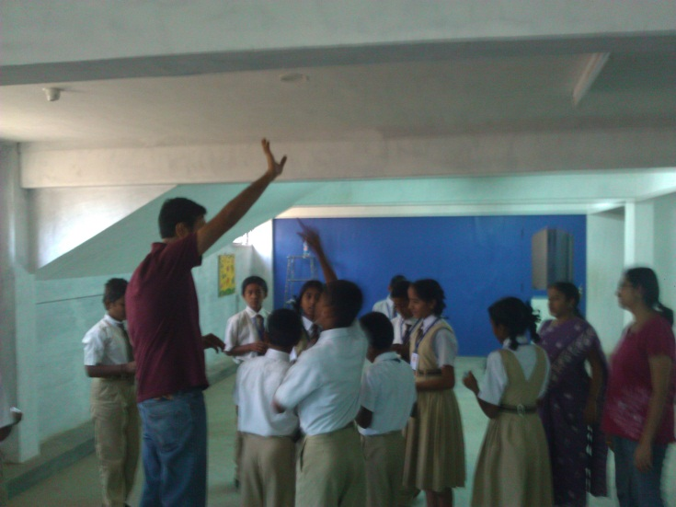
Luminary School is located about 10 km. from Vijayanagar just off Magadi Road. It is in a rural area currently, but Bangalore city is fast expanding to this area. It is a private English medium school primarily for the local kids who live in and around that area. The children are from poor and lower middle class background. We were received by three 9th standard kids who were very confident and full of smiles. The principal was not in town on that day and had left a note for us. We also received a bouquet and a large card made by the children that is currently displayed in our office. We interacted with the kids in different batches, starting from 8th and 9th followed by 6th and 7th. There were a few more girls than boys in these two batches. We conducted a few games and puzzle quizzes for them, which tested math and language skills. The puzzles required them to think differently and some of them rose well to the challenge. They thoroughly enjoyed their time with us. During the interactions, we found out that math was a favorite subject for them, but they did not like certain portions. We encouraged them to read a lot of books. Chitra Krishnamurthy showed us the puzzles and games as well as the library books that had been procured over the past few years to build up a collection in the school. A few people from Palash Trust go to Luminary School once a week (on Fridays) and spend the whole day there. They work on art and craft, needlework, theatre, games, library program and reading, counseling, emotional healing and spiritual development.
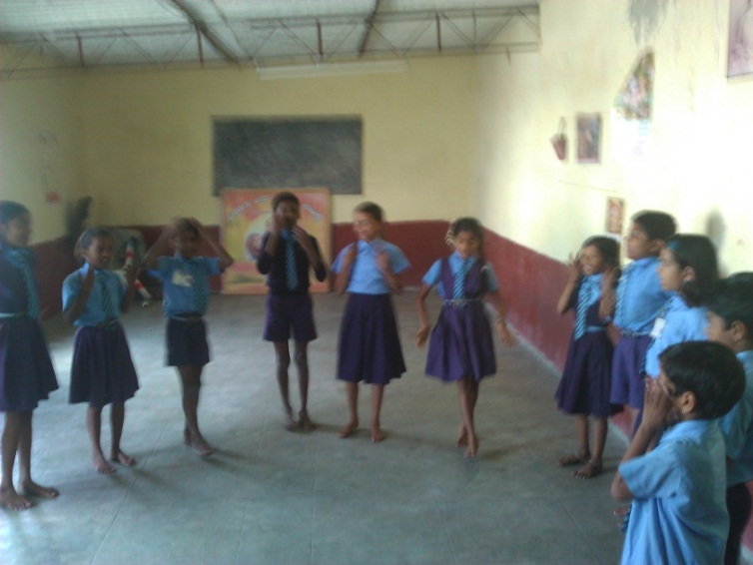
After we spent a few hours at the Luminary School, we went next to one of the Government Schools in the city that Palash Trust works with. This was called AmaraJyothi Nagar Government School in Vijayanagar close to Chitra & Krishnamurthy’s house. The school was reasonably well stocked with learning materials thanks to the Sarva Shikhsa Abhiyan program. Most of the children were in the smaller age groups in this school. The class rooms were bright but crowded. One of the Palash Trust volunteers spends time at this school and that has made a big difference. She works with them on English language skills, as well as clay work and weaving. She was there waiting for us. We also talked to the Government employed teachers and they spoke highly of the Palash Trust involvement and how it has helped. We spent some time with the older children and had them play a math related game that we had conducted at Luminary School earlier as well. Here as well, as in Luminary School, there were a few more girls than boys. We found them to be bright and engaged. They came up with a different set of strategies compared to the Luminary School children. The communication was mainly in Kannada which Srividya helped us with. We learnt that the Palash Trust volunteer gets paid Rs. 500 a month, which will barely cover her travel costs and a bit more. We recommend that we help to increase this in the future.
Finally, we went to Chitra and Krishnamurthy’s house and she showed us the library she has set up next door in a rented room. This is being used by a bunch of local children in the evenings. The key is left near her door and the system works fully on trust. The children come by, open the library, use it and lock it up when they are done. We also saw some wonderful art work done by the children which was also housed in the library – cloth bags, purses, paintings/drawings and more.
In general we felt that Palash Trust is using as little budget as possible and having good impact in whatever they engage in. Given this we would recommend looking at how we can increase our funding levels in the future. Besides the two schools we visited, there are three more schools (Pinewoods school which we only saw from outside) and two more Government schools where they are involved. In addition, there is one evening class at Nachiketa Manovikasa Kendra that is conducted by them. We will be visiting these also in the future.
Both Chitra and Krishnamurthy do this work completely from their heart and say that seeing the children bloom and do well is their main reward. They have a small team of volunteers to help them with their various activities who also work from their heart just like them. They are humble about the work they do, but we would like to say - Hats off to them and the great work they are doing!
