I, Kaustuv Chakraborty (Volunteer, Asha Kolkata Chapter), did the site visit for R.N. Basu Girls High School, Maju, Howrah on 19th December 2007. The details of the visit are as below:

- Interviewer: Kaustuv Chakraborty
- Interviewees:
  - Mr. Shyamal Majumdar – Secretary of the school
  - Ms. Kanakmala Bhattacharya – Teacher in charge of the school
  - Ms. Rajashree Biswas – Geography Teacher
  - Mr. Hiranmoy Roy – Guardian of a student of the school, as well as a School teacher of the boys school
  - Ms. Suchitra Patra – Guardian of a student of the school
  - Ms. Mahua Mukherjee – Guardian of a student of the school
  - Nilanjana Mondal, Anindita Ghoshal, Priyanka Patra – Students of the school

Background:
R.N. Basu Girls High School is situated in Maju, Howrah, West Bengal and was established in the year 1963. Currently the school is run in the premises of the R.N. Basu High School, a school for the boys and facing huge problems due to this reason. The girls’ school is upto standard X and has 972 students. It is the only girls’ school in a radius of 5 KM (3 Mi Approx).

Current State:
Currently the Teacher in charge of the school is Ms. Kanakmala Bhattacharya. Currently the school is run in the premises of the R.N. Basu High School for boys. The girl students are not allowed to use the water, toilets and electricity from the boys’ school. The desks are also vastly inadequate, especially for standards V and VI. There is hardly any place to keep office work. Also the school starts at 6:00 AM and ends at 10:25 AM as the boys’ school is supposed to start at 10:30 on the same classrooms. This schedule is followed in the winter too. Often there are shortage of desks if higher percentage of the students attend the school. The students use the nearby bush as the lavatory. The present staff room is miserable; in fact it serves as the staff room, store room and pantry together. However with the help of a person and the “Sarbasiksha Scheme” a new school for the girls is being built, but is in an unfinished condition as the “Sarbasiksha Scheme” funds a little amount of money compared to what required each year. The new school has seven classrooms and an office room already built. A new office has been set up to for running the school. It further needs toilets and five more classrooms.
The strengths of the different classrooms are as follows:
Class | Count | Remarks
V | 50
VI | 87
VII | 126
VIII | 148
IX | 169
X | 392
Total | 972

The results achieved in the last X Std public examination are as follows:
Division/ Class | Count | Remarks
1st Division | 6 | 2 Star marks
2nd Division | 26
3rd Division | 29
Compartmental | 2
Unsuccessful | 7
Total | 70

Existing Problems:
- No building/ infrastructure of their own
- Not allowed to use electricity of the current facility
- Not allowed to use bathroom of the current facility
- Not allowed to use the drinking water of the current facility
- Classrooms are overcrowded, often people sitting on floor mats
- The Girls’ school starting too early to accommodate the time of boys’ school time.
- Teachers cannot come in time due to an extreme early start
- Periods are cut down short to accommodate all the classes
- Too much shifting of the desks as the boys and girls do their study in the same classrooms but they have different strengths

Obstacles faced in starting the new building as the classrooms:
- In adequate classrooms. At least 12 required, but only 7 are complete
- No electricity, water or toilet facilities
- No infrastructure such as desks, cupboards, blackboards, etc.

Please find a few snaps those were taken during the visit:
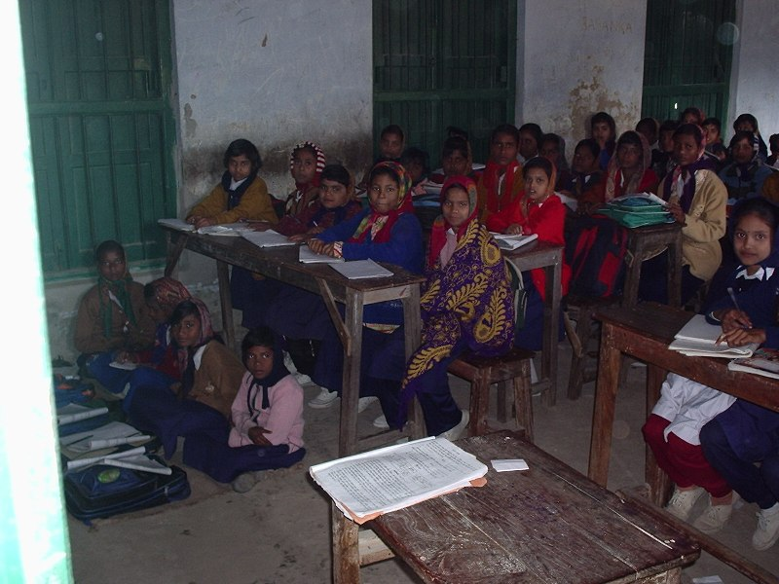
Figure 1: Class V, Section B

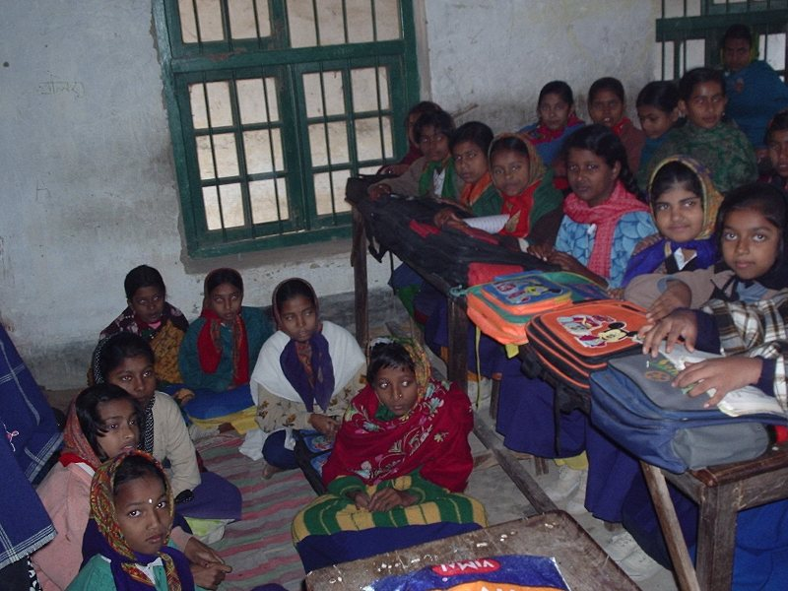
Figure 2: Figure 1: Class VI, Section B
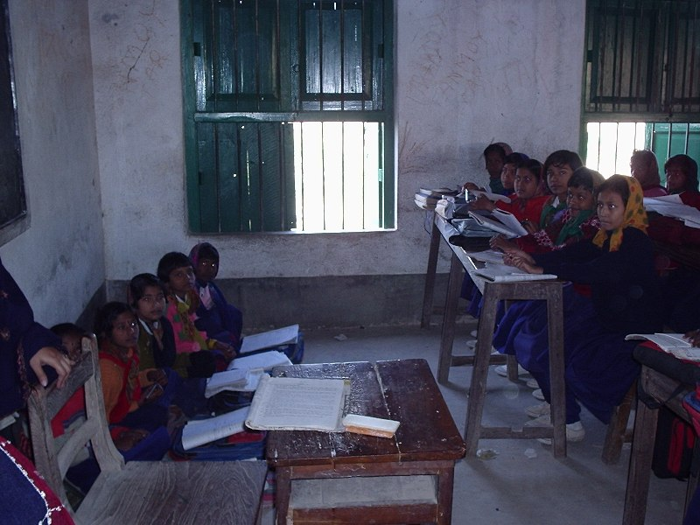
Figure 3: Class V, Section A

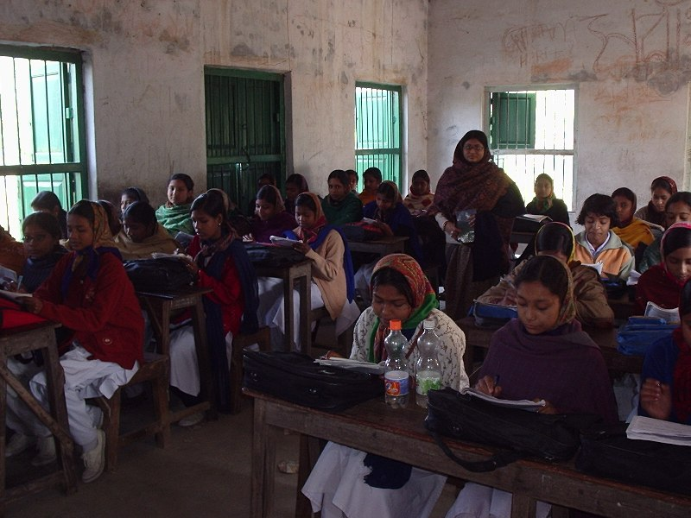
Figure 4: Class VIII
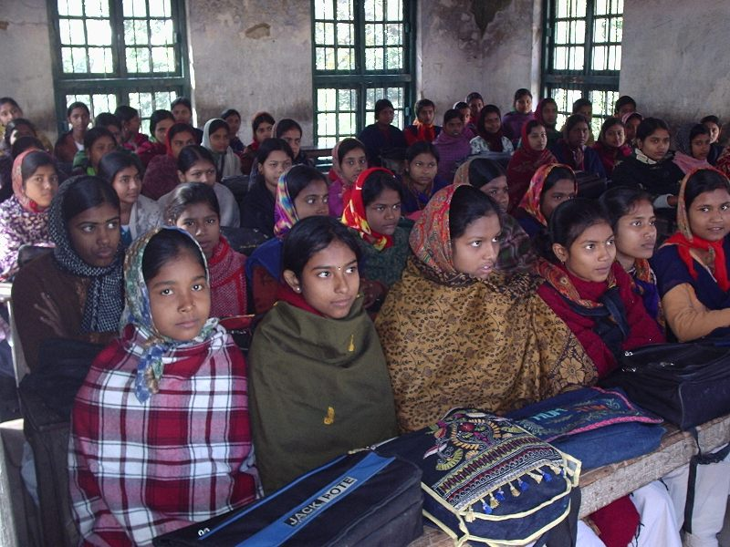
Figure 5: Class IX

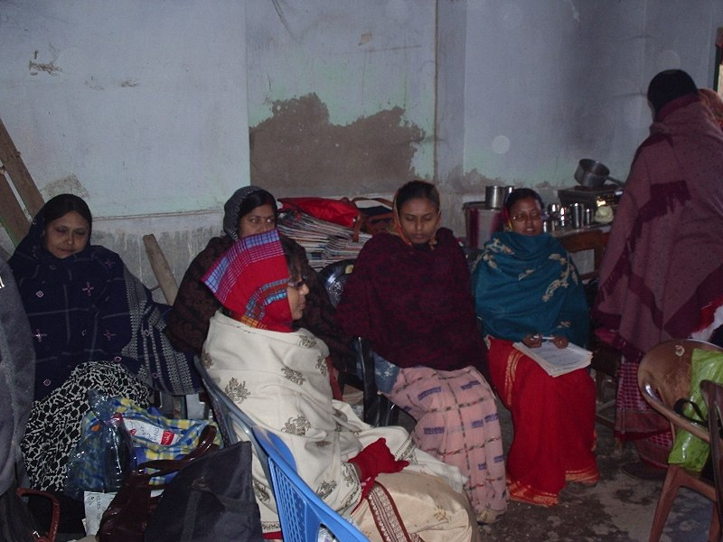
Figure 6: Current Staff Room cum Pantry cum Store Room

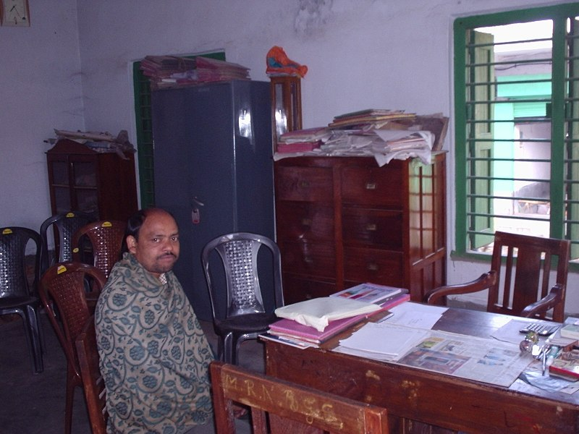
Figure 7: New Office Room

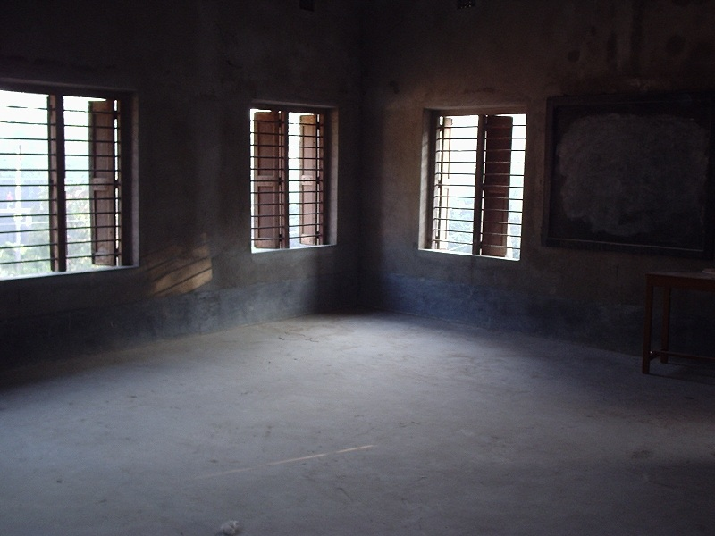
Figure 8: One of the new classrooms
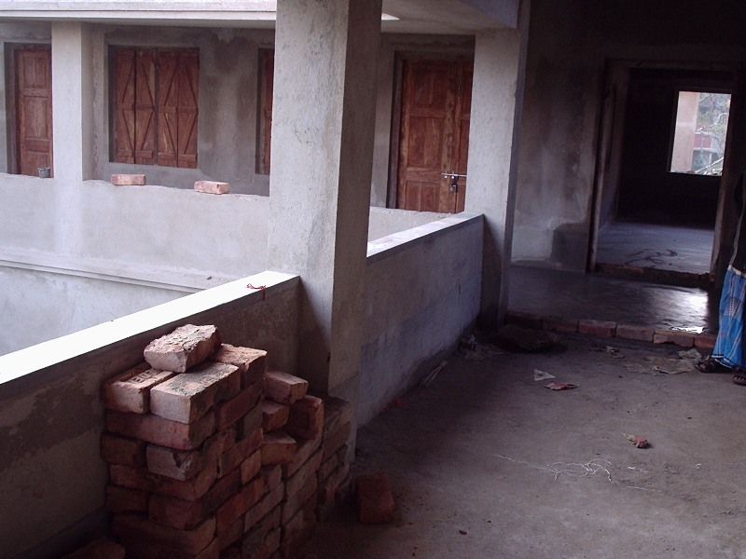
Figure 9: The new School Building which is being converted

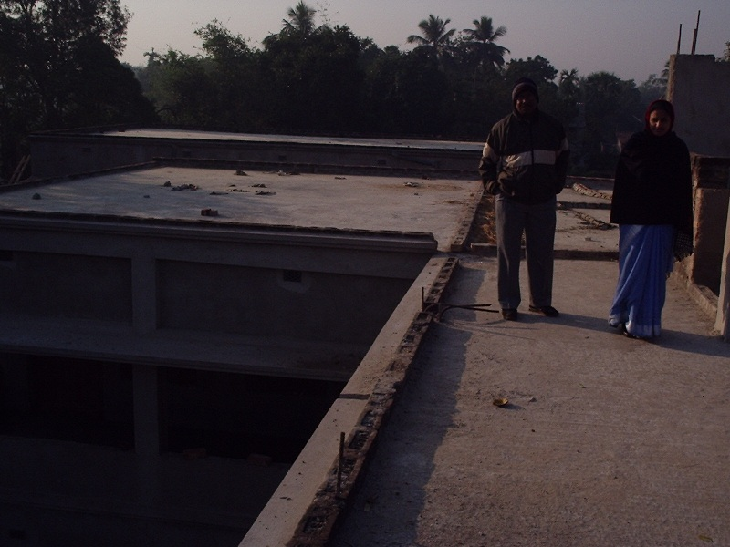
Figure 10: The new School Building which is being converted

